Ansible Instatllation

Controller mahine

vi /etc/hostname



#sudo -i

#hostname

Agent machine

vi /etc/hostname



#sudo -i

#hostname

Controller machine

vi /etc/hosts

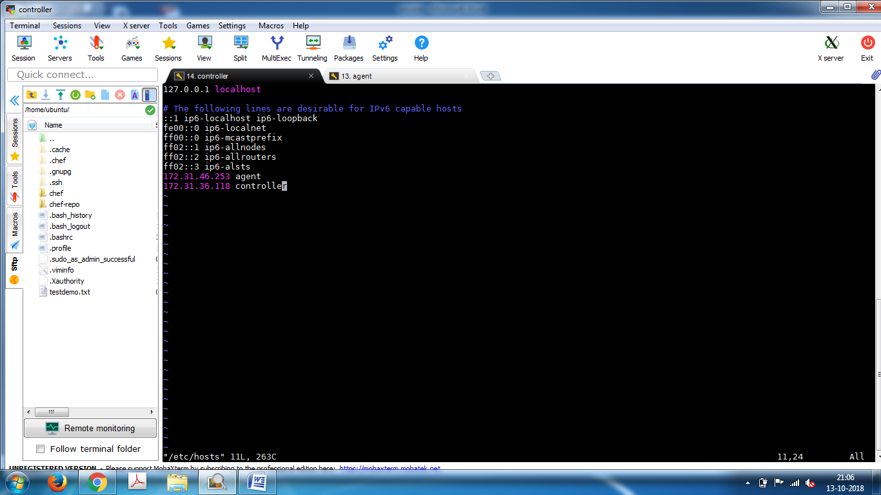

Agent machine

vi /etc/hosts

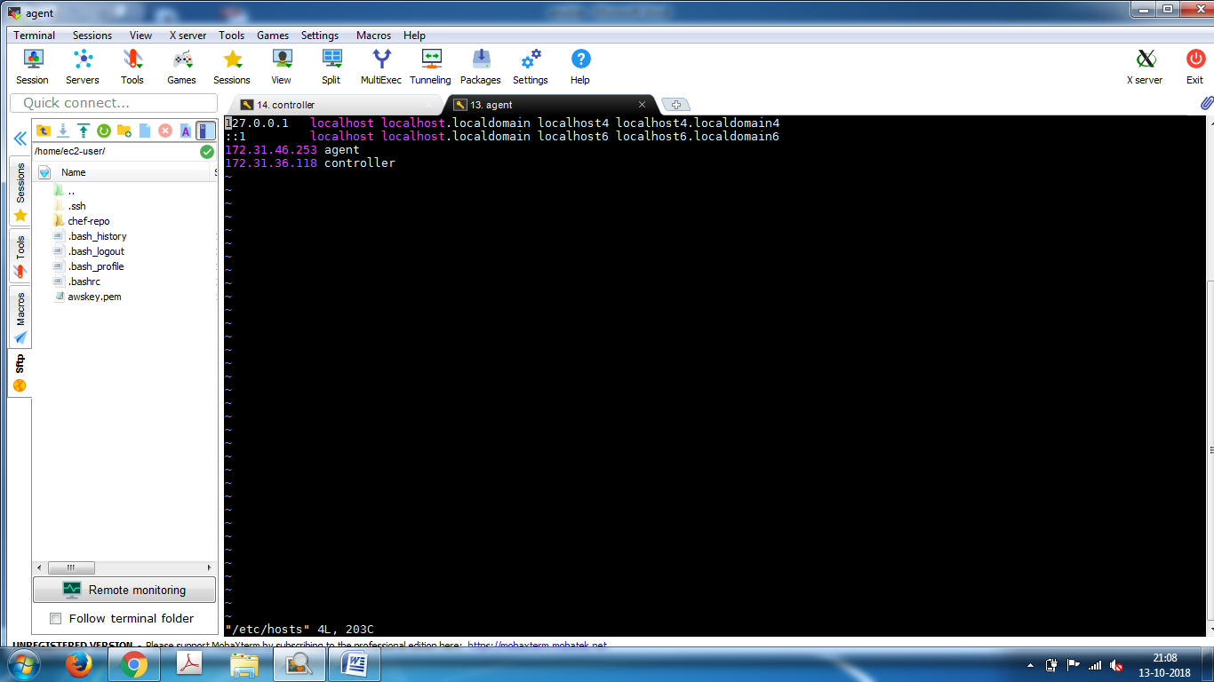

Controller machine

Ansible Installation

apt-get update -y

apt-get install software-properties-common

apt-add-repository --yes --update ppa:ansible/ansible

apt-get install ansible

#cd /etc/ansible

#ls

# cd /etc/ansible/

#vi hosts

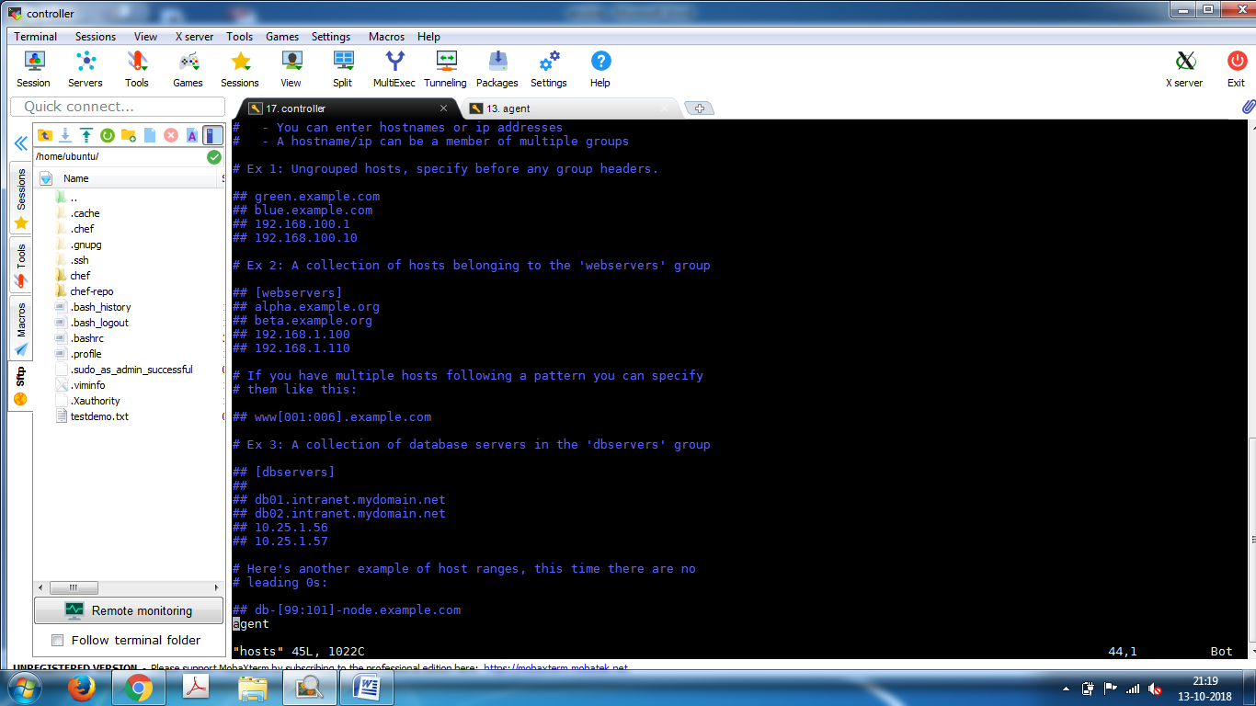

#ansible agent -m ping -u root

it will give error

generate ssh keys

# ssh-keygen -t rsa

enter

enter

enter

root@controller:/# cd ~/.ssh/

root@controller:~/.ssh# ls

authorized_keys id_rsa id_rsa.pub known_hosts

root@controller:~/.ssh# vi id_rsa.pub

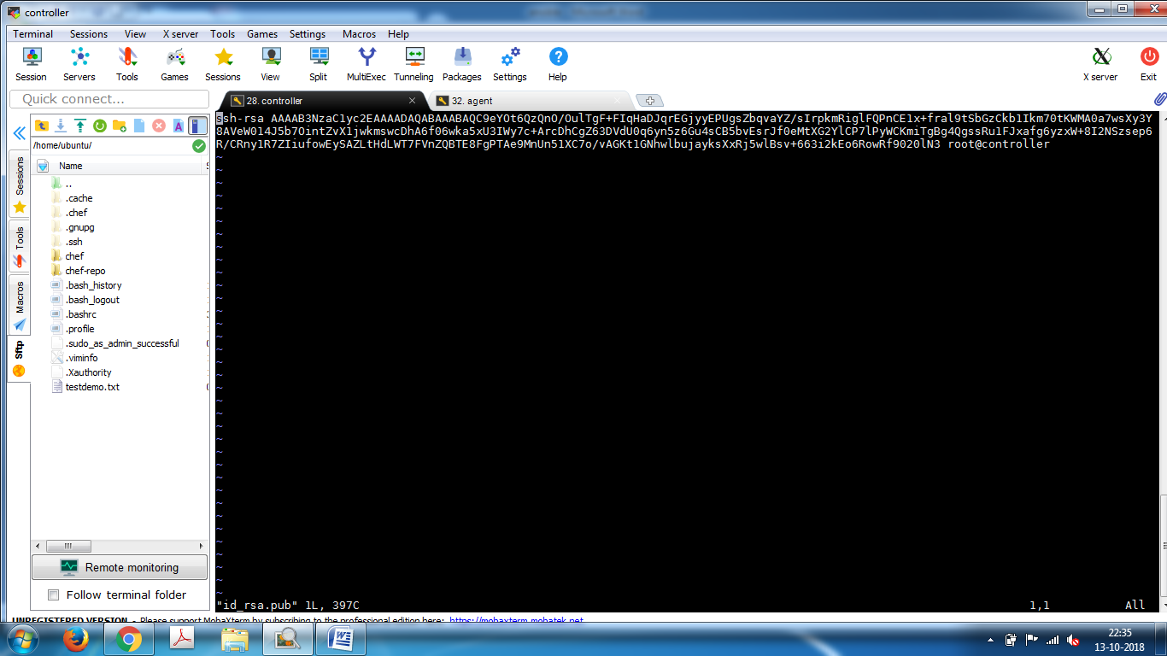

copy the key and paste in agent home directory under

[root@agent ~]# vi ~/.ssh/authorized_keys

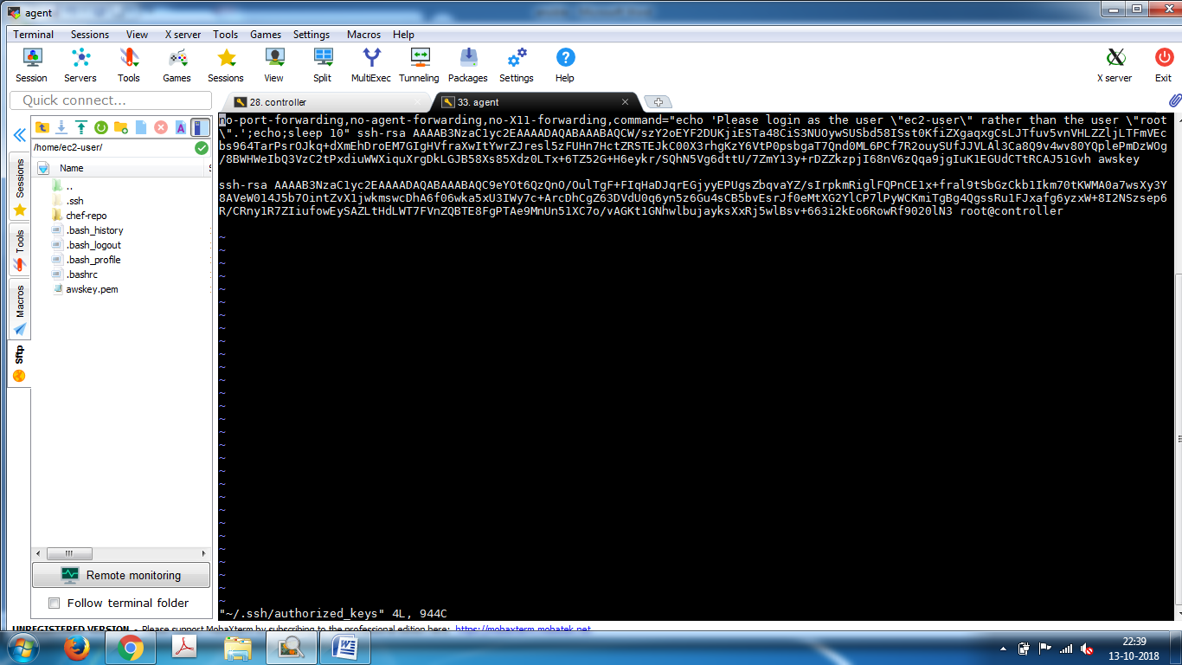

Agent machine

generate ssh keys

# ssh-keygen -t rsa

enter

enter

enter

[root@agent /]# cd ~/.ssh/

[root@agent .ssh]# ls

authorized_keys id_rsa id_rsa.pub known_hosts

[root@agent .ssh]# vi id_rsa.pub

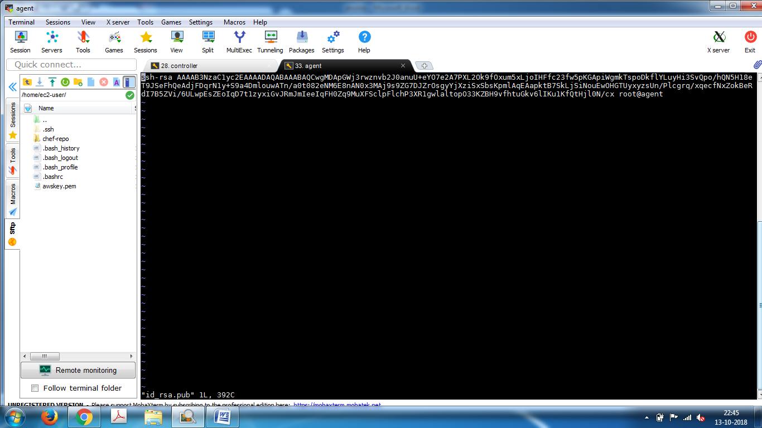

copy the key and paste it in [root@agent .ssh]# vi authorized_keys

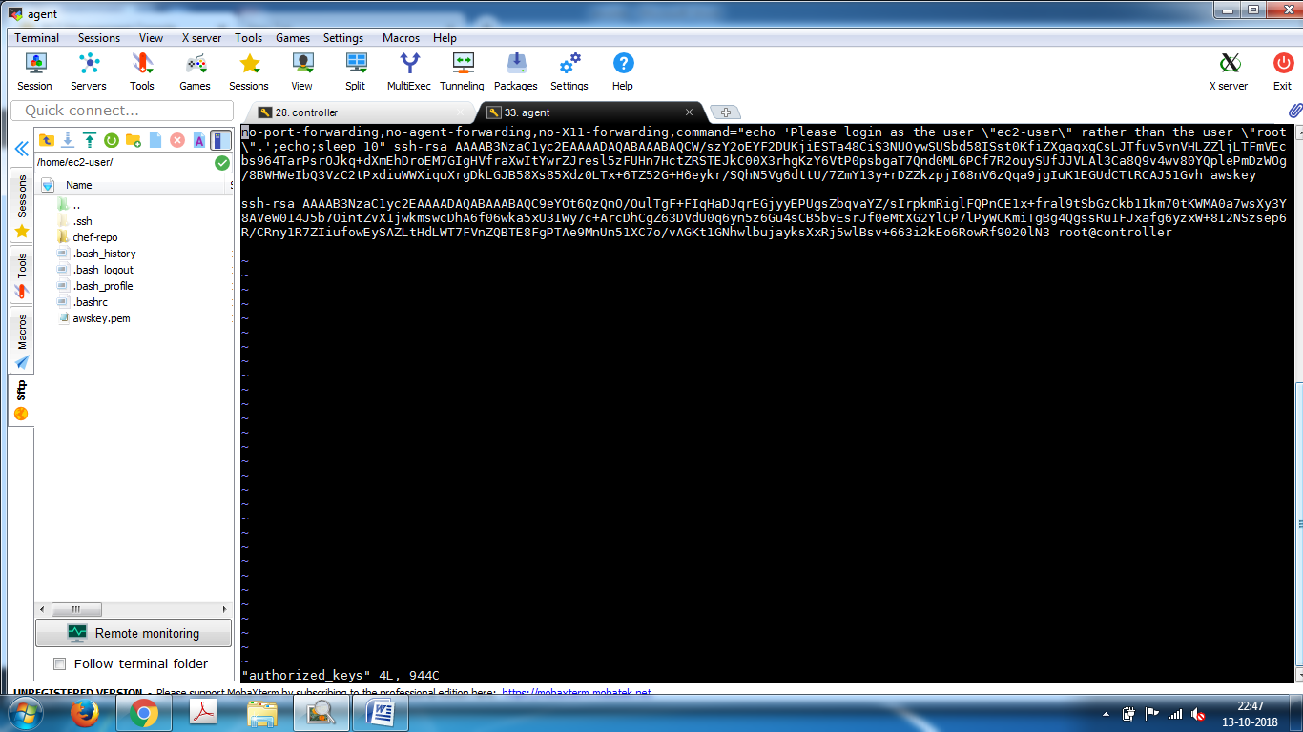

Install python in client machine

#apt-get install python

Controller machine

root@controller:/etc/ansible# ansible agent -m ping -u root

agent | SUCCESS => {

"changed": false,

"ping": "pong"

}

root@controller:/etc/ansible#