PROJECT REPORT
Survey on Digital Learning Tools Usage Among College Students
A Data Analysis Report — Pandas, NumPy, Matplotlib & Seaborn
Student Name : Waghmare Ganesh Jalindar
Class : SY Data Science
Mentor : Arjana Shaikh
Dataset : survey_data.csv — 69 responses, 22 fields
New Arts, Commerce and Science College, Ahmednagar

Step 1 — Introduction
Digital technology has become an important part of modern education. College students increasingly use digital learning tools such as Google Classroom, YouTube, online learning platforms, educational applications, video conferencing tools, e-books, digital notes, and Artificial Intelligence-based tools to support their studies.
These tools give students easy access to learning resources, flexible learning opportunities, quick information, and interactive educational content. However, excessive use of digital platforms may also create challenges such as distraction, technical problems, internet dependency, information overload, and difficulty in maintaining concentration.
This project studies how college students use digital learning tools, how frequently they use them, why they use them, and how these tools influence their learning experience, academic performance, productivity, and understanding. A 20-question survey was circulated among students and 69 valid responses were collected and analyzed using Python (Pandas, NumPy, Matplotlib, Seaborn).

Step 2 — Problem Statement
College students use a variety of digital learning tools for academic purposes, but their usage patterns and experiences differ from student to student. The study addresses the following questions:
- Which digital learning tools are commonly used by college students?
- How frequently do students use these tools?
- What are the major purposes of using digital learning tools?
- Do students believe digital tools improve their academic performance?
- How do digital tools affect students' productivity and understanding?
- What difficulties or challenges do students face while using these tools?

Step 3 — Objectives of the Study
- To identify the digital learning tools commonly used by college students.
- To study the frequency of digital learning tool usage.
- To understand the major purposes for which students use digital learning tools.
- To analyze students' perceptions regarding the usefulness of digital learning tools.
- To study the impact of digital learning tools on academic performance.
- To examine the effect of digital tools on students' productivity and understanding.
- To identify the major challenges faced by students while using digital learning tools.
- To analyze students' overall satisfaction with digital learning tools.
- To provide useful insights for improving the use of digital technology in education.

Step 4 — Scope of the Study
The study focuses on college students and their use of digital learning tools for educational purposes, covering digital platform usage, online classes, YouTube and educational videos, Google Classroom, e-books, educational apps, AI-based tools, frequency of use, academic performance and productivity, learning experience, and problems related to digital learning. The collected responses were analyzed to identify patterns and trends among college students.

Step 5 — Research Methodology

5.1 Research Design
A descriptive survey research design was used to collect information about the usage and experiences of college students with digital learning tools.

5.2 Data Collection
Primary data was collected through an online questionnaire (Google Forms). The questionnaire captured 22 fields per respondent — demographic details (age, gender, year of study), digital learning tool usage, frequency and duration of usage, purposes of usage, perceived benefits and advantages, accuracy/trust in the tools, overall experience, cost perception versus offline learning, and challenges faced.

5.3 Target Population & Sampling
The target population was college students. A convenience (non-probability) online sampling approach was used, based on the availability and willingness of respondents to participate. A total of 69 responses were collected.

5.4 Tools Used for Analysis
The raw data (CSV export from the Google Form) was cleaned and analyzed in a Jupyter notebook using:
- Pandas & NumPy — data cleaning, reshaping and descriptive statistics
- Matplotlib & Seaborn — bar charts, pie charts, histograms, correlation heatmap
- Frequency, percentage, cross-tabulation, and correlation analysis

Step 6 — Data Cleaning & Preparation
Before analysis, the following cleaning steps were carried out on the raw survey export:
- Column headers were stripped of extra whitespace and renamed to short, code-friendly names (e.g. "7. How frequently do you use digital learning tools?" → frequency).
- The respondent's name column was removed from the analysis dataset to protect personal identifiable information (PII).
- Text values such as "SY Data science (others)" were cleaned by stripping the "(others)" suffix added by the form.
- The dataset was checked for missing values — none were found across the 22 fields.
- The dataset was checked for duplicate responses — 1 duplicate row was identified (based on all fields except serial number and submission time).
- Multi-select fields (tools used, most useful tools, main benefit) were stored as pipe-separated ("|") strings and were split and re-counted individually so that a student selecting three tools contributes to all three counts.
- Ordinal fields (frequency, helpfulness, accuracy rating, overall experience) were mapped to numeric scores (e.g. Rarely = 1 … Daily = 5) to allow correlation analysis.
The cleaned dataset (df_analysis) contains 69 respondents and 21 analysis fields, and was exported as ganesh.csv for reuse.

Step 7 — Respondent Profile (Demographic Analysis)
The sample of 69 respondents was analyzed for age, gender and year/course of study.
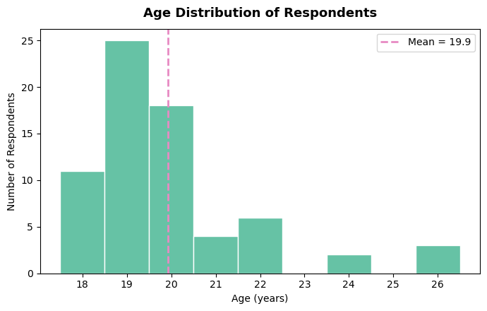
Fig. 1 — Age distribution of respondents (mean = 19.9 years, median = 19, std. dev. = 1.87, range 18–26).
Statistic | Value
Count | 69
Mean age | 19.93 years
Median age | 19.0 years
Std. deviation | 1.87
Minimum | 18
Maximum | 26

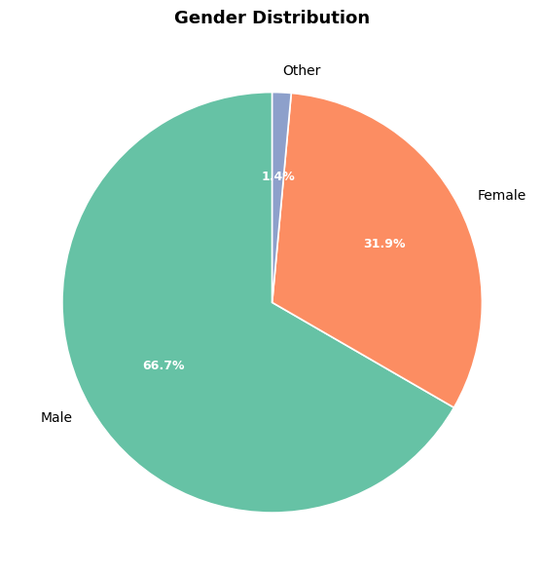
Fig. 2 — Gender distribution: Male 66.7% (46), Female 31.9% (22), Other 1.4% (1).
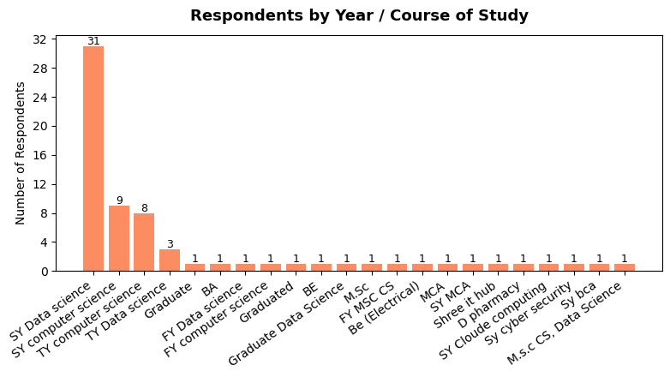
Fig. 3 — Respondents by year/course of study. Most respondents are from SY Data Science (31), followed by SY Computer Science (9) and TY Computer Science (8); the remaining respondents are spread across 17 other courses/years.

Step 8 — Digital Tool Usage Patterns
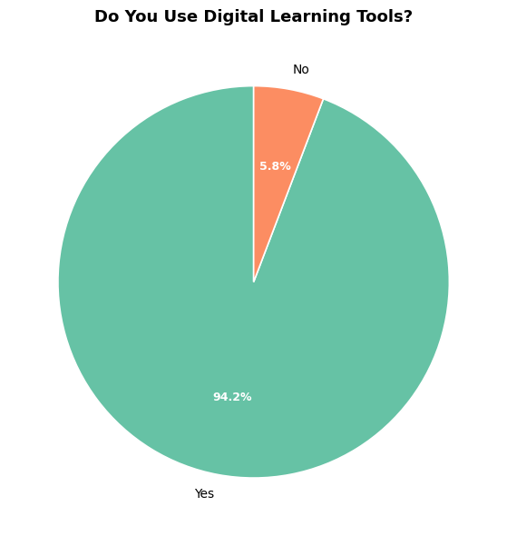
Fig. 4 — 94.2% of respondents (65 of 69) use digital learning tools for their studies; 5.8% (4) do not.
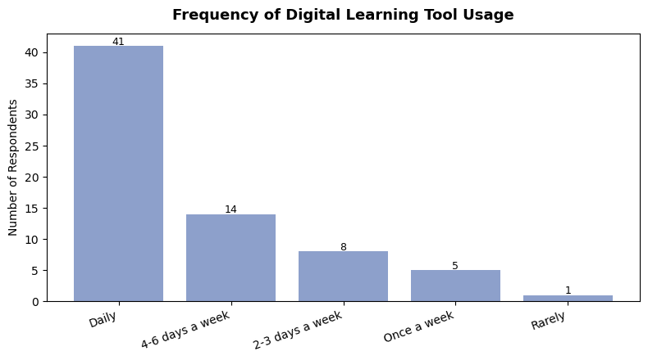
Fig. 5 — Frequency of use: Daily 41, 4–6 days/week 14, 2–3 days/week 8, Once a week 5, Rarely 1. Nearly 80% use tools daily or almost daily.
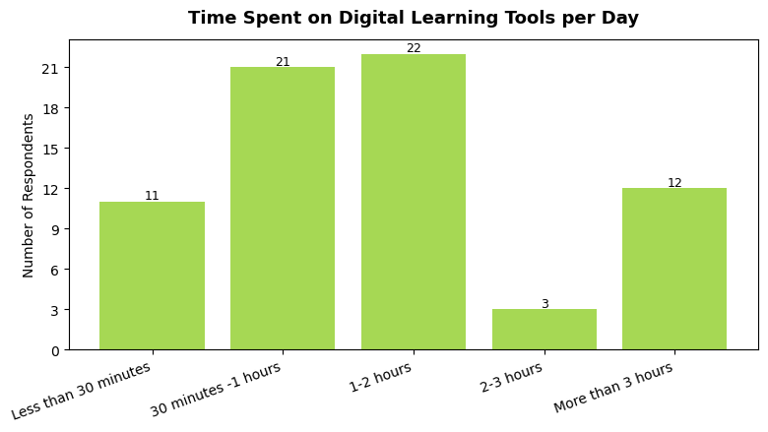
Fig. 6 — Time spent per day: 1–2 hours (22) and 30 minutes–1 hour (21) are the most common bands, followed by more than 3 hours (12) and less than 30 minutes (11); only 3 respondents spend 2–3 hours.

Step 9 — Tool Preference Analysis
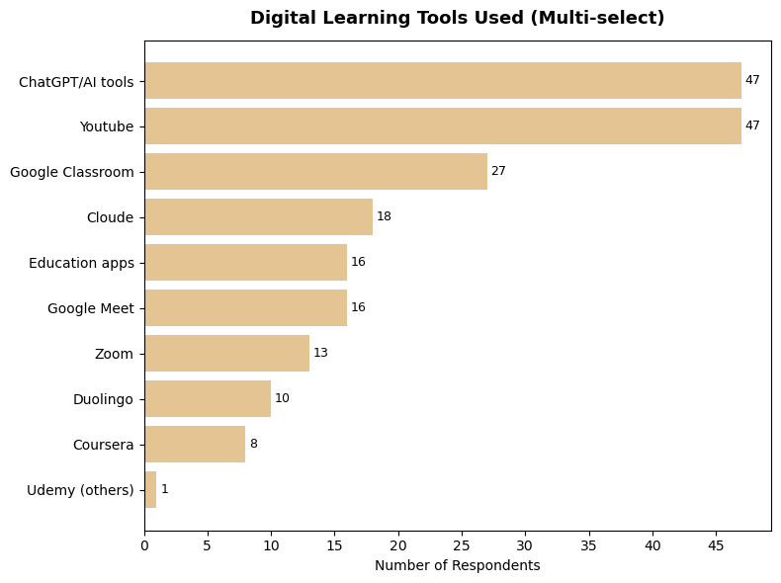
Fig. 7 — Tools used (multi-select). ChatGPT/AI tools and YouTube are tied for first place (47 respondents each), followed by Google Classroom (27), Cloud/Cloude-based tools (18), Education apps and Google Meet (16 each), Zoom (13), Duolingo (10) and Coursera (8).
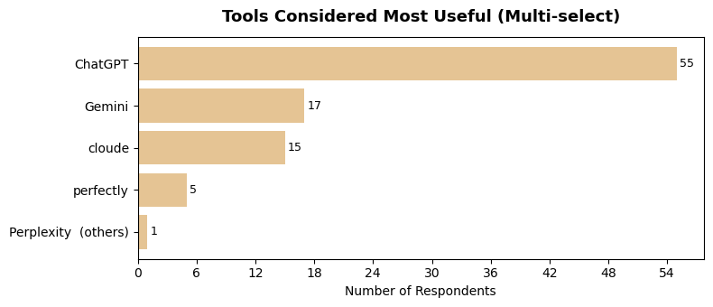
Fig. 8 — Tools considered most useful: ChatGPT is the clear leader (55), followed by Gemini (17) and cloud-based AI tools (15).

Step 10 — Perceived Usefulness, Benefits & Advantages
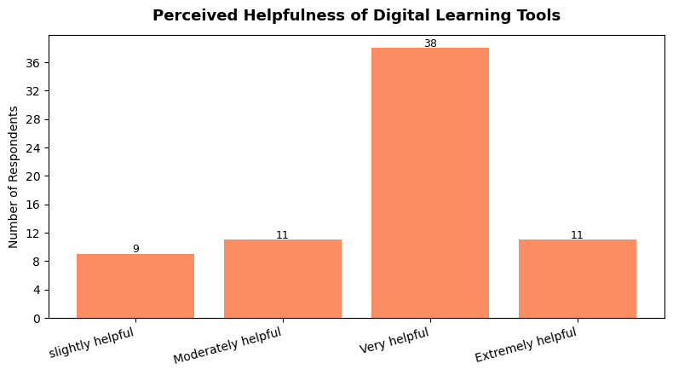
Fig. 9 — Perceived helpfulness: "Very helpful" dominates (38), followed by "Moderately helpful" and "Extremely helpful" (11 each) and "Slightly helpful" (9). Combined, 71% rate the tools Very/Extremely helpful.
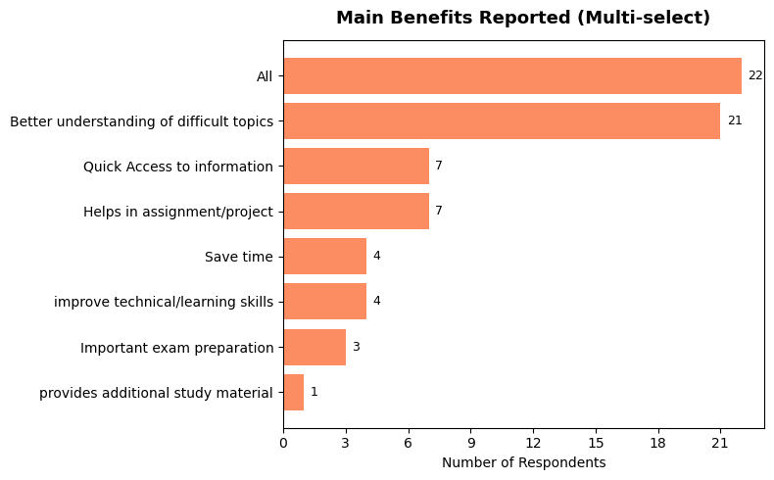
Fig. 10 — Main benefits reported (multi-select): all-round benefit ("All", 22) and "Better understanding of difficult topics" (21) lead, followed by quick access to information and help with assignments (7 each).
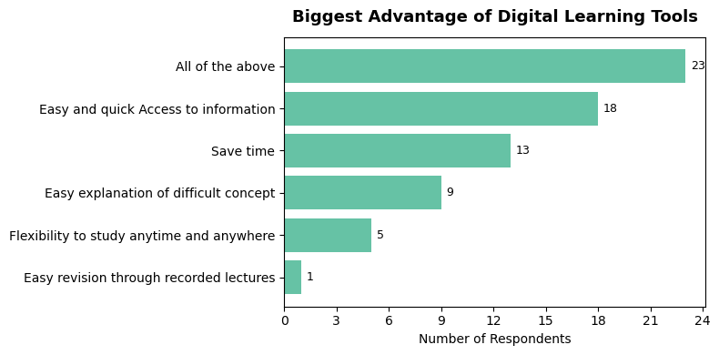
Fig. 11 — Biggest single advantage: "All of the above" (23), "Easy and quick access to information" (18), and "Saves time" (13) are the top responses.

Step 11 — Trust, Overall Experience, Device & Access
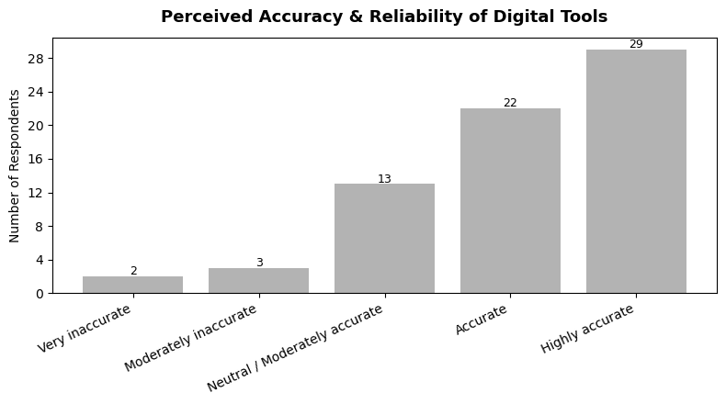
Fig. 12 — Perceived accuracy/reliability: "Highly accurate" (29) and "Accurate" (22) together account for 51 of 69 respondents; only 5 rate tools as inaccurate.
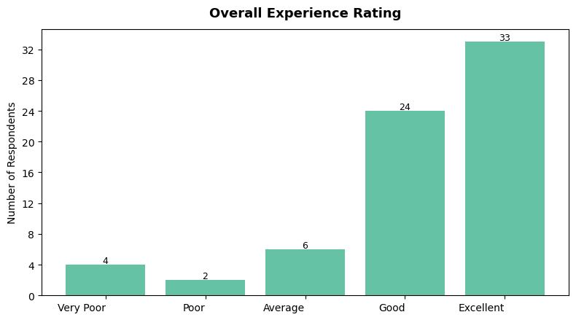
Fig. 13 — Overall experience: "Excellent" (33) and "Good" (24) dominate — 82.6% rate their overall experience as Good or Excellent.
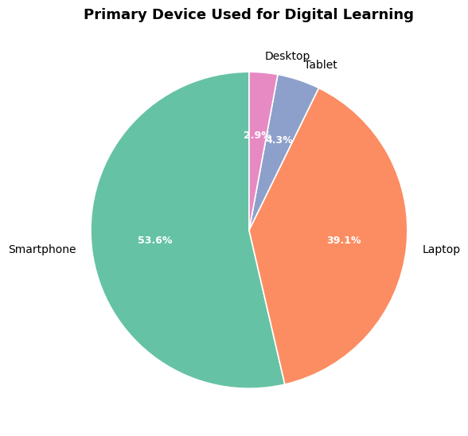
Fig. 14 — Primary device: Smartphone (53.6%) is the leading device, followed by Laptop (39.1%), Tablet (4.3%) and Desktop (2.9%).
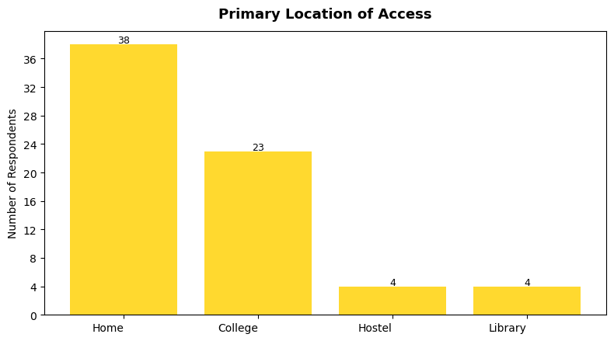
Fig. 15 — Primary access location: Home (38) is most common, followed by College (23); Hostel and Library account for 4 respondents each.

Step 12 — Challenges, Cost Perception & AI Usage
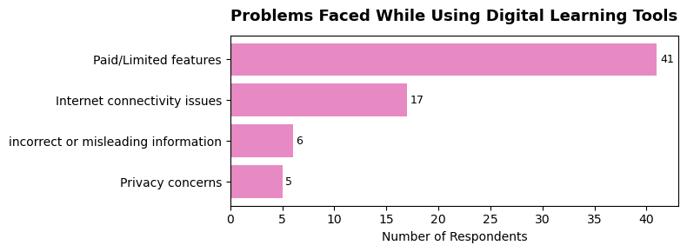
Fig. 16 — Problems faced: "Paid/limited features" is by far the biggest complaint (41), followed by internet connectivity issues (17), incorrect/misleading information (6), and privacy concerns (5).
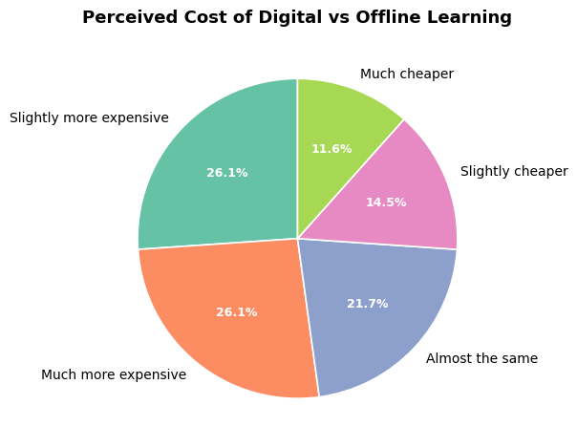
Fig. 17 — Perceived cost of digital vs. offline learning is split: 26.1% each say "much more expensive" and "slightly more expensive", 21.7% say "almost the same", and 26.1% combined say cheaper.
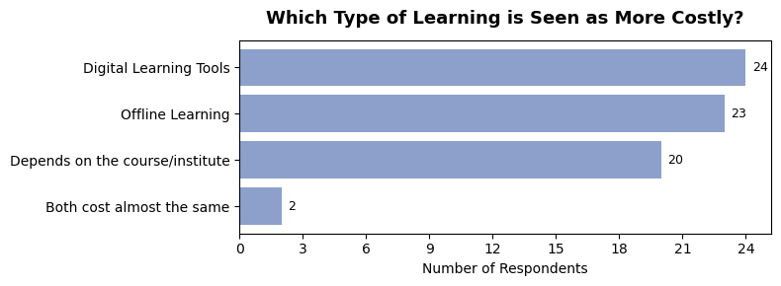
Fig. 18 — Which is costlier: opinion is nearly evenly split between digital tools (24), offline learning (23) and "depends on the course/institute" (20).
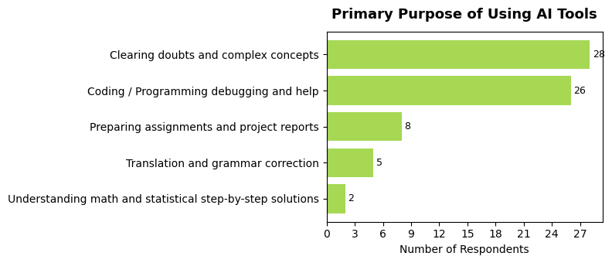
Fig. 19 — Primary purpose of using AI tools: clearing doubts/complex concepts (28) and coding/programming help (26) are the top two uses, followed by assignment/report preparation (8).

Step 13 — Cross-Tabulation & Correlation Analysis

13.1 Usage Frequency vs. Perceived Helpfulness
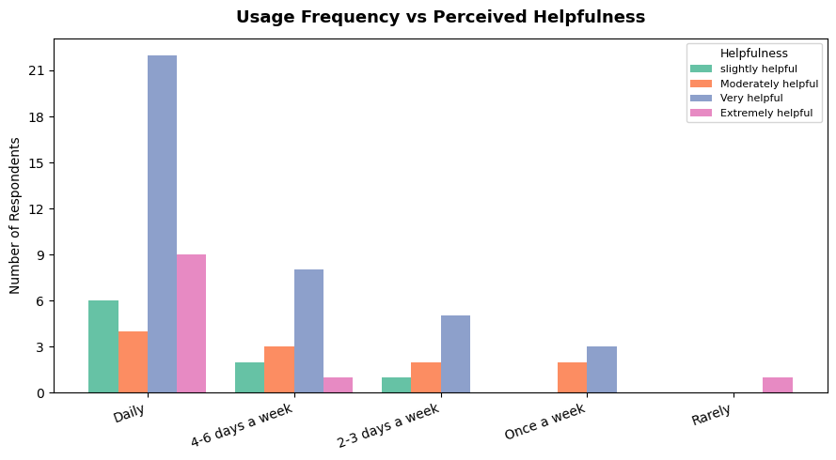
Fig. 20 — Students who use digital tools daily report the highest counts of "Very helpful" and "Extremely helpful" ratings, suggesting more frequent users tend to perceive greater benefit.

13.2 Correlation Matrix
Ordinal responses were scored numerically (e.g. Frequency: Rarely=1 … Daily=5; Helpfulness: Slightly=1 … Extremely=4; Accuracy: Very inaccurate=1 … Highly accurate=5; Experience: Very Poor=1 … Excellent=5) to compute Pearson correlation coefficients.
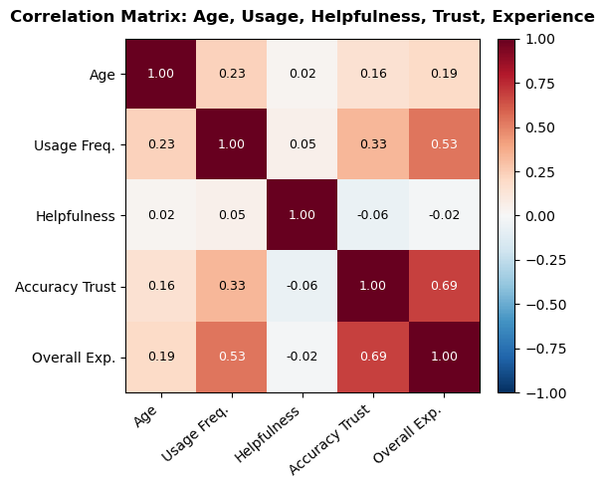
Fig. 21 — Correlation heatmap: Age, Usage Frequency, Helpfulness, Accuracy/Trust, Overall Experience.
 | Age | Usage Freq. | Helpfulness | Trust (Accuracy) | Overall Exp.
Age | 1.00 | 0.23 | 0.02 | 0.16 | 0.19
Usage Freq. | 0.23 | 1.00 | 0.05 | 0.33 | 0.53
Helpfulness | 0.02 | 0.05 | 1.00 | -0.06 | -0.02
Trust (Accuracy) | 0.16 | 0.33 | -0.06 | 1.00 | 0.69
Overall Exp. | 0.19 | 0.53 | -0.02 | 0.69 | 1.00

- Trust ↔ Overall Experience (r ≈ 0.69): the strongest relationship in the data — students who trust the accuracy of digital tools rate their overall experience far more positively.
- Usage Frequency ↔ Overall Experience (r ≈ 0.53): students who use digital tools more often also tend to report a better overall experience.
- Age and Helpfulness show negligible correlation with the other variables, suggesting experience quality is driven more by trust and habit than by age or a simple helpfulness rating.

Step 14 — Summary of Key Findings
Metric | Result
Total respondents | 69
Average age | 19.9 years (range 18–26)
Use digital learning tools | 94.2%
Use tools Daily / 4–6 days a week | 79.7%
Most used tools | YouTube & ChatGPT/AI tools (47 each)
Find tools Very/Extremely helpful | 71.0%
Top reported benefit | All-round benefit / Better understanding of difficult topics
Top problem faced | Paid/Limited features
Most used device | Smartphone (53.6%)
Rate overall experience Good/Excellent | 82.6%
Top purpose for using AI tools | Clearing doubts & complex concepts
Correlation: Usage frequency ↔ Experience | r ≈ 0.53
Correlation: Trust in accuracy ↔ Experience | r ≈ 0.69

Step 15 — Limitations of the Study
- The study is limited to students who responded to the online survey.
- The accuracy of the results depends on the honesty of respondents.
- The sample size (69) may not represent all college students.
- Students from different colleges and backgrounds may have different digital learning experiences — over 60% of the sample is concentrated in SY/TY Data Science and Computer Science courses.
- The study focuses mainly on students' self-reported perceptions and usage patterns rather than objective/measured academic performance.

Step 16 — Conclusion
The "Survey on Digital Learning Tools Usage Among College Students" set out to understand the role of digital technology in students' academic lives. The analysis of 69 responses shows that digital learning tools have near-universal adoption (94.2%) among the surveyed students, with the majority using them daily or almost daily and spending 30 minutes to 2 hours a day on them.
YouTube and ChatGPT/AI tools dominate the tool landscape, and AI tools are used mainly to clear doubts on complex concepts and for coding/assignment help. Perceived helpfulness and overall experience are strongly positive — 71% find the tools Very/Extremely helpful and 82.6% rate their overall experience as Good or Excellent. Overall experience correlates most closely with trust in the accuracy of the information (r ≈ 0.69) and with usage frequency (r ≈ 0.53), indicating that students who use these tools more, and trust them more, rate their experience higher.
The main friction points are paid/limited features and internet connectivity issues, suggesting that affordability and access — not tool quality — remain the biggest barriers to digital learning. Cost perception itself is split roughly evenly between digital tools being seen as more expensive, cheaper, or about the same as offline learning, with opinion on which is "costlier" divided almost equally among digital tools, offline learning, and "it depends on the course/institute".
These findings can help educators and institutions understand how students actually use digital technology in their studies, and highlight two priorities for improving digital learning support: (a) improving access to free/affordable tiers of key tools, and (b) improving and communicating the accuracy/reliability of AI-based learning tools, since trust is the single strongest driver of a positive learning experience.

Step 17 — Recommendations
- Institutions could negotiate discounted or campus-wide licenses for the most-used paid tools to address the "Paid/Limited features" barrier reported by 41 of 69 students.
- Improving campus Wi-Fi/internet access would directly address the second most common problem (connectivity issues, 17 respondents).
- Given the strong link between trust and experience (r ≈ 0.69), students would benefit from guidance on verifying AI-generated answers, and instructors could recommend vetted AI/education tools.
- Since ChatGPT/AI tools are used heavily for coding help and clearing doubts, structured AI-literacy sessions could help students use these tools more effectively and critically.

References & Data Sources
Primary data: online questionnaire (Google Form), 69 responses, collected 21 August – 7 September 2026. Analysis notebook: field_project.ipynb (Pandas, NumPy, Matplotlib, Seaborn). Exported dataset: ganesh.csv.

