**LetsUpgrade –Devops Assignment-1**

**Git Hub Account Screen Shot:**

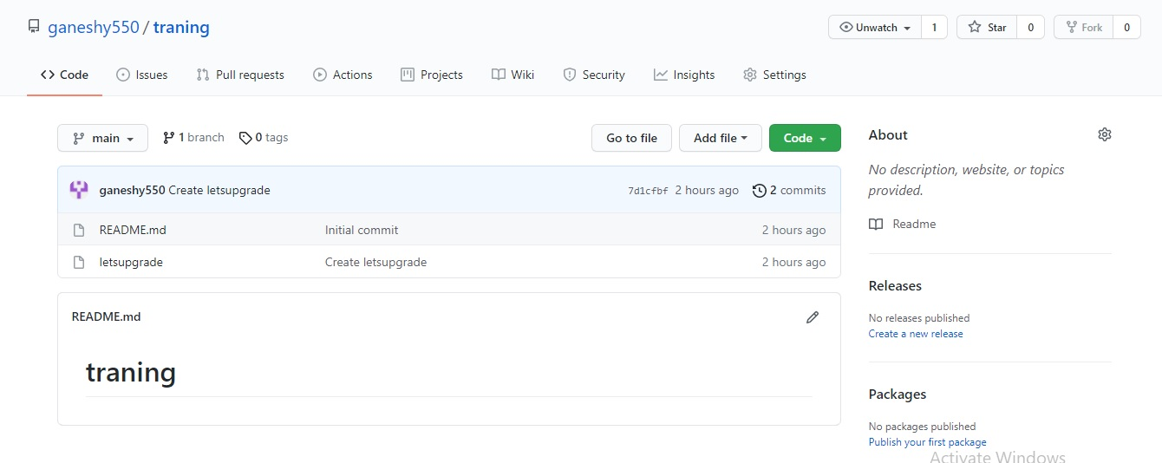

**Git Commands Screen Shot:**

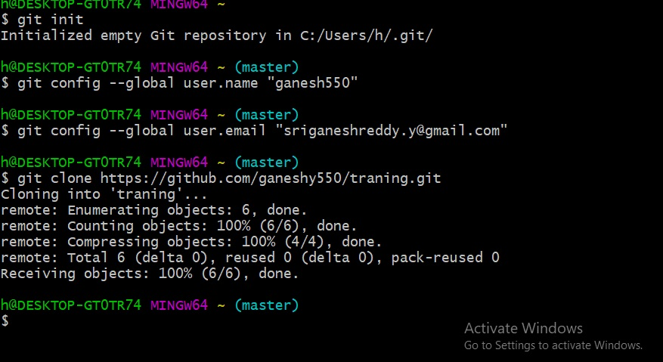

**Local Repository:**

