Extensions
Technical Specifications Document

TS: SandilyaCollege

Submitted To

Sandilya Group of Organization

Version Control
File Name | TS_SandilyaCollege | Version No. | 0.1
Prepared By | Ganeswar Barik | Latest Version Date | 03-March-11

Document Tracking Information

Document Revision History

Date | Author | Version | Change Reference

Referenced Documents

Document Name | Location | Version

Reviewers

Date | Name | Position | Version

Contents

Introduction 1
High Level Design 1
Technologies to be use. 2
Architecture notes 3
Caching Requirements 3
Logging Requirements 3
Security proxy component 3
Bean Instantiation 3
Internationalization 3
Validation 3
Package structure. 3
Dependency Jar 5
Database and PL/SQL 5

Introduction
The purpose of this document is to describe the technical specifications related to Management of Sandilya School & College.

High Level Design

This is the high-level design for Sandilya College.

User
DB
(MySql)
HB
C
A
C
H
E

Hibern
ate
View
JSP
I
N
T
E
P
C
E
P
T
E
R

Controler

Action/
FormBean
Service Layer

Bisuness logic
Modelbean/Vo

Technologies to be use.

Following are the technologies to be use.
Sturts2
Spring3.0
Hibernate
JSP/Servlet
Html5
Tomcat 7.0
XWork

Architecture notes

Caching Requirements
Will user Hibernate Cache

Logging Requirements
We will be using Spring AOP for logging.

Security proxy component
We will user Blowfish encryption mechanism.

Bean Instantiation
It will user Spring Bean Factory to instantiate the every Bean

Internationalization
User Struts Internationalization.
Please refer struts-global-resourcebundle.pdf for implementation

Validation
Xwork-validation will use
Please refer struts-Xwork-validation.pdf for implementation

Package structure.

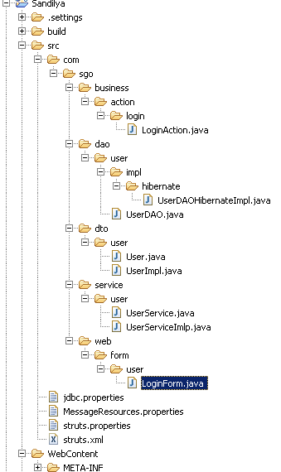

Dependency Jar
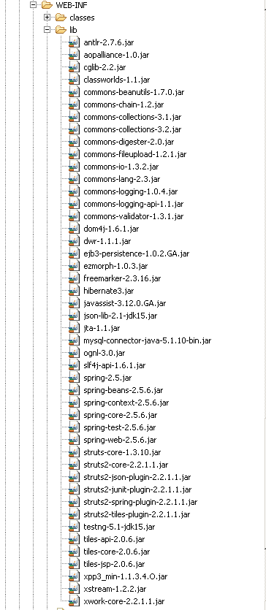

Database and PL/SQL

The following PL/SQL packages are needed:



