Online Income Tax Proof Submission Employee User Manual

Information Type: SOP

Company Name: NTT Data

Information Owner: Patient Access Support

Contents

|  |  |  |
| --- | --- | --- |
| S.no | Content | Page.No |
| 1 | Content | 2 |
| 2 | Login | 3 |
| 3 | Register | 4 |
| 4 | Guidelines | 5 |
| 5 | HRA | 6 |
| 6 | House Loan | 7 |
| 7 | 80C | 8 |
| 8 | 80D | 9 |
| 9 | Others | 10 |
| 10 | Final Submission and 12BB | 11 |

Login

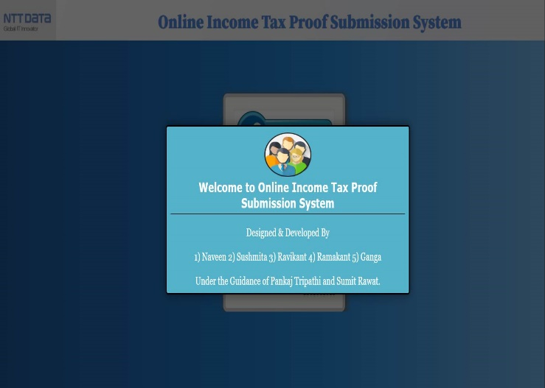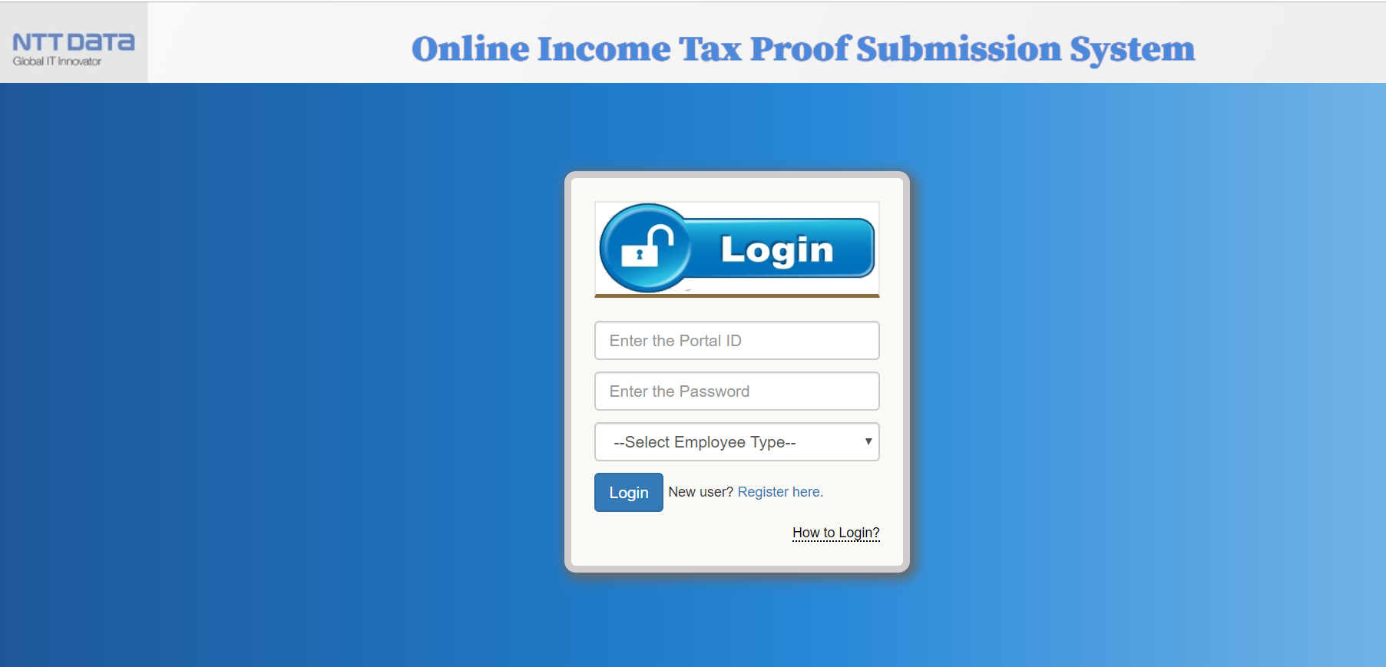

* Enter your log in credentials when you are already registered with Online income tax proof submission system.
* Still you have doubts to know how to login please put your cursor on **“How to Login?”.**
* If you are not registered with Online income tax proof submission system, please click on register.

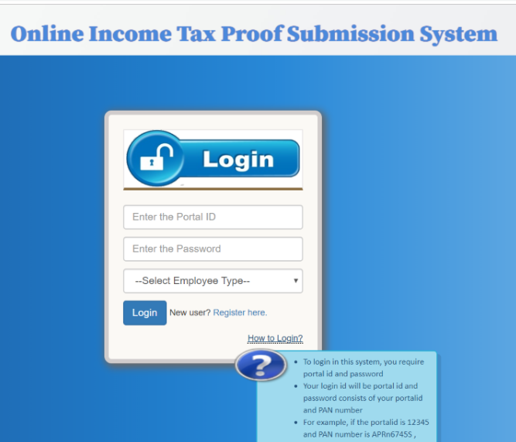

Register

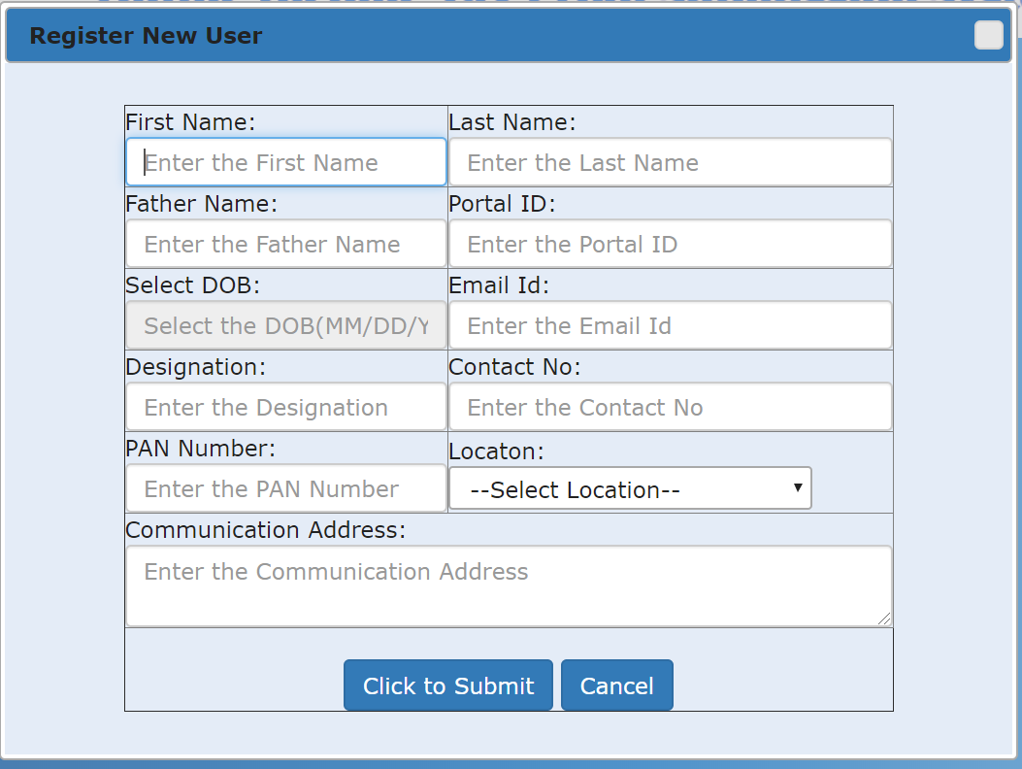

* Enter the credentials to register the new user.
* Fallow the steps shown in this window to login.
* Please check the pattern of the Password that is automatically generated when you are registering.

Guidelines

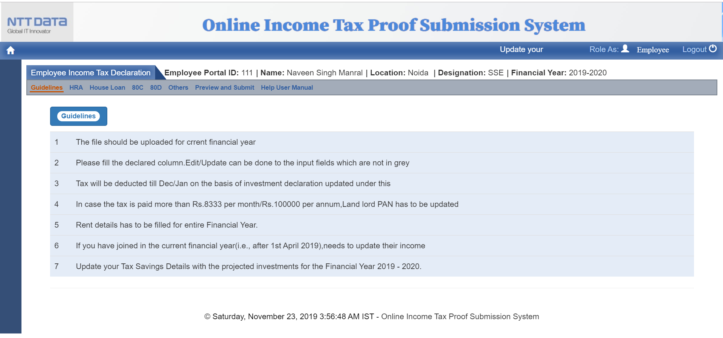

* Check the details provided on the screen are yours or not. If it is yours, please proceed further tabs

Else contact admin for more details

* Read the Guideline carefully for submitting your Tax proof.

HRA

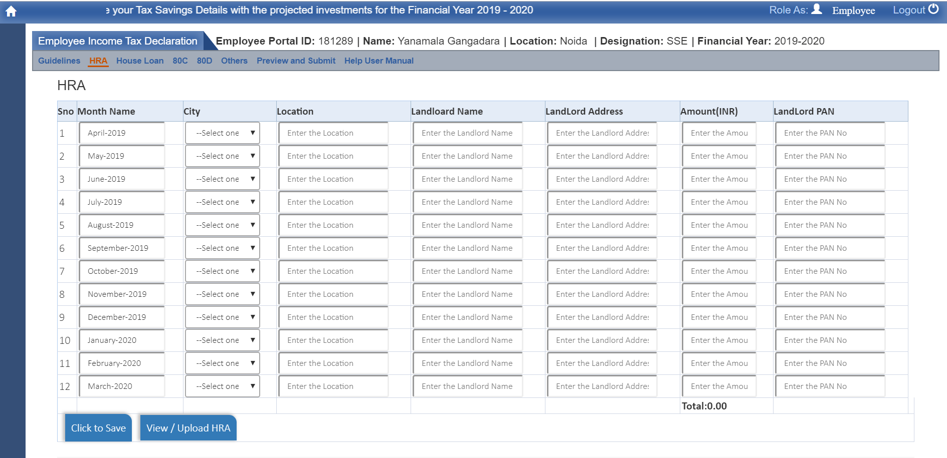

* Enter the required fields and enter the amount monthly basis.
* Fist entry will be replicated to all the months details replicated items are editable.
* Incase your amount is exceeded 100000/- your land lord pan number is required.
* Upload the proof as shown below.

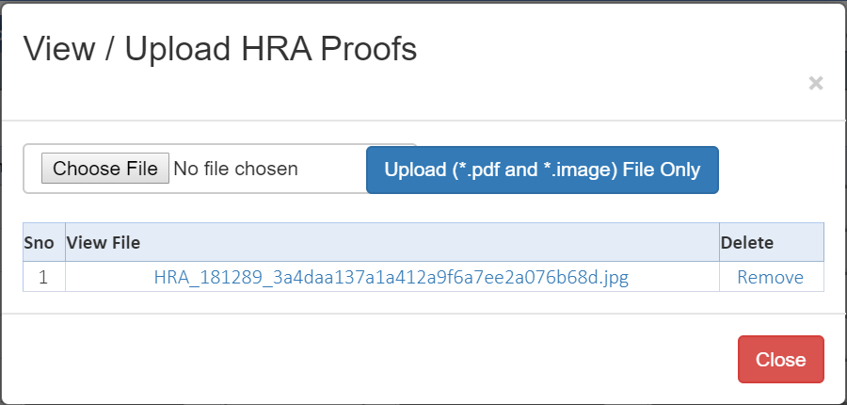

* Select file which is less than 2MB to upload as a PDF.

House Loan

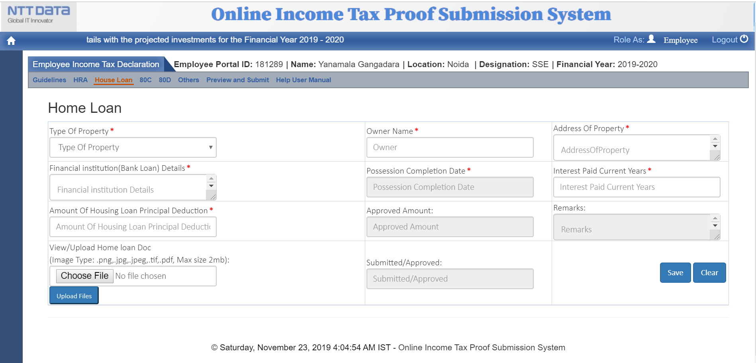

* Enter the details which are required and click on Save Home Loan
* Click on upload button and select the file to upload the proof.
* View the file to check weather perfect file is selected.

80C

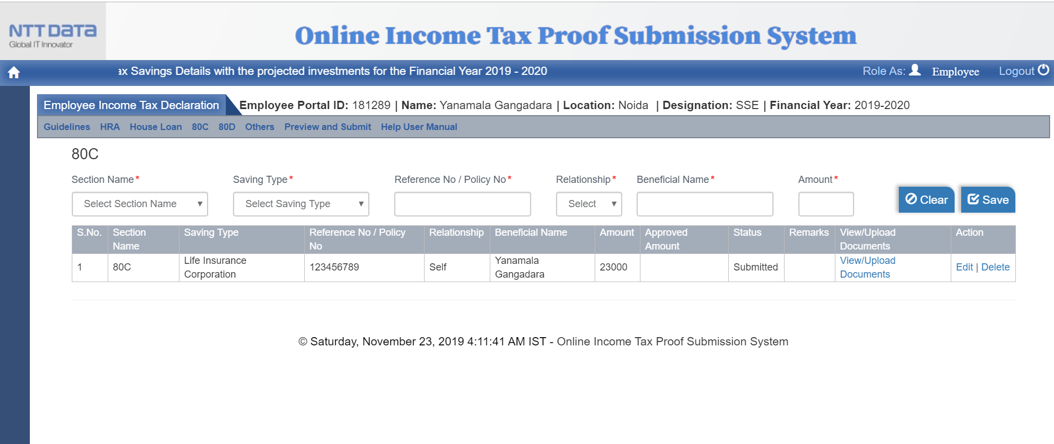

* Enter the details which are required and click on Save
* Click on upload button and select the file to upload the proof.
* View the file to check weather perfect file is selected.
* Click on Save Button to save

80D

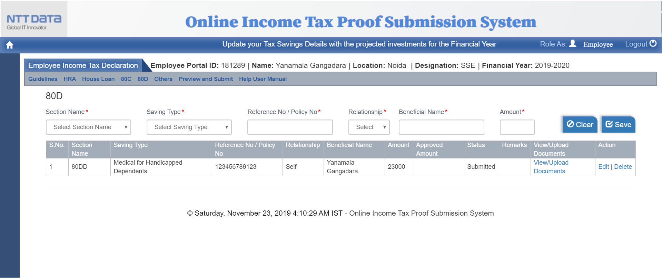

* Enter the details which are required and click on Save
* Click on upload button and select the file to upload the proof.
* View the file to check weather perfect file is selected.
* Click on Save Button to save

Others

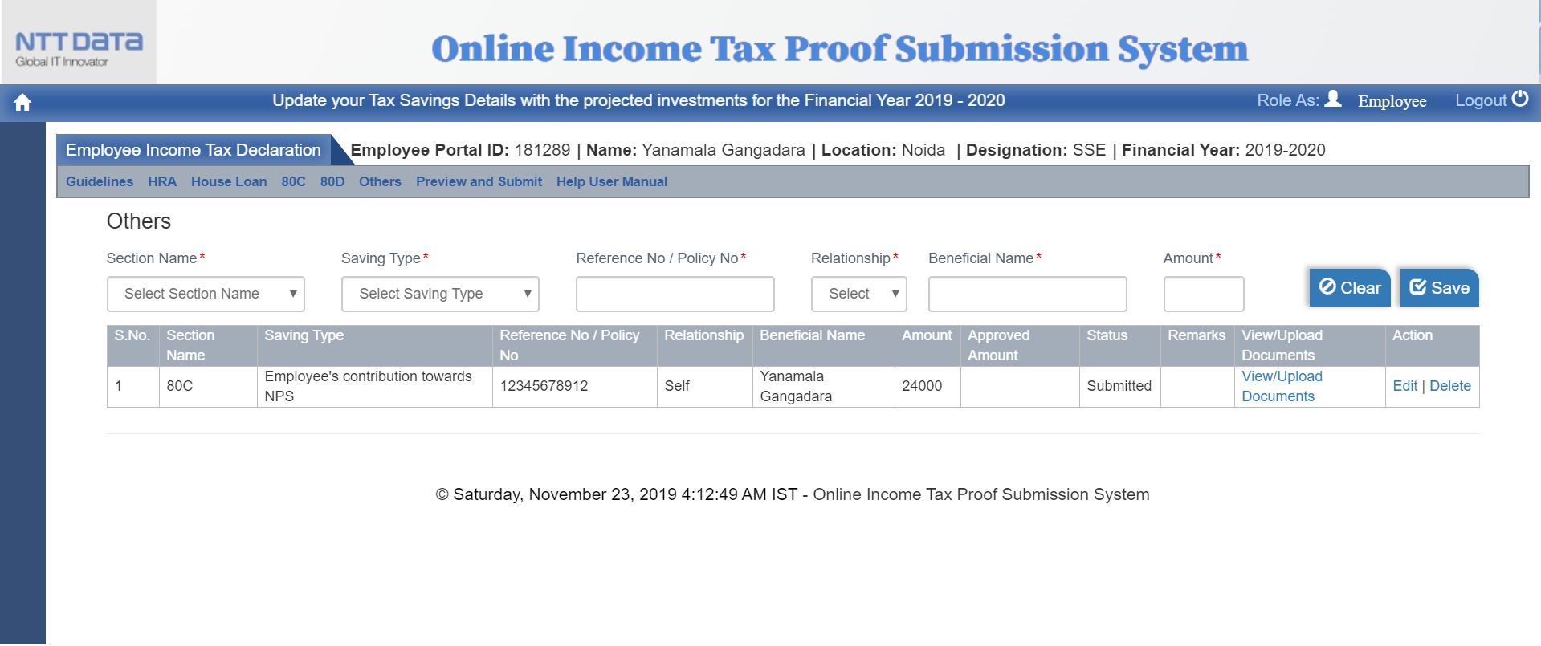

* Enter the details which are required and click on Save
* Click on upload button and select the file to upload the proof.
* View the file to check weather perfect file is selected.
* Click on Save Button to save

Final submission and 12BB

Preview the document weather the entered details are correct or not.

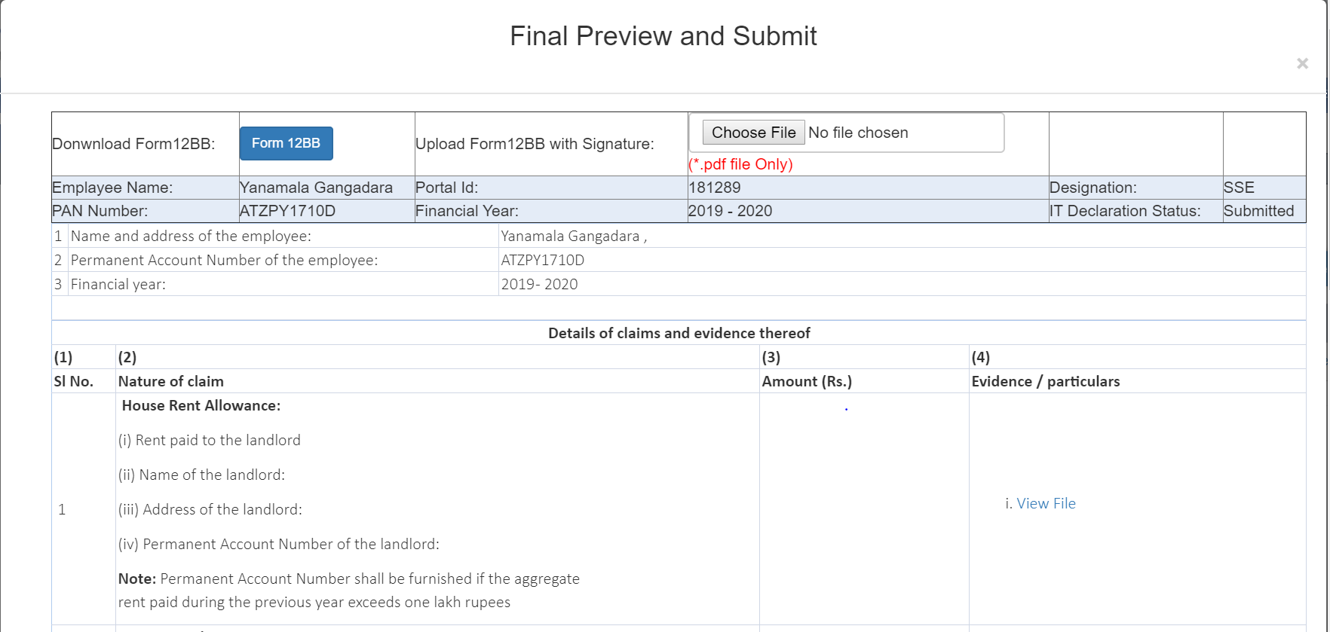

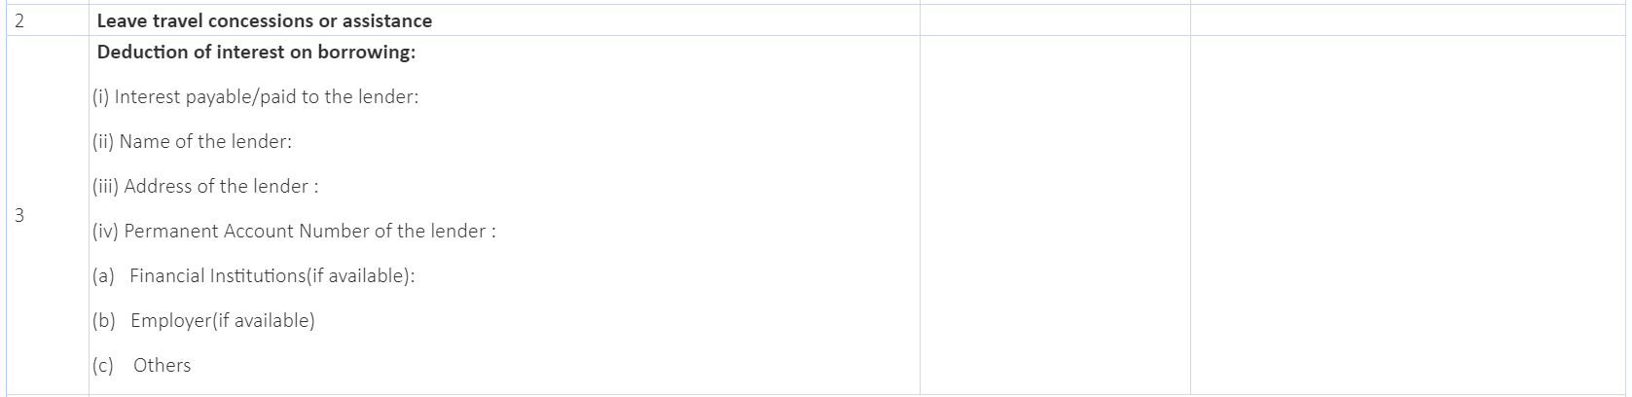

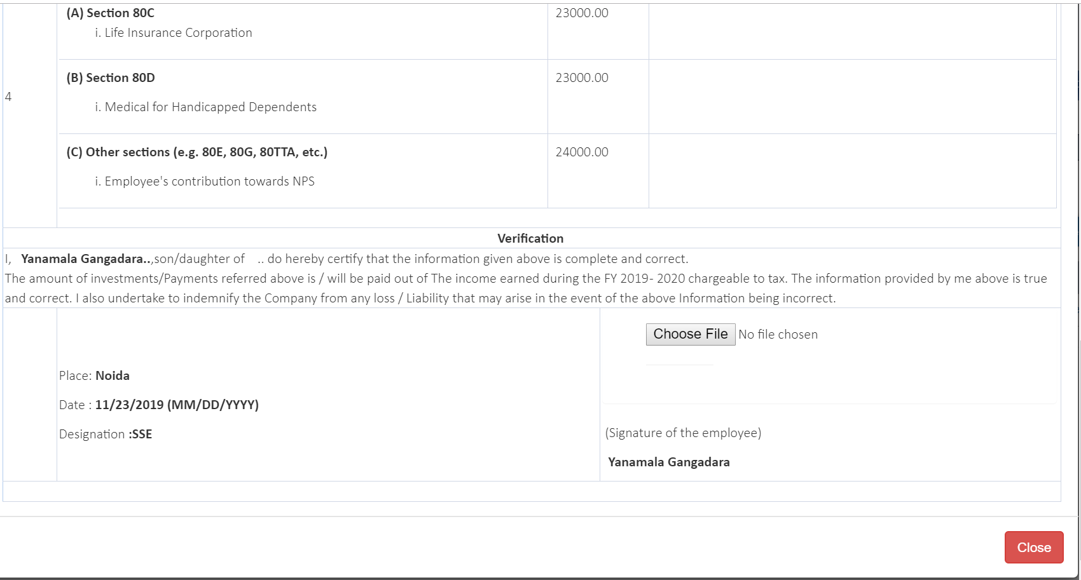

**Here we have two options to submit 12BB**

**Fallow only one option**

* **By downloading 12BB from preview and submit screen and make it signed and upload** 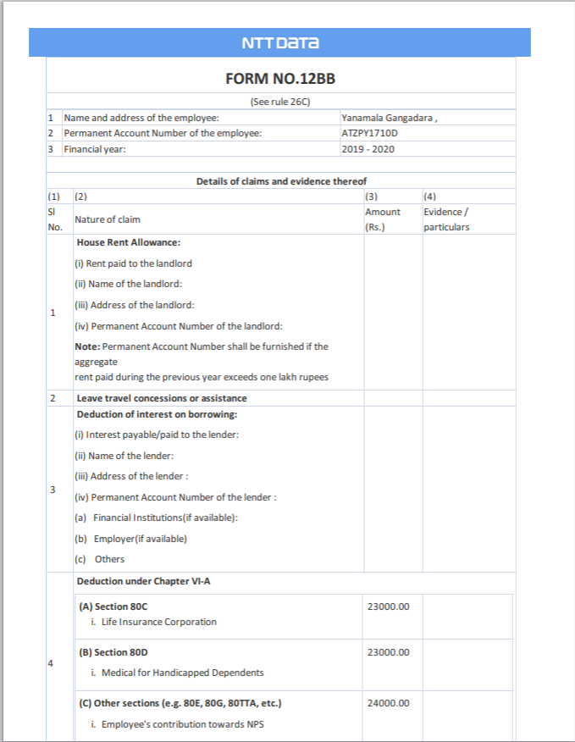

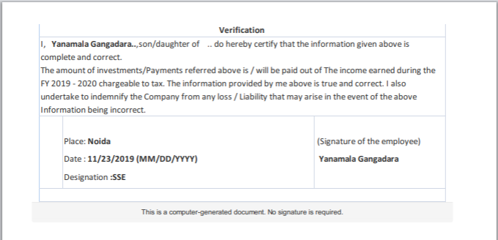

* **Uploading the signature where signature of the employee field.**

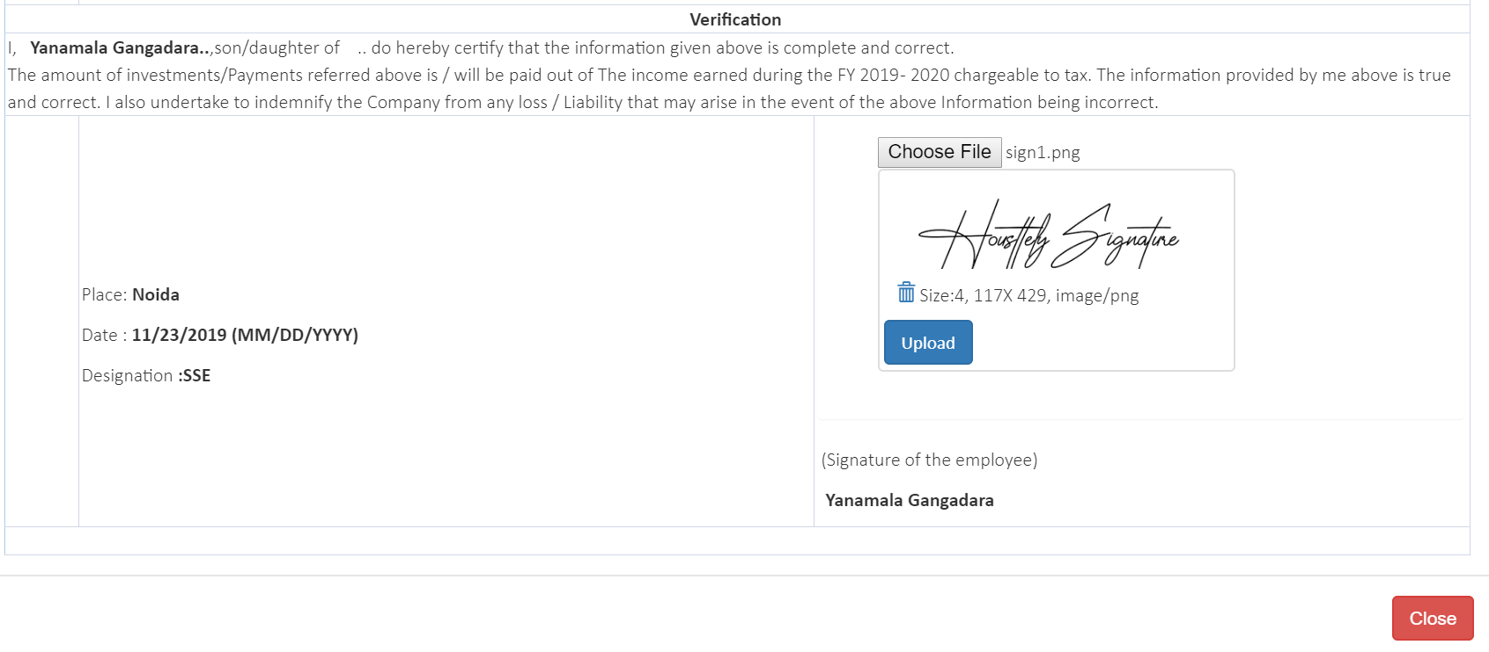

We find this in the end if preview and submit.

Click on Upload and if you want submit click on OK else cancel

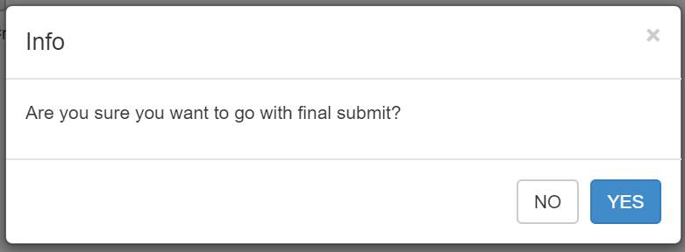

Employee will get confirmation that proofs has been submitted.



* If all the details are correct click on Final submit and close.

Click on Form 12BB to download the submitted document in PDF format



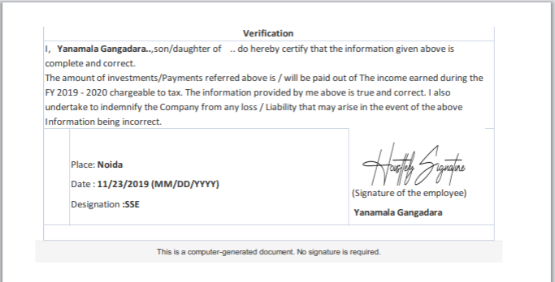

You are successfully submitted your income tax proof