INTERNSHIP ASSIGNMENT REPORT
Week 4 Task: Predictive Modeling and Optimization in Logistics Systems
Predictive Modeling and Optimization of Delivery Times in an E-commerce Logistics System Using Python
Submitted by
Gangadevi L
B.Tech Information Technology (III Year)
Sri Manakula Vinayagar Engineering College
Internship Organisation: Yuva Intern
Internship Period: 25 Sept 2026 to 23 Oct 2026
Date of Submission: 22 Oct 2026
Note: All data in this report is simulated. No real company data was used.

Abstract
This report develops and evaluates a machine learning model that predicts the delivery time of e-commerce shipments and uses it to test simple optimization ideas. A simulated dataset of 1010 raw shipment records was generated with a fixed random seed (42); 10 duplicates were removed, leaving 1000 shipments, and 25 missing weights and 15 missing traffic levels were filled inside the modelling pipeline. Linear Regression, Decision Tree and Random Forest models were trained on 800 shipments and tested on 200 unseen shipments, using MAE, RMSE and R², five-fold cross-validation and grid-search tuning.
Linear Regression performed best (MAE 1.43 h, RMSE 1.77 h, R² 0.960); the tuned Random Forest followed (RMSE 2.22 h). Distance was the dominant factor (about 4.61 h per 100 km), and each extra hour of dispatch delay added about 0.94 h. In a what-if analysis, capping dispatch delay at 1 hour reduced the mean predicted delivery time from 22.42 h to 21.19 h (-5.49%). These are simulated model predictions, not verified operational improvements. The complete code, dataset documentation, charts, results and interview questions are included in the appendices so that the report is self-contained.
Acknowledgement
I would like to express my sincere gratitude to the organisation for providing me with the opportunity to undertake this internship task on Logistics Data Analyst. This task has enabled me to explore the practical applications of data analysis, predictive modeling, and optimisation techniques in addressing logistics-related challenges.
I am grateful for the feedback and constructive suggestions received on my previous reports, which helped me identify areas for improvement and enhance the overall quality of my work. This feedback encouraged me to incorporate concrete data, numerical evidence, detailed analysis, and appropriate visualisations to support my findings and make the report more informative and meaningful.
I would also like to acknowledge the official documentation and learning resources of Python, pandas, NumPy, scikit-learn, and Matplotlib, which served as valuable references throughout the implementation and analysis of this task. These resources helped me understand the relevant concepts, apply suitable analytical techniques, and present the results in a structured and systematic manner.
Overall, completing this task has been a valuable learning experience that has contributed to improving my technical knowledge, analytical thinking, and problem-solving abilities. It has also helped me gain a better understanding of how data-driven approaches can support decision-making and improve efficiency in logistics operations.

Gangadevi L
Table of Contents
1. Introduction 9
1.1 Introduction to Logistics Predictive Analytics 9
1.2 Background of the Problem 9
1.3 Importance of Delivery-Time Prediction 9
1.4 Problem Statement 9
1.5 Project Objectives 9
1.6 Scope of the Project 10
2. Problem Definition and Dataset Description 11
2.1 Definition of the Prediction Problem 11
2.2 Description of the Hypothetical Logistics Dataset 11
2.3 Dataset Features and Target Variable 11
2.4 Data Types and Feature Descriptions 11
2.5 Dataset Generation and Assumptions 12
2.6 Data Quality and Limitations 12
3. Data Preparation and Exploratory Analysis 13
3.1 Data Loading 13
3.2 Data Inspection 13
3.3 Missing-Value Handling 13
3.4 Duplicate Detection and Removal 13
3.5 Categorical Feature Encoding 14
3.6 Feature Selection 14
3.7 Exploratory Data Analysis 14
3.8 Correlation Analysis 15
3.9 Data Preprocessing Pipeline 16
4. Predictive Model Selection and Implementation 17
4.1 Overview of Predictive Modeling 17
4.2 Selection of the Target Variable 17
4.3 Linear Regression 17
4.4 Decision Tree Regression 17
4.5 Random Forest Regression 17
4.6 Rationale for Model Selection 17
4.7 Training and Testing Data Split 17
4.8 Feature Engineering and Preprocessing 18
4.9 Model Training 18
4.10 Python Implementation 18
5. Model Evaluation and Validation 19
5.1 Importance of Model Evaluation 19
5.2 Mean Absolute Error (MAE) 19
5.3 Root Mean Squared Error (RMSE) 19
5.4 R-squared (R²) 19
5.5 Comparison of Model Performance 19
5.6 Cross-Validation 20
5.7 Hyperparameter Tuning 20
5.8 Interpretation of Results 21
5.9 Model Limitations 21

6. Predictive Insights and Results Analysis 22
6.1 Summary of Model Results 22
6.2 Actual Versus Predicted Delivery Times 22
6.3 Analysis of Prediction Errors 22
6.4 Impact of Distance on Delivery Time 23
6.5 Impact of Dispatch Delay 23
6.6 Impact of Traffic and Weather 23
6.7 Feature Importance 23
6.8 Practical Interpretation of Model Findings 24
7. Logistics Optimization Strategies 25
7.1 Introduction to Logistics Optimization 25
7.2 Improving Dispatch Scheduling 25
7.3 Delivery Route Planning 25
7.4 Resource and Vehicle Allocation 25
7.5 Managing Traffic and Weather Risks 25
7.6 Reducing Late Deliveries 25
7.7 Cost-Minimization Strategies 26
7.8 Prediction-Based Decision-Making 26
7.9 Proposed Optimization Framework 26
8. Implementation Workflow and Technical Documentation 28
8.1 System Workflow 28
8.2 Software and Libraries Used 28
8.3 Project Folder Structure 28
8.4 Code Execution Instructions 29
8.5 Expected Outputs 29
8.6 Reproducibility 29
8.7 Practical Applications 29
9. Limitations and Ethical Considerations 30
9.1 Limitations of Simulated Data 30
9.2 Prediction Errors and Uncertainty 30
9.3 Data Quality Challenges 30
9.4 Real-World Implementation Challenges 30
9.5 Responsible Use of Predictive Models 30
10. Conclusion and Recommendations 31
10.1 Summary of Work 31
10.2 Key Findings 31
10.3 Recommended Actions 31
10.4 Future Improvements 31
10.5 Skills and Learning Outcomes 32
References 33
Appendix A: Complete Python Source Code (.py) 34
A.1 Source Code: logistics_prediction.py 34
A.2 Console Output of the Program Run Used for This Report 45
Appendix B: Complete Dataset Documentation (.csv) 48
B.1 Dataset Overview 48
B.2 Column Explanations 48
B.3 Sample Records 48
Appendix C: Python Dependencies and Execution Instructions 50
C.1 Required Python Version and Libraries 50
C.2 Step-by-Step Execution Instructions 50
C.3 Expected Output Files 50
C.4 Regenerating the Dataset, Metrics and Graphs 51
C.5 Troubleshooting Common Beginner Errors 51
Appendix D: Complete Visualization Gallery 52
D.1 Delivery-Time Distribution 52
D.2 Distance Versus Delivery Time 52
D.3 Actual Versus Predicted Delivery Times 53
D.4 Residual / Error Distribution 53
D.5 Model Performance Comparison 54
D.6 Feature Importance 54
Appendix E: Model Evaluation Results 55
E.1 Evaluation Metrics and Cross-Validation 55
E.2 Best-Performing Model and Reason for Selection 55
E.3 Sample Actual-Versus-Predicted Values 55
E.4 Interpretation of Prediction Errors 55
E.5 Important Model Features 55
E.6 Limitations of the Evaluation 56
Appendix F: Optimization Analysis and Supporting Calculations 57
F.1 Optimization Problem and Baseline Assumptions 57
F.2 Proposed Operational Improvements 57
F.3 Python Code for the What-If Scenario 57
F.4 Baseline and Scenario Predictions 57
F.5 Interpretation of the Results 58
F.6 Practical Recommendations 58
Appendix G: Additional Tables and Technical Details 59
G.1 Data-Cleaning Summary 59
G.2 Feature Encoding Explanation 59
G.3 Model Parameter Settings 59
G.4 Linear Regression Coefficients 59
G.5 Important Formulas 60
G.6 Additional Calculation 60

List of Figures
Figure 1: Distribution of delivery times 52
Figure 2: Distance vs delivery time (coloured by traffic level) 52
Figure 3: Actual vs predicted delivery times (Linear Regression, test set) 53
Figure 4: Residual distribution (actual minus predicted) 53
Figure 5: Model performance comparison (MAE and RMSE, test set) 54
Figure 6: Feature importance (tuned Random Forest) 54
List of Tables
Table 1: Features and target variable 11
Table 2: Data types as reported by pandas 11
Table 3: Assumptions used to generate the dataset 12
Table 4: Data-quality inspection results (from program output) 13
Table 5: Dataset before and after cleaning 14
Table 6: Summary statistics of the cleaned dataset 14
Table 7: Average delivery time by category (from the 1,000 cleaned rows) 15
Table 8: Average delivery time by distance band and dispatch-delay band 15
Table 9: Correlation of numeric features with delivery time 15
Table 10: Model comparison on the test set (200 shipments) 19
Table 11: 5-fold cross-validation results on the training set 20
Table 12: Hyperparameter grids and selected values 20
Table 13: Sample of actual vs predicted delivery times (first 10 test rows, Linear Regression) 22
Table 14: Mean absolute error of the selected model by group (test set) 22
Table 15: What-if analysis: Linear Regression predictions on 200 test shipments (SIMULATED) 26
Table 16: Software environment used to run the program 28
Table 17: Dataset documentation 48
Table 18: Column dictionary with units 48
Table 19: First 20 records of logistics dataset.csv (simulated) 48
Table 20: Libraries and installation 50
Table 21: Files created by the program 50
Table 22: Common errors and fixes 51
Table 23: Complete evaluation results (model_evaluation_results.csv) 55
Table 24: Random Forest (tuned) feature importances 55
Table 25: Scenario definitions 57
Table 26: What-if results, Linear Regression (selected model) - SIMULATED 57
Table 27: What-if cross-check, Random Forest (tuned) - SIMULATED 58
Table 28: Cleaning actions and results 59
Table 29: How columns are transformed before modelling 59
Table 30: Model settings used 59
Table 31: Linear Regression coefficients (scaled inputs) 59

1. Introduction

1.1 Introduction to Logistics Predictive Analytics
Logistics is the work of moving goods from a seller to a customer in the right condition, at the right time and at a reasonable cost. In an e-commerce business, every order becomes a shipment, and thousands of shipments are handled each day. Each shipment passes through dispatch, transport and final delivery, and delay at any stage affects the customer experience.
Predictive analytics means using past data to estimate a future value. In this project the value to be estimated is the delivery time of a shipment, measured in hours. A machine learning model learns the relationship between shipment details (such as distance and traffic) and the delivery time, and then estimates the delivery time for a new shipment before it is delivered.
This report builds such a model in Python, measures how accurate it is, and then uses the model to test simple "what-if" operational ideas. All data used in the report is simulated; it does not come from any real company.

1.2 Background of the Problem
Delivery promises such as "delivered within 36 hours" are made to customers before a shipment travels. If the promise is based only on rough averages, long-distance, delayed or weather-affected shipments are often late, while short shipments are promised more time than they need. A data-driven estimate for each shipment is more precise than one average for all shipments.
The two earlier internship reports received feedback that they were thorough but generic and needed more concrete examples, numbers and original analysis. This report therefore (a) generates a dataset of 1,000 shipments, (b) deliberately includes missing values and duplicate rows so that real cleaning steps can be demonstrated with counts, (c) reports every number from actual program output, and (d) links each recommendation to a measured result.

1.3 Importance of Delivery-Time Prediction
- Customer promises: realistic delivery estimates reduce complaints and cancellations.
- Planning: warehouses and drivers can be scheduled when expected delivery times are known.
- Early warning: shipments predicted to exceed the promised window can be flagged and given priority.
- Cost control: late deliveries create re-delivery, support and compensation costs, so avoiding them saves money.

1.4 Problem Statement
Given the distance, dispatch delay, traffic level, weather condition, shipment weight, delivery method and number of packages of a shipment, predict its actual delivery time in hours, evaluate how accurate the prediction is, and suggest operational changes that could reduce delivery time.

1.5 Project Objectives
- Generate a reproducible simulated dataset of about 1,000 e-commerce shipments with realistic relationships.
- Clean and prepare the data (missing values, duplicates, categorical encoding) without data leakage.
- Train and compare Linear Regression, Decision Tree and Random Forest models.
- Evaluate the models using MAE, RMSE and R², with 5-fold cross-validation and hyperparameter tuning.
- Analyse predictions, errors and important features using six visualizations.
- Run a numerical what-if analysis of simple optimization strategies and clearly label it as simulated.

1.6 Scope of the Project
The project covers one prediction task (delivery time regression) on one simulated dataset. It does not cover real route optimization, vehicle routing algorithms, live traffic data or any real company records. The what-if analysis shows what the trained model predicts under changed inputs; it is not proof that the same improvement would occur in real operations.

2. Problem Definition and Dataset Description

2.1 Definition of the Prediction Problem
This is a supervised regression problem. "Supervised" means the model learns from examples where the correct answer (actual delivery time) is known. "Regression" means the answer is a continuous number (for example 23.4 hours) rather than a category.
Input (features): distance, dispatch delay, traffic level, weather condition, shipment weight, delivery method, number of packages. Output (target): actual delivery time in hours.

2.2 Description of the Hypothetical Logistics Dataset
The dataset represents shipments of a hypothetical e-commerce company. The program first creates 1,000 unique shipments and then adds 10 duplicate rows, 25 missing shipment weights and 15 missing traffic levels on purpose, giving a raw file of 1010 rows and 9 columns. After cleaning, 1000 rows remain. The data is simulated and does not represent actual company records.

2.3 Dataset Features and Target Variable
Table 1: Features and target variable
Column | Role | Description
shipment_id | Identifier | Unique label SHP0001 to SHP1000 (not used for training)
distance_km | Feature | Route distance in kilometres
dispatch_delay_hours | Feature | Hours between order readiness and dispatch
traffic_level | Feature | Low, Medium or High traffic on the route
weather_condition | Feature | Clear, Rain or Storm
shipment_weight_kg | Feature | Total weight of the shipment in kilograms
delivery_method | Feature | Economy, Standard or Express
num_packages | Feature | Number of packages in the shipment
actual_delivery_time_hours | TARGET | Time from dispatch to delivery, in hours

2.4 Data Types and Feature Descriptions
Table 2: Data types as reported by pandas
Column | pandas type | Kind | Unit / values
shipment_id | str (text) | Identifier | SHP0001 ...
distance_km | float64 | Numeric | km
dispatch_delay_hours | float64 | Numeric | hours
traffic_level | str (text) | Categorical | Low / Medium / High
weather_condition | str (text) | Categorical | Clear / Rain / Storm
shipment_weight_kg | float64 | Numeric | kg
delivery_method | str (text) | Categorical | Economy / Standard / Express
num_packages | int64 | Numeric (count) | packages
actual_delivery_time_hours | float64 | Numeric (target) | hours

2.5 Dataset Generation and Assumptions
The data is generated with NumPy using a fixed random seed (seed = 42), so anyone who runs the code gets exactly the same file. Features are drawn from simple probability distributions, and the target is built from a formula plus random noise:
Time = 8 + 0.04 × Distance × TrafficFactor × WeatherFactor + 0.9 × Delay + 0.04 × Weight + 0.25 × Packages + MethodAdjustment + Noise (Equation 1: target construction)
where Noise follows a Normal distribution with mean 0 and standard deviation 1.5 hours. The 8 hours represents base handling time. The factors and distributions are listed below. They are assumptions chosen by the student to behave sensibly (longer distance and delay increase time; bad traffic and weather add more time), not measured facts.
Table 3: Assumptions used to generate the dataset
Item | Assumption
Distance | Gamma distribution (shape 2, scale 130), limited to 5-1500 km
Dispatch delay | Exponential distribution (mean 2 h), limited to 0-12 h
Shipment weight | Log-normal distribution, limited to 0.5-60 kg
Number of packages | Poisson(2) + 1, limited to 1-10
Traffic level | Low 35%, Medium 45%, High 20%; factor 1.00 / 1.10 / 1.25
Weather | Clear 60%, Rain 30%, Storm 10%; factor 1.00 / 1.08 / 1.20
Delivery method | Standard 50%, Express 25%, Economy 25%; adjustment 0 / -3 / +5 h
Random noise | Normal(0, 1.5) hours added to every shipment

Because traffic and weather multiply the travel part of the time, their effect is larger on long routes. This makes the relationship slightly non-linear, which gives tree-based models a fair chance to compete.

2.6 Data Quality and Limitations
- Injected problems: 25 missing weights, 15 missing traffic levels and 10 duplicate rows were added deliberately. They show cleaning steps; they are not findings about any real company.
- Known formula: because the target comes from a formula, the models can reach high accuracy. Real logistics data is noisier and has many more influencing factors.
- Missing factors: real delivery times depend on vehicle type, driver, road works, customs, address quality and more. These are not simulated.
- Simplified categories: traffic and weather have only three levels each, and weather is the same for the whole journey.

3. Data Preparation and Exploratory Analysis

3.1 Data Loading
The program generates the raw dataset, saves it as logistics_dataset_raw.csv and works on a pandas DataFrame. Reading a CSV file in the same way is a single line:
import pandas as pd
raw_df = pd.read_csv("logistics_dataset_raw.csv")
print("Raw dataset shape:", raw_df.shape)
Output from the program: Raw dataset shape: (1010, 9).

3.2 Data Inspection
Data types, missing values and duplicates are inspected before any modelling. The program also checks for impossible values (distance of zero or less, negative delay, non-positive delivery time).
print(raw_df.dtypes)
missing_before = raw_df.isna().sum()
dup_count = int(raw_df.duplicated().sum())
Table 4: Data-quality inspection results (from program output)
Check | Result
Rows and columns in raw file | 1010 rows, 9 columns
Missing values in shipment_weight_kg | 25
Missing values in traffic_level | 15
Missing values in all other columns | 0
Exact duplicate rows | 10
Impossible values (distance <= 0, delay < 0, time <= 0) | 0

3.3 Missing-Value Handling
There are 25 missing weights (2.5% of 1010 rows) and 15 missing traffic levels (1.5%). Both are small, so rows are not deleted; they are filled instead:
- Numeric columns are filled with the median of the training data. The median of shipment weight is 6.07 kg (computed on all 1,000 cleaned rows for reporting; the pipeline recomputes it from training rows only).
- Categorical columns are filled with the most frequent value. The most frequent traffic level is Medium.
The imputers are placed inside the scikit-learn Pipeline. This means the filling values are learned only from the training rows and then applied to the test rows, which avoids data leakage (the test data influencing the training steps).

3.4 Duplicate Detection and Removal
pandas found 10 exact duplicate rows. The same shipment record appearing twice would give it double weight in training and could also appear in both the training and test sets, making the test score look better than it should be. Duplicates were removed with drop_duplicates(), leaving 1000 rows.
Table 5: Dataset before and after cleaning
Measure | Before cleaning | After cleaning
Number of rows | 1010 | 1000
Duplicate rows | 10 | 0
Missing shipment_weight_kg | 25 | 25 (filled in pipeline)
Missing traffic_level | 15 | 15 (filled in pipeline)
Impossible values | 0 | 0

The 10 duplicates did not contain missing values, so the number of missing cells did not change after de-duplication. This is shown by the program output, not assumed.

3.5 Categorical Feature Encoding
Machine learning models need numbers, so text categories are converted using one-hot encoding: each category becomes its own 0/1 column. For example, a shipment with traffic_level = High becomes traffic_level_High = 1, traffic_level_Medium = 0, traffic_level_Low = 0. Three categorical columns with three values each create 9 new columns. Together with 4 numeric columns the model receives 13 input columns. OneHotEncoder(handle_unknown="ignore") prevents errors if an unseen category appears later.

3.6 Feature Selection
The shipment_id column is removed because it is only a label and carries no information about delivery time; keeping it could let a model memorise IDs. The remaining 7 columns are all kept because each is available before delivery and has a plausible operational link to delivery time. The target column is never included in the features, which would be a form of leakage.

3.7 Exploratory Data Analysis
Exploratory Data Analysis (EDA) means studying the data before modelling. Table 6 shows summary statistics for the numeric columns.
Table 6: Summary statistics of the cleaned dataset
Statistic | Distance (km) | Delay (h) | Weight (kg) | Packages | Delivery time (h)
count | 1000 | 1000 | 975 | 1000 | 1000
mean | 255.89 | 2.00 | 8.26 | 2.89 | 22.90
std | 180.93 | 1.95 | 7.78 | 1.38 | 9.46
min | 10.10 | 0.00 | 0.67 | 1.00 | 5.55
25% | 126.10 | 0.55 | 3.47 | 2.00 | 16.14
50% | 218.10 | 1.44 | 6.07 | 3.00 | 21.14
75% | 341.32 | 2.77 | 10.12 | 4.00 | 27.77
max | 1307.90 | 12.00 | 60.00 | 8.00 | 78.90

Observations: the average delivery time is 22.90 hours with a standard deviation of 9.46 hours; the fastest shipment took 5.55 h and the slowest 78.90 h. Weight has 975 values because 25 are missing. The average dispatch delay is 2.00 hours but the maximum is 12.00 hours, so a few shipments wait very long.
Table 7: Average delivery time by category (from the 1,000 cleaned rows)
Feature | Category | Shipments | Mean delivery time (h)
Traffic level | Low | 345 | 21.36
Traffic level | Medium | 434 | 23.31
Traffic level | High | 206 | 24.63
Weather | Clear | 599 | 21.86
Weather | Rain | 296 | 24.40
Weather | Storm | 105 | 24.58
Delivery method | Express | 277 | 19.22
Delivery method | Standard | 490 | 22.37
Delivery method | Economy | 233 | 28.38

Traffic: High traffic shipments average 24.63 h versus 21.36 h for Low traffic (a gap of 3.27 h). Weather: Storm shipments average 24.58 h versus 21.86 h in clear weather. Delivery method: Express averages 19.22 h and Economy 28.38 h. These are raw averages; they are mixed with distance effects, which is why a model is needed to separate them.
Table 8: Average delivery time by distance band and dispatch-delay band
Group | Band | Shipments | Mean delivery time (h)
Distance (km) | 0-100 | 187 | 13.79
Distance (km) | 100-300 | 502 | 19.87
Distance (km) | 300-600 | 256 | 30.52
Distance (km) | 600+ | 55 | 45.99
Dispatch delay | 0-1 h | 400 | 21.58
Dispatch delay | 1-3 h | 375 | 22.59
Dispatch delay | 3+ h | 225 | 25.74

Mean delivery time rises from 13.79 h for shipments under 100 km to 45.99 h for shipments over 600 km. Shipments with a dispatch delay above 3 hours average 25.74 h compared with 21.58 h for delays up to 1 hour.

3.8 Correlation Analysis
Correlation measures how strongly two numeric columns move together, from -1 to +1. Table 9 shows the Pearson correlation of each numeric feature with delivery time.
Table 9: Correlation of numeric features with delivery time
Feature | Correlation | Reading
distance_km | 0.906 | Very strong positive
dispatch_delay_hours | 0.201 | Weak positive
num_packages | 0.039 | Almost none
shipment_weight_kg | 0.030 | Almost none

Distance is clearly the strongest single driver. The delay correlation (0.201) looks small, but this does not mean delay is unimportant: each hour of delay adds almost one full hour to delivery time in the data-generating formula; its correlation is lower mainly because distance causes a much larger spread in delivery time. Weight and package count have almost no linear relationship with delivery time, matching their small coefficients in the formula (0.04 h per kg and 0.25 h per package).

3.9 Data Preprocessing Pipeline
All steps are combined in one scikit-learn Pipeline so that every model receives identical preprocessing:
num = Pipeline([("impute", SimpleImputer(strategy="median")),
("scale", StandardScaler())])
cat = Pipeline([("impute", SimpleImputer(strategy="most_frequent")),
("onehot", OneHotEncoder(handle_unknown="ignore"))])
prep = ColumnTransformer([("num", num, NUM_COLS), ("cat", cat, CAT_COLS)])
model = Pipeline([("prep", prep), ("model", LinearRegression())])
Scaling (StandardScaler) is needed for fairness in Linear Regression coefficients and does not harm tree models, so one preprocessor is used for all three.

4. Predictive Model Selection and Implementation

4.1 Overview of Predictive Modeling
A predictive model is a mathematical function learned from data. Training means showing the model many shipments with known delivery times so it can find patterns. Testing means checking its predictions on shipments it has never seen. The gap between training and test accuracy tells us whether the model has truly learned (generalised) or merely memorised (overfitted).

4.2 Selection of the Target Variable
The target is actual_delivery_time_hours. It was chosen because it is what customers experience, it is measurable for every shipment, and a good forecast directly supports promise dates, scheduling and early warnings. The target is a continuous number, so regression models are appropriate.

4.3 Linear Regression
Linear Regression predicts delivery time as a weighted sum of the inputs: Time = b0 + b1 x Distance + b2 x Delay + ... Each weight (coefficient) says how many hours are added when that input increases by one unit while others stay the same. It is simple, fast and easy to explain, and the coefficients can be read directly. Its weakness is that it assumes straight-line effects and cannot capture complex interactions by itself.

4.4 Decision Tree Regression
A decision tree asks a series of yes/no questions (for example "is distance below 300 km?") and ends in a leaf that predicts the average delivery time of the training shipments in that leaf. It can capture non-linear patterns and interactions and is easy to visualise. Its weakness is that a deep tree memorises training data (overfitting) and its predictions are step-shaped rather than smooth.

4.5 Random Forest Regression
A random forest builds many decision trees on random samples of the data and averages their predictions. Averaging reduces overfitting and usually gives more stable results than one tree. It also provides feature importance scores. The cost is lower interpretability and the fact that it cannot predict beyond the range of the training values.

4.6 Rationale for Model Selection
These three models were chosen because they go from simple to advanced and suit a beginner: a transparent baseline (Linear Regression), an interpretable non-linear model (Decision Tree) and a stronger ensemble (Random Forest). Comparing them on the same data shows whether extra complexity is actually useful. More complicated algorithms were avoided on purpose, because they are harder to explain and are not justified for a 1,000-row table.

4.7 Training and Testing Data Split
The 1,000 cleaned rows were split randomly into 800 training rows (80%) and 200 test rows (20%) using train_test_split with random_state = 42. The test rows are not used for training, imputation, scaling, encoding, hyperparameter tuning or model selection; they are used once at the end to measure accuracy on unseen shipments. All five model versions are scored on the same 200 test rows.

4.8 Feature Engineering and Preprocessing
No new features were invented, to keep the project simple and honest. Preprocessing consists of imputation, scaling of numeric columns and one-hot encoding of categorical columns (Section 3.9). Because the preprocessing sits inside the Pipeline, cross-validation re-learns it separately in each fold, which prevents leakage from validation folds.

4.9 Model Training
Three baseline models were trained on the training rows: Linear Regression, a Decision Tree with default settings (no depth limit) and a Random Forest with 200 trees. Then GridSearchCV tried combinations of settings for the tree and forest, scoring each with 5-fold cross-validation on training data only. Details are in Chapter 5.

4.10 Python Implementation
The complete runnable program is in Appendix A. The key lines for training and evaluation are shown below.
X = df[NUM_COLS + CAT_COLS]; y = df[TARGET]
X_train, X_test, y_train, y_test, id_train, id_test = train_test_split(
X, y, df["shipment_id"], test_size=0.20, random_state=42)
models = {
"Linear Regression": make_pipe(LinearRegression()),
"Decision Tree": make_pipe(DecisionTreeRegressor(random_state=42)),
"Random Forest": make_pipe(RandomForestRegressor(
n_estimators=200, random_state=42, n_jobs=-1))}
for name, pipe in models.items():
pipe.fit(X_train, y_train) # learn from training rows only
p = pipe.predict(X_test) # predict unseen test rows
mae = mean_absolute_error(y_test, p)
rmse = np.sqrt(mean_squared_error(y_test, p))
r2 = r2_score(y_test, p)

5. Model Evaluation and Validation

5.1 Importance of Model Evaluation
A model must be tested on data it has not seen. A model that is perfect on its training data but poor on new data is useless in practice. Three standard regression metrics are used, each answering a slightly different question about the size of the prediction errors. In the formulas, y is the actual delivery time, ŷ is the predicted delivery time and n is the number of test shipments.

5.2 Mean Absolute Error (MAE)
MAE = (1/n) × Σ |y - ŷ| (Equation 2: MAE)
MAE is the average size of the error, ignoring whether the prediction was too high or too low. It is in hours, so it is easy to explain: an MAE of 1.43 means predictions are on average 1.43 hours away from the actual time. Lower is better.

5.3 Root Mean Squared Error (RMSE)
RMSE = √ [ (1/n) × Σ (y - ŷ)² ] (Equation 3: RMSE)
RMSE also has the unit of hours, but because errors are squared before averaging, large mistakes are penalised more heavily. RMSE is always at least as large as MAE. If RMSE is much bigger than MAE, some predictions are badly wrong. Lower is better.

5.4 R-squared (R²)
R² = 1 - [ Σ (y - ŷ)² ] / [ Σ (y - ȳ)² ] (Equation 4: R-squared)
R² is the proportion of the variation in delivery time that the model explains. R² = 1 is perfect; R² = 0 means no better than always predicting the average; negative values mean worse than the average. An R² of 0.96 means about 96% of the variation in test delivery times is explained by the model.
Worked example. For the 10 sample test shipments in Table 13, the absolute errors sum to 14.38 hours, so MAE = 14.38 / 10 = 1.438 h. The RMSE of the same 10 shipments is 2.047 h, larger than the MAE because shipment SHP0738 (error -4.74 h) is squared. These 10 rows are only an illustration; the official scores use all 200 test rows.

5.5 Comparison of Model Performance
Table 10 lists the test-set results. Every number was calculated by the program on the same 200 test shipments (file model_evaluation_results.csv).
Table 10: Model comparison on the test set (200 shipments)
Model | MAE (h) | RMSE (h) | R² | Interpretation
Linear Regression | 1.430 | 1.773 | 0.960 | Best on every metric; explains about 96% of variation. Errors average 1.4 h.
Decision Tree | 2.150 | 2.844 | 0.897 | Overfits: R² is 1.000 on training data but lower on test data.
Random Forest | 1.754 | 2.232 | 0.936 | Much better than a single tree, but behind Linear Regression on this data.
Decision Tree (tuned) | 2.140 | 2.882 | 0.894 | Tuning (depth 10, leaf 10) did not help on the test set.
Random Forest (tuned) | 1.743 | 2.219 | 0.937 | Slightly better than default forest; best tree-based model.

The highlighted row is the selected model. Linear Regression has the lowest MAE (1.430 h), the lowest RMSE (1.773 h) and the highest R² (0.960). The best tree-based model, the tuned Random Forest, has an RMSE of 2.219 h, about 25.1% higher. The default Decision Tree scores R² = 1.000 on the training rows but only 0.897 on the test rows, a clear sign of overfitting.
Linear Regression wins here because the simulated target is built mainly from additive effects, which a straight-line model captures almost exactly. This result should not be generalised to real logistics data, where non-linear patterns are common and a Random Forest may perform better.

5.6 Cross-Validation
Cross-validation checks that a good score is not just luck from one particular train/test split. In 5-fold cross-validation the 800 training rows are divided into 5 parts. The model is trained on 4 parts and scored on the remaining part; this is repeated 5 times so every part is used once for validation. The scores are then averaged. A small standard deviation across folds means stable performance. The test set is not used in this process.
Table 11: 5-fold cross-validation results on the training set
Model | CV MAE (h) | CV RMSE (h) | CV RMSE std | CV R²
Linear Regression | 1.306 | 1.664 | 0.105 | 0.969
Decision Tree | 2.507 | 3.314 | 0.217 | 0.879
Random Forest | 1.819 | 2.483 | 0.219 | 0.932
Decision Tree (tuned) | 2.340 | 3.146 | 0.190 | 0.891
Random Forest (tuned) | 1.815 | 2.477 | 0.211 | 0.933

The cross-validation ranking matches the test-set ranking: Linear Regression has the lowest CV RMSE (1.664 h, standard deviation 0.105). Since the standard deviations (about 0.1 to 0.2 h) are small compared with the gap between Linear Regression and the tree models (more than 0.8 h), the ranking is unlikely to be an accident of the split. The model was selected using the lowest cross-validated RMSE, not the test score. (For the tuned models, cross-validation was repeated on the chosen settings and may be slightly optimistic because those settings were picked using the same folds.)

5.7 Hyperparameter Tuning
Hyperparameters are settings chosen by the user before training, such as the maximum depth of a tree. GridSearchCV tries every combination in a grid and keeps the one with the best 5-fold CV RMSE on the training data.
Table 12: Hyperparameter grids and selected values
Model | Grid searched | Selected values
Decision Tree | max_depth: 3, 5, 7, 10, None; min_samples_leaf: 1, 5, 10, 20 (20 combinations) | max_depth = 10, min_samples_leaf = 10
Random Forest | n_estimators: 100, 300; max_depth: 6, 10, None; min_samples_leaf: 1, 3, 5 (18 combinations) | n_estimators = 300, max_depth = None, min_samples_leaf = 1

Tuning changed the Decision Tree CV RMSE from 3.314 h to 3.146 h, a small improvement in validation, but its test RMSE moved from 2.844 h to 2.882 h (no improvement). The Random Forest improved only marginally (test RMSE 2.232 h to 2.219 h). Linear Regression has no hyperparameters to tune in this project.

5.8 Interpretation of Results
- Linear Regression predicts delivery time with an average error of 1.43 hours, against a delivery-time average of 22.90 hours (about 6.2% of the average).
- Its test R² of 0.960 means about 96.0% of delivery-time variation is explained.
- The test R² (0.960) is close to the training R² (0.971), so there is no sign of serious overfitting.
- The remaining error is mainly the random noise (standard deviation 1.5 h) built into the simulation, which no model could remove. This is one reason the scores are not 1.0.

5.9 Model Limitations
- All scores are from simulated data with a known formula; real-company performance cannot be inferred.
- The test set has only 200 shipments, so the metrics have some uncertainty. No confidence intervals were calculated.
- A single random split and 5-fold CV were used; time-based validation (training on earlier weeks and testing on later weeks) would be better for real forecasting.
- Metrics measure average accuracy. They do not show whether errors are acceptable for a specific business promise.

6. Predictive Insights and Results Analysis
The six figures referred to in this chapter are shown with full explanations in Appendix D (Figures 1 to 6). The program saves them as PNG files in the visualizations folder.

6.1 Summary of Model Results
All models achieved R² above 0.89 on the test set. The selected model, Linear Regression, achieved MAE = 1.430 h, RMSE = 1.773 h and R² = 0.960. Random Forest (tuned) achieved MAE = 1.743 h, RMSE = 2.219 h and R² = 0.937. The ranking is Linear Regression, then Random Forest, then Decision Tree (Figure 5).

6.2 Actual Versus Predicted Delivery Times
Table 13: Sample of actual vs predicted delivery times (first 10 test rows, Linear Regression)
Shipment ID | Actual (h) | Predicted (h) | Error = predicted - actual (h)
SHP0522 | 20.77 | 21.08 | +0.31
SHP0738 | 51.41 | 46.67 | -4.74
SHP0741 | 16.46 | 16.93 | +0.47
SHP0661 | 25.49 | 28.81 | +3.32
SHP0412 | 14.52 | 13.92 | -0.60
SHP0679 | 25.56 | 24.90 | -0.66
SHP0627 | 37.00 | 36.04 | -0.96
SHP0514 | 31.31 | 30.85 | -0.46
SHP0860 | 14.58 | 12.13 | -2.45
SHP0137 | 17.35 | 17.76 | +0.41

In these ten rows, six predictions are within 1 hour of the actual value. The largest error is SHP0738, where the actual time was 51.41 h and the prediction 46.67 h (under-prediction by 4.74 h). Across all 200 test rows, 72.5% of predictions are within 2 hours and 91.5% within 3 hours of the actual time; the largest single error is 5.19 h (source: predictions.csv). Figure 3 shows the points lying close to the red perfect-prediction line.

6.3 Analysis of Prediction Errors
The mean residual (actual - predicted) is -0.018 h, essentially zero, so the model does not systematically over- or under-predict. The standard deviation of residuals is 1.77 h. Figure 4 shows a bell-shaped distribution centred on zero, which is what we expect when the remaining error is random noise.
Table 14: Mean absolute error of the selected model by group (test set)
Group | Category | MAE (h)
Weather | Clear | 1.46
Weather | Rain | 1.42
Weather | Storm | 1.30
Traffic | Low | 1.49
Traffic | Medium | 1.40
Traffic | High | 1.43
Distance band (km) | 0-100 | 1.44
Distance band (km) | 100-300 | 1.30
Distance band (km) | 300-600 | 1.61
Distance band (km) | 600+ | 1.97

The error is fairly even across weather and traffic groups (about 1.3 to 1.5 h). The error is highest for shipments over 600 km (1.97 h). Longer trips have larger noise in absolute hours, because the multiplicative traffic and weather effects are bigger on long routes and a straight-line model approximates these with an average effect. Only a few test shipments exceed 600 km, so this finding is indicative, not conclusive.

6.4 Impact of Distance on Delivery Time
Distance is the dominant factor. The correlation with delivery time is 0.906, the fitted trend line in Figure 2 rises by about 0.047 h per km (about 4.7 h per 100 km), and the model predicts that adding 100 km increases delivery time by 4.61 h on average (sensitivity test on the test rows). Operationally, distance is largely fixed once a customer orders, so the biggest controllable improvements come from reducing the other, avoidable delays, or from positioning stock closer to customers.

6.5 Impact of Dispatch Delay
Increasing the dispatch delay by 1 hour raises the predicted delivery time by 0.94 h on average (sensitivity test). The simulation formula uses 0.9 h per hour of delay, so the model recovered this effect closely. The raw correlation is only 0.201, but delay is controllable, which makes it a practical target. The average delay is 2.00 h and 225 shipments (22.5%) wait more than 3 hours.

6.6 Impact of Traffic and Weather
When every test shipment is predicted three times with only the traffic level changed, the average predicted time is 21.39 h (Low), 22.43 h (Medium) and 24.12 h (High): High traffic adds about 2.73 h compared with Low. For weather the averages are 21.98 h (Clear), 22.78 h (Rain) and 24.07 h (Storm): Storm adds about 2.09 h compared with Clear. These effects are real in the data but moderate compared with distance (4.6 h per 100 km).

6.7 Feature Importance
Figure 6 shows feature importance from the tuned Random Forest, as the table of importances is only defined for tree models. Distance has an importance of 0.858 (85.8% of the total), delivery method together 7.2%, dispatch delay 4.1%, weight 1.1%, number of packages 0.4%, traffic 0.8% and weather 0.6%.
Importance must be read carefully. Traffic and weather have low importance not because they are irrelevant (they add 2 to 3 hours as shown in Section 6.6) but because the forest gains far more accuracy by splitting on distance, which explains most of the variation. Feature importance shows how much the model uses a feature, not how much the feature changes delivery time in hours, and it does not prove causation.

6.8 Practical Interpretation of Model Findings
- Promise dates: a delivery promise per shipment based on predicted time plus a buffer (for example the 3-hour margin that covers 91.5% of test shipments) is more accurate than a single average.
- Controllable factors: dispatch delay is the clearest factor that operations can change directly; each avoided hour is predicted to save about 0.94 h.
- Risk flagging: long-distance, Economy, high-traffic and storm shipments have the highest predicted times and are natural candidates for early monitoring.
- Caution: these are patterns in simulated data and must be re-validated on real data.

7. Logistics Optimization Strategies

7.1 Introduction to Logistics Optimization
Optimization means making the logistics process faster, cheaper or more reliable. A prediction model does not optimize anything by itself; it provides a measured relationship that can be used to compare options. Throughout this chapter three types of statements are kept separate:
- Model prediction: a number produced by the trained model for given inputs.
- Hypothetical scenario: an assumed operational change (for example "cap dispatch delay at 1 hour") whose effect is estimated by changing the model inputs.
- Verified improvement: a measured real-world result. There are none in this report, because no real operation was changed.

7.2 Improving Dispatch Scheduling
Link to results: dispatch delay adds about 0.94 h per hour (Section 6.5) and 225 of 1,000 shipments wait over 3 hours. Recommendation: set a dispatch target (for example, dispatch within 1 hour of order readiness) and monitor the proportion of shipments exceeding it. What-if scenario S1 (Section 7.8) estimates the effect.

7.3 Delivery Route Planning
Link to results: distance is the strongest driver (4.6 h per 100 km). Recommendation: group nearby shipments and plan routes that avoid unnecessary distance; where possible keep stock in warehouses closer to customer clusters. The predictive model alone cannot design routes, because it does not know road networks or stop sequences; route planning needs a dedicated algorithm (for example vehicle routing methods) that could use the model's predicted times as inputs.

7.4 Resource and Vehicle Allocation
Link to results: Economy shipments take about 6 h longer than Express on average (28.38 h vs 19.22 h in the data). Recommendation: assign faster vehicles or earlier loading slots to shipments predicted near the promised window, and use Economy capacity for shipments with slack. This is an operational assumption; the model does not know vehicle capacity or driver availability, so it cannot compute an optimal allocation.

7.5 Managing Traffic and Weather Risks
Link to results: High traffic adds about 2.73 h and Storm about 2.09 h (Section 6.6). Recommendation: schedule long routes outside peak traffic where possible, and add a time buffer to promises when a storm forecast exists. Scenario S4 estimates the effect of moving High-traffic shipments to Medium-traffic conditions; weather itself cannot be controlled, so it is handled through buffers and communication.

7.6 Reducing Late Deliveries
Assume a promised window of 36 hours (an assumption for this exercise). In the test set, 18 of 200 shipments actually exceeded 36 h (source: y_test in the program), and Linear Regression predicts 20 (the tuned Random Forest predicts 17). Recommendation: score every shipment at dispatch and flag those whose predicted time is close to or above the promise so that staff can intervene.

7.7 Cost-Minimization Strategies
The data has no real cost values. To illustrate, an assumed holding/handling cost of INR 25 per shipment-hour is used. Every hour removed from a shipment's predicted time is then valued at INR 25. This figure is an assumption for demonstration and must be replaced with the company's real cost per hour. Real cost minimization would also include fuel, labour, vehicle usage and penalties, which this project does not model.

7.8 Prediction-Based Decision-Making
The what-if analysis uses the selected model (Linear Regression) and the 200 test shipments. For each scenario, the input columns are changed, the model predicts again, and the results are compared with the baseline prediction. Table 15 shows the output (file optimization_results.csv). All values are model predictions under hypothetical scenarios, not verified improvements.
Table 15: What-if analysis: Linear Regression predictions on 200 test shipments (SIMULATED)
Scenario | Mean time (h) | Change (h) | Change (%) | Pred. > 36 h | Hours saved | Assumed saving (INR)
Baseline (no change) | 22.42 | 0.00 | 0.00 | 20 | 0.0 | 0
S1: Cap dispatch delay at 1 h (all) | 21.19 | -1.23 | -5.49 | 18 | 246.0 | 6,151
S2: Halve dispatch delay (all) | 21.42 | -0.99 | -4.42 | 16 | 198.4 | 4,959
S3: Priority dispatch (<=0.5 h) for top-20% risk | 22.00 | -0.42 | -1.86 | 17 | 83.6 | 2,090
S4: Re-time High-traffic shipments to Medium | 22.06 | -0.35 | -1.58 | 18 | 70.9 | 1,772
S5: Combined S2 + S4 | 21.07 | -1.35 | -6.01 | 14 | 269.2 | 6,731

Reading the table. S1 (cap all dispatch delays at 1 hour) gives the largest single-measure reduction: the mean predicted time falls from 22.42 h to 21.19 h (-1.23 h, -5.49%), a total of 246.0 shipment-hours across 200 shipments. S2 (halve all delays) gives -0.99 h. S3 (priority dispatch within 0.5 h only for the 20% of shipments with the highest predicted time) gives only -0.42 h, because many high-risk shipments are long-distance ones whose delay is already small and whose time is driven by distance. S4 (High traffic changed to Medium) gives -0.35 h. The combined S5 gives -1.35 h (-6.01%).
Model sensitivity. To check that conclusions do not depend on one model, the same scenarios were run with the tuned Random Forest (Appendix F, Table 27). It shows the same direction but smaller reductions (for example S1: -0.96 h and S5: -0.81 h). Tree models give flat predictions beyond the patterns they saw, so they can understate changes. The difference between the two models (S1: -1.23 h vs -0.96 h) shows that the size of the benefit is uncertain; only the direction is consistent. The predicted count of late shipments is small (14 to 20) and changed little, so no firm conclusion on late deliveries should be drawn from this sample.

7.9 Proposed Optimization Framework
The following framework turns the predictions into a repeatable decision process:
- Predict: score each new shipment at dispatch using the trained model.
- Flag: mark shipments whose predicted time is near or above the promised window.
- Act: for flagged shipments, remove avoidable delay first (dispatch within 1 hour), then consider faster delivery method or re-timing.
- Measure: record actual times and compare with predictions weekly.
- Retrain: update the model with new real data and check that errors remain acceptable.
Limitations of prediction-only optimization. The model estimates time, not cost, so cost figures depend on assumptions. It cannot choose optimal routes, vehicle assignments or schedules, because these require constraints (capacity, time windows, driver hours) and optimization algorithms. The what-if assumes the relationships in the simulated data stay the same when an input is changed (a causal assumption that real data may not support). Only real trial runs, for example reducing dispatch delay in one warehouse and comparing it with a control warehouse, could produce a verified improvement.

8. Implementation Workflow and Technical Documentation

8.1 System Workflow
The program follows seven stages in order:
1. Dataset Generation | 2. Data Preparation | 3. Exploratory Analysis | 4. Model Training | 5. Model Evaluation | 6. Prediction | 7. Optimization Recommendations

Arrows are implied from left to right. Stage 1 creates logistics_dataset_raw.csv; stage 2 creates logistics_dataset.csv; stage 3 produces summary statistics; stages 4 and 5 produce model_evaluation_results.csv and best_model.joblib; stage 6 produces predictions.csv; stage 7 produces optimization_results.csv. Charts are saved throughout.

8.2 Software and Libraries Used
Table 16: Software environment used to run the program
Software | Version used | Purpose
Python | 3.12.3 | Programming language
NumPy | 2.4.4 | Random data generation and numeric operations
pandas | 3.0.2 | Tables, cleaning and grouping
scikit-learn | 1.8.0 | Models, pipelines, metrics, cross-validation
Matplotlib | 3.10.8 | Charts
joblib | installed with scikit-learn | Saving the trained model

8.3 Project Folder Structure
logistics_project/
|-- logistics_prediction.py (main program, Appendix A)
|-- requirements.txt (library list, Appendix C)
|-- logistics_dataset_raw.csv (generated, with injected issues)
|-- logistics_dataset.csv (cleaned dataset)
|-- eda_summary_statistics.csv (summary statistics)
|-- model_evaluation_results.csv (metrics for all models)
|-- predictions.csv (actual vs predicted, test set)
|-- feature_importance.csv (Random Forest importances)
|-- optimization_results.csv (what-if results)
|-- results_summary.json (numbers used in this report)
|-- best_model.joblib (saved selected model)
`-- visualizations/
|-- fig1_delivery_time_distribution.png
|-- fig2_distance_vs_delivery_time.png
|-- fig3_actual_vs_predicted.png
|-- fig4_residual_distribution.png
|-- fig5_model_comparison.png
`-- fig6_feature_importance.png

8.4 Code Execution Instructions
- Install Python 3.9 or later and open a terminal in the project folder.
- Create requirements.txt as shown in Appendix C and run: pip install -r requirements.txt
- Copy the program from Appendix A into a file named logistics_prediction.py.
- Run: python logistics_prediction.py
- Wait for the message "Done. Files saved in: ..." (grid search takes under a minute on a normal laptop).

8.5 Expected Outputs
On the console the program prints the data types, missing-value and duplicate counts, summary statistics, correlations, best hyper-parameters, the model comparison table and the what-if table. A copy of the actual console output from the run used for this report is in Appendix A.2. The CSV files and the six PNG charts listed in Section 8.3 are written to the project folder.

8.6 Reproducibility
Random seed 42 is used for data generation, injected data issues, the train/test split, the decision tree, the random forest and the cross-validation folds. Running the program again with the same library versions reproduces the same dataset (the cleaned file contained 1,000 rows) and the same metrics. Different library versions may produce small numerical differences in the models, although the data generation depends only on NumPy.

8.7 Practical Applications
- Estimating delivery dates for customers at checkout.
- Flagging shipments at risk of exceeding the promised window.
- Comparing dispatch-delay policies before running real trials.
- Teaching: a compact, end-to-end example of a regression workflow with cleaning, validation and what-if analysis.

9. Limitations and Ethical Considerations

9.1 Limitations of Simulated Data
The dataset was produced by a formula written by the student. Therefore the high R² values describe how well the models recover a known formula, not how well they would predict real deliveries. A model trained on synthetic data cannot show how well it would perform on actual logistics company data. The data also lacks real-world complications such as seasonality, festival-period demand, vehicle breakdowns and incorrect addresses.

9.2 Prediction Errors and Uncertainty
Even the best model is wrong by about 1.43 h on average and by up to 5.19 h in the worst test case. A prediction should be presented as an estimate with a margin (for example plus or minus 3 hours covered 91.5% of the test shipments here), not as a guarantee.

9.3 Data Quality Challenges
In real systems, timestamps may be recorded late or incorrectly, distances may be straight-line instead of road distance, categories may be inconsistent and missing values may follow patterns (for example, weight missing for large items). Simple median imputation, as used here, would then be too crude. Data validation and monitoring would be required.

9.4 Real-World Implementation Challenges
- Integration with order, dispatch and tracking systems.
- Retraining when conditions change (for example, new routes or carriers), known as model drift.
- Staff acceptance and training on how to use predictions.
- Real traffic and weather data would be forecasts, which are themselves uncertain, whereas the simulated features are exact.

9.5 Responsible Use of Predictive Models
Predictions should support human decisions, not replace them. If a model is used to prioritise shipments or evaluate drivers or regions, it must be checked that it does not unfairly disadvantage particular areas or customers, for example by systematically assigning slower service to certain neighbourhoods. Customer data must be protected, only necessary data should be used and the limits of the model should be communicated honestly.

10. Conclusion and Recommendations

10.1 Summary of Work
A simulated dataset of 1000 e-commerce shipments (from 1010 raw rows) was generated with a fixed seed, cleaned (10 duplicates removed; 25 missing weights and 15 missing traffic levels imputed inside the pipeline) and used to train Linear Regression, Decision Tree and Random Forest models. Models were compared on 200 unseen shipments using MAE, RMSE and R², validated with 5-fold cross-validation and tuned with grid search. A what-if analysis then estimated the effect of operational changes.

10.2 Key Findings
- Best model: Linear Regression (MAE 1.43 h, RMSE 1.77 h, R² 0.960); selected by cross-validation (CV RMSE 1.66 h). The tuned Random Forest was second (RMSE 2.22 h).
- Accuracy: 72.5% of test predictions were within 2 h and 91.5% within 3 h of actual delivery time.
- Main driver: distance (correlation 0.906; about 4.61 h per 100 km; 85.8% of Random Forest importance).
- Controllable factor: each extra hour of dispatch delay adds about 0.94 h to predicted delivery time.
- What-if (simulated): capping dispatch delay at 1 hour lowered the mean predicted time from 22.42 h to 21.19 h (-5.49%); combined with re-timing high-traffic shipments the predicted reduction was -6.01%. The Random Forest cross-check predicted smaller reductions.

10.3 Recommended Actions
- Introduce a dispatch-delay target of 1 hour and track compliance (supported by S1 and S2).
- Use per-shipment predicted time plus a margin (such as 3 hours) when giving delivery promises, then test it on real data.
- Flag shipments with long distance, Economy method, High traffic or storm conditions for earlier monitoring.
- Run a controlled pilot (one warehouse with the delay target, one without) to obtain verified results before claiming savings.
- Replace the assumed INR 25 per hour with the company's real cost figures before doing any cost estimate.
Expected outcome and decision impact. If the simulated relationships held in real operations, delay control would shorten average delivery time by roughly 1 hour per shipment (4 to 5%); on 10,000 shipments per month, that would be about 10,000 shipment-hours, but this extrapolation is only illustrative and depends on the assumptions above.

10.4 Future Improvements
- Test the workflow on real, anonymised company data and use time-based validation.
- Add features such as vehicle type, pickup hub, order time, festival period and forecast weather.
- Try gradient boosting and compare it with the Random Forest, keeping the same evaluation process.
- Predict a range (for example 10th to 90th percentile) instead of a single number.
- Combine the predictions with a route-optimization algorithm.

10.5 Skills and Learning Outcomes
Through this task I practised generating reproducible simulated data, finding and fixing data-quality issues with pandas, building leakage-free scikit-learn pipelines, comparing regression models with MAE, RMSE and R², using cross-validation and grid search, creating charts with Matplotlib, and separating model predictions from verified results. I also learned that the simplest model can be the best when the data is mostly linear, and that a high score on simulated data is not evidence of real-world accuracy.

References
[1] scikit-learn developers. scikit-learn User Guide. https://scikit-learn.org/stable/user_guide.html
[2] scikit-learn developers. LinearRegression. https://scikit-learn.org/stable/modules/generated/sklearn.linear_model.LinearRegression.html
[3] scikit-learn developers. Decision Trees. https://scikit-learn.org/stable/modules/tree.html
[4] scikit-learn developers. RandomForestRegressor. https://scikit-learn.org/stable/modules/generated/sklearn.ensemble.RandomForestRegressor.html
[5] scikit-learn developers. Ensembles: Gradient boosting, random forests, bagging, voting, stacking. https://scikit-learn.org/stable/modules/ensemble.html
[6] scikit-learn developers. Cross-validation: evaluating estimator performance. https://scikit-learn.org/stable/modules/cross_validation.html
[7] scikit-learn developers. GridSearchCV. https://scikit-learn.org/stable/modules/generated/sklearn.model_selection.GridSearchCV.html
[8] scikit-learn developers. Metrics and scoring: quantifying the quality of predictions. https://scikit-learn.org/stable/modules/model_evaluation.html
[9] scikit-learn developers. Pipelines and composite estimators (ColumnTransformer). https://scikit-learn.org/stable/modules/compose.html
[10] pandas development team. pandas documentation. https://pandas.pydata.org/docs/
[11] NumPy developers. Random Generator. https://numpy.org/doc/stable/reference/random/generator.html
[12] Matplotlib development team. Matplotlib documentation. https://matplotlib.org/stable/index.html
[13] joblib developers. joblib documentation. https://joblib.readthedocs.io/
[14] Python Software Foundation. Python 3 documentation. https://docs.python.org/3/
Note: no research papers are cited because the report uses only the official documentation of the tools and methods applied.

Appendix A: Complete Python Source Code (.py)

A.1 Source Code: logistics_prediction.py
The complete program is reproduced below without omissions (437 lines). Copy it into a file named logistics_prediction.py and run it as described in Appendix C. The dataset is simulated and does not contain any real company records.
"""
Predictive Modeling and Optimization of Delivery Times in an E-commerce
Logistics System Using Python (Week 4 Internship Task)

NOTE: The dataset is SIMULATED with a fixed random seed. It does NOT contain
records from any real company.

Run: python logistics_prediction.py
All outputs are written next to this script.
"""
import os
import json
import warnings

import numpy as np
import pandas as pd
import matplotlib
matplotlib.use("Agg") # draw charts without a screen
import matplotlib.pyplot as plt
import joblib

from sklearn.base import clone
from sklearn.compose import ColumnTransformer
from sklearn.ensemble import RandomForestRegressor
from sklearn.impute import SimpleImputer
from sklearn.linear_model import LinearRegression
from sklearn.metrics import mean_absolute_error, mean_squared_error, r2_score
from sklearn.model_selection import (GridSearchCV, KFold, cross_validate,
train_test_split)
from sklearn.pipeline import Pipeline
from sklearn.preprocessing import OneHotEncoder, StandardScaler
from sklearn.tree import DecisionTreeRegressor

warnings.filterwarnings("ignore")
SEED = 42
BASE = os.path.dirname(os.path.abspath(__file__))
VIZ = os.path.join(BASE, "visualizations")
os.makedirs(VIZ, exist_ok=True)
SUMMARY = {} # numbers reused in the report

NUM_COLS = ["distance_km", "dispatch_delay_hours", "shipment_weight_kg",
"num_packages"]
CAT_COLS = ["traffic_level", "weather_condition", "delivery_method"]
TARGET = "actual_delivery_time_hours"

# ---------------------------------------------------------------------------
# STEP 1: DATASET GENERATION (simulated, reproducible)
# ---------------------------------------------------------------------------
def generate_dataset(n=1000, seed=SEED):
"""Create n simulated shipments. Delivery time is built from a formula
plus random noise, so the relationships are known and realistic."""
rng = np.random.default_rng(seed)
distance = np.clip(rng.gamma(2.0, 130.0, n), 5, 1500).round(1)
delay = np.clip(rng.exponential(2.0, n), 0, 12).round(2)
weight = np.clip(rng.lognormal(1.8, 0.8, n), 0.5, 60).round(2)
packages = np.clip(rng.poisson(2.0, n) + 1, 1, 10)
traffic = rng.choice(["Low", "Medium", "High"], n, p=[0.35, 0.45, 0.20])
weather = rng.choice(["Clear", "Rain", "Storm"], n, p=[0.60, 0.30, 0.10])
method = rng.choice(["Standard", "Express", "Economy"], n,
p=[0.50, 0.25, 0.25])

traffic_mult = pd.Series(traffic).map(
{"Low": 1.00, "Medium": 1.10, "High": 1.25}).to_numpy()
weather_mult = pd.Series(weather).map(
{"Clear": 1.00, "Rain": 1.08, "Storm": 1.20}).to_numpy()
method_add = pd.Series(method).map(
{"Express": -3.0, "Standard": 0.0, "Economy": 5.0}).to_numpy()
noise = rng.normal(0, 1.5, n)

# Target: base handling time + travel time (slowed by traffic/weather)
# + dispatch delay + small weight/package effects + method + noise
time = (8.0 + 0.04 * distance * traffic_mult * weather_mult
+ 0.9 * delay + 0.04 * weight + 0.25 * packages
+ method_add + noise)
time = np.clip(time, 2.0, None).round(2)

return pd.DataFrame({
"shipment_id": [f"SHP{i:04d}" for i in range(1, n + 1)],
"distance_km": distance, "dispatch_delay_hours": delay,
"traffic_level": traffic, "weather_condition": weather,
"shipment_weight_kg": weight, "delivery_method": method,
"num_packages": packages, TARGET: time})

def add_data_quality_issues(df, seed=SEED):
"""Deliberately inject 25 missing weights, 15 missing traffic levels and
10 duplicate rows so that the cleaning step has something to demonstrate."""
rng = np.random.default_rng(seed + 1)
raw = df.copy()
raw.loc[rng.choice(raw.index, 25, replace=False), "shipment_weight_kg"] = np.nan
raw.loc[rng.choice(raw.index, 15, replace=False), "traffic_level"] = np.nan
dups = raw.sample(10, random_state=seed)
return pd.concat([raw, dups], ignore_index=True)

raw_df = add_data_quality_issues(generate_dataset())
raw_df.to_csv(os.path.join(BASE, "logistics_dataset_raw.csv"), index=False)
print("Raw dataset shape:", raw_df.shape)

# ---------------------------------------------------------------------------
# STEP 2: DATA INSPECTION AND CLEANING
# ---------------------------------------------------------------------------
print("\nData types:\n", raw_df.dtypes)
missing_before = raw_df.isna().sum()
dup_count = int(raw_df.duplicated().sum())
print("\nMissing values before cleaning:\n", missing_before[missing_before > 0])
print("Duplicate rows:", dup_count)

df = raw_df.drop_duplicates().reset_index(drop=True)
invalid = int(((df["distance_km"] <= 0) | (df["dispatch_delay_hours"] < 0)
| (df[TARGET] <= 0)).sum())
missing_after_dedup = df.isna().sum()
print("Rows after removing duplicates:", len(df), "| invalid values:", invalid)
print("Missing values after de-duplication:\n",
missing_after_dedup[missing_after_dedup > 0])
df.to_csv(os.path.join(BASE, "logistics_dataset.csv"), index=False)

SUMMARY["raw_rows"] = int(len(raw_df))
SUMMARY["clean_rows"] = int(len(df))
SUMMARY["duplicates_removed"] = dup_count
SUMMARY["invalid_rows"] = invalid
SUMMARY["missing_before"] = {k: int(v) for k, v in missing_before.items()}
SUMMARY["missing_after_dedup"] = {k: int(v) for k, v in
missing_after_dedup.items()}
SUMMARY["median_weight"] = float(df["shipment_weight_kg"].median())
SUMMARY["mode_traffic"] = str(df["traffic_level"].mode()[0])

# ---------------------------------------------------------------------------
# STEP 3: EXPLORATORY DATA ANALYSIS
# ---------------------------------------------------------------------------
desc = df[NUM_COLS + [TARGET]].describe().round(2)
print("\nSummary statistics:\n", desc)
desc.to_csv(os.path.join(BASE, "eda_summary_statistics.csv"))
SUMMARY["describe"] = json.loads(desc.to_json())
corr = df[NUM_COLS + [TARGET]].corr()[TARGET].drop(TARGET).round(3)
print("\nCorrelation with delivery time:\n", corr)
SUMMARY["corr"] = corr.to_dict()
for col in CAT_COLS:
SUMMARY["mean_by_" + col] = df.groupby(col)[TARGET].mean().round(2).to_dict()
SUMMARY["count_by_" + col] = df[col].value_counts().to_dict()
df["distance_band"] = pd.cut(df["distance_km"], [0, 100, 300, 600, 2000],
labels=["0-100", "100-300", "300-600", "600+"])
df["delay_band"] = pd.cut(df["dispatch_delay_hours"], [-0.01, 1, 3, 20],
labels=["0-1 h", "1-3 h", "3+ h"])
SUMMARY["mean_by_distance_band"] = (
df.groupby("distance_band", observed=True)[TARGET].agg(["count", "mean"])
.round(2).reset_index().astype(str).values.tolist())
SUMMARY["mean_by_delay_band"] = (
df.groupby("delay_band", observed=True)[TARGET].agg(["count", "mean"])
.round(2).reset_index().astype(str).values.tolist())
df = df.drop(columns=["distance_band", "delay_band"])

# ---------------------------------------------------------------------------
# STEP 4: FEATURE / TARGET SEPARATION AND TRAIN-TEST SPLIT
# ---------------------------------------------------------------------------
# shipment_id is only a label, so it is not used as a feature.
X = df[NUM_COLS + CAT_COLS]
y = df[TARGET]
X_train, X_test, y_train, y_test, id_train, id_test = train_test_split(
X, y, df["shipment_id"], test_size=0.20, random_state=SEED)
print("\nTrain rows:", len(X_train), "| Test rows:", len(X_test))
SUMMARY["n_train"], SUMMARY["n_test"] = len(X_train), len(X_test)

# Preprocessing lives INSIDE the pipeline, so imputation values, scaling and
# encoding categories are learned from the training data only (no leakage).
def make_preprocessor():
num = Pipeline([("impute", SimpleImputer(strategy="median")),
("scale", StandardScaler())])
cat = Pipeline([("impute", SimpleImputer(strategy="most_frequent")),
("onehot", OneHotEncoder(handle_unknown="ignore"))])
return ColumnTransformer([("num", num, NUM_COLS), ("cat", cat, CAT_COLS)])

def make_pipe(model):
return Pipeline([("prep", make_preprocessor()), ("model", model)])

# ---------------------------------------------------------------------------
# STEP 5: MODEL TRAINING (baseline settings)
# ---------------------------------------------------------------------------
models = {
"Linear Regression": make_pipe(LinearRegression()),
"Decision Tree": make_pipe(DecisionTreeRegressor(random_state=SEED)),
"Random Forest": make_pipe(RandomForestRegressor(
n_estimators=200, random_state=SEED, n_jobs=-1)),
}
for name, pipe in models.items():
pipe.fit(X_train, y_train)

# ---------------------------------------------------------------------------
# STEP 6: HYPERPARAMETER TUNING (grid search with 5-fold CV on training data)
# ---------------------------------------------------------------------------
kf = KFold(n_splits=5, shuffle=True, random_state=SEED)
dt_grid = {"model__max_depth": [3, 5, 7, 10, None],
"model__min_samples_leaf": [1, 5, 10, 20]}
rf_grid = {"model__n_estimators": [100, 300],
"model__max_depth": [6, 10, None],
"model__min_samples_leaf": [1, 3, 5]}
tuned = {}
for label, pipe, grid in [
("Decision Tree (tuned)", models["Decision Tree"], dt_grid),
("Random Forest (tuned)", models["Random Forest"], rf_grid)]:
gs = GridSearchCV(clone(pipe), grid, cv=kf, n_jobs=-1,
scoring="neg_root_mean_squared_error")
gs.fit(X_train, y_train)
tuned[label] = gs.best_estimator_
SUMMARY["best_params_" + label] = {k.replace("model__", ""): (
None if v is None else int(v)) for k, v in gs.best_params_.items()}
print(label, "best params:", gs.best_params_,
"| CV RMSE:", round(-gs.best_score_, 3))
models.update(tuned)

# ---------------------------------------------------------------------------
# STEP 7: EVALUATION ON THE SAME TEST SET + 5-FOLD CROSS-VALIDATION
# ---------------------------------------------------------------------------
def rmse(a, b):
return float(np.sqrt(mean_squared_error(a, b)))

rows, cv_rows, preds = [], [], {}
for name, pipe in models.items():
p = pipe.predict(X_test)
preds[name] = p
train_r2 = r2_score(y_train, pipe.predict(X_train))
cv = cross_validate(clone(pipe), X_train, y_train, cv=kf,
scoring=["neg_mean_absolute_error",
"neg_root_mean_squared_error", "r2"])
rows.append({"Model": name,
"MAE": mean_absolute_error(y_test, p),
"RMSE": rmse(y_test, p), "R2": r2_score(y_test, p),
"Train_R2": train_r2})
cv_rows.append({"Model": name,
"CV_MAE_mean": -cv["test_neg_mean_absolute_error"].mean(),
"CV_RMSE_mean": -cv["test_neg_root_mean_squared_error"].mean(),
"CV_RMSE_std": cv["test_neg_root_mean_squared_error"].std(),
"CV_R2_mean": cv["test_r2"].mean()})
results = pd.DataFrame(rows).merge(pd.DataFrame(cv_rows), on="Model")

# Model selection uses cross-validation on TRAINING data only (not test data).
best_name = results.loc[results["CV_RMSE_mean"].idxmin(), "Model"]
results["Selected"] = results["Model"] == best_name
results = results.round(4)
results.to_csv(os.path.join(BASE, "model_evaluation_results.csv"), index=False)
print("\n", results.to_string(index=False))
print("\nSelected model (lowest CV RMSE):", best_name)
SUMMARY["results"] = results.to_dict(orient="records")
SUMMARY["best_name"] = best_name
best_model = models[best_name]
rf_model = models["Random Forest (tuned)"]
joblib.dump(best_model, os.path.join(BASE, "best_model.joblib"))

# ---------------------------------------------------------------------------
# STEP 8: PREDICTIONS AND ERROR ANALYSIS
# ---------------------------------------------------------------------------
best_pred = preds[best_name]
pred_df = pd.DataFrame({"shipment_id": id_test.values,
"actual_hours": y_test.values.round(2),
"predicted_hours": best_pred.round(2)})
pred_df["error_hours"] = (pred_df["predicted_hours"] - pred_df["actual_hours"]).round(2)
pred_df["abs_error_hours"] = pred_df["error_hours"].abs().round(2)
for name in models:
pred_df["pred_" + name.replace(" ", "_").replace("(", "").replace(")", "")] = \
preds[name].round(2)
pred_df.to_csv(os.path.join(BASE, "predictions.csv"), index=False)
resid = y_test.values - best_pred
SUMMARY["resid_mean"] = float(resid.mean())
SUMMARY["resid_std"] = float(resid.std())
SUMMARY["within_2h"] = float((np.abs(resid) <= 2).mean() * 100)
SUMMARY["within_3h"] = float((np.abs(resid) <= 3).mean() * 100)
SUMMARY["max_abs_err"] = float(np.abs(resid).max())
SUMMARY["sample_predictions"] = pred_df.head(10)[
["shipment_id", "actual_hours", "predicted_hours", "error_hours"]
].values.tolist()
err_df = X_test.copy()
err_df["abs_err"] = np.abs(resid)
err_df["dist_band"] = pd.cut(err_df["distance_km"], [0, 100, 300, 600, 2000],
labels=["0-100", "100-300", "300-600", "600+"])
SUMMARY["mae_by_weather"] = err_df.groupby("weather_condition")["abs_err"] \
.mean().round(2).to_dict()
SUMMARY["mae_by_traffic"] = err_df.groupby("traffic_level")["abs_err"] \
.mean().round(2).to_dict()
SUMMARY["mae_by_distband"] = err_df.groupby("dist_band", observed=True)[
"abs_err"].mean().round(2).astype(float).to_dict()
SUMMARY["mae_by_distband"] = {str(k): v for k, v in
SUMMARY["mae_by_distband"].items()}

# Feature importance of the tuned Random Forest (tree-based model)
feat_names = rf_model.named_steps["prep"].get_feature_names_out()
imp = pd.DataFrame({"feature": [f.split("__")[1] for f in feat_names],
"importance": rf_model.named_steps["model"]
.feature_importances_}).sort_values("importance",
ascending=False)
imp.round(4).to_csv(os.path.join(BASE, "feature_importance.csv"), index=False)
SUMMARY["importance"] = imp.round(4).values.tolist()
print("\nTop features (tuned Random Forest):\n", imp.head(8).round(4))
if best_name == "Linear Regression":
coef = best_model.named_steps["model"].coef_
lr_names = best_model.named_steps["prep"].get_feature_names_out()
SUMMARY["lr_coefs"] = {n.split("__")[1]: float(c)
for n, c in zip(lr_names, coef)}
SUMMARY["lr_intercept"] = float(best_model.named_steps["model"].intercept_)

# Simple sensitivity check: model-predicted effect of +1 h delay / +100 km
base_p = best_model.predict(X_test)
X_d = X_test.copy(); X_d["dispatch_delay_hours"] += 1
X_k = X_test.copy(); X_k["distance_km"] += 100
SUMMARY["effect_plus1h_delay"] = float((best_model.predict(X_d) - base_p).mean())
SUMMARY["effect_plus100km"] = float((best_model.predict(X_k) - base_p).mean())
for lab, col, vals in [("traffic", "traffic_level", ["Low", "Medium", "High"]),
("weather", "weather_condition", ["Clear", "Rain", "Storm"])]:
eff = {}
for v in vals:
Xv = X_test.copy(); Xv[col] = v
eff[v] = float(best_model.predict(Xv).mean())
SUMMARY["all_shipments_" + lab] = eff

# ---------------------------------------------------------------------------
# STEP 9: SIX VISUALIZATIONS
# ---------------------------------------------------------------------------
plt.rcParams.update({"figure.dpi": 150, "font.size": 10})

# Figure 1: distribution of delivery times
plt.figure(figsize=(7, 4.2))
plt.hist(df[TARGET], bins=30, color="#2f6f9f", edgecolor="white")
plt.axvline(df[TARGET].mean(), color="red", ls="--",
label=f"Mean = {df[TARGET].mean():.1f} h")
plt.xlabel("Actual delivery time (hours)"); plt.ylabel("Number of shipments")
plt.title("Figure 1: Distribution of Delivery Times"); plt.legend()
plt.tight_layout(); plt.savefig(os.path.join(VIZ, "fig1_delivery_time_distribution.png")); plt.close()

# Figure 2: distance versus delivery time (coloured by traffic)
plt.figure(figsize=(7, 4.2))
for lvl, c in [("Low", "#2e8b57"), ("Medium", "#e0a800"), ("High", "#c0392b")]:
s = df[df["traffic_level"] == lvl]
plt.scatter(s["distance_km"], s[TARGET], s=10, alpha=0.6, color=c, label=lvl)
m, b = np.polyfit(df["distance_km"], df[TARGET], 1)
xs = np.linspace(df["distance_km"].min(), df["distance_km"].max(), 50)
plt.plot(xs, m * xs + b, color="black", lw=1.5, label="Trend line")
plt.xlabel("Distance (km)"); plt.ylabel("Actual delivery time (hours)")
plt.title("Figure 2: Distance vs Delivery Time (by traffic level)")
plt.legend(title="Traffic"); plt.tight_layout()
plt.savefig(os.path.join(VIZ, "fig2_distance_vs_delivery_time.png")); plt.close()
SUMMARY["trend_slope_per_km"] = float(m)

# Figure 3: actual versus predicted (selected model, test set)
plt.figure(figsize=(5.6, 5.4))
plt.scatter(y_test, best_pred, s=14, alpha=0.65, color="#2f6f9f")
lim = [min(y_test.min(), best_pred.min()), max(y_test.max(), best_pred.max())]
plt.plot(lim, lim, "r--", label="Perfect prediction")
plt.xlabel("Actual delivery time (hours)"); plt.ylabel("Predicted (hours)")
plt.title(f"Figure 3: Actual vs Predicted\n({best_name}, test set)")
plt.legend(); plt.tight_layout()
plt.savefig(os.path.join(VIZ, "fig3_actual_vs_predicted.png")); plt.close()

# Figure 4: residual (error) distribution
plt.figure(figsize=(7, 4.2))
plt.hist(resid, bins=25, color="#6a5acd", edgecolor="white")
plt.axvline(0, color="red", ls="--")
plt.xlabel("Residual = actual - predicted (hours)"); plt.ylabel("Count")
plt.title(f"Figure 4: Residual Distribution ({best_name})")
plt.tight_layout(); plt.savefig(os.path.join(VIZ, "fig4_residual_distribution.png")); plt.close()

# Figure 5: model performance comparison
fig, ax = plt.subplots(figsize=(8, 4.4))
idx = np.arange(len(results)); w = 0.38
ax.bar(idx - w / 2, results["MAE"], w, label="MAE", color="#2f6f9f")
ax.bar(idx + w / 2, results["RMSE"], w, label="RMSE", color="#e07b39")
ax.set_xticks(idx)
ax.set_xticklabels([n.replace(" (", "\n(") for n in results["Model"]], fontsize=8)
ax.set_ylabel("Error (hours) - lower is better")
ax.set_title("Figure 5: Model Performance Comparison (test set)"); ax.legend()
plt.tight_layout(); plt.savefig(os.path.join(VIZ, "fig5_model_comparison.png")); plt.close()

# Figure 6: feature importance (tuned Random Forest)
top = imp.head(10).iloc[::-1]
plt.figure(figsize=(7, 4.4))
plt.barh(top["feature"], top["importance"], color="#2e8b57")
plt.xlabel("Importance (share of total)")
plt.title("Figure 6: Feature Importance (Random Forest, tuned)")
plt.tight_layout(); plt.savefig(os.path.join(VIZ, "fig6_feature_importance.png")); plt.close()

# ---------------------------------------------------------------------------
# STEP 10: WHAT-IF OPTIMIZATION ANALYSIS (simulated scenarios)
# ---------------------------------------------------------------------------
SLA_HOURS = 36.0 # assumed promised delivery window
COST_PER_SHIPMENT_HOUR = 25.0 # ASSUMED holding/handling cost (INR per hour)

def scenario_inputs(X0, base_pred):
"""Return a dict of modified copies of the test features."""
sc = {}
a = X0.copy(); a["dispatch_delay_hours"] = a["dispatch_delay_hours"].clip(upper=1.0)
sc["S1: Cap dispatch delay at 1 h (all)"] = a
b = X0.copy(); b["dispatch_delay_hours"] = b["dispatch_delay_hours"] * 0.5
sc["S2: Halve dispatch delay (all)"] = b
c = X0.copy()
risky = base_pred >= np.percentile(base_pred, 80) # top 20% predicted
c.loc[risky, "dispatch_delay_hours"] = c.loc[risky, "dispatch_delay_hours"].clip(upper=0.5)
sc["S3: Priority dispatch (<=0.5 h) for top-20% risk"] = c
d = X0.copy(); d.loc[d["traffic_level"] == "High", "traffic_level"] = "Medium"
sc["S4: Re-time High-traffic shipments to Medium"] = d
e = b.copy(); e.loc[e["traffic_level"] == "High", "traffic_level"] = "Medium"
sc["S5: Combined S2 + S4"] = e
return sc

opt_rows = []
for mname, mdl in [(best_name, best_model), ("Random Forest (tuned)", rf_model)]:
if mname == "Random Forest (tuned)" and best_name == mname:
continue
base = mdl.predict(X_test)
opt_rows.append({"Model": mname, "Scenario": "Baseline (no change)",
"Mean_predicted_hours": base.mean(),
"Change_hours": 0.0, "Change_percent": 0.0,
"Predicted_SLA_breaches": int((base > SLA_HOURS).sum()),
"Hours_saved_total": 0.0, "Est_cost_saving_INR": 0.0})
for sname, Xs in scenario_inputs(X_test, base).items():
p = mdl.predict(Xs)
saved = float((base - p).sum())
opt_rows.append({"Model": mname, "Scenario": sname,
"Mean_predicted_hours": p.mean(),
"Change_hours": p.mean() - base.mean(),
"Change_percent": 100 * (p.mean() - base.mean()) / base.mean(),
"Predicted_SLA_breaches": int((p > SLA_HOURS).sum()),
"Hours_saved_total": saved,
"Est_cost_saving_INR": saved * COST_PER_SHIPMENT_HOUR})
opt = pd.DataFrame(opt_rows).round(3)
opt.to_csv(os.path.join(BASE, "optimization_results.csv"), index=False)
print("\nWhat-if results (SIMULATED, model-predicted):\n", opt.to_string(index=False))
SUMMARY["optimization"] = opt.to_dict(orient="records")
SUMMARY["sla"], SUMMARY["cost_rate"] = SLA_HOURS, COST_PER_SHIPMENT_HOUR
SUMMARY["actual_breaches_test"] = int((y_test > SLA_HOURS).sum())

with open(os.path.join(BASE, "results_summary.json"), "w") as f:
json.dump(SUMMARY, f, indent=1, default=str)
print("\nDone. Files saved in:", BASE)

A.2 Console Output of the Program Run Used for This Report
The text below is the actual console output captured when the program above was executed (Python 3.12.3, scikit-learn 1.8.0, pandas 3.0.2). All numbers in this report come from this run and from the CSV files it wrote. Wide pandas tables are shown exactly as printed.
Raw dataset shape: (1010, 9)

Data types:
shipment_id str
distance_km float64
dispatch_delay_hours float64
traffic_level str
weather_condition str
shipment_weight_kg float64
delivery_method str
num_packages int64
actual_delivery_time_hours float64
dtype: object

Missing values before cleaning:
traffic_level 15
shipment_weight_kg 25
dtype: int64
Duplicate rows: 10
Rows after removing duplicates: 1000 | invalid values: 0
Missing values after de-duplication:
traffic_level 15
shipment_weight_kg 25
dtype: int64

Summary statistics:
distance_km ... actual_delivery_time_hours
count 1000.00 ... 1000.00
mean 255.89 ... 22.90
std 180.93 ... 9.46
min 10.10 ... 5.55
25% 126.10 ... 16.14
50% 218.10 ... 21.14
75% 341.32 ... 27.77
max 1307.90 ... 78.90

[8 rows x 5 columns]

Correlation with delivery time:
distance_km 0.906
dispatch_delay_hours 0.201
shipment_weight_kg 0.030
num_packages 0.039
Name: actual_delivery_time_hours, dtype: float64

Train rows: 800 | Test rows: 200
Decision Tree (tuned) best params: {'model__max_depth': 10, 'model__min_samples_leaf': 10} | CV RMSE: 3.146
Random Forest (tuned) best params: {'model__max_depth': None, 'model__min_samples_leaf': 1, 'model__n_estimators': 300} | CV RMSE: 2.476

Model MAE RMSE R2 Train_R2 CV_MAE_mean CV_RMSE_mean CV_RMSE_std CV_R2_mean Selected
Linear Regression 1.4301 1.7734 0.9599 0.9708 1.3058 1.6640 0.1050 0.9692 True
Decision Tree 2.1496 2.8439 0.8969 1.0000 2.5067 3.3145 0.2172 0.8795 False
Random Forest 1.7540 2.2322 0.9365 0.9915 1.8185 2.4832 0.2190 0.9324 False
Decision Tree (tuned) 2.1405 2.8817 0.8941 0.9402 2.3402 3.1455 0.1895 0.8914 False
Random Forest (tuned) 1.7434 2.2194 0.9372 0.9915 1.8147 2.4765 0.2109 0.9327 False

Selected model (lowest CV RMSE): Linear Regression

Top features (tuned Random Forest):
feature importance
0 distance_km 0.8579
10 delivery_method_Economy 0.0608
1 dispatch_delay_hours 0.0409
2 shipment_weight_kg 0.0108
11 delivery_method_Express 0.0064
12 delivery_method_Standard 0.0049
3 num_packages 0.0040
4 traffic_level_High 0.0039

What-if results (SIMULATED, model-predicted):
Model Scenario Mean_predicted_hours Change_hours Change_percent Predicted_SLA_breaches Hours_saved_total Est_cost_saving_INR
Linear Regression Baseline (no change) 22.416 0.000 0.000 20 0.000 0.000
Linear Regression S1: Cap dispatch delay at 1 h (all) 21.186 -1.230 -5.488 18 246.041 6151.036
Linear Regression S2: Halve dispatch delay (all) 21.424 -0.992 -4.425 16 198.369 4959.218
Linear Regression S3: Priority dispatch (<=0.5 h) for top-20% risk 21.998 -0.418 -1.865 17 83.597 2089.928
Linear Regression S4: Re-time High-traffic shipments to Medium 22.062 -0.354 -1.581 18 70.870 1771.762
Linear Regression S5: Combined S2 + S4 21.070 -1.346 -6.006 14 269.239 6730.980
Random Forest (tuned) Baseline (no change) 22.253 0.000 0.000 17 0.000 0.000
Random Forest (tuned) S1: Cap dispatch delay at 1 h (all) 21.293 -0.960 -4.314 17 191.993 4799.828
Random Forest (tuned) S2: Halve dispatch delay (all) 21.547 -0.707 -3.175 17 141.309 3532.737
Random Forest (tuned) S3: Priority dispatch (<=0.5 h) for top-20% risk 22.077 -0.176 -0.791 17 35.204 880.110
Random Forest (tuned) S4: Re-time High-traffic shipments to Medium 22.159 -0.094 -0.424 17 18.861 471.528
Random Forest (tuned) S5: Combined S2 + S4 21.447 -0.806 -3.622 17 161.181 4029.524

Done. Files saved in: /home/claude/logistics_project

Appendix B: Complete Dataset Documentation (.csv)

B.1 Dataset Overview
Table 17: Dataset documentation
Item | Description
Cleaned dataset file | logistics_dataset.csv (written by the program)
Raw dataset file | logistics_dataset_raw.csv (before cleaning)
Generation method | Appendix A, functions generate_dataset() and add_data_quality_issues(), NumPy default_rng with seed 42
Dimensions | Raw: 1010 rows x 9 columns; cleaned: 1000 rows x 9 columns
Target variable | actual_delivery_time_hours
Nature of data | SIMULATED. It does not contain actual company records.
Target construction | Formula plus Normal(0, 1.5) noise (Section 2.5)

B.2 Column Explanations
Table 18: Column dictionary with units
Column | Type | Unit | Explanation
shipment_id | text | - | Unique shipment label (SHP0001-SHP1000)
distance_km | float | km | Route distance
dispatch_delay_hours | float | hours | Wait before the shipment leaves the warehouse
traffic_level | text | Low / Medium / High | Expected traffic on the route
weather_condition | text | Clear / Rain / Storm | Weather during the journey
shipment_weight_kg | float | kg | Total weight (25 values deliberately missing)
delivery_method | text | Economy / Standard / Express | Service level chosen
num_packages | integer | count | Packages in the shipment
actual_delivery_time_hours | float | hours | TARGET: dispatch-to-delivery time

B.3 Sample Records
The first 20 of the 1,000 cleaned records are shown below. The full file is regenerated exactly by the program in Appendix A (fixed seed 42); including all 1,000 rows would add more than 20 pages without adding information.
Table 19: First 20 records of logistics_dataset.csv (simulated)
ID | Dist. (km) | Delay (h) | Traffic | Weather | Weight (kg) | Method | Pkgs | Time (h)
SHP0001 | 271.9 | 0.69 | Medium | Clear | 7.53 | Standard | 3 | 22.04
SHP0002 | 368.6 | 2.59 | Low | Clear | 5.59 | Economy | 5 | 30.57
SHP0003 | 238.8 | 3.27 | High | Clear | 9.56 | Economy | 4 | 32.09
SHP0004 | 213.9 | 1.72 | Medium | Rain | 2.26 | Express | 1 | 17.29
SHP0005 | 400.3 | 2.65 | Low | Rain | 8.05 | Standard | 5 | 29.6
SHP0006 | 227.9 | 1.67 | Low | Clear | 14.49 | Express | 2 | 16.99
SHP0007 | 305.0 | 0.85 | Medium | Rain | 8.93 | Economy | 3 | 30.87
SHP0008 | 284.6 | 2.52 | High | Clear | 6.76 | Standard | 1 | 25.88
SHP0009 | 400.1 | 2.34 | High | Clear | 5.6 | Economy | 3 | 36.75
SHP0010 | 187.1 | 0.31 | Low | Storm | 3.1 | Economy | 2 | 23.99
SHP0011 | 493.4 | 2.84 | Medium | Clear | 5.71 | Standard | 3 | 30.51
SHP0012 | 152.4 | 0.9 | Low | Clear | 16.57 | Express | 1 | 10.14
SHP0013 | 318.8 | 5.36 | Medium | Clear | 5.5 | Express | 2 | 24.46
SHP0014 | 293.6 | 3.7 | Medium | Clear | 2.97 | Economy | 2 | 29.57
SHP0015 | 141.6 | 1.44 | Low | Rain | 4.08 | Economy | 3 | 22.2
SHP0016 | 337.4 | 1.87 | Medium | Storm | 7.1 | Standard | 3 | 28.56
SHP0017 | 198.1 | 0.28 | High | Clear | 4.49 | Standard | 1 | 19.46
SHP0018 | 105.7 | 1.35 | Low | Clear | 8.92 | Standard | 3 | 12.68
SHP0019 | 366.9 | 1.17 | Low | Clear | 9.19 | Economy | 6 | 30.58
SHP0020 | 73.6 | 0.92 | Low | Clear |  | Standard | 6 | 11.75

Appendix C: Python Dependencies and Execution Instructions

C.1 Required Python Version and Libraries
The program was run with Python 3.12.3. Python 3.9 or newer is expected to work, but only version 3.12.3 was tested. The libraries below were used; the versions are those actually used in the run.
Table 20: Libraries and installation
Library | Version used | Install command
numpy | 2.4.4 | pip install numpy
pandas | 3.0.2 | pip install pandas
scikit-learn | 1.8.0 | pip install scikit-learn
matplotlib | 3.10.8 | pip install matplotlib
joblib | comes with scikit-learn | pip install joblib

Suggested requirements.txt (the minimum versions are suggestions only and were not tested on older releases):
numpy>=1.24
pandas>=2.0
scikit-learn>=1.2
matplotlib>=3.7
joblib>=1.2

C.2 Step-by-Step Execution Instructions
- Create a folder named logistics_project on your computer.
- Open Notepad or VS Code, paste the code from Appendix A.1 and save it as logistics_prediction.py inside the folder.
- Open a terminal (Command Prompt on Windows) in that folder.
- Run: pip install numpy pandas scikit-learn matplotlib joblib
- Run: python logistics_prediction.py (on some systems: python3 logistics_prediction.py).
- Wait until the last line says "Done. Files saved in: ...". Open the folder to see the output files.

C.3 Expected Output Files
Table 21: Files created by the program
File | Contents
logistics_dataset_raw.csv | 1010 rows with injected missing values and duplicates
logistics_dataset.csv | 1000 cleaned rows
eda_summary_statistics.csv | Summary statistics (Table 6)
model_evaluation_results.csv | Test and cross-validation metrics for five models
predictions.csv | 200 test shipments: actual and predicted times
feature_importance.csv | Random Forest importances
optimization_results.csv | Baseline and what-if scenario results
results_summary.json | All numbers reused in this report
best_model.joblib | Saved selected pipeline (Linear Regression)
visualizations/fig1 ... fig6 (PNG) | The six charts shown in Appendix D

C.4 Regenerating the Dataset, Metrics and Graphs
Running the program regenerates everything. Delete the output files and run it again to confirm: the dataset, metrics and charts will be identical because the random seed is fixed (SEED = 42). To use a different random dataset, change the value of SEED at the top of the program; the results in this report will then no longer apply.

C.5 Troubleshooting Common Beginner Errors
Table 22: Common errors and fixes
Error message | Likely cause and fix
ModuleNotFoundError: No module named sklearn | Install with: pip install scikit-learn (the package name differs from the import name)
python is not recognized | Python is not on PATH. Reinstall Python and tick "Add Python to PATH", or use py logistics_prediction.py
SyntaxError | The code was pasted incorrectly. Make sure the indentation is preserved and no line was broken
PermissionError when saving files | Close any CSV file open in Excel, or run from a folder where you can write files
Charts do not appear on screen | This is expected; the program saves them as PNG files in the visualizations folder
Slightly different metric values | Different library versions can change model details slightly; the dataset itself stays the same

Appendix D: Complete Visualization Gallery
All six charts were produced by the program in Appendix A (Section "STEP 9") from the simulated data and are saved in the visualizations folder. Each is followed by an explanation, key observations and practical implications.

D.1 Delivery-Time Distribution
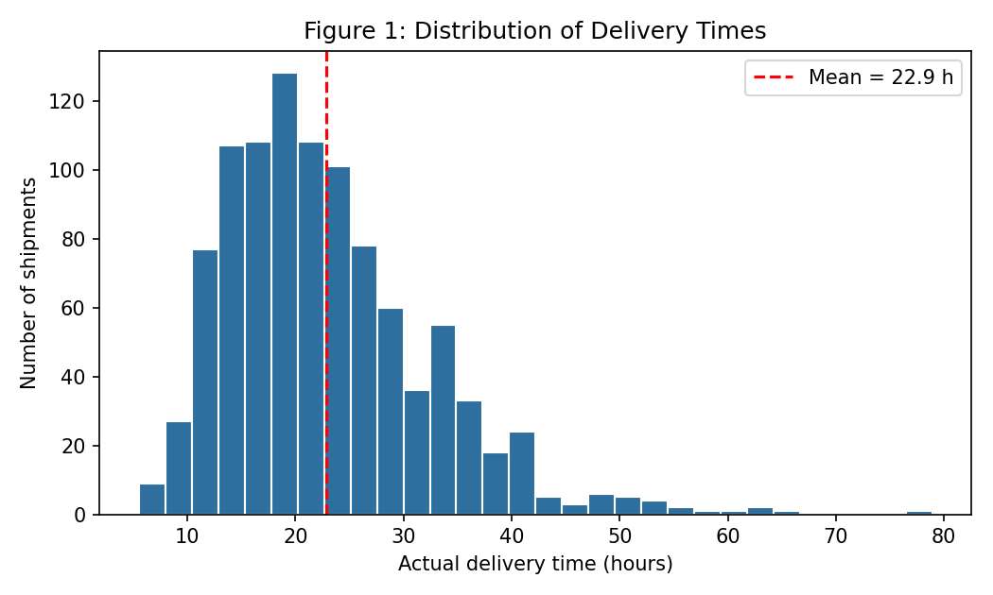
Figure 1: Distribution of delivery times
What it shows: how many shipments fall in each delivery-time range. Observations: the mean is 22.90 h and the median 21.14 h; the distribution is right-skewed, with a long tail up to 78.90 h caused by long-distance shipments. Implication: one average promise would be too long for most shipments and too short for the tail; delivery promises should be set per shipment.

D.2 Distance Versus Delivery Time
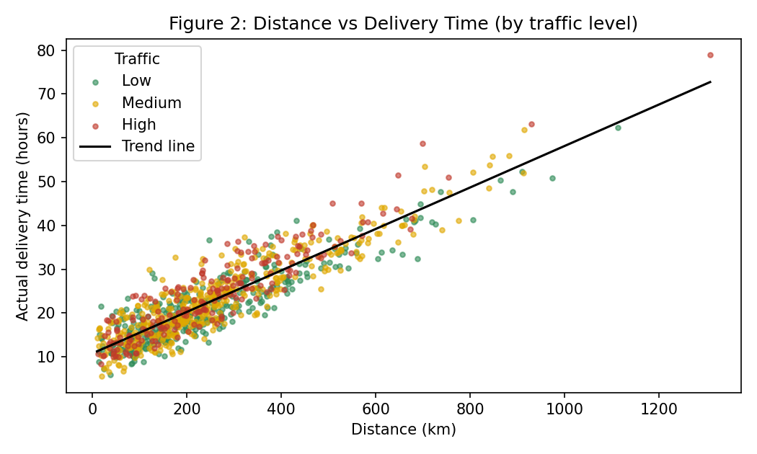
Figure 2: Distance vs delivery time (coloured by traffic level)
What it shows: each point is one shipment; the black line is a straight-line trend. Observations: a clear upward pattern (correlation 0.906), about 0.047 h per km. At the same distance, red (High traffic) points tend to sit above green (Low traffic) points and the spread widens for longer routes. Implication: distance sets the baseline; traffic adds a distance-dependent extra, so long routes benefit most from traffic-aware scheduling.

D.3 Actual Versus Predicted Delivery Times
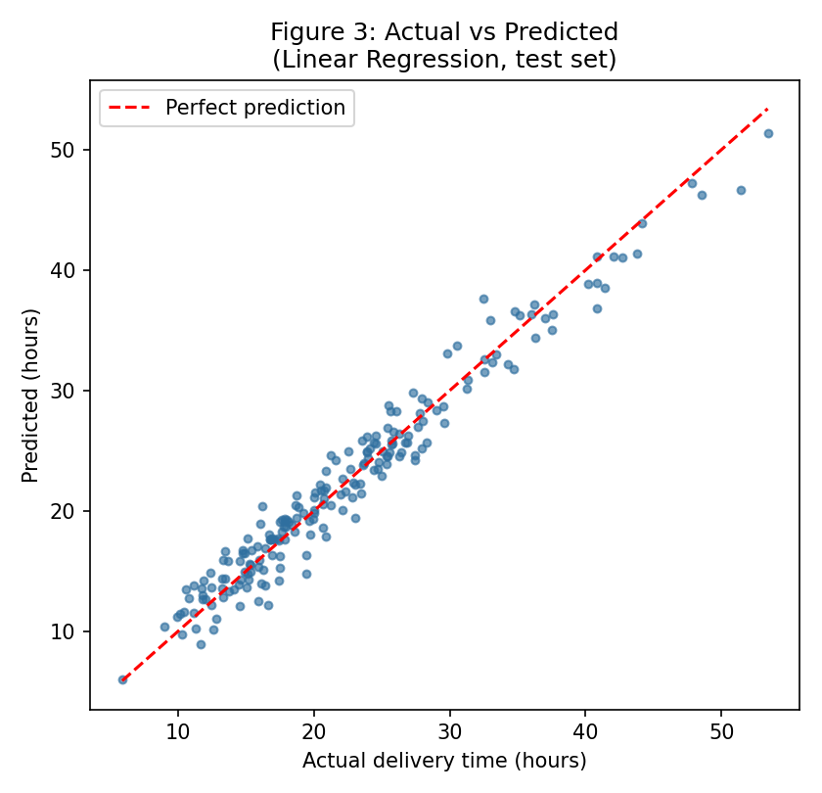
Figure 3: Actual vs predicted delivery times (Linear Regression, test set)
What it shows: predicted against actual time for the 200 test shipments; the red dashed line is perfect prediction. Observations: points cluster tightly around the line (R² = 0.960); 72.5% of predictions are within 2 h. Implication: the model is accurate enough to estimate delivery times on this simulated data, though larger deviations occur for long shipments.

D.4 Residual / Error Distribution
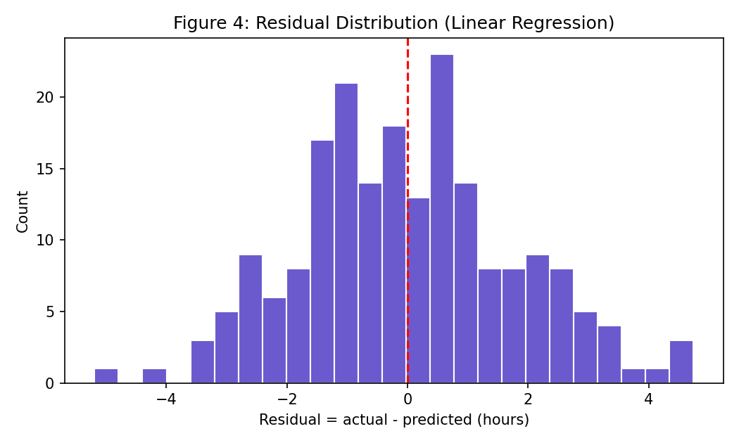
Figure 4: Residual distribution (actual minus predicted)
What it shows: the size and direction of prediction errors. Observations: a bell shape centred near zero (mean -0.018 h, standard deviation 1.77 h); largest absolute error 5.19 h. Implication: errors are balanced (no systematic over- or under-prediction), so a promise margin of about 3 hours would cover 91.5% of cases in this test set.

D.5 Model Performance Comparison
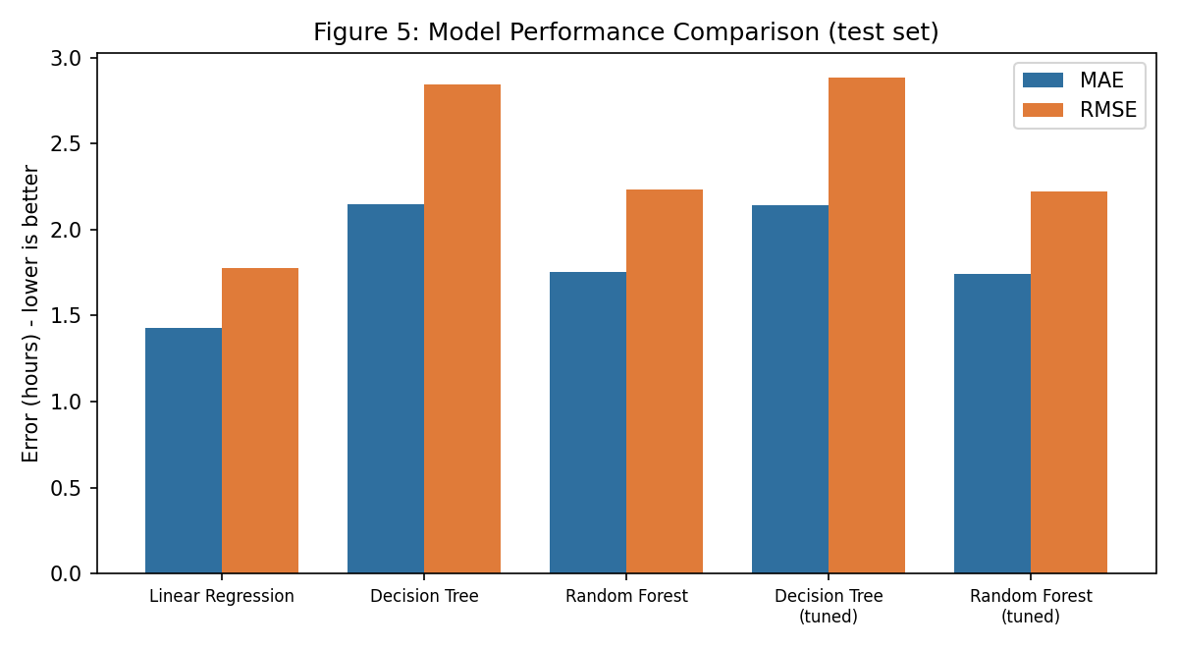
Figure 5: Model performance comparison (MAE and RMSE, test set)
What it shows: MAE and RMSE for all five model versions. Observations: Linear Regression has the lowest bars (MAE 1.43 h, RMSE 1.77 h); the Random Forest versions are around 2.22 h RMSE and the Decision Trees around 2.84 h. Implication: on this simulated, mostly additive data a simple model is enough; model complexity should be justified by results, not assumed.

D.6 Feature Importance
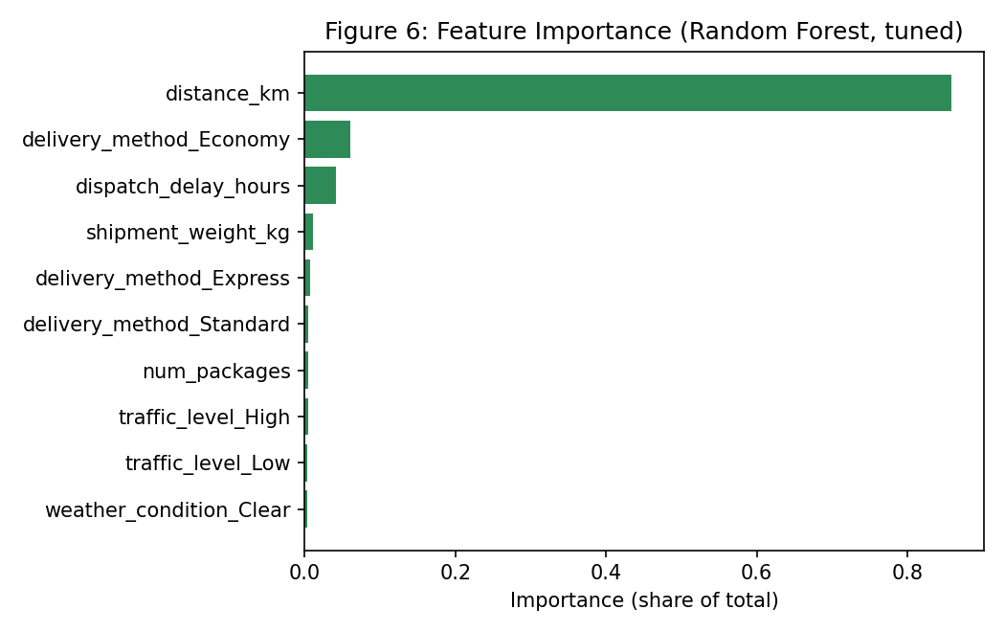
Figure 6: Feature importance (tuned Random Forest)
What it shows: how much the Random Forest relies on each input column. Observations: distance dominates (85.8%); Economy delivery method (6.1%) and dispatch delay (4.1%) follow; traffic and weather levels each have under 1% total importance although they add about 2 to 3 hours in the what-if checks. Implication: importance shows what the model uses, not the size of the effect in hours; dispatch delay, although only third, is the most controllable factor.

Appendix E: Model Evaluation Results

E.1 Evaluation Metrics and Cross-Validation
Table 23: Complete evaluation results (model_evaluation_results.csv)
Model | MAE | RMSE | R² | Train R² | CV RMSE | CV R²
Linear Regression | 1.430 | 1.773 | 0.960 | 0.971 | 1.664 | 0.969
Decision Tree | 2.150 | 2.844 | 0.897 | 1.000 | 3.314 | 0.879
Random Forest | 1.754 | 2.232 | 0.936 | 0.992 | 2.483 | 0.932
Decision Tree (tuned) | 2.140 | 2.882 | 0.894 | 0.940 | 3.146 | 0.891
Random Forest (tuned) | 1.743 | 2.219 | 0.937 | 0.992 | 2.477 | 0.933

E.2 Best-Performing Model and Reason for Selection
Linear Regression was selected because it had the lowest 5-fold cross-validated RMSE on the training data (1.664 h), and the test results agree (RMSE 1.773 h, R² 0.960). It is also the simplest and most explainable model. The selection did not use the test set.

E.3 Sample Actual-Versus-Predicted Values
The ten sample predictions are in Table 13 (Section 6.2). The complete set of 200 is in predictions.csv, which also contains the predictions of the other four models.

E.4 Interpretation of Prediction Errors
Mean error -0.018 h; standard deviation 1.77 h; 72.5% within 2 h and 91.5% within 3 h. Errors were similar across weather and traffic groups and highest for shipments over 600 km (1.97 h, based on few shipments).

E.5 Important Model Features
Table 24: Random Forest (tuned) feature importances
Feature | Importance
distance_km | 0.858
delivery_method_Economy | 0.061
dispatch_delay_hours | 0.041
shipment_weight_kg | 0.011
delivery_method_Express | 0.006
delivery_method_Standard | 0.005
num_packages | 0.004
traffic_level_High | 0.004
traffic_level_Low | 0.004
weather_condition_Clear | 0.003
weather_condition_Storm | 0.002
weather_condition_Rain | 0.001
traffic_level_Medium | 0.001

E.6 Limitations of the Evaluation
- Simulated data with a known formula: scores do not predict real-world performance.
- Only 200 test rows; no confidence intervals were calculated.
- A random split was used, not a time-based split.
- The tuned models' cross-validation scores may be slightly optimistic because the settings were selected on the same folds.

Appendix F: Optimization Analysis and Supporting Calculations

F.1 Optimization Problem and Baseline Assumptions
Problem: can simple operational changes reduce the predicted delivery time? Baseline: the 200 test shipments exactly as they are, predicted by the selected model. Assumptions: (1) the promised window is 36 hours; (2) the cost of one shipment-hour is INR 25 (assumed, not measured); (3) changing an input in the model corresponds to the same real change; (4) other inputs stay the same.

F.2 Proposed Operational Improvements
Table 25: Scenario definitions
Scenario | Change applied to the test shipments
S1 | Dispatch delay capped at 1.0 hour (delays above 1 h become 1 h)
S2 | All dispatch delays reduced by 50%
S3 | Only the 20% of shipments with the highest baseline predicted time: delay capped at 0.5 h
S4 | Shipments with High traffic re-timed to Medium traffic
S5 | S2 and S4 together

F.3 Python Code for the What-If Scenario
The full code is in Appendix A (STEP 10). The core idea is shown below:
base = model.predict(X_test) # baseline predictions
X_s1 = X_test.copy()
X_s1["dispatch_delay_hours"] = X_s1["dispatch_delay_hours"].clip(upper=1.0)
p_s1 = model.predict(X_s1) # scenario predictions
change_hours = p_s1.mean() - base.mean()
hours_saved = (base - p_s1).sum()
saving_inr = hours_saved * COST_PER_SHIPMENT_HOUR # assumed rate

F.4 Baseline and Scenario Predictions
Table 26: What-if results, Linear Regression (selected model) - SIMULATED
Scenario | Mean (h) | Change (h) | Change (%) | Pred. > 36 h | Hours saved | Assumed INR
Baseline (no change) | 22.42 | 0.00 | 0.00 | 20 | 0.0 | 0
S1: Cap dispatch delay at 1 h (all) | 21.19 | -1.23 | -5.49 | 18 | 246.0 | 6,151
S2: Halve dispatch delay (all) | 21.42 | -0.99 | -4.42 | 16 | 198.4 | 4,959
S3: Priority dispatch (<=0.5 h) for top-20% risk | 22.00 | -0.42 | -1.86 | 17 | 83.6 | 2,090
S4: Re-time High-traffic shipments to Medium | 22.06 | -0.35 | -1.58 | 18 | 70.9 | 1,772
S5: Combined S2 + S4 | 21.07 | -1.35 | -6.01 | 14 | 269.2 | 6,731

Table 27: What-if cross-check, Random Forest (tuned) - SIMULATED
Scenario | Mean (h) | Change (h) | Change (%) | Pred. > 36 h | Hours saved | Assumed INR
Baseline (no change) | 22.25 | 0.00 | 0.00 | 17 | 0.0 | 0
S1: Cap dispatch delay at 1 h (all) | 21.29 | -0.96 | -4.31 | 17 | 192.0 | 4,800
S2: Halve dispatch delay (all) | 21.55 | -0.71 | -3.17 | 17 | 141.3 | 3,533
S3: Priority dispatch (<=0.5 h) for top-20% risk | 22.08 | -0.18 | -0.79 | 17 | 35.2 | 880
S4: Re-time High-traffic shipments to Medium | 22.16 | -0.09 | -0.42 | 17 | 18.9 | 472
S5: Combined S2 + S4 | 21.45 | -0.81 | -3.62 | 17 | 161.2 | 4,030

F.5 Interpretation of the Results
For 200 test shipments, S1 gives the largest predicted reduction (-1.23 h per shipment, -5.49%, 246.0 shipment-hours in total). Per shipment, S1 would be worth about INR 30.8 at the assumed rate. S3 helps little because high-risk shipments are mostly high-distance. The Random Forest shows smaller reductions, so the benefit size is uncertain. All numbers are model predictions in a simulation; none is a verified improvement in real operations.

F.6 Practical Recommendations
- Prioritise dispatch-delay control for all shipments over selective priority for only the highest-risk ones.
- Use the combined effect (S5) only as an indicator; traffic re-timing depends on whether routes and drivers can actually move.
- Replace the assumed INR 25 per hour with real figures and run a controlled pilot before reporting savings.

Appendix G: Additional Tables and Technical Details

G.1 Data-Cleaning Summary
Table 28: Cleaning actions and results
Issue | Count | Action | Where done
Duplicate rows | 10 | Removed with drop_duplicates() | Before split
Missing shipment_weight_kg | 25 | Median imputation | Inside pipeline (training data only)
Missing traffic_level | 15 | Most-frequent imputation | Inside pipeline (training data only)
Impossible values | 0 | None needed | Checked before split
Identifier column | 1 | shipment_id excluded from features | Feature selection

G.2 Feature Encoding Explanation
Table 29: How columns are transformed before modelling
Column type | Columns | Transformation | Result
Numeric | distance_km, dispatch_delay_hours, shipment_weight_kg, num_packages | Median imputation, standard scaling (mean 0, std 1) | 4 columns
Categorical | traffic_level, weather_condition, delivery_method | Most-frequent imputation, one-hot encoding | 9 columns (3 each)

G.3 Model Parameter Settings
Table 30: Model settings used
Model | Settings
Linear Regression | Default settings (ordinary least squares)
Decision Tree | random_state = 42; other defaults (no depth limit)
Random Forest | n_estimators = 200, random_state = 42, other defaults
Decision Tree (tuned) | max_depth = 10, min_samples_leaf = 10
Random Forest (tuned) | n_estimators = 300, max_depth = None, min_samples_leaf = 1
Train/test split | 80% / 20%, random_state = 42 (800 / 200 rows)
Cross-validation | KFold, 5 splits, shuffle = True, random_state = 42

G.4 Linear Regression Coefficients
The selected model's intercept is 24.09 h. Numeric inputs were scaled, so their coefficients are hours per one standard deviation; the categorical coefficients are shifts in hours for each one-hot column. Because one-hot columns of the same feature add up to 1, the individual category coefficients are only meaningful relative to each other (for example Economy minus Express).
Table 31: Linear Regression coefficients (scaled inputs)
Input column | Coefficient (h)
distance_km | 8.520
dispatch_delay_hours | 1.797
shipment_weight_kg | 0.379
num_packages | 0.317
traffic_level_High | 1.471
traffic_level_Low | -1.255
traffic_level_Medium | -0.216
weather_condition_Clear | -0.966
weather_condition_Rain | -0.161
weather_condition_Storm | 1.127
delivery_method_Economy | 4.260
delivery_method_Express | -3.499
delivery_method_Standard | -0.761

Converting the distance coefficient back to the original unit (divide by the standard deviation of about 181 km) gives roughly 0.047 h per km, close to the 0.047 h per km trend in Figure 2 and consistent with the sensitivity result of 4.61 h per 100 km. The Economy minus Express difference is 7.76 h, close to the 8 h gap built into the generator.

G.5 Important Formulas
- MAE = (1/n) x sum |y - ŷ| (Equation 2)
- RMSE = sqrt( (1/n) x sum (y - ŷ)^2 ) (Equation 3)
- R² = 1 - SS_residual / SS_total (Equation 4)
- Percentage change = 100 x (scenario mean - baseline mean) / baseline mean
- Assumed saving = hours saved x INR 25 per shipment-hour

G.6 Additional Calculation
The ratio of RMSE to MAE for the selected model is 1.24. A ratio near 1.25 is typical of errors that follow a bell-shaped distribution, which agrees with Figure 4 (values far above 1.25 would suggest a few very large errors).

