We will generate Full Stack Single Page Application (SPA) using MongoDB, Express, Vue, and Node.js CRUD Example Tutorial with step by step

We install Vue.js project using Vue CLI. Vue CLI requires the Node.js version 8.9 or above (8.11.0+ recommended).

Type the following command to install Vue CLI, if you have not installed.



You can check the version of Vue.js using this command.



1. Create a Vue.js project



Now, go inside the Vue project.



Start the Vue dev server using the following command.



2. Install Vue dependencies

Type the following command to install the **axios**, **Vue-router**and **Vue-axios**dependencies.



3. Create Vue Components

Go to the **src >> components**folder and remove the **HelloWorld.vue**file and create the following components.

1. HomeComponent.vue
2. CreateComponent.vue
3. EditComponent.vue
4. IndexComponent.vue

4. Configure the Vue router

5. Create Node Backend JS

Create one folder inside the Vue project root called **api**and go inside that folder.

Now, initialize the **package.json**file.

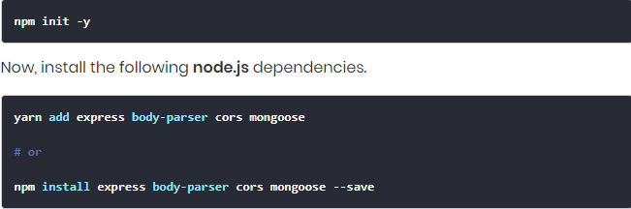

Also, install a **nodemon server**as a development dependency. So that we do not need to restart every time, we change our server code.



Now create three files called **server.js, DB.js, post.model.js,**and **post.route.js.**All these files are inside the root of the **api**folder.

6. **Setup and connect MongoDB database**

**7. Create Mongoose Schema**

**8. Define a route for Node.js Express application**

**9. Use axios to send a network request**

**10. Display the backend data**

11. **Send edit and update request**

12. **Delete or Remove the data.**

GitHub link: <https://github.com/gangadhar993/VueWorkshop>