Turning Silent Churn Into Recovered Revenue
The Revenue Recovery Engine — a story for our next leadership conversation

1. The Problem, In the Industry's Own Numbers
For years, the service drive was every dealership's most dependable profit center — a customer buys a car, keeps coming back for maintenance, and eventually buys their next car from the same store. That cycle is now breaking, and it's showing up clearly in the latest industry data.
The National Automobile Dealers Association sets 72% service retention as the benchmark for a healthy fixed-ops department. Cox Automotive's 2025 Service Industry Study found the industry is falling well short of it — and losing ground fast.
72%  NADA Retention Benchmark | 54%  Actual 2025 Return Rate* | $47.7K  Customer Lifetime Value | 7–10×  Cost to Replace a Customer
*Owners of vehicles two years old or newer who returned to their selling dealer for service in 2025 — down from 72% just two years earlier. (Cox Automotive, 2025 Service Industry Study)
That drop isn't a one-time blip. The same study found dealerships handling 12% fewer service visits than in 2018, with the dealership share of all service visits sliding from 33% to 29% as independent shops and quick-lube chains pick up the slack.
The stakes go well beyond one missed oil change. Cox Automotive's 2026 Fixed Operations and Ownership Study found that customers who return for service are 30 points more likely to buy their next vehicle from the same dealer, and 88% of consumers say their service experience directly shapes whether they'll purchase there again. The same study estimates that losing a single service customer can mean more than $12,000 in lifetime service spend walking out the door — and that despite 80% of new-vehicle buyers saying they intend to come back for service, only about one in four actually leave the lot with that first appointment already booked.
Zoom out further and the national picture is just as stark: Reynolds and Reynolds' Brand Retention Report puts nationwide brand retention at only 43.9% — meaning most customers will buy their next vehicle somewhere else entirely — and Cox Automotive calculates that even a single percentage point of retention improvement is worth roughly $700M in additional revenue across the industry.
Individually, one quiet, drifting customer is invisible. At industry scale, that drift is exactly what's showing up in these numbers — and it's exactly the gap the Revenue Recovery Engine is built to close, not by guessing, but by watching every customer against these same signals, continuously.

2. Meet the Engine: A Closed Loop, Not a Campaign
Most retention efforts work like a spotlight — they light up one problem at a time (a complaint, a lapsed customer, a recall) and then go dark again. The Revenue Recovery Engine works differently: it's a closed loop that never stops watching, and every outcome feeds back in to make the next decision smarter.
There are four moving parts to how it thinks about every customer:
- See everyone — pull one unified profile per customer from the DMS, CRM, repair orders, warranty, campaigns, and complaints, so no one is judged on partial information.
- Sort them honestly — every customer lands in exactly one of seven lifecycle segments, from “Warranty / Free Service” to “Lapsed / Dormant,” so the next action always matches where they actually are.
- Decide with data — an AI risk and opportunity score answers two questions: how likely is this customer to leave, and how much revenue is actually recoverable if we act.
- Act, measure, and learn — the right treatment goes out, the outcome gets measured, and the model updates itself for next time. Nothing is a one-shot campaign; everything is a lesson for the system.

3. Walking the Journey — One Customer at a Time
Here's what that looks like end-to-end. Follow the diagram on the following page as we walk through it.

Step 1 — Nobody falls through the cracks
Every customer enters through the Dealer Database and gets a full Customer 360 profile. Before anything else happens, we validate the basics — is the VIN right, is the contact info real, is there consent to reach out. If something's off (a duplicate profile, a missed ownership change), it gets corrected and reprocessed automatically — it never just gets dropped. That's how we get to 100% coverage with zero unclassified customers.

Step 2 — Everyone gets sorted, honestly
Once the data is clean, every customer is assigned to one lifecycle segment — Warranty, First Paid Service Due, Healthy Regular Service, Medium-Risk, Lapsed/Dormant, Quality Issue, or Ownership/Data Validation. This single step is what makes the next decision relevant instead of generic.

Step 3 — The engine decides, not a spreadsheet
The AI calculates a churn score and a recoverable revenue figure for each customer, and asks a second, harder question: root cause. Is this customer drifting because of something they did — or because of something we did? That distinction decides everything downstream.

Step 4 — The right conversation, not just any conversation
Based on the segment and the root cause, the engine picks one of five treatment journeys — a service package campaign, a goodwill recovery call, a loyalty touch, a win-back offer, or a data cleanup. Higher-cost or sensitive actions route to a manager for approval; low-cost, routine ones execute automatically. Either way, outreach goes out through whatever channel fits — SMS, email, call, WhatsApp, or an advisor task.

Step 5 — What happens next matters as much as the offer itself
If the customer books the service, that's recovered revenue — and if their original issue traced back to something on our side, it also triggers a dealer corrective action (an inspection checklist, advisor retraining, a fix to how we communicate at delivery), because a recovered customer today can still churn again tomorrow if the root cause was never fixed.
If the customer doesn't respond, the story doesn't end there. A retry strategy changes the offer, the channel, or the timing — and, importantly, it also feeds two things we used to lose: it goes back to Root Cause / Driver Analysis in case our first read on the customer was wrong, and it keeps them under Continue Customer-Level Monitoring instead of just giving up after one no.

Step 6 — The system remembers
Every outcome — recovered or not — flows into Measure Outcomes and then into AI Learns and Updates Model. Segmentation rules, risk thresholds, offer strategy, channel timing: all of it gets sharper after every single customer interaction. This is the difference between a campaign and an engine — a campaign ends; this keeps compounding.

4. The Flow, In One Picture
This is the full closed loop referenced above — every box is a decision or an action the system takes automatically; every dashed line is a feedback loop that keeps the system honest over time.
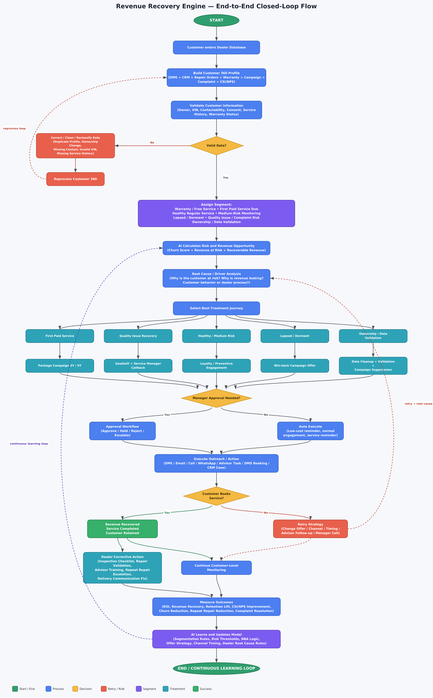

5. Why This Matters to Us
This isn't a retention gimmick — it's addressing a documented, worsening, industry-wide trend: service retention among newer-vehicle owners has fallen from 72% to 54% in just two years, even as the average dealership now leans on service and parts for over 13% of total income.
We don't yet have our own dealership's exact number on this — no one in the industry is publishing store-level figures, only national averages. That's precisely what a pilot cycle would give us: instead of citing what Cox Automotive or NADA found across the industry, we'd have our own retention gap, our own recoverable-revenue estimate, and our own before/after numbers.

6. What We're Asking For
To move from analysis to action, we're looking for:
- Sign-off to pilot the full closed loop (not just the outreach step) on one dealer's customer base.
- Access/integration approval for the systems the Customer 360 profile depends on — DMS, CRM, repair orders, warranty, and complaints.
- A review checkpoint after the first full cycle, so we can show our own real recovered-revenue numbers instead of industry projections.
Happy to walk through any part of this in more depth — the diagram on the previous page is built to be read top to bottom, and every box maps to something we can demo.

Sources
All figures in Section 1 are drawn from the following publicly available industry research:
- National Automobile Dealers Association (NADA) — service retention benchmark (72%) and customer acquisition-vs-retention cost guidance.
- Cox Automotive, 2025 Service Industry Study (Nov 2025) — 54% return rate for near-new vehicles, 12% decline in service visits since 2018, dealer service-visit share (33% → 29%).
- Cox Automotive, 2026 Fixed Operations and Ownership Study (Apr 2026) — repurchase likelihood (+30 points), 88% service-experience impact stat, $12,000+ lifetime value of a lost service customer, first-appointment scheduling gap.
- Cox Automotive, Sales Tracking Study — $47,700 customer lifetime value; $700M industry-wide revenue impact of a 1-point retention gain.
- Reynolds and Reynolds, Brand Retention Report (2024) — 43.9% nationwide brand retention rate.
Figures are cited as reported in each publisher's released study or public summary as of this document's preparation; exact methodology and sample sizes are available from each source directly.

