Darmstadt Hub -- Visit Report
Visit 3 | 15 October 2026

1. Stock and Space Utilisation
- Stock organisation remains broadly adequate. No major overstocking or accessibility issues observed.
- The hub is operational and generally well-organised at the stock level.

2. Shelf Conditions
A full shelf inspection was carried out across all 70 shelves. Findings by zone:

Ambient shelves:
- Shelves 1-8: dust accumulation, particularly on the higher racks.
- Shelves 14-17: dust present, requires cleaning.
- Shelves 20-26: dust present.
- Shelves 36-40: dusty.
- Shelves 42-44: some dust.
- Shelves 53-54: dusty.
- Shelves 58-61: dusty.

Mould -- URGENT (now recurring across three consecutive visits):
- Shelves 10-13: mould present. This is the first time mould has been recorded here.
- Shelves 33-35, 37, 45, 47, 49: mould present. This has now been recorded across all three visits to this hub. The issue remains completely unresolved.
- Shelf 41: mould present (fridge).
- Mould in fridge units is a food safety and hygiene risk. The persistence of mould on these shelves across three consecutive visits without resolution is unacceptable and requires immediate escalation.

Fridges:
- Shelves 18-19, 22-23, 27-28, 31-32: good condition.
- Fridge 13: right door handle is approximately 70% broken. This is a practical issue that slows pickers down and affects their pick rate. Needs to be replaced as soon as possible.

Freezers:
- Shelves 9-15 (freezers): clean and in good order.

Clean / satisfactory:
- Shelves 55, 57, 62, 63, 65, 66, 67, 69, 70: good condition, no action needed.

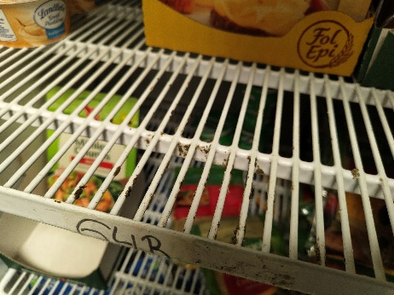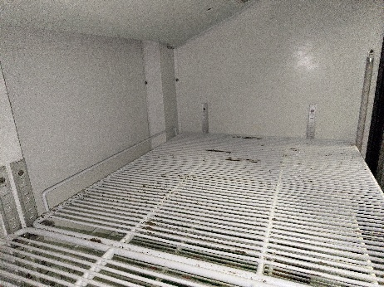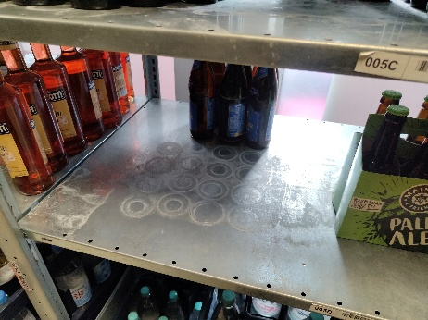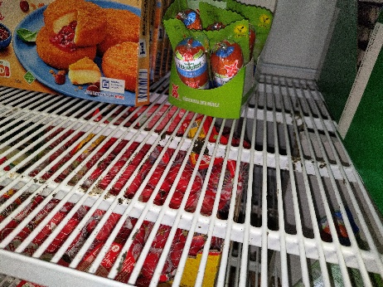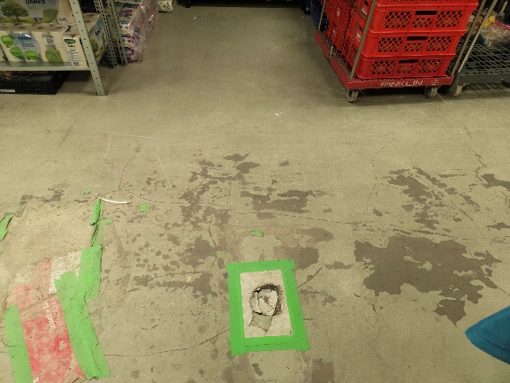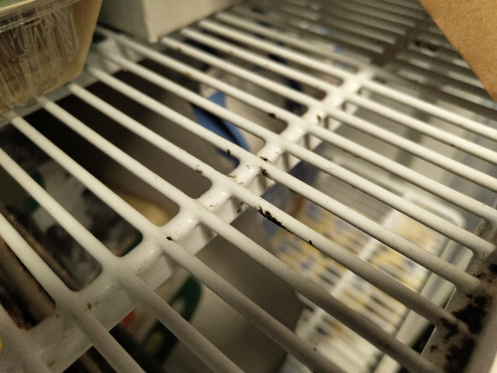

3. Floor Hazard -- Hole in Floor
- A significant hole in the floor was identified in the hub.
- This is not uneven flooring or a surface irregularity -- there is a literal hole in the floor that creates a physical obstruction during inbound stock handling.
- When roller racks carrying heavy inbound items (in particular drinks) are moved, the hole causes the rack to lose balance. This is both a safety risk for staff and an operational problem that slows down the inbound process.
- This issue was raised by two separate pickers independently and is clearly causing daily inconvenience.
- Immediate repair is required. This should be treated as a safety hazard and escalated accordingly.

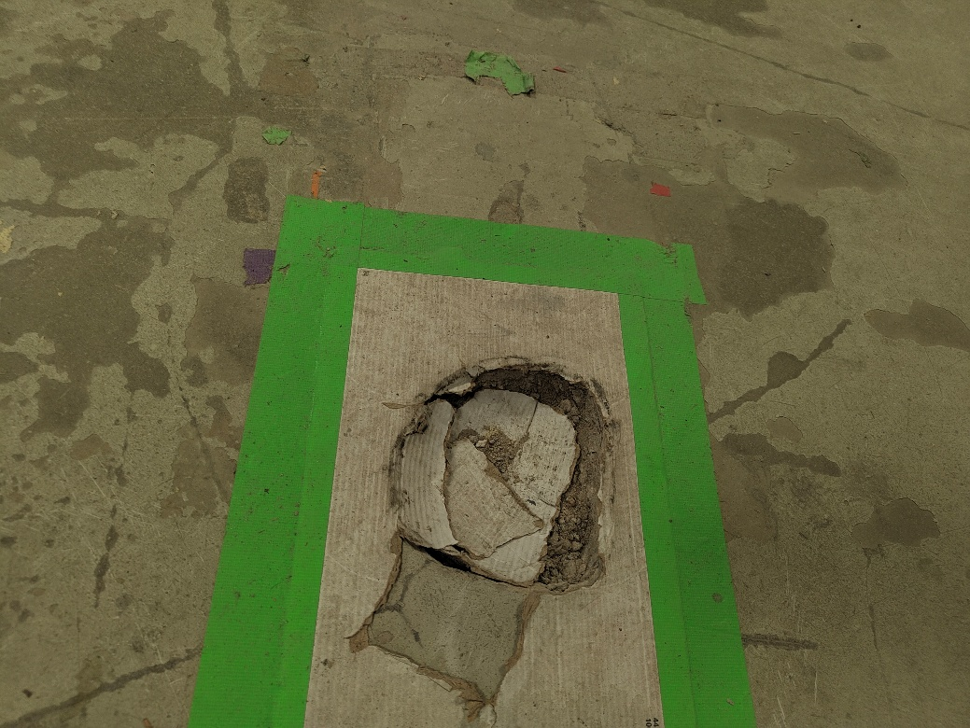

4. Water Filter
- The water filter remains out of service. This has been flagged in every visit -- Visit 1, Visit 2, and now Visit 3 -- without resolution.
- This is a basic staff welfare issue. The filter needs to be repaired or replaced as a priority.

5. Rider Safety -- Helmets
- Riders continue to not wear helmets despite repeated instructions from the manager.
- The manager has been consistently reminding riders to wear helmets, but the instructions are not being followed.
- Riders could not be spoken to directly during this visit due to operational constraints -- taking riders offline would have impacted live operations.
- Verbal reminders alone are clearly not sufficient. A more structured and enforceable approach is needed:
- Clear written notices to be posted in visible locations in the bike room and rider area.
- Helmet and uniform requirements to be included in formal onboarding documentation for all new riders.
- Formal escalation process to be initiated if non-compliance continues after written notices are in place.

6. Staff Feedback
Picker 1:
- Positive about the work environment and management.
- Raised concern about mould in the fridges -- particularly the recurring mould that has not been resolved across visits.
- Flagged fridge 13 door handle as broken, noting it is slowing down pick rates.

Picker 2:
- Echoed the same concerns as Picker 1 -- mould in fridges and fridge 13 handle.
- Positive about the work environment overall.
- Flagged water filter still not working -- noted this is a persistent issue.
- Flagged the hole in the floor as causing operational difficulty, particularly when moving heavy inbound stock on roller racks.

7. Overall Impression
- The hub is functioning and the team appears engaged. The manager is present and active.
- However, several serious issues have now been present and unresolved across all three visits: mould on shelves, AC leakage, water filter, and floor repairs. The pattern of repeated visits from maintenance without effective resolution is a concern.
- Two issues require immediate escalation: the hole in the floor (safety risk and operational impact) and mould in the fridges (food safety risk, three visits unresolved).
- Helmet non-compliance remains a persistent issue despite the manager's efforts. A structural solution is now needed rather than continued verbal reminders.

8. Priority Actions
- IMMEDIATE: Hole in the floor -- repair required urgently. Active safety risk and operational impact on inbound stock handling.
- IMMEDIATE: Mould in fridges (shelves 10-13, 33-35, 37, 41, 45, 47, 49) -- food safety risk. Three consecutive visits unresolved. Immediate cleaning and root cause investigation required.
- Fridge 13 door handle -- replace as soon as possible. Directly impacting picker efficiency.
- AC leakage -- escalate for permanent fix. Repeated maintenance visits have not resolved the issue. (Recurring from Visit 1 and Visit 2)
- Water filter -- repair or replace. Recurring from all three visits. Staff welfare impact.
- Helmet non-compliance -- post written notices in bike room; add requirements to onboarding documentation; initiate formal escalation process.
- Dust on ambient shelves (1-8, 14-17, 20-26, 36-44, 53-54, 58-61) -- schedule a cleaning round.

