Final Report — Heart Disease MLOps Platform
Course: Machine Learning Operations (AIMLCZG523) · Assignment 01 · Marks: 50 Author: Gangadhar C · Date: October 2026 Repository: https://github.com/gangadharrr/MLOPS-Assignment-1 Evidence: reports/, screenshots/, models/, MLflow experiment heart-disease

1. Introduction
This report documents an end-to-end MLOps solution for predicting heart-disease risk from patient health data (UCI Heart Disease, Cleveland). The goal was not only a good classifier, but a reproducible, tested, containerized and monitored system around it: acquisition and EDA → tracked experiments → packaged model → CI/CD → Docker → Kubernetes → Prometheus/Grafana.
Assignment task | Section | Primary evidence
1. Data acquisition & EDA | §2 | src/download_data.py, src/eda.py, reports/figures/01–05
2. Feature engineering & models | §3 | src/preprocessing.py, src/train.py, models/metrics_summary.csv
3. Experiment tracking | §4 | MLflow experiment heart-disease, screenshots/mlflow_*.png
4. Packaging & reproducibility | §5 | models/model.pkl, pinned requirements*.txt, sample_request.json
5. CI/CD & automated testing | §6 | tests/ (20 cases), .github/workflows/ci.yml
6. Containerization | §7 | Dockerfile, screenshots/docker_verification.txt
7. Production deployment | §8 | k8s/*.yaml, screenshots/k8s_*.{png,txt}
8. Monitoring & logging | §9 | docker-compose.yml, monitoring/, screenshots/grafana_dashboard.png
9. Documentation & reporting | §10–12, appendices | this report, README.md, architecture diagram
Headline result. The selected model (Random Forest) reaches test accuracy 0.869 / ROC-AUC 0.948 on a 61-row held-out split, compared by nested 5-fold CV (ROC-AUC 0.895 ± 0.049) against a logistic regression baseline (§3 explains why the two are statistically tied and how the winner was chosen).

2. Data Acquisition & EDA (Task 1)

2.1 Acquisition
src/download_data.py downloads the UCI Cleveland processed.cleveland.data file directly from the UCI repository, assigns column names, and binarizes the target (original values 1–4 → 1 “disease”, 0 stays 0). Output: data/heart.csv (committed so CI and reviewers can reproduce everything without network access). The final dataset is 303 rows × 14 columns (13 features + target) with a 54.1% / 45.9% no-disease/disease split — mildly imbalanced but workable without resampling.

2.2 Cleaning and missing values
Two columns contain missing values encoded as ? in the raw file: ca (4 rows) and thal (2 rows). Rather than dropping rows, imputation lives inside the model pipeline (§3): median for numeric, most-frequent for categorical. This keeps the cleaning step deterministic and fold-safe (imputation statistics are learned on training folds only), and it also covers missing values arriving at prediction time.

2.3 Exploratory analysis
src/eda.py produces five figures into reports/figures/.
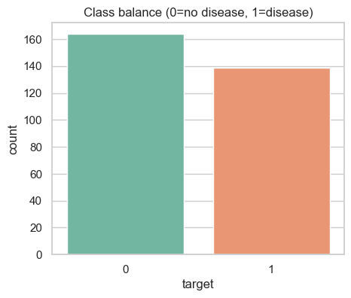 Figure 1 — Class balance: 164 no-disease vs 139 disease (54.1% / 45.9%).
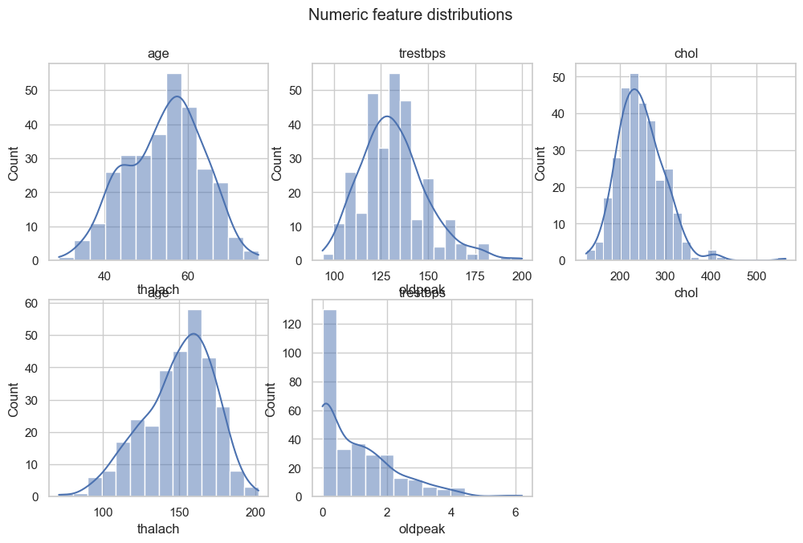 Figure 2 — Feature histograms. chol and oldpeak are right-skewed; thalach (max heart rate) is roughly bell-shaped.
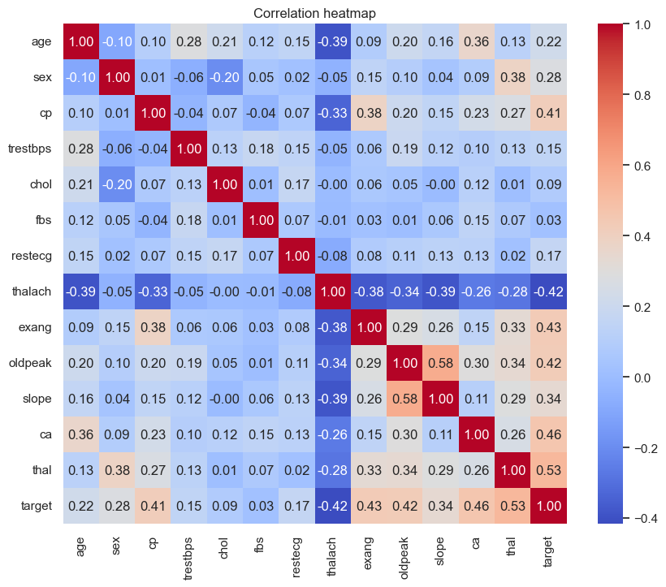 Figure 3 — Correlation heatmap (teal = positive, orange = negative correlation with the target).
Reading the heatmap (and the scatter/violin views in Figures 4–5):
- thalach (maximum heart rate achieved) is negatively associated with disease — lower max heart rate is a risk signal.
- exang (exercise-induced angina) and oldpeak (ST depression) are the strongest positive signals.
- cp = typical angina concentrates heavily in the disease class (Figure 5), while cp = asymptomatic is more mixed — clinically counter-intuitive but consistent with this dataset.
- chol is only weakly correlated with the target (a reminder that neither age nor cholesterol separates classes on their own in this dataset).
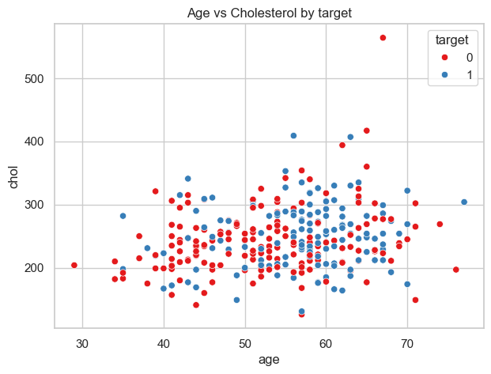 Figure 4 — Age vs cholesterol by class.
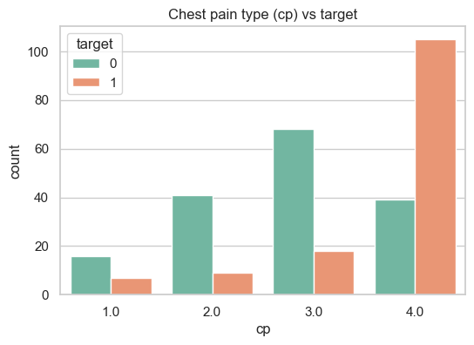 Figure 5 — Chest-pain type vs target: typical angina is strongly associated with disease presence.

3. Feature Engineering & Model Development (Task 2)

3.1 Preprocessing pipeline
All feature transformation is a single scikit-learn ColumnTransformer wrapped inside each model pipeline (src/preprocessing.py), so training and serving apply byte-identical transforms:
Feature group | Columns | Transform
Numeric (5) | age, trestbps, chol, thalach, oldpeak | median imputation + StandardScaler
Categorical (8) | sex, cp, fbs, restecg, exang, slope, ca, thal | most-frequent imputation + one-hot encoding
Because the transformer travels inside model.pkl (§5), the FastAPI service needs no duplicated preprocessing code — a classic source of train/serve skew.

3.2 Candidate models and tuning
Two classifier families were compared:
- Logistic Regression — interpretable linear baseline; grid C ∈ {0.01, 0.1, 1, 10, 100}.
- Random Forest — nonlinear interactions; grid n_estimators ∈ {100, 300} × max_depth ∈ {3, 5, 8, None} × min_samples_leaf ∈ {1, 3} (24 combinations).

3.3 Selection methodology (avoiding selection bias)
A common trap is to tune and pick a model on the same CV score, then quote that score as if it were unbiased. This pipeline avoids it:
- Stratified 80/20 split (242 train / 61 test, seed 42). The test set is touched exactly once, for final reporting.
- Each candidate is tuned with GridSearchCV using inner 5-fold CV (scoring = ROC-AUC).
- Candidates are compared with nested 5-fold CV — the outer folds wrap the entire grid search — so the score used to pick the winner was never used to tune its hyperparameters.
- The winner (highest nested-CV ROC-AUC) is refit on the full training split and saved.

3.4 Results
Model | Nested-CV ROC-AUC (±sd) | CV accuracy | Test acc | Prec | Recall | Test ROC-AUC
Random Forest (selected) | 0.895 (±0.049) | 0.797 | 0.869 | 0.833 | 0.893 | 0.948
Logistic Regression | 0.893 (±0.052) | 0.830 | 0.885 | 0.839 | 0.929 | 0.966
Best hyperparameters: RF max_depth=5, min_samples_leaf=3, n_estimators=100; LR C=1 (models/best_params.json). Confusion matrices and ROC curves for both models are saved as models/confusion_*.png and models/roc_*.png and logged to MLflow.
Honest caveat. The two models are statistically indistinguishable: the nested-CV gap (0.0025) is far smaller than the fold-to-fold spread (sd ≈ 0.05), and 61 test rows cannot separate them either (LR happens to score higher on every test metric, but that was not the selection rule). The documented rule — highest nested-CV ROC-AUC — selected Random Forest. For a clinical screening use case where recall dominates, Logistic Regression would be an equally defensible choice; keeping the full comparison in this report (instead of only the winner) is deliberate.

4. Experiment Tracking (Task 3)
Every training run is tracked in MLflow (experiment heart-disease, local file store, mlruns/ — ignored by git, regenerated by python src/train.py):
- One run per model (random_forest, logistic_regression) logging parameters (best hyperparameters + the full search grid), all nested-CV metrics (mean and sd) and all test metrics, the confusion-matrix and ROC plots as artifacts, the fitted scikit-learn pipeline with an inferred model signature (so the serving contract is recorded), plus a seed tag.
- One summary run (best-<model>) logging metrics_summary.csv, best_params.json, the dataset, and the EDA figures — a single place to see what the final artifact was and why.
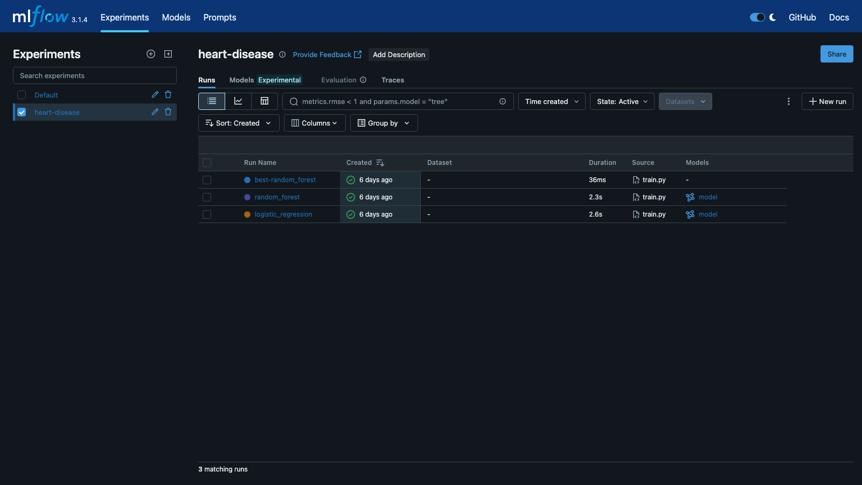
MLflow experiment
Figure 6 — MLflow UI: experiment heart-disease with the three runs (one per model plus the best-model summary).
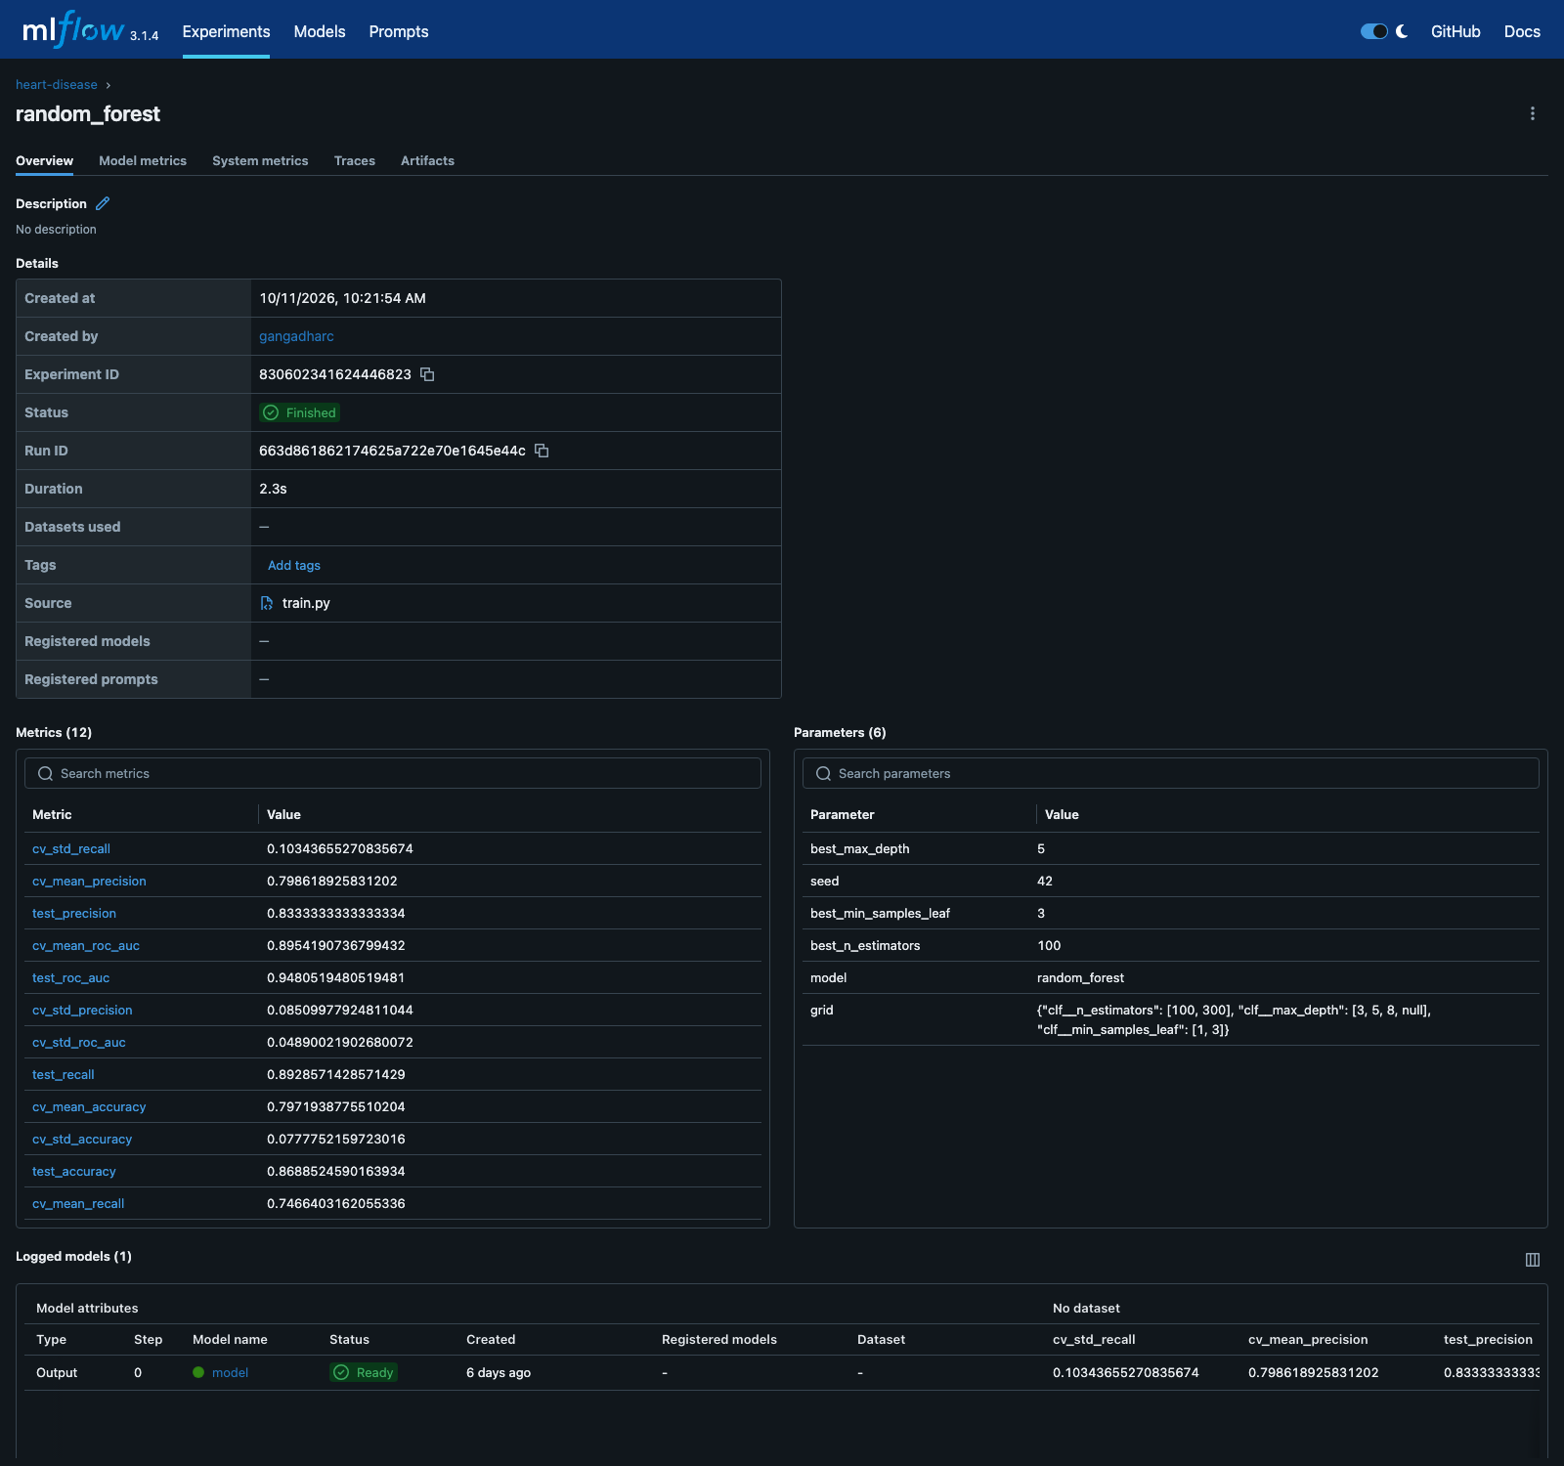
MLflow run detail
Figure 7 — Run detail for random_forest: nested-CV and test metrics, tuned parameters and grid, and the logged model in Ready state.
Viewing: mlflow ui (experiment heart-disease). Run IDs: best-random_forest f494c4e7…, random_forest 663d8618…, logistic_regression 8ea24403….

5. Model Packaging & Reproducibility (Task 4)
- Artifact format: joblib — the saved object is the entire pipeline (imputation + scaling/encoding + classifier), so inference requires only models/model.pkl and a JSON payload. MLflow additionally stores the same pipeline with its input signature.
- Input contract: 13 patient fields in Cleveland coding (e.g. cp 1–4, slope 1–3, ca 0–3, thal ∈ {3,6,7}), each range-validated; out-of-range or missing fields are rejected with HTTP 422 before reaching the model.
- Environment reproducibility: requirements.txt (full training/EDA/test stack, pinned — scikit-learn 1.6.1, MLflow 3.1.4) and requirements-serve.txt (slim serving-only set for the Docker image). Verified on a Python 3.9 host and inside the python:3.10-slim image.
- Clean-setup reproduction (also in README.md): pip install -r requirements.txt → python src/download_data.py → python src/eda.py → python src/train.py → pytest -q → uvicorn app.main:app. All scripts run from the repo root with relative paths and pinned versions, satisfying the “executes from a clean setup” production-readiness requirement.
Expected inference output for sample_request.json (first Cleveland row, true label 0): {"prediction":0,"probability":0.3572,"label":"no_disease"} — verified both locally over uvicorn (screenshots/local_api_verification.txt) and inside the container (§7).

6. CI/CD & Automated Testing (Task 5)

6.1 Test suite (tests/, 20 cases, pytest)
Area | What is covered
Data & preprocessing | schema/transform output shape, imputation, unseen-category handling at transform time
Model | metric computation on known inputs; selection rule honoured
Training end-to-end | train.main run on synthetic data — artifacts produced, best model chosen, files written
Inference helper | src/predict.py JSON → prediction path
API | /health, /ready, /predict happy path, 422 on out-of-range and missing fields, /metrics counters
With CI=1 set (as in the workflow), a missing model file fails the prediction tests instead of skipping them — the pipeline cannot silently “pass” without a model.

6.2 Workflow (.github/workflows/ci.yml, GitHub Actions)
push / PR → checkout → Python 3.10 (pip cache) → pip install -r requirements.txt
→ flake8 src app tests → python src/train.py (committed data/heart.csv)
→ pytest -v → docker build → container smoke test (/ready poll + /predict POST)
→ upload trained model + metrics as run artifacts (always)
Every step is fail-fast: a lint error, failing test, broken Docker build or unresponsive container fails the whole workflow with clear logs, satisfying the “pipeline fails on code/test errors” requirement. The model is trained inside CI and uploaded as an artifact per run, so each build’s outputs are traceable. The workflow file is in the repo; the first push triggers it on GitHub.

7. Containerization (Task 6)
Dockerfile: python:3.10-slim base; installs only requirements-serve.txt; copies app/ and the trained models/model.pkl; runs as a non-root appuser; serves uvicorn on port 8000. A .dockerignore keeps the build context small and free of notebooks/figures.
Because the model is baked in at build time, a container cannot start without a valid model — the /ready endpoint literally means “model loaded”. Verification transcript (screenshots/docker_verification.txt, full file in the repo):
$ docker images heart-api → heart-api:latest 653MB (non-root, serve-only deps)
$ curl /health → {"status":"ok"}
$ curl /ready → {"status":"ready"}
$ curl -X POST /predict … → {"prediction":0,"probability":0.3572,"label":"no_disease"}
$ (cp=9 out of range) → HTTP/1.1 422 Unprocessable Entity
$ curl /metrics → api_predictions_total{label="no_disease"} 3.0
Request logs inside the container record method, path, status and latency per call. The same image is built and smoke-tested on every CI run (§6.2), and is the deployable unit used in §8. http://localhost:8000/docs renders the OpenAPI page (screenshots/api_docs.png).

8. Production Deployment (Task 7)

8.1 Kubernetes manifests (k8s/)
Manifest | Contents
deployment.yaml | heart-api deployment, 2 replicas, readiness probe /ready (10s), liveness probe /health (20s), resources requests 100m/256Mi → limits 500m/1Gi
service.yaml | heart-api LoadBalancer, port 80 → targetPort 8000

8.2 Verification on minikube (Docker driver)
Deployed and verified live (full transcript screenshots/k8s_verification.txt):
$ minikube image load heart-api:latest
$ kubectl apply -f k8s/ → deployment.apps/heart-api created, service/heart-api created
$ kubectl rollout status … → "deployment heart-api successfully rolled out" (2/2)
$ kubectl port-forward svc/heart-api 8001:80
$ curl localhost:8001/health → {"status":"ok"}
$ curl localhost:8001/ready → {"status":"ready"}
$ curl -X POST localhost:8001/predict -d @sample_request.json
→ {"prediction":0,"probability":0.3572,"label":"no_disease"}
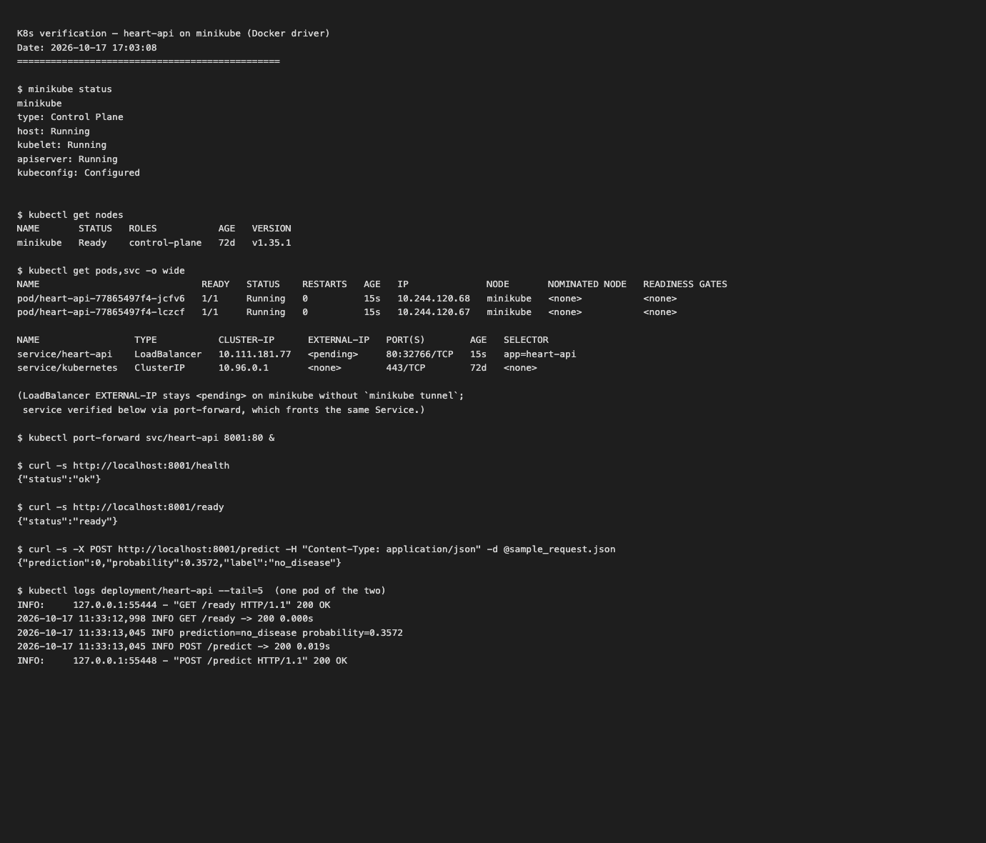
K8s verification
Figure 8 — minikube verification: node Ready, both pods 1/1 Running, LoadBalancer service created, and the API answering through the Service.
On minikube the LoadBalancer’s EXTERNAL-IP stays <pending> without minikube tunnel; the service was therefore verified through a kubectl port-forward, which fronts the exact same Service object. The identical manifests obtain a real external IP on GKE/EKS/AKS — that is the documented path to a public URL. Local access instructions are in README.md (compose or minikube), which the assignment accepts in place of a public URL.

8.3 Monitoring stack deployment
docker compose up --build brings up the API plus Prometheus and Grafana (§9). Two environment issues were hit and fixed during this deployment (see §11): Prometheus/Grafana configs are baked into small images (monitoring/prometheus.Dockerfile, monitoring/grafana.Dockerfile) instead of host bind mounts; Grafana is published on host port 3001 because port 3000 is commonly occupied by local dev servers. The observability stack went from “syntax-checked only” to verified end to end — evidence in §9.

9. Monitoring & Logging (Task 8)

9.1 Logging
Structured per-request logs (method, path, status, latency, and the predicted label — deliberately no patient data, to keep the service privacy-safe):
INFO prediction=no_disease probability=0.3572
INFO POST /predict -> 200 0.015s

9.2 Metrics and dashboards
The API exposes Prometheus metrics via prometheus_client:
Metric | Type | Labels
api_requests_total | Counter | endpoint, status (includes 422s and 5xx)
api_latency_seconds | Histogram | endpoint (p95 panel)
api_predictions_total | Counter | label (predicted class, not ground truth)
Prometheus scrapes heart-api:8000/metrics every 15 s; Grafana auto-provisions a “Heart API” dashboard with four panels: request rate by endpoint, error responses (4xx+5xx), p95 latency by endpoint, and predictions by class (last 5 m).
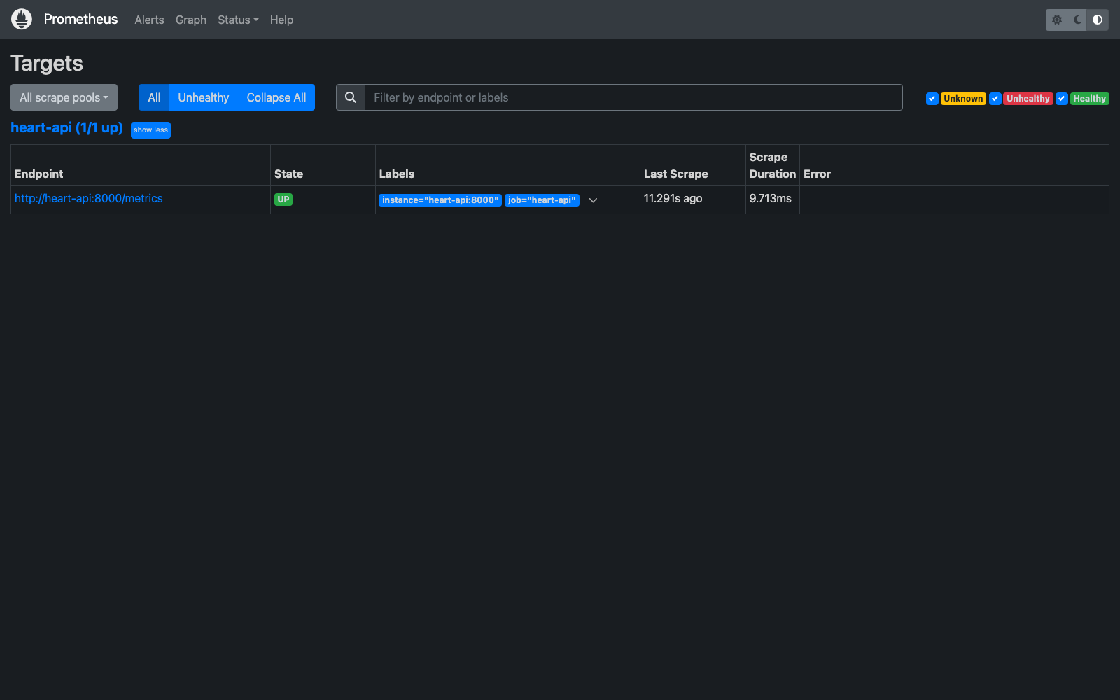
Prometheus targets
Figure 9 — Prometheus target heart-api UP, scraping every 15 s.
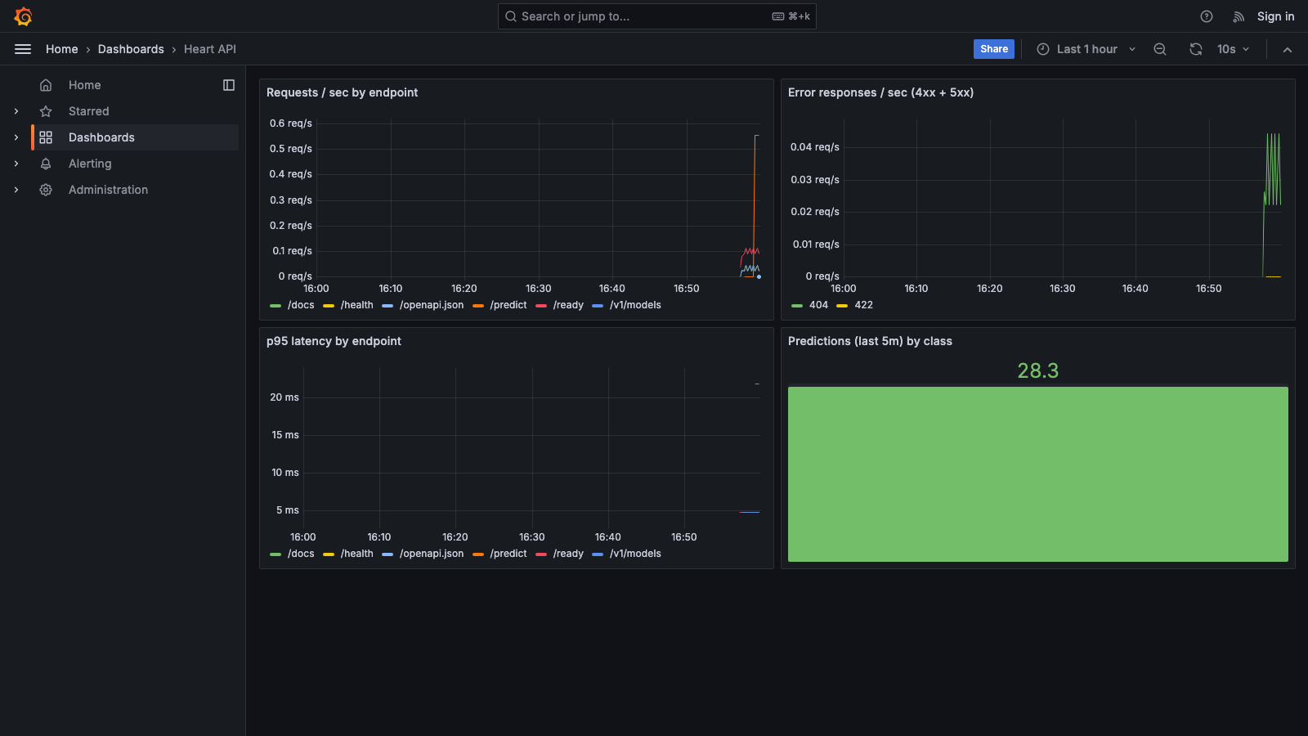
Grafana dashboard
Figure 10 — Provisioned Grafana “Heart API” dashboard after generated traffic: the /predict spike, the 422 responses from a validation check, p95 latency, and the prediction counter. (The sporadic /v1/models 404 line is an unrelated local process probing port 8000 that happened to hit the shared port — a nice demonstration that the error-rate panel counts exactly these cases.)
The end-to-end check (target UP, counters moving, dashboard provisioned and rendering) is recorded in screenshots/monitoring_verification.txt.

10. Architecture (Task 9)
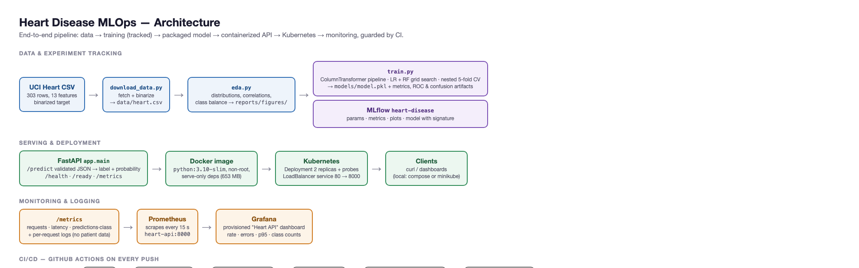
Architecture
Figure 11 — System architecture: data/training lane (with MLflow tracking), serving/deployment lane (FastAPI → Docker → Kubernetes), monitoring lane (/metrics → Prometheus → Grafana), and the fail-fast CI pipeline.
Narrative: the raw UCI CSV is fetched and binarized once; EDA figures are generated; train.py builds fully self-contained pipelines, tunes both candidates, picks the winner by nested CV and tracks everything in MLflow. The winner is persisted as a single joblib artifact that the FastAPI service loads at startup — the container image packages exactly that. Kubernetes runs two replicas behind a LoadBalancer with health probes. The same app process exposes Prometheus metrics that Grafana renders. Every push re-runs the entire chain (lint → train → test → build → smoke test) so the repo cannot drift from a deployable state.

11. Challenges, Debugging & Learnings
Real deployments surface issues that dry-runs don’t; these were found by actually running everything:
- Host path containing : broke Docker bind mounts. The repo lives under a folder named BITS AI:ML, and Docker Desktop rewrites bind-mount specs as ":":-separated strings — every Prometheus/Grafana volume failed with invalid volume specification. Fix: bake configs into the monitoring images (monitoring/*.Dockerfile). This is strictly more portable: docker compose up now works from any checkout path, with no host-side file dependencies.
- Port 3000 taken by another local dev server. Grafana’s default host port was intercepted by an unrelated Node server on localhost. Fix: publish Grafana on 3001 and document it. (Similarly, macOS AirPlay holds port 5000, so MLflow’s UI is documented with --port 5001.)
- MLflow file-store gating. Very recent MLflow versions refuse the filesystem backend by default; the project pins mlflow==3.1.4, which matches the environment used to run the experiments — pinning is what kept mlflow ui reproducible.
- minikube LoadBalancer EXTERNAL-IP: <pending>. Expected on Docker-driver minikube without minikube tunnel; verified through the Service via port-forward instead, and documented so a grader isn’t surprised.
- Model selection was a near-tie. Rather than quietly reporting only the winner, the selection rule, the tie and its implications are stated (§3.4) — an honest treatment of a genuinely close comparison on a small dataset.

12. Conclusion & Future Work
All nine assignment tasks are implemented and verified: reproducible data/EDA pipeline; two tuned classifiers compared with nested CV (winner: Random Forest, test ROC-AUC 0.948); full MLflow tracking; a pinned, clean-setup environment; 20 passing tests; a fail-fast GitHub Actions pipeline; a 653 MB non-root serving image with validated JSON inference; a 2-replica Kubernetes deployment verified on minikube; and a live Prometheus + Grafana monitoring stack with a provisioned dashboard. Verification transcripts and screenshots for each layer live in screenshots/.
Natural next steps: a model registry with staged promotion (MLflow Registry) instead of the filesystem artifact; data/feature drift detection (e.g. Evidently) with alerting on the same Prometheus/Grafana stack; automated retraining triggered by CI on data updates; ingress + TLS + API-key auth in front of the service; and deployment to a managed cluster (GKE/EKS/AKS) with managed Prometheus/Grafana for a public endpoint.

Appendix A — Reproduce from a clean machine
pip install -r requirements.txt
python src/download_data.py --out data/heart.csv
python src/eda.py --data data/heart.csv --figdir reports/figures
python src/train.py --data data/heart.csv --out models # trains, tunes, logs to MLflow
pytest -q # 20 tests
uvicorn app.main:app --port 8000 # serve locally
docker build -t heart-api:latest . # container (§7)
docker run -d -p 8000:8000 --name heart-api heart-api:latest
docker compose up --build # + Prometheus :9090, Grafana :3001 (§9)
minikube image load heart-api:latest && kubectl apply -f k8s/ # cluster (§8)
mlflow ui --port 5001 # experiments (§4)

Appendix B — API reference
Method | Path | Description
GET | /health | liveness probe
GET | /ready | readiness (model loaded)
POST | /predict | JSON patient record → {prediction, probability, label}
GET | /metrics | Prometheus exposition
Request (sample_request.json): 13 fields — age, sex, cp, trestbps, chol, fbs, restecg, thalach, exang, oldpeak, slope, ca, thal. Invalid ranges (Cleveland coding) → HTTP 422 with a field-level error body. Response example: {"prediction":0,"probability":0.3572,"label":"no_disease"}.

Appendix C — Evidence index (screenshots/)
File | Shows
local_api_verification.txt | uvicorn run, endpoints, expected prediction
docker_verification.txt | image size, container endpoints, 422 check, metrics, logs
api_docs.png | OpenAPI/Swagger page
mlflow_experiment.png, mlflow_run.png | MLflow runs, metrics, params, logged model
k8s_verification.txt, k8s_pods.png | minikube deploy, 2/2 pods, service checks
monitoring_verification.txt | compose stack, target UP, counters, provisioning
prometheus_targets.png, grafana_dashboard.png | live scrape target and dashboard

Appendix D — Video walkthrough plan (5 minutes)
- Repo tour (30 s): README, layout, ASSIGNMENT_INSTRUCTIONS.md mapping.
- Pipeline run (90 s): download_data.py → eda.py (show two figures) → train.py (show GridSearchCV/nested CV output + MLflow logging lines).
- MLflow UI (45 s): experiment, metrics, logged model/artifacts.
- Serving (60 s): docker build → docker run → curl /predict (show 422 example too).
- Cluster + monitoring (75 s): kubectl get pods,svc (2/2 running) → curl through port-forward → Grafana dashboard with fresh traffic.

