# Working with Directories

/ → Root Directory

**/home** → Home directory

### # List directory

$ **ls**

# Detailed view of directories

$ **ls -l**

### # Change directory

$ **cd**

# Go to previous directory

$ **cd ..**

### # Present working directory

$ **pwd**

### # Read content of file

$ **cat <file_name>.txt**

### # Displays arguments to the screen

$ **echo “Hello World!”**

### # Exit the shell / current dir

$ **exit**

### # Clear the screen

$ **clear**

### # help for particular command

$ **-h**

$ **--help**

### # Create new directory

$ **mkdir <dir_name>**

# File and Directory Permissions

### # Changing permissions

$ **chmod 777 <file_name>**

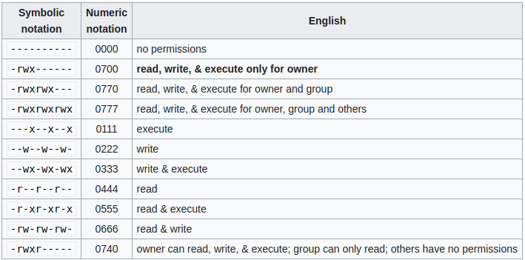

**Note:**

777(directories) / 666(files) permission- mode allows everyone on the system full access to file / directory.

### **# Editor**

$ **vim <filename>**

**Insert mode**

i → insert at the cursor position

**Command mode**

:w → writes/saves the file

:w! → forces the file to be saved

:q → quit

:q! → quit without saving

:wq! → write and quit

**Deleting texts**

dd → delete a line

# Deleting Copying and Moving

### #Remove file

$ **rm <file_name>**

e.g. rm foo.txt

### # Remove directory

$ **rm -rf <directory_name>**

e.g. rm -rf new_directory

### # Copying file

$ **scp <current_filename> /<directory_name>**

e.g cp new_file.txt /home

### # Copy directory

$ **scp -r <current_filename> /<directory_name>**

e.g. cp -r foo /home

### # Move file to new directory

$ **mv <current_filename> /<new_location>**

e.g. mv foo.txt /home

### # Copying file from one server to another

$ **scp <current_filename> username@<server_ip_address>:/home/<username>**

e.g scp filename dgxserver@172.18.84.64:/home/dgxserver

### # For sharing multiple files from one server to another

$ **scp filename1 filename2 filename3 dgxserver@172.18.84.64:/home/dgxserver**

### # For sharing directory from one server to another

$ **scp -r <current_directory_name> /<directory_name>**

e.g scp -r user_data/ dgxserver@172.18.84.64:/home/dgxserver

# File and Directory Permissions

### # Creating user with sudo privilege

$ **adduser jasmeet**

$ **usermod -aG sudo jasmeet**

# Verifying it by checking id of new user

$ **id jasmeet**

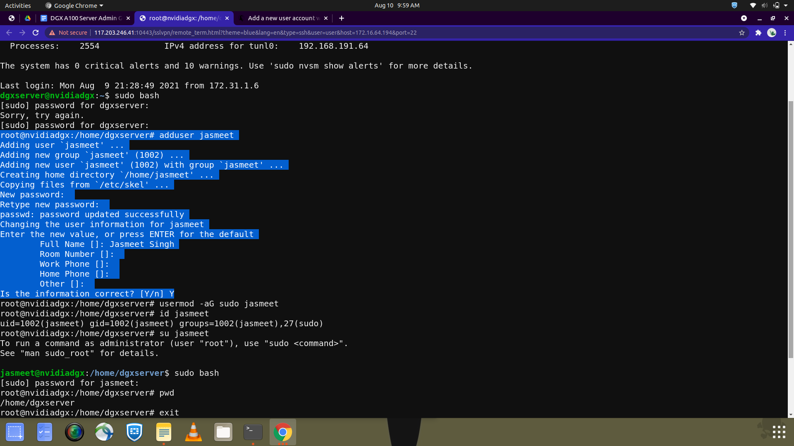

# Granting sudo privileges to existing user

$ **usermod -aG sudo <username>**

# Creating non-sudo user

$ **adduser <username>**

$ **id <username>**