E-Commerce Customer Behaviour & Sales Analytics
Big Data Analytics Project | SDG 8: Decent Work and Economic Growth

Abstract
This project analyzes online retail transactions to understand customer purchasing behaviour, sales trends, product demand and geographic performance. It combines Python, PySpark, Hadoop MapReduce, Hive, MongoDB, Cassandra, SQL and Power BI in a scalable analytics workflow. Customer segmentation is performed using Recency, Frequency and Monetary (RFM) features.

1. Introduction
E-commerce platforms generate large volumes of transaction data. Analyzing these records helps businesses understand customer value, improve retention, identify popular products and plan sales operations. This project demonstrates a multi-tool big-data pipeline using a public retail dataset.

2. Objectives
- Analyze revenue, orders, quantity and product performance.
- Understand customer purchase frequency and recency.
- Segment customers using RFM analysis.
- Compare sales across countries and months.
- Demonstrate distributed processing with Hadoop, Hive and PySpark.
- Store transaction/customer records using MongoDB and Cassandra.
- Present insights through an interactive Power BI dashboard.

3. Dataset
The project uses the UCI Online Retail dataset (ID 352), containing 541,909 transaction lines from 1 December 2010 to 9 December 2011. Fields include InvoiceNo, StockCode, Description, Quantity, InvoiceDate, UnitPrice, CustomerID and Country. The original dataset contains cancellations/returns (invoice numbers beginning with C), and some CustomerID values may be missing. The pipeline preserves raw data and filters invalid/cancelled lines for positive-sales KPIs.
Source: Chen, D. (2015). Online Retail [Dataset]. UCI Machine Learning Repository. DOI: 10.24432/C5BW33. Licensed CC BY 4.0.

4. System Architecture
UCI Dataset → Python cleaning/RFM → HDFS → Hadoop MapReduce / Hive / PySpark → MongoDB & Cassandra → Power BI dashboard.

5. Methodology
- Download the official dataset using the included UCI downloader.
- Clean data types and identify cancellations, returns and missing customer IDs.
- Calculate Revenue = Quantity × UnitPrice for valid positive sales.
- Aggregate revenue by month, country and product.
- Compute customer Recency, Frequency and Monetary values and assign segments.
- Run scalable aggregation using PySpark, Hive and Hadoop Streaming MapReduce.
- Load order and customer summary documents into MongoDB and customer-partitioned rows into Cassandra.
- Build an interactive Power BI dashboard using generated CSV outputs.

6. Technology Stack
- Python / Pandas / NumPy: cleaning, EDA and RFM segmentation.
- Hadoop MapReduce: country-level revenue aggregation.
- Hive: SQL-based data warehouse queries.
- PySpark: distributed ETL and aggregations.
- MongoDB: flexible order documents and customer summaries.
- Cassandra: customer-partitioned transaction lookup.
- Power BI: KPIs, trends, segmentation and geographic comparisons.
- GitHub: version control and project collaboration.

7. RFM Customer Segmentation
Recency measures days since the customer's latest purchase; Frequency counts distinct invoices; Monetary sums purchase revenue. Quintile scores are combined to label Champions, Loyal Customers, At Risk, New/Promising and Need Attention. The exact thresholds are data-driven and calculated when the full dataset is processed.

8. Dashboard Preview
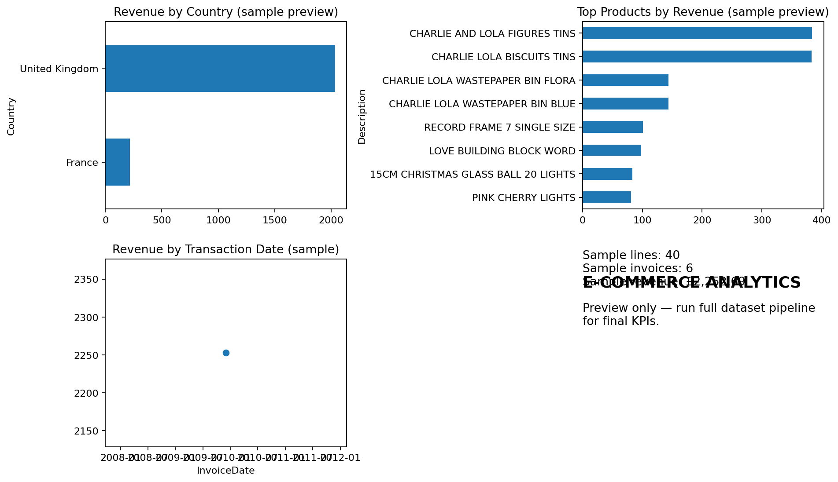
This image uses the small authentic sample included for preview only. Final KPI values and visuals should be refreshed from the full UCI dataset after running the pipeline.

9. Expected Outcomes
The dashboard enables users to identify high-value customers, repeat-purchase behaviour, best-selling products, leading countries and monthly revenue patterns. These insights can support customer retention and operational planning.

10. SDG 8 Connection
The project supports SDG 8 by demonstrating how data analytics can help digital businesses improve productivity, make informed decisions and support sustainable economic activity.

11. Conclusion
The project provides an end-to-end learning implementation for customer and sales analytics. It integrates batch processing, SQL querying, NoSQL storage, customer segmentation and BI visualization. The included scripts can be executed in an appropriately configured lab environment.

Appendix
Refer to RUN_ME_FIRST.txt for execution steps and each technology folder for scripts and queries.

