VNRVJIET
Name of the laboratory:
OPERATING SYSTEMS

Aim: write a c-program for FCFS scheduling algorithm A. without arrival times, B. with arrival times
A. without arrival times
Algorithm:
- Start.
- Input the number of processes (n).
- Input the Arrival Time (AT) and Burst Time (BT) for each process.
- Initialize current_time = 0, total_wt = 0, and total_tat = 0.
- For each process:
  - If current_time < AT, set current_time = AT.
  - Calculate CT = current_time + BT.
  - Calculate TAT = CT − AT.
  - Calculate WT = TAT − BT.
  - Update current_time = CT.
- Add WT and TAT to their respective totals.
  - Calculate:
  - Average Waiting Time = Total WT / n
  - Average Turnaround Time = Total TAT / n
- Display AT, BT, CT, WT, TAT, Average WT, and Average TAT.
- Stop.

B. with arrival times
Algorithm:
- Start.
- Input the number of processes (n).
- Input the Burst Time (BT) for each process.
- Initialize WT[0] = 0, total_wt = 0, and total_tat = 0.
- For each process:
  - Calculate WT using the previous process's burst time.
  - Calculate TAT = WT + BT.
  - Add WT and TAT to their respective totals.
- Calculate:
  - Average Waiting Time = Total WT / n
  - Average Turnaround Time = Total TAT / n
- Display BT, WT, TAT, Average WT, and Average TAT.
- Stop.

Name of the Experiment: FCFS and SJF
Scheduling algorithms

Experiment No: 1 Date: 23-07-2026
25071A6230 1

25071A6230 2
VNRVJIET
Name of the laboratory:
OPERATING SYSTEMS

Name of the Experiment:

Experiment No: Date:
25071A6230 3

A. without arrival times
Program:
#include <stdio.h>
int main() {
int n, bt[20], wt[20], tat[20];
float twt = 0, ttat = 0;
printf("Roll no: 25071A6230\n");
printf("Enter number of processes: ");
scanf("%d", &n);
for (int i = 0; i < n; i++) {
printf("Enter Burst Time for P%d: ", i + 1);
scanf("%d", &bt[i]);
}
wt[0] = 0;
for (int i = 0; i < n; i++) {
if (i > 0) wt[i] = wt[i - 1] + bt[i - 1];
tat[i] = wt[i] + bt[i];
twt += wt[i]; ttat += tat[i];
}
printf("\nProcess\tBT\tWT\tTAT\n");
for (int i = 0; i < n; i++)
printf("P%d\t%d\t%d\t%d\n", i + 1, bt[i], wt[i], tat[i]);
printf("\nAvg WT = %.2f | Avg TAT = %.2f\n", twt / n, ttat / n);
return 0;
}
Testcases:
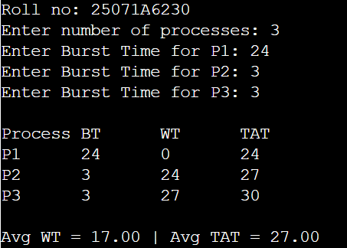
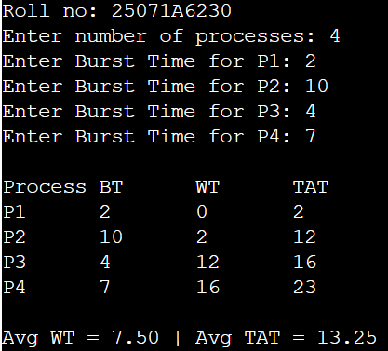
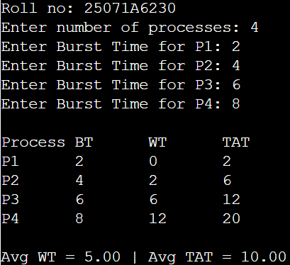
25071A6230 4
VNRVJIET
Name of the laboratory:
OPERATING SYSTEMS

B. with arrival times
Program:
#include <stdio.h>
int main() {
int n, at[20], bt[20], time = 0;
float twt = 0, ttat = 0;
printf("Roll no: 25071A6230\n");
printf("Enter number of processes: ");
scanf("%d", &n);
for (int i = 0; i < n; i++) {
printf("Enter Arrival Time and Burst Time for P%d: ", i + 1);
scanf("%d%d", &at[i], &bt[i]);
}
printf("\nProcess\tAT\tBT\tCT\tWT\tTAT\n");
for (int i = 0; i < n; i++) {
if (time < at[i]) time = at[i];
time += bt[i];
int tat = time - at[i], wt = tat - bt[i];
twt += wt; ttat += tat;
printf("P%d\t%d\t%d\t%d\t%d\t%d\n", i + 1, at[i], bt[i], time, wt, tat);
}
printf("\nAverage Waiting Time = %.2f\nAverage Turnaround Time = %.2f\n", twt / n, ttat / n);
return 0;
}
Testcases:
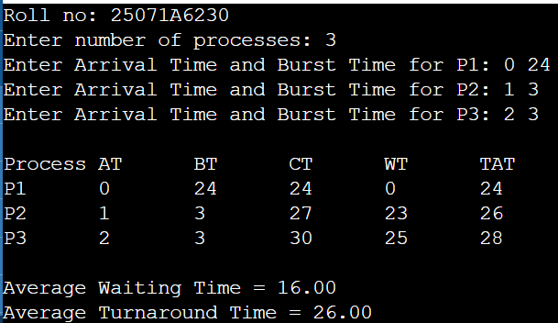
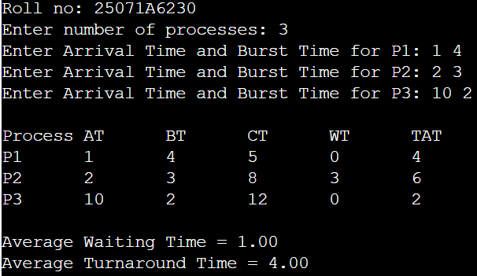
Name of the Experiment:

Experiment No: Date:
25071A6230 5

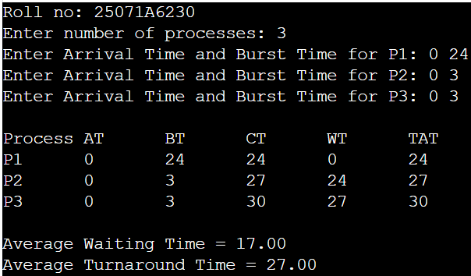
25071A6230 6
VNRVJIET
Name of the laboratory:
OPERATING SYSTEMS

Aim: write a c-program for SJF scheduling algorithm A. Non-preemptive B. Preemptive
A. non-preemptive
Algorithm:
- Start.
- Input the number of processes (n), Arrival Time (AT), and Burst Time (BT).
- Initialize current_time = 0 and mark all processes as unvisited.
- Repeat until all processes are completed:
  - Select the arrived process (AT ≤ current_time) with the smallest Burst Time (BT).
  - If no process has arrived, increase current_time by 1.
- Otherwise:
  - Execute the selected process.
  - Calculate CT, TAT, and WT.
  - Update current_time = CT.
  - Mark the process as completed.
- Calculate the Average Waiting Time (AWT) and Average Turnaround Time (ATAT).
- Display AT, BT, CT, WT, TAT, AWT, and ATAT.
- Stop.
B. Preemptive
Algorithm:
- Start.
- Input the number of processes (n), Arrival Time (AT), and Burst Time (BT). Set Remaining Time (RT) = BT for each process.
- Initialize time = 0 and completed = 0.
- Repeat until all processes are completed:
  - Select the arrived process (AT ≤ time) with the smallest Remaining Time (RT).
  - If no process is ready, increase time by 1.
  - Otherwise:
    - Execute the selected process for 1 time unit.
    - Decrease RT by 1 and increase time by 1.
    - If RT = 0, calculate CT, mark the process as completed, and increment completed.
- Calculate TAT, WT, Average Waiting Time (AWT), and Average Turnaround Time (ATAT).
- Display AT, BT, CT, WT, TAT, AWT, and ATAT.
- Stop.

Name of the Experiment:

Experiment No: Date:
25071A6230 7

25071A6230 8
VNRVJIET
Name of the laboratory:
OPERATING SYSTEMS

Name of the Experiment:

Experiment No: Date:
25071A6230 9

A. non-preemptive
Program:
#include <stdio.h>
int main() {
printf("Roll no: 25071A6230\n");
int n, p[10], at[10], bt[10], ct[10], tat[10], wt[10], vis[10]={0}, cur=0, done=0;
float twt=0, ttat=0;
printf("Enter number of processes: "); scanf("%d", &n);
for(int i=0; i<n; i++) { p[i]=i+1; printf("Enter Arrival Time and Burst Time for P%d: ", i+1); scanf("%d%d", &at[i], &bt[i]); }
while(done < n) {
int idx = -1, min_bt = 1e9;
for(int i=0; i<n; i++)
if(at[i] <= cur && !vis[i] && bt[i] < min_bt) { min_bt = bt[i]; idx = i; }
if(idx == -1) cur++;
else {
cur += bt[idx]; ct[idx] = cur; tat[idx] = ct[idx] - at[idx];
wt[idx] = tat[idx] - bt[idx]; twt += wt[idx]; ttat += tat[idx]; vis[idx] = 1; done++;
}
}
printf("\nProcess\tAT\tBT\tCT\tWT\tTAT\n");
for(int i=0; i<n; i++) printf("P%d\t%d\t%d\t%d\t%d\t%d\n", p[i], at[i], bt[i], ct[i], wt[i], tat[i]);
printf("\nAverage Waiting Time = %.2f\nAverage Turnaround Time = %.2f\n", twt/n, ttat/n);
return 0;}
Testcases:
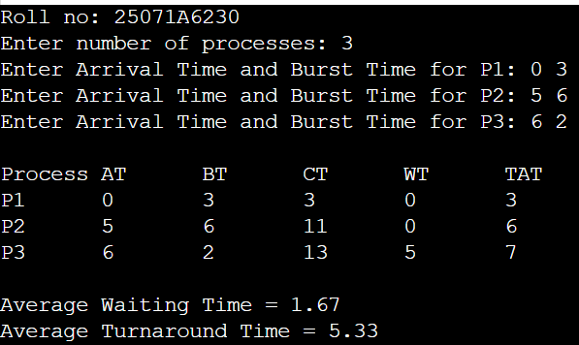
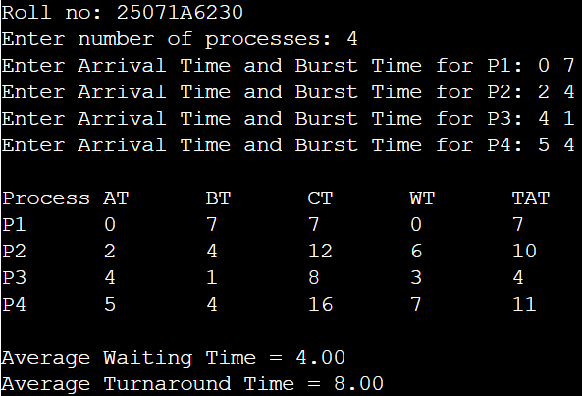
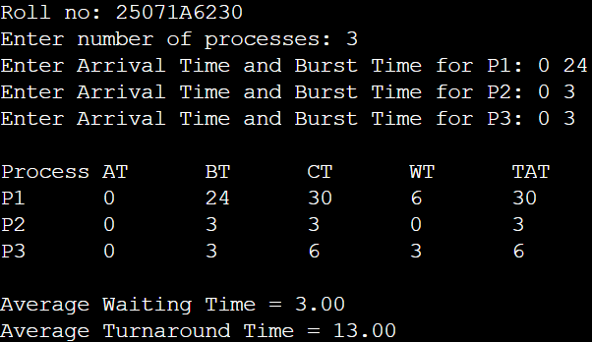
25071A6230 10
VNRVJIET
Name of the laboratory:
OPERATING SYSTEMS

B. preemptive
Program:
#include <stdio.h>
int main() {
printf("Roll no: 25071A6230\n");
int n, at[10], bt[10], rt[10], ct[10], done = 0, time = 0, min_rt, idx;
float twt = 0, ttat = 0;
printf("Enter number of processes: "); scanf("%d", &n);
for (int i = 0; i < n; i++) {
printf("Enter Arrival Time and Burst Time for P%d: ", i + 1);
scanf("%d%d", &at[i], &bt[i]); rt[i] = bt[i];
}
while (done < n) {
min_rt = 1e9; idx = -1;
for (int i = 0; i < n; i++)
if (at[i] <= time && rt[i] > 0 && rt[i] < min_rt) { min_rt = rt[i]; idx = i; }
if (idx == -1) { time++; continue; }
rt[idx]--; time++;
if (rt[idx] == 0) { done++; ct[idx] = time; }
}
printf("\nProcess\tAT\tBT\tCT\tWT\tTAT\n");
for (int i = 0; i < n; i++) {
int tat = ct[i] - at[i], wt = tat - bt[i];
twt += wt; ttat += tat;
printf("P%d\t%d\t%d\t%d\t%d\t%d\n", i + 1, at[i], bt[i], ct[i], wt, tat);
}
printf("\nAverage Waiting Time = %.2f\nAverage Turnaround Time = %.2f\n", twt / n, ttat / n);
return 0;
}
Testcases:
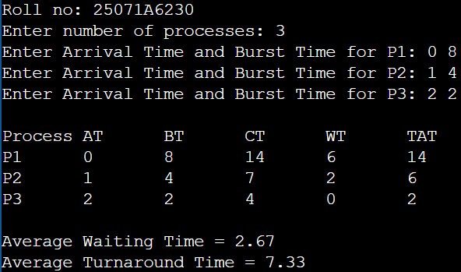
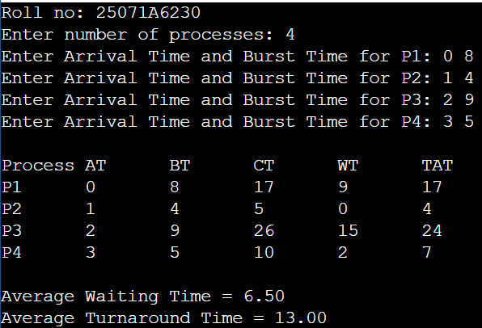
Name of the Experiment:

Experiment No: Date:
25071A6230 11

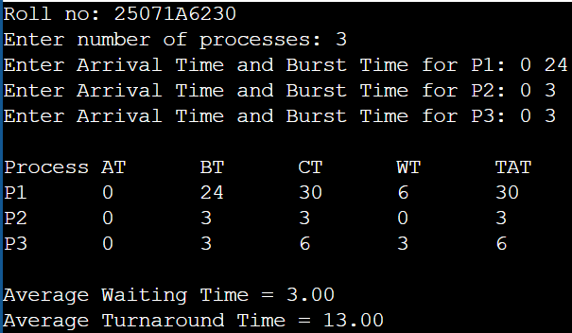
25071A6230 12
VNRVJIET
Name of the laboratory:
OPERATING SYSTEMS

Aim: write a c-program for priority scheduling algorithm A. Non-preemptive B. Preemptive
A. non-preemptive
Algorithm:
- Start.
- Input the number of processes (n), Arrival Time (AT), Burst Time (BT), and Priority (Pr).
- Initialize current_time = 0 and mark all processes as unvisited.
- Repeat until all processes are completed:
  - Select the arrived process (AT ≤ current_time) with the highest priority (lowest Priority value).
  - If no process is ready, increase current_time by 1.
  - Otherwise:
    - Execute the selected process.
    - Calculate CT, TAT, and WT.
    - Update current_time = CT.
    - Mark the process as completed.
- Calculate Average Waiting Time (AWT) and Average Turnaround Time (ATAT).
- Display AT, BT, Priority, CT, WT, TAT, AWT, and ATAT.
- Stop.
B. Preemptive
Algorithm:
- Start.
- Input the number of processes (n), Arrival Time (AT), Burst Time (BT), and Priority (Pr). Set Remaining Time (RT) = BT for each process.
- Initialize time = 0 and completed = 0.
- Repeat until all processes are completed:
  - Select the arrived process (AT ≤ time) with the highest priority (lowest Priority value).
  - If no process is ready, increase time by 1.
  - Otherwise:
  - Execute the selected process for 1 time unit.
  - Decrease RT by 1 and increase time by 1.
  - If RT = 0, calculate CT, mark the process as completed, and increment completed.
- Calculate TAT, WT, Average Waiting Time (AWT), and Average Turnaround Time (ATAT).
- Display AT, BT, Priority, CT, WT, TAT, AWT, and ATAT.
- Stop.

Name of the Experiment: Priority and Round
Robin Scheduling algorithms

Experiment No: 2 Date: 30-07-2026
25071A6230 13

25071A6230 14
VNRVJIET
Name of the laboratory:
OPERATING SYSTEMS

Name of the Experiment:

Experiment No: Date:
25071A6230 15

A. non-preemptive
Program:
#include <stdio.h>
int main() {
printf("Roll no: 25071A6230\n");
int n, at[10], bt[10], pr[10], ct[10], vis[10]={0}, cur=0, done=0;
float twt=0, ttat=0;
printf("Enter number of processes: ");
scanf("%d", &n);
for(int i=0; i<n; i++) {
printf("Enter Arrival Time, Burst Time and Priority for P%d: ", i+1); scanf("%d%d%d", &at[i], &bt[i], &pr[i]); }
while(done < n) {
int idx = -1, min_pr = 1e9;
for(int i=0; i<n; i++)
if(at[i] <= cur && !vis[i] && pr[i] < min_pr) { min_pr = pr[i]; idx = i; }
if(idx == -1) cur++;
else { cur += bt[idx]; ct[idx] = cur; vis[idx] = 1; done++; }
}
printf("\nProcess\tAT\tBT\tPr\tCT\tWT\tTAT\n");
for(int i=0; i<n; i++) {
int tat = ct[i] - at[i], wt = tat - bt[i]; twt += wt; ttat += tat;
printf("P%d\t%d\t%d\t%d\t%d\t%d\t%d\n", i+1, at[i], bt[i], pr[i], ct[i], wt, tat);
}
printf("\nAverage Waiting Time = %.2f\nAverage Turnaround Time = %.2f\n", twt/n, ttat/n);
return 0;
}
Testcases:
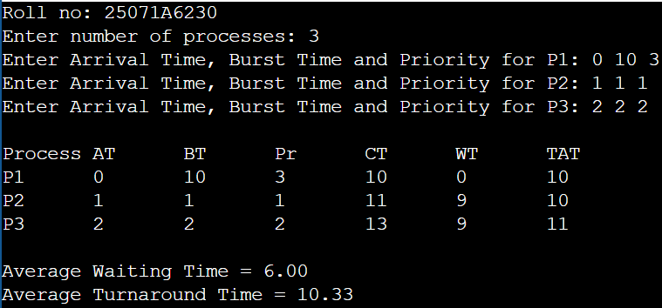
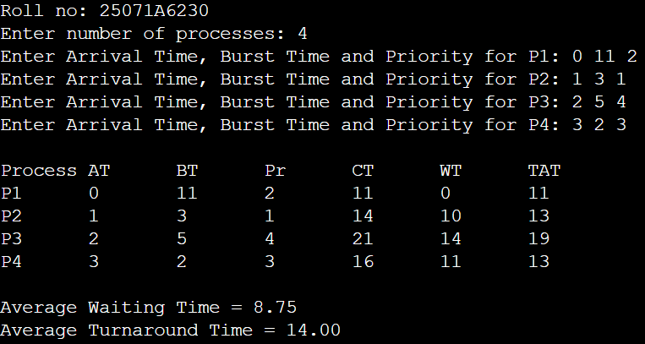
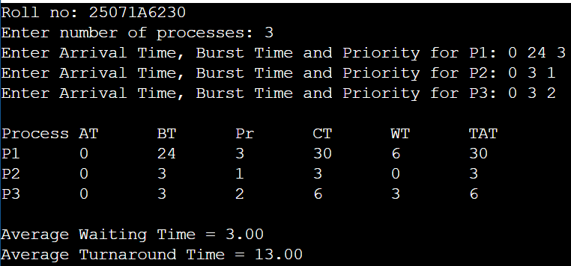
25071A6230 16
VNRVJIET
Name of the laboratory:
OPERATING SYSTEMS

B. preemptive
Program:
#include <stdio.h>
int main() {
printf("Roll no: 25071A6230\n");
int n, at[10], bt[10], pr[10], rt[10], ct[10], done = 0, time = 0, min_pr, idx;
float twt = 0, ttat = 0;
printf("Enter number of processes: "); scanf("%d", &n);
for (int i = 0; i < n; i++) {
printf("Enter Arrival Time, Burst Time and Priority for P%d: ", i + 1);
scanf("%d%d%d", &at[i], &bt[i], &pr[i]); rt[i] = bt[i];
}
while (done < n) {
min_pr = 1e9; idx = -1;
for (int i = 0; i < n; i++)
if (at[i] <= time && rt[i] > 0 && pr[i] < min_pr) { min_pr = pr[i]; idx = i; }
if (idx == -1) { time++; continue; }
rt[idx]--; time++;
if (rt[idx] == 0) { done++; ct[idx] = time; }
}
printf("\nProcess\tAT\tBT\tPr\tCT\tWT\tTAT\n");
for (int i = 0; i < n; i++) {
int tat = ct[i] - at[i], wt = tat - bt[i]; twt += wt; ttat += tat;
printf("P%d\t%d\t%d\t%d\t%d\t%d\t%d\n", i + 1, at[i], bt[i], pr[i], ct[i], wt, tat);
}
printf("\nAverage Waiting Time = %.2f\nAverage Turnaround Time = %.2f\n", twt / n, ttat / n);
return 0;
}
Testcases:
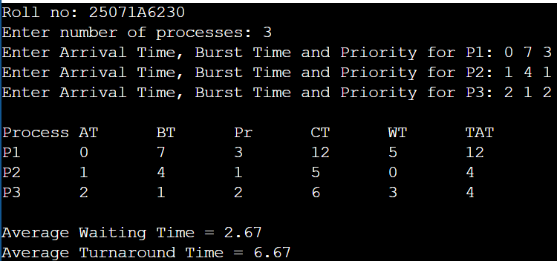
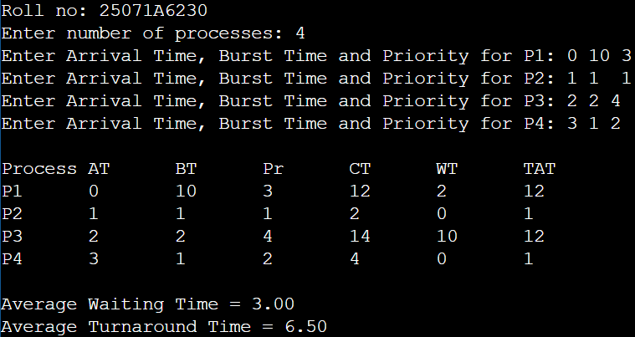
Name of the Experiment:

Experiment No: Date:
25071A6230 17

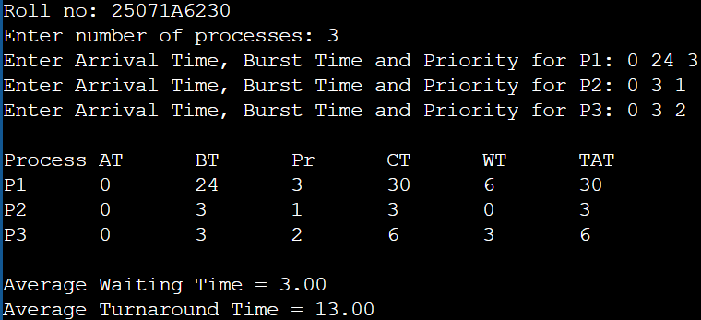
25071A6230 18
VNRVJIET
Name of the laboratory:
OPERATING SYSTEMS

Aim: write a c-program for Round Robin scheduling algorithm A. Time Quantum=2, B. Time Quantum=10
A. Time Quantum=2
Algorithm:
- Start.
- Input the number of processes (n), Arrival Time (AT), and Burst Time (BT). Set Time Quantum (TQ) = 2 and Remaining Time (RT) = BT for each process.
- Initialize time = 0 and completed = 0.
- Repeat until all processes are completed:
  - Select the first process from the Ready Queue.
  - Execute the process for 2 units or until it finishes.
  - Update RT and time.
  - Add any newly arrived processes to the Ready Queue.
  - If RT > 0, add the process back to the Ready Queue; otherwise, calculate CT and mark it as completed.
- Calculate TAT, WT, Average Waiting Time (AWT), and Average Turnaround Time (ATAT).
- Display AT, BT, CT, WT, TAT, AWT, and ATAT.
- Stop.
B. Time Quantum=10
Algorithm:
- Start.
- Input the number of processes (n), Arrival Time (AT), and Burst Time (BT). Set Time Quantum (TQ) = 10 and Remaining Time (RT) = BT for each process.
- Initialize time = 0 and completed = 0.
- Repeat until all processes are completed:
  - Select the first process from the Ready Queue.
  - Execute the process for 10 units or until it finishes.
  - Update RT and time.
  - Add any newly arrived processes to the Ready Queue.
  - If RT > 0, add the process back to the Ready Queue; otherwise, calculate CT and mark it as completed.
- Calculate TAT, WT, Average Waiting Time (AWT), and Average Turnaround Time (ATAT).
- Display AT, BT, CT, WT, TAT, AWT, and ATAT.
- Stop.

Name of the Experiment:

Experiment No: Date:
25071A6230 19
25071A6230 20
VNRVJIET
Name of the laboratory:
OPERATING SYSTEMS

Name of the Experiment:

Experiment No: Date:
25071A6230 21

A. Time Quantum=2
Program:
#include <stdio.h>
int main() {
printf("Roll no: 25071A6230\n");
int n, tq = 2, at[10], bt[10], rt[10], ct[10], done = 0, time = 0;
float twt = 0, ttat = 0;
printf("Enter number of processes: "); scanf("%d", &n);
for (int i = 0; i < n; i++) {
printf("Enter Arrival Time and Burst Time for P%d: ", i + 1);
scanf("%d%d", &at[i], &bt[i]); rt[i] = bt[i];}
while (done < n) {
int exec = 0;
for (int i = 0; i < n; i++) {
if (at[i] <= time && rt[i] > 0) {
exec = 1;
int slice = (rt[i] > tq) ? tq : rt[i];
rt[i] -= slice; time += slice;
if (rt[i] == 0) { done++; ct[i] = time; } }}
if (!exec) time++;}
printf("\nProcess\tAT\tBT\tCT\tWT\tTAT\n");
for (int i = 0; i < n; i++) {
int tat = ct[i] - at[i], wt = tat - bt[i]; twt += wt; ttat += tat;
printf("P%d\t%d\t%d\t%d\t%d\t%d\n", i + 1, at[i], bt[i], ct[i], wt, tat); }
printf("\nAverage Waiting Time = %.2f\nAverage Turnaround Time = %.2f\n", twt / n, ttat / n);
return 0;}
Testcases:
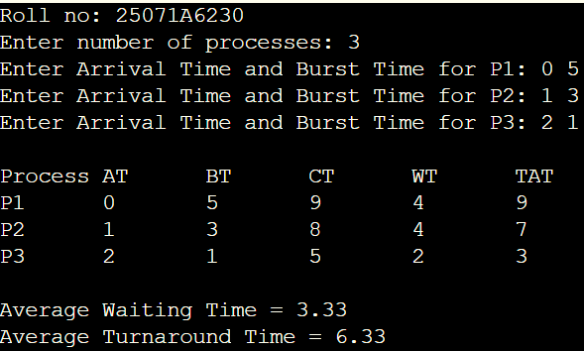
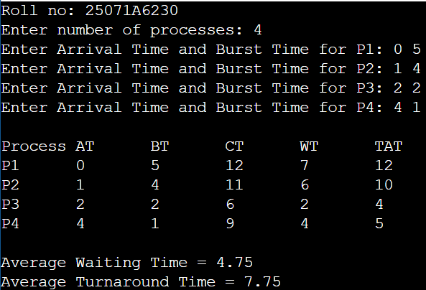
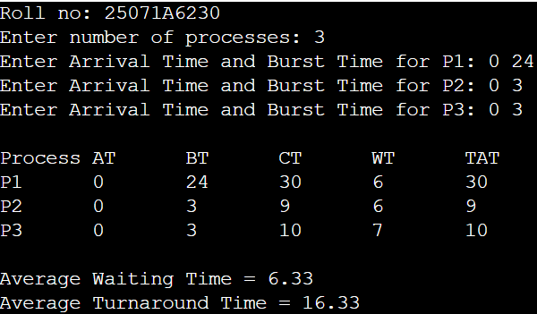
25071A6230 22
VNRVJIET
Name of the laboratory:
OPERATING SYSTEMS

B. Time Quantum=10
Program:
#include <stdio.h>
int main() {
printf("Roll no: 25071A6230\n");
int n, tq = 10, at[10], bt[10], rt[10], ct[10], done = 0, time = 0;
float twt = 0, ttat = 0;
printf("Enter number of processes: "); scanf("%d", &n);
for (int i = 0; i < n; i++) {
printf("Enter Arrival Time and Burst Time for P%d: ", i + 1);
scanf("%d%d", &at[i], &bt[i]); rt[i] = bt[i];
}
while (done < n) {
int exec = 0;
for (int i = 0; i < n; i++) {
if (at[i] <= time && rt[i] > 0) {
exec = 1;
int slice = (rt[i] > tq) ? tq : rt[i];
rt[i] -= slice; time += slice;
if (rt[i] == 0) { done++; ct[i] = time; }
}
}
if (!exec) time++;
}
printf("\nProcess\tAT\tBT\tCT\tWT\tTAT\n");
for (int i = 0; i < n; i++) {
int tat = ct[i] - at[i], wt = tat - bt[i]; twt += wt; ttat += tat;
printf("P%d\t%d\t%d\t%d\t%d\t%d\n", i + 1, at[i], bt[i], ct[i], wt, tat);
}
printf("\nAverage Waiting Time = %.2f\nAverage Turnaround Time = %.2f\n", twt / n, ttat / n);
return 0;
}
Testcases:
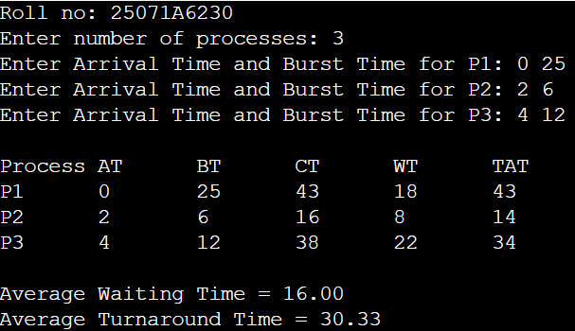

Name of the Experiment:

Experiment No: Date:
25071A6230 23

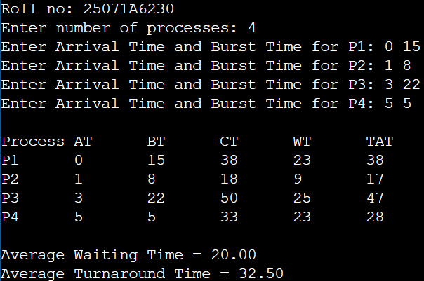
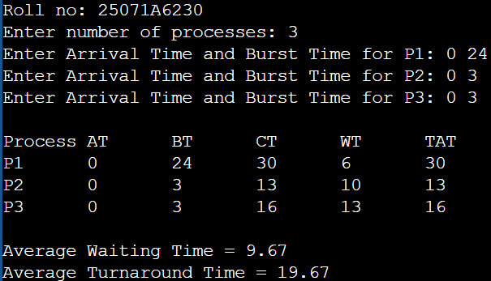
25071A6230 24

VNRVJIET
Name of the laboratory:
OPERATING SYSTEMS

Aim: Make the analysis of all scheduling algorithms
Testcases:
FCFS scheduling without arrival times | FCFS scheduling arrival times
SJF scheduling non-preemptive | SJF scheduling preemptive
Priority scheduling non-preemptive | Priority scheduling preemptive
Round Robin scheduling, Time quantum=2 | Round Robin scheduling, Time quantum=10

Name of the Experiment: Banker’s algorithm and
Analysis of the scheduling algorithms

Experiment No: 3 Date: 23-07-2026
25071A6230 25

25071A6230 26
VNRVJIET
Name of the laboratory:
OPERATING SYSTEMS

Aim: write a c-program for Banker’s algorithm
Algorithm:
- Start.
- Input the number of processes (n), resource types (m), Allocation, Max, and Available matrices.
- Calculate the Need Matrix:
  - Need = Max − Allocation
- Initialize:
  - Work = Available
  - Mark all processes as unfinished.
- Repeat until all processes are finished:
  - Select an unfinished process whose Need ≤ Work.
  - If found:
    - Work = Work + Allocation
    - Mark the process as finished.
    - Add it to the Safe Sequence.
  - If no suitable process is found, stop.
- Check the result:
  - If all processes are finished, the system is in a Safe State and display the Safe Sequence.
  - Otherwise, the system is in an Unsafe State.
- Stop.

Name of the Experiment:

Experiment No: Date:
25071A6230 27

25071A6230 28

VNRVJIET
Name of the laboratory:
OPERATING SYSTEMS

Program:
#include <stdio.h>
int main() {
printf("Roll no: 25071A6230\n");
int n, m, alloc[10][10], max[10][10], need[10][10], avail[10], finish[10] = {0}, safeSeq[10], count = 0;
printf("Enter number of processes: "); scanf("%d", &n);
printf("Enter number of resource types: "); scanf("%d", &m);
printf("Enter Allocation Matrix:\n");
for (int i = 0; i < n; i++)
for (int j = 0; j < m; j++) scanf("%d", &alloc[i][j]);
printf("Enter Max Matrix:\n");
for (int i = 0; i < n; i++)
for (int j = 0; j < m; j++) {
scanf("%d", &max[i][j]);
need[i][j] = max[i][j] - alloc[i][j];
}
printf("Enter Available Resources:\n");
for (int j = 0; j < m; j++) scanf("%d", &avail[j]);
int work[10];
for (int j = 0; j < m; j++) work[j] = avail[j];
while (count < n) {
int found = 0;
for (int i = 0; i < n; i++) {
if (!finish[i]) {
int possible = 1;
for (int j = 0; j < m; j++) {
if (need[i][j] > work[j]) { possible = 0; break; }
}
if (possible) {
for (int j = 0; j < m; j++) work[j] += alloc[i][j];
safeSeq[count++] = i;

Name of the Experiment:

Experiment No: Date:
25071A6230 29

finish[i] = 1;
found = 1; }
}
}
if (!found) break;
}
if (count == n) {
printf("\nSystem is in a SAFE STATE.\nSafe Sequence: ");
for (int i = 0; i < n; i++) printf("P%d ", safeSeq[i] + 1);
printf("\n");
} else {
printf("\nSystem is in an UNSAFE STATE (Deadlock possible).\n");
}
return 0;}
Testcases:
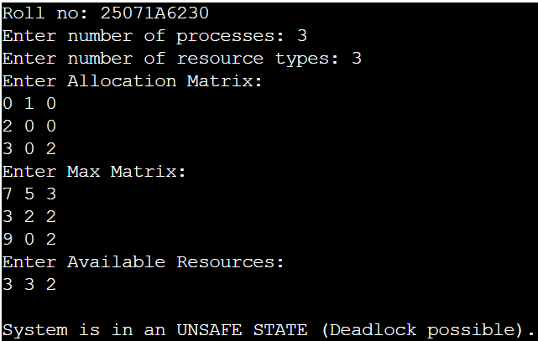

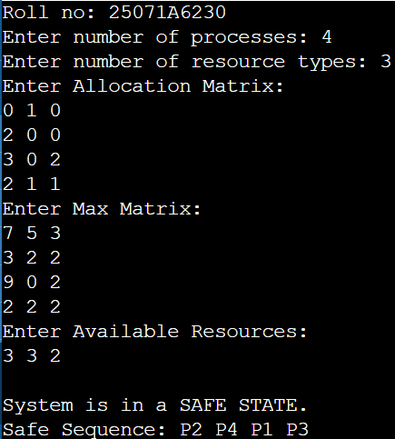

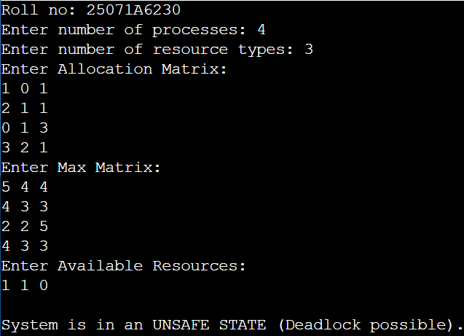
25071A6230 30
VNRVJIET
Name of the laboratory:
OPERATING SYSTEMS

Aim: Implementation of the following Memory Allocation Methods for fixed partition a) First Fit b) Worst Fit c) Best Fit
A. First Fit
Algorithm:
- Start.
- Input the number of memory partitions (m) and their sizes, and the number of processes (n) and their memory requirements.
- Initialize all processes as unallocated.
- For each process:
  - Search the partitions from the first partition.
  - If an unallocated partition is large enough, allocate it to the process.
  - Mark the partition as allocated and stop searching.
- Calculate the Internal Fragmentation for each allocated partition:
  - Fragmentation = Partition Size − Process Size
- Display the process, allocated partition, partition size, and internal fragmentation.
- Stop.
B. Worst Fit
Algorithm:
- Start.
- Input the number of memory partitions (m) and their sizes, and the number of processes (n) and their memory requirements.
- Initialize all processes as unallocated.
- For each process:
  - Search all unallocated partitions.
  - Find the largest partition that is large enough for the process.
  - If a suitable partition is found, allocate it to the process and mark it as allocated.
- Calculate the Internal Fragmentation:
  - Fragmentation = Partition Size − Process Size
- Display the process, allocated partition, partition size, and internal fragmentation.
- Stop.
C. Best Fit
Algorithm:
- Start.
- Input the number of memory partitions (m) and their sizes, and the number of processes (n) and their memory requirements.
- Initialize all processes as unallocated.
- For each process:
  - Search all unallocated partitions.
  - Find the smallest partition that is large enough for the process.
  - If a suitable partition is found, allocate it to the process and mark it as allocated.
- Calculate the Internal Fragmentation:
  - Fragmentation = Partition Size − Process Size
- Display the process, allocated partition, partition size, and internal fragmentation.
- Stop.
Name of the Experiment: Implementation of
Memory Allocation Methods

Experiment No: 4 Date: 27-08-2026
25071A6230 31

25071A6230 32
VNRVJIET
Name of the laboratory:
OPERATING SYSTEMS

Name of the Experiment:

Experiment No: Date:
25071A6230 33

25071A6230 34
VNRVJIET
Name of the laboratory:
OPERATING SYSTEMS

A. First Fit
Program:
#include <stdio.h>
int main() {
printf("Roll no: 25071A6230\n");
int m, n, bsize[10], psize[10], alloc[10], occupied[10] = {0};
printf("Enter number of blocks: "); scanf("%d", &m);
printf("Enter block sizes: ");
for (int i = 0; i < m; i++) scanf("%d", &bsize[i]);
printf("Enter number of processes: "); scanf("%d", &n);
printf("Enter process sizes: ");
for (int i = 0; i < n; i++) {
scanf("%d", &psize[i]); alloc[i] = -1;
}
for (int i = 0; i < n; i++) {
for (int j = 0; j < m; j++) {
if (!occupied[j] && bsize[j] >= psize[i]) {
alloc[i] = j;
occupied[j] = 1;
break; } } }
printf("\nProcess\tProcess Size\tBlock No.\tBlock Size\tInternal Frag\n");
for (int i = 0; i < n; i++) {
if (alloc[i] != -1)
printf("P%d\t%d\t\t%d\t\t%d\t\t%d\n", i + 1, psize[i], alloc[i] + 1, bsize[alloc[i]], bsize[alloc[i]] - psize[i]);
else
printf("P%d\t%d\t\tNot Allocated\t-\t\t-\n", i + 1, psize[i]);}
return 0;}
Testcases:
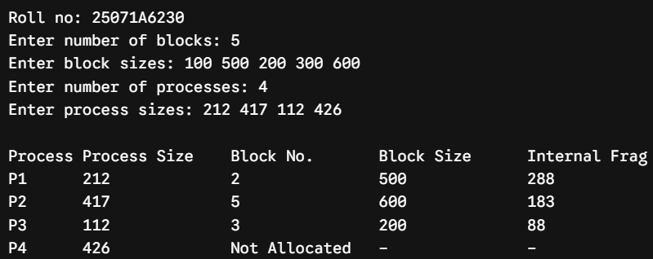
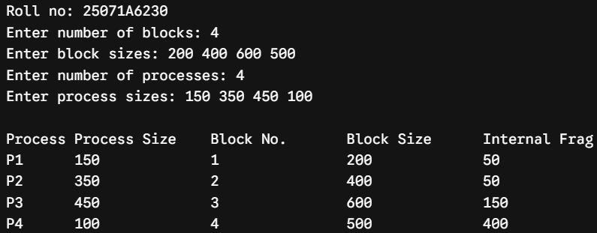
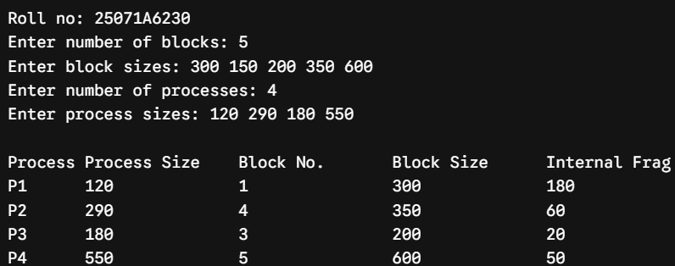
Name of the Experiment:

Experiment No: Date:
25071A6230 35

B. Worst Fit
Program:
#include <stdio.h>
int main() {
printf("Roll no: 25071A6230\n");
int m, n, bsize[10], psize[10], alloc[10], occupied[10] = {0};
printf("Enter number of blocks: "); scanf("%d", &m);
printf("Enter block sizes: ");
for (int i = 0; i < m; i++) scanf("%d", &bsize[i]);
printf("Enter number of processes: "); scanf("%d", &n);
printf("Enter process sizes: ");
for (int i = 0; i < n; i++) { scanf("%d", &psize[i]); alloc[i] = -1; }
for (int i = 0; i < n; i++) {
int worstIdx = -1;
for (int j = 0; j < m; j++) {
if (!occupied[j] && bsize[j] >= psize[i]) {
if (worstIdx == -1 || bsize[j] > bsize[worstIdx])
worstIdx = j;} }
if (worstIdx != -1) {
alloc[i] = worstIdx;
occupied[worstIdx] = 1; }}
printf("\nProcess\tProcess Size\tBlock No.\tBlock Size\tInternal Frag\n");
for (int i = 0; i < n; i++) {
if (alloc[i] != -1)
printf("P%d\t%d\t\t%d\t\t%d\t\t%d\n", i + 1, psize[i], alloc[i] + 1, bsize[alloc[i]], bsize[alloc[i]] - psize[i]);
else
printf("P%d\t%d\t\tNot Allocated\t-\t\t-\n", i + 1, psize[i]); }
return 0;}
Testcases:
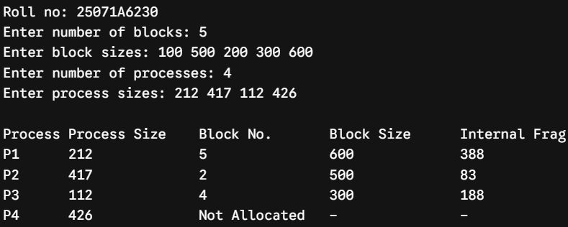
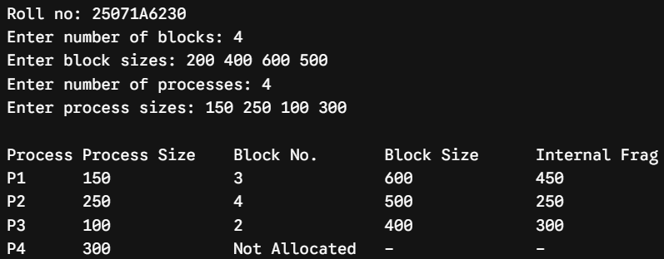
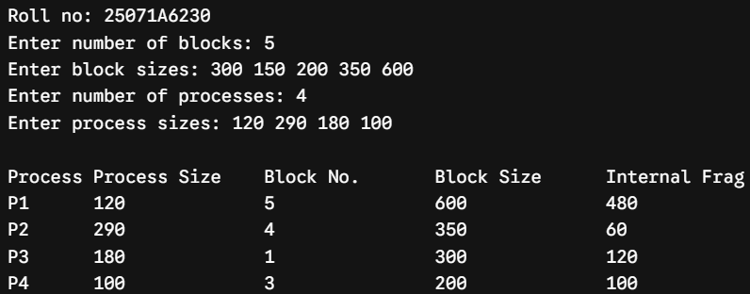
25071A6230 36
VNRVJIET
Name of the laboratory:
OPERATING SYSTEMS

C. Best Fit
Program:
#include <stdio.h>
int main() {
printf("Roll no: 25071A6230\n");
int m, n, bsize[10], psize[10], alloc[10], occupied[10] = {0};
printf("Enter number of blocks: "); scanf("%d", &m);
printf("Enter block sizes: ");
for (int i = 0; i < m; i++) scanf("%d", &bsize[i]);
printf("Enter number of processes: "); scanf("%d", &n);
printf("Enter process sizes: ");
for (int i = 0; i < n; i++) { scanf("%d", &psize[i]); alloc[i] = -1; }

for (int i = 0; i < n; i++) {
int bestIdx = -1;
for (int j = 0; j < m; j++) {
if (!occupied[j] && bsize[j] >= psize[i]) {
if (bestIdx == -1 || bsize[j] < bsize[bestIdx])
bestIdx = j;
}
}
if (bestIdx != -1) {
alloc[i] = bestIdx;
occupied[bestIdx] = 1;
}
}
printf("\nProcess\tProcess Size\tBlock No.\tBlock Size\tInternal Frag\n");
for (int i = 0; i < n; i++) {
if (alloc[i] != -1)
printf("P%d\t%d\t\t%d\t\t%d\t\t%d\n", i + 1, psize[i], alloc[i] + 1, bsize[alloc[i]], bsize[alloc[i]] - psize[i]);
else
printf("P%d\t%d\t\tNot Allocated\t-\t\t-\n", i + 1, psize[i]);
}
return 0;
}
Testcases:
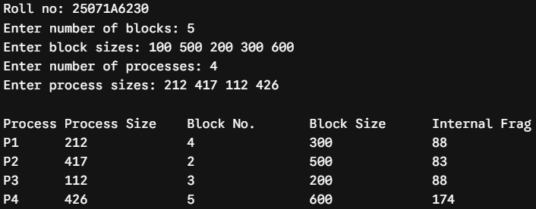

Name of the Experiment:

Experiment No: Date:
25071A6230 37

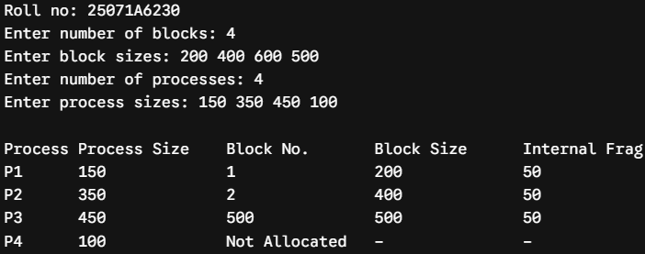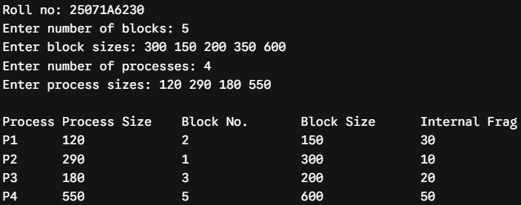

25071A6230 38
VNRVJIET
Name of the laboratory:
OPERATING SYSTEMS

Aim: Implementation of Paging Technique of Memory Management
Algorithm:
- Start.
- Input the main memory size (MS) and page size (PS), then calculate the Total Frames.
- Input the process size and calculate the Total Pages required.
- If Total Pages > Total Frames, display "Memory insufficient" and stop.
- Input the frame number for each page and create the Page Table.
- Input the Logical Address (LA) and calculate:
  - Page Number = LA / PS
  - Offset = LA % PS
- If the page number is valid:
  - Find the Frame Number from the Page Table.
  - Calculate:
      - Physical Address = (Frame Number × PS) + Offset
  - Display the Page Number, Offset, Frame Number, and Physical Address.
- Otherwise, display "Invalid Logical Address".
- Stop

Name of the Experiment: Paging Technique
Memory Management

Experiment No: 5 Date: 27-08-2026
25071A6230 39

25071A6230 40
VNRVJIET
Name of the laboratory:
OPERATING SYSTEMS

Program:
#include <stdio.h>

int main() {
printf("Roll no: 25071A6230\n");
int ms, ps, p_size, total_frames, total_pages;
int page_table[20];
int la, p, d, pa;

printf("Enter main memory size (in bytes): ");
scanf("%d", &ms);
printf("Enter page size (in bytes): ");
scanf("%d", &ps);

total_frames = ms / ps;
printf("Total frames available in memory: %d\n\n", total_frames);

printf("Enter process size (in bytes): ");
scanf("%d", &p_size);

total_pages = p_size / ps;
if (p_size % ps != 0) total_pages++;

if (total_pages > total_frames) {
printf("\nMemory Allocation Failed: Not enough frames available.\n");
return 0;
}

printf("Total pages required for process: %d\n", total_pages);
printf("Enter frame numbers allocated to each page:\n");
for (int i = 0; i < total_pages; i++) {
printf("Page %d -> Frame No: ", i);
scanf("%d", &page_table[i]);
}

printf("\nEnter Logical Address to translate: ");
scanf("%d", &la);

p = la / ps;
d = la % ps;

if (p >= total_pages) {
printf("\nInvalid Logical Address! (Page number %d exceeds allocated pages)\n", p);
}

Name of the Experiment:

Experiment No: Date:
25071A6230 41

else {
pa = (page_table[p] * ps) + d;
printf("\n--- Address Translation Details ---\n");
printf("Page Number (p) : %d\n", p);
printf("Page Offset (d) : %d\n", d);
printf("Allocated Frame No : %d\n", page_table[p]);
printf("Physical Address : %d\n", pa);
}

return 0;
}
Testcases:
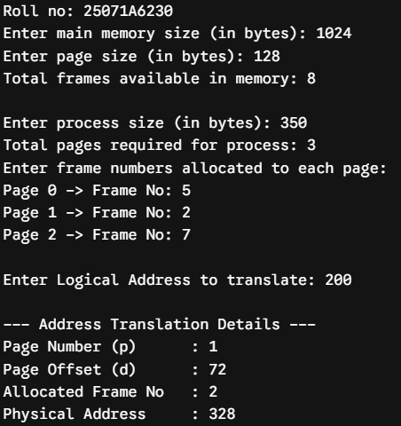
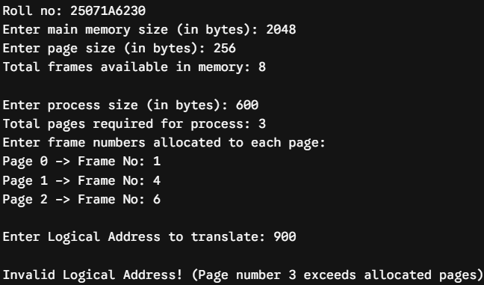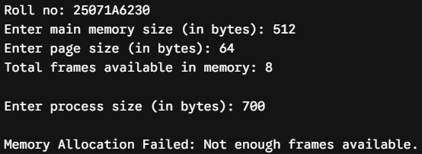
25071A6230 42
VNRVJIET
Name of the laboratory:
OPERATING SYSTEMS

Aim: Simulate frame allocation Methods. A) minimum number of frames B) equal allocation C) proportional allocation
A. minimum number of frames
Algorithm:
- Start.
- Input total available frames and minimum frames required per process.
- Input number of processes and their page requirements.
- Check whether available frames are sufficient for all processes.
- Allocate the minimum required frames to each process.
- Calculate and display the remaining unallocated frames.
- Stop.

B. equal allocation
Algorithm:
- Start.
- Input total number of available frames and number of processes m.
- Calculate frames allocated to each process:
Frames per Process = Total Frames / m
- Calculate remaining frames:
Leftover = Total Frames % m
- Display frames allocated to each process and the leftover frames.
- Stop.

C. proportional allocation
Algorithm:
- Start.
- Input total number of frames m and number of processes n.
- Input page requirement s[i] for each process and calculate total requirement S.
- Calculate frames allocated to each process:
Allocation[i] = (s[i] / S) × m
- Calculate total allocated frames and remaining unallocated frames.
- Display process requirements, allocated frames, and remaining frames.
- Stop.

Name of the Experiment: frame allocation
Methods.

Experiment No: 7 Date: 3-09-2026
25071A6230 43

25071A6230 44
VNRVJIET
Name of the laboratory:
OPERATING SYSTEMS

Name of the Experiment:

Experiment No: Date:
25071A6230 45

25071A6230 46
VNRVJIET
Name of the laboratory:
OPERATING SYSTEMS

A. minimum number of frames
Program:
#include <stdio.h>

int main() {
printf("Roll no: 25071A6230\n\n");
int total_frames, min_per_process, n;
int page_req[10], allocated[10];

printf("Enter total frames in physical memory: ");
scanf("%d", &total_frames);
printf("Enter minimum frames required per process (by architecture): ");
scanf("%d", &min_per_process);
printf("Enter number of processes: ");
scanf("%d", &n);

int total_min_needed = n * min_per_process;
if (total_min_needed > total_frames) {
printf("\nAllocation Failed! Total available frames (%d) < Required minimum frames (%d).\n",
total_frames, total_min_needed);
return 0;
}

printf("\nEnter page requirements for each process:\n");
for (int i = 0; i < n; i++) {
printf("Process P%d: ", i + 1);
scanf("%d", &page_req[i]);
allocated[i] = min_per_process;
}

int total_allocated = total_min_needed;
int remaining = total_frames - total_allocated;

printf("\n--- Minimum Frame Allocation Result ---\n");
printf("Process\tPage Req\tAllocated Frames\tStatus\n");
for (int i = 0; i < n; i++) {
printf("P%d\t%d\t\t%d\t\t\t%s\n",
i + 1, page_req[i], allocated[i],
(allocated[i] >= page_req[i]) ? "Satisfied" : "Needs Swap Space");
}
printf("\nTotal Frames Allocated: %d / %d", total_allocated, total_frames);
printf("\nRemaining Unallocated Frames: %d\n", remaining);

return 0;
}

Name of the Experiment:

Experiment No: Date:
25071A6230 47

Testcases:
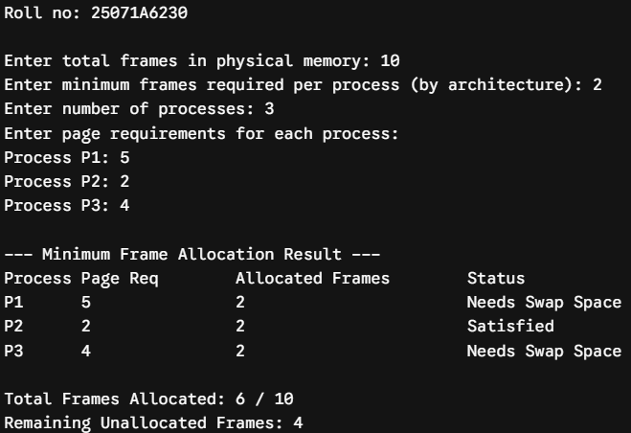
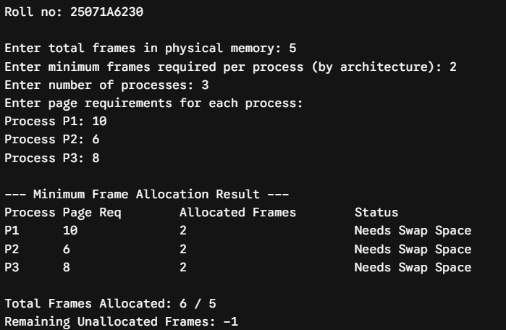
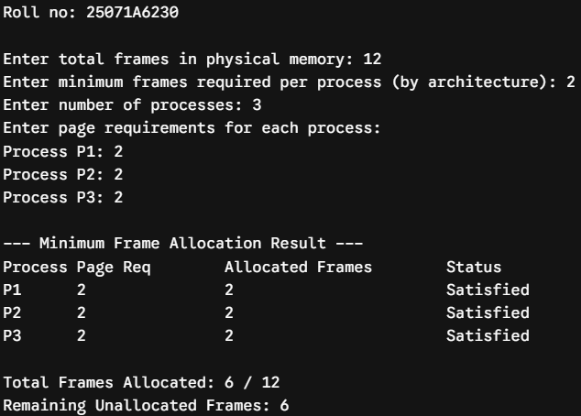
25071A6230 48
VNRVJIET
Name of the laboratory:
OPERATING SYSTEMS

B. equal allocation
Program:
#include <stdio.h>

int main() {
printf("Roll no: 25071A6230\n\n");
int total_frames, m;
int page_req[10], allocated[10];

printf("Enter total frames in physical memory: ");
scanf("%d", &total_frames);
printf("Enter number of processes: ");
scanf("%d", &m);

if (m <= 0 || total_frames < m) {
printf("\nAllocation Failed! Insufficient frames for equal allocation.\n");
return 0;
}

printf("Enter page requirements for each process:\n");
for (int i = 0; i < m; i++) {
printf("Process P%d: ", i + 1);
scanf("%d", &page_req[i]);
}

int equal_share = total_frames / m;
int leftover = total_frames % m;

printf("\n--- Equal Frame Allocation Result ---\n");
printf("Process\tPage Req\tAllocated Frames\tUnmet Pages\n");
for (int i = 0; i < m; i++) {
allocated[i] = equal_share;
int unmet = (page_req[i] > allocated[i]) ? (page_req[i] - allocated[i]) : 0;
printf("P%d\t%d\t\t%d\t\t\t%d\n", i + 1, page_req[i], allocated[i], unmet);
}

printf("\nTotal Allocated Frames: %d / %d", equal_share * m, total_frames);
printf("\nLeftover System Frames: %d\n", leftover);

return 0;
}

Name of the Experiment:

Experiment No: Date:
25071A6230 49

Testcases:
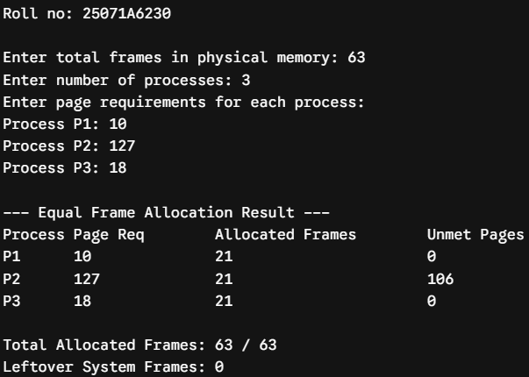
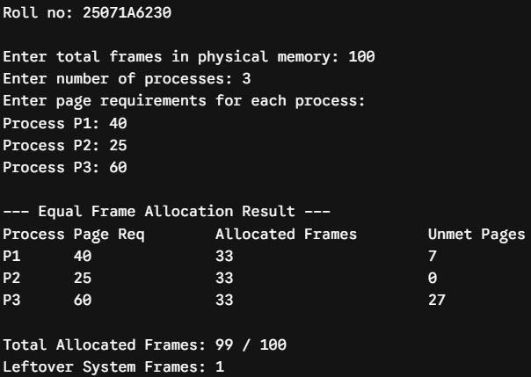
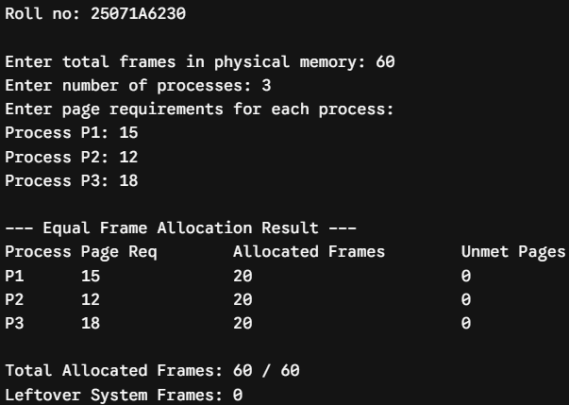
25071A6230 50
VNRVJIET
Name of the laboratory:
OPERATING SYSTEMS

C. proportional allocation
Program:
#include <stdio.h>
int main() {
printf("Roll no: 25071A6230\n\n");
int m, n;
int s[10], a[10];
int S = 0, total_allocated = 0;

printf("Enter total frames available in physical memory: ");
scanf("%d", &m);
printf("Enter number of processes: ");
scanf("%d", &n);

printf("Enter size (in pages/virtual memory) for each process:\n");
for (int i = 0; i < n; i++) {
printf("Process P%d size: ", i + 1);
scanf("%d", &s[i]);
S += s[i];
}

if (S == 0) {
printf("\nInvalid total process size.\n");
return 0;
}
printf("\n--- Proportional Frame Allocation Result ---\n");
printf("Total Virtual Memory Required (S) = %d pages\n\n", S);
printf("Process\tSize (s_i)\tAllocated Frames (a_i)\tPercentage\n");

for (int i = 0; i < n; i++) {
a[i] = (int)(((double)s[i] / S) * m);
total_allocated += a[i];
double pct = ((double)s[i] / S) * 100.0;
printf("P%d\t%d\t\t%d\t\t\t%.2f%%\n", i + 1, s[i], a[i], pct);
}
printf("\nTotal Frames Allocated: %d / %d", total_allocated, m);
printf("\nUnallocated Buffer Frames: %d\n", m - total_allocated);

return 0;
}

Name of the Experiment:

Experiment No: Date:
25071A6230 51

Testcases:
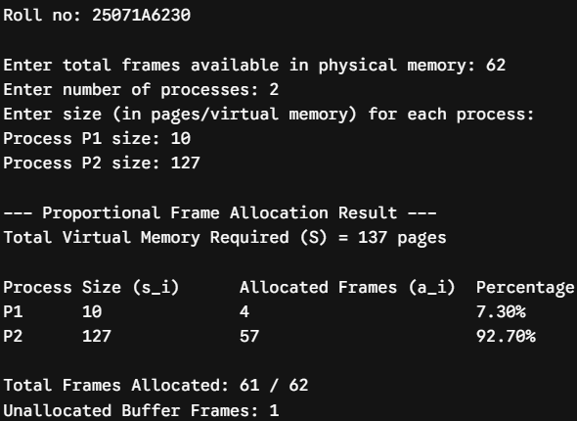
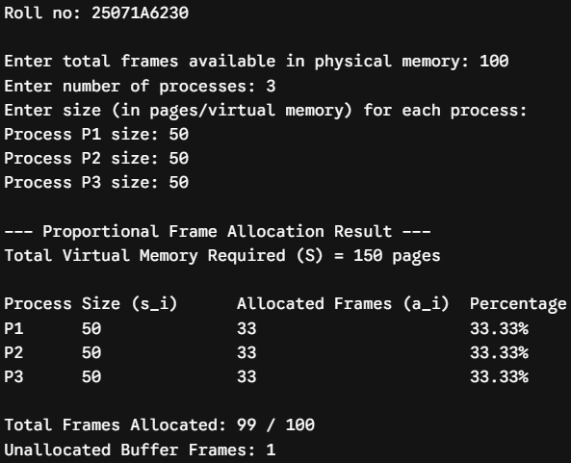
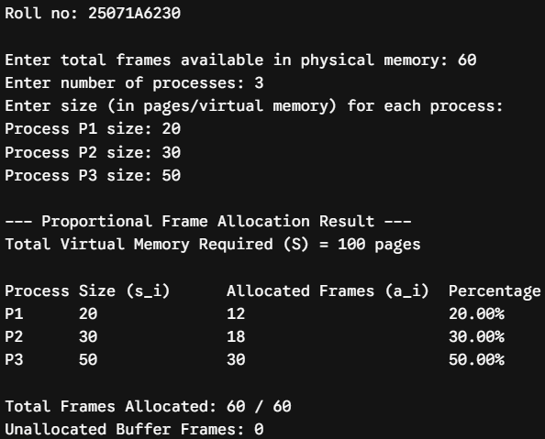
25071A6230 52
VNRVJIET
Name of the laboratory:
OPERATING SYSTEMS

Aim: Simulate the following Disk scheduling algorithms. A) FCFS B) SSTF C) SCAN
A) FCFS
Algorithm:
- Start.
- Input the number of disk requests (n), request sequence, and initial head position.
- Initialize Total Head Movement (THM) = 0.
- For each request:
  - Calculate the distance between the current head and the request.
  - Add the distance to THM.
  - Move the head to the requested position.
- Calculate:
  - Average Seek Time = THM / n
- Display the Total Head Movement and Average Seek Time.
- Stop.

B) SSTF
Algorithm:
- Start
- Input number of requests n, request sequence, and initial head position.
- Initialize THM = 0 and mark all requests as unvisited.
- Repeat n times:
  - Find the unvisited request closest to the current head.
  - Mark it as visited.
  - Add the distance to THM.
  - Move the head to that request.
- Calculate:
  - Average Seek Time = THM / n
- Display Total Head Movement and Average Seek Time.
- Stop.

c) SCAN
Algorithm:
- Start.
- Input number of requests n, request sequence, initial head position, disk size, and direction (LEFT or RIGHT).
- Sort the request sequence in ascending order.
- Initialize THM = 0 and divide requests based on the current head position.
- If direction is RIGHT:
- Service requests to the right in ascending order.
- Move the head to disk_size - 1.
- Reverse direction and service remaining requests in descending order.
- If direction is LEFT:
- Service requests to the left in descending order.
- Move the head to 0.
- Reverse direction and service remaining requests in ascending order.
- Calculate Average Seek Time = THM / n and display Total Head Movement and Average Seek Time.
- Stop.
Name of the Experiment: Disk Scheduling
Algorithms a) FCFS b) SSTF c) SCAN

Experiment No: 8 Date: 10-09-2026
25071A6230 53

25071A6230 54
VNRVJIET
Name of the laboratory:
OPERATING SYSTEMS

Name of the Experiment:

Experiment No: Date:
25071A6230 55

25071A6230 56
VNRVJIET
Name of the laboratory:
OPERATING SYSTEMS

A) FCFS
Program:
#include <stdio.h>
#include <stdlib.h>
int main() {
printf("Roll no: 25071A6230\n");
int n, head, req[20], thm = 0;
printf("Enter number of requests: "); scanf("%d", &n);
printf("Enter request sequence: ");
for (int i = 0; i < n; i++) scanf("%d", &req[i]);
printf("Enter initial head position: "); scanf("%d", &head);

printf("\nSeek Sequence: %d", head);
for (int i = 0; i < n; i++) {
thm += abs(req[i] - head);
head = req[i];
printf(" -> %d", head);
}
printf("\nTotal Head Movement = %d\nAverage Seek Time = %.2f\n", thm, (float)thm / n);
return 0;
}
Testcases:
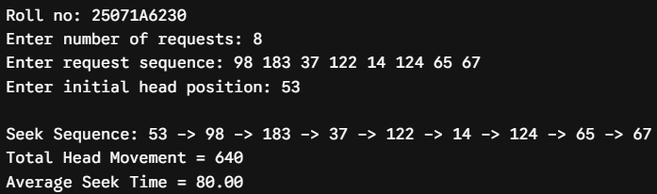
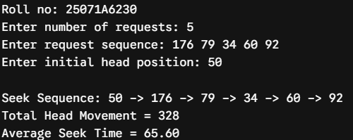
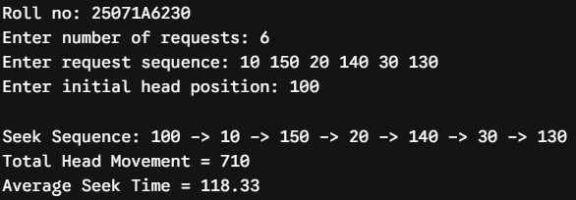
Name of the Experiment:

Experiment No: Date:
25071A6230 57

B) SSTF
Program:
#include <stdio.h>
#include <stdlib.h>
int main() {
printf("Roll no: 25071A6230\n");
int n, head, req[20], visited[20] = {0}, thm = 0;
printf("Enter number of requests: "); scanf("%d", &n);
printf("Enter request sequence: ");
for (int i = 0; i < n; i++) scanf("%d", &req[i]);
printf("Enter initial head position: "); scanf("%d", &head);

printf("\nSeek Sequence: %d", head);
for (int count = 0; count < n; count++) {
int min_dist = 1e9, idx = -1;
for (int i = 0; i < n; i++) {
if (!visited[i] && abs(req[i] - head) < min_dist) {
min_dist = abs(req[i] - head);
idx = i;
}
}
visited[idx] = 1;
thm += min_dist;
head = req[idx];
printf(" -> %d", head);
}
printf("\nTotal Head Movement = %d\nAverage Seek Time = %.2f\n", thm, (float)thm / n);
return 0;
}
Testcases:
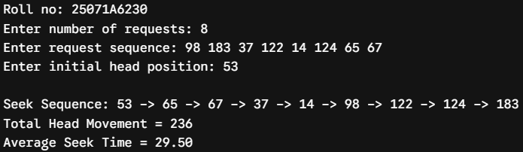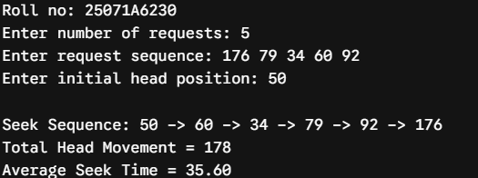
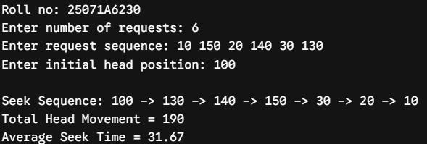
25071A6230 58
VNRVJIET
Name of the laboratory:
OPERATING SYSTEMS

C) SCAN
Program:
#include <stdio.h>
#include <stdlib.h>
int main() {
printf("Roll no: 25071A6230\n");
int n, h, r[30], s, d, thm = 0, p = 0;
printf("Enter number of requests: "); scanf("%d", &n);
printf("Enter request sequence: "); for (int i = 0; i < n; i++) scanf("%d", &r[i]);
printf("Enter initial head position: "); scanf("%d", &h);
printf("Enter total disk size: "); scanf("%d", &s);
printf("Enter direction (1 for High/Right, 0 for Low/Left): "); scanf("%d", &d);
r[n++] = h; r[n++] = d ? s - 1 : 0;
for (int i = 0; i < n - 1; i++)
for (int j = 0; j < n - i - 1; j++)
if (r[j] > r[j + 1]) { int t = r[j]; r[j] = r[j + 1]; r[j + 1] = t; }
while (r[p] != h) p++;
printf("\nSeek Sequence: %d", h);
int cur = h, step = d ? 1 : -1, start = d ? p + 1 : p - 1, end = d ? n : -1;
for (int pass = 0; pass < 2; pass++) {
for (int i = start; i != end; i += step) { thm += abs(r[i] - cur); cur = r[i]; printf(" -> %d", cur); }
step = -step; start = (d == (pass == 0)) ? p - 1 : p + 1; end = (d == (pass == 0)) ? -1 : n;
}
printf("\nTotal Head Movement = %d\nAverage Seek Time = %.2f\n", thm, (float)thm / (n - 2));
return 0;
}
Testcases:
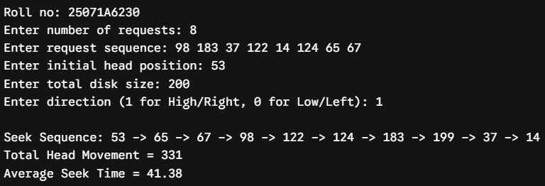
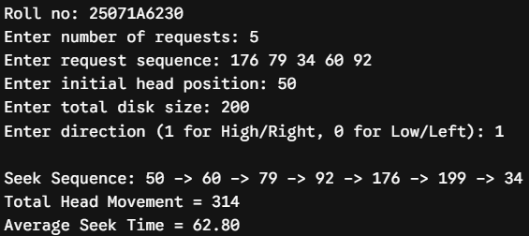
Name of the Experiment:

Experiment No: Date:
25071A6230 59

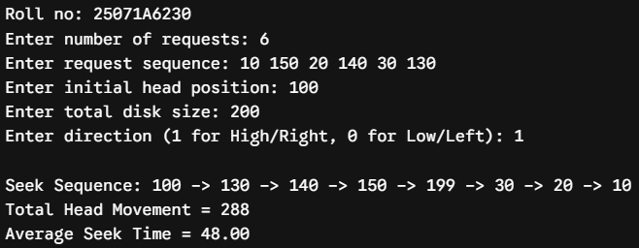

25071A6230 60
VNRVJIET
Name of the laboratory:
OPERATING SYSTEMS

Aim: Simulate the following Disk scheduling algorithms. A) C-SCAN B) LOOK C) C-LOOK
A) C- SCAN
Algorithm:
- Start.
- Input number of requests n, request sequence, initial head position, and disk size.
- Sort the request sequence in ascending order.
- If direction is RIGHT:
  - Service requests from the current head towards disk_size - 1.
  - Move the head directly to 0.
  - Continue servicing the remaining requests in ascending order.
- Calculate Total Head Movement and Average Seek Time.
- Display the results.
- Stop.
B) LOOK
Algorithm:
- Start.
- Input number of requests n, request sequence, initial head position, and direction.
- Sort the request sequence in ascending order.
- If direction is RIGHT:
  - Service requests to the right up to the maximum requested track.
  - Reverse direction and service the remaining requests to the left.
- If direction is LEFT:
  - Service requests to the left up to the minimum requested track.
  - Reverse direction and service the remaining requests to the right.
- Calculate Total Head Movement and Average Seek Time.
- Display the results.
- Stop.
B) C-LOOK
Algorithm:
- Start.
- Input number of requests n, request sequence, initial head position, and direction.
- Sort the request sequence in ascending order.
- If direction is RIGHT:
  - Service requests to the right up to the maximum requested track.
  - Jump directly to the minimum requested track.
  - Service the remaining requests up to the track before the starting head.
- Calculate Total Head Movement and Average Seek Time.
- Display the results.
- Stop.

Name of the Experiment: Disk scheduling
Algorithms a) C-SCAN b) LOOK c) C-LOOK

Experiment No: 9 Date: 17-09-2026
25071A6230 61

25071A6230 62
VNRVJIET
Name of the laboratory:
OPERATING SYSTEMS

Name of the Experiment:

Experiment No: Date:
25071A6230 63

25071A6230 64
VNRVJIET
Name of the laboratory:
OPERATING SYSTEMS

C) C-SCAN
Program:
#include <stdio.h>
#include <stdlib.h>
int main() {
printf("Roll no: 25071A6230\n");
int n, head, req[30], disk_size, thm = 0;
printf("Enter number of requests: "); scanf("%d", &n);
printf("Enter request sequence: ");
for (int i = 0; i < n; i++) scanf("%d", &req[i]);
printf("Enter initial head position: "); scanf("%d", &head);
printf("Enter total disk size: "); scanf("%d", &disk_size);

req[n++] = head;
req[n++] = 0;
req[n++] = disk_size - 1;

for (int i = 0; i < n - 1; i++) {
for (int j = 0; j < n - i - 1; j++) {
if (req[j] > req[j + 1]) {
int t = req[j]; req[j] = req[j + 1]; req[j + 1] = t;}}
}
int pos = 0;
for (int i = 0; i < n; i++) if (req[i] == head) { pos = i; break; }

printf("\nSeek Sequence: %d", head);
int cur = head;
for (int i = pos + 1; i < n; i++) {
thm += abs(req[i] - cur); cur = req[i]; printf(" -> %d", cur);
}
for (int i = 0; i < pos; i++) {
thm += abs(req[i] - cur); cur = req[i]; printf(" -> %d", cur);}
printf("\nTotal Head Movement = %d\nAverage Seek Time = %.2f\n", thm, (float)thm / (n - 3));
return 0;
}
Testcases:
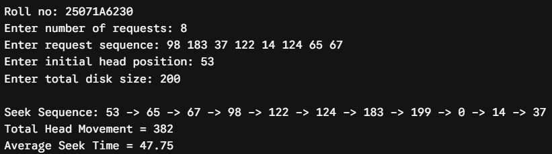

Name of the Experiment:

Experiment No: Date:
25071A6230 65

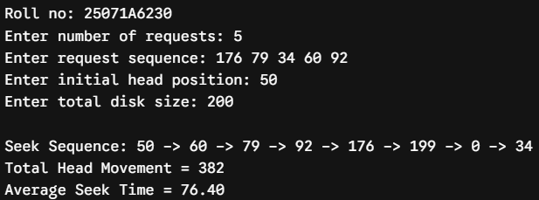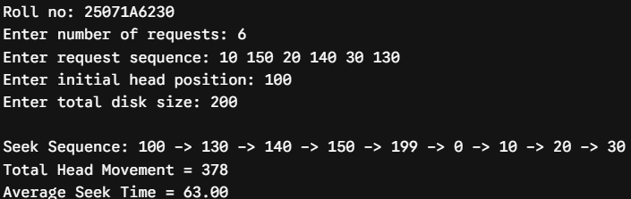
25071A6230 66
VNRVJIET
Name of the laboratory:
OPERATING SYSTEMS

C) LOOK
Program:
#include <stdio.h>
#include <stdlib.h>
int main() {
printf("Roll no: 25071A6230\n");
int n, head, req[25], thm = 0;
printf("Enter number of requests: "); scanf("%d", &n);
printf("Enter request sequence: ");
for (int i = 0; i < n; i++) scanf("%d", &req[i]);
printf("Enter initial head position: "); scanf("%d", &head);

req[n++] = head;
for (int i = 0; i < n - 1; i++) {
for (int j = 0; j < n - i - 1; j++) {
if (req[j] > req[j + 1]) {
int t = req[j]; req[j] = req[j + 1]; req[j + 1] = t;
}
}
}

int pos = 0;
for (int i = 0; i < n; i++) if (req[i] == head) { pos = i; break; }

printf("\nSeek Sequence: %d", head);
int cur = head;
for (int i = pos + 1; i < n; i++) {
thm += abs(req[i] - cur); cur = req[i]; printf(" -> %d", cur);
}
for (int i = pos - 1; i >= 0; i--) {
thm += abs(req[i] - cur); cur = req[i]; printf(" -> %d", cur);
}

printf("\nTotal Head Movement = %d\nAverage Seek Time = %.2f\n", thm, (float)thm / (n - 1));
return 0;
}
Testcases:
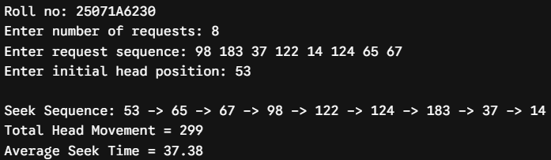

Name of the Experiment:

Experiment No: Date:
25071A6230 67

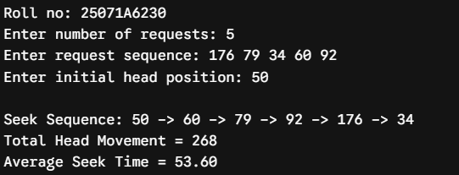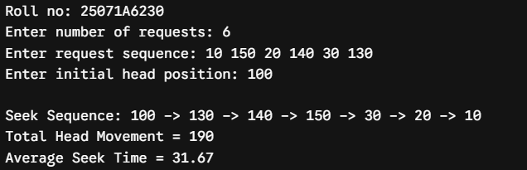
25071A6230 68
VNRVJIET
Name of the laboratory:
OPERATING SYSTEMS

C) C-LOOK
Program:
#include <stdio.h>
#include <stdlib.h>
int main() {
printf("Roll no: 25071A6230\n");
int n, head, req[25], thm = 0;
printf("Enter number of requests: "); scanf("%d", &n);
printf("Enter request sequence: ");
for (int i = 0; i < n; i++) scanf("%d", &req[i]);
printf("Enter initial head position: "); scanf("%d", &head);

req[n++] = head;
for (int i = 0; i < n - 1; i++) {
for (int j = 0; j < n - i - 1; j++) {
if (req[j] > req[j + 1]) {
int t = req[j]; req[j] = req[j + 1]; req[j + 1] = t;
}
}
}

int pos = 0;
for (int i = 0; i < n; i++) if (req[i] == head) { pos = i; break; }

printf("\nSeek Sequence: %d", head);
int cur = head;
for (int i = pos + 1; i < n; i++) {
thm += abs(req[i] - cur); cur = req[i]; printf(" -> %d", cur);
}
for (int i = 0; i < pos; i++) {
thm += abs(req[i] - cur); cur = req[i]; printf(" -> %d", cur);
}

printf("\nTotal Head Movement = %d\nAverage Seek Time = %.2f\n", thm, (float)thm / (n - 1));
return 0;
}

Name of the Experiment:

Experiment No: Date:
25071A6230 69

Testcases:
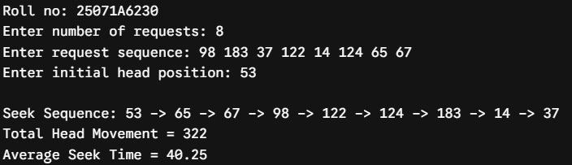
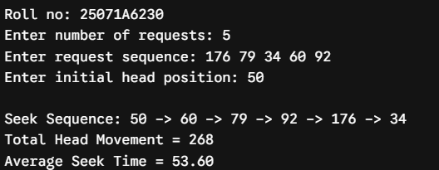
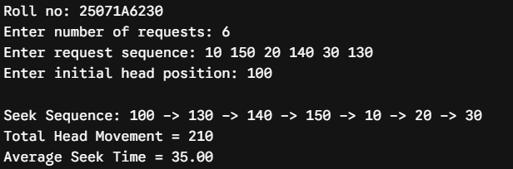
25071A6230 70
VNRVJIET
Name of the laboratory:
OPERATING SYSTEMS

Aim: Simulate all file allocation strategies. A. Sequential, B. Indexed, C. Linked
A. Sequential
Algorithm:
- Start.
- Input disk block status, total number of blocks, starting block, and file length.
- Check whether all blocks from start to start + length - 1 are free.
- If all blocks are free, allocate them to the file.
- Display the allocation status and allocated block numbers.
- Stop.

B. Indexed
Algorithm:
- Start.
- Input index block number and number of file blocks n.
- Check whether the index block is free.
- Input the required block numbers and check whether all blocks are free.
- If all blocks are free, allocate the index block and all required blocks.
- Display the index block and its allocated block mapping.
- Stop.

C. Linked
Algorithm:
- Start.
- Input starting block number and number of blocks n.
- Input the block numbers forming the linked chain.
- Check whether all required blocks are free.
- Allocate the blocks and link them in sequence, ending with -1.
- Display the linked block sequence.
- Stop.

Name of the Experiment: File Allocation
Strategies

Experiment No: 10 Date: 24-09-2026
25071A6230 71

25071A6230 72
VNRVJIET
Name of the laboratory:
OPERATING SYSTEMS

Name of the Experiment:

Experiment No: Date:
25071A6230 73

25071A6230 74
VNRVJIET
Name of the laboratory:
OPERATING SYSTEMS

A. Sequential
Program:
#include <stdio.h>

int main() {
printf("Roll no: 25071A6230\n");
int disk[50] = {0}, start, len, alloc = 1;
printf("Enter start block and length of file: ");
scanf("%d %d", &start, &len);
for (int i = start; i < start + len; i++) if (disk[i]) alloc = 0;
if (alloc) {
printf("File allocated successfully. Blocks: ");
for (int i = start; i < start + len; i++) {
disk[i] = 1; printf("%d ", i);
}
printf("\n");
} else printf("Allocation failed: Contiguous blocks unavailable.\n");
return 0;
}
Testcases:
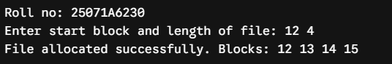
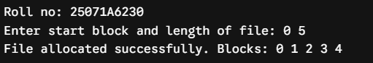
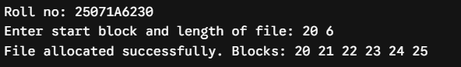

Name of the Experiment:

Experiment No: Date:
25071A6230 75

B. Indexed
Program:
#include <stdio.h>

int main() {
printf("Roll no: 25071A6230\n");
int disk[50] = {0}, idx, n, b[20], alloc = 1;
printf("Enter index block: "); scanf("%d", &idx);
printf("Enter number of blocks and block numbers: "); scanf("%d", &n);
for (int i = 0; i < n; i++) scanf("%d", &b[i]);
if (disk[idx]) alloc = 0;
for (int i = 0; i < n; i++) if (disk[b[i]]) alloc = 0;
if (alloc) {
disk[idx] = 1; printf("Index Block %d points to: ", idx);
for (int i = 0; i < n; i++) { disk[b[i]] = 1; printf("%d ", b[i]); }
printf("\nFile allocated successfully.\n");
} else printf("Allocation failed: Index or data blocks already allocated.\n");
return 0;
}
Testcases:
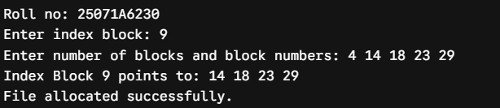
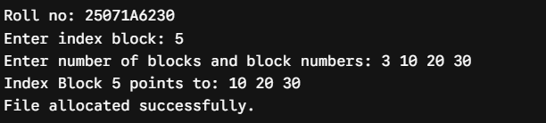
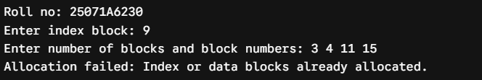

25071A6230 76
VNRVJIET
Name of the laboratory:
OPERATING SYSTEMS

C. Linked
Program:
#include <stdio.h>

int main() {
printf("Roll no: 25071A6230\n");
int disk[50] = {0}, n, b[20], alloc = 1;
printf("Enter number of blocks and block sequence: "); scanf("%d", &n);
for (int i = 0; i < n; i++) scanf("%d", &b[i]);
for (int i = 0; i < n; i++) if (disk[b[i]]) alloc = 0;
if (alloc) {
printf("Linked Allocation Sequence: ");
for (int i = 0; i < n; i++) {
disk[b[i]] = 1; printf("%d -> ", b[i]);
}
printf("NULL\nFile allocated successfully.\n");
} else printf("Allocation failed: One or more blocks already allocated.\n");
return 0;
}
Testcases:
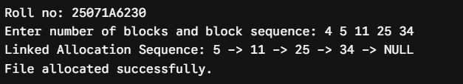
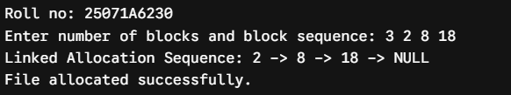
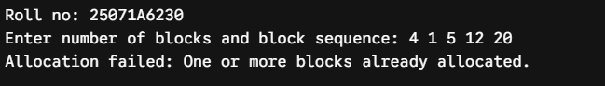

Name of the Experiment:

Experiment No: Date:
25071A6230 77

25071A6230 78
VNRVJIET
Name of the laboratory:
OPERATING SYSTEMS

Aim: Implementation of the following Page Replacement Algorithms A. FIFO, B. LRU, C. Optimal.
A. FIFO
Algorithm:
- Start.
- Input number of frames f, reference string length n, and page reference sequence.
- Initialize all frames to -1, set replacement pointer idx = 0, and page faults to 0.
- For each page in the reference string:
- Check whether the page is already in a frame.
- If not found, replace the page at idx.
- Update idx = (idx + 1) % f and increment page faults.
- Calculate and display total page faults and page fault rate.
- Stop.

B. LRU
Algorithm:
- Start.
- Input number of frames f, reference string length n, and page reference sequence.
- Initialize all frames to -1, timestamps to 0, and page faults to 0.
- For each page in the reference string:
- Check whether the page is present in a frame.
- If found, update its timestamp.
- If not found, replace the page with the smallest timestamp and increment page faults.
- Calculate and display total page faults and page fault rate.
- Stop.

C. Optimal
Algorithm:
- Start.
- Input number of frames f, reference string length n, and page reference sequence.
- Initialize all frames to -1 and page faults to 0.
- For each page in the reference string:
  - Check whether the page is already present.
  - If not present and an empty frame exists, allocate the page.
  - Otherwise, replace the page that will be used farthest in the future or not used again.
  - Increment page faults.
- Calculate and display total page faults and page fault rate.
- Stop.

Name of the Experiment: Page
Replacement algorithms

Experiment No: 6 Date: 08-10-2026
25071A6230 79

25071A6230 80
VNRVJIET
Name of the laboratory:
OPERATING SYSTEMS

Name of the Experiment:

Experiment No: Date:
25071A6230 81

25071A6230 82
VNRVJIET
Name of the laboratory:
OPERATING SYSTEMS

A. FIFO
Program:
#include <stdio.h>
int main() {
printf("Roll no: 25071A6230\n");
int f, n, p[30], m[10], pf = 0, idx = 0;
printf("Enter number of frames and pages: "); scanf("%d %d", &f, &n);
printf("Enter page reference string: "); for (int i = 0; i < n; i++) scanf("%d", &p[i]);
for (int i = 0; i < f; i++) m[i] = -1;
for (int i = 0; i < n; i++) {
int hit = 0;
for (int j = 0; j < f; j++) if (m[j] == p[i]) hit = 1;
if (!hit) { m[idx] = p[i]; idx = (idx + 1) % f; pf++; }
}
printf("Total Page Faults = %d\nPage Fault Rate = %.2f%%\n", pf, (float)pf / n * 100);
return 0;
}
Testcases:
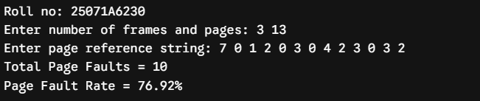
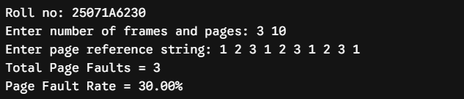
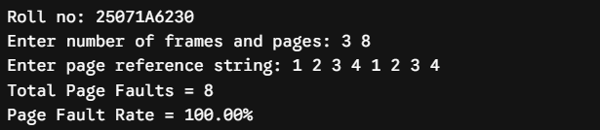

Name of the Experiment:

Experiment No: Date:
25071A6230 83

B. LRU
Program:
#include <stdio.h>
int main() {
printf("Roll no: 25071A6230\n");
int f, n, p[30], m[10], t[10] = {0}, pf = 0;
printf("Enter number of frames and pages: "); scanf("%d %d", &f, &n);
printf("Enter page reference string: "); for (int i = 0; i < n; i++) scanf("%d", &p[i]);
for (int i = 0; i < f; i++) m[i] = -1;
for (int i = 0; i < n; i++) {
int hit = 0, lru = 0;
for (int j = 0; j < f; j++) if (m[j] == p[i]) { hit = 1; t[j] = i + 1; }
if (!hit) {
for (int j = 1; j < f; j++) if (t[j] < t[lru]) lru = j;
m[lru] = p[i]; t[lru] = i + 1; pf++;
}
}
printf("Total Page Faults = %d\nPage Fault Rate = %.2f%%\n", pf, (float)pf / n * 100);
return 0;
}
Testcases:
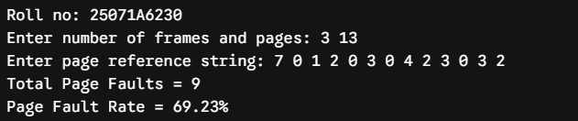
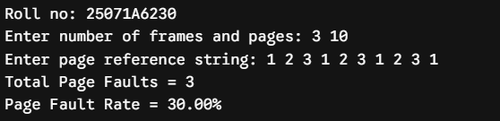
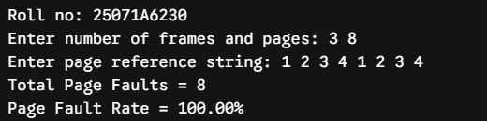

25071A6230 84
VNRVJIET
Name of the laboratory:
OPERATING SYSTEMS

C. Optimal
Program:
#include <stdio.h>
int main() {
printf("Roll no: 25071A6230\n");
int f, n, p[30], m[10], pf = 0;
printf("Enter number of frames and pages: "); scanf("%d %d", &f, &n);
printf("Enter page reference string: "); for (int i = 0; i < n; i++) scanf("%d", &p[i]);
for (int i = 0; i < f; i++) m[i] = -1;
for (int i = 0; i < n; i++) {
int hit = 0, opt = -1, max = -1;
for (int j = 0; j < f; j++) if (m[j] == p[i]) hit = 1;
if (!hit) {
for (int j = 0; j < f; j++) {
int k; for (k = i + 1; k < n; k++) if (m[j] == p[k]) break;
if (k > max) { max = k; opt = j; }
}
m[opt] = p[i]; pf++;
}
}
printf("Total Page Faults = %d\nPage Fault Rate = %.2f%%\n", pf, (float)pf / n * 100);
return 0;
}
Testcases:
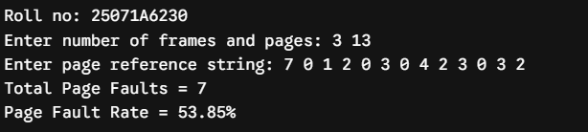
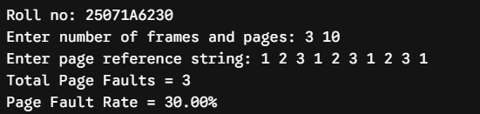
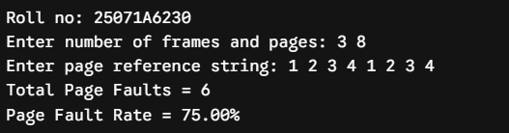

Name of the Experiment:

Experiment No: Date:
25071A6230 85

25071A6230 86

