《网络互连技术》实验报告
实验6 MSTP+VRRP配置
学 号： | 3116001779 |  | 姓 名： | 陈淦 |  | 指导教师： | 容振邦
实验时间： | 2019-4-11 |  | 实验地点： | 黎耀球楼202B |  | 成 绩：

一、实验目的
- 掌握多区域OSPF和VRRP的基本配置。

二、实验设备
实验采用eNSP来完成，主要设备如下所示：
- 三层交换机两台，二层交换机两台
- PC机四台
- 路由器一台
- 以太网若干条

三、实验原理
虚拟路由冗余协议(Virtual Router Redundancy Protocol，简称VRRP)是由IETF提出的解决局域网中配置静态网关出现单点失效现象的路由协议，1998年已推出正式的RFC2338协议标准。VRRP广泛应用在边缘网络中，它的设计目标是支持特定情况下IP数据流量失败转移不会引起混乱，允许主机使用单路由器，以及及时在实际第一跳路由器使用失败的情形下仍能够维护路由器间的连通性。
四、实验拓扑
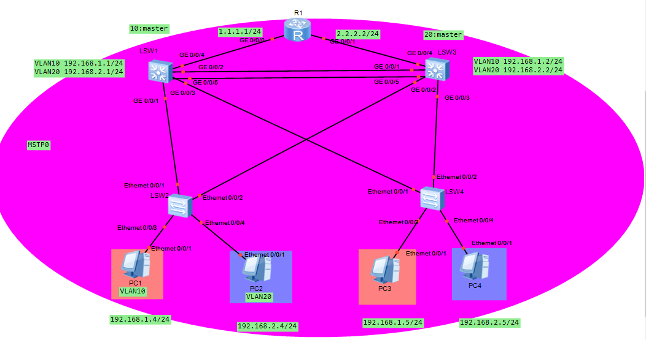
四、实验配置
实验如上图连接好设备后开始对设备进行配置，具体如下：
<LSW2>dis current-configuration
#
sysname LSW2
#
undo info-center enable
#
vlan batch 2 to 20
#
cluster enable
ntdp enable
ndp enable
#
drop illegal-mac alarm
#
diffserv domain default
#
drop-profile default
#
aaa
authentication-scheme default
authorization-scheme default
accounting-scheme default
domain default
domain default_admin
local-user admin password simple admin
local-user admin service-type http
#
interface Vlanif1
#
interface MEth0/0/1
#
interface Ethernet0/0/1
port link-type trunk
port trunk allow-pass vlan 2 to 4094
#
interface Ethernet0/0/2
port link-type trunk
port trunk allow-pass vlan 2 to 4094
#
interface Ethernet0/0/3
port link-type access
port default vlan 10
#
interface Ethernet0/0/4
port link-type access
port default vlan 20
#
interface Ethernet0/0/5
#
interface Ethernet0/0/6
#
interface Ethernet0/0/7
#
interface Ethernet0/0/8
#
interface Ethernet0/0/9
#
interface Ethernet0/0/10
#
interface Ethernet0/0/11
#
interface Ethernet0/0/12
#
interface Ethernet0/0/13
#
interface Ethernet0/0/14
#
interface Ethernet0/0/15
#
interface Ethernet0/0/16
#
interface Ethernet0/0/17
#
interface Ethernet0/0/18
#
interface Ethernet0/0/19
#
interface Ethernet0/0/20
#
interface Ethernet0/0/21
#
interface Ethernet0/0/22
#
interface GigabitEthernet0/0/1
#
interface GigabitEthernet0/0/2
#
interface NULL0
#
user-interface con 0
user-interface vty 0 4
#
Return

<LSW1>dis current-configuration
#
sysname LSW1
#
undo info-center enable
#
vlan batch 2 to 20 100
#
cluster enable
ntdp enable
ndp enable
#
drop illegal-mac alarm
#
diffserv domain default
#
drop-profile default
#
aaa
authentication-scheme default
authorization-scheme default
accounting-scheme default
domain default
domain default_admin
local-user admin password simple admin
local-user admin service-type http
#
interface Vlanif1
#
interface Vlanif10
ip address 192.168.1.1 255.255.255.0
vrrp vrid 10 virtual-ip 192.168.1.254
vrrp vrid 10 priority 150
vrrp vrid 10 preempt-mode timer delay 10
vrrp vrid 10 track interface GigabitEthernet0/0/4 reduced 50
#
interface Vlanif20
ip address 192.168.2.1 255.255.255.0
vrrp vrid 20 virtual-ip 192.168.2.254
#
interface Vlanif100
ip address 1.1.1.1 255.255.255.0
#
interface MEth0/0/1
#
interface Eth-Trunk1
port link-type trunk
port trunk allow-pass vlan 2 to 4094
#
interface GigabitEthernet0/0/1
port link-type trunk
port trunk allow-pass vlan 2 to 4094
#
interface GigabitEthernet0/0/2
shutdown
eth-trunk 1
#
interface GigabitEthernet0/0/3
shutdown
port link-type trunk
port trunk allow-pass vlan 2 to 4094
#
interface GigabitEthernet0/0/4
port link-type access
port default vlan 100
#
interface GigabitEthernet0/0/5
shutdown
eth-trunk 1
#
interface GigabitEthernet0/0/6
#
interface GigabitEthernet0/0/7
#
interface GigabitEthernet0/0/8
#
interface GigabitEthernet0/0/9
#
interface GigabitEthernet0/0/10
#
interface GigabitEthernet0/0/11
#
interface GigabitEthernet0/0/12
#
interface GigabitEthernet0/0/13
#
interface GigabitEthernet0/0/14
#
interface GigabitEthernet0/0/15
#
interface GigabitEthernet0/0/16
#
interface GigabitEthernet0/0/17
#
interface GigabitEthernet0/0/18
#
interface GigabitEthernet0/0/19
#
interface GigabitEthernet0/0/20
#
interface GigabitEthernet0/0/21
#
interface GigabitEthernet0/0/22
#
interface GigabitEthernet0/0/23
#
interface GigabitEthernet0/0/24
#
interface NULL0
#
user-interface con 0
user-interface vty 0 4
#
Return

<LSW1>dis current-configuration
#
sysname LSW1
#
undo info-center enable
#
vlan batch 2 to 20 100
#
cluster enable
ntdp enable
ndp enable
#
drop illegal-mac alarm
#
diffserv domain default
#
drop-profile default
#
aaa
authentication-scheme default
authorization-scheme default
accounting-scheme default
domain default
domain default_admin
local-user admin password simple admin
local-user admin service-type http
#
interface Vlanif1
#
interface Vlanif10
ip address 192.168.1.1 255.255.255.0
vrrp vrid 10 virtual-ip 192.168.1.254
vrrp vrid 10 priority 150
vrrp vrid 10 preempt-mode timer delay 10
vrrp vrid 10 track interface GigabitEthernet0/0/4 reduced 50
#
interface Vlanif20
ip address 192.168.2.1 255.255.255.0
vrrp vrid 20 virtual-ip 192.168.2.254
#
interface Vlanif100
ip address 1.1.1.1 255.255.255.0
#
interface MEth0/0/1
#
interface Eth-Trunk1
port link-type trunk
port trunk allow-pass vlan 2 to 4094
#
interface GigabitEthernet0/0/1
port link-type trunk
port trunk allow-pass vlan 2 to 4094
#
interface GigabitEthernet0/0/2
shutdown
eth-trunk 1
#
interface GigabitEthernet0/0/3
shutdown
port link-type trunk
port trunk allow-pass vlan 2 to 4094
#
interface GigabitEthernet0/0/4
port link-type access
port default vlan 100
#
interface GigabitEthernet0/0/5
shutdown
eth-trunk 1
#
interface GigabitEthernet0/0/6
#
interface GigabitEthernet0/0/7
#
interface GigabitEthernet0/0/8
#
interface GigabitEthernet0/0/9
#
interface GigabitEthernet0/0/10
#
interface GigabitEthernet0/0/11
#
interface GigabitEthernet0/0/12
#
interface GigabitEthernet0/0/13
#
interface GigabitEthernet0/0/14
#
interface GigabitEthernet0/0/15
#
interface GigabitEthernet0/0/16
#
interface GigabitEthernet0/0/17
#
interface GigabitEthernet0/0/18
#
interface GigabitEthernet0/0/19
#
interface GigabitEthernet0/0/20
#
interface GigabitEthernet0/0/21
#
interface GigabitEthernet0/0/22
#
interface GigabitEthernet0/0/23
#
interface GigabitEthernet0/0/24
#
interface NULL0
#
user-interface con 0
user-interface vty 0 4
#
Return

<LSW3>dis curr
#
sysname LSW3
#
undo info-center enable
#
vlan batch 2 to 20 100
#
cluster enable
ntdp enable
ndp enable
#
drop illegal-mac alarm
#
diffserv domain default
#
drop-profile default
#
aaa
authentication-scheme default
authorization-scheme default
accounting-scheme default
domain default
domain default_admin
local-user admin password simple admin
local-user admin service-type http
#
interface Vlanif1
#
interface Vlanif10
ip address 192.168.1.2 255.255.255.0
vrrp vrid 10 virtual-ip 192.168.1.254
#
interface Vlanif20
ip address 192.168.2.2 255.255.255.0
vrrp vrid 20 virtual-ip 192.168.2.254
vrrp vrid 20 priority 150
vrrp vrid 20 preempt-mode timer delay 10
vrrp vrid 20 track interface GigabitEthernet0/0/4 reduced 50
#
interface Vlanif100
ip address 2.2.2.1 255.255.255.0
#
interface MEth0/0/1
#
interface Eth-Trunk1
port link-type trunk
port trunk allow-pass vlan 2 to 4094
#
interface GigabitEthernet0/0/1
eth-trunk 1
#
interface GigabitEthernet0/0/2
port link-type trunk
port trunk allow-pass vlan 2 to 4094
#
interface GigabitEthernet0/0/3
port link-type trunk
port trunk allow-pass vlan 2 to 4094
#
interface GigabitEthernet0/0/4
port link-type access
port default vlan 100
#
interface GigabitEthernet0/0/5
eth-trunk 1
#
interface GigabitEthernet0/0/6
#
interface GigabitEthernet0/0/7
#
interface GigabitEthernet0/0/8
#
interface GigabitEthernet0/0/9
#
interface GigabitEthernet0/0/10
#
interface GigabitEthernet0/0/11
#
interface GigabitEthernet0/0/12
#
interface GigabitEthernet0/0/13
#
interface GigabitEthernet0/0/14
#
interface GigabitEthernet0/0/15
#
interface GigabitEthernet0/0/16
#
interface GigabitEthernet0/0/17
#
interface GigabitEthernet0/0/18
#
interface GigabitEthernet0/0/19
#
interface GigabitEthernet0/0/20
#
interface GigabitEthernet0/0/21
#
interface GigabitEthernet0/0/22
#
interface GigabitEthernet0/0/23
#
interface GigabitEthernet0/0/24
#
interface NULL0
#
user-interface con 0
user-interface vty 0 4
#
return

<LSW4>dis current-configuration
#
sysname LSW4
#
undo info-center enable
#
vlan batch 2 to 20
#
cluster enable
ntdp enable
ndp enable
#
drop illegal-mac alarm
#
diffserv domain default
#
drop-profile default
#
aaa
authentication-scheme default
authorization-scheme default
accounting-scheme default
domain default
domain default_admin
local-user admin password simple admin
local-user admin service-type http
#
interface Vlanif1
#
interface MEth0/0/1
#
interface Ethernet0/0/1
port link-type trunk
port trunk allow-pass vlan 2 to 4094
#
interface Ethernet0/0/2
port link-type trunk
port trunk allow-pass vlan 2 to 4094
#
interface Ethernet0/0/3
port link-type access
port default vlan 10
#
interface Ethernet0/0/4
port link-type access
port default vlan 20
#
interface Ethernet0/0/5
#
interface Ethernet0/0/6
#
interface Ethernet0/0/7
#
interface Ethernet0/0/8
#
interface Ethernet0/0/9
#
interface Ethernet0/0/10
#
interface Ethernet0/0/11
#
interface Ethernet0/0/12
#
interface Ethernet0/0/13
#
interface Ethernet0/0/14
#
interface Ethernet0/0/15
#
interface Ethernet0/0/16
#
interface Ethernet0/0/17
#
interface Ethernet0/0/18
#
interface Ethernet0/0/19
#
interface Ethernet0/0/20
#
interface Ethernet0/0/21
#
interface Ethernet0/0/22
#
interface GigabitEthernet0/0/1
#
interface GigabitEthernet0/0/2
#
interface NULL0
#
user-interface con 0
user-interface vty 0 4
#
Return

PC1配置
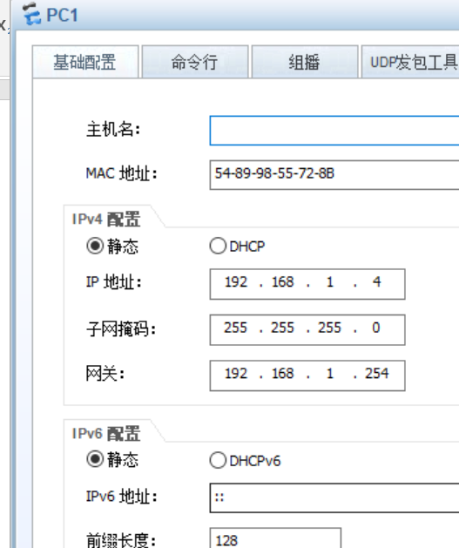

PC2配置
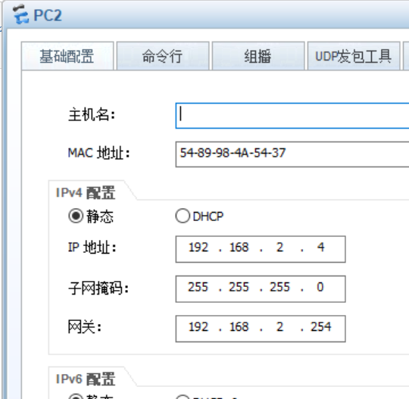

- 实验测试

在关闭GE 0/0/2 GE 0/0/5 GE 0/0/3 之后PC1任然可以PC3 PC4进行通信
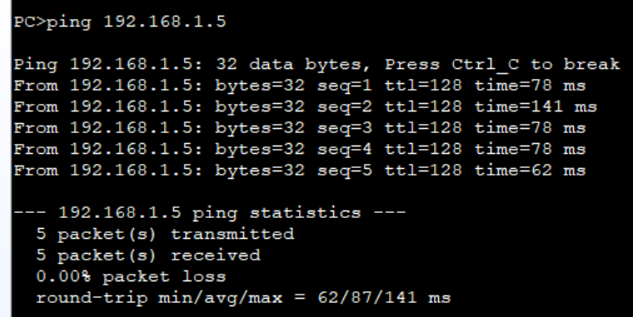

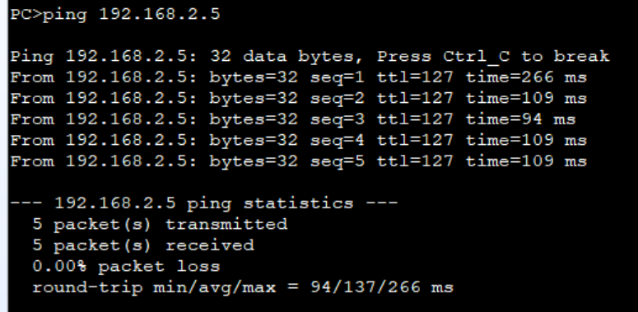
- 实验总结
通过此次试验巩固了前面所学的MSTP协议以及相应端口类型的选型与配置。学习了VRRP（虚拟路由器冗余协议）的运作原理与相关配置，以及他们的使用场景是在IP数据流量失败转移不会引起混乱，允许主机使用单路由器，以及及时在实际第一跳路由器使用失败的情形下仍能够维护路由器间的连通性。

