《网络互连技术》实验报告
实验5 OSPF配置
学 号： | 3116001779 |  | 姓 名： | 陈淦 |  | 指导教师： | 容振邦
实验时间： | 2019-4-4 |  | 实验地点： | 黎耀球楼202B |  | 成 绩：

一、实验目的
- 掌握多区域OSPF的基本配置。
- 掌握NSSA区域的基本配置
- 学习虚拟链路的配置
- 配置路由重分发

二、实验设备
实验采用eNSP来完成，主要设备如下所示：
- 路由器7台
- PC机一台
- 以太网若干条

三、实验原理
开放式最短路径优先（英语：Open Shortest Path First，缩写为 OSPF）是对链路状态路由协议的一种实现，隶属内部网关协议（IGP），故运作于自治系统内部。采用戴克斯特拉算法（Dijkstra's algorithm）被用来计算最短路径树。它使用“代价（Cost）”作为路由度量。链路状态数据库（LSDB）用来保存当前网络拓扑结构，路由器上属于同一区域的链路状态数据库是相同的（属于多个区域的路由器会为每个区域维护一份链路状态数据库）。OSPF分为OSPFv2和OSPFv3两个版本,其中OSPFv2用在IPv4网络，OSPFv3用在IPv6网络。OSPFv2是由RFC 2328定义的，OSPFv3是由RFC 5340定义的。
四、实验拓扑
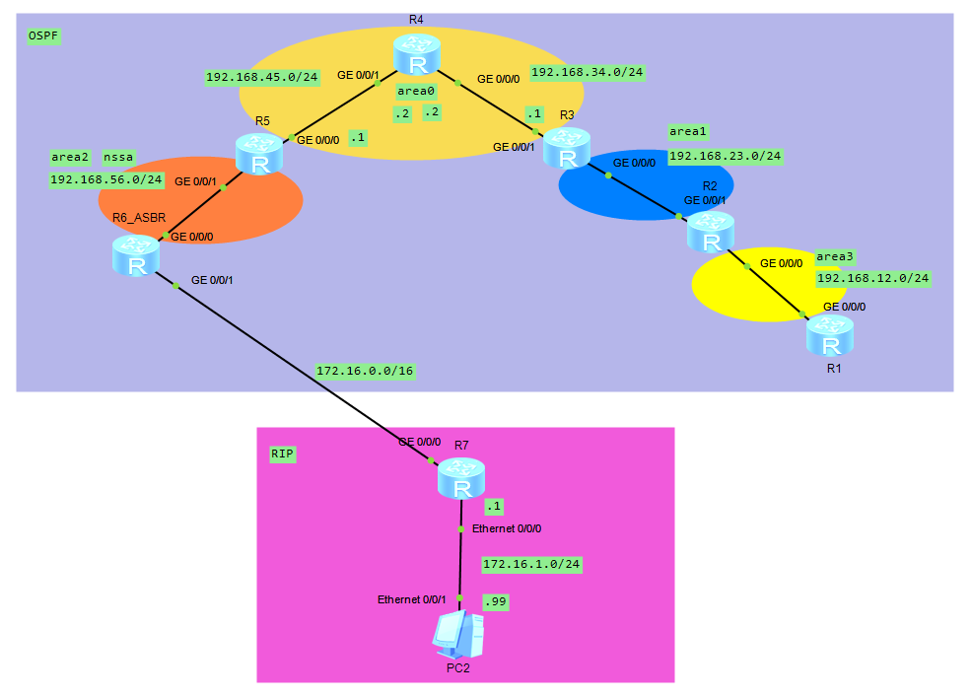
四、实验配置
实验如上图连接好设备后开始对设备进行配置，具体如下：
<R1>display current-configuration
#
sysname R1
#
aaa
authentication-scheme default
authorization-scheme default
accounting-scheme default
domain default
domain default_admin
local-user admin password cipher \<)jWzs+*:ani^>"qh^;-1_#
local-user admin service-type http
#
firewall zone Local
priority 16
#
interface Ethernet0/0/0
#
interface Ethernet0/0/1
#
interface Serial0/0/0
link-protocol ppp
#
interface Serial0/0/1
link-protocol ppp
#
interface Serial0/0/2
link-protocol ppp
#
interface Serial0/0/3
link-protocol ppp
#
interface GigabitEthernet0/0/0
ip address 192.168.12.1 255.255.255.0
#
interface GigabitEthernet0/0/1
#
interface GigabitEthernet0/0/2
#
interface GigabitEthernet0/0/3
#
wlan
#
interface NULL0
#
ospf 1 router-id 1.1.1.1
area 0.0.0.3
network 192.168.12.1 0.0.0.0
#
user-interface con 0
user-interface vty 0 4
user-interface vty 16 20
#
Return

<R2>display current-configuration
#
sysname R2
#
aaa
authentication-scheme default
authorization-scheme default
accounting-scheme default
domain default
domain default_admin
local-user admin password cipher Y*\|HLG[Y5pe}@HMNPn@V1Q#
local-user admin service-type http
#
firewall zone Local
priority 16
#
interface Ethernet0/0/0
#
interface Ethernet0/0/1
#
interface Serial0/0/0
link-protocol ppp
#
interface Serial0/0/1
link-protocol ppp
#
interface Serial0/0/2
link-protocol ppp
#
interface Serial0/0/3
link-protocol ppp
#
interface GigabitEthernet0/0/0
ip address 192.168.12.2 255.255.255.0
#
interface GigabitEthernet0/0/1
ip address 192.168.23.2 255.255.255.0
#
interface GigabitEthernet0/0/2
#
interface GigabitEthernet0/0/3
#
wlan
#
interface NULL0
#
ospf 1 router-id 2.2.2.2
area 0.0.0.1
network 192.168.23.2 0.0.0.0
vlink-peer 3.3.3.3
area 0.0.0.3
network 192.168.12.2 0.0.0.0
#
user-interface con 0
user-interface vty 0 4
user-interface vty 16 20
#
Return

<R3>display current-configuration
#
sysname R3
#
aaa
authentication-scheme default
authorization-scheme default
accounting-scheme default
domain default
domain default_admin
local-user admin password cipher Lb~h<MvKU9ajUn1vMEIB+1G#
local-user admin service-type http
#
firewall zone Local
priority 16
#
interface Ethernet0/0/0
#
interface Ethernet0/0/1
#
interface Serial0/0/0
link-protocol ppp
#
interface Serial0/0/1
link-protocol ppp
#
interface Serial0/0/2
link-protocol ppp
#
interface Serial0/0/3
link-protocol ppp
#
interface GigabitEthernet0/0/0
ip address 192.168.23.3 255.255.255.0
#
interface GigabitEthernet0/0/1
ip address 192.168.34.1 255.255.255.0
#
interface GigabitEthernet0/0/2
#
interface GigabitEthernet0/0/3
#
wlan
#
interface NULL0
#
ospf 1 router-id 3.3.3.3
area 0.0.0.0
network 192.168.34.1 0.0.0.0
area 0.0.0.1
network 192.168.23.3 0.0.0.0
vlink-peer 2.2.2.2
#
user-interface con 0
user-interface vty 0 4
user-interface vty 16 20
#
Return

<R4>dis cur
#
sysname R4
#
aaa
authentication-scheme default
authorization-scheme default
accounting-scheme default
domain default
domain default_admin
local-user admin password cipher I@qZ>s3UmQ3IF$':[285"1X#
local-user admin service-type http
#
firewall zone Local
priority 16
#
interface Ethernet0/0/0
#
interface Ethernet0/0/1
#
interface Serial0/0/0
link-protocol ppp
#
interface Serial0/0/1
link-protocol ppp
#
interface Serial0/0/2
link-protocol ppp
#
interface Serial0/0/3
link-protocol ppp
#
interface GigabitEthernet0/0/0
ip address 192.168.34.2 255.255.255.0
#
interface GigabitEthernet0/0/1
ip address 192.168.45.2 255.255.255.0
#
interface GigabitEthernet0/0/2
#
interface GigabitEthernet0/0/3
#
wlan
#
interface NULL0
#
ospf 1 router-id 4.4.4.4
area 0.0.0.0
network 192.168.34.2 0.0.0.0
network 192.168.45.2 0.0.0.0
#
user-interface con 0
user-interface vty 0 4
user-interface vty 16 20
#
Return

<R5>dis cur
#
sysname R5
#
aaa
authentication-scheme default
authorization-scheme default
accounting-scheme default
domain default
domain default_admin
local-user admin password cipher ]Um/CSkA8ZjKUGU-KkpBZ1H#
local-user admin service-type http
#
firewall zone Local
priority 16
#
interface Ethernet0/0/0
#
interface Ethernet0/0/1
#
interface Serial0/0/0
link-protocol ppp
#
interface Serial0/0/1
link-protocol ppp
#
interface Serial0/0/2
link-protocol ppp
#
interface Serial0/0/3
link-protocol ppp
#
interface GigabitEthernet0/0/0
ip address 192.168.45.1 255.255.255.0
#
interface GigabitEthernet0/0/1
ip address 192.168.56.5 255.255.255.0
#
interface GigabitEthernet0/0/2
#
interface GigabitEthernet0/0/3
#
wlan
#
interface NULL0
#
ospf 1 router-id 5.5.5.5
area 0.0.0.0
network 192.168.45.1 0.0.0.0
area 0.0.0.2
network 192.168.56.5 0.0.0.0
nssa
#
user-interface con 0
user-interface vty 0 4
user-interface vty 16 20
#
Return

<R6>dis cur
#
sysname R6
#
aaa
authentication-scheme default
authorization-scheme default
accounting-scheme default
domain default
domain default_admin
local-user admin password cipher kJ,nVGHBd4bL^B&WSBiQ31T#
local-user admin service-type http
#
firewall zone Local
priority 16
#
interface Ethernet0/0/0
#
interface Ethernet0/0/1
#
interface Serial0/0/0
link-protocol ppp
#
interface Serial0/0/1
link-protocol ppp
#
interface Serial0/0/2
link-protocol ppp
#
interface Serial0/0/3
link-protocol ppp
#
interface GigabitEthernet0/0/0
ip address 192.168.56.6 255.255.255.0
#
interface GigabitEthernet0/0/1
ip address 172.16.6.0 255.255.0.0
#
interface GigabitEthernet0/0/2
#
interface GigabitEthernet0/0/3
#
wlan
#
interface NULL0
#
ospf 1
import-route rip 1
area 0.0.0.2
network 192.168.56.6 0.0.0.0
nssa
#
rip 1
network 172.16.0.0
#
user-interface con 0
user-interface vty 0 4
user-interface vty 16 20
#
Return

<R7>dis cur
#
sysname R7
#
aaa
authentication-scheme default
authorization-scheme default
accounting-scheme default
domain default
domain default_admin
local-user admin password cipher OOCM4m($F4ajUn1vMEIBNUw#
local-user admin service-type http
#
firewall zone Local
priority 16
#
interface Ethernet0/0/0
ip address 172.16.1.7 255.255.255.0
#
interface Ethernet0/0/1
#
interface Serial0/0/0
link-protocol ppp
#
interface Serial0/0/1
link-protocol ppp
#
interface Serial0/0/2
link-protocol ppp
#
interface Serial0/0/3
link-protocol ppp
#
interface GigabitEthernet0/0/0
ip address 172.16.7.0 255.255.0.0
#
interface GigabitEthernet0/0/1
#
interface GigabitEthernet0/0/2
#
interface GigabitEthernet0/0/3
#
wlan
#
interface NULL0
#
rip 1
version 2
network 172.16.0.0
#
ip route-static 0.0.0.0 0.0.0.0 172.16.6.0
#
user-interface con 0
user-interface vty 0 4
user-interface vty 16 20
#
Return

PC2配置表
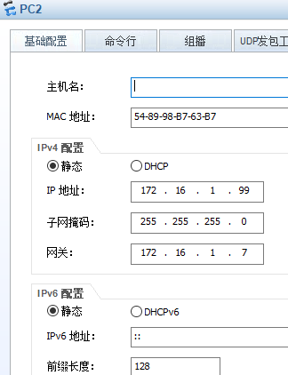

- 实验测试
测试PC2与R1的连通性
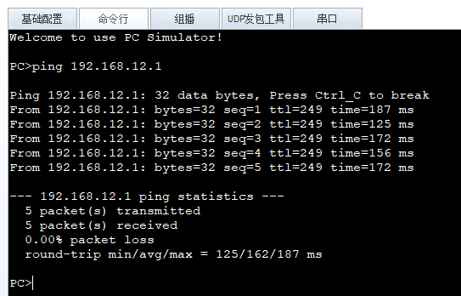
R4的路由表
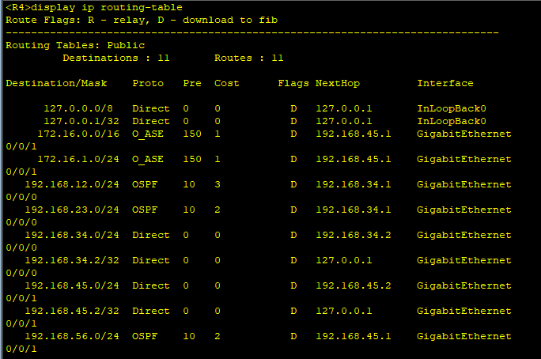

- 实验总结
通过此次动手实验更好的掌握学习了OSPF的配置操作以及OSPF的实现原理。了解了OSPF的历史与发展，以及其所适用的场景。更牢固的掌握了内部路由器，骨干路由器，区域边界路由器，自制系统边界路由器的特点和使用方法。实操了在哪种情况下对虚链路的设置以达到预期效果。对不同类型的LSA有了深刻的理解，以及他们是怎样产生的，描述的是什么信息以及泛洪区域。

