**Project – 6**

**Google analytics**

Google Analytics is a web analytics service that provides statistics and basic analytical tools for search engine optimization ([SEO](https://www.techtarget.com/whatis/definition/search-engine-optimization-SEO)) and marketing purposes. The service is part of the Google Marketing Platform and is available for free to anyone with a Google account.

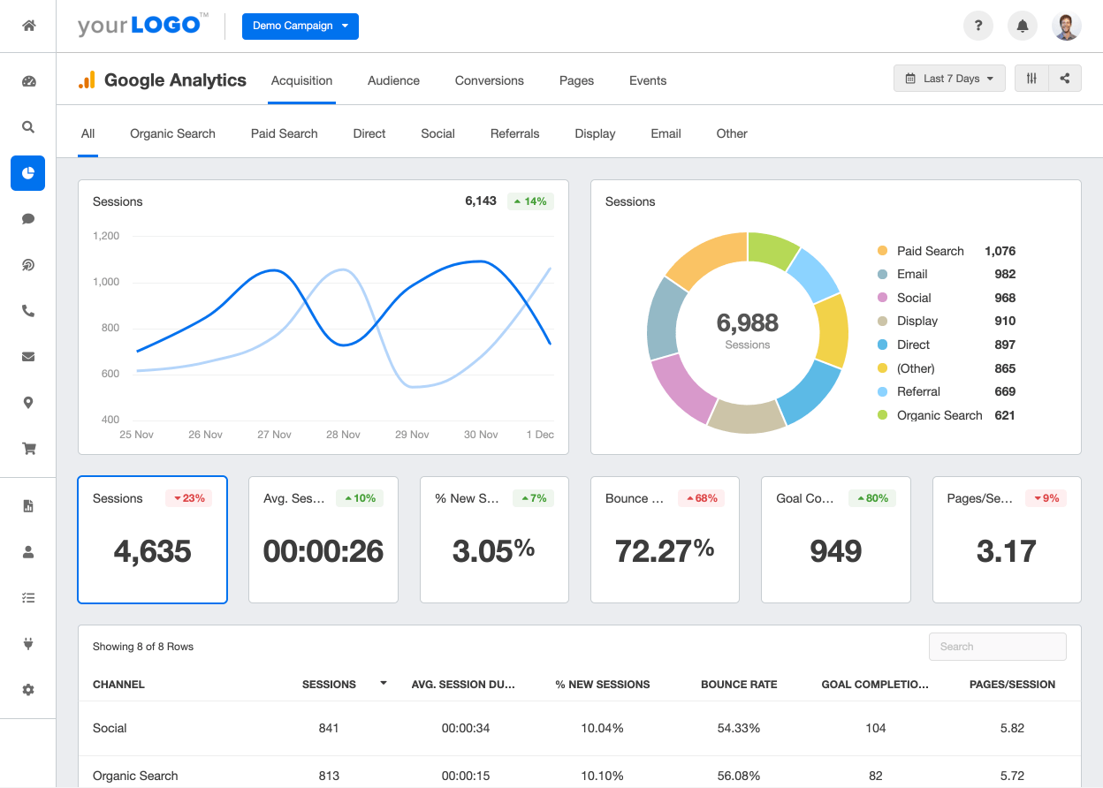

And I have also made a report on my website. That is the analytics report of my blog. And it is follows

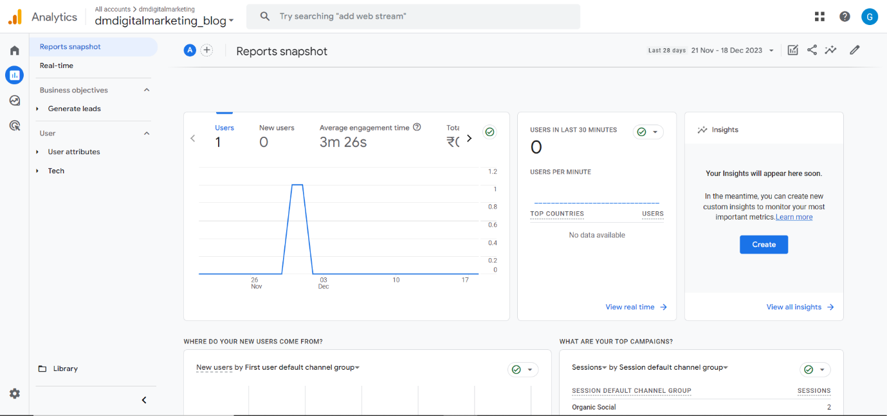

As above is the account of google analytics.