00 — Annotated Wireframe: Exit Form
Work item: Create Annotated Wireframe (Exit Form) | Module: Exit Form | Date: 2026-11-02 | Repository source: docs/exit-form/00-annotated-wireframe.md
Screenshots of the Exit Form as built today (commit a7916f6), taken from the running React components with sample data. The form opens as a full-screen modal from the Client screen → Input Forms tab → Exit (new form) or View/Edit on an Exit row (edit). Numbered red markers match the tables below. Sample data is fictional.
Rules referenced as BR-EF-… / EF-GAP-… are in 03-business-rules.md; fields are specified in 06-field-spec.md.
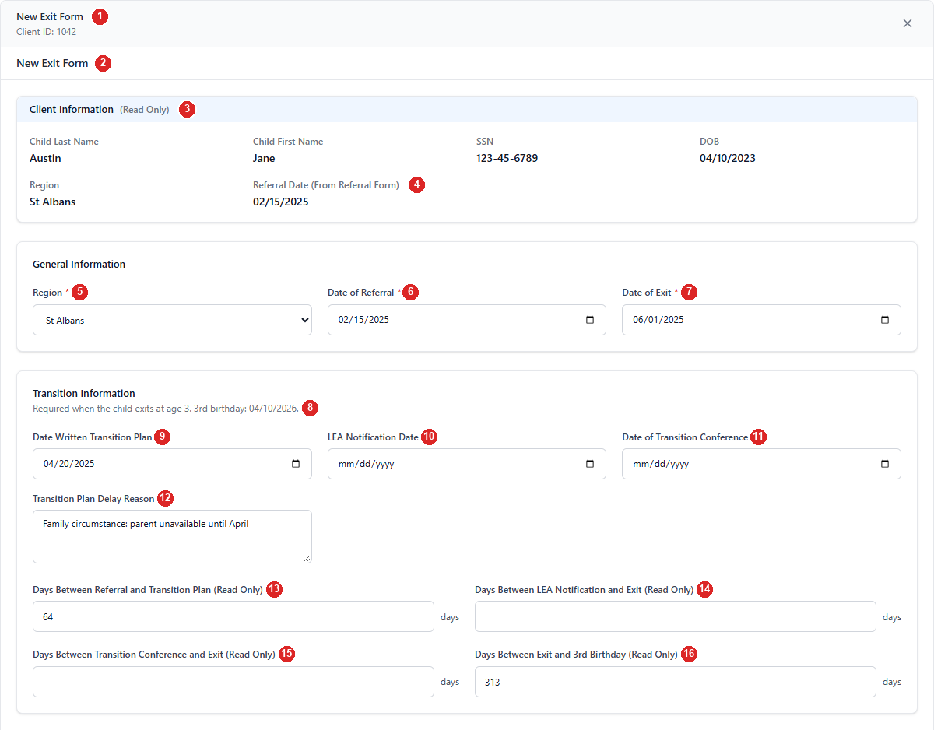
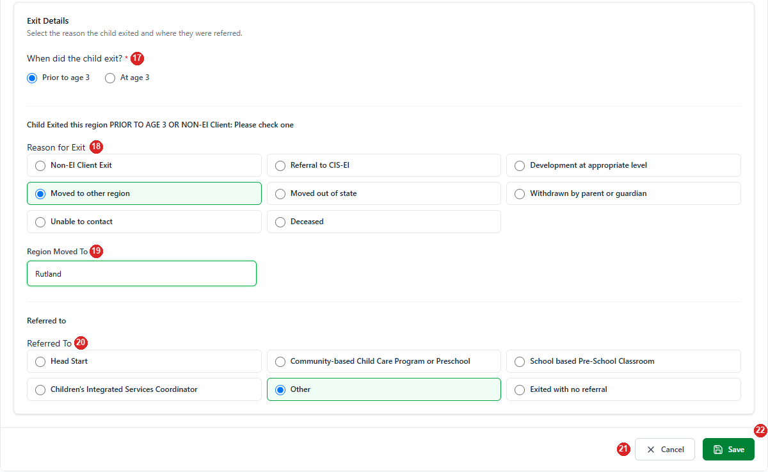
Figure 1 — New form. Region and Date of Referral are prefilled from the child's latest Active / Referral form; the exit date is before the 3rd birthday, so "Prior to age 3" is selected automatically.
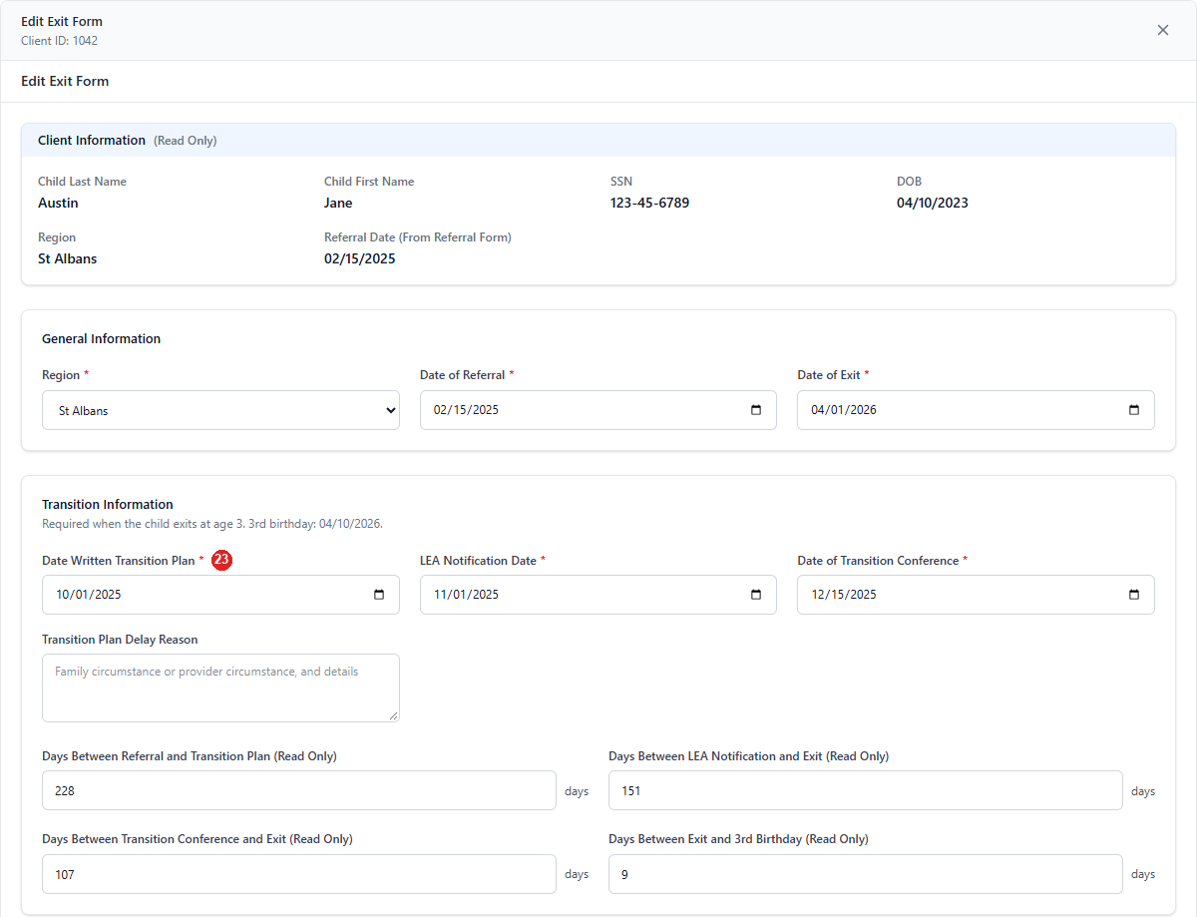
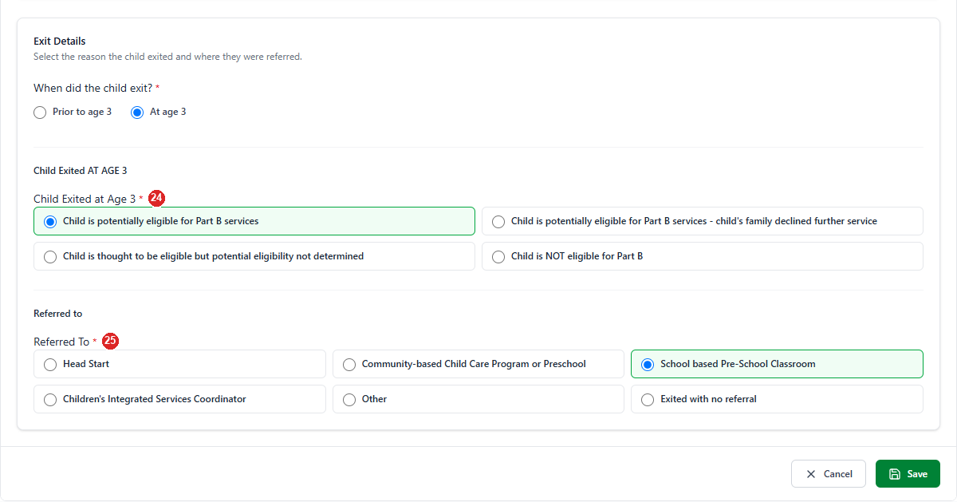
Figure 2 — Editing a form where the child exited at age 3: the three transition dates and Referred To become required (markers 23–25).
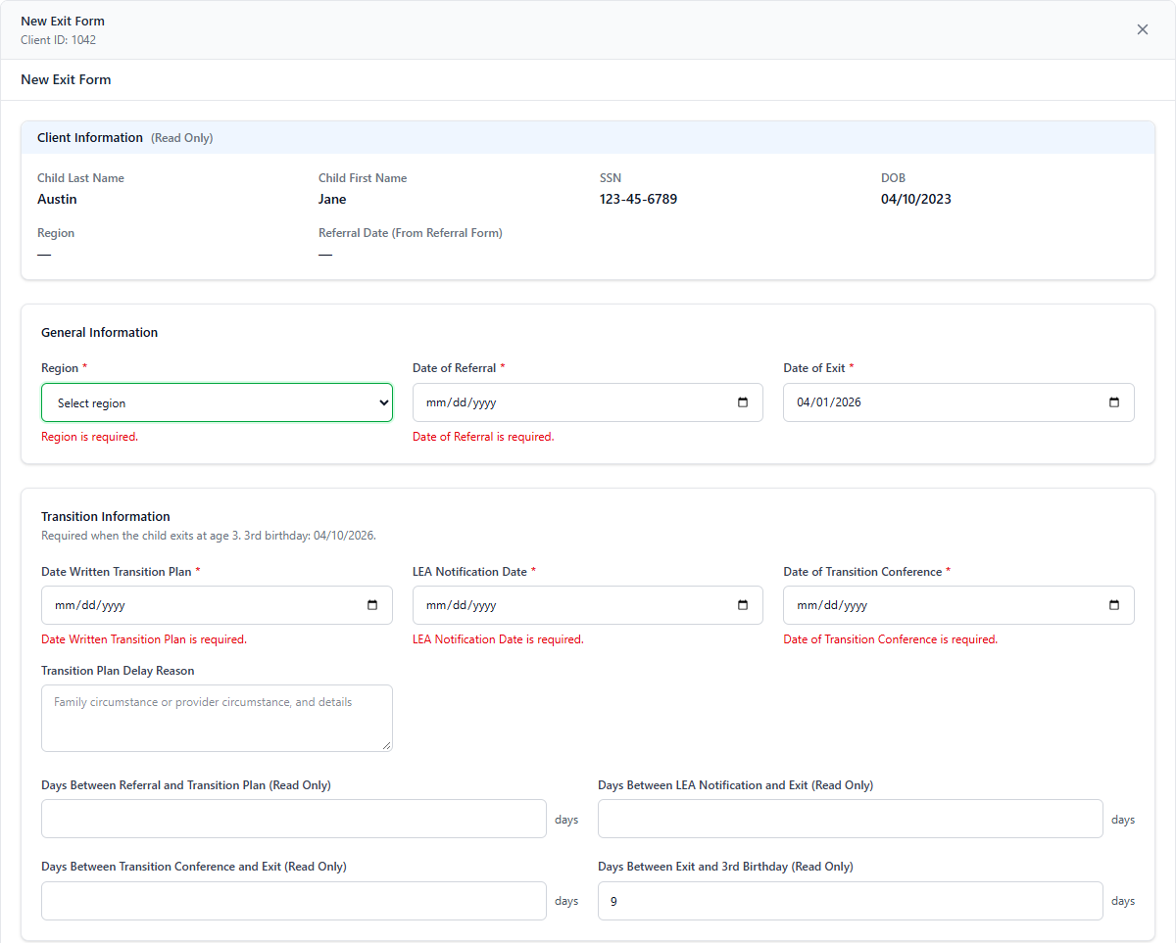
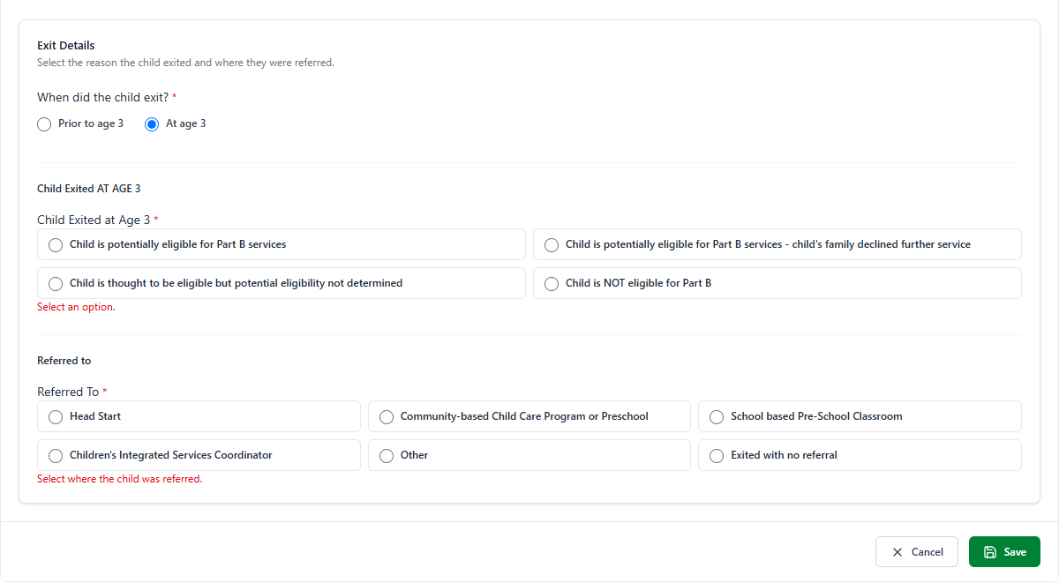
Figure 3 — Save pressed with missing data: each field shows its message and a toast says "Please fix the highlighted fields."

Header and Client Information
# | Element | Type | Behaviour | Data | Rules
1 | Modal header | Title, Client ID, × | "New Exit Form" / "Edit Exit Form" and the Client ID. × closes without saving. | ChildID | BR-EF-01, 06
2 | Page heading | Text | Repeats "New Exit Form" / "Edit Exit Form" (EF-GAP-12). | mode | BR-EF-05
3 | Client details | Read-only labels | Child Last Name, First Name, SSN (unmasked), DOB (MM/DD/YYYY). County and Status are not shown on this form. | stblPeople | BR-EF-24, EF-GAP-13
4 | Region, Referral Date (From Referral Form) | Read-only labels | Follow the Region and Date of Referral fields below as the user types. | form values | BR-EF-24, EF-GAP-11

General Information
# | Element | Type | Behaviour | Data | Rules
5 | Region * | Dropdown | Active regions; "Select region" = 0. New forms: prefilled. "Region is required." | Region | BR-EF-20, 21
6 | Date of Referral * | Date | Required; not before DOB. New forms: prefilled from the latest Active / Referral form. | ReferralDate | BR-EF-21, 22
7 | Date of Exit * | Date | Required; not before DOB or Date of Referral. Also sets FormDate. | ExitDate (+ FormDate) | BR-EF-11, 23

Transition Information
# | Element | Type | Behaviour | Data | Rules
8 | Section description | Text | "Required when the child exits at age 3." plus the 3rd birthday (DOB + 3 years) when the DOB is known. | DOB | BR-EF-36
9 | Date Written Transition Plan | Date | Required only for an exit at age 3. Not before Date of Referral; not after Date of Exit. | TransitionPlanCompleted | BR-EF-30..33
10 | LEA Notification Date | Date | Same rules as 9. | CLLEANotificationDate | BR-EF-30..33
11 | Date of Transition Conference | Date | Required only for an exit at age 3; not after Date of Exit. | TransitionMeeting | BR-EF-30, 32
12 | Transition Plan Delay Reason | Text area | Optional. Placeholder: "Family circumstance or provider circumstance, and details". | TransitionPlanReason | BR-EF-34, EF-GAP-05
13 | Days Between Referral and Transition Plan | Read-only number | Transition Plan date − Date of Referral. Not saved. | — | BR-EF-35
14 | Days Between LEA Notification and Exit | Read-only number | Date of Exit − LEA Notification Date. Not saved. | — | BR-EF-35
15 | Days Between Transition Conference and Exit | Read-only number | Date of Exit − Transition Conference. Not saved. | — | BR-EF-35
16 | Days Between Exit and 3rd Birthday | Read-only number | 3rd birthday − Date of Exit (negative after the birthday). Not saved. | — | BR-EF-35

Exit Details
# | Element | Type | Behaviour | Data | Rules
17 | When did the child exit? * | Radio: Prior to age 3 / At age 3 | Picks which list is shown. New forms follow the exit date until the user picks: "At age 3" from 31 days before the 3rd birthday. | UI only (decides which code column is filled) | BR-EF-40
18 | Reason for Exit * (prior to age 3) | Radio ×8 | Non-EI Client Exit, Referral to CIS-EI, Development at appropriate level, Moved to other region, Moved out of state, Withdrawn by parent or guardian, Unable to contact, Deceased. | ExitPriorToAge3 (7, 8, 1–6) | BR-EF-41, 42
19 | Region Moved To | Text | Shown only for "Moved to other region"; max 255. | MovedOtherRegion | BR-EF-43
20 | Referred To | Radio ×6 | Head Start, Community-based Child Care Program or Preschool, School based Pre-School Classroom, Children's Integrated Services Coordinator, Other, Exited with no referral. Optional for prior to age 3. | ReferredTo (1–5, 99) | BR-EF-47, 48
23 | Transition dates (at age 3) | Required markers | The three transition dates show * and are required. | — | BR-EF-30
24 | Child Exited at Age 3 * | Radio ×4 | Potentially eligible for Part B · Potentially eligible – family declined · Thought eligible – eligibility not determined · NOT eligible for Part B. | ExitAtAge3 (1–4) | BR-EF-44, 46
25 | Referred To * (at age 3) | Radio ×6 | Required for an exit at age 3. | ReferredTo | BR-EF-47

Actions
# | Element | Behaviour | Messages
21 | Cancel | Closes without saving (no warning). | —
22 | Save | Validates, then creates (POST) or updates (PUT); the Input Forms grid refreshes and the modal closes. Shows "Saving..." while busy. | "Exit Form saved successfully." / "Exit Form updated successfully." / "Please fix the highlighted fields." / server message or "Failed to save Exit Form."

Other screen states: "Loading Exit Form..." · "Exit Form could not be loaded." · "Exit Form record not found." (edit, then the modal closes).

