07 — Entity-Relationship Diagram: Exit Form
Work item: Create ERD (Exit Form) | Module: Exit Form | Date: 2026-11-02 | Repository source: docs/exit-form/07-erd.md
Built from the dbCDD DDL (2026-09-09), checked against the local database. Solid lines are physical FKs; dashed lines are logical relationships (used by queries, not enforced by the database).
stblExitForm has 45 columns. The diagrams show the key and referencing columns only; see 04-data-dictionary.md for every column, grouped as: header (6), location / coordinator / referral (11), COSF questions (6), exit date and transition (10), exit reason and referral (7), audit (5).

1a. Core: the form, its client and the forms it's prefilled from
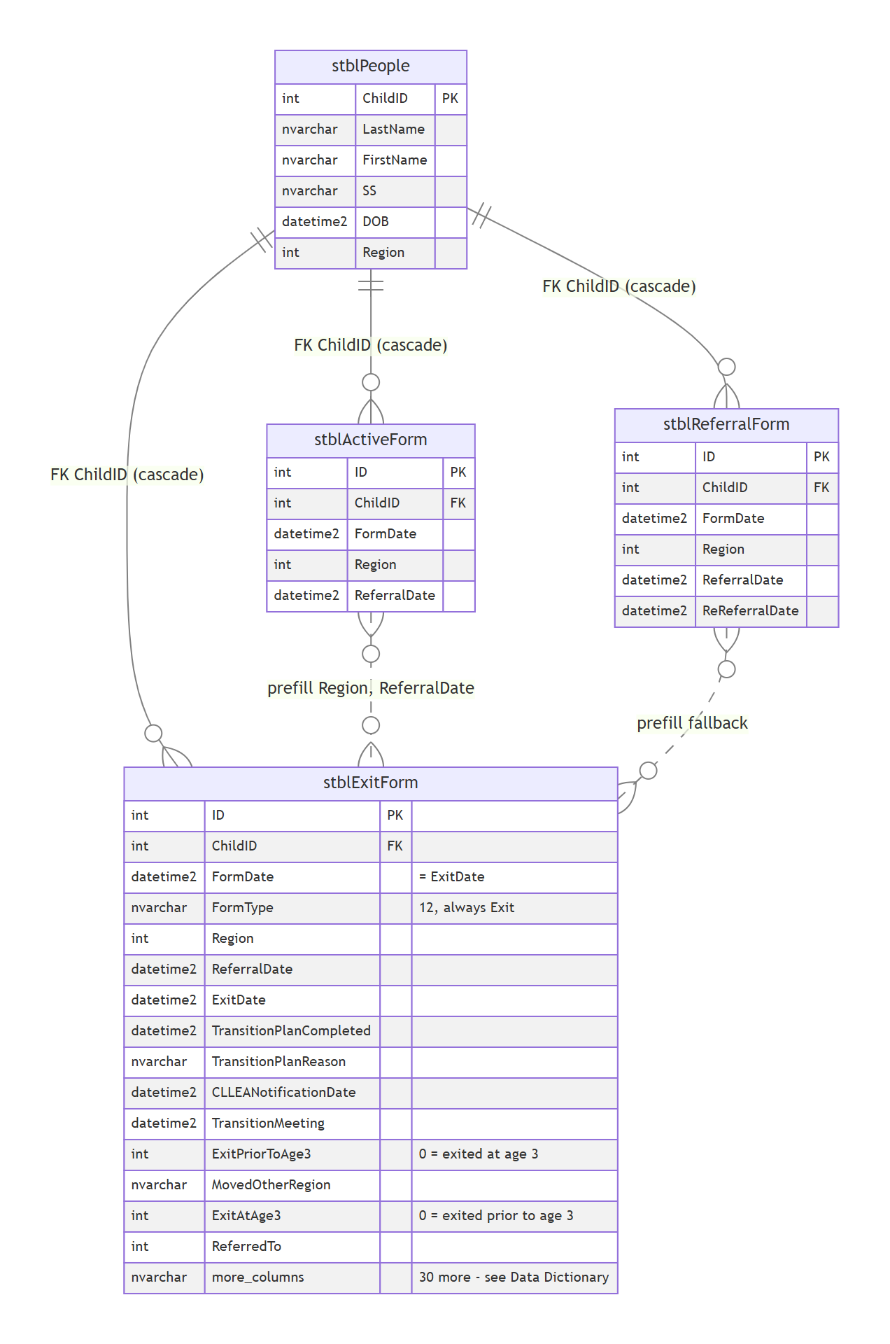

1b. Lookups and code lists referenced by the form
Only the referencing columns of stblExitForm are shown. The three exit code lists have no table in dbCDD; they live in the backend config.
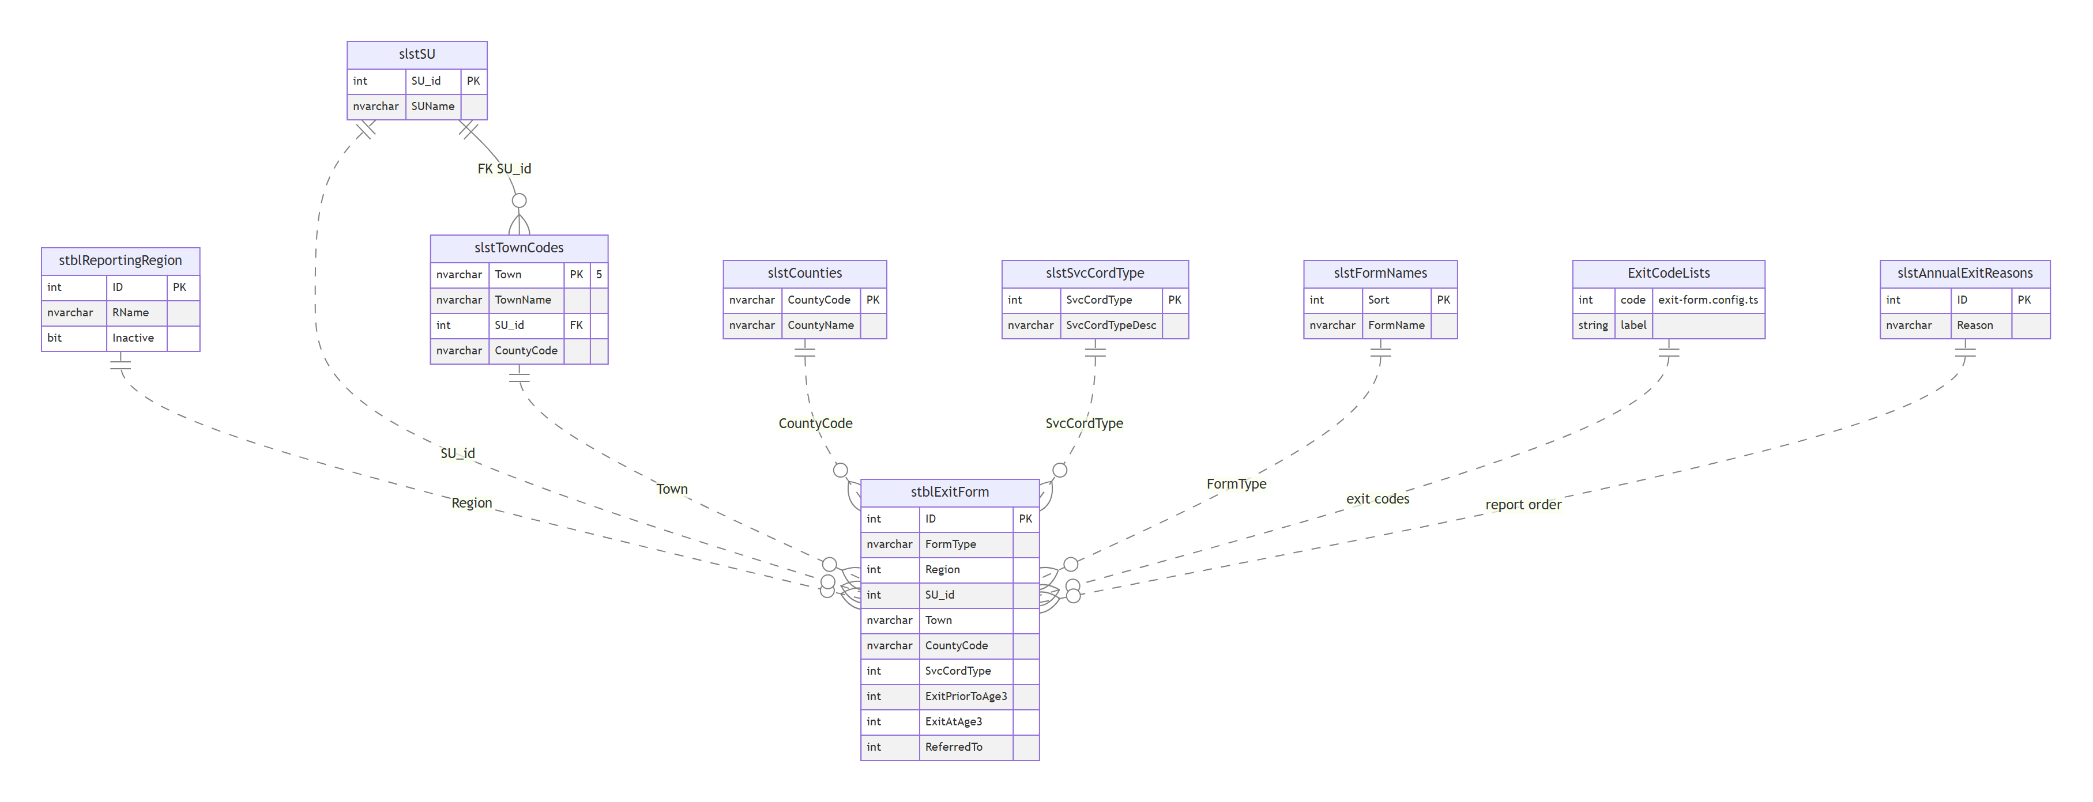

2. Relationship catalogue
# | Parent | Child | Join | Physical FK | On delete | Notes
R1 | stblPeople | stblExitForm | ChildID | stblExitForm$stblPeoplestblExitForm (WITH NOCHECK) | Cascade | Deleting a client deletes its Exit Forms
R2 | stblActiveForm | stblExitForm | ChildID, latest by FormDate | No | — | Prefill of Region and ReferralDate for a new form
R3 | stblReferralForm | stblExitForm | ChildID, latest by re-referral / referral date | No | — | Prefill fallback
R4 | stblReportingRegion | stblExitForm | Region = ID | No | — | UI picks from active regions
R5 | slstSU | stblExitForm | SU_id | No | — | Not on the screen [Decision]
R6 | slstTownCodes | stblExitForm | Town | No | — | Form column nvarchar(3), lookup key nvarchar(5)
R7 | slstCounties | stblExitForm | CountyCode | No | — | Not on the screen
R8 | slstSvcCordType | stblExitForm | SvcCordType | No | — | Not on the screen
R9 | slstFormNames | stblExitForm | FormType = FormName (text) | No | — | Always 'Exit', so it matches
R10 | (config) code lists | stblExitForm | ExitPriorToAge3, ExitAtAge3, ReferredTo | No | — | No table; values checked by the backend
R11 | slstAnnualExitReasons | stblExitForm | reports map codes to ID with Choose(...) | No | — | Codes 7 and 8 have no mapping (EF-GAP-02)
R12 | slstSU | slstTownCodes | SU_id | slstTownCodes$slstSUslstTownCodes | No action | Only FK among the lookups

3. Notes for the DBA
- The only enforced relationship is R1 (cascade), and it was created WITH NOCHECK, so SQL Server doesn't trust it for query plans. Re-enable it WITH CHECK after confirming there are no orphans.
- No index on stblExitForm.ChildID; the client lookup (WHERE ChildID = …), the Input Forms history and the cascade delete scan the table.
- The exit code lists exist only in code and in column descriptions. A lookup table (slstExitReasonPriorToAge3, slstExitAtAge3, slstReferredTo) would let reports join instead of hard-coding Choose(...) mappings.

