01 — Code Annotations: Exit Form
Work item: Supporting document | Module: Exit Form | Date: 2026-11-05
File-by-file walkthrough of the Exit Form feature. Line references are to the current code.

1. Architecture
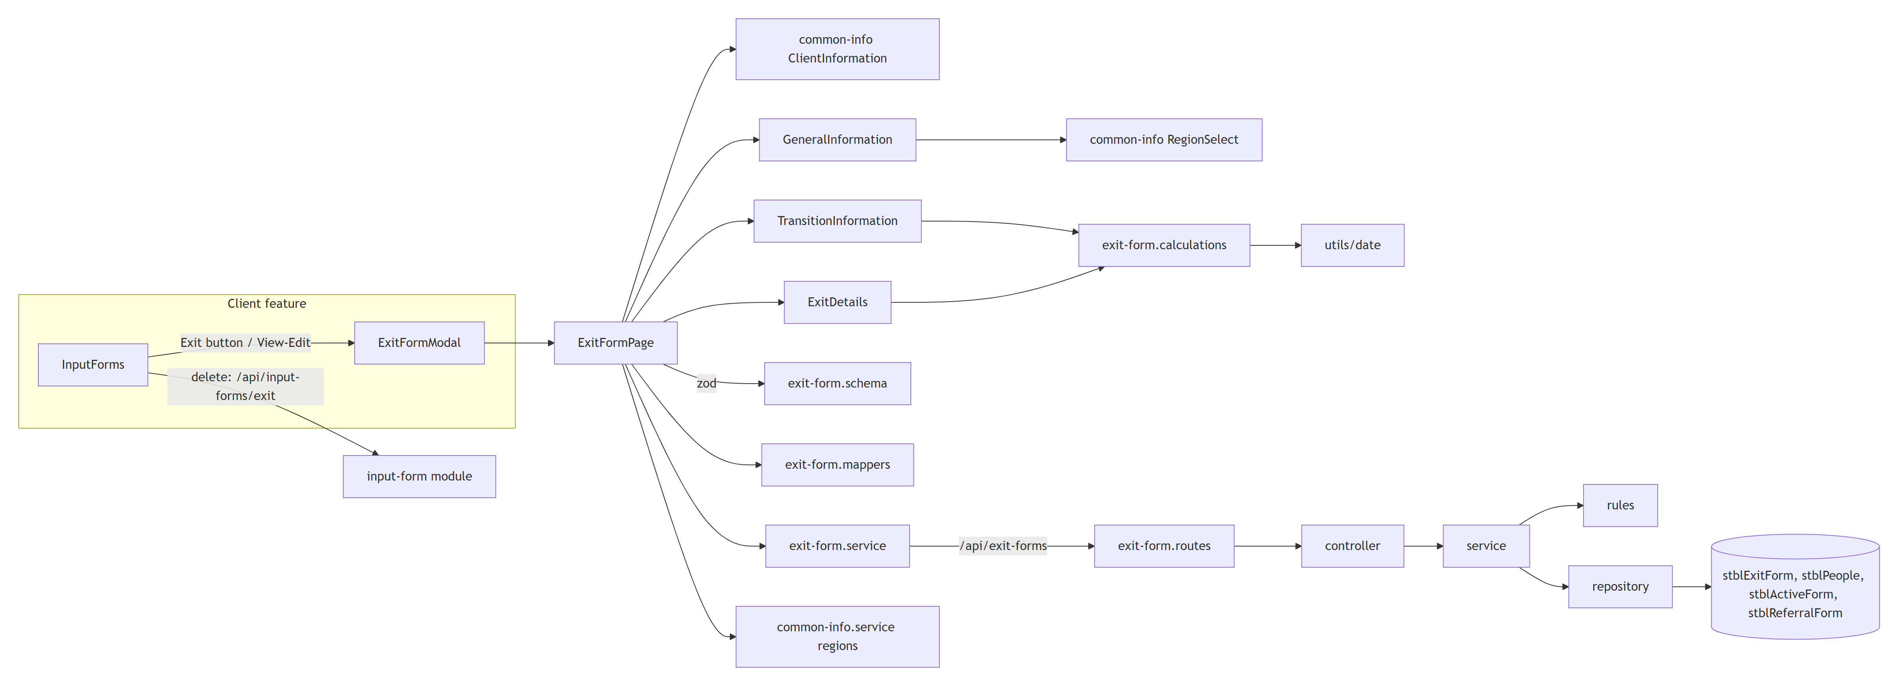
The form uses react-hook-form with a zod resolver. All sections share one form context (FormProvider). The backend splits pure rules (exit-form.rules.ts) from database access (exit-form.repository.ts), so the rules are unit-tested without a database.

2. Backend — backend/src/modules/exit-form
File | Annotation
index.ts | Exports the router as exitFormRoutes (mounted at /api/exit-forms in app.ts:61, no auth) and the types.
exit-form.routes.ts | GET /lookups/options first (so lookups isn't read as a child ID), then GET/POST /:childId, GET /:childId/defaults, GET/PUT/DELETE /:childId/:id. Every route has @swagger comments (schemas ExitFormInput, ExitForm), so the API appears in /api-docs.
exit-form.controller.ts | One-line adapters. create returns 201; the body defaults to {}.
exit-form.types.ts | ExitFormRecord (open record), ExitFormClient (the stblPeople header), ExitFormDefaults (Region, ReferralDate).
exit-form.config.ts | Table names (ACTIVE_FORM_TABLE is re-exported from the Active Form config); EXIT_FORM_TYPE = 'Exit'; COLUMNS — the 38 writable columns with a kind (int, yesNo, bit, date, text) and max length, used for both parsing and SQL binding; the three code lists EXIT_PRIOR_TO_AGE_3, EXIT_AT_AGE_3, REFERRED_TO; and the constants NOT_THIS_EXIT_PATH = 0, EXIT_AT_AGE_3_NOT_ELIGIBLE = 4, EXIT_PRIOR_MOVED_OTHER_REGION = 2.

2.1 exit-form.rules.ts
Function | Annotation
error(message, status) | Throws an Error tagged with a status (400 by default). The global error middleware ignores the tag and returns 500 (EF-GAP-08).
toIsoDate(value) | Date, ISO timestamp or YYYY-MM-DD → YYYY-MM-DD, else null. Used to compare dates as strings.
parseDate / parseInt32 / parseYesNo / parseBit / parseText | Per-kind parsing. Dates must be YYYY-MM-DD and real (round-trip check). Yes/No accepts true/false, yes/no, -1/0/1 and stores -1 / 0. Text is trimmed, blank → null, and checked against the column length.
checkCode(value, field, options, allowNotThisPath) | Rejects a code that isn't in the list ("… has an unknown value: …"); the exit-path columns also allow 0.
normalizePayload(raw) (:103) | Body → typed columns. Drops unknown keys, ID, ChildID and FormType (always 'Exit'). Returns only keys that were sent, so it works for partial updates.
applyExitPath(p) (:148) | When one path has a real code, sets the other path's column to 0 (legacy convention).
clearDependentFields(p) (:163) | MovedOtherRegion → null unless ExitPriorToAge3 = 2; EXFNoPartB1-3 → false unless ExitAtAge3 = 4. Only when that answer is part of the save.
validateRecord(record, dob) (:175) | Cross-field rules on the merged record: dates not before DOB; exit not before referral; transition plan and LEA dates not before referral; transition dates not after exit; not both paths; Referred To required when ExitAtAge3 = 4.

2.2 exit-form.service.ts
Function | Annotation
int(value, name) | Positive-integer check for ChildID / ID.
child(childId) | Loads the client or throws "Client not found" (404).
prepare(raw) | normalizePayload → applyExitPath → clearDependentFields.
get | Returns { client, forms }.
getOne | One form, or "Exit Form not found" (404).
create | Requires Region and ExitDate; sets FormDate = ExitDate when not sent; validates; inserts.
update | Requires the row to exist. Region / ExitDate can't be cleared. If the saved FormDate equalled the saved ExitDate, a new ExitDate moves FormDate too. Validates the merged row; partial update.
remove | Deletes; "Exit Form not found" if 0 rows. Returns { success: true }.
defaults | Prefill for a new form: Region and ReferralDate from the latest Active form, falling back to the latest Referral form, then the client's region.
lookups.options | Returns the three code lists from the config.

2.3 exit-form.repository.ts
Function | Annotation
clean(payload) | Keeps only COLUMNS keys (second guard after the rules).
bind(req, key, value) | Types parameters from the column kind: dates as NVarChar(10) (the legacy "SQL Server" ODBC driver rejects date parameters, HY004), int/yesNo as Int, bit as Bit, text as NVarChar(max length).
col(name) | Brackets a column name. Safe because names come from COLUMNS.
getClient | stblPeople header for the form.
findByChildId | SELECT * for the client, newest exit first (ExitDate nulls last, then ID DESC).
findOne | One row by ChildID + ID.
insert | INSERT (ChildID, FormType='Exit', …keys) OUTPUT INSERTED.ID, then re-reads the row.
update | UPDATE SET …keys, LastUpdateDate = GETDATE(), LastUpdateUser = SUSER_SNAME(); re-reads. No keys → just re-reads.
remove | DELETE + SELECT @@ROWCOUNT.
findLatestReferral | Latest stblReferralForm by COALESCE(ReReferralDate, ReferralDate, FormDate).
findLatestActive | Latest stblActiveForm by FormDate.

3. Frontend — frontend/src/features/exit-form
File | Annotation
index.ts | Exports ExitFormPage.
schemas/exit-form.schema.ts | createExitFormSchema(dob): Region ≥ 1; Date of Referral and Date of Exit required; date format; then the same cross-field rules as the backend, plus: exit path required, a reason required for its path, and for at age 3 the outcome, Referred To and all three transition dates required.
utils/exit-form.calculations.ts | thirdBirthday(dob), calculateExit(values, dob) (the four day counts) and suggestExitPath(exitDate, dob) (at age 3 from 31 days before the 3rd birthday). Built on the shared utils/date.ts (toDateInput, daysBetween, addToDate, formatDate — UTC, so daylight saving can't shift a count).
utils/exit-form.mappers.ts | recordToValues (DB row → form; 0/null codes → not chosen; the path comes from whichever code is set), defaultsToValues (prefill), valuesToPayload (form → API: only the fields on the screen; the other path's code and MovedOtherRegion are sent as null).
components/ExitFormControls.tsx | Section (card with title and description) and SubSection.

3.1 pages/ExitFormPage.tsx
Props: childId, formId? (edit when set), onClose, onSaved?.
Part | Annotation
apiMessage | Server message (or error) from an Axios error, else a fallback.
ClientAndGeneral | Watches Region and ReferralDate so the read-only Client Information shows the selected region's name and the typed referral date.
Load effect | In parallel: GET /api/exit-forms/{childId}, regions, options, and (new only) GET …/defaults. Edit mode finds the form by ID or shows "Exit Form record not found." and closes.
Schema | Rebuilt when the DOB is known (useMemo). Validation runs on submit.
saveForm | valuesToPayload → PUT (edit) or POST (new) → success toast → onSaved() (parent reloads and closes). Errors show the server message.
Render | Loading / error states; sticky header; Client Information, General, Transition, Exit Details; sticky footer Cancel / Save ("Saving...").

3.2 Sections
Component | Annotation
GeneralInformation.tsx | Region (RegionSelect, valueAsNumber, placeholder 0), Date of Referral, Date of Exit — all required.
TransitionInformation.tsx | Three dates (required only when the path is at age 3), Transition Plan Delay Reason (textarea), and four read-only day counts from calculateExit. The description shows the 3rd birthday.
ExitDetails.tsx | Path radios; an effect suggests the path for new forms until the user picks one (:34). Prior → reason radios (+ "Region Moved To" for code 2). At age 3 → outcome radios. Referred To radios once a path is chosen (required for at age 3).

3.3 Shared files outside the feature
File | Annotation
common-info/components/ClientInformation.tsx | Shared read-only client card. County and Status show only when passed; the Exit Form doesn't pass them.
common-info Field, FieldGroup, RegionSelect, inputClass | Shared form controls; required fields show * inside the label.
services/exit-form.service.ts | Axios wrapper: get, defaults, create, update, options.
types/exit-form.ts | ExitFormClient, ExitFormRecord, ExitFormDefaults, ExitFormOptions, ExitFormCalculated, ExitFormValues, DEFAULT_EXIT_FORM_VALUES.
client/components/InputForm/InputForms.tsx | Hosts ExitFormModal; deletes Exit rows through the generic input-form API.

3.4 Tests
Area | File | Test cases
Backend | exit-form.rules.test.ts | 59
Backend | exit-form.service.test.ts | 50
Backend | exit-form.repository.test.ts | 20
Backend | exit-form.controller.test.ts | 11
Backend | exit-form.routes.test.ts | 9
Frontend | ExitFormPage.test.tsx | 25
Frontend | exit-form.schema.test.ts | 23
Frontend | exit-form.mappers.test.ts | 16
Frontend | ExitDetails.test.tsx | 15
Frontend | exit-form.calculations.test.ts | 13
Frontend | TransitionInformation.test.tsx | 12
Frontend | utils/date.test.ts (shared) | 12
Frontend | GeneralInformation.test.tsx | 8
Frontend | services/exit-form.service.test.ts | 6
Frontend | ExitFormControls.test.tsx | 3

Counts are it/test blocks; it.each blocks run once per row, so the backend suite runs 196 tests for the module. Frontend tests run in Vitest browser mode (Chromium).

