00 — Annotated Wireframe: Active Form
Work item: Create Annotated Wireframe (Active Form) | Module: Active Form | Date: 2026-10-01 | Repository source: docs/active-form/00-annotated-wireframe.md
Wireframe of the Active Form as built today. It opens as a full-screen modal from the Client screen → Input Forms tab → Active (new) or View/Edit on an Active row (edit). Numbered red markers match the table below. Sample data is fictional.
Rules referenced as BR-AF-… / AF-GAP-… are in 03-business-rules.md; fields are specified in 06-field-spec.md.
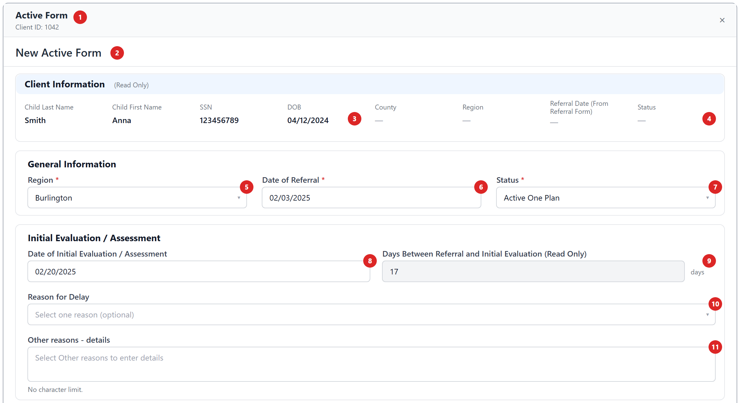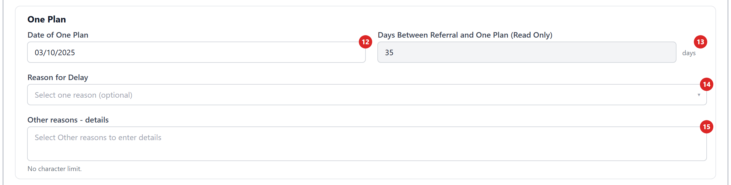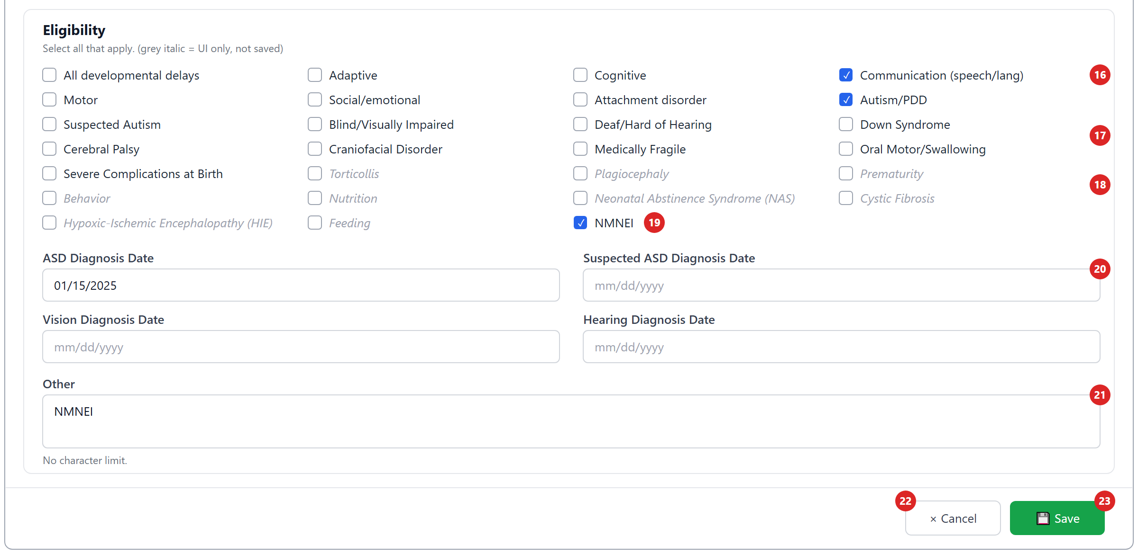
Grey italic conditions are on screen but not saved (AF-GAP-02).

Header and Client Information
# | Element | Type | Behaviour | Data | Rules
1 | Modal header | Title, Client ID, × | × closes without saving. | ChildID | BR-AF-01, 06
2 | Page heading | Text | "New Active Form" or "Edit Active Form". | mode | BR-AF-05
3 | Client details | Read-only labels | Child Last Name, First Name, SSN (unmasked), DOB (MM/DD/YYYY). | stblPeople | AF-GAP-17
4 | County, Region, Referral Date (From Referral Form), Status | Read-only labels | Always "—"; the page never supplies them. | — | AF-GAP-07

General Information
# | Element | Type | Behaviour | Data | Rules
5 | Region * | Dropdown | Active regions; defaults to the client's region. "Region is required." | Region | BR-AF-20, 21
6 | Date of Referral * | Date | Required; not before DOB. Free entry: legacy reports need it to equal the Referral form's date. | ReferralDate | BR-AF-22, 23, AF-GAP-05
7 | Status * | Dropdown | Active One Plan / Active One Plan – CAPTA → saved as aop / aop-capta. | FormType | BR-AF-12, 13, AF-GAP-03

Initial Evaluation / Assessment
# | Element | Type | Behaviour | Data | Rules
8 | Date of Initial Evaluation / Assessment | Date | Required by validation (no * shown); can't be before Referral Date or DOB. | InitialEvalDate | BR-AF-30, 31, AF-GAP-15
9 | Days Between Referral and Initial Evaluation | Read-only number | Calculated; not saved. 45-day compliance isn't stored. | — | BR-AF-32, 33, AF-GAP-04
10 | Reason for Delay | Dropdown, 2 groups | Optional. "1. Due to family and/or child circumstances" (+ "Auto Eligible") or "2. NOT due to … (non-compliant)". | DelayFC / DelayNotFC | BR-AF-50..52
11 | Other reasons – details | Text area | Not saved. | (should be DelayFCOther / DelayNotFCOther) | BR-AF-53, AF-GAP-01

One Plan
# | Element | Type | Behaviour | Data | Rules
12 | Date of One Plan | Date | Required by validation; can't be before Referral Date or DOB. | InitialMeetingDate | BR-AF-40, 41
13 | Days Between Referral and One Plan | Read-only number | Calculated; not saved. | — | BR-AF-42, 44
14 | Reason for Delay | Dropdown, 2 groups | Optional (no "Auto Eligible" here). | MeetingDelayFC / MeetingDelayNC | BR-AF-50, 51
15 | Other reasons – details | Text area | Not saved. | (should be MeetingDelayFCOther / MeetingDelayNCOther) | AF-GAP-01

Eligibility
# | Element | Type | Behaviour | Data | Rules
16 | Developmental delays | Checkboxes ×6 | All, Adaptive, Cognitive, Communication, Motor, Social/emotional. | DDAll … DDSocial | BR-AF-61
17 | Diagnosed conditions | Checkboxes ×11 | Attachment … Severe Complications at Birth. | DCAttachment … DCBirth | BR-AF-62
18 | UI-only conditions | Checkboxes ×9 | Torticollis, Plagiocephaly, Prematurity, Behavior, Nutrition, NAS, Cystic Fibrosis, HIE, Feeding — not saved. | none | BR-AF-63, AF-GAP-02
19 | NMNEI | Checkbox | Ticking adds a line "NMNEI" to Other; unticking removes it. | inside DCOtherDesc | BR-AF-64, AF-GAP-10
20 | Diagnosis dates | Dates ×4 | ASD, Suspected ASD, Vision, Hearing; always editable; not before DOB. | AutismDate, SuspectedDate, BlindDate, DeafDate | BR-AF-65
21 | Other | Text area | Free text (+ NMNEI line). Hint says "No character limit", but the DB allows 255. | DCOtherDesc | BR-AF-66, AF-GAP-12

Actions
# | Element | Behaviour | Messages
22 | Cancel | Closes without saving. | —
23 | Save | Validates, then creates or updates; the Input Forms grid refreshes and the modal closes. Shows "Saving..." while busy. | "Active Form saved successfully." / "Active Form updated successfully." / server message or "Failed to save Active Form."
Other screen states: "Loading Active Form..." · "Client information could not be loaded." · "Active Form record not found." (edit, then closes).

