07 — Entity-Relationship Diagram: Active Form
Work item: Create ERD (Active Form) | Module: Active Form | Date: 2026-10-01 | Repository source: docs/active-form/07-erd.md
Built from the dbCDD DDL (2026-09-09). Solid lines are physical FKs; dashed lines are logical relationships (used by queries, not enforced by the database).
stblActiveForm has 72 columns. The diagrams show the key and referencing columns only; see 04-data-dictionary.md for every column, grouped as: header (6), location and service coordinator (15), evaluation and One Plan (23), eligibility (23), audit (5).

1a. Core: the form, its client and its referral
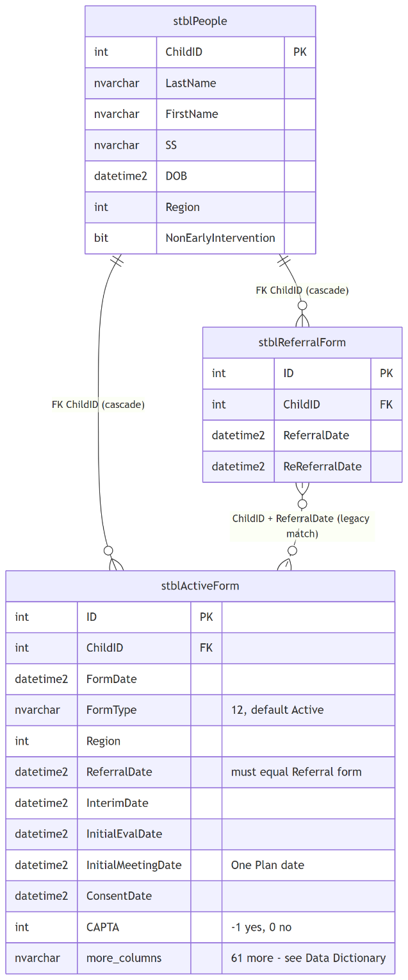

1b. Lookups referenced by the form
Only the referencing columns of stblActiveForm are shown.
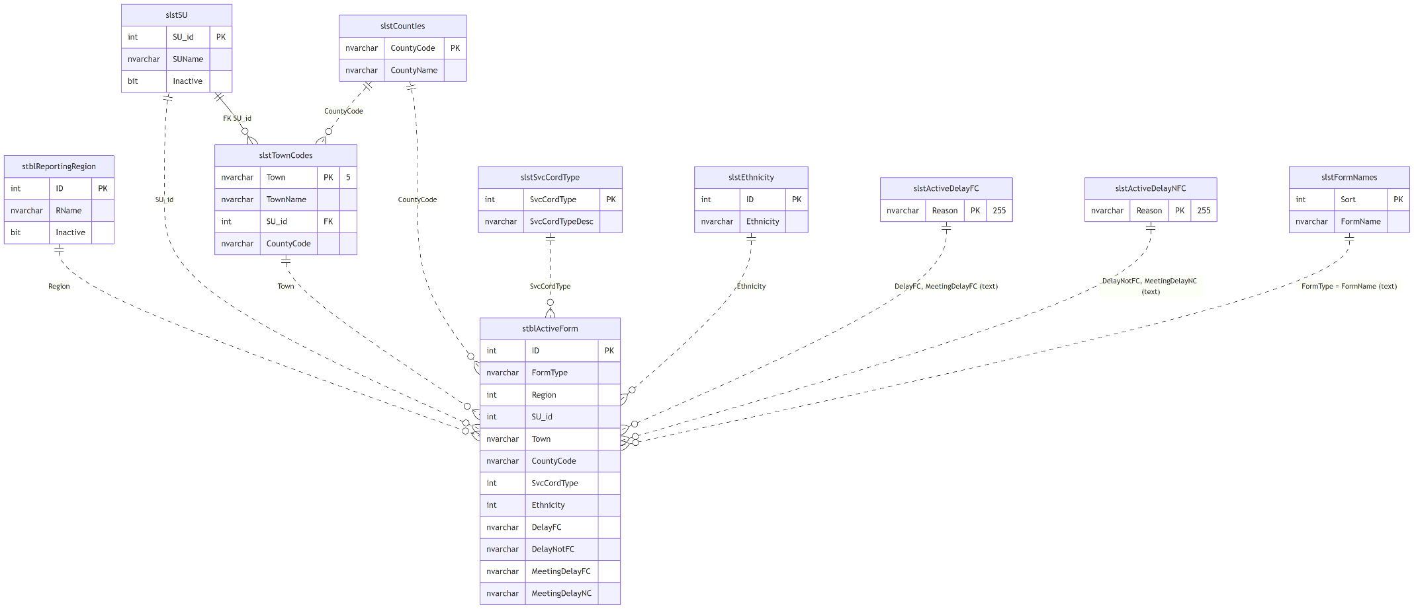

2. Relationship catalogue
# | Parent | Child | Join | Physical FK | On delete | Notes
R1 | stblPeople | stblActiveForm | ChildID | stblActiveForm$stblPeoplestblActiveForm | Cascade | Deleting a client deletes its Active Forms
R2 | stblReportingRegion | stblActiveForm | Region = ID | No | — | UI picks from active regions
R3 | slstSU | stblActiveForm | SU_id | No | — | SUName also copied onto the form
R4 | slstTownCodes | stblActiveForm | Town | No | — | Form column is nvarchar(3), lookup key nvarchar(5)
R5 | slstCounties | stblActiveForm | CountyCode | No | — | Derivable from Town
R6 | slstSvcCordType | stblActiveForm | SvcCordType | No | — | Values 1–4 per column description
R7 | slstEthnicity | stblActiveForm | Ethnicity = ID | No | — | Not used by the new UI
R8 | slstActiveDelayFC | stblActiveForm | DelayFC, MeetingDelayFC = Reason (text) | No | — | Lookup text is 255, form columns 50
R9 | slstActiveDelayNFC | stblActiveForm | DelayNotFC, MeetingDelayNC = Reason (text) | No | — | Same
R10 | slstFormNames | stblActiveForm | FormType = FormName (text) | No | — | aop values don't match
R11 | slstSU | slstTownCodes | SU_id | slstTownCodes$slstSUslstTownCodes | No action | Only FK among the lookups
R12 | stblReferralForm | stblActiveForm | ChildID and ReferralDate | No | — | Legacy LoopAB / Base0701 match a referral to its Active Form by equal dates

3. Notes for the DBA
- The only enforced relationship is R1 (cascade). Every lookup is matched by value; text lookups (R8–R10) break silently on spelling or length differences.
- No index on stblActiveForm.ChildID; the client lookup (WHERE ChildID = …) and the cascade delete scan the table.
- Town nvarchar(3) can't hold slstTownCodes.Town nvarchar(5) values longer than 3 characters.

