01 — Code Annotations: Active Form
Work item: Supporting document | Module: Active Form | Date: 2026-10-01 | Repository source: docs/active-form/01-annotations.md
File-by-file walkthrough of the Active Form feature. Line references are to the working tree on 2026-10-01. That tree includes uncommitted changes: GeneralInformation.tsx (region type import) and the removal of /lookups/regions from the controller and routes.

1. Architecture
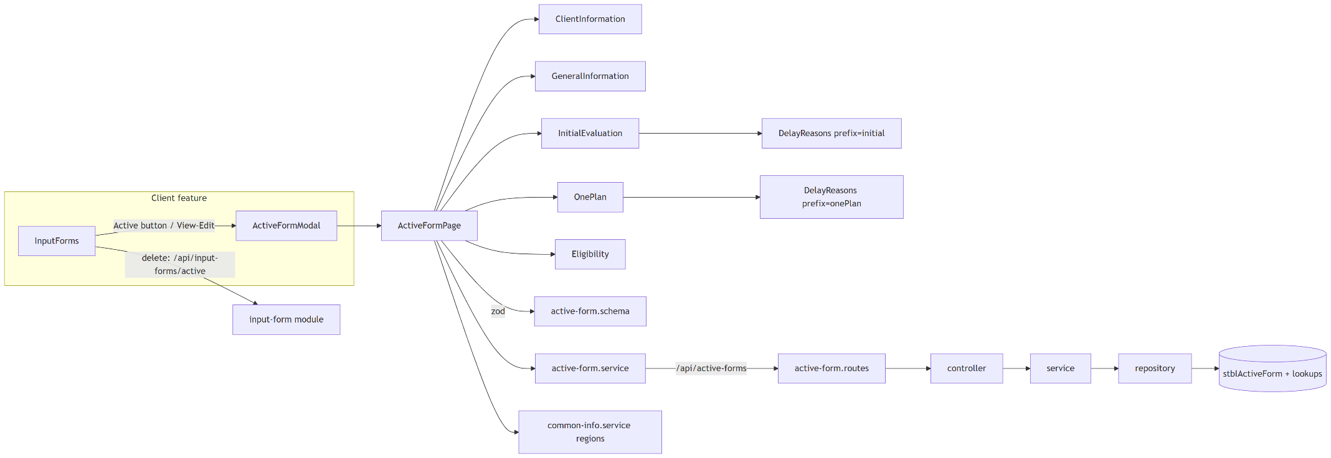
The form uses react-hook-form with a zod resolver; all sections share one form context (FormProvider).

2. Backend — backend/src/modules/active-form
File | Annotation
index.ts | Exports the router as activeFormRoutes (mounted at /api/active-forms in app.ts:58, no auth) and the types.
active-form.routes.ts | 4 lookup routes first ("must come before /:childId"), then GET/POST /:childId and GET/PUT/DELETE /:childId/:id. No @swagger comments.
active-form.controller.ts | One-line adapters. create returns 201. towns passes search only when it's a string.
active-form.types.ts | ActiveFormRecord is an untyped Record<string, unknown>. ActiveFormClient.Region is typed string (the DB column is int). ActiveFormWithClient is unused.
active-form.config.ts | ACTIVE_FORM_TABLE, the write whitelist WRITABLE_COLUMNS (65 columns) and the lookup table names. Comment documents the aliases status → FormType, onePlanDate → InitialMeetingDate.

2.1 active-form.service.ts
Function | Annotation
error(message, status) | Throws an Error tagged with a status (400 default). The global error middleware ignores the tag and returns 500.
int(value, name) | Positive-integer check for ChildID / ID.
date(value, field) | Empty → null; else must be YYYY-MM-DD and a real calendar date (round-trip check).
aliases(raw) | Copies status → FormType and onePlanDate → InitialMeetingDate (only if the target isn't already set), then deletes the aliases.
validateDates(p, dob) | Referral, InitialEval and OnePlan must not be before DOB. The commented-out version above it also checked eval/One Plan ≥ referral (:36-52).
child(childId) | Loads the client or throws "Client not found" (404).
townMapping(p) | If Town is sent, resolves it by code or name and sets Town, CountyCode and SU_id (if not sent).
get | Returns { client, forms }.
create | Rejects Region: "", validates dates against DOB, maps town, inserts.
update | Requires the row to exist; validates the merged row (existing + changes); partial update.
remove | Deletes; "Active Form not found" if 0 rows. Returns { success: true }.
lookups | Pass-through to repository lookup queries.

2.2 active-form.repository.ts
Function | Annotation
clean(payload) | Drops ID, ChildID, childId and anything not in the whitelist.
bind(req, key, value) | Types parameters from the JS value: null → NVarChar, boolean → Bit, integer → Int, else NVarChar (so dates and numeric strings rely on SQL Server's implicit conversion).
col(name) | Brackets a column name ([Name], with ] escaped). Safe because names come from the whitelist.
getClient | stblPeople header for the form.
findByChildId | SELECT * for the client, ORDER BY ReferralDate IS NULL, ReferralDate DESC, ID DESC.
findOne | One row by ChildID + ID.
insert | Dynamic INSERT (ChildID, …keys) OUTPUT INSERTED.ID, then re-reads the row.
update | Dynamic UPDATE SET …keys, LastUpdateDate = GETDATE(); re-reads. Does nothing if no keys survive the whitelist.
remove | DELETE + SELECT @@ROWCOUNT.
getSupervisoryUnions / getTowns / getTown / getServiceCoordinatorTypes / getDelayReasons | Lookup queries; getDelayReasons runs both lists in parallel.

3. Frontend — frontend/src/features/active-form
File | Annotation
index.ts | Exports the page plus ActiveFormAddPage / ActiveFormEditPage, which are unused re-exports of the same page.
schemas/active-form.schema.ts | Zod schema: Region ≥ 1; Referral, Initial Evaluation and One Plan dates required; status required; date format checks; eval and One Plan ≥ referral. Booleans for every eligibility item, including the 9 UI-only ones.
components/FormField.tsx | Field: label, optional red *, child control, error text.
components/formStyles.ts | Shared input class (green focus ring).

3.1 pages/ActiveFormPage.tsx
Props: childId, formId? (edit when set), onClose, onSaved?.
Part | Annotation
toDateInput | Cuts any date string to YYYY-MM-DD.
toValues(form) | DB row → form values. Delay columns become family::x / provider::x. onePlanDate comes from InitialMeetingDate. NMNEI is ticked if DCOtherDesc has a line "NMNEI". The 9 UI-only conditions read non-existent columns, so they're always false.
toPayload(values, isNew) | Form values → API body. Sets FormDate = today (local) on new forms. Splits the delay reasons into the FC/NotFC pair. Omits DelayDetails, MeetingDelayDetails and the 9 UI-only conditions.
validateDates | Second pass after zod: all 7 dates ≥ DOB; eval and One Plan ≥ referral. Shows the first failure as a toast.
Load effect | In parallel: GET /api/active-forms/{childId}, regions, delay reasons. Edit mode finds the form in forms by ID; new mode defaults Region to the client's region.
saveForm | DOB checks → POST or PUT → success toast → onSaved() (parent refreshes and closes). Errors show the server message.
Render | Loading/error states; sticky header "New/Edit Active Form"; five sections; sticky footer Cancel / Save ("Saving...").

3.2 Sections
Component | Annotation
ClientInformation.tsx | Read-only header with 8 items. Optional props county, regionName, referralDate, status are never passed, so those four always show "—". SSN is unmasked.
GeneralInformation.tsx | Region select (valueAsNumber, "Select region" = 0), Date of Referral, Status (aop / aop-capta) (:65-66). The register rules are ignored because the zod resolver takes over; the zod messages are shown.
InitialEvaluation.tsx | Evaluation date (min = later of referral and DOB); read-only day count (dayjs.diff); DelayReasons prefix="initial".
OnePlan.tsx | Same pattern for onePlanDate; DelayReasons prefix="onePlan".
DelayReasons.tsx | One select with two option groups (family / provider). Values are prefixed family:: or provider::. Adds "Auto Eligible" to family for the initial evaluation. The "Other reasons – details" textarea is registered to DelayDetails/MeetingDelayDetails, which aren't saved.
Eligibility.tsx | 26 condition checkboxes + NMNEI; 4 diagnosis dates (min = DOB); "Other" textarea. An effect keeps a line "NMNEI" in Other in sync with the NMNEI checkbox.

3.3 Shared files outside the feature
File | Annotation
services/active-form.service.ts | Axios wrapper for all 9 endpoints. The UI uses get, create, update and delayReasons.
types/active-form.ts | ActiveFormClient, ActiveFormRecord (open index signature), lookup types, ActiveFormValues, DEFAULT_ACTIVE_FORM_VALUES.
client/components/InputForm/InputForms.tsx | Hosts the modal (ActiveFormModal); deletes Active rows via the generic input-form API.

3.4 Tests
There are no tests for the Active Form feature or module. InputForms.test.tsx mocks ActiveFormPage and only checks that the modal opens and that the delete confirmation says "Active Form".

