00 — Annotated Wireframe: Client Screen
Work item: 94268 Create Annotated Wireframe | Module: Client | Date: 2026-10-01 | Repository source: docs/client/00-annotated-wireframe.md
Wireframe of the Client screen (ClientPage) as built today. Numbered red markers match the tables below. Sample data is fictional.
The screen has three stacked areas:
- Client Lookup & Details (top) — find a client and view/edit demographics.
- Action bar — Lock/Unlock, Delete, Add New, Done.
- Tabs — Client Status (status, notes, service history) and Input Forms (form history and form entry).
Rules referenced as BR-… are in 03-business-rules.md; fields are specified in 06-field-spec.md.

View 1 — Client Status tab
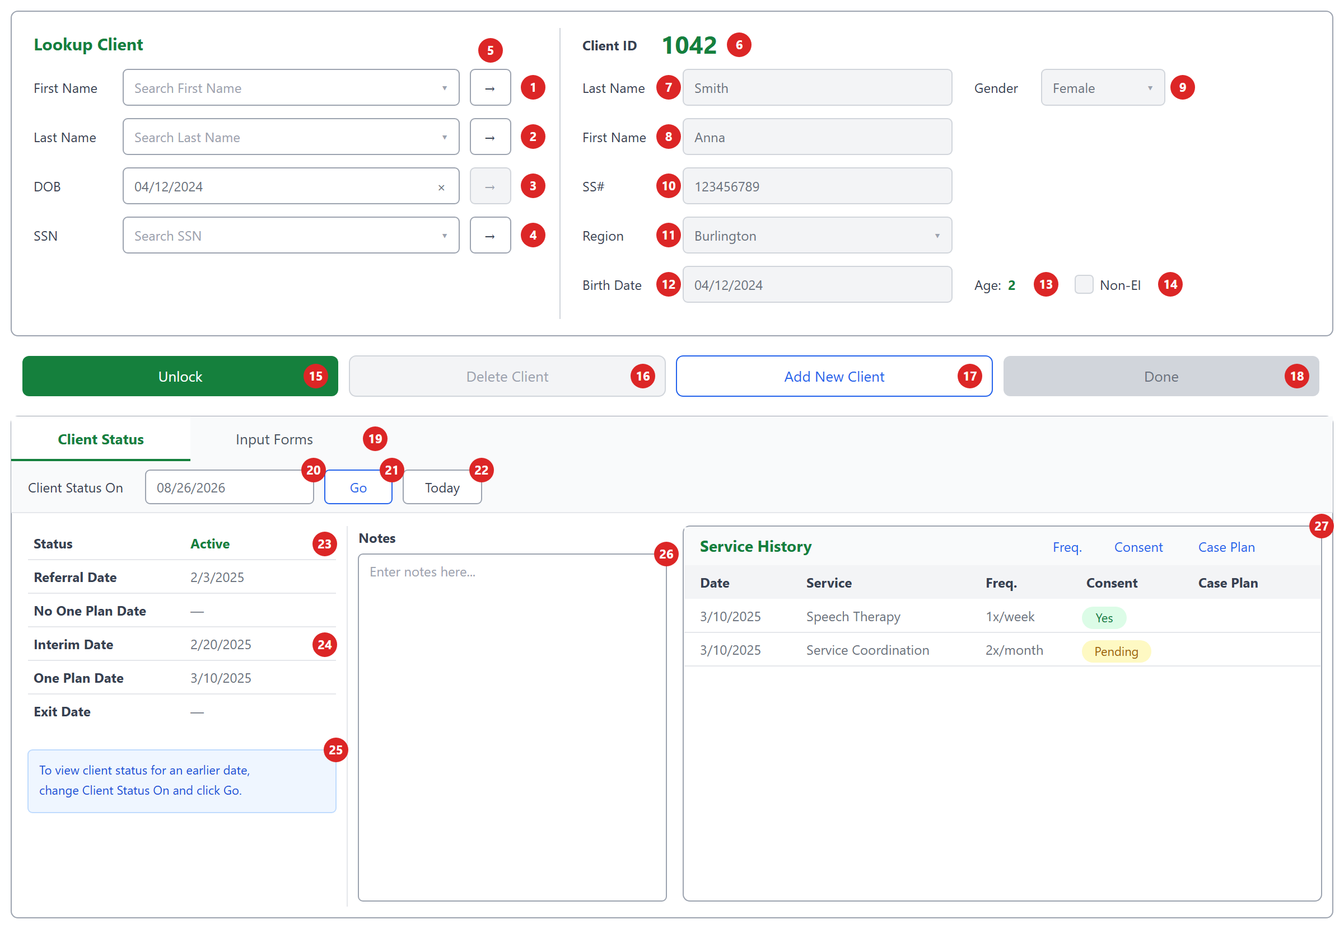
Shown in the locked state (default after a client is loaded): demographic fields greyed out, Delete and Done disabled.

Client Lookup (left panel)
# | Element | Type | Behaviour | Data / API | Rules
1 | First Name lookup | Searchable dropdown | Typing searches clients whose first name starts with the text; up to 20 results shown as "First Last". | GET /api/clients/search/firstname | BR-LKP-01, 03, 04
2 | Last Name lookup | Searchable dropdown | Same as 1, on last name. | GET /api/clients/search/lastname | BR-LKP-01, 03
3 | DOB | Date input with × clear | Shows the loaded client's DOB. The → button is always disabled (no DOB search). ⚠ Editing this box changes the client's DOB even when locked. | stblPeople.DOB | BR-LKP-08, BR-GAP-03
4 | SSN lookup | Searchable dropdown | Typing searches SSNs containing the text; results show the SSN. | GET /api/clients/search/ssn | BR-LKP-02
5 | → (Load) buttons | Button ×4 | Loads the selected client into the right panel and fills all three lookup boxes with that client. Disabled until a result is chosen. | GET /api/clients/{id} | BR-LKP-06, 07

Client Details (right panel)
# | Element | Type | Behaviour | Data | Rules
6 | Client ID | Read-only label | Shows the ID, or New for an unsaved client. | ChildID | BR-ID-01, 02
7 | Last Name | Text | Required. Editable only when unlocked. | LastName nvarchar(50) | BR-VAL-01, 04
8 | First Name | Text | Required. Editable only when unlocked. | FirstName nvarchar(50) | BR-VAL-02, 04
9 | Gender | Dropdown | Select / Male / Female. (DB also allows U = Unknown.) | Gender nvarchar(1) | BR-VAL-05, BR-GAP-24
10 | SS# | Text | Max 10 characters in the UI. FITP extract expects 9 digits. | SS nvarchar(15) | BR-VAL-06, BR-GAP-04
11 | Region | Searchable dropdown | Active reporting regions. | Region → stblReportingRegion | BR-VAL-09
12 | Birth Date | Date | Editable only when unlocked. | DOB datetime2 | BR-VAL-08
13 | Age | Calculated label | Whole years from Birth Date; -- if no DOB. | derived | BR-DER-01
14 | Non-EI | Checkbox | Checked = not an Early Intervention client. | NonEarlyIntervention bit | BR-VAL-11

Action bar
# | Element | Enabled when | Behaviour | API | Rules
15 | Unlock / Lock | Always | Switches the details panel between read-only and editable. Label shows the action ("Unlock" while locked). | — | BR-LCK-01, 02, 06
16 | Delete Client | Client loaded and unlocked | Asks "Are you sure you want to delete this client?", then deletes the client and all their forms. | DELETE /api/clients/{id} | BR-LCK-08, BR-DEL-01..03
17 | Add New Client | Always | Clears the screen and unlocks it for a new client. Does not save pending edits. | — | BR-LCK-05
18 | Done | Unlocked | Checks Last/First Name, then creates or updates the client, then locks the screen. | POST /api/clients or PUT /api/clients/{id} | BR-LCK-07, 09, BR-GAP-01

Tabs and Client Status
# | Element | Type | Behaviour | Data / API | Rules
19 | Tabs | Tab bar | Client Status (default) / Input Forms. Switching reloads the tab's data. | — | —
20 | Client Status On | Date | Date the status is calculated for; defaults to today. Changing it reloads the status. | ?date= | BR-DER-08
21 | Go | Button | Reloads the status for the chosen date. Shows "Loading..." while busy. | GET /api/clients/{id}/status | —
22 | Today | Button | Resets the date to today and reloads. | same | BR-DER-08
23 | Status | Label | Client's status as of the date. Green when Active. | status | BR-DER-02, BR-STS-01..04, BR-GAP-21
24 | Milestone dates | Labels ×5 | Referral, No One Plan, Interim, One Plan and Exit dates as of the chosen date; — when none. | referralDate … exitDate | BR-DER-03..07, BR-GAP-21
25 | Help message | Info box | "To view client status for an earlier date, change Client Status On and click Go." | — | —
26 | Notes | Text area | Client notes. Editable, but not saved yet — requirement: must save. | stblPeople.Notes | BR-GAP-10
27 | Service History | Table | Date, Service, Freq., Consent (Yes = green, Pending = yellow), Case Plan. Empty state: "No service history available." | GET /api/clients/{id}/service-history | BR-SVC-01..07, BR-GAP-20
Screen messages (toasts): "Last Name is required." · "First Name is required." · "Client created successfully" · "Client updated successfully" · "Client deleted successfully." · "Failed to save client." · "Failed to delete client."

View 2 — Input Forms tab
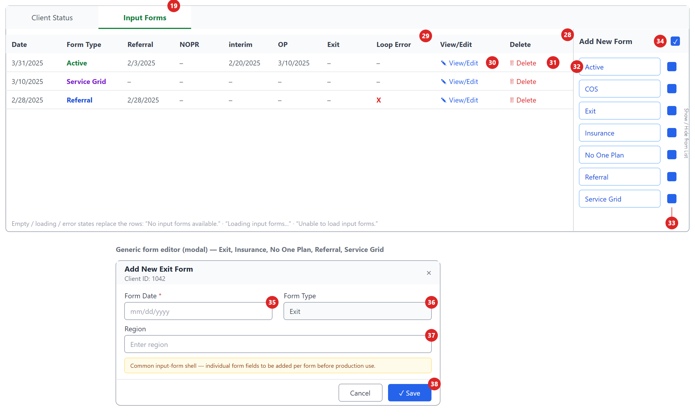
# | Element | Type | Behaviour | Data / API | Rules
28 | Form history grid | Table | All forms for the client, newest first: Date, Form Type, Referral, NOPR, interim, OP, Exit, Loop Error. Form types are coloured: Active green, Service Grid purple, others blue. | GET /api/input-forms/history/{childId} | BR-IF-03, 04, BR-GAP-22
29 | Loop Error | Column | Red X when the form is out of sequence (e.g. Exit without an Active form). Today it always shows –. | loopError | BR-LOOP-01..07
30 | View/Edit | Link | Opens the form: Active and COS open their full editors; other forms open the generic editor (35–38). | GET/PUT /api/input-forms/{form}/{childId}/{id} | BR-IF-08
31 | Delete | Link | Asks "Delete {type} dated {date}?", then deletes the form and refreshes the grid. | DELETE /api/input-forms/{form}/{childId}/{id} | BR-IF-06
32 | Add New Form buttons | Button ×7 | Active, COS, Exit, Insurance, No One Plan, Referral, Service Grid — opens a blank form of that type. | POST /api/input-forms/{form}/{childId} | BR-IF-02
33 | Show/Hide checkboxes | Checkbox ×7 | Hides or shows that form type in the grid (display only). | — | BR-IF-05
34 | Check-all | Checkbox | Shows or hides all form types at once. | — | BR-IF-05

Generic form editor (modal)
Used for Exit, Insurance, No One Plan, Referral and Service Grid. It's an interim shell; the banner says the full form fields are still to be added.
# | Element | Type | Behaviour | Data | Rules
35 | Form Date | Date (required) | "Form Date is required." if empty. | FormDate | BR-IF-07, BR-IF-09
36 | Form Type | Text | Pre-filled with the form name. Should be read-only; max 12 characters in the DB. | FormType nvarchar(12) | BR-IF-02
37 | Region | Text | Free text today; should be the region dropdown. | Region | —
38 | Cancel / Save | Buttons | Save creates or updates the form, then refreshes the grid. Error: "Unable to save the form." | POST/PUT /api/input-forms/… | —
Before a client is selected, the tab shows: "Select a client to view input forms."

