03 — Business Rules
Work item: 94269 Create Business Rules Catalog Entries | Module: Client | Date: 2026-10-01 | Repository source: docs/client/03-business-rules.md
Rules are written as implemented today, with the legacy rule (from the dbCDD stored procedures/views) alongside wherever the two differ. Each rule has an ID and the layer that enforces it: FE = frontend, BE = backend, DB = database constraint.

1. Client identity
ID | Rule | Enforced | Source
BR-ID-01 | A client is a row in stblPeople, identified by ChildID (int IDENTITY(1,1), clustered PK). | DB | DDL
BR-ID-02 | A client with no ChildID is new; the UI shows Client ID: New. | FE | ClientLookup
BR-ID-03 | Display name is FirstName LastName in the lookup; legacy reports use LastName, FirstName. | FE | mapClientToOption; legacy CName
BR-ID-04 | Nothing prevents duplicate people. The legacy system relied on data-cleaning views (DCFindDuplicateSSNs, FindDuplicatesInPeopleTable) to find duplicate SSNs after the fact. | — | DDL views

2. Required fields and validation
ID | Rule | Enforced | Source
BR-VAL-01 | Last Name is required (after trimming). Message: "Last Name is required." | FE (create + update); BE (update only); DB rejects '' but accepts NULL | ClientActions; updateClient; CHECK (len(LastName) > 0)
BR-VAL-02 | First Name is required (after trimming). Message: "First Name is required." | Same as above | CHECK (len(FirstName) > 0)
BR-VAL-03 | Last Name is checked before First Name; only the first failure is shown. | FE | saveClient
BR-VAL-04 | Last Name and First Name are at most 50 characters. | DB | nvarchar(50)
BR-VAL-05 | Gender is M (Male), F (Female), U (Unknown) or NULL (no entry). The UI offers only M/F. The server keeps only the first character. | DB description; FE; BE | MS_Description; ClientLookup; repository
BR-VAL-06 | SSN: at most 15 characters in the DB. The FITP extract uses only the first 9 characters and assumes digits only. The UI allows 10. No format check anywhere. | DB, FE | nvarchar(15); Get_CIS_FITP_Output; maxLength={10}
BR-VAL-07 | SSTemp = 1 means the SSN is a temporary number; 0 (default) means a real SSN. | DB | MS_Description, default 0
BR-VAL-08 | Date of birth is entered as a calendar date. On create an invalid date is stored as NULL; on update it causes an error. | FE, BE | TRY_CONVERT vs CONVERT
BR-VAL-09 | Region should be an active reporting region. Only the UI enforces this; the DB has no FK, so any integer (including 0) is accepted. | FE | No FK stblPeople.Region → stblReportingRegion.ID
BR-VAL-10 | On create, strings are trimmed and empty strings become NULL. | BE | createClient
BR-VAL-11 | NonEarlyIntervention: 0 = Early Intervention (EI) client, 1 = non-EI client. Defaults to 0. Drives the FITP extract ('NOEI' vs 'FITP', and the default exit date: DOB + 3 years for EI, last referral + 5 years for non-EI). | DB, legacy | DF_stblPeople_EarlyIntegration; Get_CIS_FITP_Output

3. Lock / edit workflow
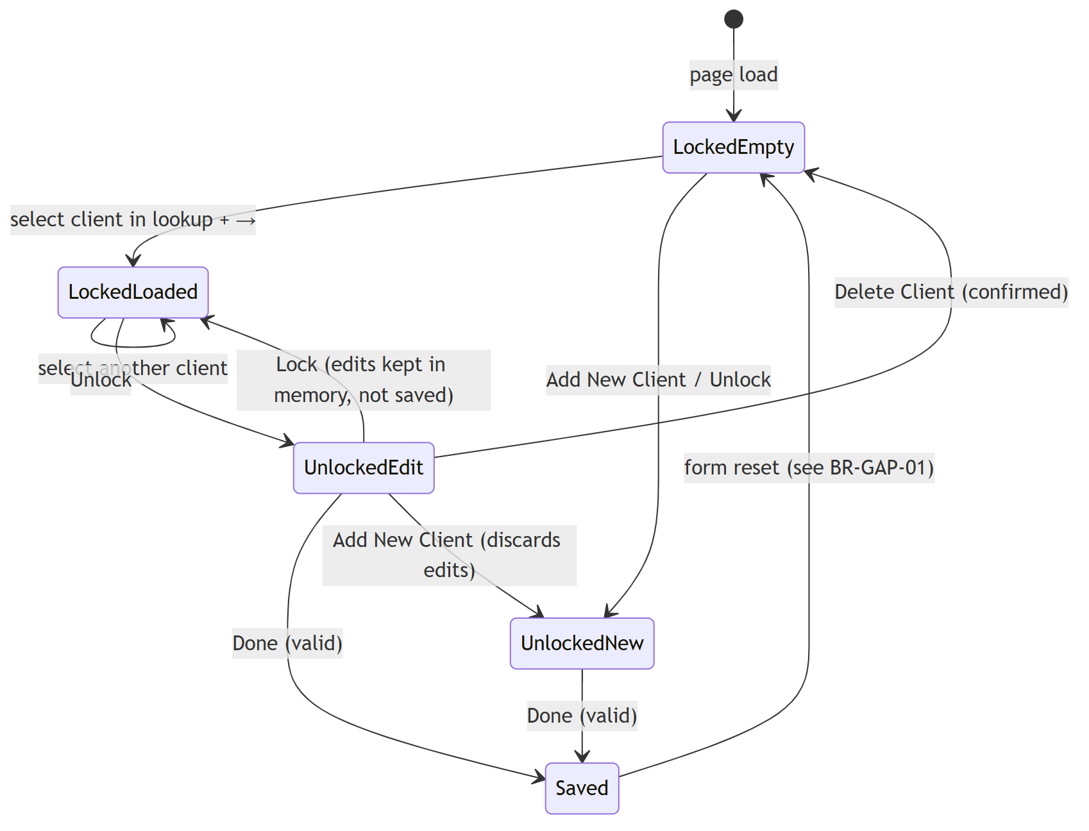
ID | Rule | Source
BR-LCK-01 | The screen opens locked. | ClientPage isLocked = true
BR-LCK-02 | While locked, demographic inputs (Last/First Name, Gender, SS#, Region, Birth Date, Non-EI) are disabled. | ClientLookup
BR-LCK-03 | Done (save) and Delete are disabled while locked. | ClientActions
BR-LCK-04 | After a successful save or delete, the screen re-locks. | ClientActions
BR-LCK-05 | Add New Client clears the form, unlocks it, and clears the lookup. It does not save or warn about unsaved changes. | addNewClient
BR-LCK-06 | Lock does not revert unsaved edits; they stay on screen until another client is loaded. | toggleLock
BR-LCK-07 | Save: if ChildID exists → update; otherwise → create. | saveClient
BR-LCK-08 | Delete requires a loaded client, an unlocked screen and the confirmation "Are you sure you want to delete this client?". | deleteClient
BR-LCK-09 | Toasts: "Client created successfully", "Client updated successfully", "Client deleted successfully."; on failure "Failed to save client." / "Failed to delete client." | ClientActions
BR-LCK-10 | No optimistic-concurrency check: if two users edit the same client, the last save wins. stblPeople.SSMA_TimeStamp (rowversion) is available for this but is not used. | DDL; updateClient

4. Client lookup
ID | Rule | Source
BR-LKP-01 | First Name and Last Name search are starts-with matches. | LIKE 'x%'
BR-LKP-02 | SSN search is a contains match. | LIKE '%x%'
BR-LKP-03 | Each search returns at most 20 clients. Name searches sort by the searched name, then the other name; SSN sorts by Last, First. | repository
BR-LKP-04 | Leading/trailing spaces are ignored; an empty search clears the list without calling the API. | ClientLookup
BR-LKP-05 | Case sensitivity follows the database collation (not in the script; SQL Server default is case-insensitive — confirm). | DB
BR-LKP-06 | A client loads only when the user picks a match and presses →. | ClientLookup
BR-LKP-07 | Loading a client fills all three lookup boxes with that client. | loadClient
BR-LKP-08 | DOB lookup is not available (→ permanently disabled). | ClientLookup

5. Client status (Status tab)

5.1 Current implementation
ID | Rule | Source
BR-DER-01 | Age = whole years between DOB and today, minus 1 if this year's birthday hasn't happened yet. No DOB → --. | calculateAge
BR-DER-02 | Status as of D = raw FormType of the most recent form (any of the 7 form tables) with FormDate ≤ D. | getClientStatus
BR-DER-03 | Referral Date = MAX(stblActiveForm.ReferralDate) ≤ D. | same
BR-DER-04 | No One Plan Date = MAX(stblNoOnePlanForm.StatusDate) ≤ D. | same
BR-DER-05 | Interim Date = MAX(stblActiveForm.InterimDate) ≤ D. | same
BR-DER-06 | One Plan Date = MAX(stblCOSCoverForm.OnePlanDate) ≤ D. | same
BR-DER-07 | Exit Date = MAX(stblExitForm.ExitDate) ≤ D. | same
BR-DER-08 | "Client Status On" defaults to today; changing it reloads immediately. Today resets it. | ClientStatus

5.2 Legacy rule (GetClientFormStats_rpt, parameters @txtChildID, @txtStatusDate)
The legacy screen took the latest form on or before D from each of four key forms only, filtering on FormDate:
Output | Legacy source (each: latest row with FormDate ≤ D)
Status | The most recent of those four forms, labelled by which table it came from: Referral → "Referred In Process", Active → "Active", Exit → "Exited", No One Plan → "No One Plan Resulting"
Referral Date | stblReferralForm: ReReferralDate if set, else ReferralDate
Interim Date | stblActiveForm.InterimDate — blank if earlier than Referral Date
One Plan Date | stblActiveForm.InitialMeetingDate ("Date of initial meeting to develop the initial One Plan") — blank if earlier than Referral Date
Exit Date | stblExitForm.ExitDate — intended to be blank if earlier than Referral Date
No One Plan Date | stblNoOnePlanForm.StatusDate — intended to be blank if earlier than Referral Date
Rules derived from it:
ID | Rule
BR-STS-01 | Only Referral, Active, Exit and No One Plan forms determine status. COS, Insurance and Service Grid forms do not change status.
BR-STS-02 | Status labels are business terms, not form codes: Referred In Process, Active, Exited, No One Plan Resulting.
BR-STS-03 | Milestone dates belong to the current referral episode: dates earlier than the current referral date are blanked, because they came from a previous episode.
BR-STS-04 | "As of D" is decided by each form's FormDate, not by the milestone date itself.
The SQL Server port of this procedure has bugs of its own: TOP 1 without ORDER BY (the ORDER BY FormDate DESC was commented out), and the Exit/NOPR CASE expressions have no ELSE, so they always return NULL. Treat the intent above as the rule, not the procedure's literal output.

5.3 Service history
ID | Current rule | Legacy rule (GetServiceHistory_rpt)
BR-SVC-01 | Source: stblServiceGridForm ⋈ Services (warehouse copy) ⟕ slstServiceNames | Source: stblServiceGridForm ⋈ stblServices ⋈ slstServiceNames
BR-SVC-02 | All services for the client | Excludes OutcomeStatus = 3 (Outcome Cont.)
BR-SVC-03 | No date filter from the UI | stblServiceGridForm.ConsentDate ≤ status date
BR-SVC-04 | Date shown = Service Grid FormDate | Date shown depends on OutcomeStatus: 1 New Outcome → ActualStartDate; 2 New Frequency → grid ConsentDate; 4 Service Ended → EndDate
BR-SVC-05 | Consent = Yes if Services.ConsentDate is set, else Pending | Consent date = stblServiceGridForm.ConsentDate ("Date of Signed Consent"). The procedure notes that service-level ConsentDate is always NULL
BR-SVC-06 | Frequency = Services.Frequency | Legacy returns HowLong (no Frequency column exists in stblServices)
BR-SVC-07 | Sort: newest form first | Sort: slstServiceNames.SortOrder, then ConsentDate (keeps Service Coordination at the top)

6. Input Forms tab
ID | Rule | Source
BR-IF-01 | Forms are available only after a client is selected ("Select a client to view input forms."). | InputForms
BR-IF-02 | Form types: Active, COS, Exit, Insurance, No One Plan, Referral, Service Grid. The DB default FormType of each table is exactly these labels (nvarchar(12)). | INPUT_FORM_OPTIONS; DDL defaults
BR-IF-03 | History lists all forms for the client, newest FormDate first. Legacy tie-break: slstFormNames.Sort DESC, then form ID. | getHistory; sqryFormList
BR-IF-04 | aop, aop-capta, Active One Plan, Active One Plan - CAPTA display as Active. (The last two are longer than 12 characters, so they can't be stored.) | FormType component
BR-IF-05 | Users can show/hide form types in the grid; all are shown by default. Display only. | InputForms
BR-IF-06 | Deleting a form asks "Delete {type} dated {m/d/yyyy}?". | handleDelete
BR-IF-07 | Generic forms require a Form Date. | InputFormEditor
BR-IF-08 | Active and COS forms open their dedicated editors. | InputForms
BR-IF-09 | FormDate meaning differs by form: Referral/Active/Exit/NOPR → last day of the reporting month (from MonthReporting); COS → OnePlanDate for entry, ExitDate for exit; Insurance → date completed; Service Grid → creation date. | MS_Description

6.1 History grid columns — legacy definition (sqryFormListA)
Column | Legacy value per form
Referral | Referral form: FormDate. Others: blank
NOPR | No One Plan form: StatusDate. Others: blank
Interim | Active form: InterimDate. Others: blank
OP | Active form: InitialMeetingDate. Others: blank
Exit | Exit form: ExitDate. Others: blank

6.2 Loop errors (legacy sqryFormListComplete → stblLoopErrors)
A "loop" is one referral-to-exit episode. A form is flagged as a loop error when it appears out of sequence. For each form, the previous key form is the form on the same date with a lower slstFormNames.Sort; if there is none, it is the latest form on an earlier date. Insurance, Service Grid and COS forms are never used as the previous key form.
ID | The form is a loop error when…
BR-LOOP-01 | a Referral follows a Referral or an Active form (a new referral while one is already open or active)
BR-LOOP-02 | a No One Plan form does not follow a Referral
BR-LOOP-03 | an Active form does not follow a Referral
BR-LOOP-04 | an Exit form does not follow an Active form
BR-LOOP-05 | a Service Grid form does not follow an Active form
BR-LOOP-06 | a No One Plan, Active, Exit or Service Grid form has no previous key form at all
BR-LOOP-07 | FormDate is NULL
A child with any loop error is written to stblLoopErrors (ChildID PK, CName, QDate). The rewrite returns loopError = false for every row (BR-GAP-22).

7. Audit
ID | Rule | Source
BR-AUD-01 | InsertDate/LastUpdateDate default to GETDATE(); InsertUser/LastUpdateUser default to SUSER_SNAME() (the SQL login). All four are NOT NULL. | DDL defaults
BR-AUD-02 | The rewrite sends InsertUser = 'SYSTEM', which overrides the DB default. On update it sets LastUpdateDate = GETDATE() and LastUpdateUser = 'SYSTEM'. | repository
BR-AUD-03 | The legacy DB has a stblAudit table (ChildID, SS, User, Timestamp, Comment). It is not written by the rewrite. Confirm whether SSN/identity changes must still be audited there. | DDL

8. Delete
ID | Rule | Source
BR-DEL-01 | Deleting a client is a hard delete of the stblPeople row. | deleteClient
BR-DEL-02 | The DB cascades the delete to all 7 form tables, and from there to stblCOSCoverSource, stblCOSCoverTeam and stblServices. A client's entire history is removed in one statement. | FKs ON DELETE CASCADE
BR-DEL-03 | Rows keyed by ChildID without an FK are orphaned: Loops, Services, stblAudit, stblLoopErrors, InitialExistingDiagnosticTable, ManytoManyDiagnostics. | DDL
BR-DEL-04 | The FKs were created WITH NOCHECK and then enabled. They apply to new changes, but SQL Server marks them untrusted and existing orphans were never validated. | DDL

9. Security and privacy
ID | Rule / observation | Source
BR-SEC-01 | /api/clients/* has no authentication middleware. Any caller that can reach the API can read, search, create, update and delete clients (and, via cascade, all their forms), including SSNs. | client.routes.ts vs dashboard.routes.ts
BR-SEC-02 | SSNs are returned in full by GET /, GET /:id and /search/ssn; no masking. | repository
BR-SEC-03 | All SQL is parameterised. | repository
BR-SEC-04 | createClient / updateClient console.log the full request body (including SSN) to server logs. | repository

Known gaps and defects
Severity is a suggestion for triage. Items marked (DDL) were found or re-rated after reviewing the database script.
ID | Severity | Description | Where
BR-GAP-01 | High | Create/Update return { message }, but the frontend treats the response as the saved client. After every save the form goes blank; after a create the user never sees the new ChildID. | client.controller.ts:9, :13; ClientActions
BR-GAP-02 | High | No authentication on client routes. Combined with BR-DEL-02, an unauthenticated DELETE wipes a child's entire record set. | client.routes.ts
BR-GAP-03 | High | The lookup-panel DOB field edits the loaded client's DOB even while locked. | ClientLookup.tsx:302-313
BR-GAP-20 | High (DDL) | Service history reads the warehouse table Services (no FK, populated by the reporting process, ID nullable), not the live table stblServices. Services entered through the new app are not in it, so history is stale or empty. Frequency and service-level ConsentDate exist only in the warehouse table. | getServiceHistory
BR-GAP-21 | High (DDL) | Status logic differs from legacy (§5.2): 7 forms instead of 4; raw FormType instead of status labels; Referral Date from the Active form instead of the Referral form; One Plan Date from COS OnePlanDate instead of Active InitialMeetingDate; filters on milestone dates instead of FormDate; previous-episode dates not blanked. | getClientStatus
BR-GAP-10 | High | Notes on the Client Status tab are editable but never saved. Requirement confirmed: they must save to stblPeople.Notes. Because PUT /:id overwrites every column (BR-GAP-08), add a dedicated endpoint such as PATCH /api/clients/:id/notes. | ClientStatus / Notes
BR-GAP-05 | Medium → High (DDL) | Create has no server-side name check, and blanks become NULL. The DB CHECK (len(x) > 0) lets NULL through, so a client with no name can be saved. | createClient
BR-GAP-23 | Medium (DDL) | The new Active form saves FormType = 'aop' / 'aop-capta'; the DB default and slstFormNames use 'Active'. Legacy objects that INNER JOIN slstFormNames ON FormType = FormName (sqryFormList, sqryFormListTemp, sqryKeyFormsMaxType, point-in-time and Indicator 3 reports, loop-error logic) silently drop these forms. | GeneralInformation.tsx:65
BR-GAP-22 | Medium (DDL) | Input Forms history differs from legacy sqryFormListA (§6.1): Active rows show ReferralDate instead of blank; NOPR uses FormDate instead of StatusDate; OP comes from COS OnePlanDate instead of Active InitialMeetingDate; Exit also shows COS ExitDate; loop error is always false instead of applying §6.2. | input-form.history.repository.ts
BR-GAP-04 | Medium | SS# maxLength=10 matches neither format: a 9-digit SSN fits, but a dashed one (11 characters) doesn't. The FITP extract needs 9 digits (README Q3). | ClientLookup.tsx:472
BR-GAP-06 | Medium | Errors tagged status: 400 are returned as 500. | error.middleware.ts
BR-GAP-07 | Medium | New clients default to region: 0. With no FK, 0 is stored. Legacy reports that INNER JOIN stblReportingRegion (e.g. DCMissingEthnicity, DCRecordsWithNoReferrals) then skip the child. | emptyClient
BR-GAP-08 | Medium | Update overwrites every column; any field omitted from the body becomes NULL/0 (e.g. Notes). | updateClient
BR-GAP-09 | Medium (DDL) | Create and update bind columns differently. Update binds VarChar for nvarchar columns (LastName, FirstName, SS, Gender, Notes), so non-Latin characters are lost. Names bound as VarChar(100) against nvarchar(50) fail with a truncation error (500) above 50 characters. Notes is bound as 4000 characters, but the column is nvarchar(max). Region is bound as VarChar(50) but the column is int. | updateClient
BR-GAP-11 | Medium | Dates are parsed as UTC midnight and shown in local time, so they can display a day early in US time zones. | calculateAge, ClientStatus formatDate
BR-GAP-24 | Low (DDL) | Gender U (Unknown) is valid in the DB but missing from the UI dropdown. A client with U shows "Select", and re-saving keeps U only if the user doesn't touch the field. | ClientLookup
BR-GAP-12 | Low | Service history ignores the "Client Status On" date. | ClientStatus.tsx:101
BR-GAP-13 | Low | Status colouring expects active/inactive; neither the current output nor the legacy labels use inactive. | getStatusClass
BR-GAP-14 | Low | Status tie-break compares record IDs across different tables. Legacy used slstFormNames.Sort. | getClientStatus
BR-GAP-15 | Low | GET /:id returns 200 with an empty body for unknown IDs; PUT/DELETE succeed on unknown IDs. | controller
BR-GAP-16 | Low | Lookup searches fire on every keystroke. There are no indexes on LastName, FirstName, SS (only the PK), so every keystroke scans stblPeople. | ClientLookup; DDL
BR-GAP-17 | Low | Regions are fetched twice on page load; /api/clients/regions duplicates /api/common-info/regions. WHERE Inactive = 0 also hides regions where Inactive is NULL (the column is nullable). | —
BR-GAP-18 | Low | isNewClient is maintained but never read. | ClientPage / ClientActions
BR-GAP-19 | Low | % or _ typed in the search boxes act as SQL wildcards. | repository
BR-GAP-25 | Low (DDL) | slstServiceNames.SvcCode is not unique (PK is SvcNameID). If a code repeats, the service-history join returns duplicate rows. | getServiceHistory

