07 — Entity-Relationship Diagram
Work item: 94271 Create ERD | Module: Client | Date: 2026-10-01 | Repository source: docs/client/07-erd.md
Built from the dbCDD DDL (2026-09-09). Solid relationship lines are physical FKs (all ON UPDATE CASCADE ON DELETE CASCADE, created WITH NOCHECK). Relationships marked logical exist only in queries; the DB doesn't enforce them.
Form tables show only the columns this module uses.

1. Client module ERD
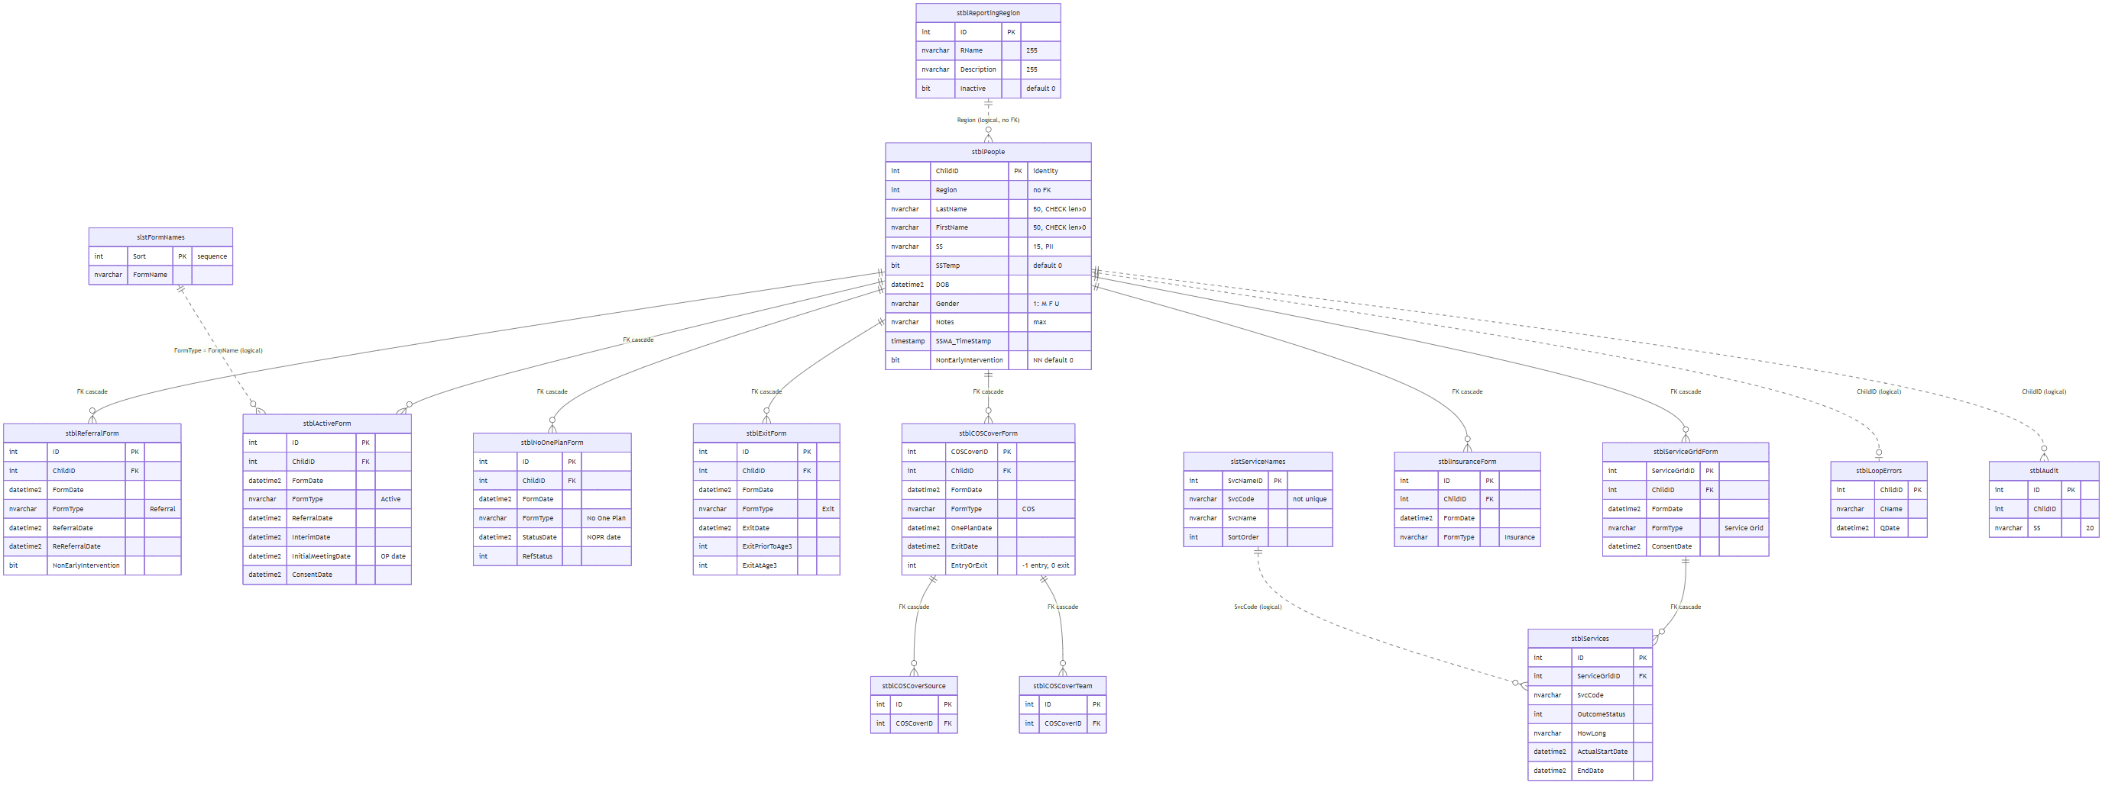

2. Warehouse tables touched by the rewrite
The current service-history query reads Services, which belongs to the reporting warehouse, not to the operational schema (BR-GAP-20).
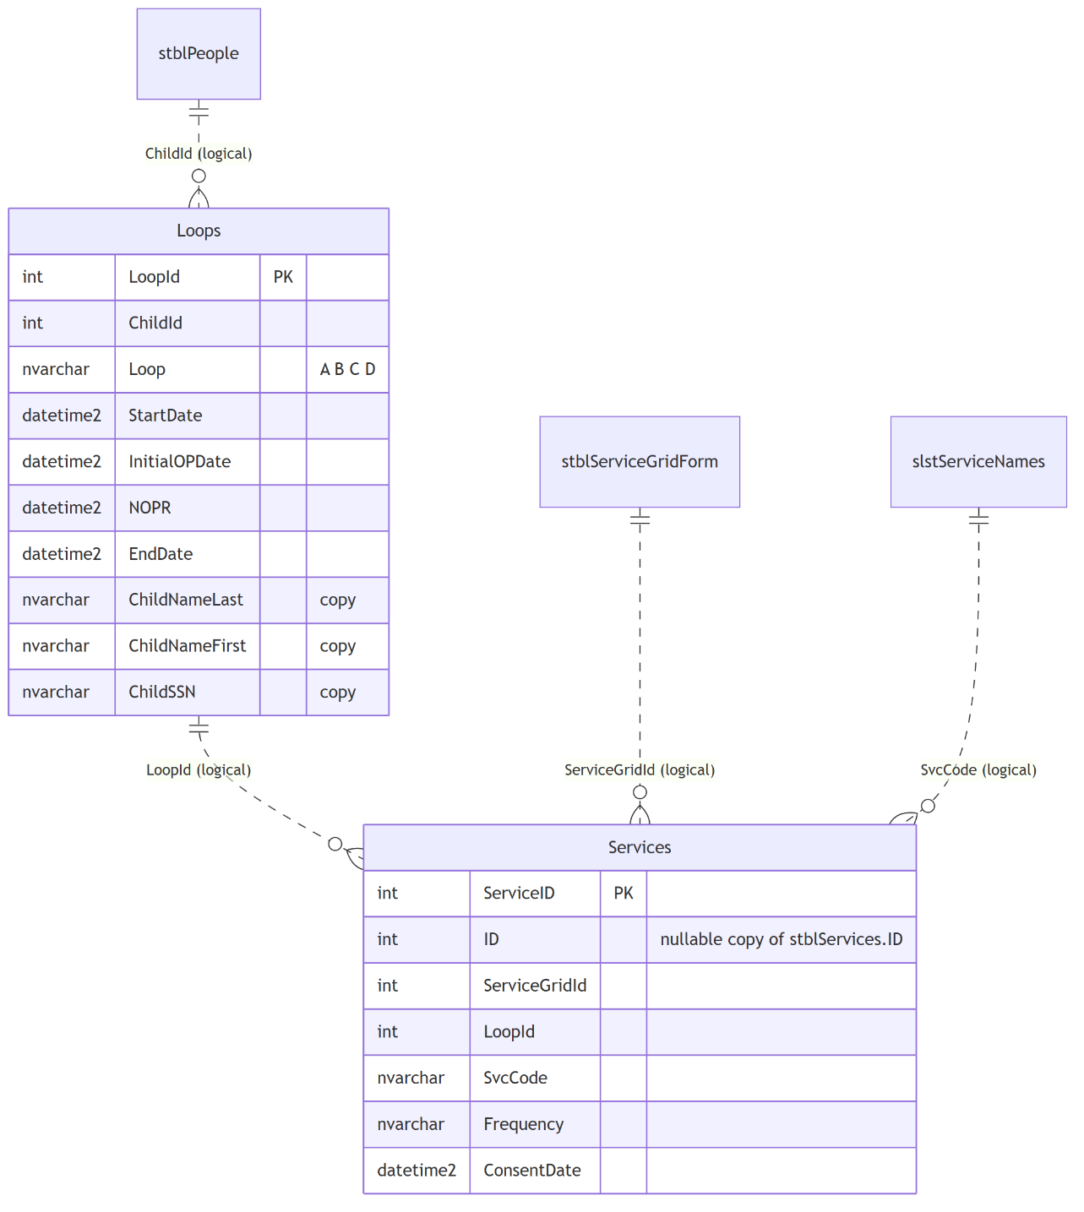

3. Relationship catalogue
# | Parent (1) | Child (many) | Join | Physical FK | On delete | Used in
R1 | stblReportingRegion | stblPeople | Region = ID | No | — | Region dropdown
R2 | stblPeople | stblReferralForm | ChildID | stblReferralForm$stblPeoplestblReferralForm | Cascade | Status, history
R3 | stblPeople | stblActiveForm | ChildID | stblActiveForm$stblPeoplestblActiveForm | Cascade | Status, history
R4 | stblPeople | stblNoOnePlanForm | ChildID | stblNoOnePlanForm$stblPeoplestblNoOnePlanForm | Cascade | Status, history
R5 | stblPeople | stblExitForm | ChildID | stblExitForm$stblPeoplestblExitForm | Cascade | Status, history
R6 | stblPeople | stblCOSCoverForm | ChildID | stblCOSCoverForm$stblPeoplestblCOSCoverForm | Cascade | Status, history
R7 | stblPeople | stblServiceGridForm | ChildID | stblServiceGridForm$stblPeoplestblServiceGridForm | Cascade | Status, history, services
R8 | stblPeople | stblInsuranceForm | ChildID | stblInsuranceForm$stblPeoplestblInsuranceForm | Cascade | Status, history
R9 | stblServiceGridForm | stblServices | ServiceGridID | stblServices$stblServiceGridFormstblServices | Cascade | Legacy service history
R10 | stblCOSCoverForm | stblCOSCoverSource / stblCOSCoverTeam | COSCoverID | Yes (2) | Cascade | COS feature
R11 | slstServiceNames | stblServices / Services | SvcCode | No (and SvcCode not unique) | — | Service history
R12 | stblPeople | stblLoopErrors, stblAudit, Loops, diagnostics | ChildID | No | Orphaned on delete | Legacy reports
R13 | slstFormNames | all form tables | FormType = FormName | No (text match) | — | Legacy form ordering, loop errors

Cascade path when a client is deleted
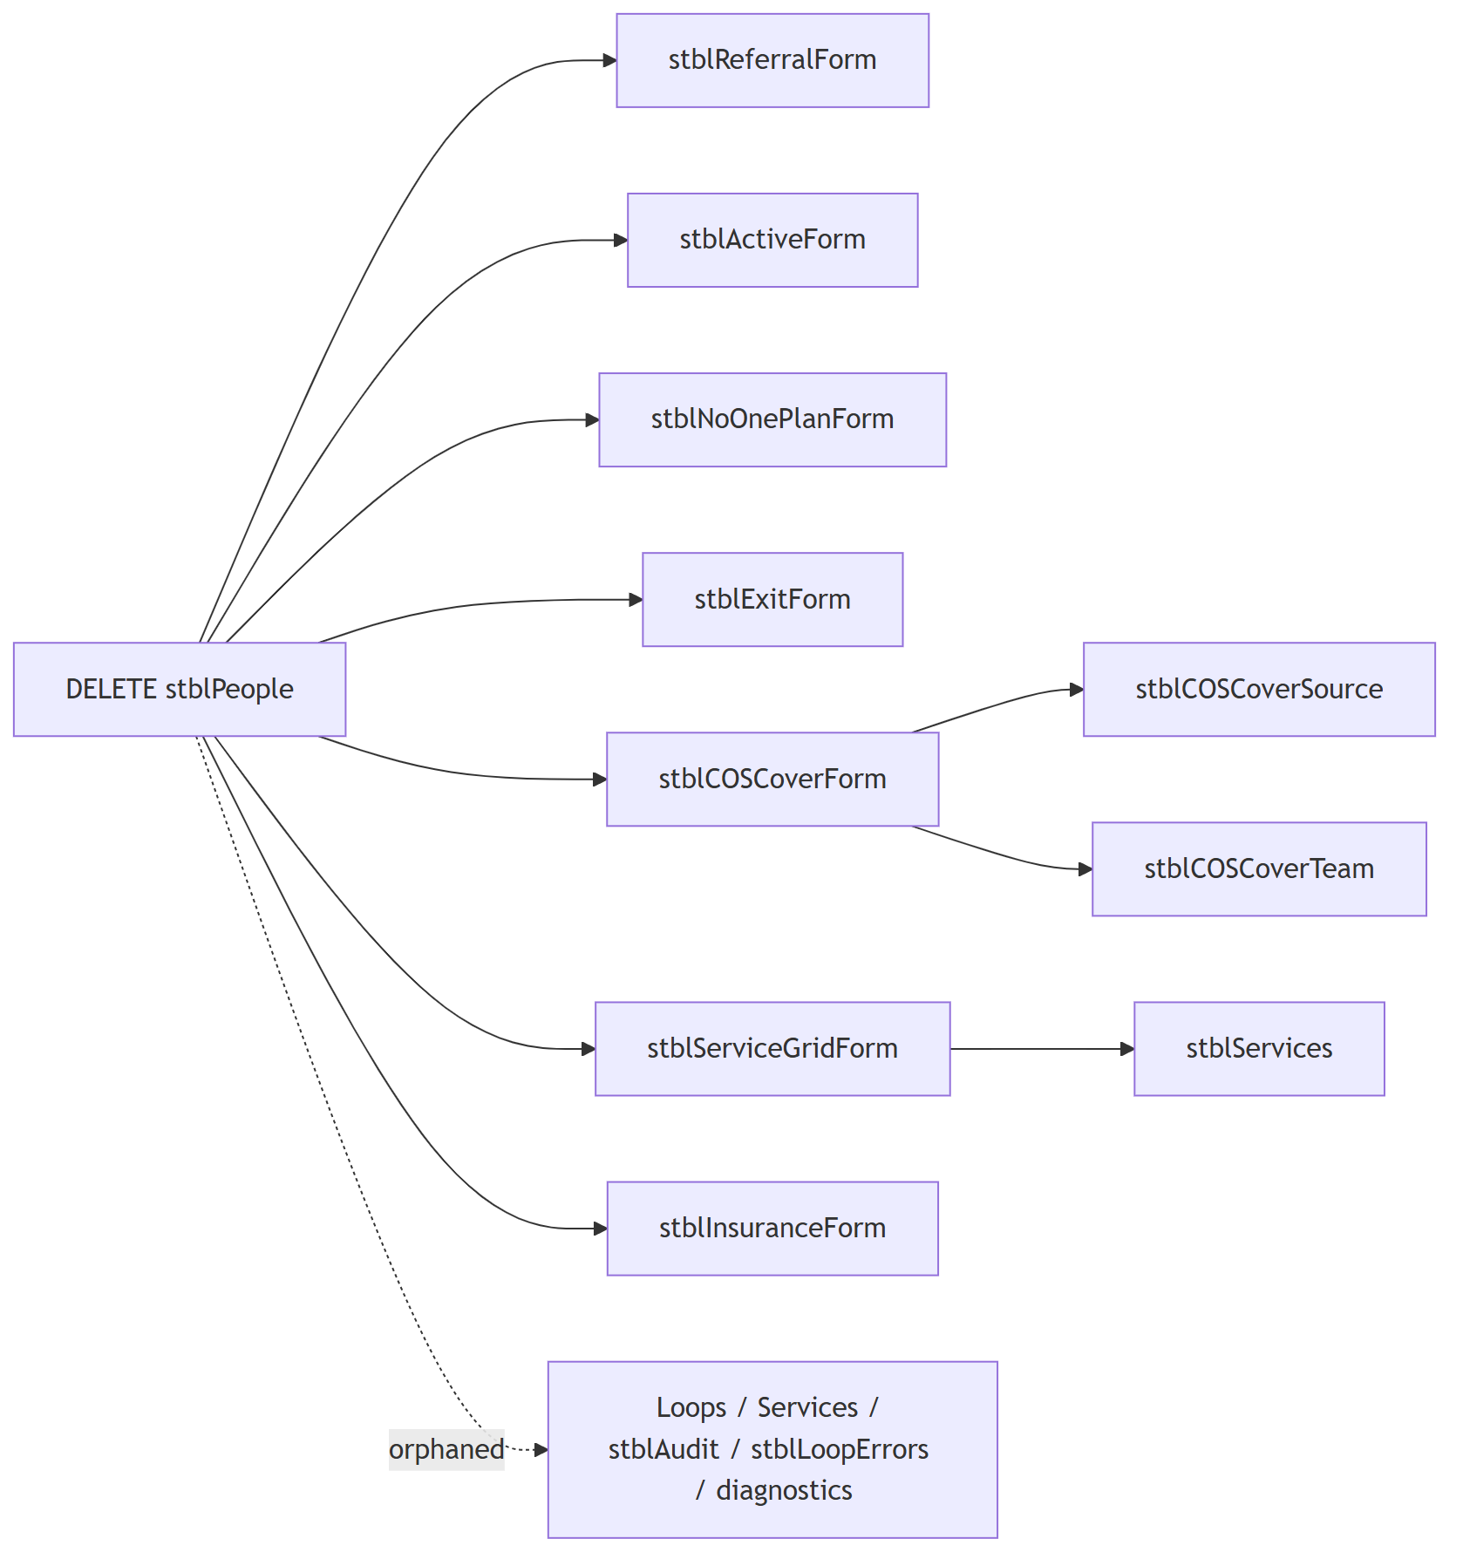

4. Notes for the DBA
- Every FK was created WITH NOCHECK, so SQL Server marks it untrusted (is_not_trusted = 1). Run ALTER TABLE … WITH CHECK CHECK CONSTRAINT … after cleaning orphans, so the optimiser can rely on them.
- No non-clustered indexes exist on stblPeople(LastName), (FirstName), (SS), or on ChildID in any form table. The FK columns are unindexed too, which also makes the cascade delete scan each child table.
- stblPeople.Region has no FK to stblReportingRegion; check for orphans (including 0) before adding one.

