00 — Annotated Wireframe: Insurance Form
Work item: Create Annotated Wireframe (Insurance Form) | Module: Insurance Form | Date: 2026-11-14
Screenshots of the Insurance Form as built today, taken from the running application with sample data. The form opens as a full-screen modal from the Client screen → Input Forms tab → Insurance (new form) or View/Edit on an Insurance row (edit). Numbered red markers match the tables below. Sample data is fictional.
Figure 1 — New form, permission to bill private insurance
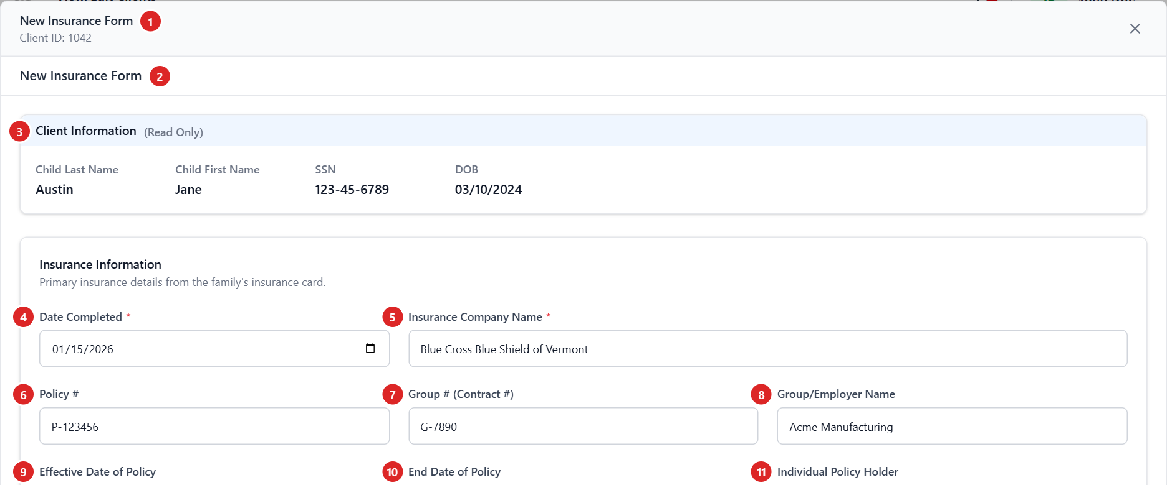
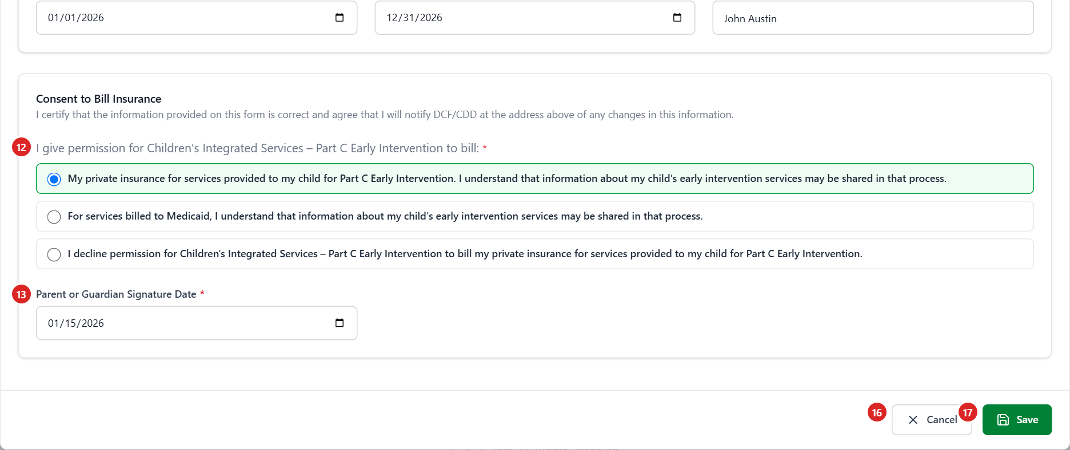
Figure 2 — Decline billing private insurance
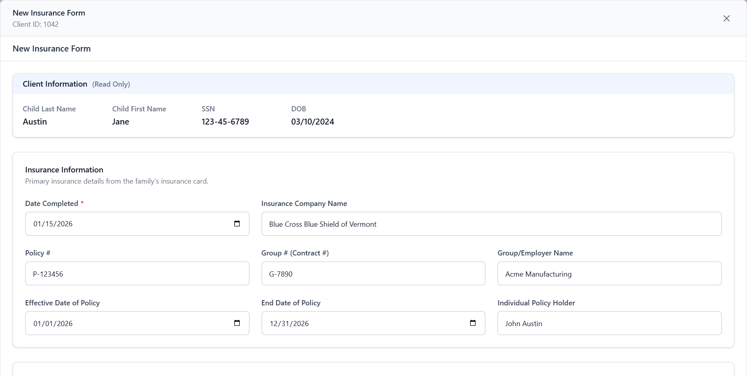
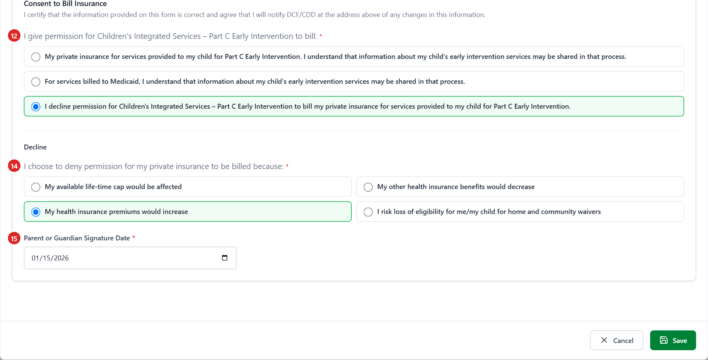
Figure 3 — Save with missing and invalid values
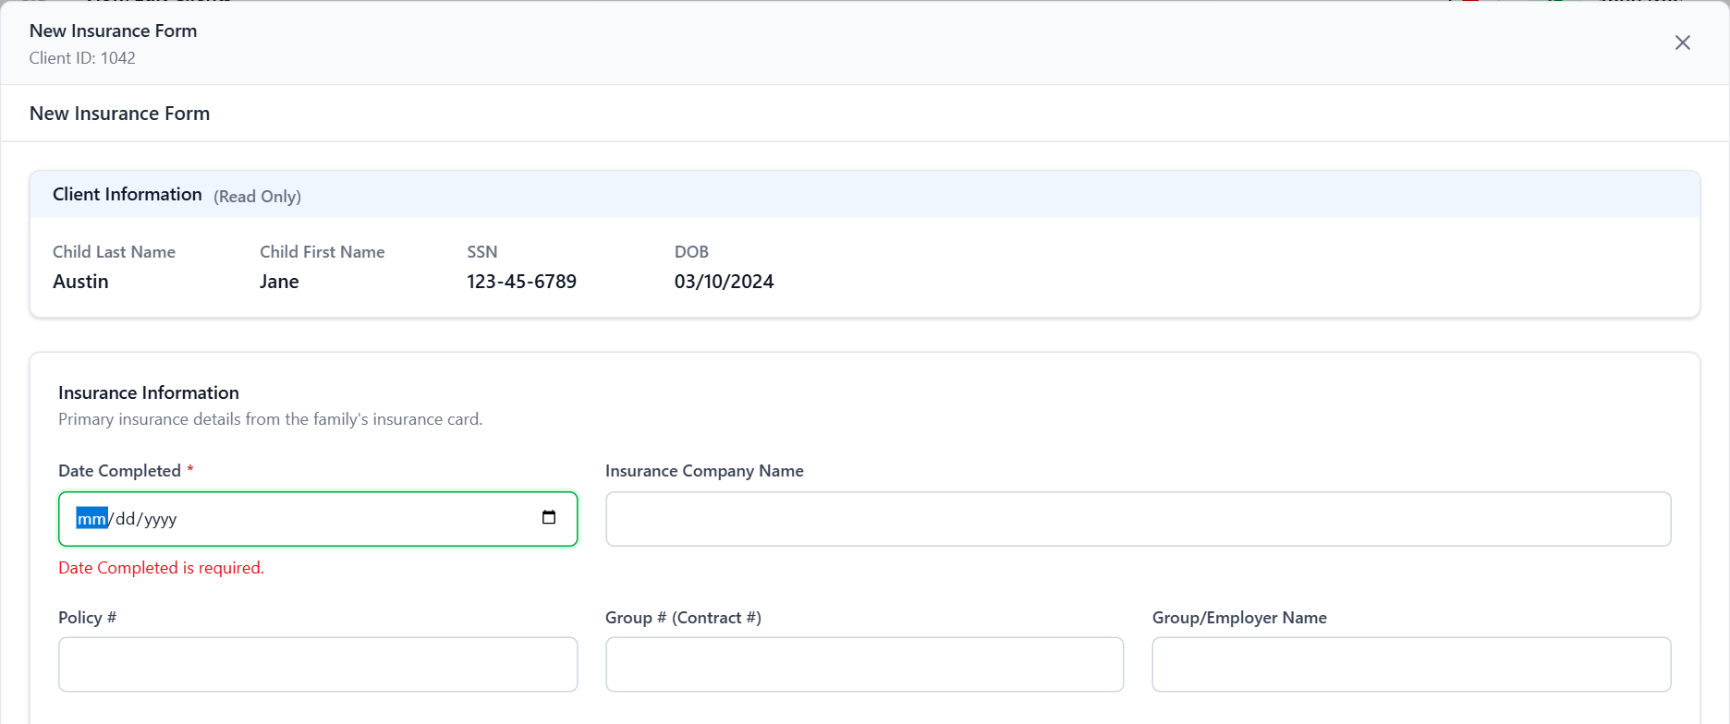
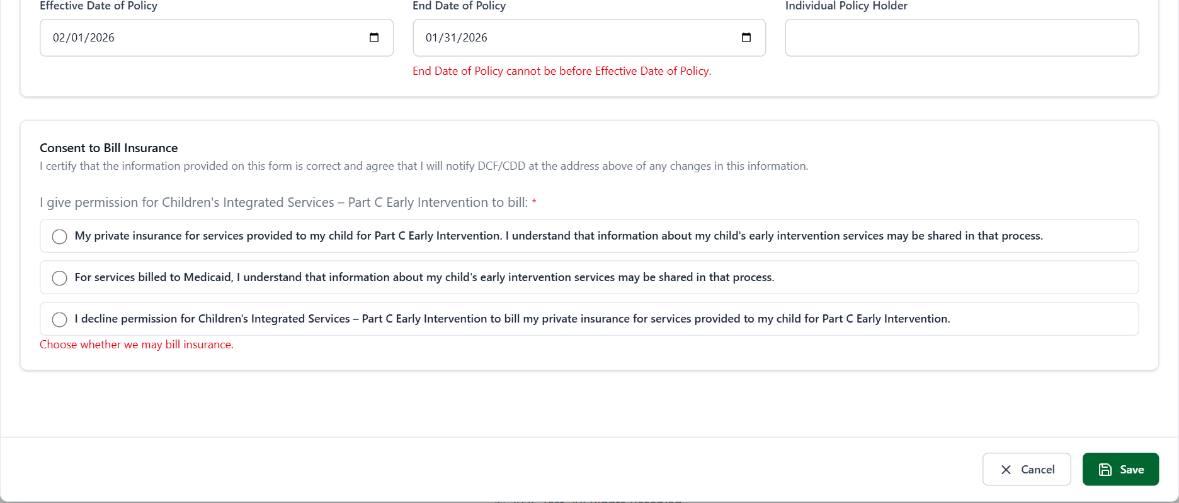

Header and Client Information
# | Element | Type | Behaviour | Data | Rules
1 | Modal header | Title, Client ID, × | "New Insurance Form" / "Edit Insurance Form" and the Client ID. × closes without saving. | ChildID | BR-IF-01, 06
2 | Page heading | Text | Repeats the modal title (IF-GAP-09). | mode | BR-IF-05
3 | Client Information | Read-only labels | Child Last Name, First Name, SSN (unmasked), DOB (MM/DD/YYYY). No Region or Referral Date: this form records neither. | stblPeople | IF-GAP-10

Insurance Information
# | Element | Type | Behaviour | Data | Rules
4 | Date Completed * | Date | Required; not before DOB; picker starts at DOB. Shown in the Input Forms history; FITP picks the latest form by this date. | FormDate | BR-IF-11, 36, 40
5 | Insurance Company Name | Text (255) | Required (red * appears) only when consent 1 is chosen. Saved in BranchAddress [Decision]. | BranchAddress | BR-IF-20, 32
6 | Policy # | Text (255) | Optional. FITP sends the first 20 characters (IF-GAP-07). | PolicyNumber | BR-IF-21, 42
7 | Group # (Contract #) | Text (255) | Optional. FITP sends the first 16 characters (IF-GAP-07). | GroupNumber | BR-IF-21, 42
8 | Group/Employer Name | Text (255) | Optional. | GroupName | BR-IF-21
9 | Effective Date of Policy | Date | Optional. Sent to FITP. | EffectiveDate | BR-IF-22, 42
10 | End Date of Policy | Date | Optional; not before Effective Date (picker starts there). Sent to FITP. | EndDate | BR-IF-22, 42
11 | Individual Policy Holder | Text (255) | Optional. | PolicyHolder | BR-IF-21

Removed from the legacy screen (not used any more): Ins. Co # dropdown, Coverage Code dropdown, Phone. Their columns are kept untouched (BR-IF-23).

Consent to Bill Insurance
# | Element | Type | Behaviour | Data | Rules
12 | I give permission … to bill: * | 3 option cards (radio) | One choice: private insurance (1), Medicaid (2), decline (3). The chosen card turns green. Legacy consent wording from the API. | BillingConsent | BR-IF-30, 37
13 | Parent or Guardian Signature Date * | Date | Shown for consent 1 or 2. Required; not before DOB. | ParentSignatureDate | BR-IF-31, 36
14 | I choose to deny permission … because: * | 4 option cards (radio) | Shown for consent 3, in a Decline sub-section. Exactly one reason [Decision]. | DeclineReasonCap / …Benefits / …Premium / …Eligibility | BR-IF-33, 38
15 | Parent or Guardian Signature Date * | Date | Shown for consent 3. Required; not before DOB. | ParentSignatureDate2 | BR-IF-34, 36

Actions
# | Element | Behaviour | Rules
16 | Cancel | Closes without saving (no warning, IF-GAP-11). | BR-IF-06
17 | Save | Checks the form. Errors show under each field plus "Please fix the highlighted fields." (Figure 3). On success: "Insurance Form saved successfully." / "… updated successfully.", the history reloads and the modal closes. API errors are shown as a message. | BR-IF-06, 35

Screen messages
Message | When
Date Completed is required. | Date Completed empty
Enter a valid date. | A date that isn't a real calendar date
Use 255 characters or fewer. | Text longer than the column
{Label} cannot be before Date of Birth. | Date Completed or a signature date before DOB
End Date of Policy cannot be before Effective Date of Policy. | End before Effective
Choose whether we may bill insurance. | No consent chosen
Parent or Guardian Signature Date is required. | Signature date missing for the chosen answer
Insurance Company Name is required for private insurance billing. | Consent 1 without a company name
Choose a reason. | Consent 3 without a reason

