07 — Entity-Relationship Diagram: Insurance Form
Work item: Create ERD (Insurance Form) | Module: Insurance Form | Date: 2026-11-14
Built from the local dbCDD database. Solid lines are physical FKs; dashed lines are logical relationships (used by queries, not enforced by the database).
stblInsuranceForm has 27 columns. The diagrams show the key and referencing columns plus the columns the form uses; see 04-data-dictionary.md for every column.

1a. Core: the form and its client
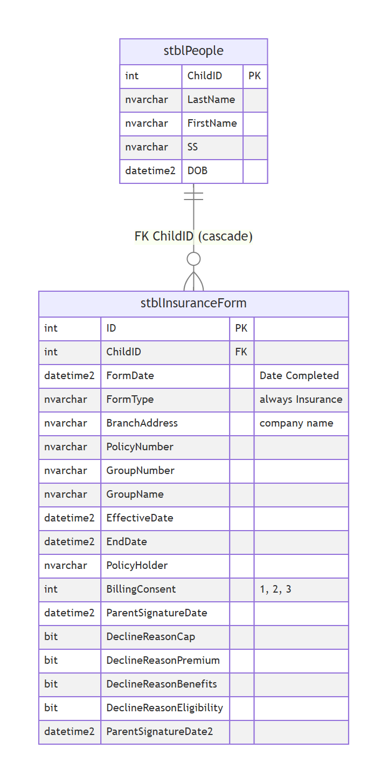

1b. Lookups and code lists referenced by the form
Only the referencing columns of stblInsuranceForm are shown. The consent and decline-reason lists have no table in dbCDD; they live in the backend config.
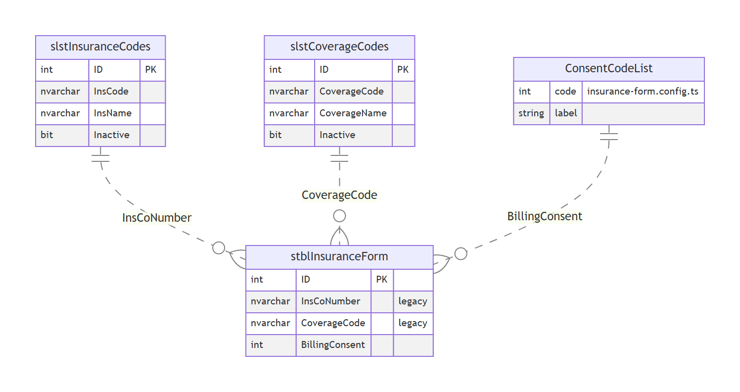

2. Relationship catalogue
# | Parent | Child | Join | Physical FK | On delete | Notes
R1 | stblPeople | stblInsuranceForm | ChildID | stblInsuranceForm$stblPeoplestblInsuranceForm (WITH NOCHECK) | Cascade | Deleting a client deletes its Insurance Forms; ON UPDATE CASCADE too
R2 | slstInsuranceCodes | stblInsuranceForm | InsCoNumber = InsCode (text) | No | — | Legacy Ins. Co # dropdown; not on the new screen [Decision]
R3 | slstCoverageCodes | stblInsuranceForm | CoverageCode = CoverageCode (text) | No | — | Legacy Coverage Code dropdown; form column nvarchar(5), lookup nvarchar(255)
R4 | (config) consent list | stblInsuranceForm | BillingConsent | No | — | 1 private, 2 Medicaid, 3 decline; no table
R5 | stblInsuranceForm | FITP extract | latest FormDate, then ID, per ChildID | — | — | Get_CIS_FITP_Output reads one form per child (BR-IF-40)

3. Notes for the DBA
- The only enforced relationship is R1 (cascade), and it was created WITH NOCHECK, so SQL Server doesn't trust it for query plans. Re-enable it WITH CHECK after confirming there are no orphans.
- No index on stblInsuranceForm.ChildID. The client look-up, the Input Forms history, the FITP "latest form per child" query and the cascade delete all scan the table. An index on (ChildID, FormDate DESC, ID DESC) serves all four.
- The consent codes exist only in code and in the FITP procedures. A lookup table (slstBillingConsent) would document 1 and 2 (IF-GAP-04) and let reports join instead of hard-coding = 3.

