01 — Code Annotations: Insurance Form
Work item: Supporting document | Module: Insurance Form | Date: 2026-11-14
File-by-file walkthrough of the Insurance Form feature. Line references are to the current code.

1. Architecture
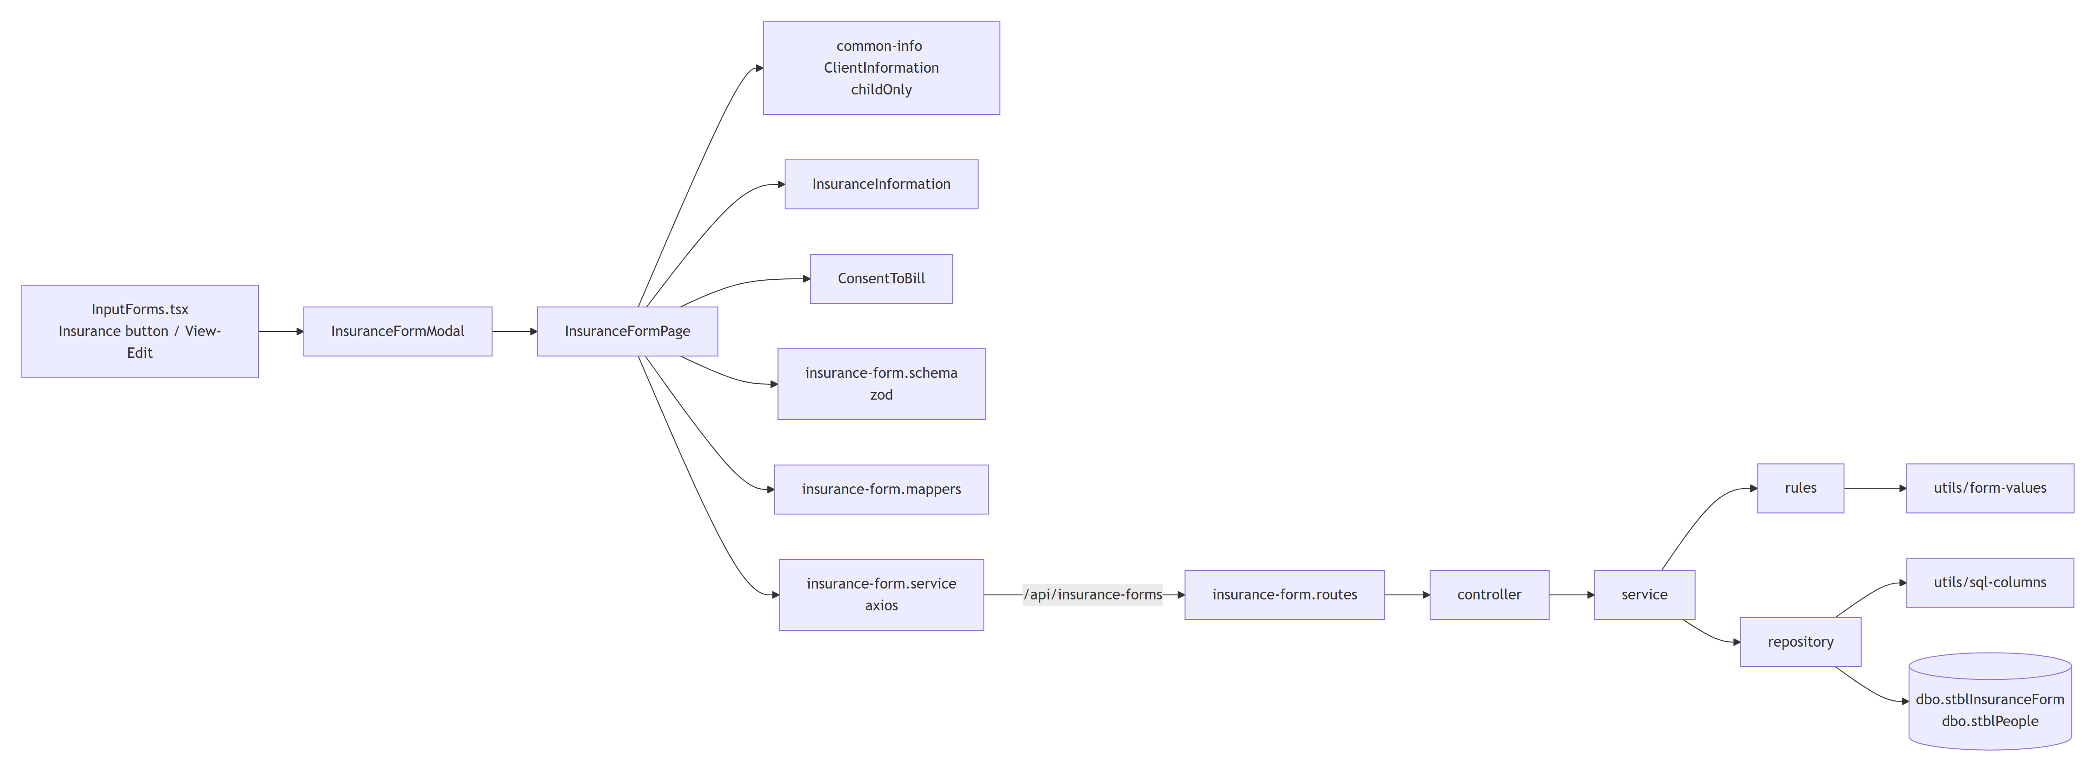
Request flow for a save: the page checks the form with the zod schema → valuesToPayload builds the body → POST / PUT /api/insurance-forms/{childId}[/{id}] → controller → service: normalizePayload → clearDependentFields → validateRecord → repository insert / update → the saved row is read back and returned.

2. Backend — backend/src/modules/insurance-form
File | Role
insurance-form.config.ts | Table name, FormType literal, writable columns, consent codes and wording, decline reasons
insurance-form.rules.ts | Request parsing, clearing, cross-field validation
insurance-form.service.ts | Use cases: get, getOne, create, update, remove, lookups
insurance-form.repository.ts | SQL against stblInsuranceForm and stblPeople
insurance-form.controller.ts | Express handlers (one line each)
insurance-form.routes.ts | 6 routes with Swagger annotations
insurance-form.types.ts, index.ts | Types and the router export, mounted at /api/insurance-forms in app.ts

2.1 insurance-form.config.ts
Location | What it does
L9 INSURANCE_FORM_TYPE | 'Insurance', the literal reports filter on (BR-IF-10, 43)
L22 COLUMNS | The 15 writable columns and their kind (date, int, bit, text max 255). Leaving out InsCoNumber, InsuranceName, CoverageCode, Phone is what keeps their values (BR-IF-23)
L48 BILLING_CONSENT | Codes 1/2/3 with the legacy consent wording (BR-IF-30, 37)
L69–70 | BILLING_CONSENT_PRIVATE = 1, BILLING_CONSENT_DECLINE = 3
L73 DECLINE_REASONS | The four reason columns and their wording

2.2 insurance-form.rules.ts
Function | What it does
L30 normalizePayload | Keeps only COLUMNS keys; parses dates (YYYY-MM-DD, real calendar day), whole numbers, bits and text (trim, max length) with the shared utils/form-values.ts; rejects an unknown BillingConsent
L72 clearDependentFields(p, consent) | Clears the other answer's fields for the given consent (BR-IF-35). consent defaults to the body's value; update passes the saved one when the body doesn't change it
L84 validateRecord(record, dob) | Date Completed required; dates vs DOB; End ≥ Effective; consent required; per-answer requirements (BR-IF-11, 22, 30–36)

2.3 insurance-form.service.ts
Function | What it does
L11 int | ChildID / ID must be positive integers (BR-IF-03)
L17 child | Loads the client or fails with "Client not found" (404)
L23 get | Client + all their forms
L39 create | normalize → clear → validate against DOB → insert → read back
L52 update | Loads the saved row (404 if missing) → normalize → clear using the body's consent or the saved one → validate the merged row → update
L70 remove | Deletes; 404 when nothing was deleted
L78 lookups.options | { billingConsent, declineReasons }

2.4 insurance-form.repository.ts
Function | What it does
L11 getClient | ChildID, LastName, FirstName, SS, DOB from stblPeople
L30 findByChildId | All forms, FormDate nulls last, then FormDate DESC, ID DESC (the FITP order)
L47 findOne | One form of the client
L62 insert | Adds ChildID and FormType = 'Insurance', binds each column with the shared utils/sql-columns.ts, OUTPUT INSERTED.ID, reads the row back
L89 update | SET only the columns sent, plus LastUpdateDate = GETDATE(), LastUpdateUser = SUSER_SNAME()
L118 remove | DELETE and @@ROWCOUNT

Dates are bound as nvarchar(10) YYYY-MM-DD: the legacy "SQL Server" ODBC driver rejects date parameters (HY004).

3. Frontend — frontend/src/features/insurance-form
File | Role
pages/InsuranceFormPage.tsx | Loads client, forms and options; Add / Edit; Save / Cancel
components/InsuranceInformation.tsx | Date Completed, company name, policy fields
components/ConsentToBill.tsx | Consent options, signature dates, Decline sub-section
schemas/insurance-form.schema.ts | zod rules matching the backend
utils/insurance-form.mappers.ts | Row → form values, form values → API body
services/insurance-form.service.ts | get, create, update, options
types/insurance-form.ts | Row, response, options, form model, defaults

3.1 pages/InsuranceFormPage.tsx
Part | What it does
useEffect load | get(childId) + options() in parallel; edit picks the form by ID or closes with "Insurance Form record not found." (BR-IF-05)
useForm | zod resolver built from the client's DOB; validates on submit
saveForm | valuesToPayload → update or create; success toast; onSaved (reload history) or onClose; API message on failure via the shared utils/api-message.ts
render | ClientInformation childOnly → InsuranceInformation dob → ConsentToBill options dob → Cancel / Save

3.2 Components
Component | Notes
InsuranceInformation (L29) | useWatch on BillingConsent (company name * when 1) and EffectiveDate (End Date min); Date Completed min = DOB; text fields maxLength 255
ConsentToBill (L25) | Option cards for the three consents; signature date for 1/2; SubSection "Decline" with the reason cards and the second signature date for 3; both date pickers start at DOB

Shared pieces from common-info: Field, FieldGroup, Section / SubSection (components/FormSection.tsx), inputClass, radioClass, optionClass (styles/formStyles.ts), ClientInformation with childOnly.

3.3 schemas/insurance-form.schema.ts
Location | What it does
L12 isDate | YYYY-MM-DD that round-trips, so 2026-02-30 is rejected
L23 AFTER_BIRTH | Date Completed and the signature date of the chosen answer vs DOB
L33 createInsuranceFormSchema(dob) | Field rules + superRefine cross-field rules (BR-IF-11, 22, 30–36)

3.4 utils/insurance-form.mappers.ts
Function | What it does
L17 recordToValues | Dates → YYYY-MM-DD; BillingConsent 1–3 → '1'–'3', anything else unchosen; first reason bit set → declineReason (BR-IF-50, 51)
L42 valuesToPayload | Text trimmed / NULL; declineReason → the four bits; other answer's signature date sent as NULL (BR-IF-35)

4. Tests
Area | File | Tests
Backend rules | insurance-form.rules.test.ts | Parsing, clearing (incl. saved consent), every validation message
Backend service | insurance-form.service.test.ts | Create / update / get / remove, partial updates, 404s
Backend repository | insurance-form.repository.test.ts | SQL text, parameter types, read-back
Backend controller, routes | insurance-form.controller.test.ts, insurance-form.routes.test.ts | Status codes, route table
Frontend page | InsuranceFormPage.test.tsx | New / edit, each consent, validation, limits, API errors
Frontend schema, mappers, service | insurance-form.schema.test.ts, insurance-form.mappers.test.ts, services/insurance-form.service.test.ts | Rules, mapping both ways, URLs
Input Forms tab | InputForms.test.tsx | Opens, edits, closes and saves the Insurance modal

Backend: 100 tests, 100% of lines covered. Frontend: 41 Insurance Form tests plus the Input Forms tab tests.

