HSBC Savings Account Balance Processing System

目录
Deliverables 1
Source code 1
K8s deployment manifests 1
Test Coverage Report 1
Resilience Test Result 2
Performance Test Result 4
Application Service 4
Build 5
Build Jar File 5
Execute Unit Test - Exclude Integration Test 5
Execute Integration test - Exclude Unit Test 5
Generate Coverage 5
Test Application Locally 5
Build Docker Image 6
Deploy 6
Dev (local machine, not inside docker) 6
Staging (docker in local machine) 6
Prod (docker in alibaba cloud) 7
API 7
Open Savings Account API 8
Request 8
Response 8
Batch Open Savings Account API 8
Request 9
Response 9
Deposit Withdraw API 10
Request 10
Response 10
Money Transfer API 11
Request 11
Response 12
Batch Money Transfer API 12
Request 13
Response 13
Generate Mock Transactions API 14
Request 14
Response 14
Design 15
Database Schema 15
Entity Relationship 16
Architect 17
Data Consistency 17
Performance 17

Deliverables

Source code
https://github.com/gangqiangxu-commits/hsbc/

K8s deployment manifests
https://github.com/gangqiangxu-commits/hsbc/blob/main/k8s.yml

Test Coverage Report
https://github.com/gangqiangxu-commits/hsbc/blob/main/coverage/index.html

To view the report, please fork the source code repository and open the above file locally using a web browser.

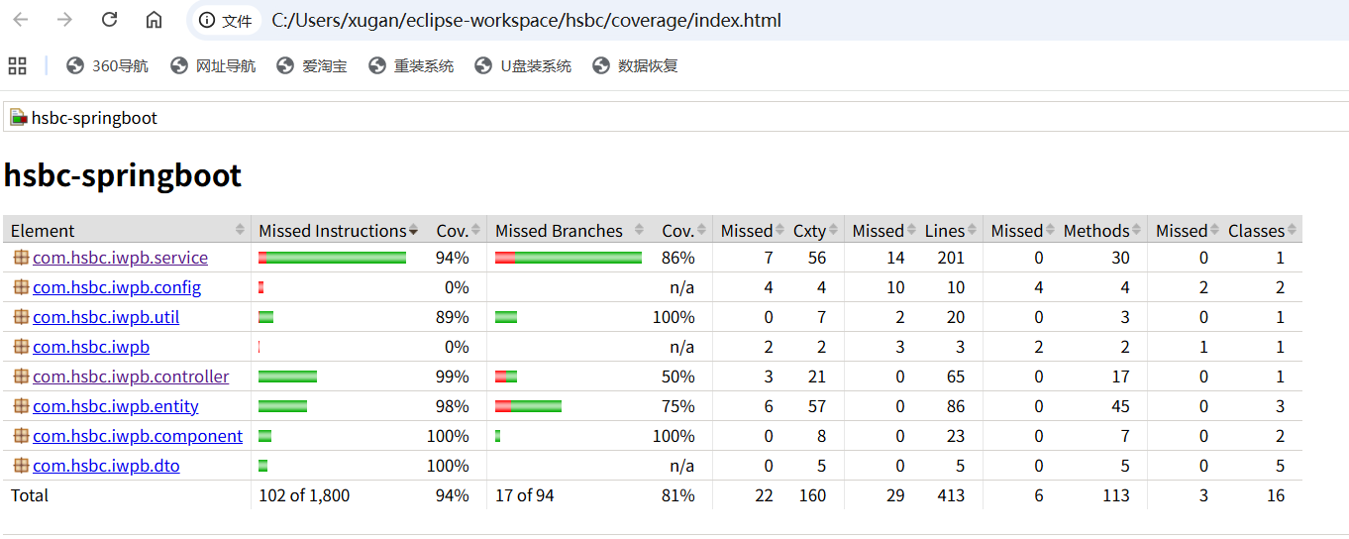

Resilience Test Result

Deleted containers on Alibaba ACK at 2025-11-20 13:18:52
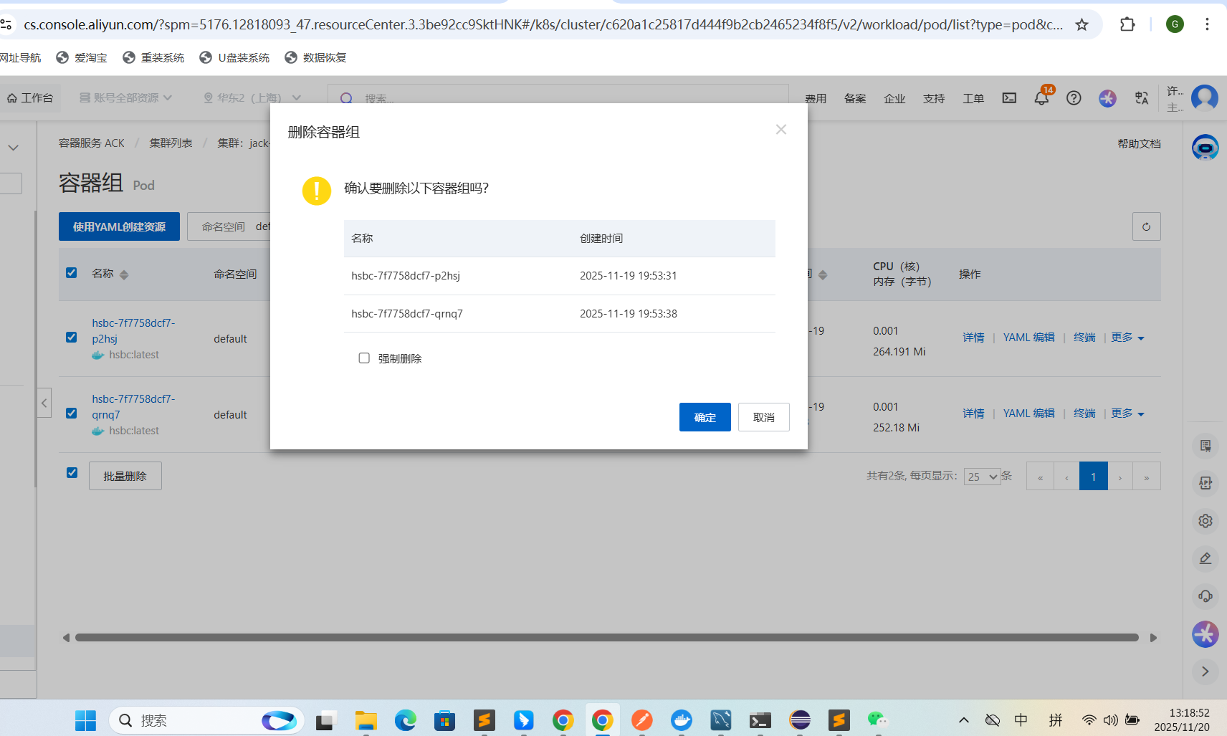

New containers created at 2025-11-20 13:18:58
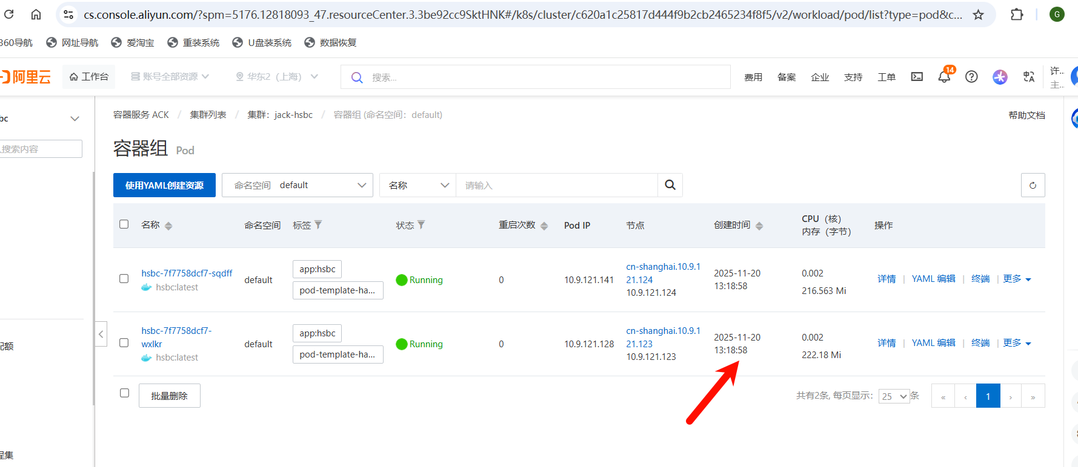

Pod recovery time is 6 seconds.

It takes around 20 seconds for the application service to start.

So the total recovery time for the application is less than 30 seconds.
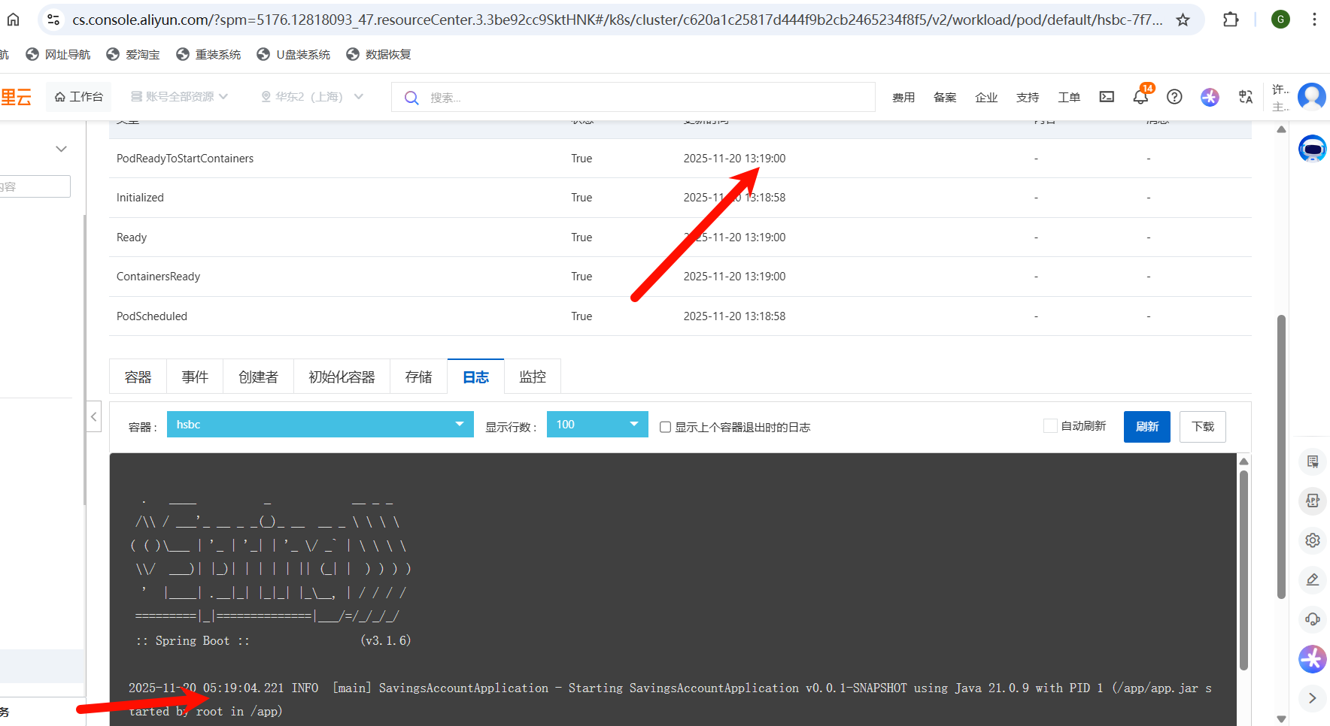

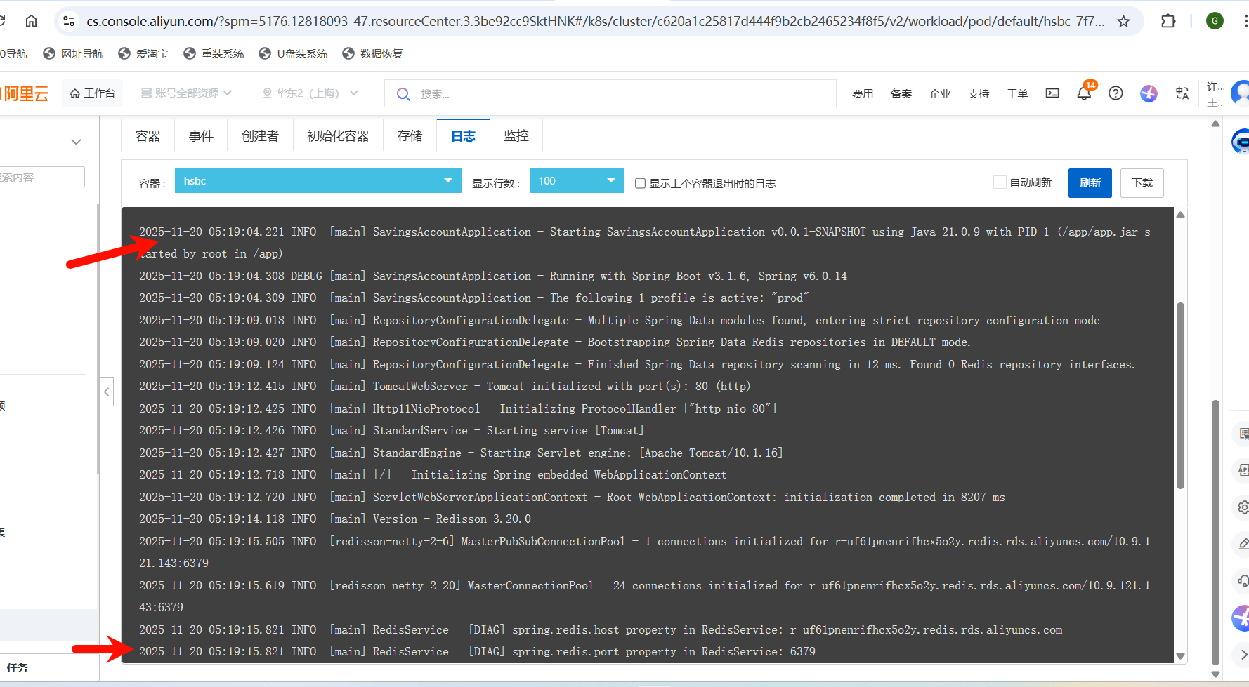

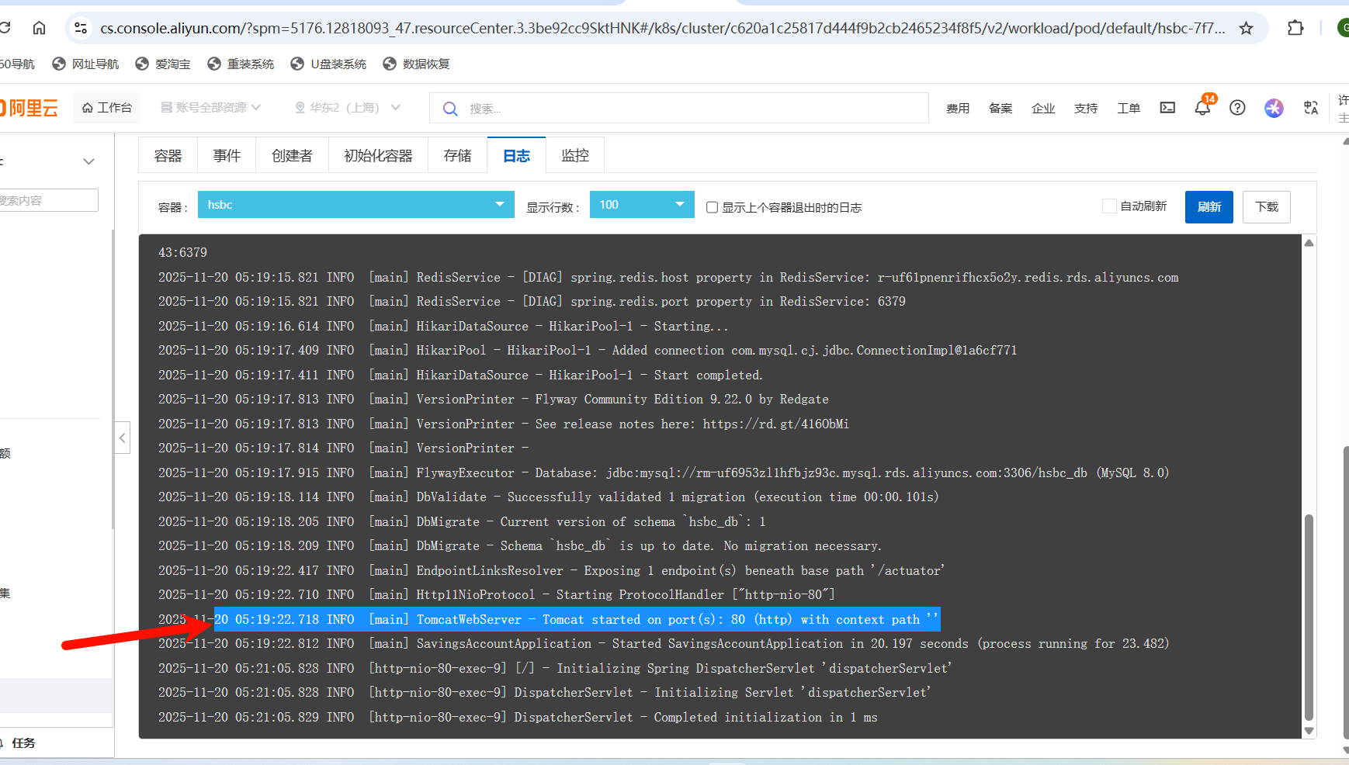

Performance Test Result

https://github.com/gangqiangxu-commits/hsbc/tree/main/performance-test-report

Application Service
The application service has been deployed to alibaba cloud and the loader balancer is “nlb-cjcgvvtjd95y6gbcb9.cn-shanghai.nlb.aliyuncsslb.com”.

http://{HOST_IP}/swagger-ui/index.html

Steps to get {HOST_IP}
- Open a terminal
- Execute “ping nlb-cjcgvvtjd95y6gbcb9.cn-shanghai.nlb.aliyuncsslb.com” to get ip
- http://101.132.43.228/swagger-ui/index.html
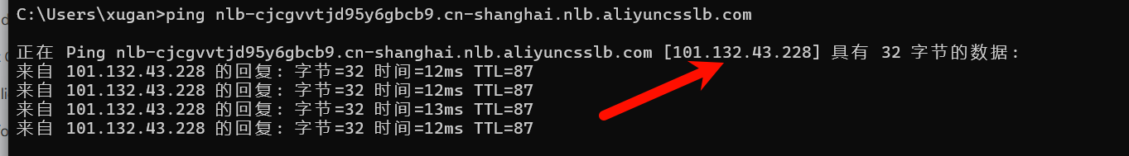

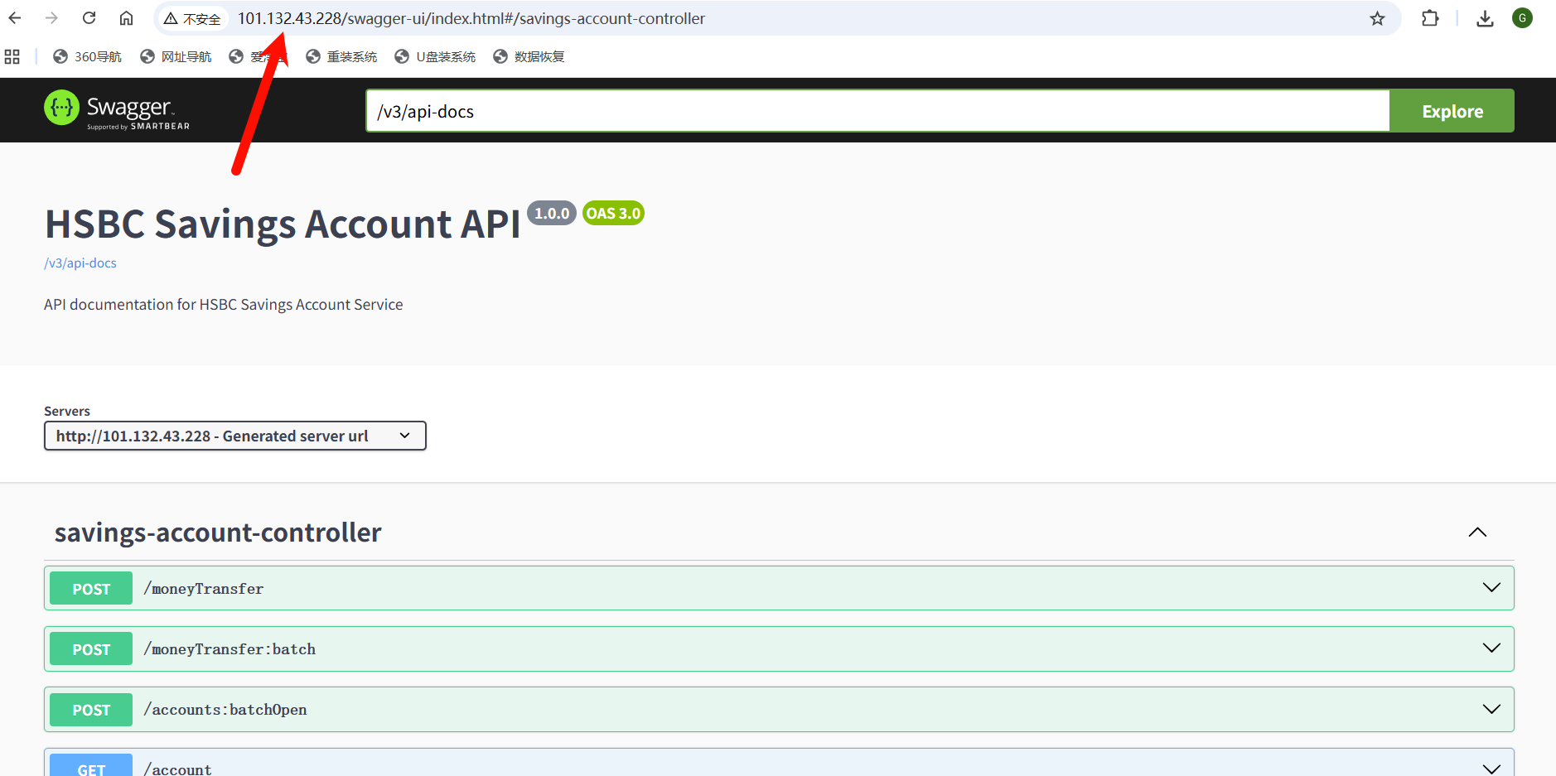

Build

Build Jar File
mvn clean package

Execute Unit Test - Exclude Integration Test
mvn -Dtest=*Test test

Execute Integration test - Exclude Unit Test
mvn -Dtest=*IT test

Generate Coverage
mvn clean test jacoco:report

Test Application Locally

run-dev-profile.cmd for windows and run-dev-profile.sh for linux

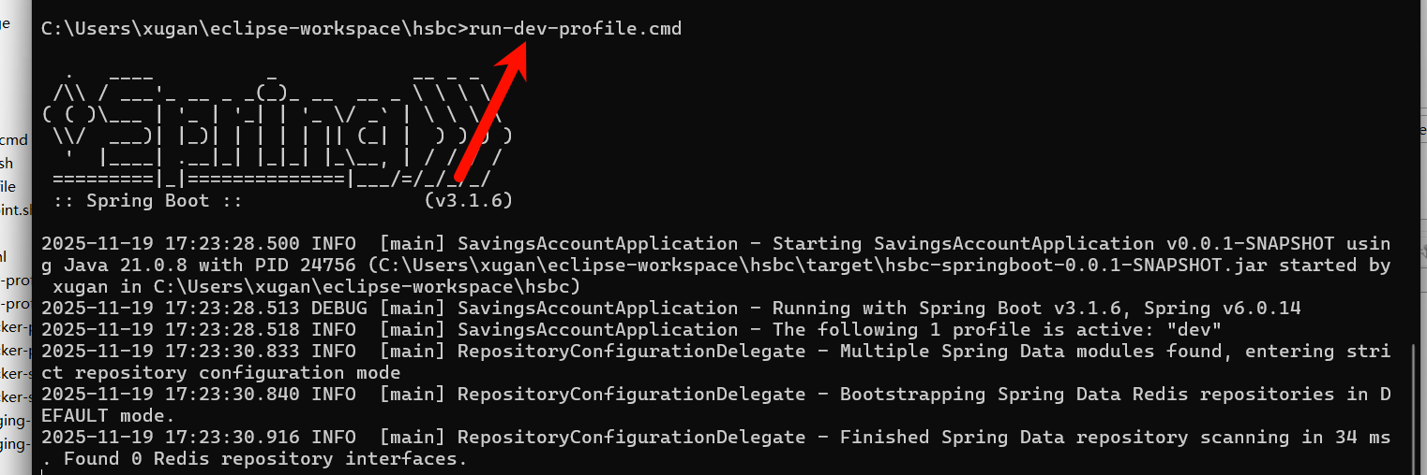

Build Docker Image
docker build --no-cache -t hsbc-springboot-app:latest .

Deploy

Make sure redis (default port, no password) and mysql (default port) are installed and accessible. Please create “hsbc_db” in mysql in advance.

Dev (local machine, not inside docker)

java -jar -Dspring.profiles.active=dev target/hsbc-springboot-0.0.1-SNAPSHOT.jar

Staging (docker in local machine)

docker run -d -p 80:80 --name my-container my-image:latest

Configure below environmental variables:

- name: DB_HOST
value: your_db_host_on_cloud
- name: DB_USERNAME
value: your_user_on_cloud_db
- name: DB_PASSWORD
value: your_password_on_cloud_db
- name: REDIS_HOST
value: your_redis_host_on_cloud
- name: SPRING_PROFILES_ACTIVE
value: staging

Prod (docker in alibaba cloud)

docker run -d -p 80:80 --name my-container my-image:latest

Configure below environmental variables:

- name: DB_HOST
value: your_db_host_on_cloud
- name: DB_USERNAME
value: your_user_on_cloud_db
- name: DB_PASSWORD
value: your_password_on_cloud_db
- name: REDIS_HOST
value: your_redis_host_on_cloud
- name: SPRING_PROFILES_ACTIVE
value: prod

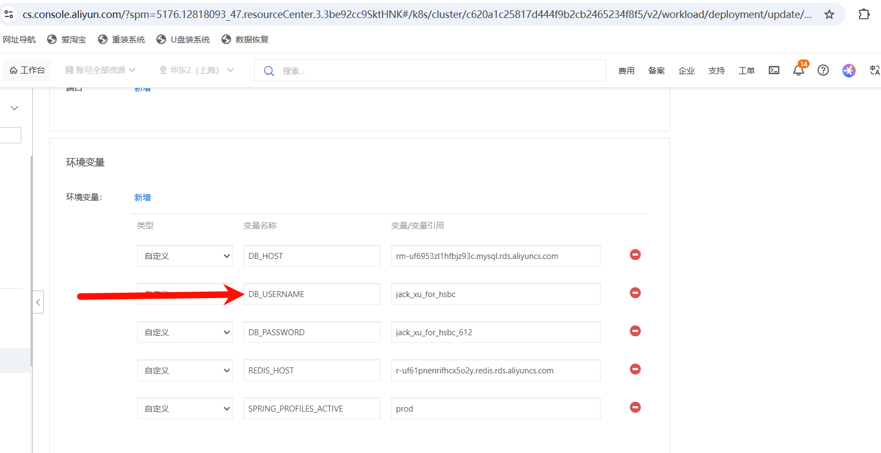

API
For more details, refer to swagger ui. http://localhost/swagger-ui/index.htm

Open Savings Account API

It’s used to create a “Savings Account” for users.

http://localhost/swagger-ui/index.html#/savings-account-controller/openAccount

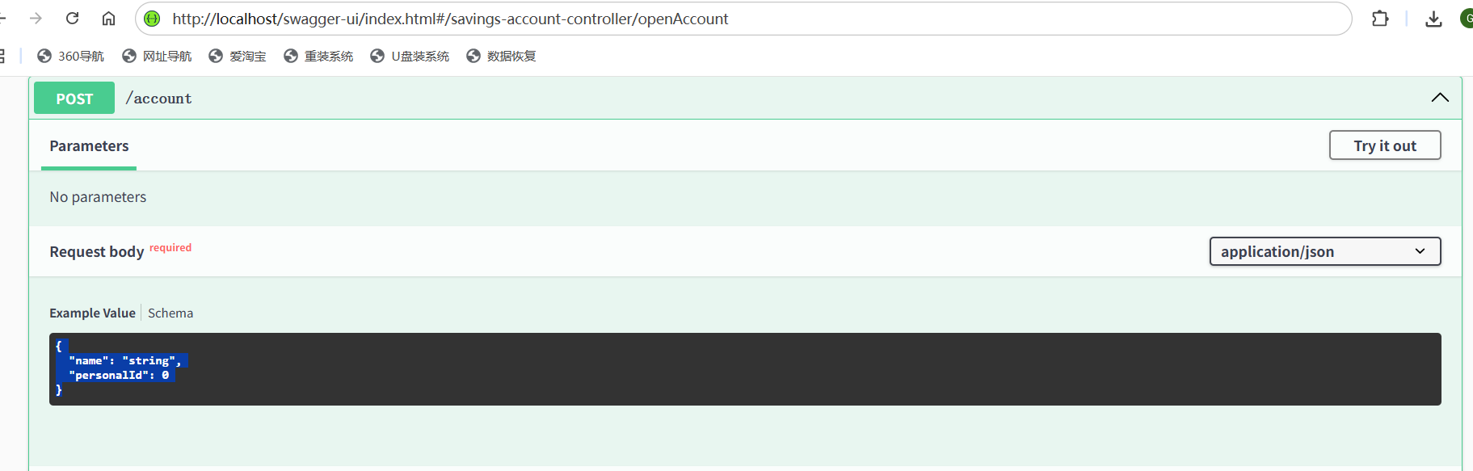

Request

{
"name": "string",
"personalId": 0
}

Response

{
"accountNumber": 0,
"name": "string",
"personalId": 0,
"balance": 0,
"createdAt": "2025-11-19T09:27:55.506Z",
"lastUpdated": "2025-11-19T09:27:55.506Z"
}

Batch Open Savings Account API

This API is used to create multiple accounts within one request.

http://localhost/swagger-ui/index.html#/savings-account-controller/batchOpenAccounts

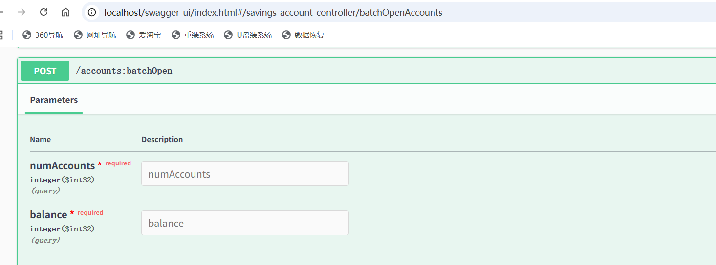

Request

numAccounts - how many accounts do you want to create - max to 1000
balance - the amount that will be deposited into the newly created account (all the numAccounts accounts)

Response
List of accounts created.

[
{
"accountNumber": 0,
"name": "string",
"personalId": 0,
"balance": 0,
"createdAt": "2025-11-19T09:52:45.307Z",
"lastUpdated": "2025-11-19T09:52:45.307Z"
}
]

Deposit Withdraw API
It’s used to deposit into or withdraw money from the “Savings Account” and then the “balance” of the “Savings Account” will be updated accordingly.

A positive amount means deposit (account balance will be increased) and a negative amount means withdrawal (account balance will be reduced).

For example, depositing 100 to account A means the balance for account A will be increased by 100. And withdrawing 100 from account A means the balance for account A will be reduced by 100.
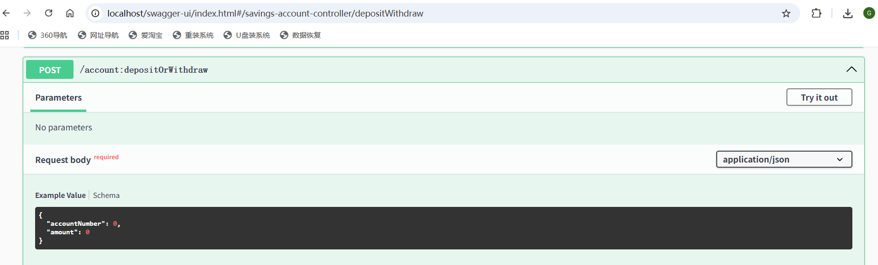
http://localhost/swagger-ui/index.html#/savings-account-controller/depositWithdraw

Request

{
"accountNumber": 1,
"amount": 100
}

This request means to deposit 100 (positive means deposit, -100 means withdraw) to an account whose number is 1.

Response
{
"account": {
"accountNumber": 0,
"name": "string",
"personalId": 0,
"balance": 0,
"createdAt": "2025-11-19T09:37:24.651Z",
"lastUpdated": "2025-11-19T09:37:24.651Z"
},
"success": true,
"errorMessage": "string"
}

The response contains a “success” flag to tell whether the deposit/withdrawal is success or not (like balance is not enough which will lead to failure). The “account” field tells the account information after the deposit/withdrawal.

Money Transfer API

http://localhost/swagger-ui/index.html#/savings-account-controller/processMoneyTransfer

This API is used to transfer an amount from “source account” to “destination account”.

For example, transfer 100 from account A to account B - which means the balance for account A will be reduced by 100 and the balance for account B will be increased by 100.

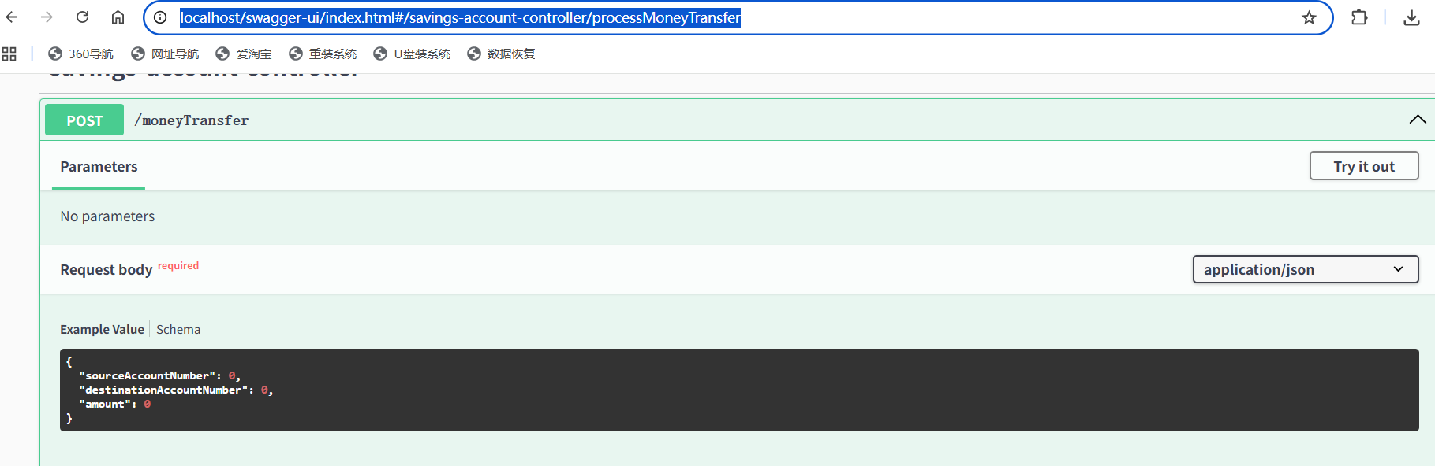

Request

{
"sourceAccountNumber": 12,
"destinationAccountNumber": 13,
"amount": 231
}

This request means transfer 231 from account 12 to account 13.

Response
{
"sourceAccount": {
"accountNumber": 12,
"name": "string",
"personalId": 0,
"balance": 333,
"createdAt": "2025-11-19T09:43:22.625Z",
"lastUpdated": "2025-11-19T09:43:22.625Z"
},
"success": true,
"errorMessage": "string"
}

This response means the request has been processed successfully and the balance for account 12 is 333 after the “money transfer”.

Batch Money Transfer API

This API processes multiple “money transfers” within one request.
http://localhost/swagger-ui/index.html#/savings-account-controller/batchMoneyTransfer

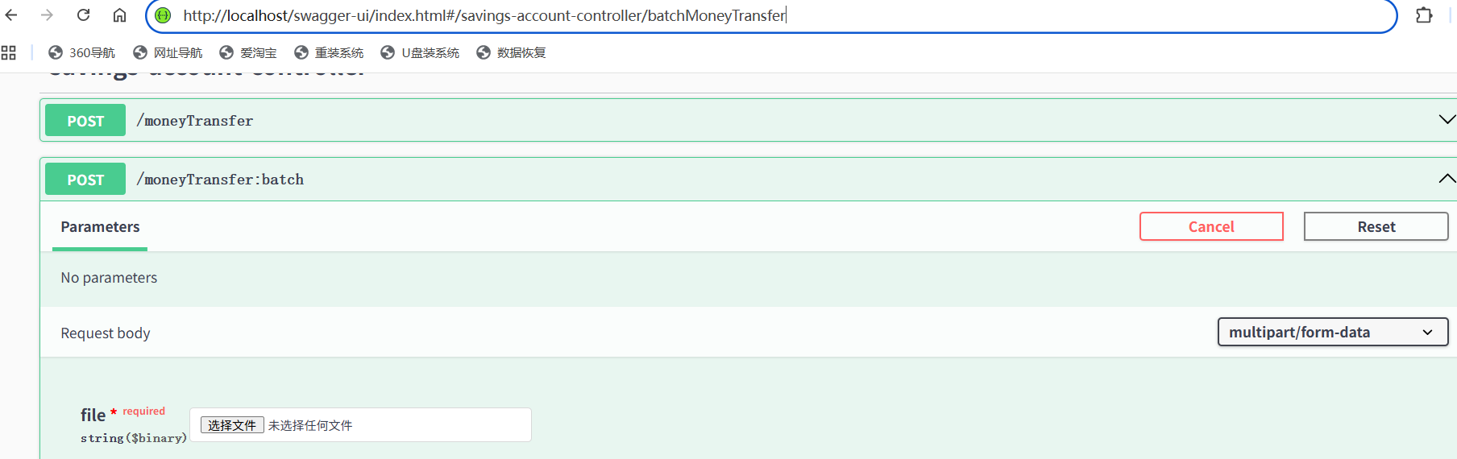

Request

A CSV file contains multiple lines and each line will contain 3 columns (columns are separated by space).

Sample file (csv file):

1 75 5333 # transfer 5333 from account 1 to account 75
1 69 5333
1 77 5333
2 71 5333
2 98 5333
2 40 5333
3 32 5333
……

Response
List of “money transfer responses” - one “money transfer response” for each “money transfer request”.

[
{
"sourceAccount": {
"accountNumber": 1,
"name": "Mocked User1600",
"personalId": 75,
"balance": 27693,
"createdAt": "2025-11-18T15:13:31",
"lastUpdated": "2025-11-18T15:13:31"
},
"success": true,
"errorMessage": ""
},
…,
{
…
}
]

Generate Mock Transactions API

This API is used to generate a csv file that contains transaction data (money transfer) and can be consumed by ‘Batch Money Transfer API’.

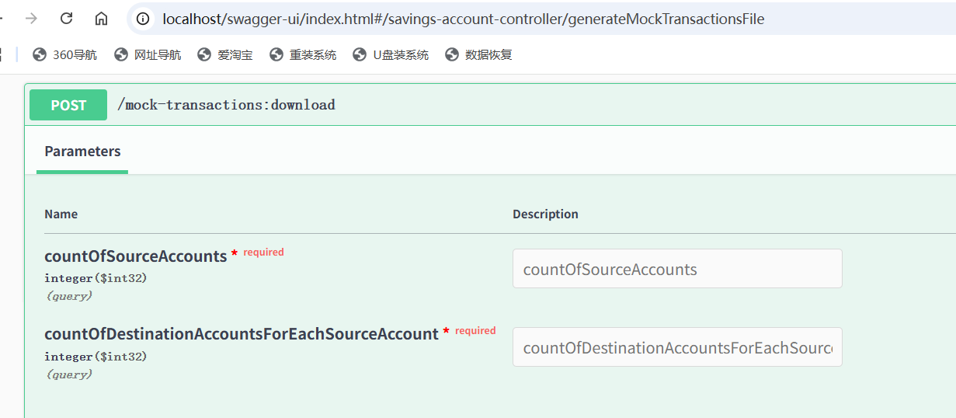

Request

countOfSourceAccounts - how many source accounts for the mocked transaction data (max to 100)

countOfDestinationAccountsForEachSourceAccount - for each source account, how many destination accounts should be used (up to 100).

Total number of “money transfer” request in the generated csv file - up to countOfSourceAccounts * countOfDestinationAccountsForEachSourceAccount (up to 100 * 100 = 100 00).

Response

A CSV file that contains the generated mocked transaction data.

1 75 5333 # transfer 5333 from account 1 to account 75
1 69 5333
1 77 5333
2 71 5333
2 98 5333
2 40 5333
3 32 5333
……

Other APIs

For other API, please refer to swagger ui.

http://localhost/swagger-ui/index.html

Design

Database Schema

-- Table: savings_account
CREATE TABLE IF NOT EXISTS savings_account (
account_number BIGINT PRIMARY KEY AUTO_INCREMENT,
name VARCHAR(255) NOT NULL,
personal_id BIGINT NOT NULL,
balance BIGINT NOT NULL,
created_at TIMESTAMP NOT NULL DEFAULT CURRENT_TIMESTAMP,
last_updated TIMESTAMP NOT NULL DEFAULT CURRENT_TIMESTAMP ON UPDATE CURRENT_TIMESTAMP
);

-- Table: deposit_withdraw_history
CREATE TABLE IF NOT EXISTS deposit_withdraw_history (
transaction_id BIGINT PRIMARY KEY,
account_number BIGINT NOT NULL,
amount BIGINT NOT NULL,
created_at TIMESTAMP NOT NULL DEFAULT CURRENT_TIMESTAMP,
CONSTRAINT fk_account_number FOREIGN KEY (account_number) REFERENCES savings_account(account_number),
INDEX idx_udwh_account_number (account_number),
INDEX idx_udwh_created_at (created_at)
);

-- Table: money_transfer_history
CREATE TABLE IF NOT EXISTS money_transfer_history (
transaction_id BIGINT PRIMARY KEY,
source_account_number BIGINT NOT NULL,
destination_account_number BIGINT NOT NULL,
amount BIGINT NOT NULL,
created_at TIMESTAMP NOT NULL DEFAULT CURRENT_TIMESTAMP,
CONSTRAINT fk_source_account FOREIGN KEY (source_account_number) REFERENCES savings_account(account_number),
CONSTRAINT fk_destination_account FOREIGN KEY (destination_account_number) REFERENCES savings_account(account_number),
INDEX idx_mth_source_account (source_account_number),
INDEX idx_mth_destination_account (destination_account_number),
INDEX idx_mth_created_at (created_at)
);

Entity Relationship
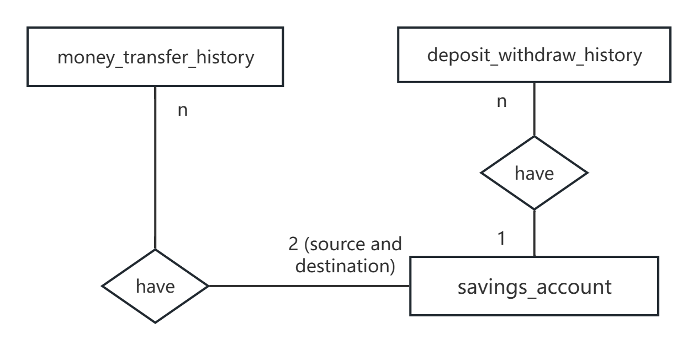

Architect
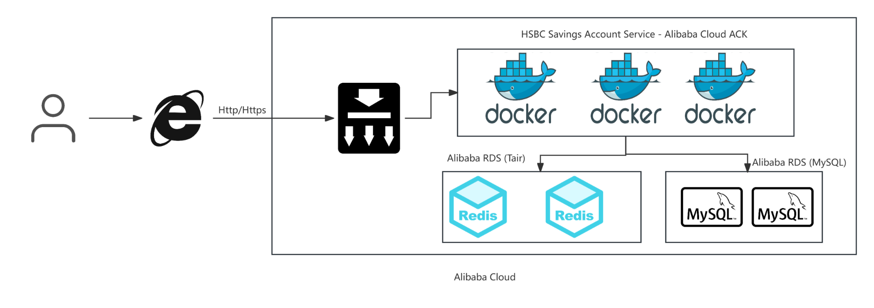

Data Consistency

When updating the balance for an account, “redisson lock” for the account will be used to make sure only one thread can update the balance for that account.

Such lock is used for both “depositOrWithdraw” and “money transfer” API.

Performance

Java virtual thread is used to process “batch money transfer” for performance consideration. Similar practice should be applied for “batch open accounts” and “batch deposit/withdraw” as well.

However, due to time limitations, I will mark such change as TODO for now.

