Screenshot 1: Screenshot 2026-09-11 084635.png
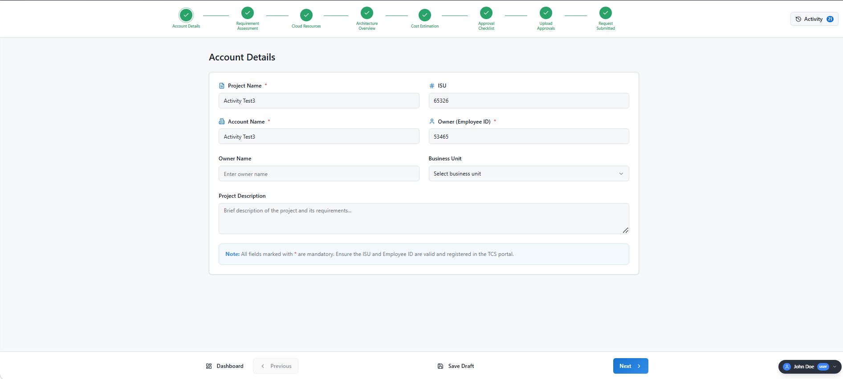

Screenshot 2: Screenshot 2026-09-11 084703.png
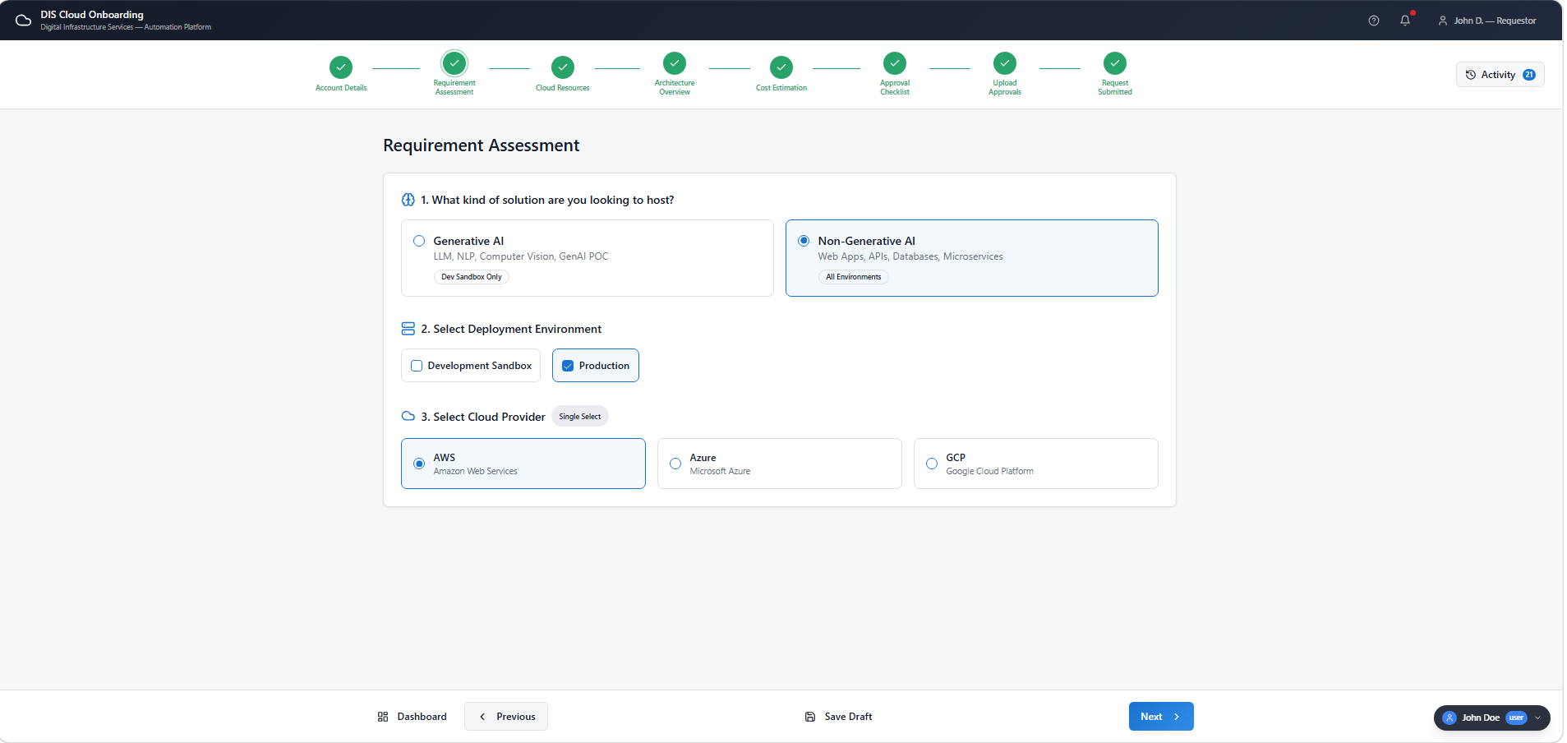

Screenshot 3: Screenshot 2026-09-11 084734.png
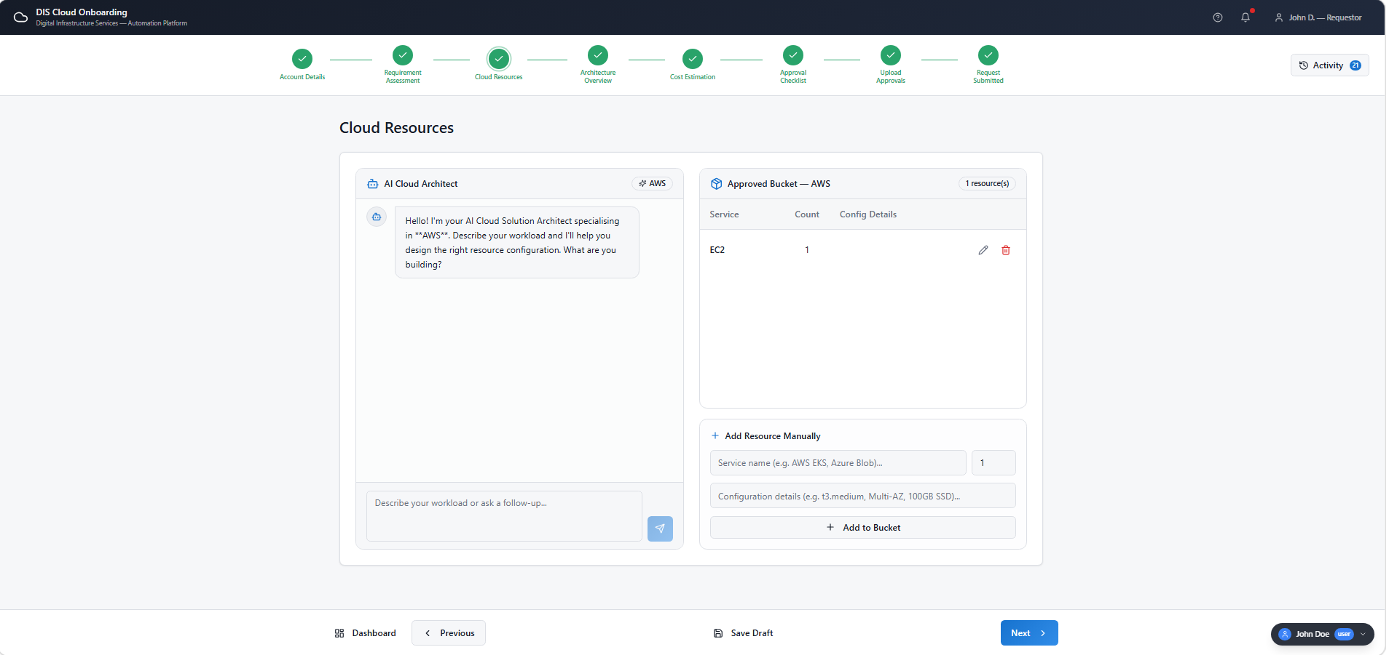

Screenshot 4: Screenshot 2026-09-11 084806.png
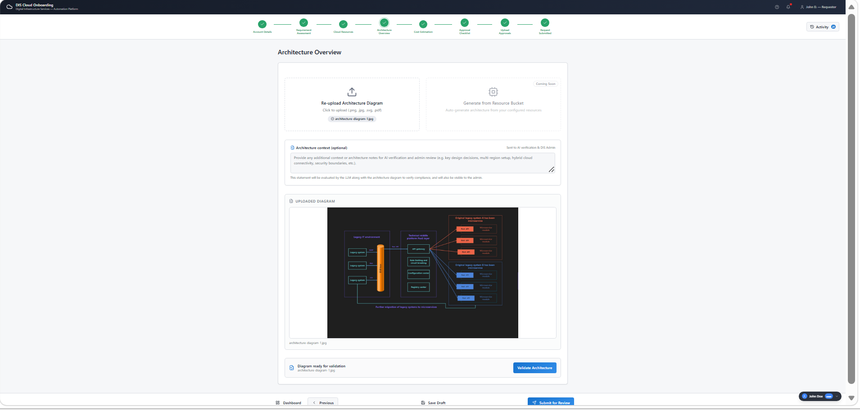

Screenshot 5: Screenshot 2026-09-11 084826.png
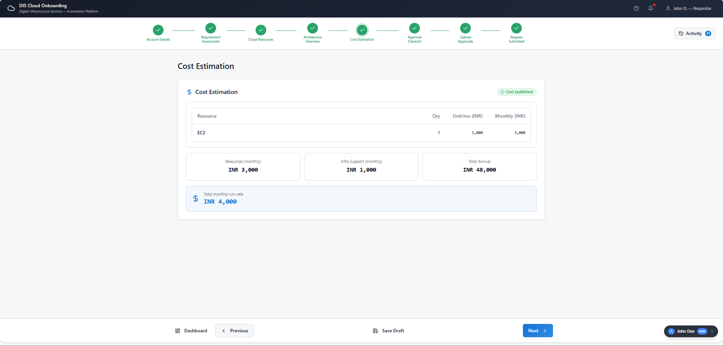

Screenshot 6: Screenshot 2026-09-11 084846.png
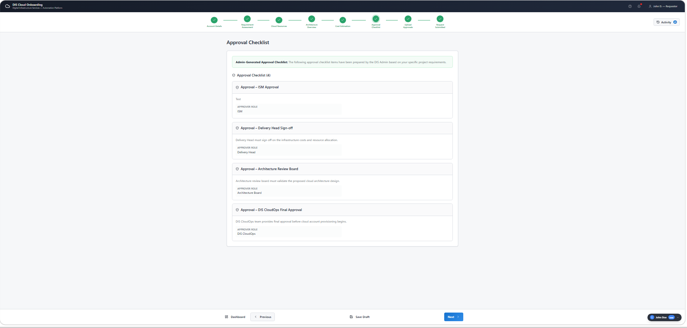

Screenshot 7: Screenshot 2026-09-11 084902.png
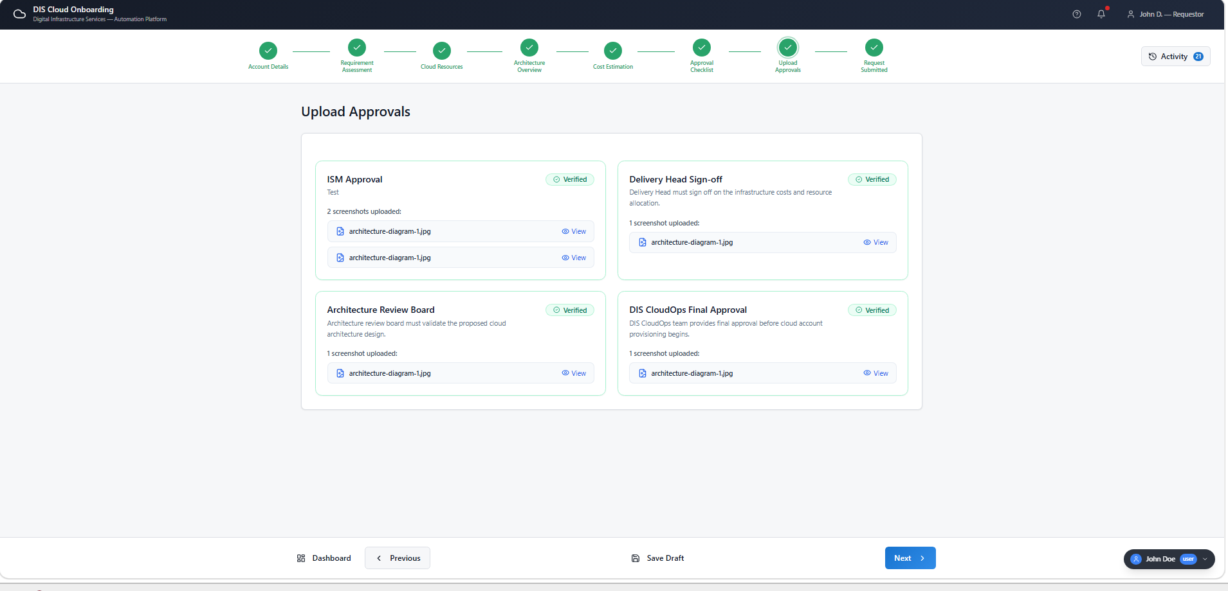

Screenshot 8: Screenshot 2026-09-11 085111.png
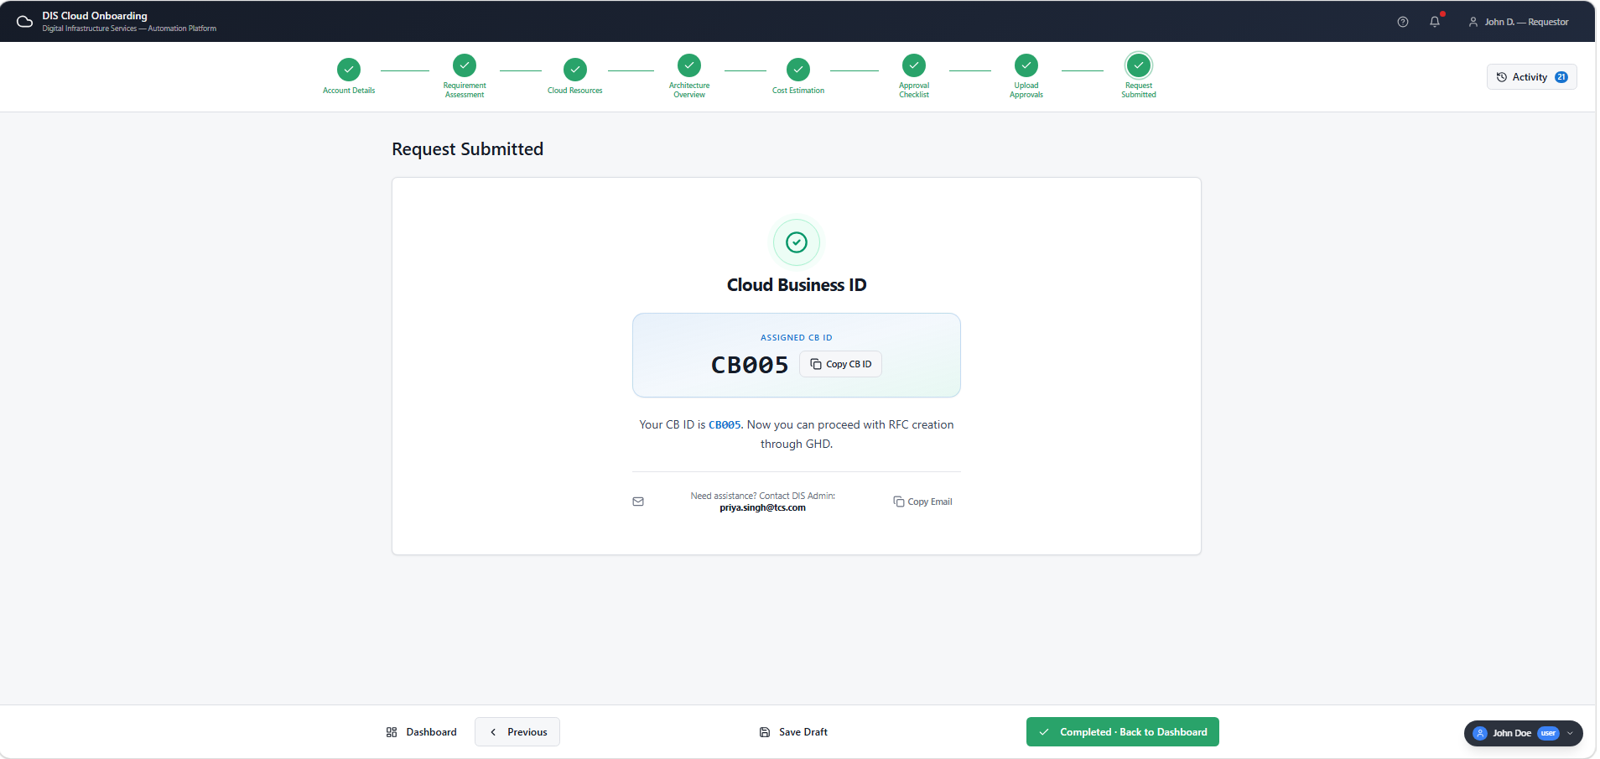

Screenshot 9: Screenshot 2026-09-11 085259.png
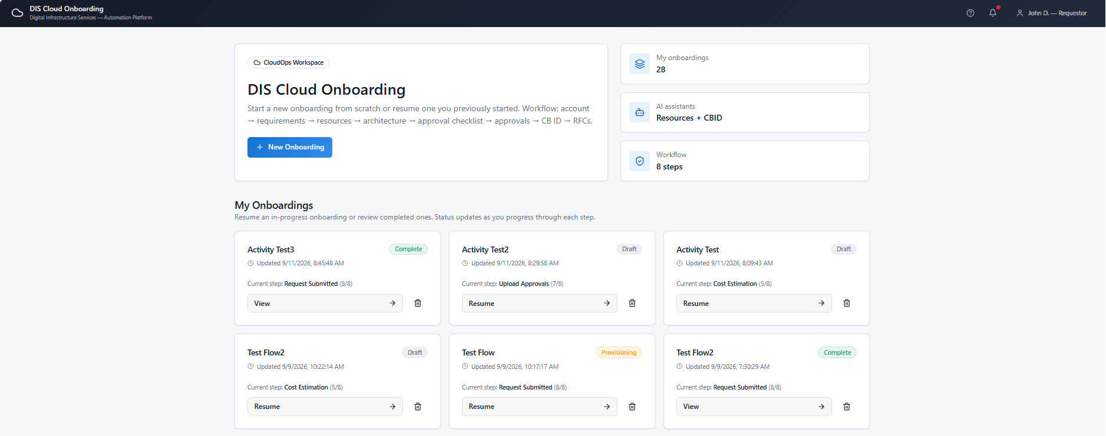

Screenshot 10: Screenshot 2026-09-11 085340.png
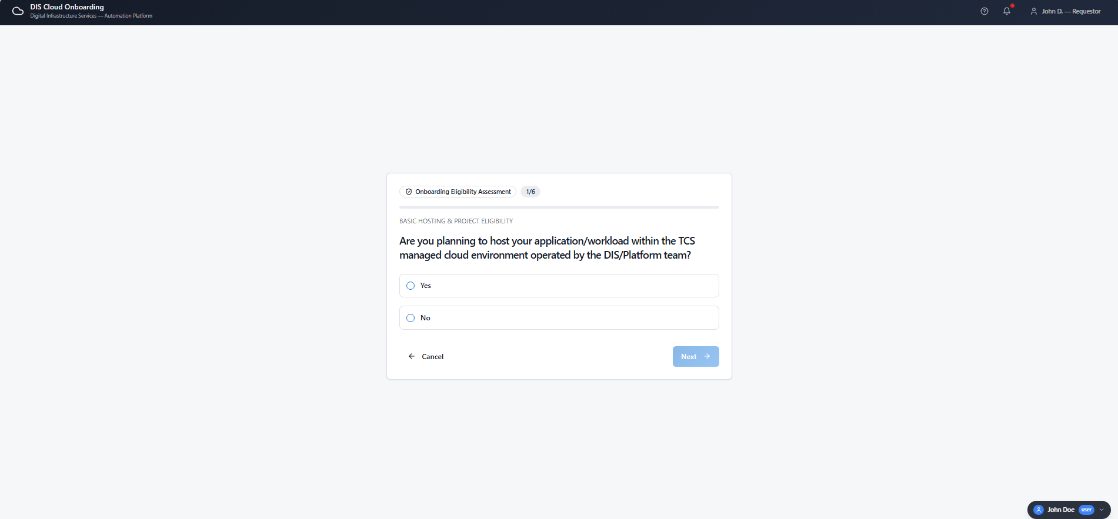

Super Admin Dashboard
Screenshot 11: Screenshot 2026-09-11 085423.png
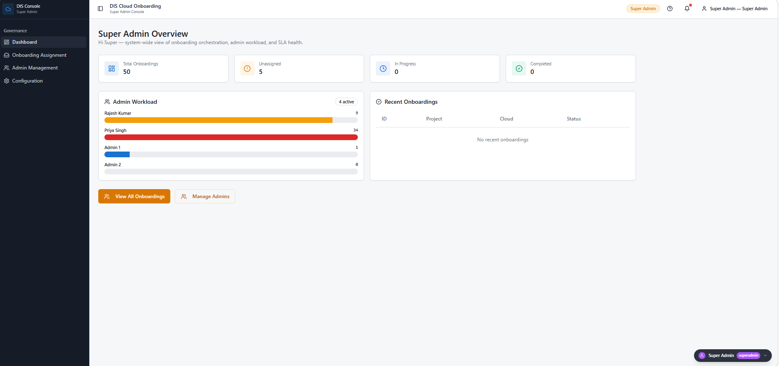

Screenshot 12: Screenshot 2026-09-11 085458.png
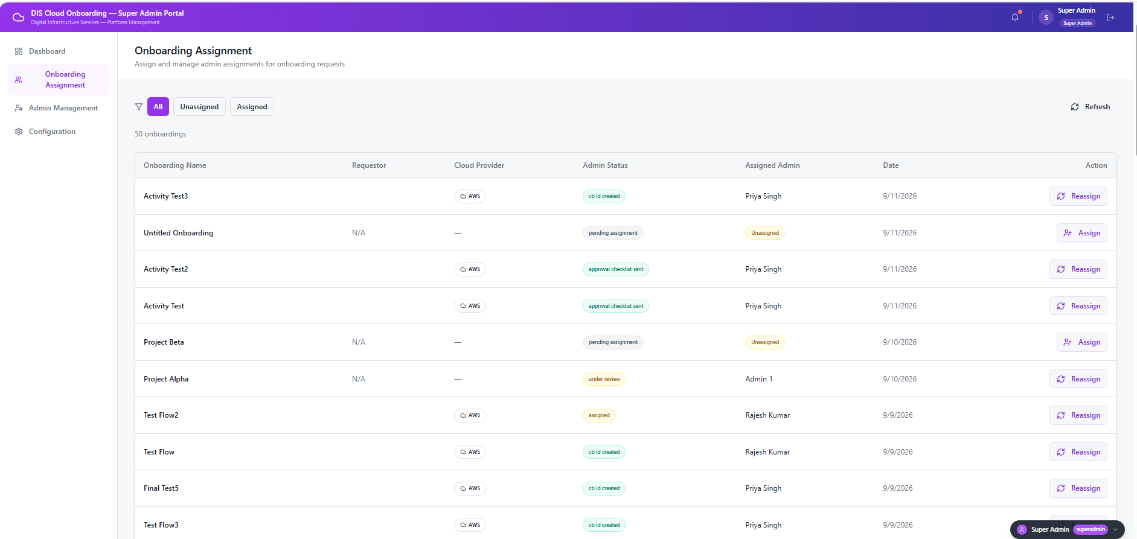

Screenshot 13: Screenshot 2026-09-11 085555.png
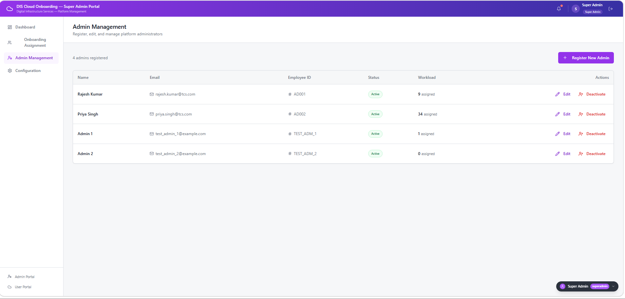

Screenshot 14: Screenshot 2026-09-11 085618.png
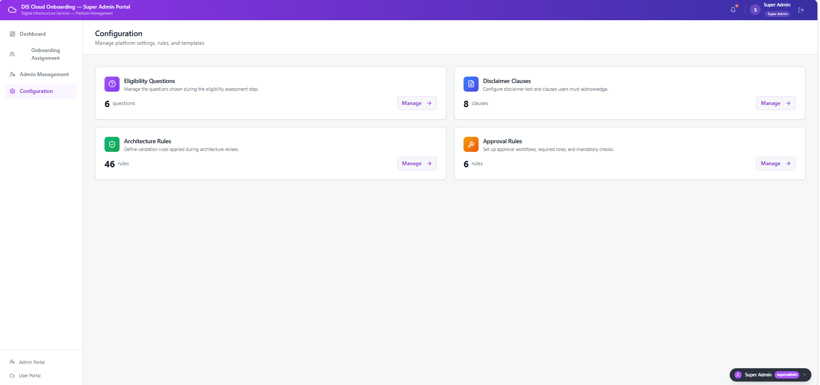

Admin Dashboard
Screenshot 15: Screenshot 2026-09-11 085659.png
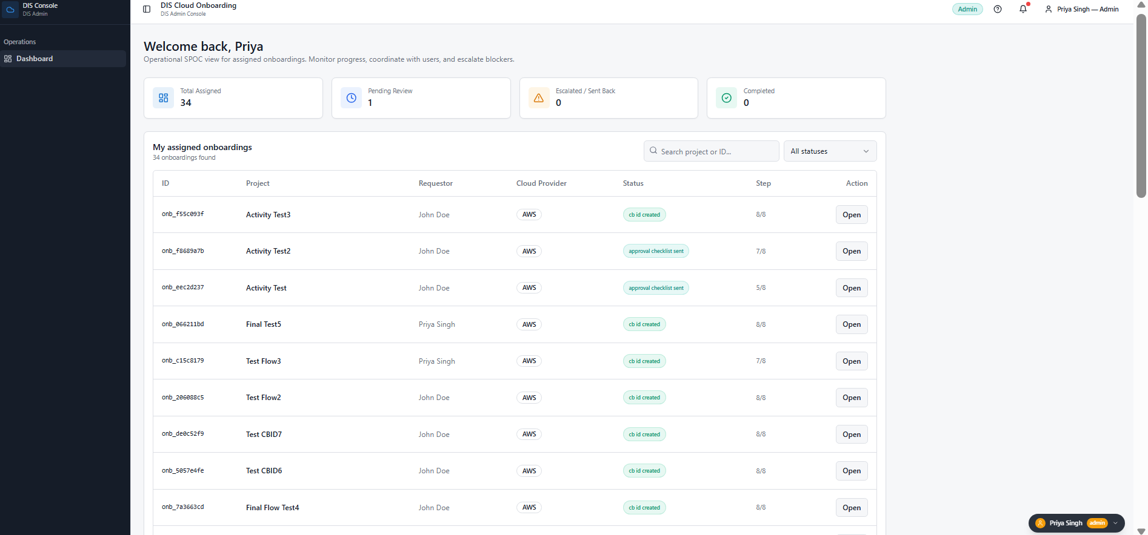

Screenshot 16: Screenshot 2026-09-11 085725.png
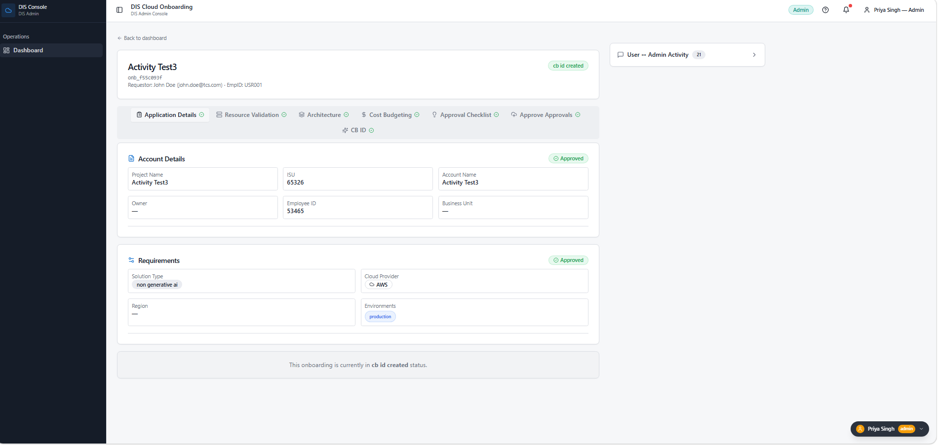

Screenshot 17: Screenshot 2026-09-11 085748.png
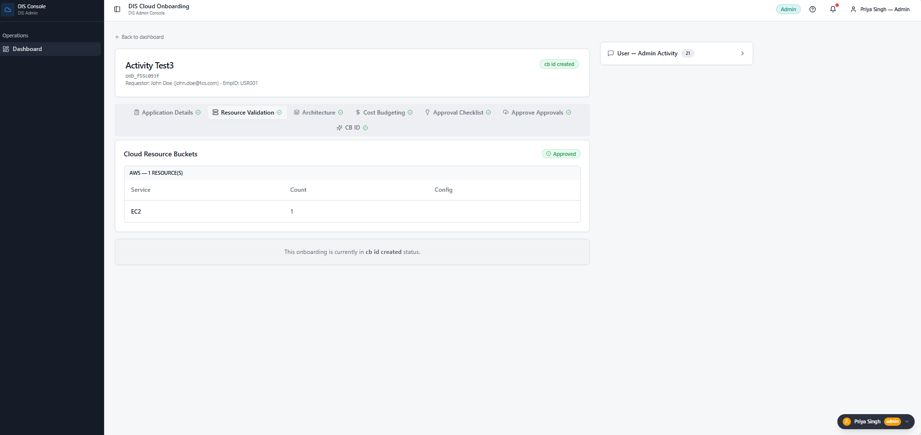

Screenshot 18: Screenshot 2026-09-11 085809.png
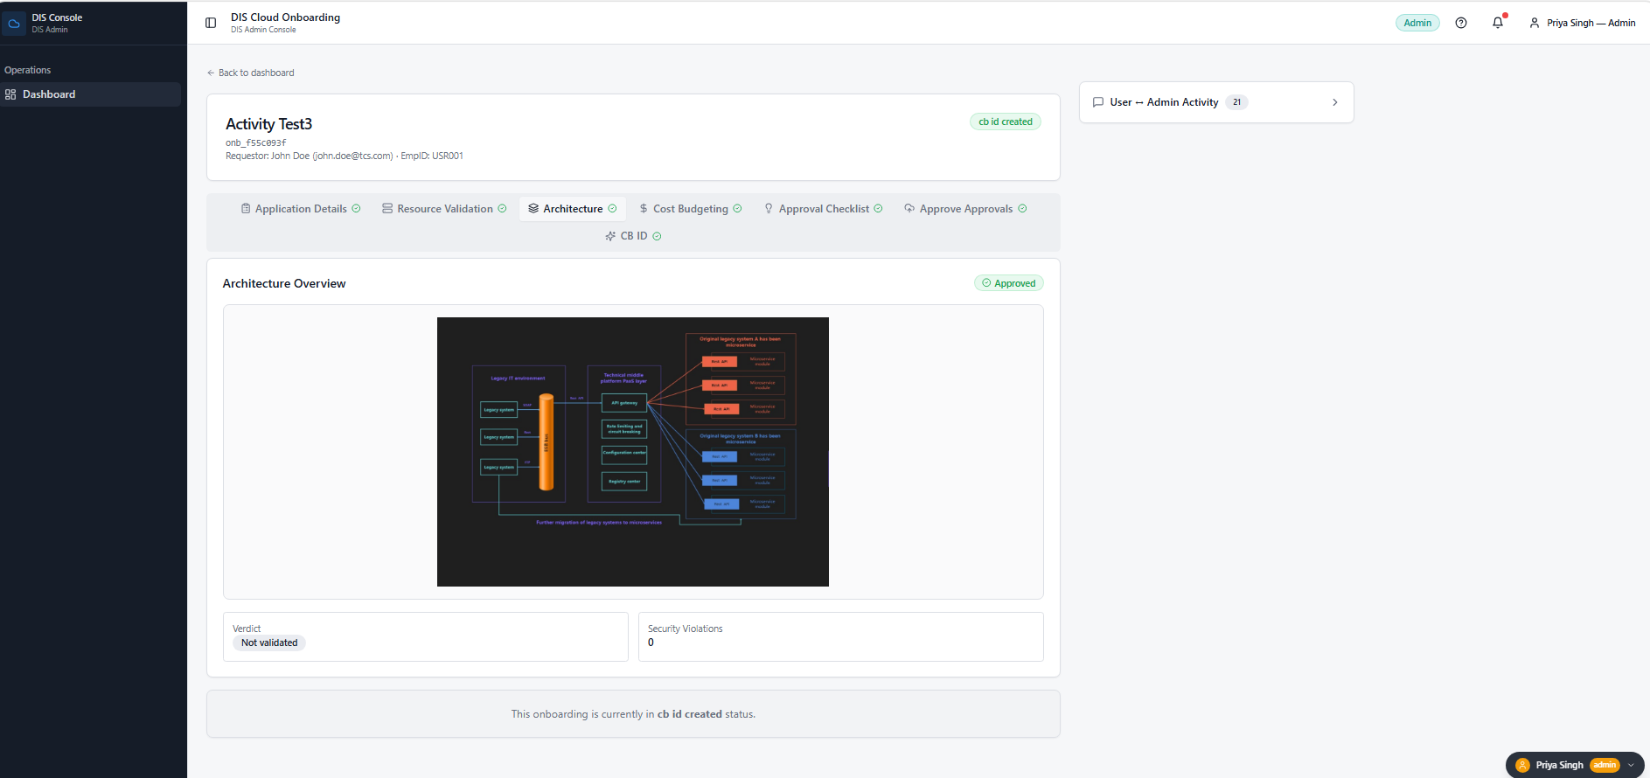

Screenshot 19: Screenshot 2026-09-11 085840.png
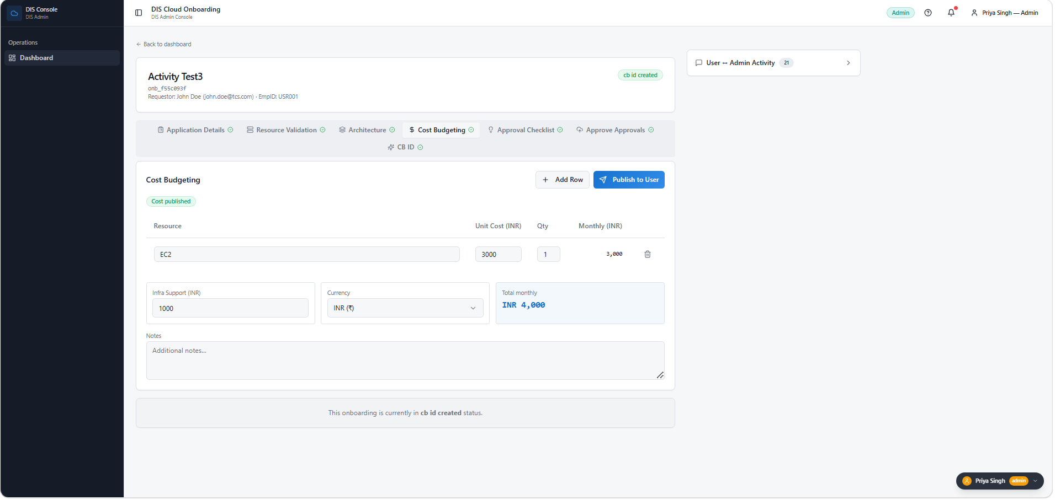

Screenshot 20: Screenshot 2026-09-11 085908.png
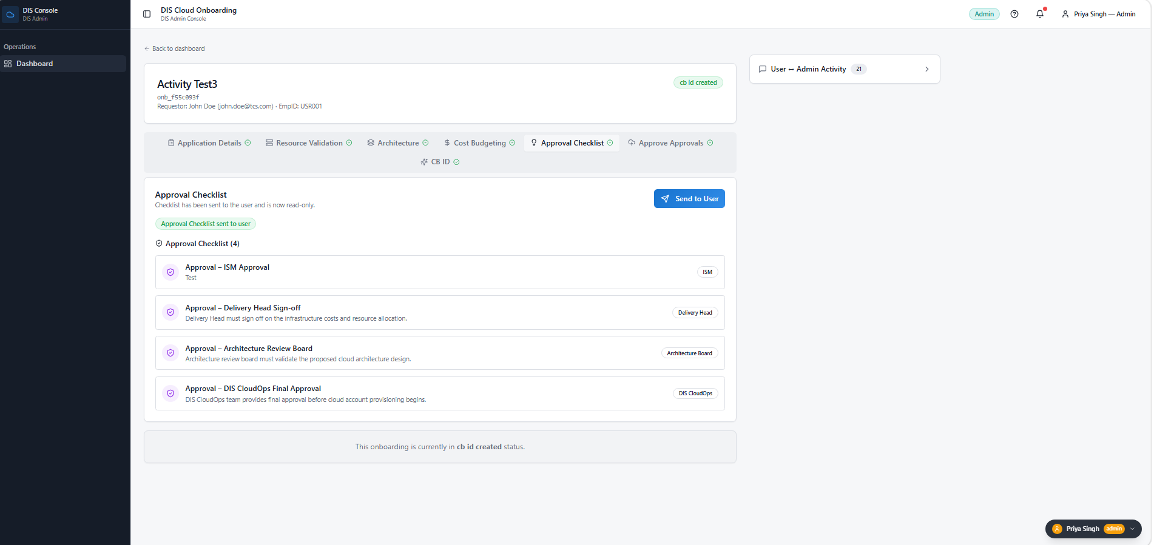

Screenshot 21: Screenshot 2026-09-11 085933.png
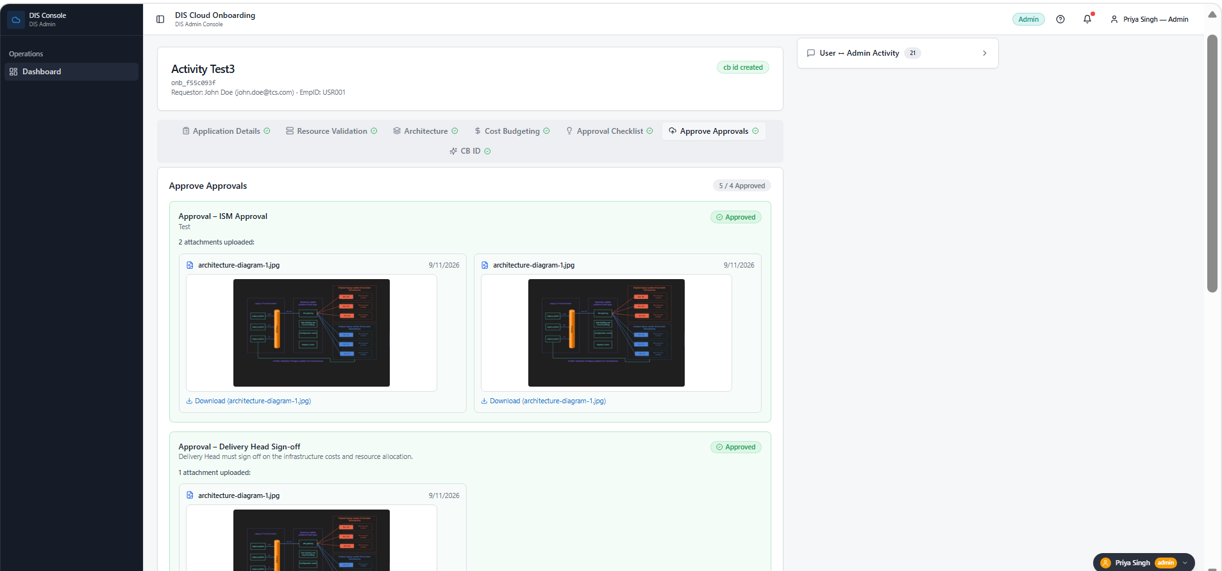

Screenshot 22: Screenshot 2026-09-11 090018.png
