**UserProfile-Assignment option1**

The Node JS project UserProject is a simple Node.js project, having two model User(UserQueue) and UserRole(UserRoleQueue).

For starting the project download it from GIT and go to the project folder from windows terminal and run **npm install** to download the required node_modules folder.

**Project Start**

After node_modules is created, to start the project run **npm run start** to start the project. The application runs on port 3000 with context root as /userProfile. Standard logging is done with help of Winston.

**Workflow**

Package.json🡪index,js🡪start the webserver and listen for routes arriving with help of express🡪Routes arrives and driven to controller file with help of router.js🡪controller files read the input query strings and drive to data layer from where manipulation/calculation is done and returns the result back to controller🡪User gets the response.

**Request**

Firstly put User data like below:

For 1st Request:

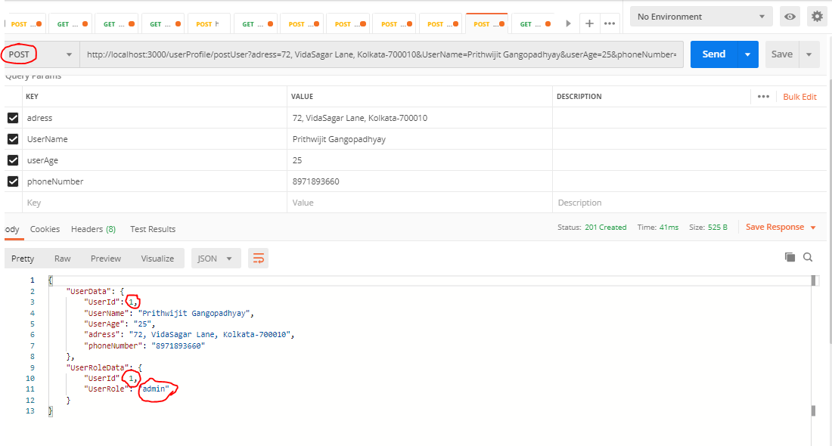

For 2nd Request:

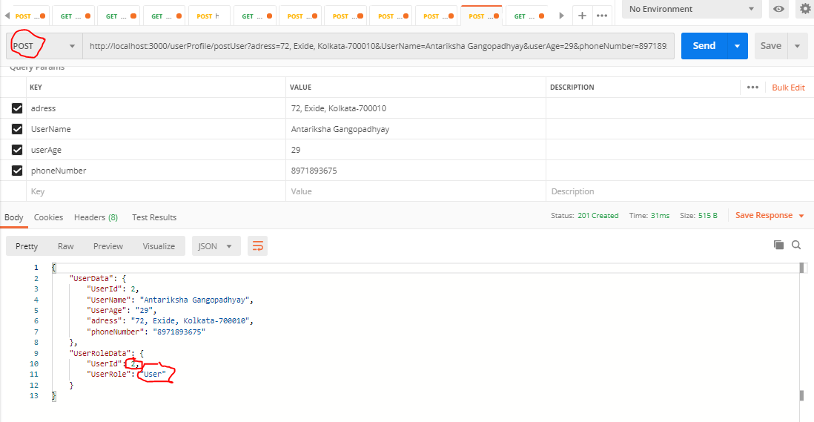

For 3rd Request:

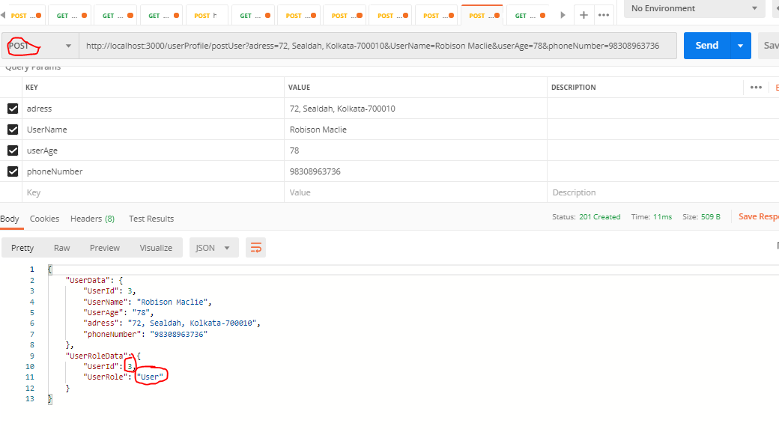

Similarly, For get request:

For userId one the role is Admin and subsequest roles are user. Below is the snapshot:

For 1st User get request:

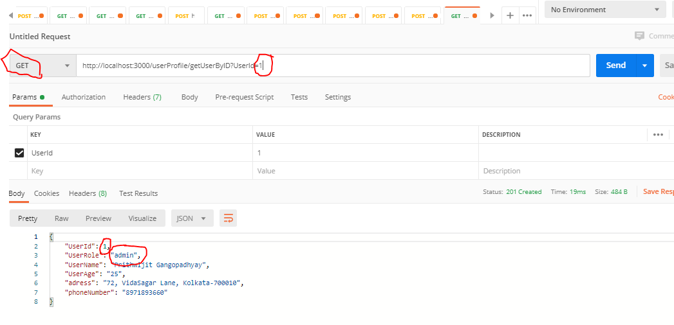

For Other user get request:

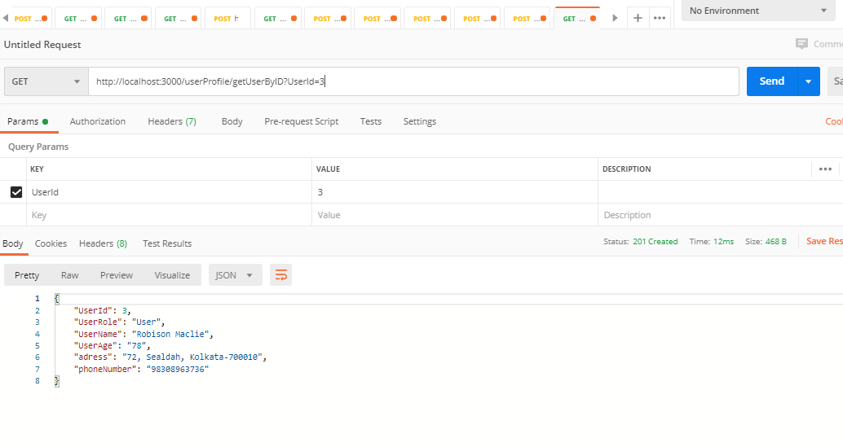

[1]

1. UserProfiling by Prithwijit Gangopadhyay