Roster Application

Motivation for Developing a New Roster App
- Outdated technology used in the current Roster Application.
- High manual effort required to assign shifts to employees.
- Limited user-friendliness.
- High dependency on HRMS DB
- Frequent bugs and error
EOC Managers' Insights on the Current Roster Application
1. System Performance and Functionality
• Performance Issues: The application is slow.
• Functionality Gaps: Key usability and functionality aspects are missing, impacting user experience.
2. Data Management
• Manual Data Entry: Excessive manual effort is required for adding employees and updating rosters.
• Automation Needs:
- Automate monthly shift updates for employees.
- Implement an Excel import template for bulk data uploads.
• Synchronization Issues: Employee data is not properly synced, causing inconsistencies.
3. Roster and Shift Management
• Automation Challenges: Roster automation does not align with actual schedules or preferences.
• Shift Details: Shift timings and details are inconsistent and irrelevant dashboards add confusion.
• Color Coding and Layout: Improve employee visibility with locked headers and color-coded shifts.
4. Timesheet and Leave Management
• Timesheet Issues: Inaccurate WFH and WFO statuses are reported.
• Leave Automation Malfunction: Leaves are not picked up correctly, leading to discrepancies.
5. Access and Security
• WFH Login Protocol: Enforce login via laptops for WFH scenarios to ensure accountability.
• Manager-Specific Security Role: Enable managers to update employee information securely.
6. Incident and Record Management
• Incident Creation Support: Lack of robust support for incident creation.
• Record Modification Limitation: Users cannot modify records opened via the database view.
7. Active Table and Filters
• Active Table Updates: The table does not reflect real-time changes.
• Team Clearance Filters: Filters for managing team clearance are non-functional.
Technology Stack of New Roster Application
1. Frontend
- Framework - Angular
- Languages - HTML, CSS
- Packages - Angular CLI, Bootstrap, PrimeNg
2. Backend
- Framework - .Net Core
- Languages - C#
- WebApi - ASP.Net WebAPI (to expose RESTful services)
- Authentication - JWT (JSON Web Token)
3. Database
- ORM - Entity Framework Core
- Database - SQL Server
- Approach - Code First/ Db First ?
4. Development Environment & Tools
- IDE/Editor - Visual Studio 2022
- Package Manager - NuGet(for .Net Core), npm(for Angular)
- Version Control - Git

Feature 1: Menu -> Team
This feature allows team managers, responsible for overseeing teams that work in shifts, to create and manage their teams within the Roster Application.
1.1 Sub-Menu New
Roles- Admin and Manager role
For Admin Role:
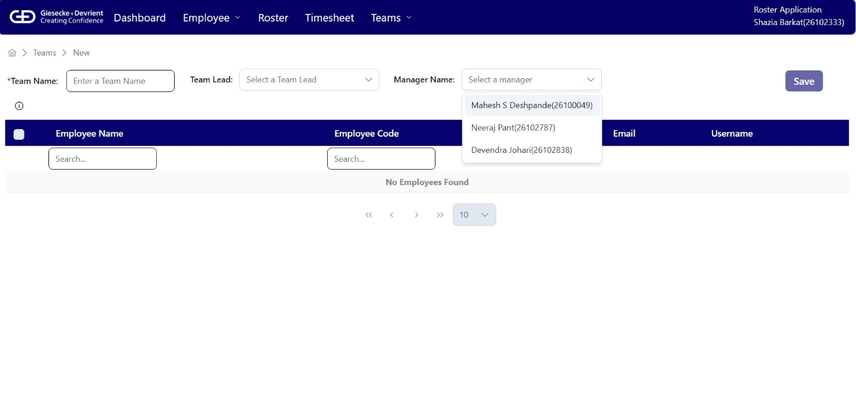
For Manager Role:
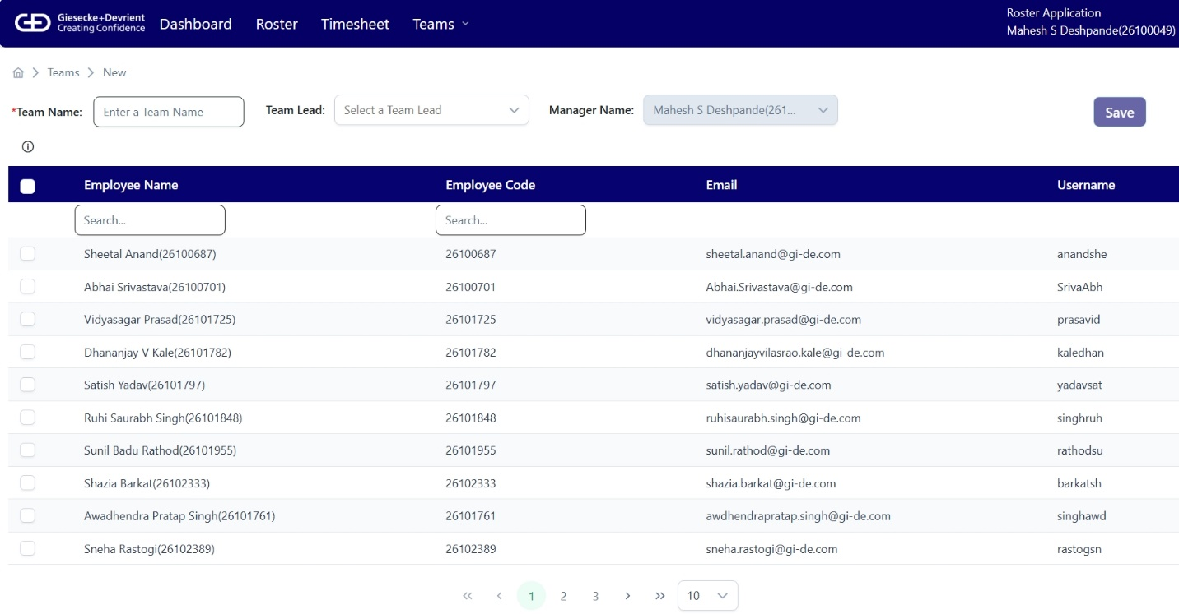
1. Team Name
The "Team Name" is a required field that must be completed by the user when creating a team.
2. Team Lead
Contains the name of employee who is onboarded as team lead in the application. This role has special privileges than a employee.
3. Manager
This is a role-based feature that functions according to the logged-in user's role.
a. Manager Role:
If the logged-in user has the Manager role, the text box will be automatically populated with their name and disabled. The logged-in user must be assigned the Manager role in the HRMS.
b. Admin Role:
If the logged-in user has the Admin role, they will see a dropdown list populated with the available managers from HRMS.

4. Employee Table
This table is populated with employee data from HRMS, displaying only those employees who report to the manager selected/displayed in the Manager box.
a. Check box:
This column is used to select the employees to be consider in team creation.
b. Employee Name:
It contains the name of the employee as per in HRMS
c. Employee Id:
It contains the corresponding employee id from HRMS
d. Email:
It contains the corresponding employee's email from HRMS
e. User Id:
It contains the windows user id of the employee.
4. Save:
This button allows the user to save the selected employees and create a new team. Upon successful save, the application redirects to the "View Teams" menu page, where the newly added team is included in the list.
The 'Save' button will be disabled until all the below rules are followed.
Rules
- We do not allow user to create duplicate team with different names. It means that the number of employees and the employees themselves must be different in each team.
- The team's name must be unique within a manager's scope.
- At least one employee must be selected for the team.

1.2 Sub-Menu View
Roles - All users of the application
For Admin Role:
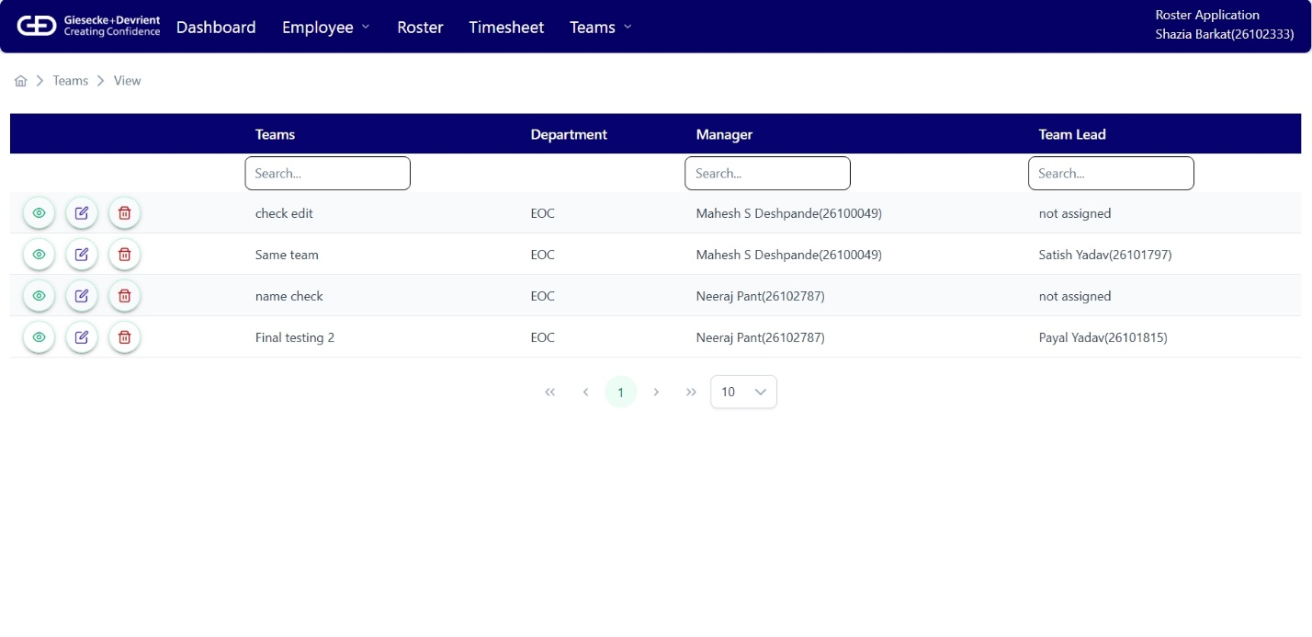
For Manager Role:
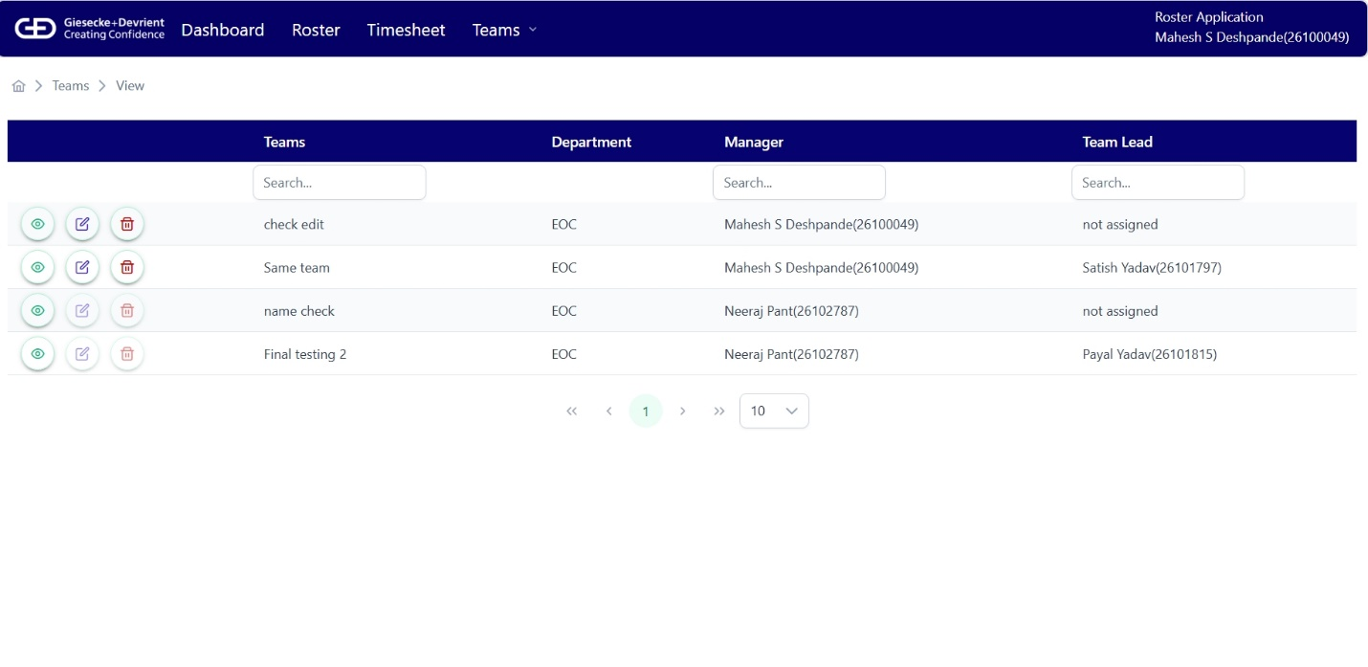
This is a role-based feature that functions according to the logged-in user's role.
1. Manager Role:
If the logged-in user has the Manager role, the action buttons will be enabled for his team only. The logged-in user must be assigned the Manager role in the HRMS.
2. Admin Role:
If the logged-in user has the Admin role, the action buttons will be enabled for all the teams.
3. Team List Table
This table includes all the teams.
a. Action buttons
- View
It opens a page identical to "Create New Team," but with the data pre-populated for that specific team. If there is no Team Lead for the team, then 'Not assigned' appears in the disabled textbox. It only displays the selected employees in the team with their name, employee ID, email, and username. All employees in the application have the same view for this page.
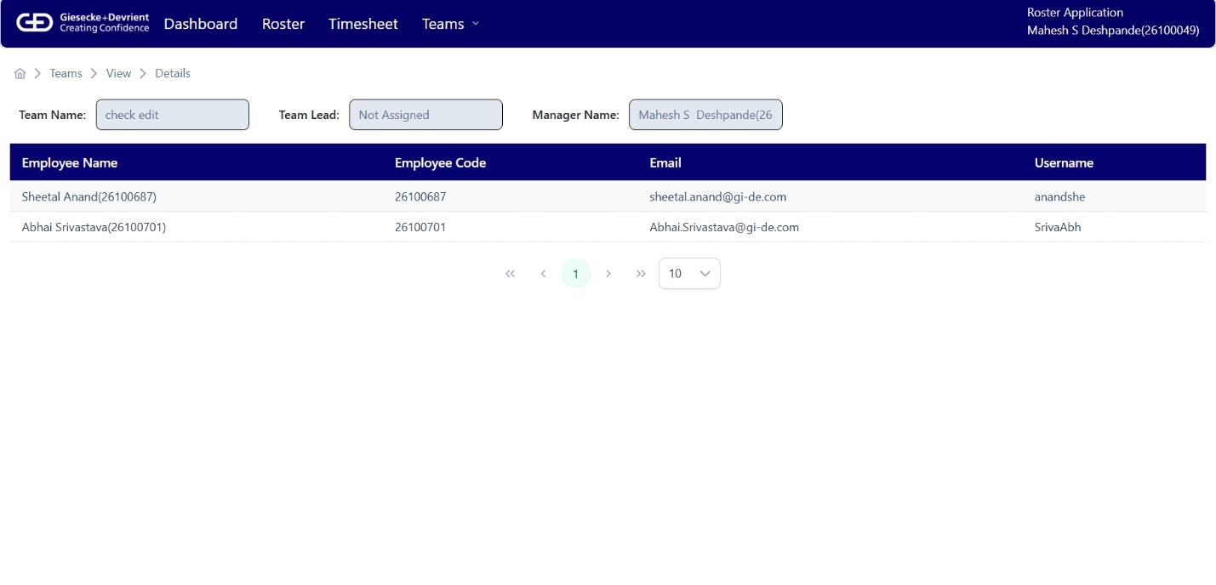
- Edit
Enabled Only for Admin and Manager role employees. It opens a page identical to "Create New Team". Here user can select/deselect the employee to update the employee list in a selected team. User can change the Team Name or Team Lead of the Team.
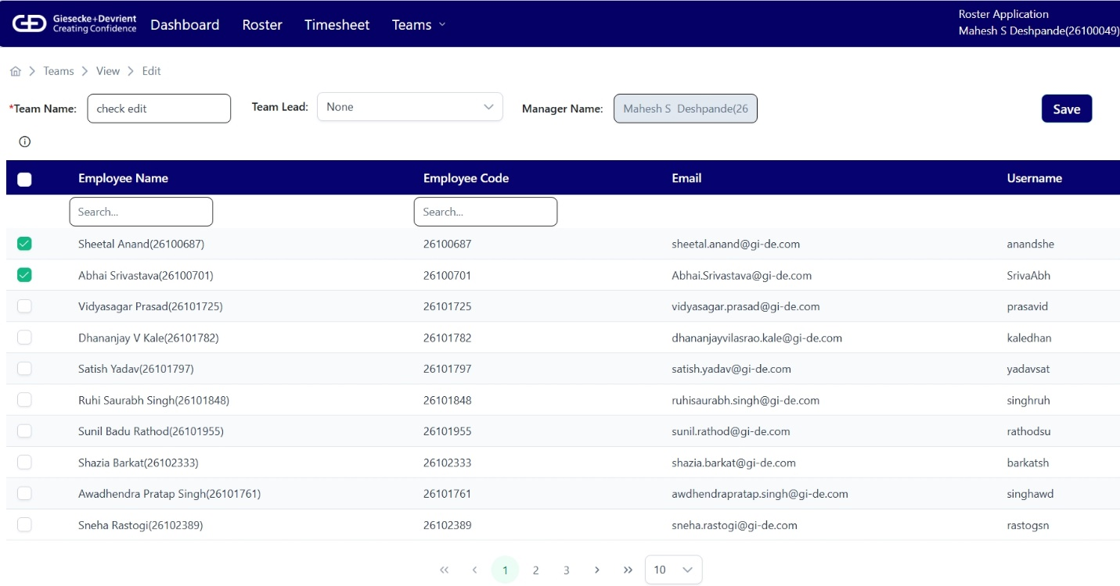
- Delete
Enabled Only for Admin and Manager role employees. On this button click a confirmation pop-up will come with yes and no button. It deletes the Team with its associated employees.
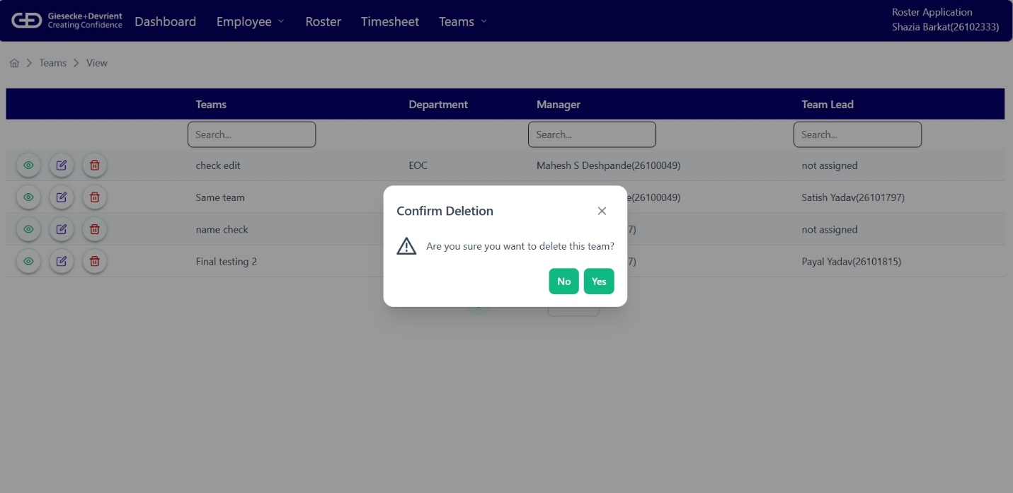
b. Teams
Displays the name assigned to the Team. This is a unique identifier entered during the team creation process and helps distinguish each team.
c. Department
Displays the name of the department of Team.
d. Manager
Shows the full name of the manager who oversees the team. This name is fetched based-on the application who is onboarded as Manager role. If the logged-in user has a Manager role, this column helps identify their own team(s).
e. Team Lead
Displays the full name of the designated team lead. If a team lead has not been assigned, the field displays "Not assigned".

Feature 2: Menu -> Employee -> Add: Onboarding Employees- Admin, Manager and Team Lead
Onboarding of Employees with following roles -
- Manager
- Team lead
- Admin (On Request)
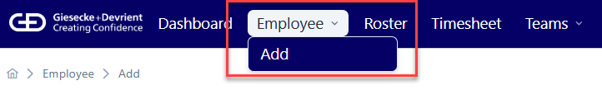
## Access - Only admin has access to this page/menu to perform any action.
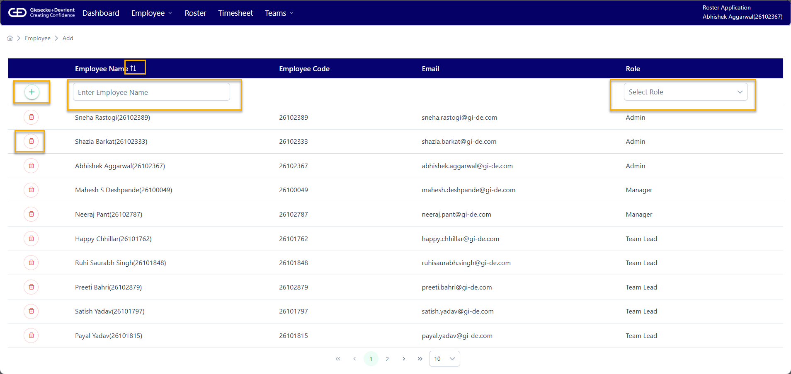
1. Table:
- First Row- To add any employee and assign any of the 3 roles with add button.
- Table shows all the onboarded employee with role Admin/Manager/Team Lead.
- Every entry has deleted button to de-board any onboarded employee
2. Employee name:
- Dropdown gets populated from HRMS data of all employees.
- This is a mandatory field to onboard any manager/team lead.
3. Employee Code:
- This column contains the Employee code from HRMS to uniquely identify the employee.
- Auto fills when user selects employee name.
4. E-mail:
- The Email of selected Employee from HRMS.
- Auto fills when user selects employee name.
5. Role:
- The feature offers 3 roles which can be assigned: Admin/Manager/Team Lead
- Mandatory Field to onboard any employee
- Manager : ​
  - Allowed roles- admin​
  - Not allowed- Team Lead & Employee​
- Team Lead: ​
  - Allowed all roles: Admin & Manager​
- Employee: No Use case here
6. Features:
- Easy One click Onboarding or deleting option​
- Confirmation dialog at both addition and deletion to avoid any errorneous operation​
- Pagination at bottom with custom number of results.​
7. Rule(s):
- All Roles: Can‘t delete User if has any active team​
