LAB1

[**Edit**](https://github.com/gani-umkc/CSEE-5590-Web-Programming/wiki/LAB1/_edit)[**New Page**](https://github.com/gani-umkc/CSEE-5590-Web-Programming/wiki/_new)

gani-umkc edited this page just now · [4 revisions](https://github.com/gani-umkc/CSEE-5590-Web-Programming/wiki/LAB1/_history)

**Create Account**

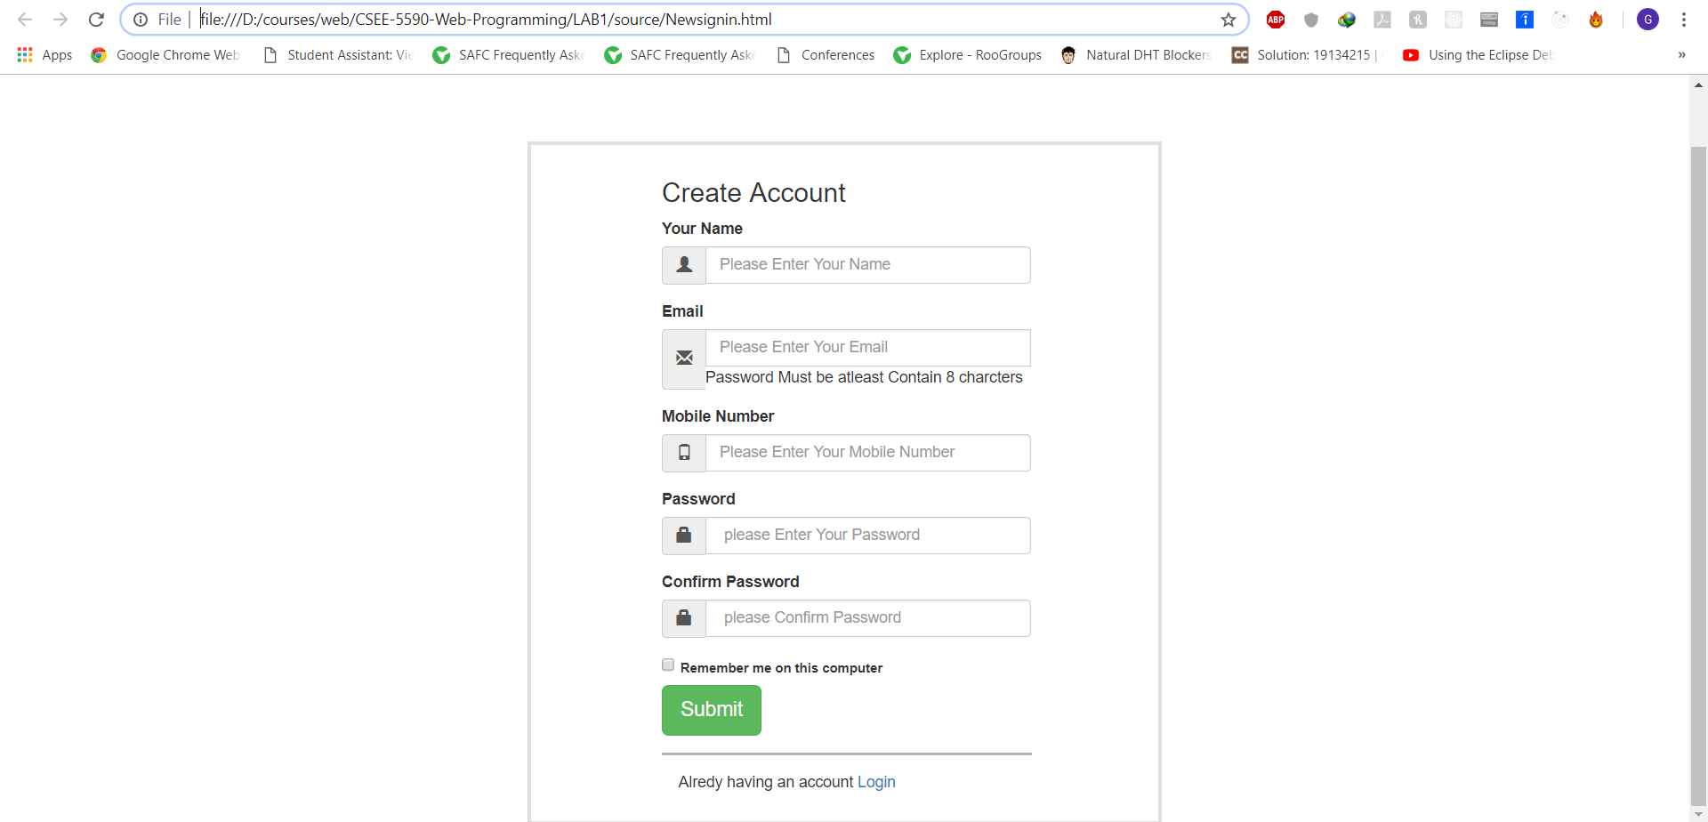

**Home Page**

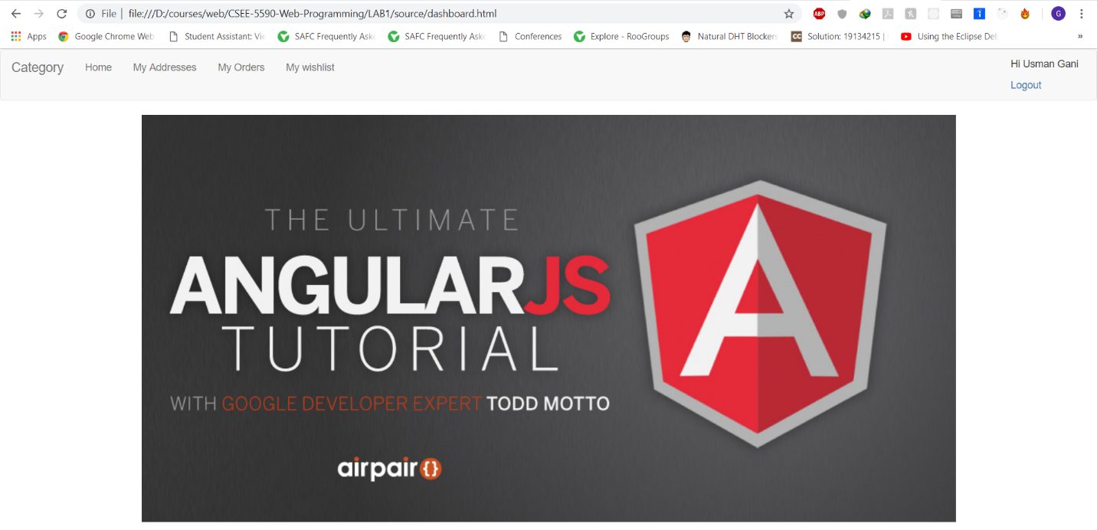

**Dashboard Page**

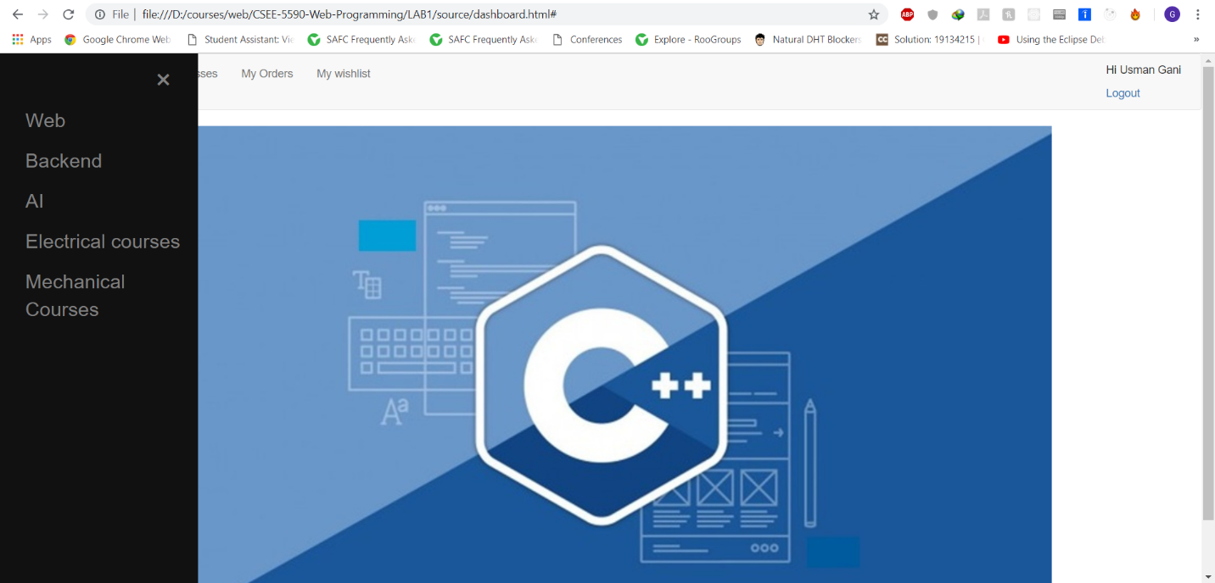

**Backend Cources Page**

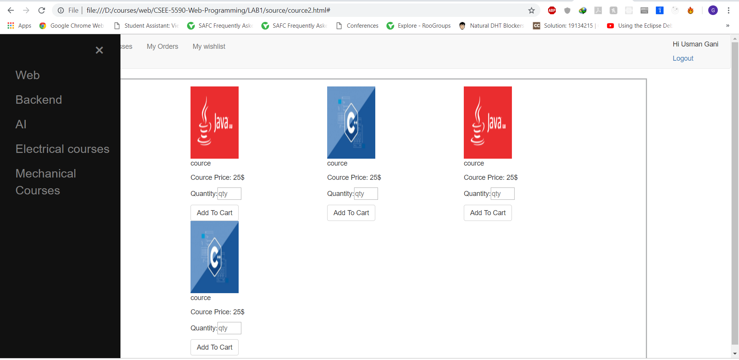

**Web Cources Page**

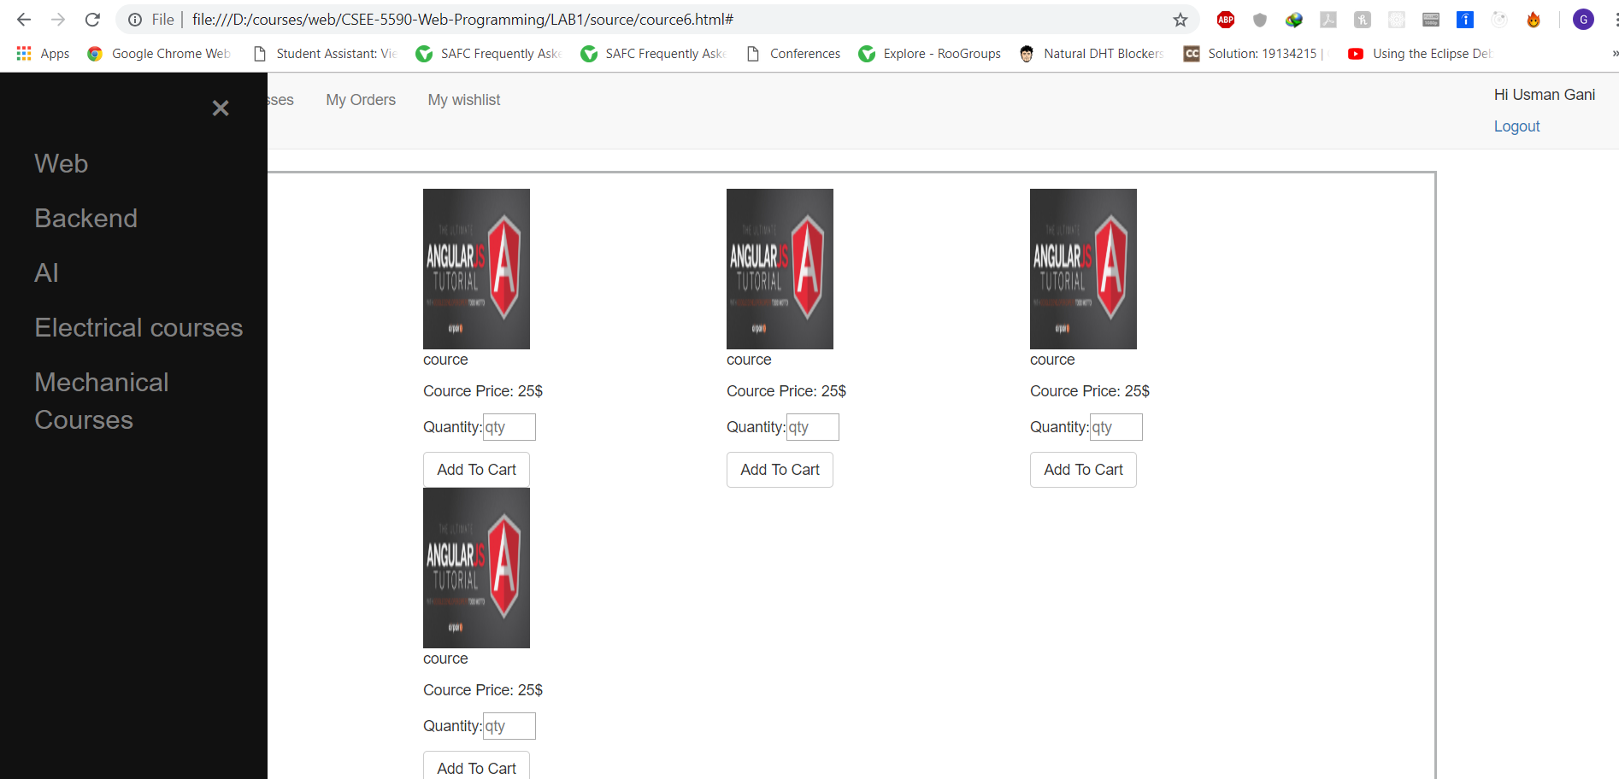

**Web Cources Page**

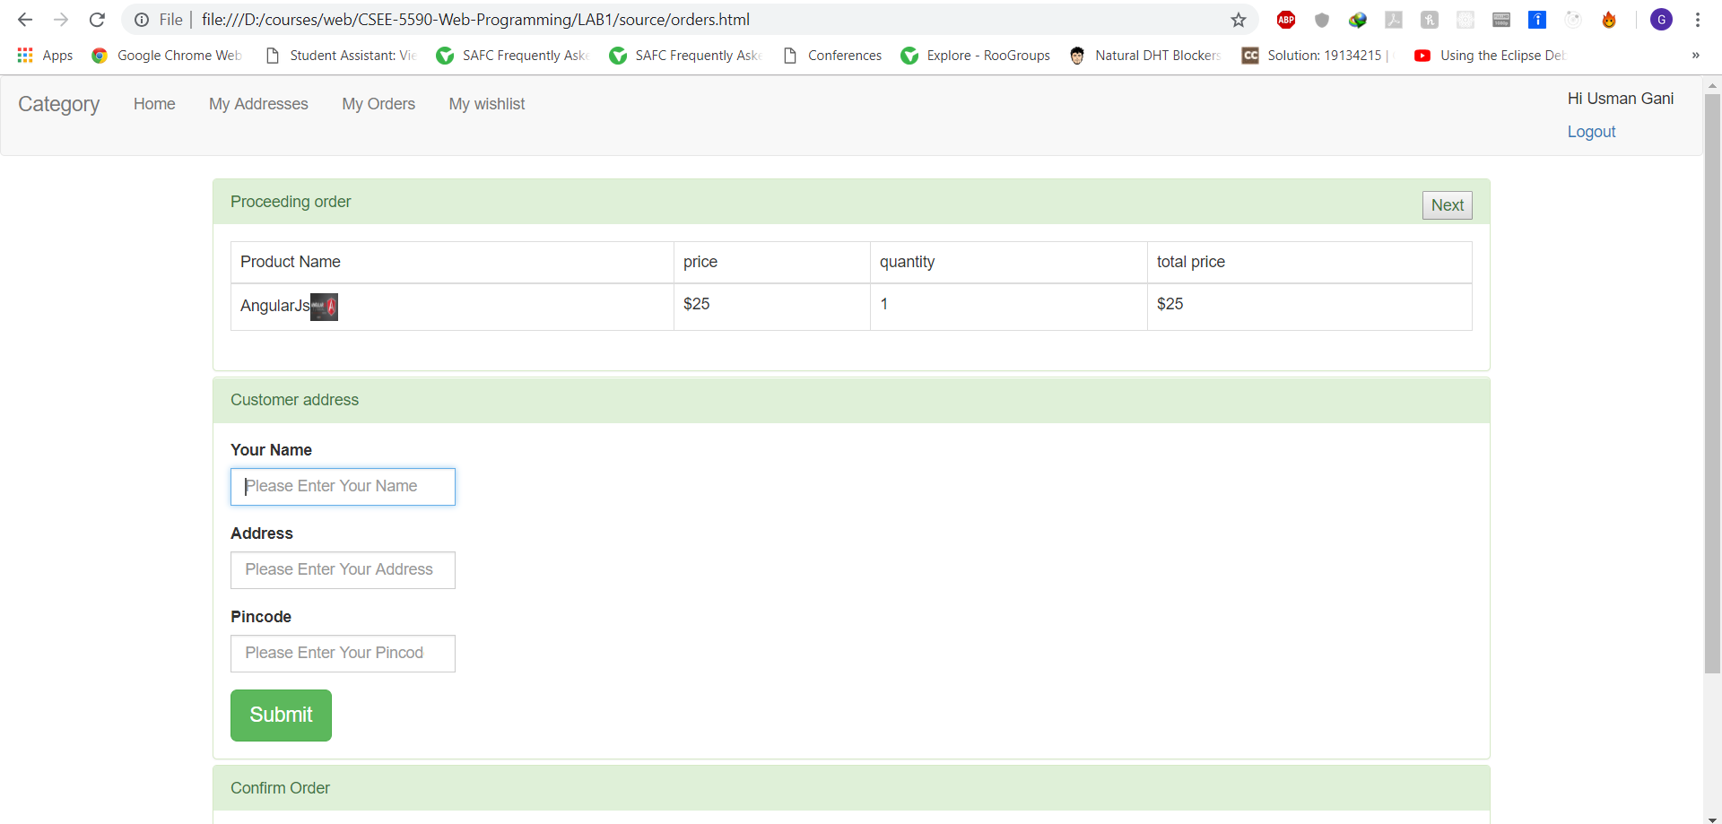

**Order History Page**

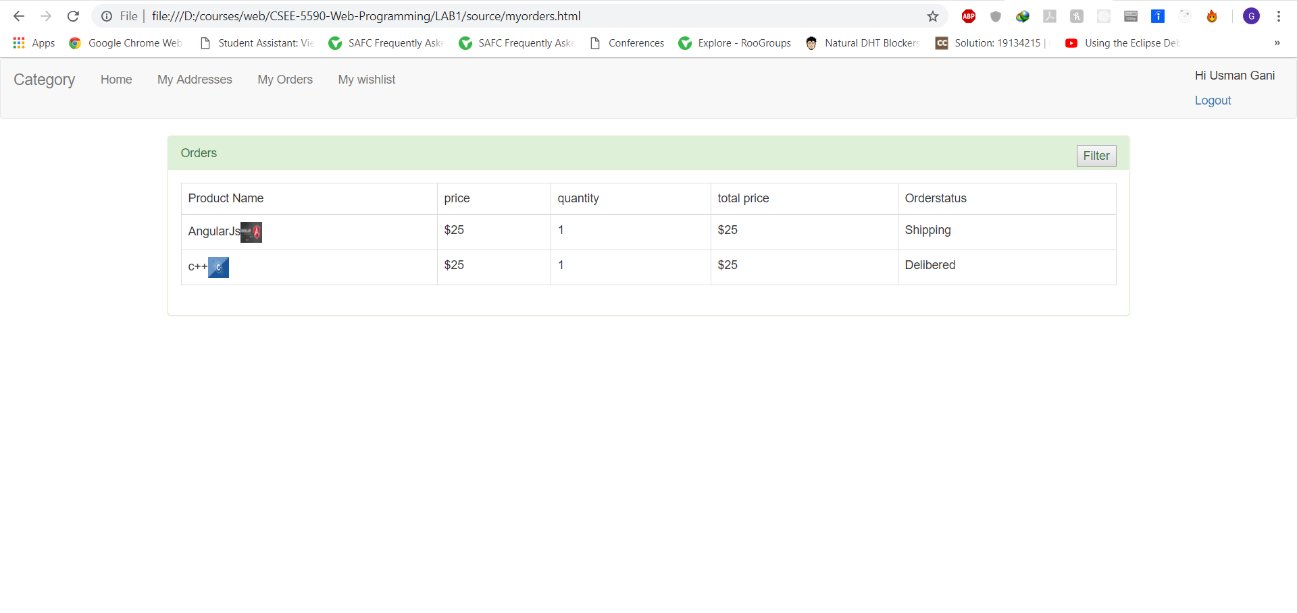

**Dashboard Code**

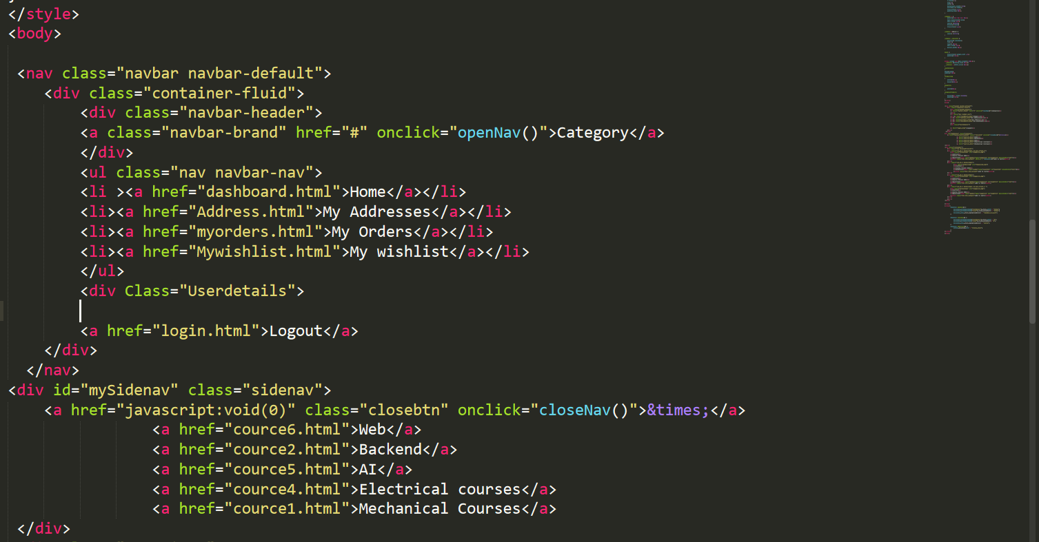

**Side Navigation Bar code**

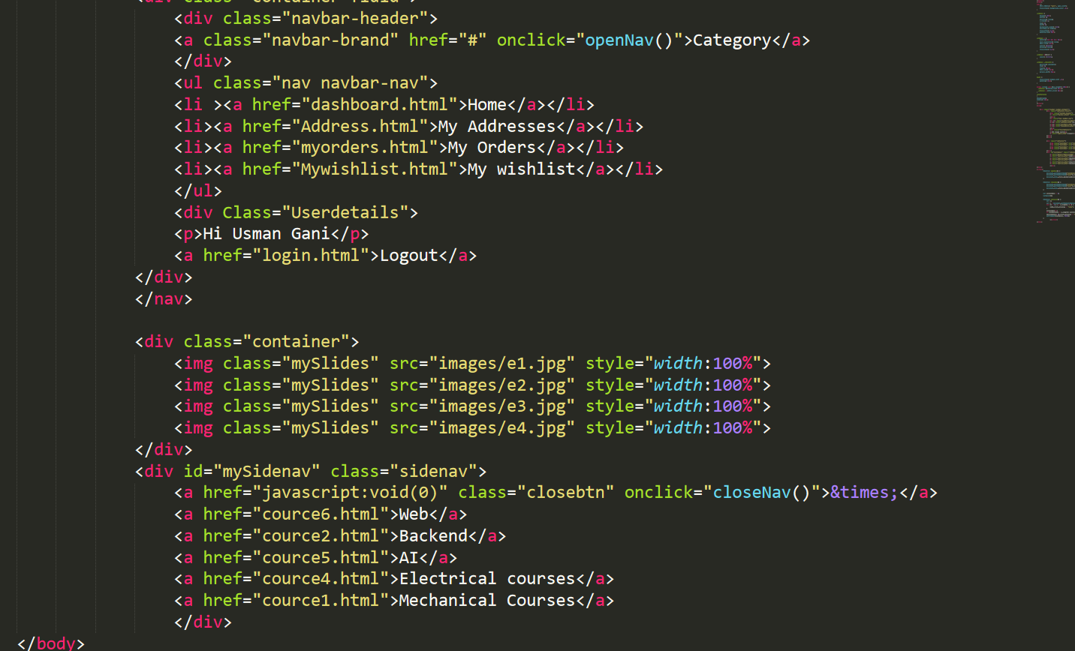

**Order History code**

