DATABASE DESIGN DOCUMENT
Movie Theatre Ticket Booking and Box Office Analysis System

1. ER Diagram
The ER diagram below is based on the table and key information supplied from movie_theatre_db. Primary keys (PK), foreign keys (FK), and unique foreign-key relationships are labelled.
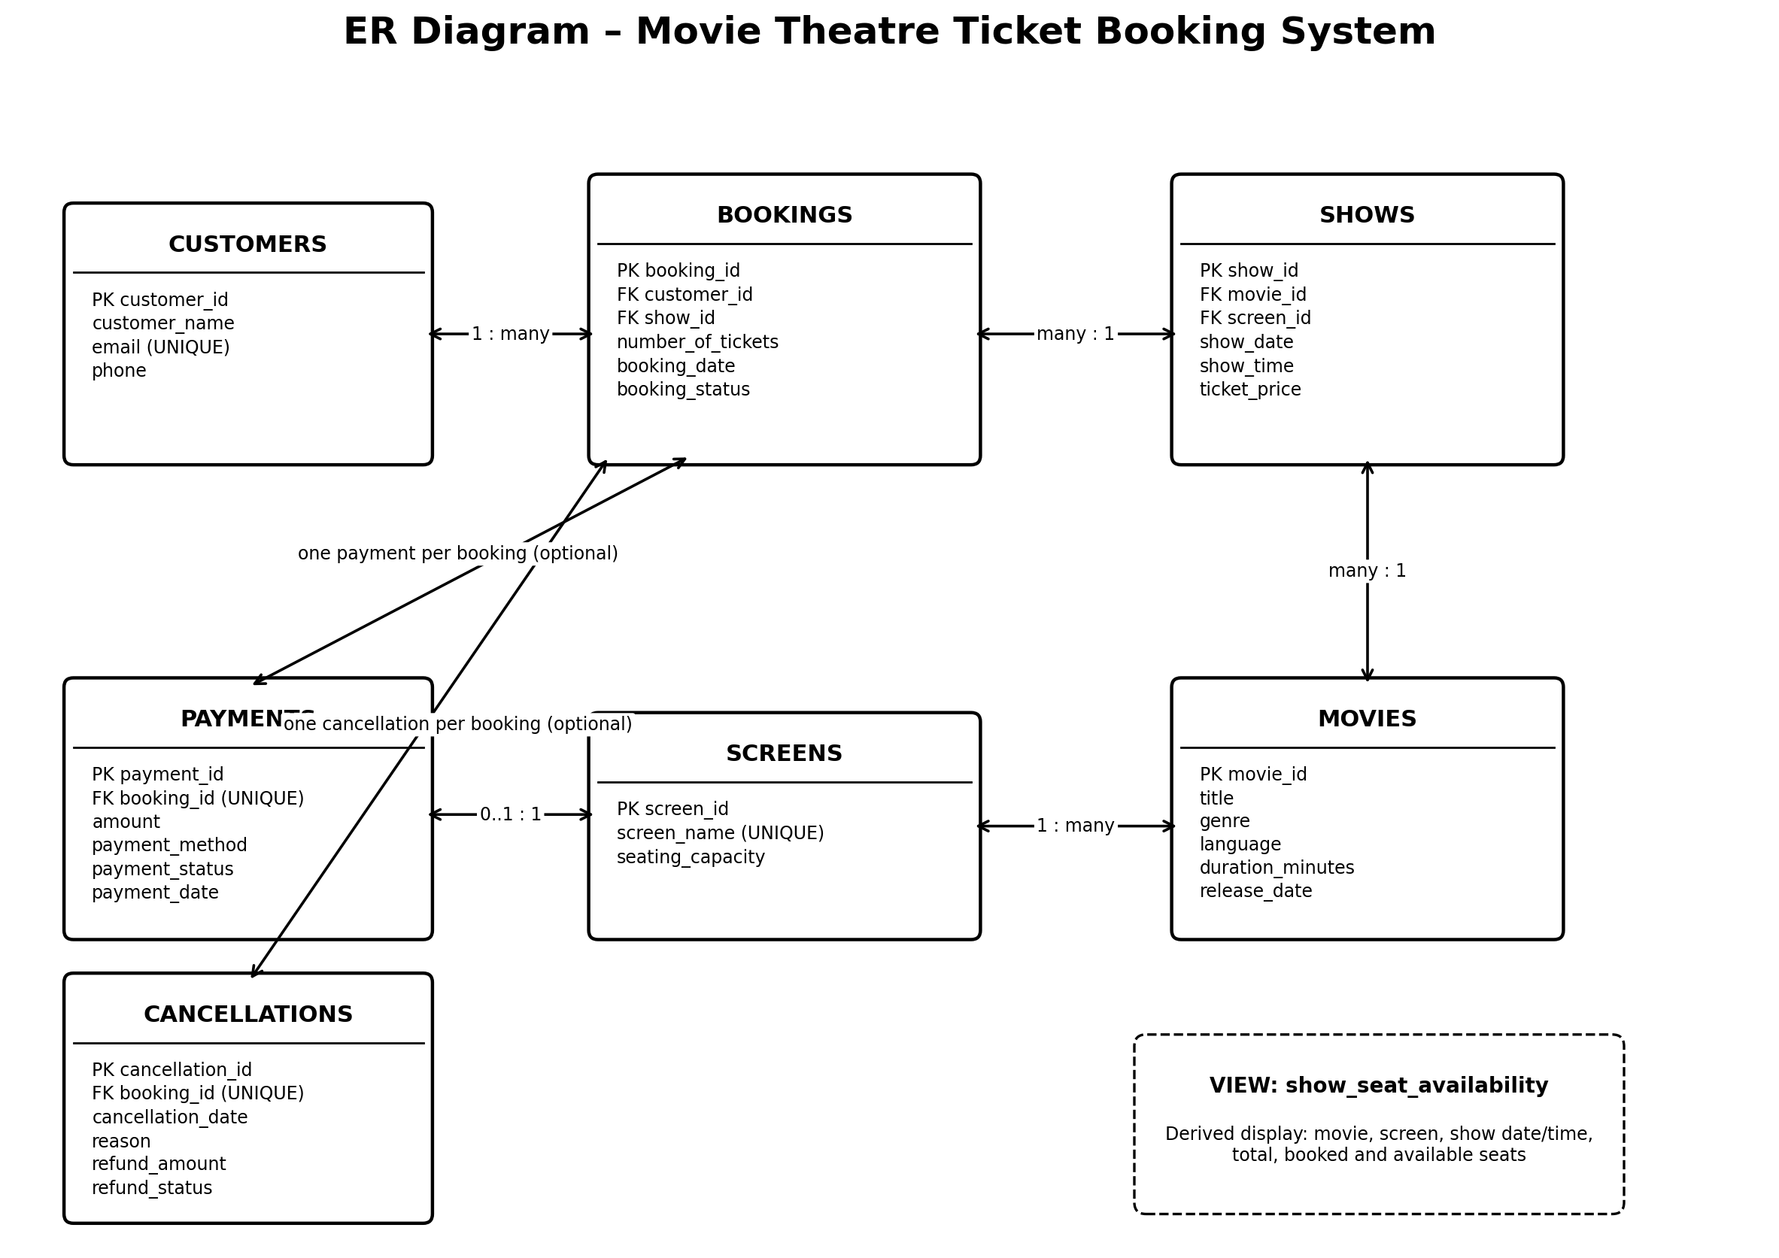

2. Relational Model
CUSTOMERS: CUSTOMERS(customer_id PK, customer_name, email UNIQUE, phone)
MOVIES: MOVIES(movie_id PK, title, genre, language, duration_minutes, release_date)
SCREENS: SCREENS(screen_id PK, screen_name UNIQUE, seating_capacity)
SHOWS: SHOWS(show_id PK, movie_id FK → MOVIES.movie_id, screen_id FK → SCREENS.screen_id, show_date, show_time, ticket_price)
BOOKINGS: BOOKINGS(booking_id PK, customer_id FK → CUSTOMERS.customer_id, show_id FK → SHOWS.show_id, number_of_tickets, booking_date, booking_status)
PAYMENTS: PAYMENTS(payment_id PK, booking_id FK UNIQUE → BOOKINGS.booking_id, amount, payment_method, payment_status, payment_date)
CANCELLATIONS: CANCELLATIONS(cancellation_id PK, booking_id FK UNIQUE → BOOKINGS.booking_id, cancellation_date, reason, refund_amount, refund_status)

3. Relationships and Cardinality
- CUSTOMERS 1 — many BOOKINGS: one customer can make multiple bookings; each booking references one customer.
- SHOWS 1 — many BOOKINGS: one show can be referenced by multiple bookings; each booking references one show.
- MOVIES 1 — many SHOWS: each show references one movie; a movie can have multiple shows.
- SCREENS 1 — many SHOWS: each show references one screen; a screen can host multiple shows at different times.
- BOOKINGS 1 — zero or one PAYMENTS: payments.booking_id is unique and references bookings.booking_id.
- BOOKINGS 1 — zero or one CANCELLATIONS: cancellations.booking_id is unique and references bookings.booking_id.

4. View: show_seat_availability
show_seat_availability is a database VIEW, not a base table. The supplied output shows show_id, movie_name, screen_name, show_date, show_time, total_seats, booked_seats and available_seats. It is used by the booking flow to check available seats. Its exact SQL definition should be exported from MySQL for the SQL submission.

5. Key and Constraint Notes
- customers.email is UNIQUE when a value is supplied; the column is nullable.
- screens.screen_name is UNIQUE.
- payments.booking_id is UNIQUE and a foreign key to bookings.booking_id, so at most one payment row can exist per booking.
- cancellations.booking_id is UNIQUE and a foreign key to bookings.booking_id, so at most one cancellation row can exist per booking.
- The supplied metadata output repeated some booking_id and screen_id rows because key metadata can produce separate rows for the foreign-key and unique-key constraints. These are not duplicate columns in the actual table.

6. Normalization – Initial Assessment
The listed relations appear to use atomic columns and primary keys, which is consistent with First Normal Form (1NF). In the listed tables, non-key attributes are described as belonging to their table's primary key, and movie, screen, customer, show, payment and cancellation details are separated into related relations. This structure is consistent with a 3NF design in principle. A formal claim of 2NF/3NF requires checking all functional dependencies and the complete CREATE TABLE definitions, including any additional unique constraints and composite keys. Therefore, treat this as a preliminary normalization assessment, not a substitute for dependency verification.

7. Items to Verify Before Final Submission
- Export SHOW CREATE TABLE for all seven base tables to confirm every constraint and default.
- Export SHOW CREATE VIEW show_seat_availability to document its calculation accurately.
- Confirm whether bookings with booking_status = 'Cancelled' are excluded from booked_seats in the view.
- Check whether show_id and screen_id constraints match the intended scheduling rules.

