Design Diagrams
Movie Theatre Ticket Booking and Box Office Analysis System
These diagrams describe the current high-level project design. The class diagram is a module/DAO overview rather than a source-code UML class specification. The ER diagram will be prepared separately after verifying the actual MySQL table definitions.

1. System Architecture
Shows the Java/JDBC and Python analysis paths connected to the MySQL database.
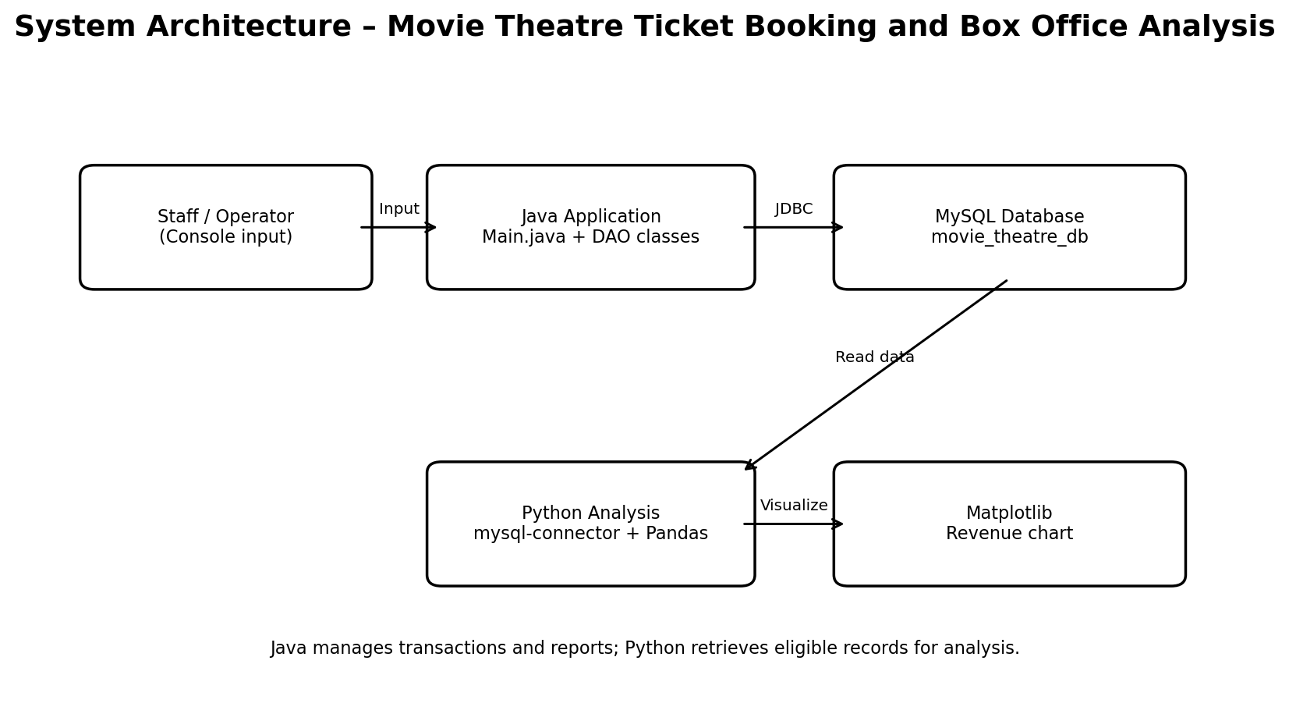

2. Use Case Diagram
Shows the main operator and administrator interactions supported by the project.
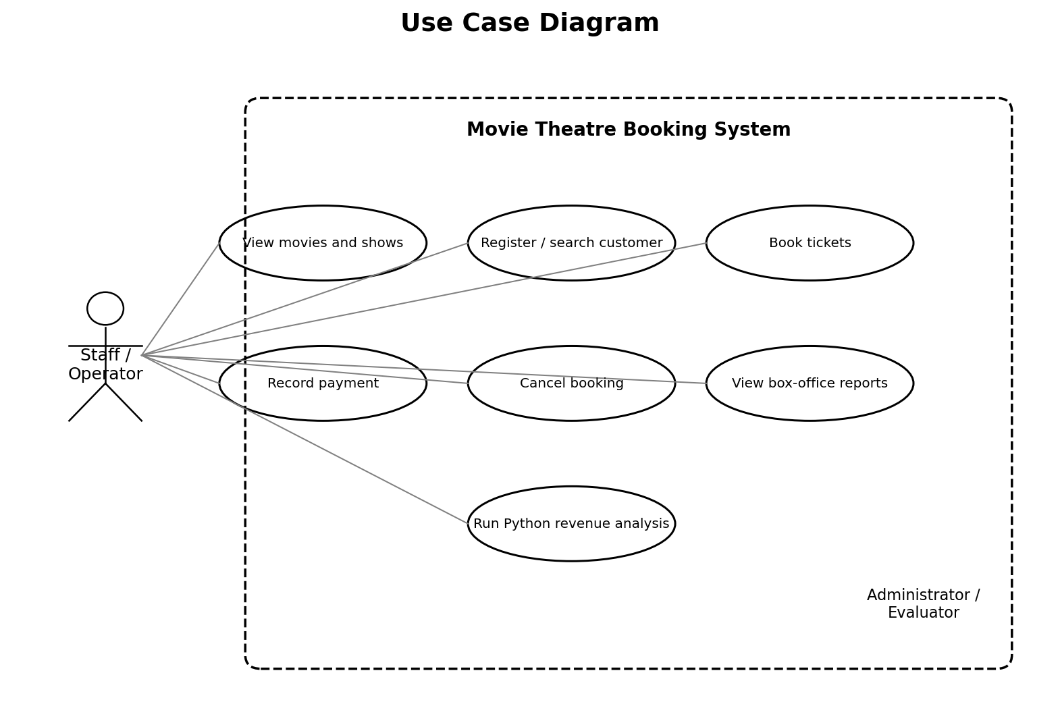

3. Ticket Booking Activity Diagram
Shows the main booking flow, including validation and the success/error paths.
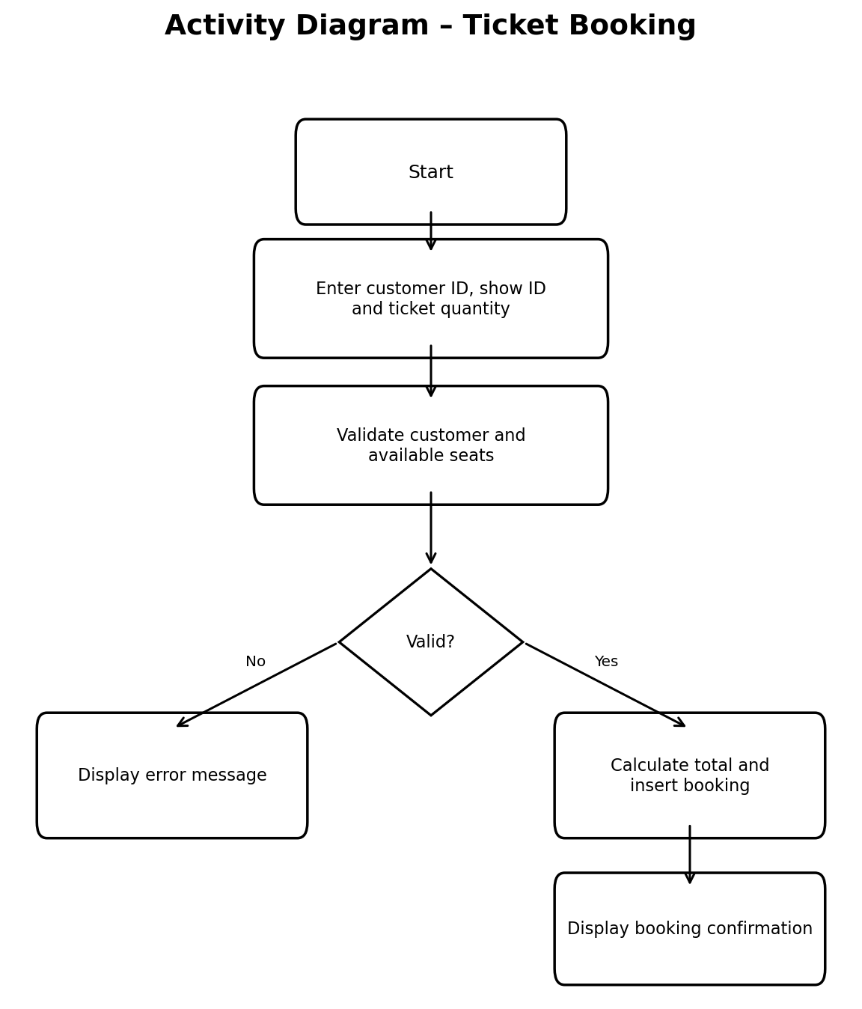

4. High-Level Class / DAO Diagram
Shows the Main class, DAO modules, database connection and database boundary.
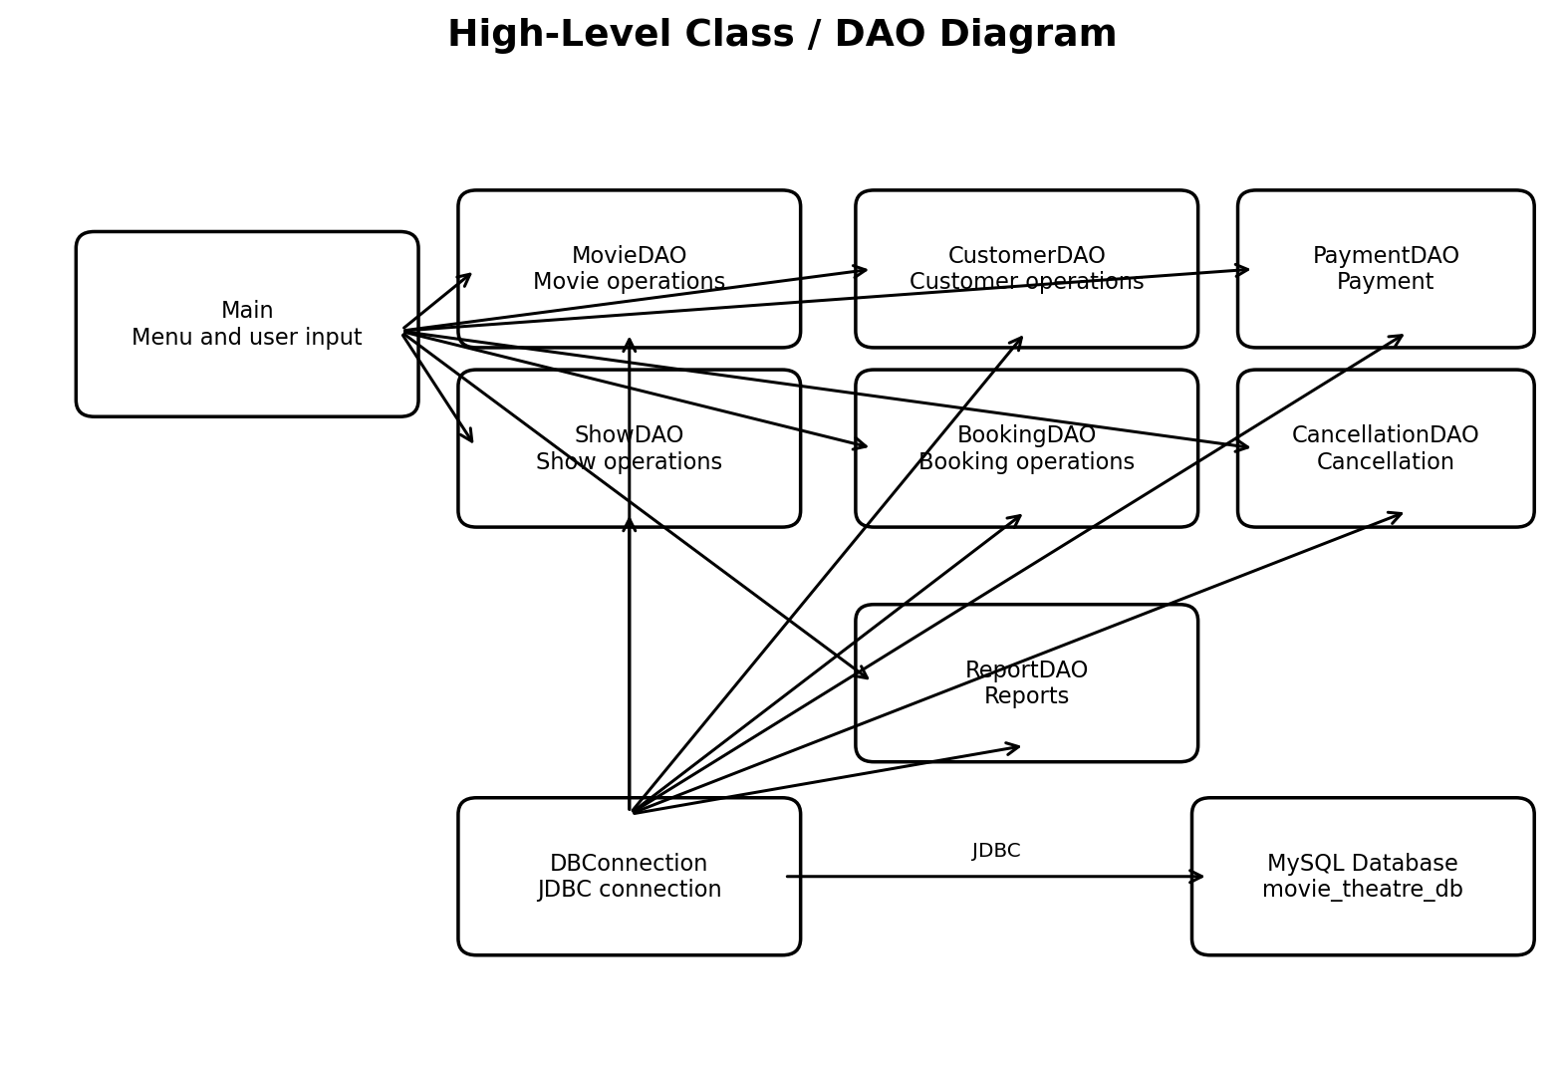

Note for Final Submission
The exact ER diagram and relational model must be generated from the real database schema. Do not treat the current high-level diagrams as a replacement for a schema-verified ER diagram.

