Nama : Ganis Dwiarum Prabandari

NIM : 123180106

Mata Kuliah : Praktikum IoT

Plug : C

**Tugas Pertemuan 4**

Perintah :

Membuat simulasi arduino led’s dengan lampu berwarna merah, kuning, dan hijau.

Gambar :

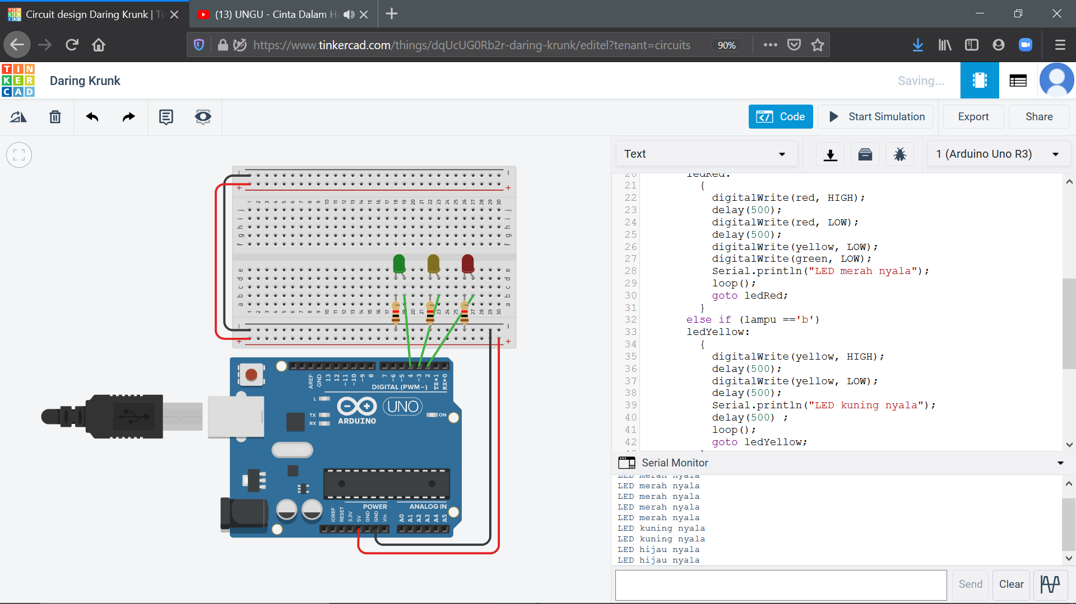

**Gambar 1** Gambar Simulasi

Source Code :

|  |
| --- |
| int red = 2;  int yellow = 3;  int green = 4;  char lampu;  void setup()  {  Serial.begin(9600);  pinMode(red, OUTPUT);  pinMode(yellow, OUTPUT);  pinMode(green, OUTPUT);  }  void loop()  {  while (Serial.available())  {  lampu = Serial.read(); |

**Source Code 1** Source Code Simulator

if (lampu == 'a')

ledRed:

{

digitalWrite(red, HIGH);

delay(500);

digitalWrite(red, LOW);

delay(500);

digitalWrite(yellow, LOW);

digitalWrite(green, LOW);

Serial.println("LED merah nyala");

loop();

goto ledRed;

}

else if (lampu =='b')

ledYellow:

{

digitalWrite(yellow, HIGH);

delay(500);

digitalWrite(yellow, LOW);

delay(500);

Serial.println("LED kuning nyala");

delay(500) ;

loop();

goto ledYellow;

}

else if (lampu =='c')

ledGreen:

{

digitalWrite(green, HIGH);

delay(500);

digitalWrite(green, LOW);

delay(500);

Serial.println("LED hijau nyala");

delay(500) ;

loop();

goto ledGreen;

}

}

}

**Source Code 2** Lanjutan Source Code Simulator

Link github Tugas : https://github.com/ganisdwpr/Tugas-1-Prak-IoT