PRESENTED BY

**Trisha Chander BL.EN.U4CSE19133**

**V Ganith BL.EN.U4CSE19134**

**Vasanth S BL.EN.U4CSE19139**

Description:-

We have used JavaScript, HTML, CSS for the frontend and SQL, myPHPadmin for the back-end. We used MY SQL software for relational models Visual Studio Code software as text editor.

HTML:-

We have created home page about, login, sign up page and about-us page using HTML. We’ve also added UIs for the users to interact with our website and fill in details based on the forms.

CSS:-

We have designed every HTML page using CSS. We represented every module (on home screen) and every button elegantly by using CSS.

Java Script :-

We used JS for validating the entered credentials by user in register page.

HOW IT WORKS?

1. The users are broadly divided as
   1. User
      1. Patient
      2. Donor
   2. Doctor
   3. Organization (which is a hospital in this case)
2. If you’re a patient or a donor, you are required to register/ log in.
   1. Use the **Login** or the **Sign up** module

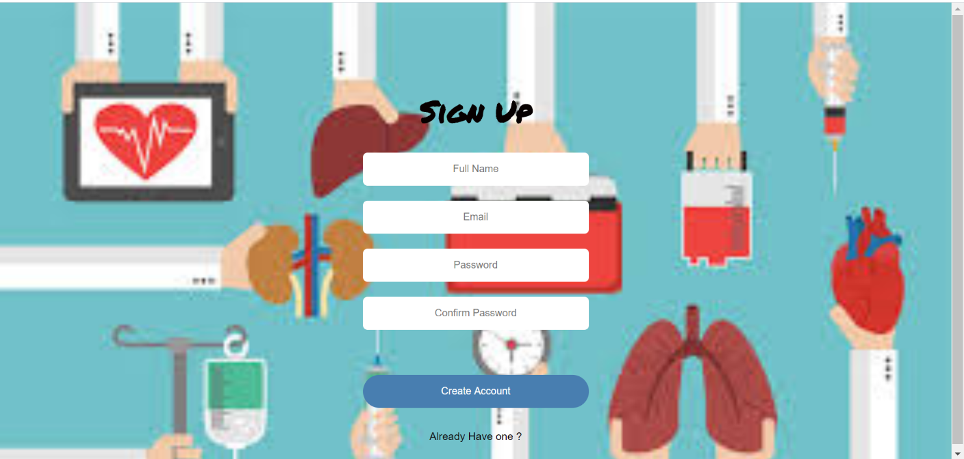

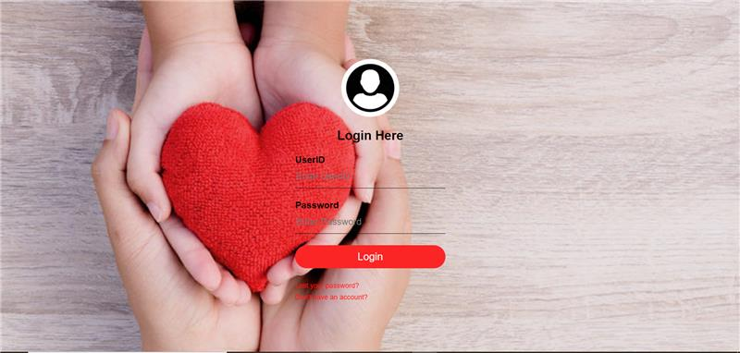

1. The users will also be able to see the live count of our users, doctors and organizations
   1. This would also dynamically change as you register for the respective options

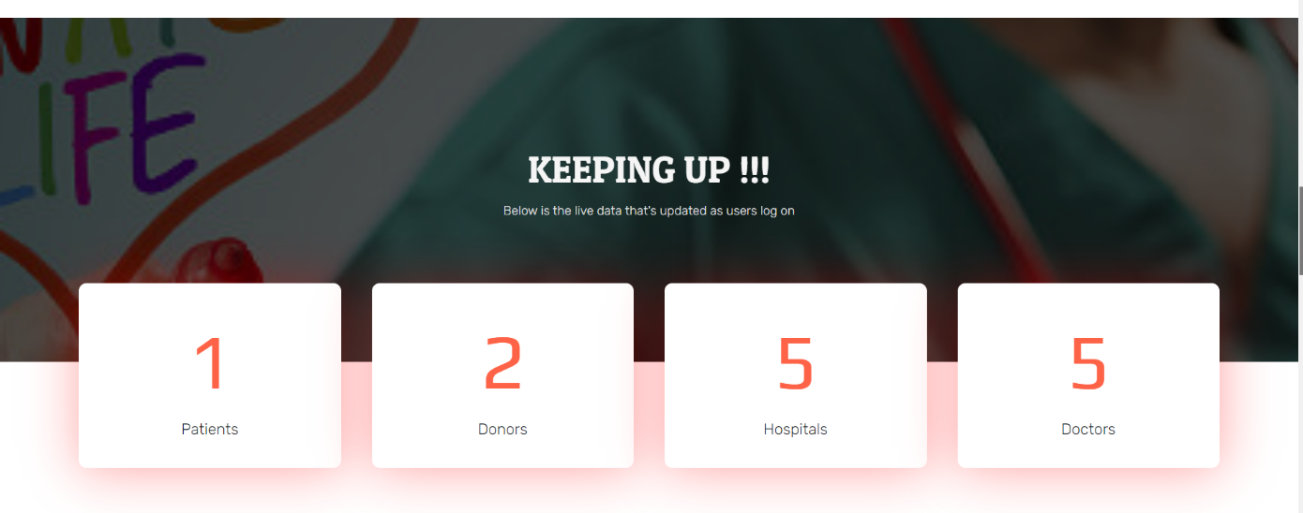

1. Clicking on the **Explore** button as a **Doctor** you will be prompted to fill in the fields and you’ll be registered as a new doctor

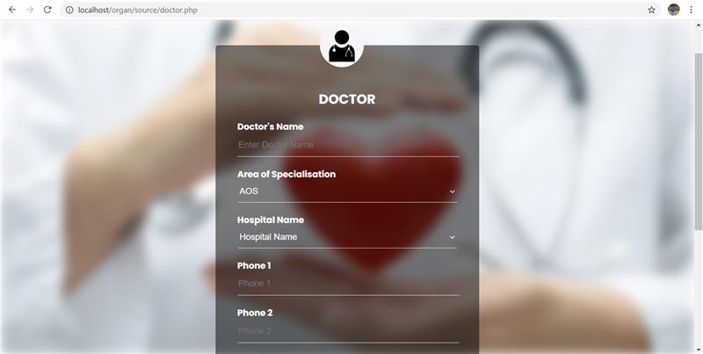

1. Clicking on the **Explore** button as an **Organization** you will be prompted to fill in the fields and you’ll be registered as a new organization

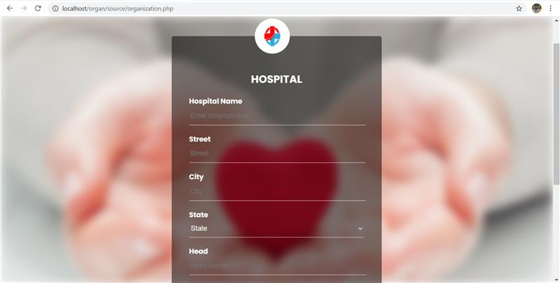

1. Clicking on the **Explore** button as an **User** you will be prompted to fill in the fields and you’ll be registered as a new user – patient or a donor

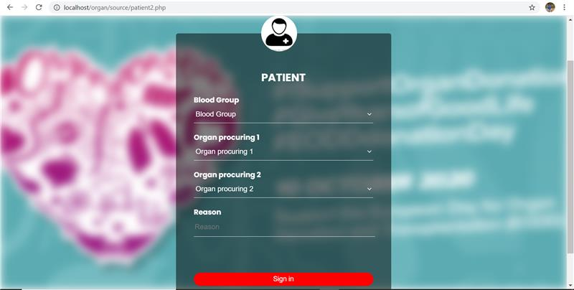

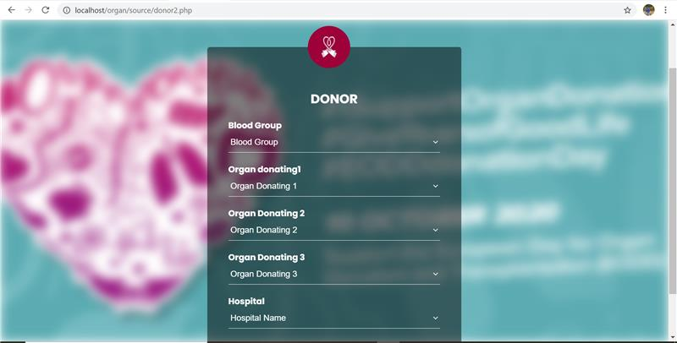

1. By clicking the **For Patients and Donors** you would be redirected to a page that displays the information of the donor and patient details
2. By clicking the **For Hospitals** link, you would be redirected to a page that displays the information of the patient, donors and hospital records.

Link: <http://iamdonor.epizy.com/source/home.php#section1>

Source Code:

