System and Software Requirements Description (SSRD)

RecruitMe Enterprise Application

Version 1.0
May 10, 2017

Ganith Perera – Project Leader
Naduni Pulsarani

Version History
Date | Author | Version | Changes made | Reasons for changes
5/10/12 | All | 3.0 | - Added user’s manual and installation manual | Completion of project
5/3/12 | Rob | 2.1 | - Wording changes  - Clarified LOS-1 due to what we now know about OpenMRS system. | Completion of project
12/1/11 | All | 2.0 | - Added List Clinics requirement  - Added several new evolutionary requirements (derived from old version of OCD) | 2nd iteration, making consistent with SSAD
10/26/11 | All | 1.5 | - Added some preconditions, cleaned up wording of functional requirements  - Clarified some pre-/post-conditions for level of service requirements  - Shortened length of expository paragraphs in GUI mockup section  - Made RESTful API a required feature, not just an evolutionary requirement. | IV&V from Ralph’s team, Professor Duggan comments
10/4/11 | All | 1.0 | Initial version

Table of Contents
Contents
System and Software Requirements Description (SSRD) i
Version History iii
Table of Contents iv
Table of Tables vi
Table of Figures vii
1. Introduction 1
1.1 Purpose of the SSRD 1
1.2 Status of the SSRD 1
2. Product Requirements 2
2.1 Functional Requirements 2
2.2 Level of Service/Quality Requirements 4
2.3. Platform Requirements 6
2.4. Programming Language Requirements 7
2.5. Software Requirements 8
3. Interface Requirements 9
3.1 User Interface Standards Requirements 9
3.2 Hardware Interface Requirements 9
3.3 Software Interface Requirements 10
4. Process Requirements 11
4.1. Budget and Schedule Requirements 11
4.2. Documentation Requirements 11
4.3. Tools Requirements 11
4.4. Deployment/Transition Requirements 12
4.5. Miscellaneous/Additional Requirements 12
5. Evolutionary Requirements 13
6. Installation Manual 15
6.1 Tomcat + SSL Setup 15
6.2 Patient Data Transfer OPDS System Setup 18
7. User’s Manual 19
7.1 Module Overview 19
7.2 Overview of Pages 20
7.3 Patient Data Request Walk-Through 25
7.4 FAQ/Common Problems 27

Table of Tables
Table 1: FR-1 History of Peer-to-Peer Transactions 2
Table 2: FR-2 Role-Based Access Management 2
Table 3: FR-3 Managing Outgoing Requests 3
Table 4: FR-4 Managing Incoming Requests 3
Table 5: FR-5 List Available Clinics 3
Table 6: LOS-1 Patient Medical Data Privacy 4
Table 7: LOS-2 Patient Personally-Identifiable Information Privacy 4
Table 8: LOS-3 Integrity of Displayed Information 4
Table 9: LOS-4 Availability 5
Table 10: LOS-5 Non-Blocking 5
Table 11: LOS-6 Attribution 5
Table 12: Minimum hardware requirements for OpenMRS system handling up to and exceeding hundreds of patients 6
Table 13: Minimum hardware requirements for OpenMRS system handling up to and exceeding 10,000 patients 6
Table 14: Minimum hardware requirements for OpenMRS system handling up to and exceeding 250,000 patients 7
Table 15: Apache Tomcat as Web Server 7
Table 16: Firefox as the Web Browser 7
Table 17: Java as the main programming language 7
Table 18: SQL as the Query Language 7
Table 19: MySQL as the DBMS 8
Table 20: Open MRS as the existing system to build upon 8
Table 21: Hibernate as the object relational mapping library 8
Table 22: XHTML 1.0 Transitional Compliance 9
Table 23: UIR-2 OpenMRS XForms Module 9
Table 24: HR-1 Power 9
Table 25: HR-2 Internet Connectivity 9
Table 26: SIR-1 RESTful API 10
Table 27: Schedule of 28 Weeks 11
Table 28: No Monetary Budget 11
Table 29: Traditional Senior Design Documentation 11
Table 30: Eclipse as the Interface Development Environment 12
Table 31: Delivery of Final Product in OpenMRS Module Repository 12
Table 32: Skills Required of System Maintainer 12
Table 33: Collaboration with Other Teams 12
Table 34: EFR-1 Secure System Backup 13
Table 35: EFR-2 Language Translation 14
Table 36: EFR-3 2G connectivity 14
Table 37: EFR-4 Patient Authentication 14

Table of Figures
Figure 1: Secure and Distributed Backup 13
Figure 2: Clinics and Settings Page 20
Figure 3: New Clinic Form 21
Figure 4: New Setting Form 21
Figure 5: Recent Transactions Page 21
Figure 6: My Requests Page 22
Figure 7: New Patient Data Request Form 23
Figure 8: Outgoing Requests Page 23
Figure 9: Incoming Requests Page 24
Figure 10: Clinics Overview Page 24

1. Introduction

1.1 Purpose of the SSRD
The purpose of the SSRD is to document the requirements of the OpenMRS patient data transfer (PDT) module that derived from negotiation sessions with the clients. Moreover, the SSRD will act as a contract for the developers about the delivered system. Hence, the SSRD defines what the delivered system will do and what will be the behavior of the system.

1.2 Status of the SSRD
The SSRD is currently in its final version, created after the completion of the project. The vast majority of this document was completed in the Fall 2011 semester, and only minor wording changes have resulted since the implementation of the project. All of the requirements agreed upon with the clients in the December 1, 2011 version of this document have been implemented by the team.

2. Product Requirements
This section of the SSRD describes various types of requirements relating to the system.

2.1 Functional Requirements
This section of the SSRD contains requirements pertaining to the functions to be performed by the system being developed.
Table 1: FR-1 History of Peer-to-Peer Transactions
Functional Requirement: | FR-1: History of Peer-to-Peer Transactions
Description: | The system shall display past transactions to the user, so they know which records have been recently received. The transactions are filtered using criteria specified by the user. Such transactions include patient record requests, record transmissions, and any failures as a result of denials.
Priority: | M (Must Have)
Input(s): | Transactions for the clinic, column to sort by, date range
Source(s): | Web form for filter criteria, DB for transactions
Output(s): | List of transactions, meeting the input criteria
Destination(s): | Web-based output
Precondition(s): | none
Postcondition(s): | none
Table 2: FR-2 Role-Based Access Management
Functional Requirement: | FR-2: Role-Based Access Management
Description: | An administrative user shall be able to map roles to users, giving them new capabilities within the system. This can be used by an administrator to set up initial user roles, as well as revoke/delegate administrative rights. This functionality will be extended to our modifications, which will assign roles for requesting and approving patient record transfer.
Priority: | M (Must Have)
Input(s): | User(s), Role(s)
Source(s): | Web Form
Output(s): | Success/Failure flag
Destination(s): | Access Control List
Precondition(s): | none
Postcondition(s): | - User(s) are assigned specified role(s) and changes are reflected in the Access Control List  - Audit log is appended with information

Table 3: FR-3 Managing Outgoing Requests
Functional Requirement: | FR-3: Managing Outgoing Requests
Description: | User for a clinic shall be able to create/modify/revoke a request for a patient’s records from a peer clinic, according to their provisioned rights.
Priority: | M (Must Have)
Input(s): | User, Peer clinic, patient identifier, patient consent, (optional) scan of consent form
Source(s): | User comes from web session, all else from web form
Output(s): | Success/Failure flag
Destination(s): | Message queue of requestee clinic
Precondition(s): | Patient has supplied a clinic name and consent
Postcondition(s): | - Request message is added to the message queue corresponding with the peer clinic  - Audit trail appended with the input information

Table 4: FR-4 Managing Incoming Requests
Functional Requirement: | FR-4: Managing Incoming Requests
Description: | User for a clinic shall be able to view and approve or reject incoming requests for patient records.
Priority: | M (Must Have)
Input(s): | User, Request, Approve/Reject, Reason
Source(s): | Web Form
Output(s): | Success/Failure flag
Destination(s): | Message queue of requesting clinic
Precondition(s): | User has been authenticated, and is part of an eligible role
Postcondition(s): | - Reply is added to the requesting clinic’s message queue  - Request is removed from the queue of pending requests  - Audit trail is appended with the input information
Table 5: FR-5 List Available Clinics
Functional Requirement: | FR-5: List Available Clinics
Description: | User can request a list of all available clinics for patient data transfers, via the directory service.
Priority: | M (Must Have)
Input(s): | User
Source(s): | Web session data
Output(s): | List of clinics, and any information needed to connect to them
Destination(s): | Web Form drop-down box
Precondition(s): | User has been authenticated, and is part of an eligible role
Postcondition(s): | None (just outputs the data)

2.2 Level of Service/Quality Requirements
This section contains the level of service requirements of the system being developed, which includes any non-functional requirements which can be measured.
Table 6: LOS-1 Patient Medical Data Privacy
Level of Service Requirement: | LOS-1: Patient Medical Data Privacy
Description: | Patient medical data is never stored in a central repository.
Priority: | M (Must Have)
Desired Level: | 0
Acceptable Level: | 0
Measurability: | The amount of patient medical data on a central repository == 0
Achievability: | Design the system around this requirement, by stripping any and all patient medical data which may be used to infer or expose the patient’s identity, past locations, and patient history before interacting with a central system.
Relevance: | FR-3,4 (the requirements which deal with sending/receiving messages)

Table 7: LOS-2 Patient Personally-Identifiable Information Privacy
Level of Service Requirement: | LOS-2: Patient Personally-Identifiable Information Privacy
Description: | Patient personally-identifiable information (PII) should be minimized in central repositories.
Priority: | S (Should Have)
Desired Level: | 0 PII data on central stores
Acceptable Level: | 0 PII data
Measurability: | The inverse of the amount of patient metadata or data stored on a central repository that can be aggregated into a numeric amount.
Achievability: | Design the system around this requirement. If a central repository must be used, ensure that data is anonymized. Use peer to peer system such as OAuth where applicable for setting up sharing of patient data.
Relevance: | FR-3,4 (the requirements which deal with sending/receiving messages)

Table 8: LOS-3 Integrity of Displayed Information
Level of Service Requirement: | LOS-3: Integrity of Displayed Information
Description: | Information displayed to the user is correct
Priority: | M (Must Have)
Desired Level: | All data displayed to the user from audit logs and p2p transactions is correct according to the security policy
Acceptable Level: | All data displayed is correct or marked as untrustworthy pending scrutiny by an authorized user.
Measurability: | The messages sent are equivalent to the messages receive, which are equivalent to the messages that get stored in the DB.
Achievability: | Design the system around the requirement that only users with privileges can alter sensitive information. Peer-to-peer transactions are carried out via SSL-like mechanisms.
Relevance: | FR-* (all functional requirements)

Table 9: LOS-4 Availability
Level of Service Requirement: | LOS-4: Availability
Description: | The module will always provide its specified functionality
Priority: | M (Must Have)
Desired Level: | All functionality provided by the module is delivered quickly.
Acceptable Level: | Auditing functionality, transaction management functionality,and role management functionality are always available.
Measurability: | The number of open transactions the module can manage while still allowing for user/transaction management and auditing.
Achievability: | Unknown (depends on the overhead per transaction)
Relevance: | FR-* (all functional requirements)

Table 10: LOS-5 Non-Blocking
Level of Service Requirement: | LOS-5: Non-blocking
Description: | Unexpected failure of the module and pending transactions should not affect other modules which are a part of the OpenMRS system
Priority: | M (Must Have)
Desired Level: | If this module breaks, other modules should still be functional. This module should not introduce additional security holes which could adversely affect the functionality of other modules.
Acceptable Level: | If this module breaks, other modules should still be functional; no exceptions. (Same as Desired)
Measurability: | The uptime of the OpenMRS system, defined by the user being able to log in and use all other modules and functionality.
Achievability: | Design systems tests that simulate errors within our module, and ensure they pass.
Relevance: | FR-* (all functional requirements)

Table 11: LOS-6 Attribution
Level of Service Requirement: | LOS-6: Attribution
Description: | All details of all p2p transactions will be logged and all privilege modifications will be logged. Details include users which initiated transactions, time taken, clinics involved, success/failure, reason of success/failure, and patient name. The logs will be available to privileged users.
Priority: | M (Must Have)
Desired Level: | All usage details will be logged
Acceptable Level: | ALL usage details will be logged (Same as Desired).
Measurability: | The number of transactions present should match the information presented in the log files. In addition, the availability of the logs and their effectiveness for auditing must be considered.
Achievability: | Design the module to use logging tools (if OpenMRS already has logging functionality, use it)
Relevance: | FR-* (all functional requirements)

2.3. Platform Requirements
This section lists and describes the hardware, operating systems, browsers, and web server on which the system is required to run.

Table 12: Minimum hardware requirements for OpenMRS system handling up to and exceeding hundreds of patients
Computer Hardware Requirement: | CHR-1 Any machine running Windows XP or Ubuntu or better as the System’s Platform
Description: | 1 GHz processor or better, 256 MB of memory or more, 40 GB hard drive or larger.
Priority: | S (Should have)

Table 13: Minimum hardware requirements for OpenMRS system handling up to and exceeding 10,000 patients
Computer Hardware Requirement: | CHR-2 Any machine running Windows XP or Ubuntu or better as the System’s Platform
Description: | 1.5+ GHz, 2 GB of memory, and 150+ GB of disk space with RAID and appropriate backup facilities.
Priority: | S (Should have)

Table 14: Minimum hardware requirements for OpenMRS system handling up to and exceeding 250,000 patients
Computer Hardware Requirement: | CHR-3 Any machine running Windows XP or Ubuntu or better as the System’s Platform
Description: | two 2.26 GHz quad processors, 16 GB of memory, 500 GB of disk space with RAID and appropriate backup facilities.
Priority: | S (Should have)

Table 15: Apache Tomcat as Web Server
Process Requirement: | PL-1: Apache Tomcat as Web Server
Description: | The system must be deployed on an Apache Tomcat web server (must be version 6.029)
Priority: | M (Must have)
Table 16: Firefox as the Web Browser
Web Browser Requirement: | WBR-1: Mozilla Firefox as the Web Browser
Description: | The system must use Mozilla Firefox as its web browser in order to be compatible with the OpenMRS system and render the pages correctly. (Latest stable version)
Priority: | M (Must have)

2.4. Programming Language Requirements
Table 17: Java as the main programming language
Programming Language Requirement: | PLR-1: Java as the main programming language
Description: | OpenMRS is developed using Java, so if we want to extend it, then the programming language must be Java. (Latest stable version of Java 1.6 JDK will be used)
Priority: | M (Must have)
Table 18: SQL as the Query Language
Programming Language Requirement: | PLR-2: SQL as the Query Language
Description: | The system must use SQL as its query language in order to be compatible with the underlying MySQL database. (Latest stable version)
Priority: | M (Must have)

2.5. Software Requirements
The following are the requirements pertaining to software which must be installed on the deployment machine to operate correctly.
Table 19: MySQL as the DBMS
Computer Software Requirement: | CSR-1: MySQL as the DBMS
Description: | MySQL shall be used as the system’s database management system. The latest stable release of MySQL 5 should be used to ensure compatibility with OpenMRS.
Priority: | M (Must have)
Table 20: Open MRS as the existing system to build upon
Computer Software Requirement: | CSR-2: Open MRS as the existing system to build upon
Description: | Because the module we are making is an extension for OpenMRS having OpenMRS is a necessity for the module to work. Version 1.8.2 is the latest stable release, and that is what the system will be built on top of.
Priority: | M (Must have)
Table 21: Hibernate as the object relational mapping library
Computer Software Requirement: | CSR-3: Hibernate as the object relational mapping library.
Description: | OpenMRS already uses Hibernate to handle the mapping between objects and the underlying database, so this new system must keep with that. OpenMRS uses Hibernate 3.2.5, but this version dependency is handled by Maven so should be relatively transparent to developers.
Priority: | M (Must have)

3. Interface Requirements

3.1 User Interface Standards Requirements
Table 22: XHTML 1.0 Transitional Compliance
System Interface Requirement: | UIR-1: XHTML 1.0 Transitional Compliance
Description: | All new screens added will use the existing document type of the OpenMRS web application, which is XHTML 1.0 Transitional. It is worth noting that OpenMRS does not validate 100% but they do make an effort to do so.
Priority: | W (Want to have)
Table 23: UIR-2 OpenMRS XForms Module
System Interface Requirement: | UIR-2: OpenMRS XForms Module
Description: | OpenMRS has a system called XForms which allows users to design consistent dialog-based user interfaces. This will be used for form creation.
Priority: | S (Should Have)

3.2 Hardware Interface Requirements
Table 24: HR-1 Power
Hardware Interface Requirement: | HR-1: Power
Description: | The computer system must be able to be plugged into a power source. While this may seem obvious, power is not common at all of these rural clinics. Many times they borrow a generator once per month to input data and run reports.
Priority: | M (Must Have)
Table 25: HR-2 Internet Connectivity
Hardware Interface Requirement: | HR-2: Internet Connectivity
Description: | The new system will transfer data between clinics, which requires an Internet connection. There are alternatives to Internet connectivity, but due to time constraints we will make the assumption that the clinic has Internet.
Priority: | M (Must have)

3.3 Software Interface Requirements
Table 26: SIR-1 RESTful API
Software Interface Requirement: | SIR-1: RESTful API
Description: | The system will expose all of its functionality via HTTP verbs, using a traditional RESTful API. This will be the primary interface used when the clinics communicate to each other.
Priority: | M (Must have)

4. Process Requirements
This section contains requirements pertaining to the execution of the software development project.

4.1. Budget and Schedule Requirements
Table 27: Schedule of 28 Weeks
Process Requirement: | PRC-1: Schedule of 28 weeks
Description: | The project schedule is 28 work weeks based on CS423/CS424 course schedule. It is roughly 14 weeks in the fall semester, and 14 weeks in the spring semester, concluding in May 2012.
Priority: | M(Must have)
Table 28: No Monetary Budget
Project Requirement: | PRC-2: No monetary budget
Description: | The client does not have a monetary budget for development.
Priority: | M (Must have)

4.2. Documentation Requirements
Table 29: Traditional Senior Design Documentation
Project Requirement: | PRC-3: Traditional Senior Design Documents
Description: | OCD, SSRD, and SSAD documents will be created along with the Senior Design schedule. This will involve multiple iterations of each document, in addition to independent verification and validation (IV&V) with other project teams.
Priority: | M(Must have)

4.3. Tools Requirements
This section lists tools that are required to be used in the execution of the project.

Table 30: Eclipse as the Interface Development Environment
Process Requirement: | PRC-4: Eclipse as the Integrated Development Environment (IDE)
Description: | All development will be done using Eclipse and OpenMRS related add-ons. The OpenMRS development environment requires a large assortment of Eclipse plug-ins, documented on the OpenMRS wiki.
Priority: | M (Must have)

4.4. Deployment/Transition Requirements
This section lists and describes requirements, if any, relating to the deployment of the project’s products to the client organization. The following are examples:
Table 31: Delivery of Final Product in OpenMRS Module Repository
Process Requirement: | PR-1: Delivery of Final Product to Clients
Description: | The system will be delivered to Professor Duggan and Professor Friedman, the clients, who will be shown how to properly use it. They will be responsible for ensuring it gets deployed in Africa.
Priority: | M (Must have)
Table 32: Skills Required of System Maintainer
Process Requirement: | PR-2: Skills Required of System Maintainer
Description: | The system’s maintainer should know how to use OpenMRS, how to install OpenMRS modules, and have basic knowledge of networking (IP addresses and host names). In order to add features or further develop the system, knowledge of Eclipse, Maven, and Java will also be required.
Priority: | M (Must have)

4.5. Miscellaneous/Additional Requirements
Table 33: Collaboration with Other Teams
Miscellaneous/Additional Requirement: | MAR-1: Collaboration with Other Teams
Description: | The team must collaborate with other senior design teams to verify and validate documentation.
Priority: | M (Must have)

5. Evolutionary Requirements
This section lists any requirements which are outside the initial scope of the project but which are related and would be nice to implement if time permits.
Table 34: EFR-1 Secure System Backup
Evolutionary Functional Requirement: | EFR-1: Secure System Backup
Description: | The system should have a backup capability which will save any preferences and data associated with the system, including the patient data received as well as the audit trail.
Priority: | S (Should have)
Input(s): | 1. Administrator’s request for a database backup on an appropriate user interface page  2. Administrator’s specification of location on system server where backup is to be stored
Source(s): | Web form
Output(s): | Backup copy of the system’s database
Destination(s): | Location on destination server specified by the administrator
Precondition(s): | A user with administrative privileges has logged in and is on the proper user interface page for requesting a database backup
Post condition(s): | A copy of the system’s database exists at the location on the server specified by the administrator
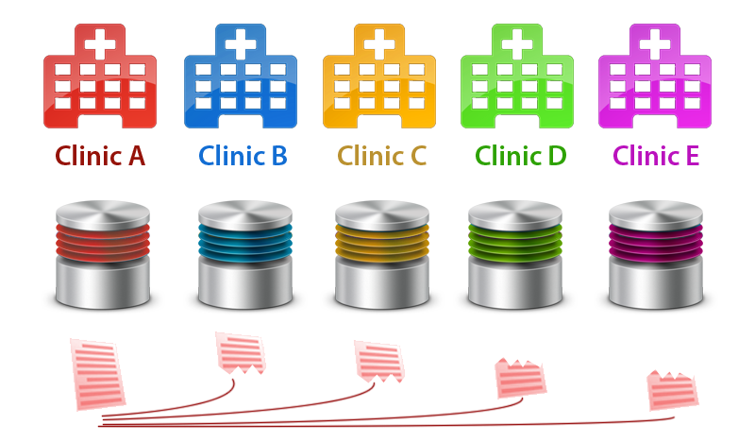
Figure 1: Secure and Distributed Backup
One of the ways to design the requirement specified in Table 34 is to make the method of data backup (as illustrated above) as distributed as possible. The operating principle of such a system is to divide each encrypted record into the number of clinics N, then split each record into N/2 parts, distributing one unique parts to each clinic. This not only provides data redundancy through 2 copies of each piece of data, but security through the distributed nature of data storage.
The diagram above demonstrates how a record would be split between 4 clinics. A record originating from Clinic A would be split into 2 parts (4 other clinics / 2), and one part would be sent to each of the other clinics. In this case, since there are 2 parts, the first part is sent to two clinics, and second to another two. It would require at least 2 of these clinics to go down for reduced redundancy, and a third (the original node, clinic A) for data loss.
Table 35: EFR-2 Language Translation
Evolutionary Functional Requirement: | EFR-2: Language Translation
Description: | The application should have the ability to display itself in different languages
Priority: | S (Should have)
Input(s): | A language selection
Source(s): | The application
Output(s): | A refreshed application displayed in the selected language
Destination(s): | GUI
Precondition(s): | The language selected is an option
Post condition(s): | The application will convert text phrases to the selected language based off a dictionary mapping language-specific dialog to the screen.

Table 36: EFR-3 2G connectivity
Evolutionary Functional Requirement: | EFR-3: 2G connectivity
Description: | The system should be able to use 2G connectivity as a backup communication if regular means of communication are not available. This is important because reliable Internet connectivity is rare in Africa.
Priority: | S (Should have)
Table 37: EFR-4 Patient Authentication
Evolutionary Functional Requirement: | EFR-4: Patient Authentication
Description: | There should be a way for a clinic A to prove to a clinic B that a patient P is attending A’s clinic and that P has supplied his or her consent for his or her information to be accessed in a way which does not reveal private information concerning P.
Priority: | S (Should have)

6. Installation Manual

6.1 Tomcat + SSL Setup
This guide will provide instruction on how to properly setup your clinic for use with the Patient Data Transfer module.

Introduction
The Patient Data Transfer (PDT) module allows your clinic to transmit and receive patient records directly with other clinics. This module provides an easy-to-use method of transferring patient data, while maintaining the security required when working with confidential information. To ensure the data transfer process is completed in a secure manner, the following steps must be followed to properly setup the pre-requisites for using this module.

Requirements
You should already have the following available to you:
- A Tomcat-based OpenMRS installation
- Patient Data Transfer Module OMOD file
- Two certificate files (provided by a governing authority)
  - OpenMRS CA Truststore (omrsca.truststore)
  - Your clinic’s private keystore (your-clinic.omrs.keystore)
- Administrative rights to the local OpenMRS server
Part I – Copying Files
- Navigate to your Tomcat installation’s root folder (usually C:\Program Files\Apache Software Foundation\Tomcat 6.0).
- Create a new folder named ‘security’
- Copy both certificate files (omrsca.truststore and your-clinic.omrs.keystore) into this directory
- Set file permissions on this folder:
- Allow read-only from the user Tomcat is running as
- Remove all other user rights
- It should be noted that the account Tomcat runs as should be non-interactive, and not used by any personnel.
Part II – Setup Tomcat
- Navigate to your Tomcat Installation’s config folder (usually C:\Program Files\Apache Software Foundation\Tomcat 6.0\conf)
- Open the server.xml file
- Under this section, add the following entry:

Under this:
<Connector executor="tomcatThreadPool" port="8080"
protocol="HTTP/1.1" connectionTimeout="20000" />
Add this, noting that you should replace the blue text with your keystore information:
<Connector port="8443" protocol="HTTP/1.1"
SSLEnabled="true" maxThreads="150" scheme="https"
secure="true" clientAuth="true" sslProtocol="TLS"
keystoreFile="security/your-clinic.omrs.keystore"
keystorePass="openmrs" connectionTimeout="20000"
truststoreFile="security/omrsca.truststore"
truststorePass="changeit" />
- Save the configuration file
- Set file permissions on server.xml :
  - Allow read-only from the user Tomcat is running as
  - Allow read-only from the administrative user.
  - Remove all other user rights
  - It should be noted that the account Tomcat runs as should be non-interactive, and not used by any personnel.
- Restart the Apache Tomcat service:
  - Right click on the taskbar icon for Tomcat, click ‘Stop’
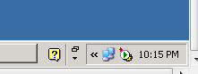
  - Wait for the service to stop
  - Right click on the taskbar icon for Tomcat, click ‘Start’
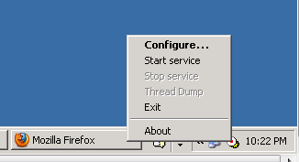
Part III – Setup OpenMRS
- Navigate to your OpenMRS instance
- Click on the ‘Patient Data Transfer’ link at the top of the navigation bar
- Click on the ‘clinics and settings’ tab to show all available clinics.
- Add your clinic information by:
  - Click the ‘New Settings’ button
  - Fill out the form using clinicDomainName for the setting name, and your clinic’s fully qualified domain name (e.g. Chicago-wrigley.unitedstates.omrs) for the value.
  - Click the ‘Submit changes’ button
- You are now ready to use the Patient Data Transfer module!

Part IV – Privileges and Roles
The PDT module utilizes the OpenMRS privilege and roles system to accomplish role-based access control (RBAC). The following is a summary of the privileges utilized by our module. It is recommended that the system maintainer creates a role for each of these privileges, as they represent separate logical roles within the system. However, each clinic may have its own needs, so it is ultimately their decision.

- Approve Inbound PDT Requests – Gives users access to the “Incoming Requests” page, where they will be able to approve incoming requests for patient data. Approving such requests is the last human-interaction which occurs before the patient’s real data is sent to a requesting clinic. It is imperative that only users who fully understand the patient consent procedures for your clinic be given access to this privilege.
- Approve Outbound PDT Requests – Gives user access to the “Outgoing Requests” page, where they will be able to approve outgoing requests for patient data. It is imperative that only users who fully understand the patient consent procedures for your clinic be given access to this privilege.
- Create New PDT Requests – Gives user access to the “My Requests” page, as well as the ability to create a new request via the “New Request” form. This privilege should be given to any user who may need to request patient data – likely all clinicians, providers, nurses, etc.
- Manage the PDT System – Gives user access to the “Clinics and Settings”, “Recent Transactions”, and “Clinics Overview” pages, as well as all related functionality. This privilege should only be given to managers or administrators in a clinic who need to configure the system or see a broad overview of what data is going in or out.

Part V – Log Setup
The PDT module keeps an application log that can be used for auditing different patient data requests. In order to save this log to a file, you must configure your Log4J settings within Tomcat. The logger name you should log is “org.openmrs.module.patientdatatransfer.LogService”. It is recommended that you log the ALL level to a rotating file. It may also be a good idea to back up the directory where you are saving these files, or simply saving to a NAS device that has redundancy.

6.2 Patient Data Transfer OPDS System Setup
This guide will outline how to setup an OpenMRS Patient Data Transfer Directory Service (OPDS) to allow name resolution between clinics utilizing the patient data transfer (PDT) module

Introduction
The Patient Data Transfer (PDT) module allows your clinic to transmit and receive patient records directly with other clinics. In order to identify the location of the other clinics, a secure name resolution service must be implemented. This is done using the Domain Name System.

Requirements
You should already have the following available to you:
- A physical or virtual machine running Debian GNU/Linux 6.0, properly provisioned and secured
- A reliable, sufficient, and static Internet connection
- The ability to receive inbound traffic on port 53 (DNS lookups)
Part I – Install and configure DNS
- Install the Bind9 DNS server (and all required pre-requisites) using apt-get install bind9
- Navigate to /etc/bind/
- Open named.conf.options
- Forwarders should be configured and enabled
- Open named.conf.local
- Add zone files entries for the attached sample zones
- Copy the sample zone files to an appropriate location, typically under ‘/etc/bind/’
Part 2 – Install and configure Apache
- Install Apache, Python, and the Python CGI packages using apt-get install apache python-3.2
- Using the attached sample configuration, add a new site into Apache’s configuration
- Ensure the certificate locations contain valid paths to the provided certificates
- Place the attached files into /var/www/cgi-bin
- Restart apache

7. User’s Manual

7.1 Module Overview
The Patient Data Transfer (PDT) Module allows separate instances of OpenMRS to transfer patient data across a network. Assuming that the installation setup from 6. Installation Manual has been followed, the system has everything it needs to perform this task.

At the most basic level, the module allows clinicians to make requests for patient data from another clinic. After the creation of a request, another local user must sign off on the request to ensure the proper procedures have been followed. After that, the request is sent over the network to the remote clinic, at which point a remote user must approve the request. Once that is complete, the patient data is packaged up and returned to the requesting clinic, where it is automatically persisted in the database.

This entire process can happen within several minutes if all the necessary approving users are ready to approve the requests, and if network connectivity is established.
The next section will explain what each page of the PDT module web interface does to give a full understanding of what is possible with the system. This will be followed by a complete walk-through of the usual patient data request procedure to give an idea of what is involved with the request process.

It is worth noting that the completed module is more of a proof-of-concept than a completed project, and therefore it may not transfer all the pieces of a patient data you may need for your purposes. Consult the “What is Patient Data?” section of the SSAD document for more information on exactly what is transferred.

7.2 Overview of Pages
Patient Data Transfer Module > Clinics and Settings
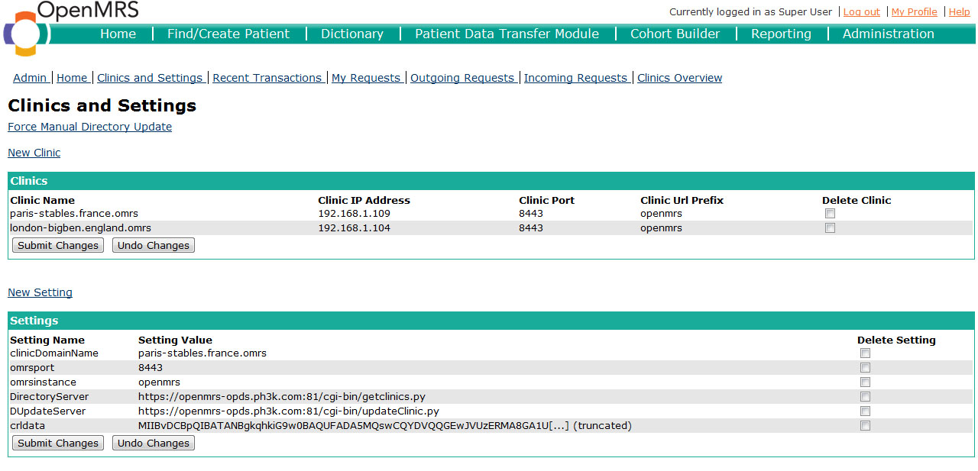
Figure 2: Clinics and Settings Page
This page is primarily for administrators who are managing the system and setting it up for the first time. The Settings section will need to be used to setup the “clinicDomainName”, the primary setting which identifies your clinic to the directory server and all other clinics. The other settings in the above screenshot will all be pulled by the directory server. The Clinics section should be automatically populated by the directory server, but a user may need to manually force an update. This interface also allows the user to add local overrides to the directory, in the event that the directory server goes down and is unable to provide up-to-date information.
The “Force Manual Directory Update” link performs both an update of the local clinic’s information in the remote directory, as well as a refresh of the locally cached directory information.
On this page you see a list of clinics and settings. The clinic table displays the “Clinic Name”, “Clinic IP Address”, “Clinic Port”, “Clinic URL Prefix”, and “Delete Clinic”. The settings table displays the “Setting Name”, “Setting Value” and “Delete Setting”. For each row in either table to delete a clinic or setting check the box under the delete clinic or delete setting column and then click submit changes. To clear the checkmarks click undo changes.
Patient Data Transfer Module > Clinics and Settings > New Clinic
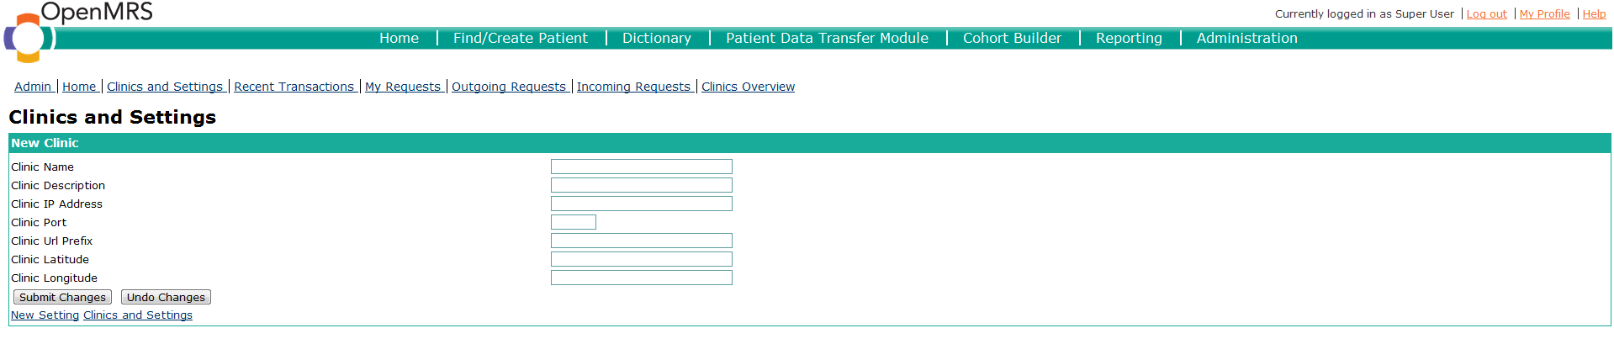
Figure 3: New Clinic Form
This page is reached by clicking the “New Clinic” link within the “Clinics and Settings” page. On this page you can create a new clinic. You are given the options to input “Clinic Name”, “Clinic IP Address”, “Clinic Port”, “Clinic URL Prefix”, “Clinic Latitude” and “Clinic Longitude”. The IP address and the port are used to specify the computer OpenMRS is running on. The URL prefix is the “instance name” in Tomcat terminology, and represents the path OpenMRS is installed to on the application server, relative to the root. The Latitude and Longitude are used to plot the clinic on the “Clinic Overview” page on a Google map. To finish creating clinic click “Submit Changes”. Click “Undo Changes” to clear all the fields.
Patient Data Transfer Module > Clinics and Settings > New Setting
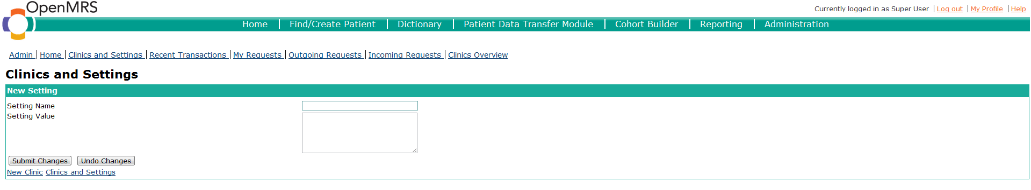
Figure 4: New Setting Form
This page is reached by clicking the “New Setting” link within the “Clinics and Settings” page. On this page you can create a new setting. You are given the options to input “Setting Name” and “Setting Value”. To finish creating setting click “Submit Changes”. Click “Undo Changes” to clear all the fields.
Patient Data Transfer Module > Recent Transactions
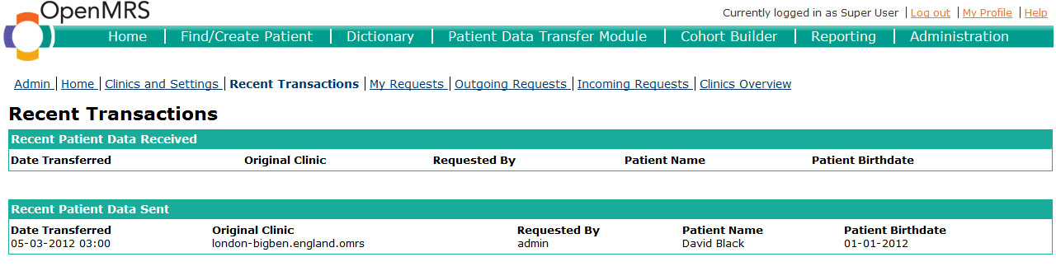
Figure 5: Recent Transactions Page
The “Recent Transactions” page shows all the most recent transitions in order of most recent to least recent. The purpose of this page is to provide a managing doctor or clinic administrator to see a quick view of what patient data has been coming in or out of the clinic in recent history. It shows two tables: “Recent Patient Data Received” which shows patient data the clinic has received and “Recent Patient Data Sent” which shows patient data the clinic has sent. Both tables list “Date Transferred”, “Original Clinic”, “Requested By” that shows the user who requested the data, “Patient Name” that displays the patients first, middle and last name, and “Patient Birthdate” that shows the patient’s birthday

Patient Data Transfer Module > My Requests
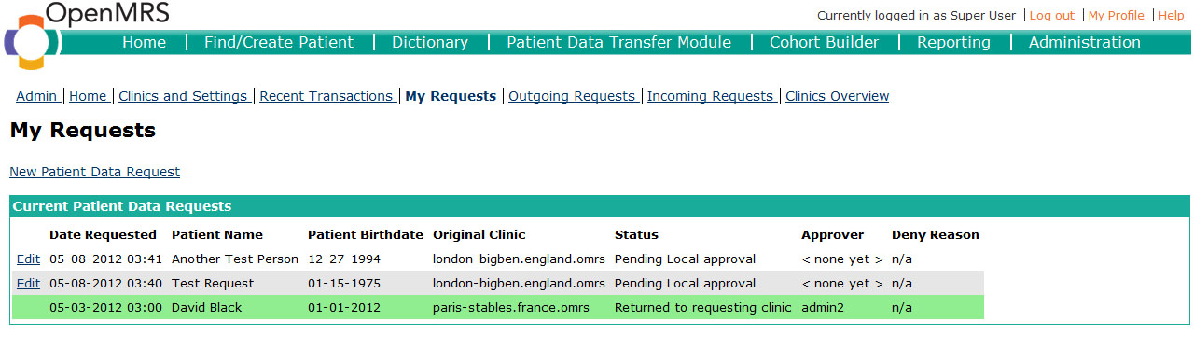
Figure 6: My Requests Page
The “My Requests” page shows a link “New Patient Data Request” to create a new patient data request. The page also shows all of the requests this user has created in the past, along with their current status. You are presented with a table that shows the Date the request was made, the patient’s first, middle, and last name, the patient’s birthdate, the clinic where the request originated from, the status of the request, the user who approved the request (if any have approved it yet), and a deny reason if the request is denied, or “n/a” if the request is not denied.
Requests that are accepted are highlighted in green. Requests that are denied or have some error associated with them are highlighted in red.
For requests that are have not been approved and sent out already, an “Edit” button appears allow the clinic to make necessary changes on the fly. After the request is edited it is instantly resubmitted and goes through the patient data request process again.
The Edit page is simply a “New Patient Data Request” page with prepopulated fields, however the request is handled differently than an actual new request.
Patient Data Transfer Module > My Requests > New Patient Data Request Page
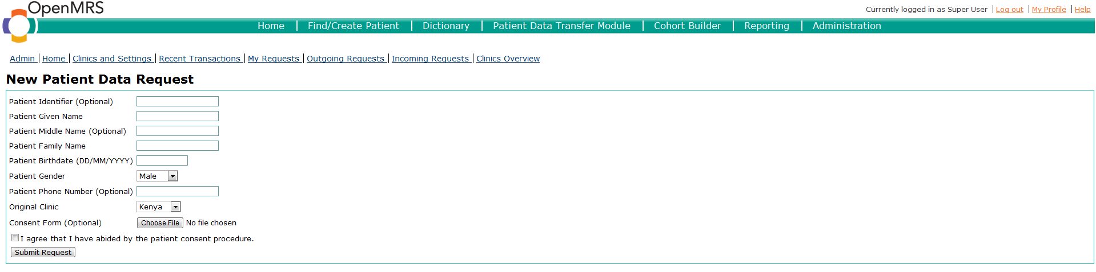
Figure 7: New Patient Data Request Form
The “New Patient Data Request” Page gives you input fields to create a new request. Fields marked as “(Optional)” are not required.
The first field is for the patient identifier. This may be useful for users who are approving the requests, but is otherwise unused by the system. The next field is for the patient’s given name (or first name), the next field is for the patient’s middle name. The next field is for the patient’s family name (or last name). The next field is for the patient’s birthdate and there is a calendar widget that pops up when the user clicks in the field for easy birthdate selection. The Next field is patient gender where the user is selects either male or female. It is important to note that the given/middle/family names, combined with the birth date and gender, are what is used to retrieve the patient’s data on the other end. The next input field is for the patient’s phone number. The next input field selects the original clinic that the patient is from, and this is the remote clinic that the request will be sent to. The next input is a button that allows the user to upload a PDF or image file of the patient’s consent form. Finally the last input field is a checkbox for the user who makes the request to agree that he or she followed the patient consent procedure. To submit the request, click the “Submit Request” button.
Patient Data Transfer Module > Outgoing Requests
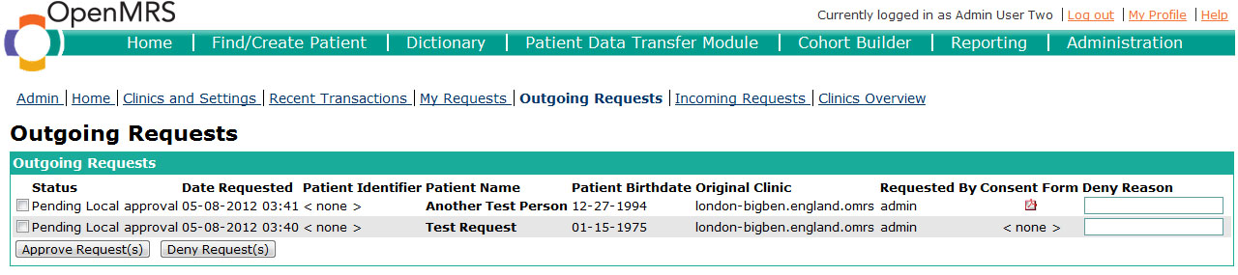
Figure 8: Outgoing Requests Page
The “outgoing requests” page shows requests that are still pending local approval from the approver to sign the consent form. You are presented with a table that shows the status of the request, the date the request was made, the patient identifier, the patient’s first, middle, and last name, the patient’s birthdate, the clinic where the request will be sent, and the user who made the request. There is also a column that displays a link to the consent form, if one was uploaded. Clicking on the icon will display the consent form within the user’s browser. Only the user who approves requests locally can see this page. To approve requests check the box besides the respective request(s) and click “Approve Request(s)”. To deny requests check the box besides the respective request(s), fill out the “Deny Reason” and click the “Deny Request(s)” button.
Patient Data Transfer Module > Incoming Requests
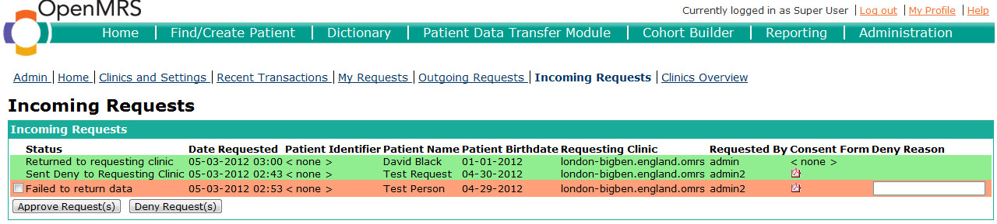
Figure 9: Incoming Requests Page
The “incoming requests” page shows requests that are still pending remote clinic approval from the appropriate user. You are presented with a table that shows the status of the request, the date the request was made, the patient identifier, the patient’s first, middle, and last name, the patient’s birthdate, the clinic where the request came from, and the user who made the request. There is also a column that displays a link to the consent form, if one was uploaded. Clicking on the icon will display the consent form within the user’s browser. Only the user who approves requests at the remote clinic sees this page. To approve requests check the box besides the respective request(s) and click “Approve Request(s)”, and to deny requests check the box besides the respective request(s), fill out the “Deny Reason” and click the “Deny Request(s)” button.

Patient Data Transfer Module > Clinics Overview
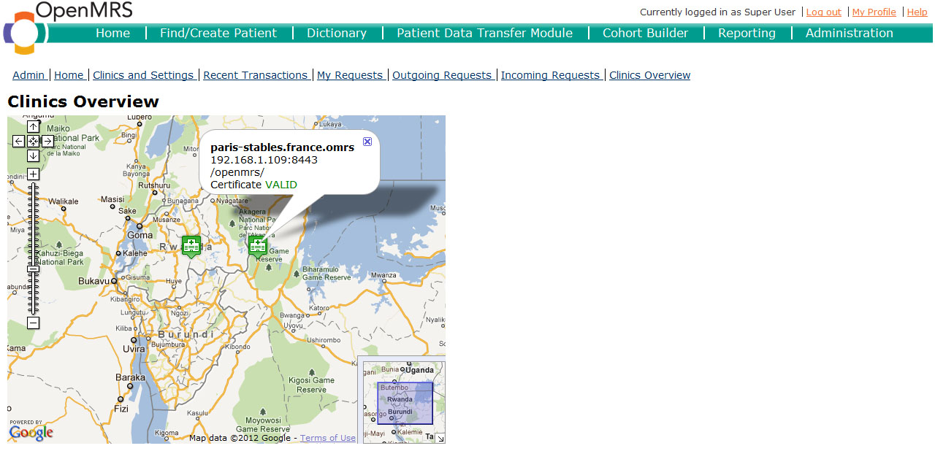
Figure 10: Clinics Overview Page
The “Clinics Overview” page displays a Google Map of all the clinics’ geographical locations. The list of clinics will be pulled from the Directory Server, and each clinic should have a latitude and longitude associated with them which is used to plot their location. When the user clicks on a clinic, pertinent information displaces, such as the name of the clinic, the IP address and port of the clinic, the directory of the OpenMRS installation, and whether the certificate is valid or revoked. It is also worth noting that the clinic’s icon on the map will be green if the certificate is valid, but red if the certificate has been revoked. The purpose of this screen is to provide an administrator with a quick view into what clinics the system knows about, and they may also be able to identify some alarming geographic trends if several nearby clinics are having their certificates revoked.

7.3 Patient Data Request Walk-Through
The following is a step-by-step guide into the patient data request process. It will be considered from two points of view – the requesting clinic (the clinic which is requesting some patient’s data from another clinic), and the remote/original/receiving clinic (the clinic where the patient data currently resides).

Requesting Patient Data:

Step 1: Enter the Patient Data Transfer Module by clicking the Patient Data Transfer Module link at the top of your screen. If you cannot see this link please refer to the FAQ section.

Step 2: Click on the “My Requests” link, and on the top of this page click on “New Patient Data Request”. This will bring you to a form you must fill out.
Step 3: Fill out the form. The minimum data that can be entered is the patient’s given name and family name. All name fields can only contain letters, apostrophes, and hyphens. The fields can also be no longer than 32 characters. In addition to this you must click the box agreeing that you have the patients consent to request the data. It is important to note that the given/middle/family names, combined with the birth date and gender, are what is used to retrieve the patient’s data on the other end. Any typos in these fields will result in a failure on the remote clinic’s end when attaching the patient’s data.

If there is some digital copy of the consent form then there is a field where you can upload the form. Only PDFs and other image extension files can be submitted. If you do not have a digital copy of the patients consent, then you still must fill out the physical form and you must make sure that there is another user with approval permissions who knows that the patient has given their consent. After this you should select the clinic that you wish to send the request to. If you do not see the clinic you wish to send it to you should consult the FAQ section. Once all relevant fields are filled out, click the submit request button.
Step 4: Wait for another user to verify the request. If you click on “My Requests” then you will be able to see your request and there will be a status next to it. If the status says “Pending local verification” then no one at your clinic has verified the request yet. Note that it is impossible for a user to approve their own request, even if they are an administrator.
Step 4a: THIS IS FOR USERS VERIFYING REQUESTS
If you look at “Outgoing Requests” then you can see requests that other users have made. You will be able to see who made the request, the consent form if there is one, and other information. If you wish to view the consent form simply click on the icon. If you wish to approve the request click the box to the left of the request then hit approve. If you wish to reject the request you can click the box to the left of the request and then hit deny. In addition to this, before you hit the deny button you can also include a reason in the Deny Reason field for why the request is being denied.
As an Approver user, understand that by approving this request you are allowing the request to proceed to the remote clinic. If there is a digital consent form uploaded, you must ensure it is filled out properly and it may be a good idea to speak with the user who requested the data as well. IT IS IMPERATIVE THAT YOU MAKE SURE THAT THERE IS PATIENT CONSENT BEFORE APPROVING ANY REQUESTS. Realize that your username will be recorded along with the request after you approve it, so there is an audit trail of what you approve.
Step 5: After another user has approved or denied the request you will be able to see the latest status on the “My Requests” page. If it was approved, the status will read “awaiting remote approval”. If it was denied, it will be highlighted red and the request will not proceed to the remote clinic. Note that if it has been denied, you will be able to see their Deny Reason and can “Edit” the request in order to correct the problems. You must now wait for the remote clinic to approve or deny your request.
Step 6: Once the remote clinic has sent your request back you will receive a notification within OpenMRS (it will appear at the top of every page). If your request was approved, the patient data will automatically be added to the database and the status on the “My Requests” page will read “Transfer Complete” If it was denied the status will read “Denied by remote clinic” and there might be a reason under the Deny Reason field.
At this point, the request process has finished, and the patient’s data will now be accessible to your local clinic. You can view the Patient Dashboard, enter visits, or do anything else that you normally do with patient’s data.

Receiving Requests for Patient Data:
Step 1: Enter the Patient Data Transfer Module by clicking the Patient Data Transfer Module link at the top of your screen. If you cannot see this link please refer to the FAQ section.

Step 2: Click on the “Incoming Requests” link to proceed to the appropriate page.

Step 3: If there are any incoming requests, you will see them listed. If there are consent forms linked with the request then you will be able to view it. If there are not any consent forms linked to the request, you should assume that there is patient consent due to the two step approval process for requests on the sending end. That being said, there is an understanding that you should not approve an incoming request unless you have personally spoken to the patient about their desire to attend another clinic. If you wish to approve any requests you can click the boxes to the left of the requests you wish to approve then hit the approve button. If you wish to reject any requests click the boxes for the requests to reject and fill out the field “Deny Reason” for all applicable requests then hit the deny button. Realize that your name will be recorded as the remote approval user, and so you should take the patient consent procedure seriously.

Step 4: The request will be returned to the requesting clinic, along with the patient data.

There are two types of errors that can occur when returning these requests back to the requesting clinic:
- “Failed to augment data” means that the system was unable to find a patient matching the request. Recall that the given/middle/family name, plus birthdate and gender, are matched to find the patient. If any of these are of different case sensitivity, then there will be no match and this error will be displayed. The suggested action step for you to take is to personally search through the patient database using the usual OpenMRS screen “Find Patients”, and determine which fields are not matching. You can then deny the request, filling out the discrepancy in the “Deny Reason” form so that the requesting user can fix it and return the request back to you.
- “Failed to return data” means a network-related error occurred. Ensure that your system has network connectivity. If it does, then please ask your system administrator to take a look. More information on this is presented below in the “Common Problems” section.

7.4 FAQ/Common Problems
Q: Why can’t I see Patient Data Transfer Module at the top of my screen?
A: Make sure that the Patient Data Transfer Module is installed on your system. For information on how to install modules consult the OpenMRS handbook.

Q: Why can’t I see the clinic I want to send the request to?
A: This is most likely a problem with the directory server. You may want to go to the “Clinics and Settings” page and click the “Force Manual Directory Update” link. If this does not work, consult the system administrator for the directory server. If you determine that there is an issue with the directory server, you could manually input the other clinic’s information using the “New Clinic” form accessible from the “Clinics and Settings” page.

Q: My request status says that there is an error sending the request. What’s wrong?
A: Make sure that you have a connection to the internet. In addition to this, the clinic that you are trying to send the request to might not have an internet connection. Ensure you have access to the Internet, and if not then consult your system administrator.
- For the system administrator troubleshooting this error: Try pinging the domain name of the requesting clinic. You may also want to try accessing that clinic from your browser, ensuring their port is open and working. If these don’t work, install the “Log Manager” module that is listed in the OpenMRS Module Repository. Within this module, enable the “org.openmrs.module.patientdatatransfer” logger with ALL level to the usual appenders. You can use the “Log Viewer” within this module to view the log in real-time without worrying about finding the files. Perform the request again and read through the log files. There should be thorough errors about anything related to the SSL setup, the network communication, or other aspects of sending the request. If worst comes to worst, you will at least be able to see a Java exception that may help you deal with the error.

Q: I am receiving an error that says “The current user has no username! Please fix before creating requests.” What’s wrong?
A: For some reason, certain default users (especially “admin”) within the OpenMRS system do not have a “username” specified. To fix this, simply go to the Administration section of OpenMRS, then “Manage Users”. Find your user, then choose to edit it. Fill in a username and save the changes. Note that you will have to log out and log back in for these changes to take effect.

Q: Everything seemed okay until I tried to approve an outgoing request. Then I received a “PKIX path building failed: sun.security.provider.certpath.SunCertPathBuilderException: unable to find valid certification path to requested target” exception. What is going on?
A: This is a known bug within the system. Please restart your Tomcat server and everything will work.

