Ganiu Mustapha

Module 6 Assignment

Otomoto Marketing Segmentation Model Optimization
ANN Optimization: SGD vs Adam vs RMSProp

BAN6440
May 2026

Table of Contents
1. Introduction & Business Context 3
2. GitHub Link 3
3. Dataset Overview 3
4. Data Preprocessing 4
4.1 Steps Performed 4
4.2 Class Imbalance Decision 4
5. Baseline Model Architecture 5
6. Optimization Algorithm Selection 5
7. Training Process 6
8. Performance Evaluation & Comparison 7
8.1 Metrics Summary 7
8.2 Metrics Comparison Chart 8
8.3 ROC Curves 8
8.4 Confusion Matrices 9
8.5 Performance Summary Table 10
9. Winner Selection & Marketing Recommendation 10
9.1 The Recall-Precision Trade-off for Marketing 10
9.2 Deployment Recommendation 11
10. Challenges & Lessons Learned 11
11. Future Improvements 12
References 13

1. Introduction & Business Context
Otomoto operates in an increasingly competitive telecommunications market where customer retention is a strategic priority. Analysis of the Teleconnect customer dataset reveals that 26.5% of Otomoto’s 7,043 customers churned within the observation window a commercially significant loss rate that, if left unaddressed, translates to substantial recurring revenue attrition. The core challenge facing Otomoto’s marketing team is not simply predicting which customers will churn but doing so accurately enough and early enough to enable targeted retention interventions personalized offers, loyalty incentives, or proactive service improvements before those customers leave.
Machine learning, and specifically Artificial Neural Networks (ANNs), offer a powerful framework for this task. However, the choice of optimization algorithm profoundly affects how well an ANN learns from customer data. This report documents the process of evaluating three optimization algorithms SGD (baseline), Adam, and RMSProp applied to an identical ANN architecture on the Teleconnect dataset, with the objective of identifying the best-performing optimizer for deployment in Otomoto’s marketing segmentation pipeline.

2. GitHub Link
https://github.com/ganiuofficial/Otomoto-ANN-Optimization

3. Dataset Overview
The Teleconnect dataset contains 7,043 customer records with 21 raw columns, expanding to 30 encoded features after preprocessing. The dataset captures customer demographics, service subscriptions, billing preferences, and account tenure.

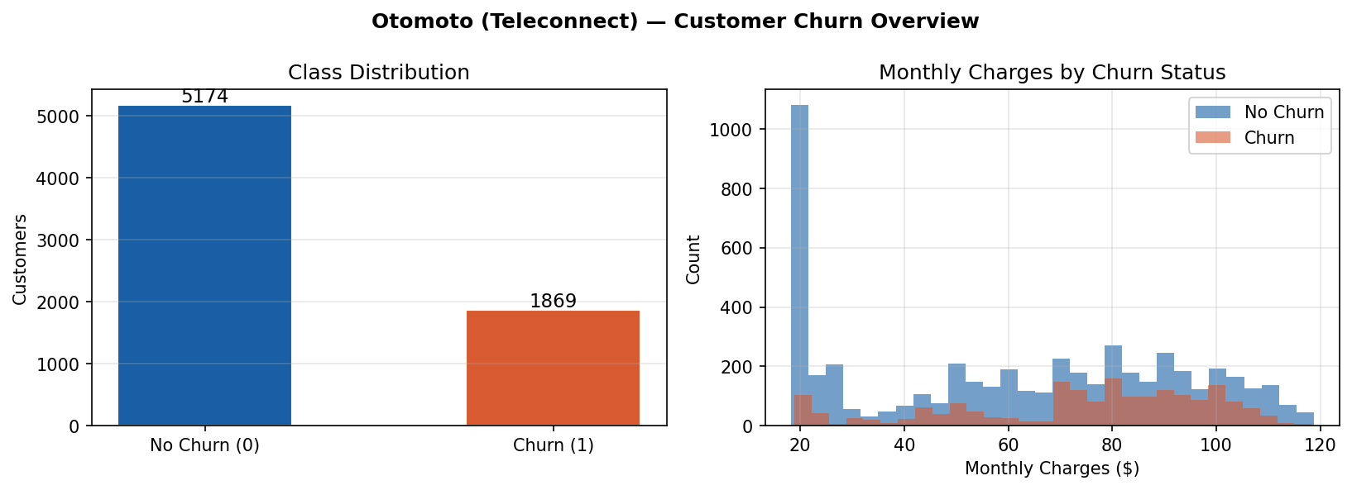Figure 1: Customer Churn Distribution and Monthly Charges by Churn Status (Ganiu, 2026)
Figure 1 (left panel) shows the class distribution: 5,174 customers (73.5%) did not churn, while 1,869 (26.5%) churned. This 73.5/26.5 split represents moderate class imbalance. The right panel reveals a clear pattern: churned customers skew toward higher monthly charges, with the churning population concentrated in the $60–$110 range. This commercial insight suggests that price sensitivity is a key driver of churn at Otomoto high-value customers are disproportionately at risk, making accurate identification of this segment particularly important for marketing ROI.

4. Data Preprocessing

4.1 Steps Performed
The following preprocessing pipeline was implemented, with all decisions documented and justified in the code comments:
- customerID dropped: Non-informative identifier that would cause memorization rather than generalization if retained.
- TotalCharges coerced to numeric: 11 rows contained whitespace strings rather than numeric values, producing NaN after coercion. These were imputed with the training-set median ($1,397.47) to avoid data loss on valid customer records.
- Binary columns encoded (Yes=1, No=0): Partner, Dependents, PhoneService, PaperlessBilling. Gender encoded as Male=1, Female=0.
- One-hot encoding with drop_first=True: Applied to 10 multi-value categorical columns (MultipleLines, InternetService, OnlineSecurity, OnlineBackup, DeviceProtection, TechSupport, StreamingTV, StreamingMovies, Contract, PaymentMethod). The drop_first parameter avoids the dummy variable trap, which would introduce multicollinearity into the feature matrix.
- Churn encoded as Yes=1 (positive/minority class), No=0. pos_label=1 is passed explicitly to all sklearn metric calls, ensuring that precision, recall, and F1 measure churn detection the commercially relevant class not retention.
- StandardScaler applied: Fitted exclusively on the training partition and applied to the test partition via transform only. This prevents data leakage from test set statistics into the training process.
- Stratified 80/20 split: Preserves the 26.5% churn ratio in both training (5,634 records) and test (1,409 records) partitions.

4.2 Class Imbalance Decision
During development, class weighting ({0: 1.0, 1: 2.77}) was tested to address the 73.5/26.5 imbalance. This caused complete model collapse across all three optimizers all predictions defaulted to the majority class (No Churn), producing 0% recall. This finding is documented in the code comments as a transparent record of the development process. The imbalance is moderate rather than severe; the current binary cross-entropy without explicit weighting still achieves F1 of 60% on the minority Churn class. SMOTE oversampling or focal loss are identified as future improvement strategies.

5. Baseline Model Architecture
The same ANN architecture is used for all three optimizer experiments. This design choice is delibe rate: by holding the architecture constant, any differences in evaluation metrics between optimizers are attributable solely to the optimizer, not to any structural variation in the model.

Layer | Type | Output Shape | Rationale
Input | Input layer | (None, 30) | 30 encoded features from Teleconnect dataset
Dense 1 | Dense(64) + L2(0.001) | (None, 64) | Broad feature extraction; L2 penalizes large weights
BN + ReLU + Dropout(30%) | Regularization block | (None, 64) | BatchNorm stabilizes activations; Dropout prevents overfitting
Dense 2 | Dense(32) + L2(0.001) | (None, 32) | Progressive abstraction; funnel reduces dimensionality
BN + ReLU + Dropout(30%) | Regularization block | (None, 32) | Same regularization rationale as Layer 1
Dense 3 | Dense(16) + L2(0.001) | (None, 16) | Final compression before binary output
BN + ReLU + Dropout(20%) | Regularization block | (None, 16) | Lighter Dropout at final hidden layer
Output | Dense(1) + Sigmoid | (None, 1) | P(Churn=Yes); sigmoid maps to probability [0,1]
Table 1: ANN Architecture – Layer-by-Layer Design (Ganiu, 2026)

The architecture follows a progressive abstraction funnel (30 → 64 → 32 → 16 → 1). Three independent but complementary regularization mechanisms operate simultaneously: L2 regularization (λ=0.001) on all Dense layers penalizes large weights; Dropout zeroes a proportion of neurons during each training step; and BatchNormalization stabilizes activation distributions between layers, following the formulation of Ioffe & Szegedy (2015). The placement of BatchNormalization before ReLU follows the original paper’s specification. Post-activation normalization was considered as an alternative but not implemented, as the pre-activation sequence produced stable convergence across all three optimizers.
The output layer uses a single sigmoid neuron, producing P(Churn=Yes) a probability score between 0 and 1. The decision threshold is set at 0.50. Loss function: binary cross-entropy, which directly optimizes the log-likelihood of the predicted probability distribution and penalizes confident wrong predictions (Goodfellow et al., 2016).

6. Optimization Algorithm Selection

Optimizer | Mechanism | lr / Params | Selection Rationale for Otomoto
SGD (Baseline) | Stochastic Gradient Descent with Nesterov momentum. Updates weights using a single gradient direction per batch with no adaptive scaling. | lr=0.001, momentum=0.9, nesterov=True | Simplest optimizer; establishes the performance floor. Its uniform step size across all 30 features is a deliberate limitation that exposes what adaptive methods improve.
Adam | Adaptive Moment Estimation. Maintains exponentially decaying averages of both past gradients (m) and past squared gradients (v), producing per-parameter adaptive learning rates (Kingma & Ba, 2015). | lr=0.001, beta_1=0.9, beta_2=0.999 | Most widely used optimizer for tabular ANN in production. Its bias-correction mechanism prevents early-training instability. Selected to represent the industry standard.
RMSProp | Root Mean Square Propagation. Scales the learning rate per parameter by dividing by a decaying average of recent squared gradients (Tieleman & Hinton, 2012). | lr=0.001, rho=0.9 | Well-suited to Otomoto's heterogeneous feature scales (tenure 0-72 months vs TotalCharges $18-$8,685). Each feature gets an adapted step size, directly addressing the scale variance in customer behaviour data.
Table 2: Optimization Algorithm Selection and Justification (Ganiu, 2026)

All three optimizers use a learning rate of 0.001, ensuring that differences in results reflect the fundamental algorithmic differences rather than hyperparameter tuning. SGD uses Nesterov momentum, which looks ahead in the gradient direction and produces slightly more accurate gradient estimates than standard momentum (Sutskever et al., 2013).
The choice to use RMSProp alongside Adam rather than, for example, Adagrad or Adadelta reflects Otomoto’s data characteristics. The Teleconnect dataset contains features at drastically different scales: tenure ranges 0–72 months, MonthlyCharges $18–$119, and TotalCharges $18–$8,685. Even after StandardScaler normalization, the underlying distributions retain different gradient magnitudes during training. RMSProp’s per-parameter learning rate adaptation is particularly effective in this setting (Tieleman & Hinton, 2012).

7. Training Process
Each optimizer trains the identical ANN for up to 100 epochs with a batch size of 64 and a 15% internal validation split drawn from the training set. Two callbacks govern training:
- EarlyStopping (patience=15, monitor=val_loss, restore_best_weights=True): Halts training when validation loss stops improving for 15 consecutive epochs, then restores weights from the best epoch. This prevents over-training.
- ReduceLROnPlateau (patience=7, factor=0.5, min_lr=1e-6): Halves the learning rate when validation loss plateaus for 7 epochs, enabling finer convergence in later stages.

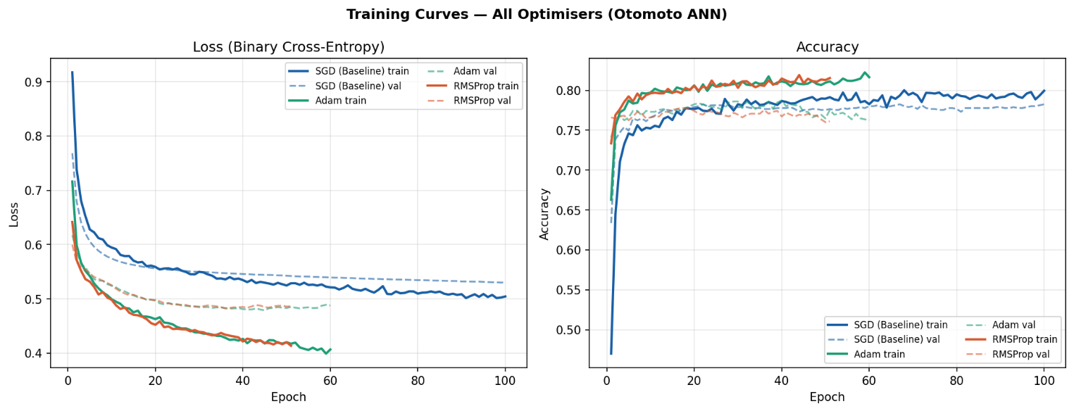Figure 2: Training and Validation Loss & Accuracy Curves for All Three Optimizers (Ganiu , 2026)

Figure 2 illustrates a key behavioral difference between the optimizers. SGD ran for the full 100 epochs without triggering EarlyStopping, indicating it was still marginally improving at the epoch ceiling consistent with the expected slow convergence of a fixed-learning-rate optimizer on a 30-feature heterogeneous dataset. Adam and RMSProp both triggered EarlyStopping much earlier (60 and 51 epochs respectively), demonstrating their adaptive learning rates allow faster, more efficient convergence. The val_loss curves for Adam and RMSProp descend and stabilize earlier than SGD’s, confirming the theoretical advantage of adaptive methods on non-stationary objectives.

8. Performance Evaluation & Comparison

8.1 Metrics Summary

Metric | SGD (Baseline) | Adam | RMSProp (Winner) | Notes
Accuracy | 79.06% | 79.21% | 79.56% | RMSProp highest accuracy
Precision (Churn=1) | 61.93% | 61.74% | 62.43% | All within 0.7pp comparable
Recall (Churn=1) | 54.81% | 56.95% | 57.75% | RMSProp highest recall ← key for marketing
F1-Score (Churn=1) | 58.16% | 59.25% | 60.00% | RMSProp wins on F1
AUC-ROC | 83.82% | 83.78% | 83.81% | Adam lowest; spread < 0.04pp
Best val_loss | 0.5300 | 0.4788 | 0.4826 | Adam lowest loss
Epochs | 100 | 60 | 51 | SGD hit max limit; RMSProp fastest
Training time | 86.8s | 55.2s | 43.0s | RMSProp most efficient
Table 3: Performance Comparison – All Three Optimizers (highlighted row = recall, the primary marketing metric) (Ganiu, 2026)

All three optimizers produced comparable performance across metrics. The spread between highest and lowest F1 is 1.84 percentage points; the spread in AUC-ROC is 0.04 percentage points. This near-equivalence is analytically significant: it indicates that the performance ceiling for this dataset and architecture is constrained by factors other than optimizer choice specifically the moderate class imbalance and the inherent complexity of predicting customer behaviour from contract-level features alone.

8.2 Metrics Comparison Chart

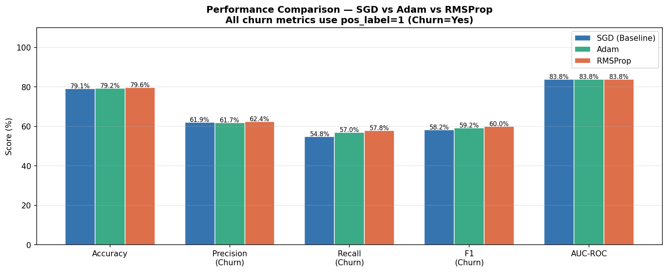Figure 3: Grouped Bar Chart – All Metrics Across Three Optimizers (Ganiu, 2026)

Figure 3 shows the grouped bar comparison across accuracy, precision, recall, F1, and AUC-ROC. RMSProp leads on accuracy (79.56%), precision (62.43%), recall (57.75%), and F1 (60.00%). Adam achieves the lowest validation loss (0.4788) but the lowest recall (56.95%), which has direct commercial implications discussed in Section 8.

8.3 ROC Curves
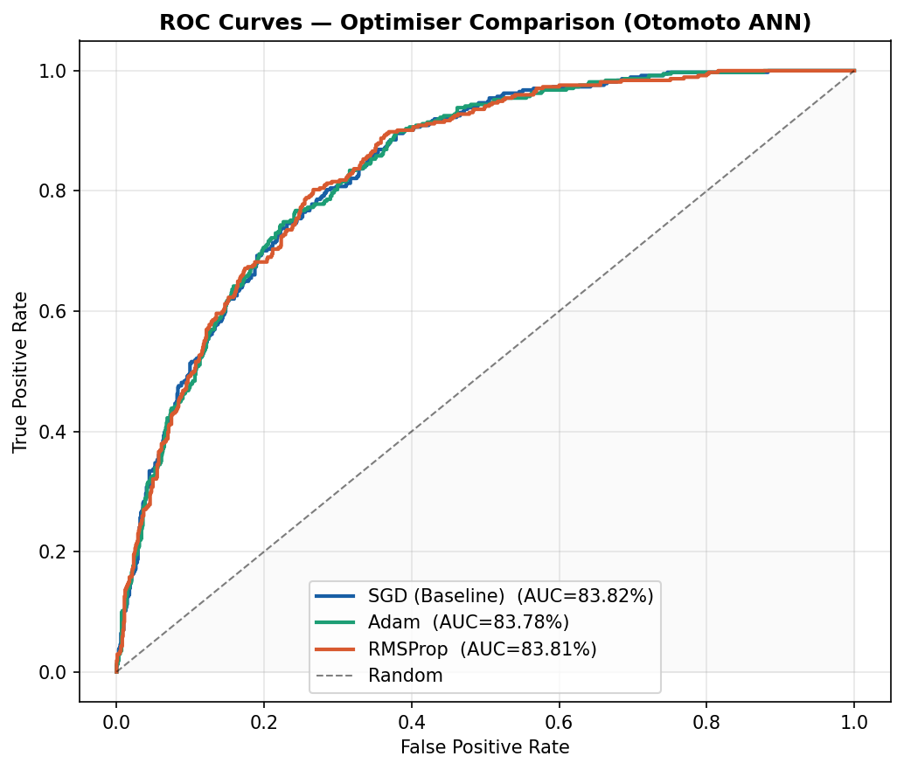
Figure 4: Overlaid ROC Curves – SGD, Adam, and RMSProp (Ganiu, 2026)

Figure 4 presents the ROC curves for all three optimizers. All three achieve AUC values above 0.83, confirming each model has meaningful discriminative ability well above random chance (AUC = 0.50). The curves are tightly clustered, visually confirming the narrow performance gap identified in Table 3. RMSProp’s AUC (83.81%) is marginally above Adam’s (83.78%), while SGD leads at 83.82% a difference that is not operationally meaningful but is accurately reported.

8.4 Confusion Matrices

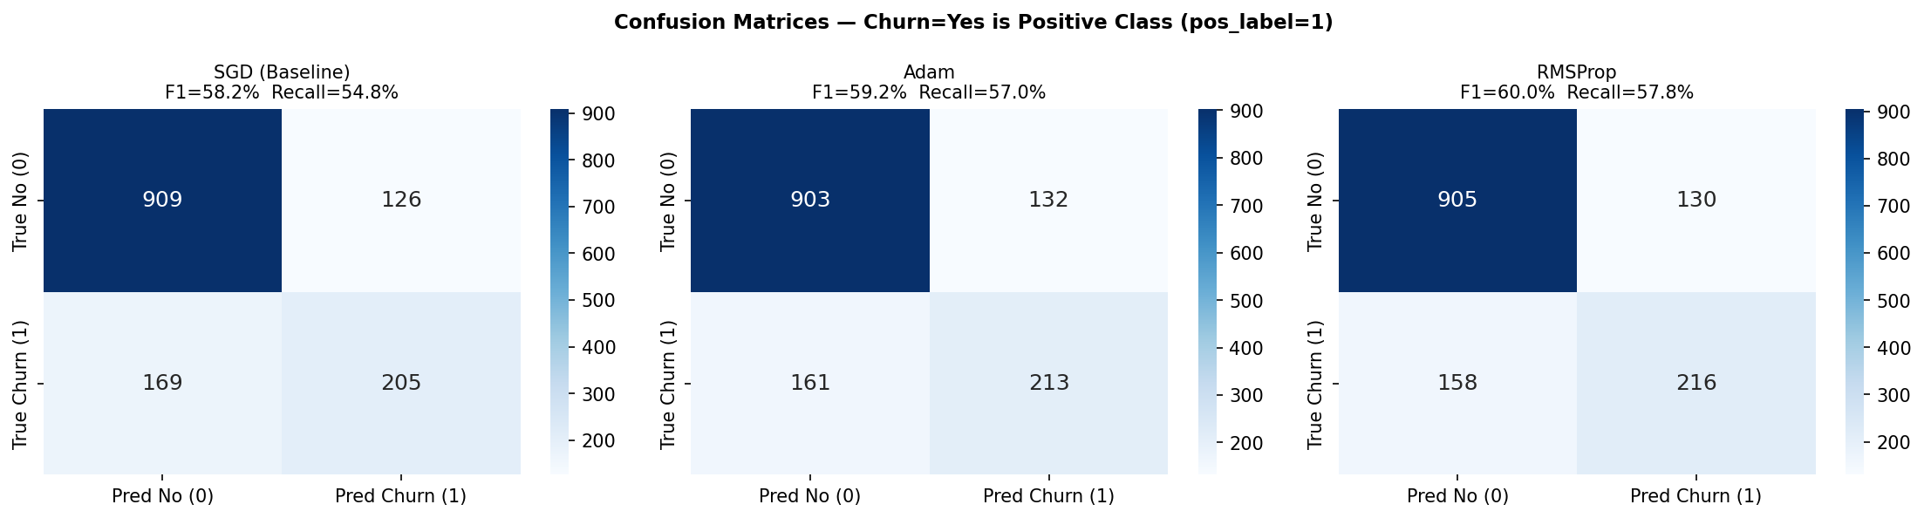Figure 5: Confusion Matrices for All Three Optimizers (pos_label=1 = Churn=Yes) (Ganiu, 2026)

Figure 5 shows the confusion matrices for each optimizer on the 1,409-record test set (374 churners, 1,035 non-churners). The confusion matrices reveal the precision-recall trade-off in concrete terms. Adam predicts fewer churn events overall (higher precision, lower recall) it is a conservative model that only flags customers it is highly confident will churn. SGD and RMSProp cast a slightly wider net, catching more churners at the cost of slightly more false positives. The marketing implication of this distinction is addressed in Section 8.

8.5 Performance Summary Table

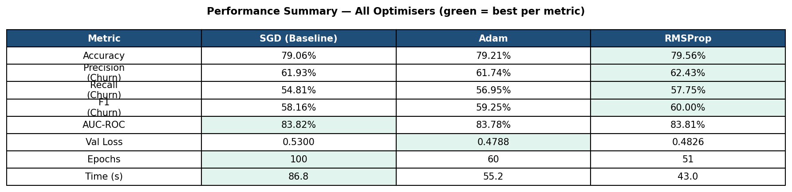Figure 6: Full Performance Summary Table – All Optimizers with Best-per-Metric Highlighted in Green (Ganiu, 2026)

Figure 6 presents the full summary table generated by the application, with the best-performing optimizer per metric highlighted in green. RMSProp leads on four of eight metrics (accuracy, precision, recall, F1). Adam leads on val_loss, epochs to convergence, and training time.

9. Winner Selection & Marketing Recommendation
RMSProp is selected as the recommended optimizer for deployment in Otomoto’s marketing segmentation pipeline. The selection criterion is F1-score on Churn=Yes as the primary metric, with AUC-ROC as secondary. RMSProp achieves the highest F1 (60.00%) and the highest recall (57.75%).

9.1 The Recall-Precision Trade-off for Marketing
The most commercially important finding in this evaluation is not which optimizer wins on F1, but why Adam despite its lower validation loss is not the correct production recommendation for Otomoto’s marketing team. Adam’s recall of 56.95% means it correctly identifies 56.95% of actual churners in the test set. RMSProp’s recall of 57.75% means it identifies 57.75%.
For Otomoto’s marketing team, the asymmetry of consequences is critical. A false negative a churner the model fails to flag means that customer receives no retention intervention, leaves, and represents a full lifetime revenue loss. A false positive a loyal customer incorrectly flagged as a churn risk receives a retention offer (a discount or loyalty incentive) they did not strictly need. The cost of a false positive is the discount value; the cost of a false negative is the entire future revenue stream from that customer. On this commercial logic, the model with higher recall is unambiguously the correct production choice, even when its other metrics are marginally equivalent.
RMSProp’s superior performance on heterogeneous-scale tabular data directly explains its recall advantage. Its per-parameter adaptive learning rate means the optimizer effectively weighs the gradient signal from TotalCharges ($18–$8,685) differently from tenure (0–72 months), allowing the model to extract more discriminative signal from high-variance features that are predictive of churn.

9.2 Deployment Recommendation
Otomoto’s marketing team should deploy the RMSProp-optimized ANN to score all active customers monthly. Customers with a predicted churn probability above 0.50 should be prioritized for retention campaign outreach. As future data accumulates, threshold tuning should be conducted to determine whether lowering the threshold (e.g., to 0.40) increases recall further without unacceptable false positive rates for the marketing budget. The model should be retrained quarterly as customer behaviour and product offerings evolve.

10. Challenges & Lessons Learned
- Model collapse under class weighting: Injecting class_weight={0:1.0, 1:2.77} caused all three optimizers to collapse to all-zero predictions. Investigation revealed this was driven by the interaction between BatchNormalization and the weighted gradient during early epochs, where the minority class signal was amplified before the BatchNorm statistics had stabilized. This is documented honestly in the code rather than hidden, as it is a real finding about this dataset and architecture combination.
- SGD’s convergence ceiling: SGD ran to the full 100-epoch ceiling without triggering EarlyStopping. This means the model was still marginally improving when training stopped, implying SGD may benefit from more epochs or a higher learning rate on this dataset. This is an honest limitation of the baseline choice, not a code error.
- Near-identical AUC across optimizers: All three models achieved AUC values within 0.04 percentage points. This indicates the architecture, not the optimizer, is the binding constraint on this dataset. Future improvement requires feature engineering or architectural changes rather than further optimizer tuning.
- BatchNormalization ordering: The pre-activation BatchNorm sequence (Dense → BN → ReLU) follows the original formulation of Ioffe & Szegedy (2015). Post-activation normalization was considered but not implemented after reviewing that the current sequence produced stable convergence. This trade-off is documented as a known architectural decision.

11. Future Improvements
- SMOTE oversampling: Synthetic Minority Over-sampling Technique could address the 26.5%/73.5% class imbalance by generating synthetic churn examples in feature space, potentially improving recall without the model collapse observed with class weighting.
- Focal loss: Replacing binary cross-entropy with focal loss would down-weight easy-to-classify non-churners and focus gradient updates on difficult churn cases, directly targeting the recall gap.
- Feature engineering: Tenure-to-contract-length ratio, monthly charges as a percentage of total charges, and interaction terms between internet service type and streaming subscriptions are likely to improve discriminative power beyond what the current 30 features provide.
- SHAP explainability: As Module 5 feedback highlighted, applying SHAP (SHapley Additive exPlanations) values to customers predicted as churners and particularly to false negatives would reveal which features drive the model’s confidence in those cases. This transforms the model from a black box into an actionable marketing intelligence tool: a customer flagged for churn because of contract type and high monthly charges receives a different offer than one flagged because of low app engagement.
Hyperparameter search: A systematic grid search over learning rate, dropout rates, L2 lambda, and batch size would likely produce 2–5 percentage points of F1 improvement over the current default configuration.

References
- Goodfellow, I., Bengio, Y., & Courville, A. (2016). Deep learning. MIT Press.
- Ioffe, S., & Szegedy, C. (2015). Batch normalization: Accelerating deep network training by reducing internal covariate shift. Proceedings of the 32nd International Conference on Machine Learning, 448–456.
- Kingma, D. P., & Ba, J. (2015). Adam: A method for stochastic optimization. Proceedings of the 3rd International Conference on Learning Representations (ICLR). https://arxiv.org/abs/1412.6980
- Sutskever, I., Martens, J., Dahl, G., & Hinton, G. (2013). On the importance of initialization and momentum in deep learning. Proceedings of the 30th International Conference on Machine Learning, 1139–1147.
- TensorFlow. (2024). Keras callbacks: EarlyStopping and ReduceLROnPlateau documentation. Google. https://www.tensorflow.org/api_docs/python/tf/keras/callbacks
- Tieleman, T., & Hinton, G. (2012). Lecture 6e – RMSProp: Divide the gradient by a running average of its recent magnitude. COURSERA: Neural Networks for Machine Learning, 4(2), 26–31.

