Solder dataset

80% traning data 20% test data

[1] " Accuracy of the pruned tree is:"
> print(accuracy)
[1] 0.6701389

90% traning data 10% test data
1] " Accuracy of the pruned tree is:"
> print(accuracy)
[1] 0.6512346

SOLDER ORIGINAL TREE

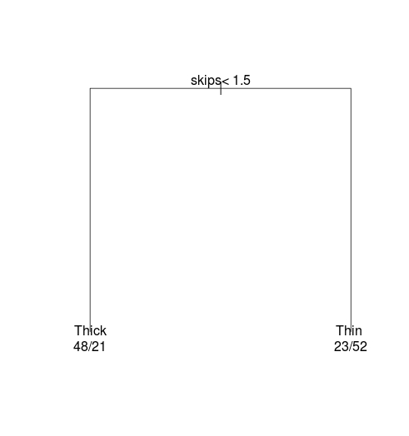

SOLDER PRUNED TREE
