**TEAM-2**

**Team Members:**

1. Sri Harsha Ganja (sxg151830)
2. Aman Miryala (axm151830)
3. Akash Patti Gupta(vxp150530)

**Project Title:** Airline Reservation System

**Name of the Website:** flyhigh airlines

**url**: localhost:600/airline

**Project Description:** The main goal of our project was to create a simple, yet appealing website that allows a person to book airline tickets online. Throughout the process we always took care such that the website is easily understandable and anyone using it for the first time also does not face any difficulty in booking a ticket or rather just searching for some flights.

**User Functionalities:**

* A user can create an account on our website which helps them to keep a track of their booking history.
* For creating an account the user will have to fill a form containing fields First Name, Last Name, Email Address, Password, Personal ID, Date of Birth, Address out of which the First Name, Last Name, Email Address, Password, Personal ID are mandatory.
* For his next visit he can directly login just by entering his email id and password at the top right corner of the home page.
* Once he is logged in he can search the flights by filling out a form which contains basic fields such as the origin, destination, an option for one way or round trip, journey date, return date if round trip is selected, and options asking for number of adults and number of children they want to book the tickets for. We have implemented some constraints in filling out this form. Such as
  + Booking can be done for flights on dates starting from the present day, i.e. bookings for flights from the past is not possible.
  + The return date must be any date after the booking date and not before it.
* Once the form is filled and the search flights button is pressed the user will be redirected to a page which has all the search results showing flights according to the details given by him and also show the number of seats available for each flights.
  + The user can also sort these results according to either the number of available seats or price for the ticket(s).
  + A responsive search tab is also provided at the top right corner of the page that can be used to display any particular results.
  + Here each flight has a unique price for the journey which was implemented by having a base price and price for every unit of distance specific to each airlines.
* There is also an option to search for the flights without logging in to the website, but when such user tries to book the ticket he will be asked to sign in before the ticket is booked.
* Once the user selects a flight he can go ahead and select the “Book Now” button upon which he will be given a prompt that the tickets where successfully booked.
* Now the user check his previous orders by going to the orders option present in the dropdown menu at the top right corner of the page. He will then be redirected to a page which shows all the tickets that were previously booked by him. Here he has a choice of cancelling his ticket.
* After the user is done with booking the tickets, he can then logout by clicking the logout option present in the dropdown menu on the top right corner of the page.

**Admin Functionalities:**

* The admin has all the functionalities that the user has and also some privileged functionalities.
* Username: [admin@airline.com](mailto:admin@airline.com) ; Password: admin
* He can access these privileged functionalities by selecting the “Admin” option for the drop down menu at the top right corner of the page.
* Upon selection of that option he will be redirected to a page containing options, which help him to ADD or DELETE or MODIFY the flight details.
  + If he wishes to add a flight he will be redirected to a page containing a form, wherein he has to fill out all the details of the new flight.
  + If he wishes to delete a flight he will be redirected to a page which displays a list of all the available flights from which he can select the flights he wants to delete.
  + If he wishes to modify a flight he will be redirected to a page where he can select the flight that he wishes to modify and then fill out a form with the modifications desired.

**DATABASE DETAILS:**

dbname : airline

user: root

password: root

host: localhost

**Database Description:**

**AIRLINE**

**flights**

|  |  |  |  |  |
| --- | --- | --- | --- | --- |
| FLIGHT_NO | AIRWAYS_ID | CAPACITY | ORIGIN | DESTINATION |

**Ticket**

|  |  |  |  |  |  |  |
| --- | --- | --- | --- | --- | --- | --- |
| TICKET_ID | FLIGHT_NO | PASSENGER_ID | FROM | TO | DATE | SEAT_NO |

**Passenger**

|  |  |  |  |  |  |  |
| --- | --- | --- | --- | --- | --- | --- |
| ID | FIRST_NAME | LAST_NAME | EMAIL | PASSWORD | DOB | ADDRESS |

**Destinations**

|  |  |  |  |
| --- | --- | --- | --- |
| ID | NAME | LONGI | LATI |

**Airways**

|  |  |  |
| --- | --- | --- |
| ID | AIRWAYS_NAME | PRICE |

**Flight_available**

|  |  |  |
| --- | --- | --- |
| FLIGHT_ID | DEPART | SEATS_BOOKED |

**Work division: (all below tasks for each operation are done on HTML,CSS,JS , PHP and SQL)**

**Sri Harsha Ganja:**

* Creation of homepage
* Creation of User Registration,
* listing flights,
* creating , updating the flights, deleting the flights,
* database schema and operations
* sorting and searching data on lists

**Aman Miryala:**

* form validations on each page Registration, flight details
* ticket booking
* listing orders/tickets
* deleting tickets
* database schema and operations

**Akash Patti:**

* CSS styling and boot strap,
* creating user interface
* admin interface
* database schema and operations

**Screen shots:**

**HOME PAGE**

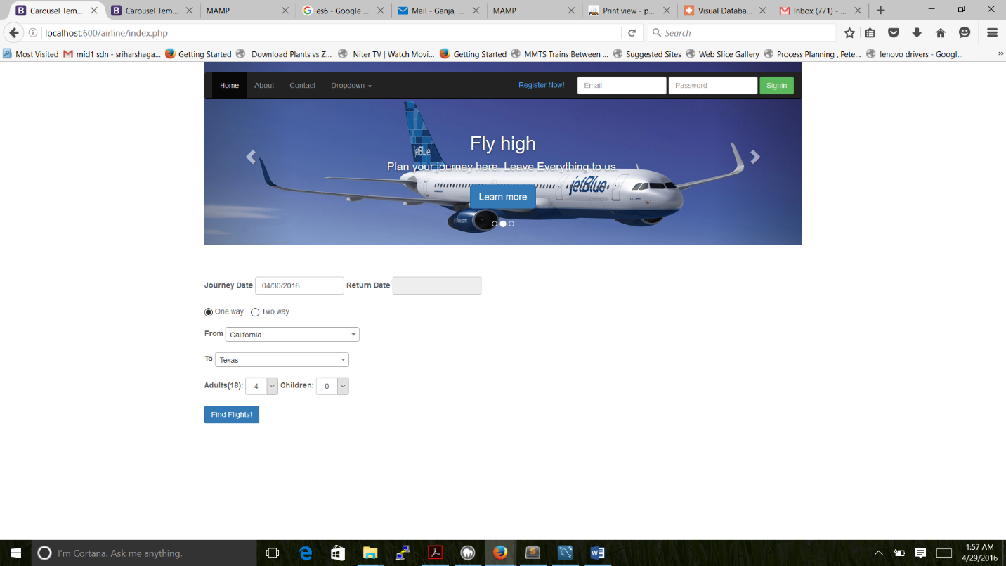

**LIST OF AVAILABLE FLIGHTS FOR PASSENGER**

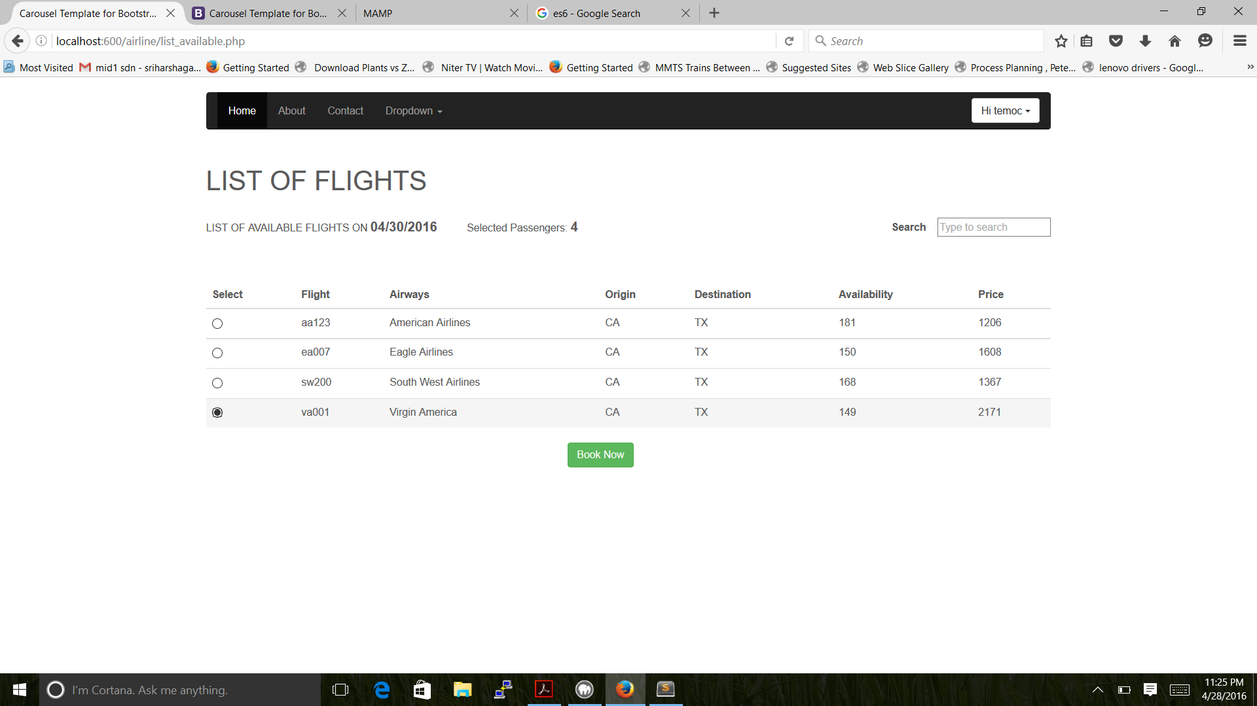

**USER REGISTRATION**

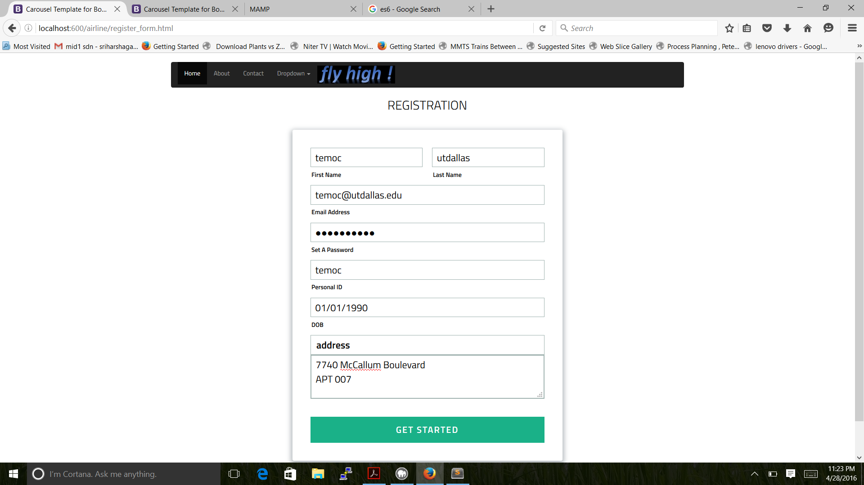

**ADMIN OPERATIONS**

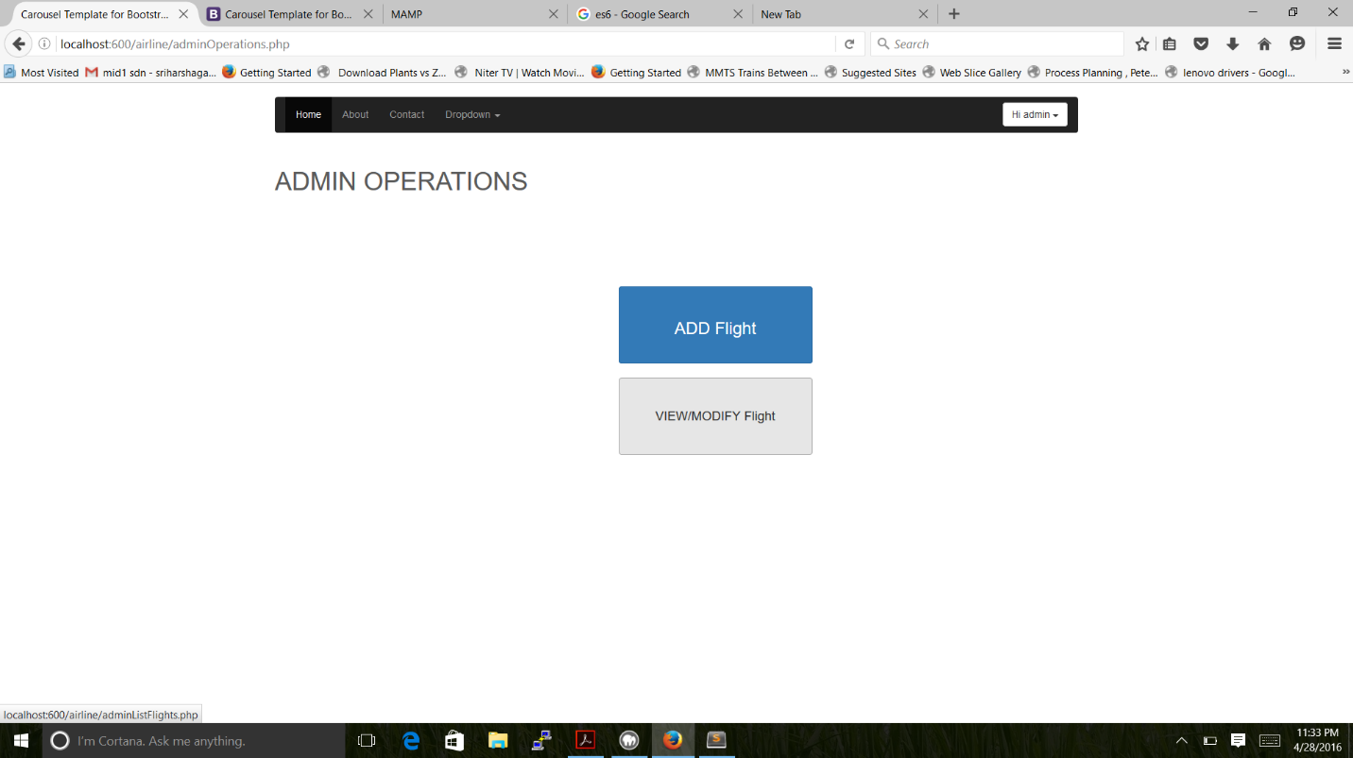

**ADD FLIGHT**

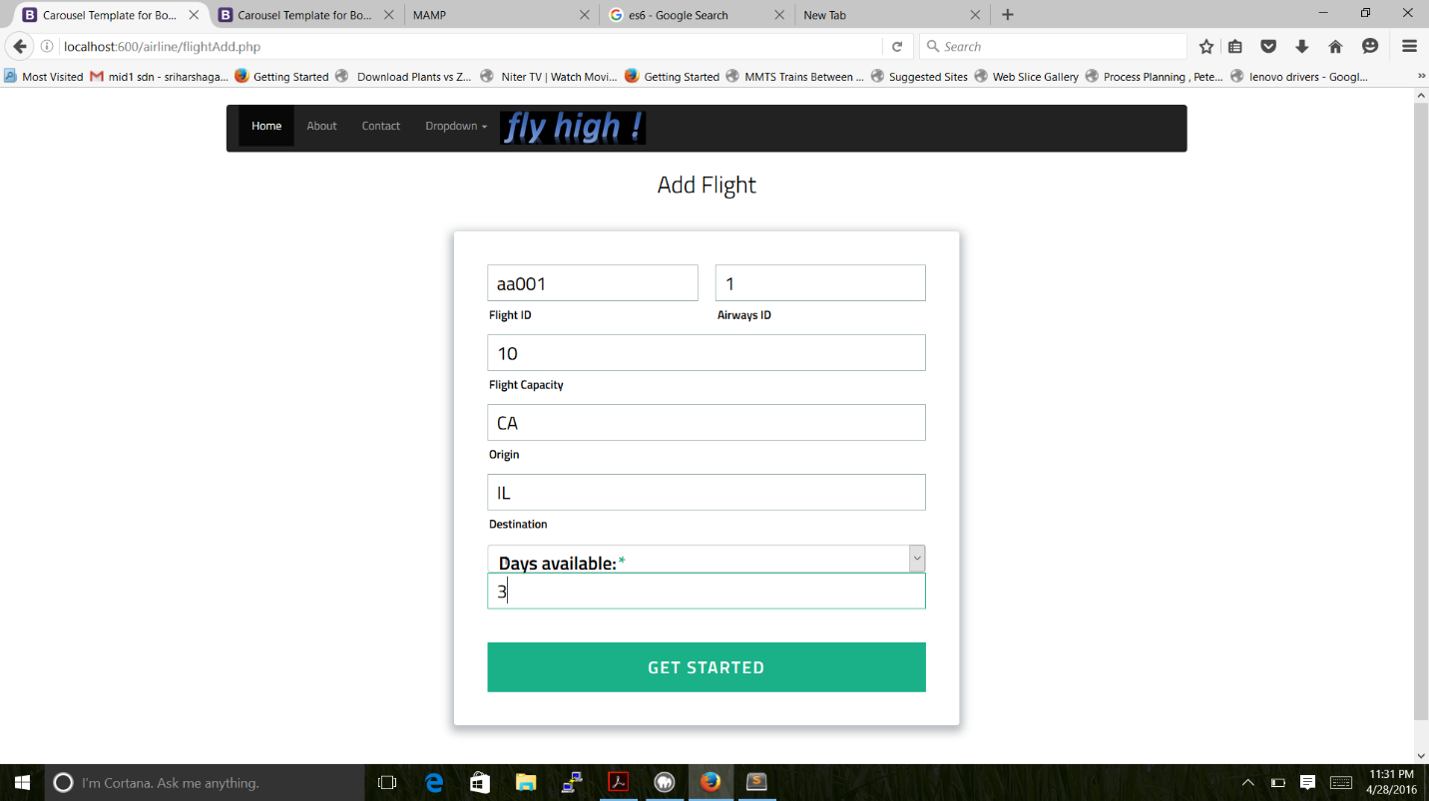

**MODIFY FLIGHT**

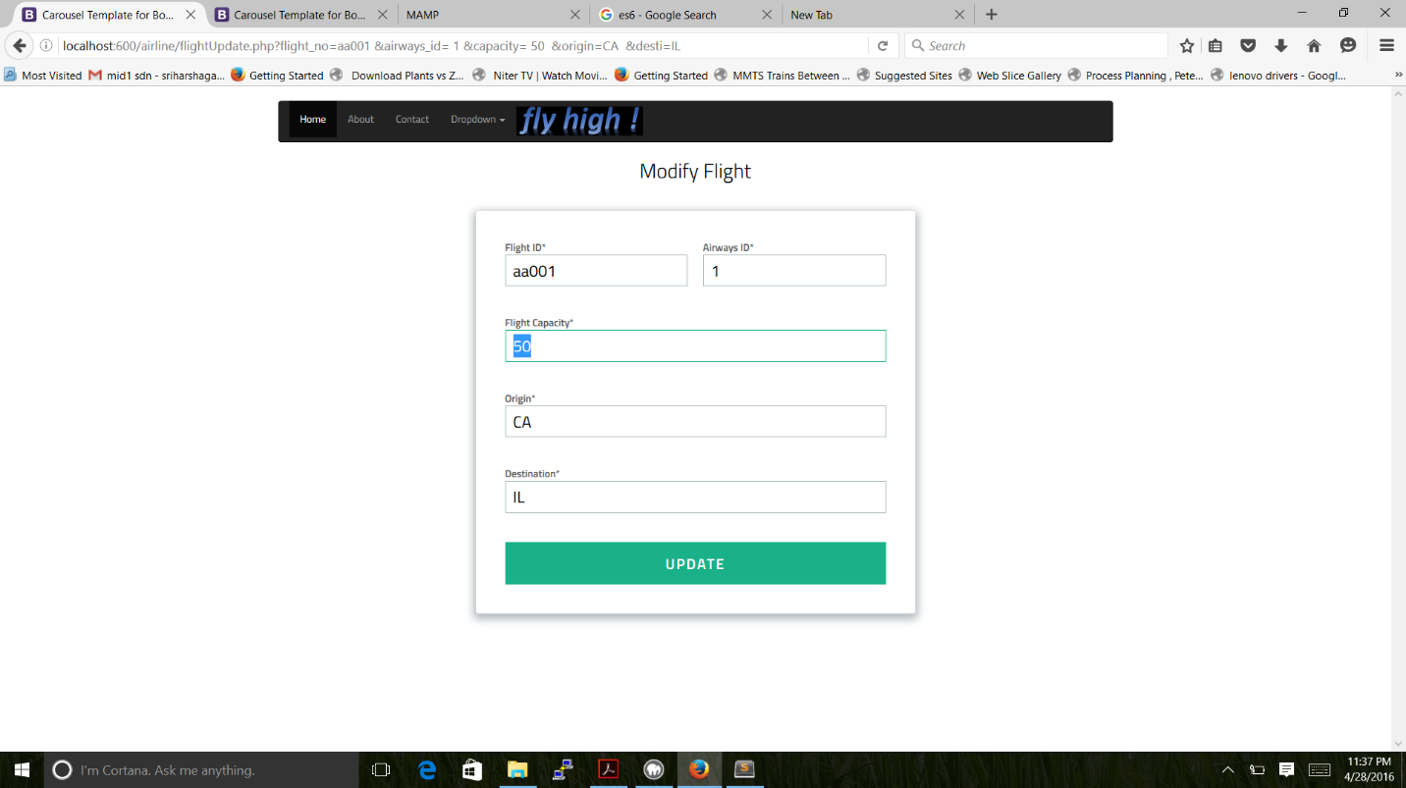

**VIEW/MODIFY/DELETE FLIGHTS**

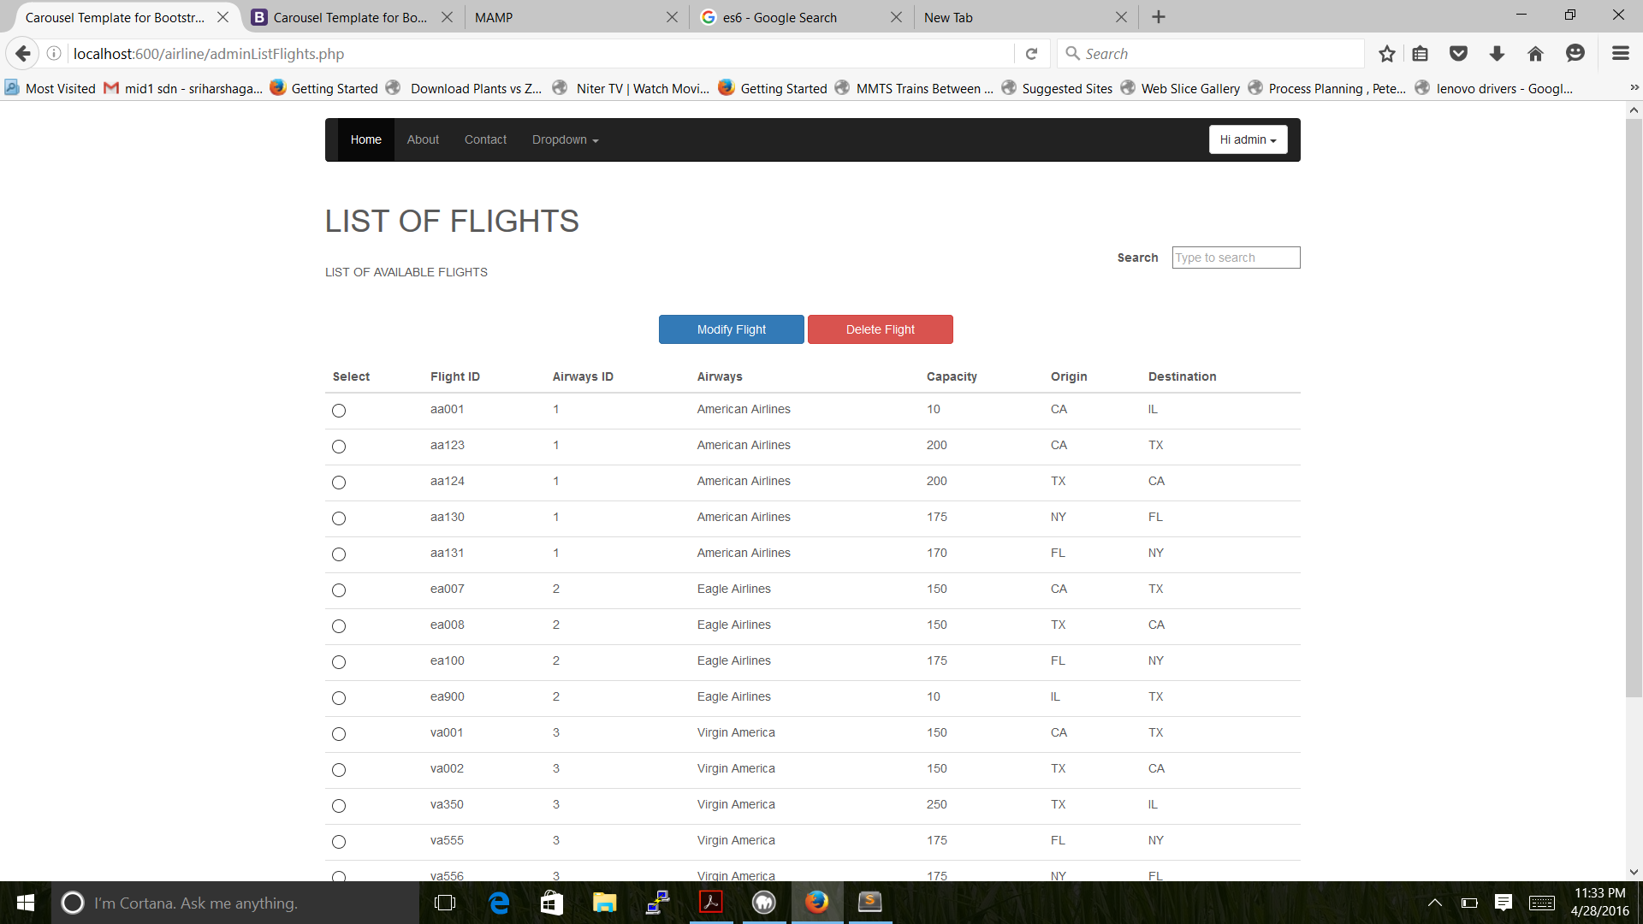

**ADMIN LIST OF ALL FLIGHTS**

