Question 1
Architecture Specification

Author: | Jeff Gan Jianfeng | Approver:

___________________________
In addition to the author(s) named on the cover sheet the following persons have collaborated on this document:
Copyright © 2016 Jeff Gan.

Table of contents
1 Introduction 5
Architecturally Significant Requirements 7
1.1 Key use cases 7
1.2 Quality requirements and constraints 7
1.3 Context Model 8
2 Analysis View <<Optional>> 8
3 Patterns and styles <<optional>> 9
4 Decomposition View 9
4.1 Decomposition Model 9
5 Dependency View 9
6 Behavioral View 9
7 Execution View <<Optional>> 9
7.1 Process view 9
7.1.1 Process model 9
7.1.2 Component to process 10
7.2 Deployment Model 11
7.2.1 Overview 11
8 Terms and Abbreviations 12
9 References 12
10 Revision history 13

Introduction
Requirement:Process a file
The detail requirement No. is the following
Req_No_1. The path to the file is to be passed to the program as a parameter. The file contains zero to more lines. Each line contains zero or more float numbers being separated by one or more space characters.
Req_No_2. The output of the program is the total count of numbers and the sum of all numbers.

This document specifies the SW architecture of the requirement: process a file . Separate system component SW architecture documents specifying the internal architecture of each system component
See other separate design document if necessary.

The following table summarizes the sections in this document and their purpose.
Section | Concern | Questions that the section answers
Key use cases | Functionality | What are the major actors that have direct interaction with the element?  What are their main goals concerning the interaction?  What are the main functional requirements for the element?  Which quality requirements affect each use case?
Quality requirements | Traceability  Breakdown of quality characteristics | What specific quality requirement should be satisfied by the element that is described in this SAS?
Context | Integration  Interoperability | What is the larger context in which the system belongs to?  What interfaces the element provides and what it requires?  Are some elements or interfaces optional?
Decomposition | Modifiability  Work division | What software modules belong to the element?  Who are responsible for these elements?
Dependency | Modifiability | What are dependencies among SW modules?  Should some of the elements be reusable independently?  What kind of future changes can be facilitated?
Responsibilities | Modifiability  Distribution of the functionality and data | How the system elements collaborate to provide the overall functionality?  What quality characteristics are attached to the operation of the system elements?  What data / information the system element holds and how it relates to the functionality of the element?
Behavior | Functionality  (Any concern that attaches to the functionality) | How the elements services are realized by the collaborations of its sub elements?  Verification that the responsibility of division is correct.
Process | Performance  Reliability  Runtime upgrade  Start-up  Restart and Recovery | What processes the element has?  How the processes are mapped to the software modules?  How the processes communicate?
Deployment | Distribution of SW  How the SW and HW interoperate | How the SW elements are deployed to the HW nodes?  What is the HW configuration of the system?
Open issues(To be done):
1. Generalize the function
2. Configuration-based development
3. More exceptions considerations
4. Log input is variable, such as print, current solution is fixed
5. Log level can be adapted in an intelligent way

Architecturally Significant Requirements
This chapter captures the architecturally significant requirements (ASR) on the systems to be built. These are major inputs into determining and evaluating the architecture under construction. There are two major requirement categories:
- Key Use Cases: the requirements that express the main functionality of the system
- Quality Requirements: the quality attributes that guide the creation of the software architecture

Key use cases
This section describes the key use cases of this architectural element. The purpose of identifying the key use cases is to find out the main functionality of the architectural element within the system context. Concentrating our efforts on the key requirements focuses the development.
- Parse the file path and name
- Handle the file content

Quality requirements and constraints
Quality Requirements:
1. Feature availability should be more than 99.995% basing on the working time
2. Anything wrong should report to the related team.
Context view

Context Model
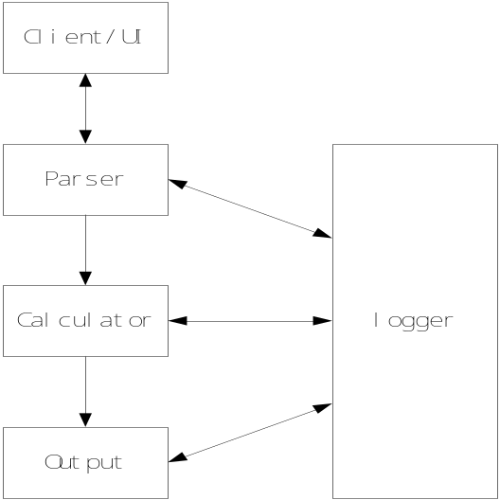
Figure 1 Question one SW Context model
Please note that this is a simplified figure that concentrates on the relationship of the SW component, the others are omitted.

Analysis View <<Optional>>
For the feature is not complex, the step will be ignored.
The following is one of the key points, the others were omitted
Parse the number including float and int using the RegExp:
([-+]?\d+(\.\d*)?|\.\d+)([eE][-+]?\d+)?

Patterns and styles <<optional>>
The Pattern for this feature, we use the SOA(Service-Oriented Architecture), each SW module(such as logger, parser…..), we consider them as a separate service and offer the service to the other SW component in a separate way.
For the coding guide, basing on the real status of the company, please refer to the following link from google:
https://google.github.io/styleguide/pyguide.html

Decomposition View

Decomposition Model
The decomposition shows how the element is composed of its parts. The decomposition describes the structure of the code architecture.
For the SW component is not complex, we did not separate the SW component in more detail layers, we consider the current SW component in the figure 1 is the last SW component.
SW component | Description | Functions
Parser | Path and File name parsing | Path and File name from UI will be parsed
Logger | Handling log | Writing the log and store the log
Calculator | Handler the number | Per the requirement, calculating the numbers in the files
Output | Handler the output | The output will be handled and showed to the users from the UI and log
Client/UI | User Interface | Console used by the users
Table 1 Software Component

Dependency View
Currently, no special dependency for the featrure.

Behavioral View

Execution View <<Optional>>

Process view

Process model
Working environment
- OS is Linux
- Python Ver: 2.7.3

Component to process
The SW component interaction diagram was showed in the following.
To simplify the procedure, on the other hand, the procedure did not confuse the readers, so the detail procedure was not written again, ignored.
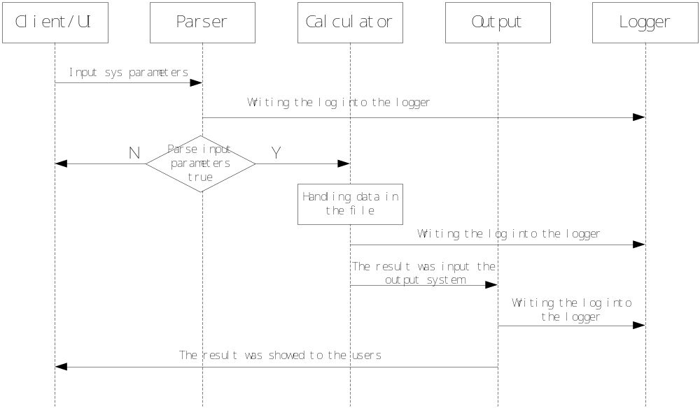

Deployment Model

Overview
In the real working conditions, we should consider the deployment from availability view in a very high level, for this feature, we should consider deploy the different SW component in separated server to avoid the interaction when some SW component did not working well.
For this feature, the deployment scenario is not clear, so we ignored the step in this phase for the time being, when the requirement is clear, we will implement it again.

Terms and Abbreviations
Term | Description
OS | Operation System

References

Identifier | Information

Revision history
Version | Date | Modified by | Status | Accepted by | Main changes
V0.0.1 | 2016.03.19 | Jeff Gan Jianfeng | Review ongoing |  | Create for the feature

