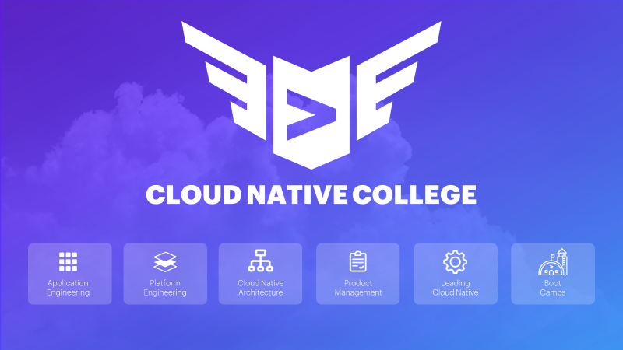

**Cloud Native College – School of Application Engineering  
FrontEnd (Associates)**

**About this Course**

The FrontEnd Associates program is a curated set of courses from Pluralsight for students interested in learning the basics of modern web development. Students start with the fundamentals before moving on to Angular.

**Modern Web Fundamentals:**

Hit the ground running with the basics of client-side web development and learn to build web pages with HTML, Cascading Style Sheets, JavaScript, and jQuery. Start making changes to your web pages using Query, AJAX, Command Line, and Node.js. Dive deeper into advanced JavaScript concepts and design patterns. Also, by the end of Fundamentals, you’ll have a foundational knowledge of one of the latest web language features, ES6, and you'll learn to create a modern, responsive website using Bootstrap 3.

**Modern Web Angular:**

Get ready to create highly interactive client-side web and hybrid/mobile applications using the leading-edge JavaScript framework—Angular. Angular is one of the fastest, most popular open source web app frameworks today, and knowing how to use it is essential for developers. You'll learn how to create components and user interfaces, data-binding, retrieving data using HTTP, and more. TypeScript is the recommended language for developing Angular 2 applications and works great with other frameworks and libraries like React and jQuery. Get started quickly learning the latest version of Angular (Angular 2+). You'll be introduced to Angular core concepts, then discover best practices for setting up Angular apps with its CLI, and finally, begin to explore Angular features like forms. Once you have the basics down, you will dig deeper into Angular’s foundations. This course will help you better understand Angular as a whole, as well as taking a closer look at routing and different form approaches.

**Virtual Instructor Led (VILT) or online self-paced**

Students will have the choice of taking virtual instructor-led courses (depending on schedule) or self-paced versions via PluralSight. The VILT courses (Fundamentals and Angular) are each 1 week long and will require 100% participation during the working day. It’s recommended for students on the bench to take the VILT courses. Please [check here](https://in.accenture.com/frontendengineeringarchdev/train/full-stack-academy/) for class schedule.

The online self-paced courses were created for students on projects that can’t take a week off and need to study offline.

Please note that you will need to take PluralSight assessments and obtain minimum scores in order to receive college certification and credit. See below for additional information

**To complete this course, you will need to have already acquired access to Pluralsight.**

**If you are part of Accenture Technology Centers in India, here is the Pluralsight Nomination Link** - [**LKMSurveys - Digital Learning Nominations (accenture.com)**](https://ts.accenture.com/sites/LKMTools/LKMSurveys/SitePages/Digital%20Learning%20Nominations.aspx)

**If you are a non-ATCi employee, please use this link to get access to Pluralsight -**  [**Pluralsight Full Library Plan: Get Access (FY21) Global**](https://mylearning.accenture.com/accenture/lang-en/management/LMS_ActDetails.asp?ActivityId=1757816&UserMode=0)**.**

Your registration request will go to your training approver for approval. If you need to expedite your approval request, you can follow up directly with your training approver listed under the Career Support section of [**My Info**](https://portal.accenture.com/#/myinfo) in the Accenture Portal.

Update the [new IT tracker](https://ts.accenture.com/sites/TECH.NA.ATA/NEWIT/Lists/NEW%20IT%20Enhancement%20Learning%20Tracker/Default%20View.aspx) with your personal details and chosen cloud native specialization

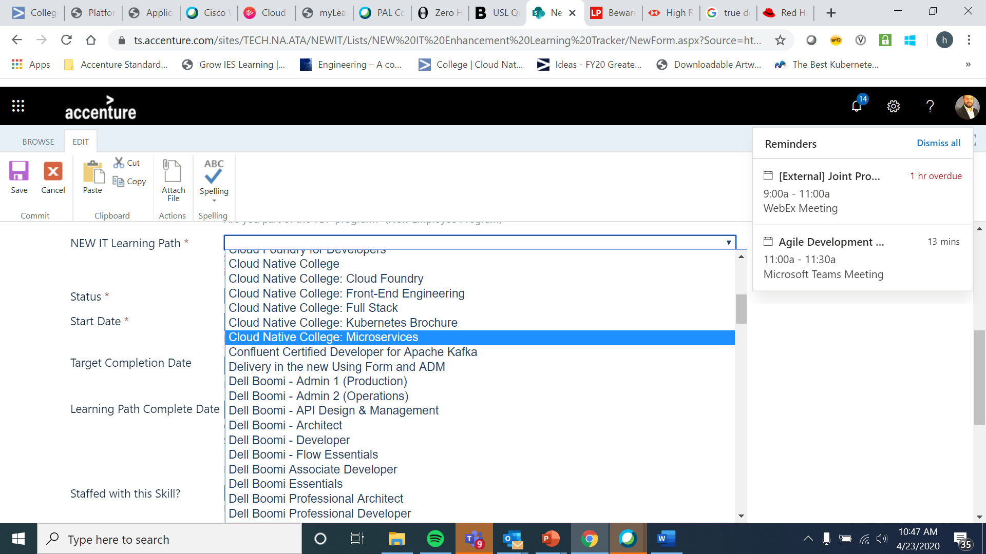

**\*\*Please note that you can exchange Angular for React in the Associates path and still receive credit for certification. We just require that you complete one of them for Associates certification. You will need to complete both to receive a Practitioner certification**

Students who already have web fundamentals (HTML, javascript, CSS) can test out by taking the plural sight skills assessment and score at least 150+ points. See the below section on Assessments.

**Course Entry Criteria**

**Modern Web Fundamentals:**

**Required Knowledge and Experience:**

* Beginner – no requirements

**Curriculum (Pluralsight - channels)**

* HTML 5 (27 hours 22min)
* JavaScript (21 hours 26min)
* CSS (10 hours 48min)

**Modern Web Angular**

**Required Knowledge and Experience:**

* JavaScript - basic knowledge (1 yr. experience)
* Object Oriented Programming - concept knowledge
* Completed MW Fundamentals, or in lieu of taking the course, completed and received a score of proficient (150) on the following Skill IQ Assessments:
* [Building Websites with HTML, CSS, and JavaScript](https://app.pluralsight.com/score/skill-assessment/html-css-javascript/intro#/v2/landing)

**Curriculum (Pluralsight - channels)**

* Angular (52 hours 28min)

**Course Access & Instructions**

* 1. Send an email to [johanna.dela.cruz@accenture.com](mailto:johanna.dela.cruz@accenture.com) stating your intent to enroll in cloud native college for MicroServices associates
  2. Obtain your PluralSight License
  3. Decide if you want to take the Virtual Instructor Led (check schedules) or self-paced version. You can select a mix of VILT and Self-Paced if you like, it doesn’t have to be one or the other, so long as you complete both MWA Fundamentals and MWA Angular. It’s highly recommended to take the VILT versions if you are on the bench (check schedules):
     + Register for ([VILT Fundamentals](https://mylearning.accenture.com/mylearningui/learner/coursedetail/1471624) or [VILT Angular](https://mylearning.accenture.com/mylearningui/learner/coursedetail/1471585)) or
     + Register for the self-paced - [Fundamentals](https://mylearning.accenture.com/mylearningui/learner/coursedetail/1549211) or [Angular](https://mylearning.accenture.com/mylearningui/learner/coursedetail/1549212)
  4. Wait for course approval and start the courses

**Steps for taking the Self-Paced online versions**

1. Launch [Pluralsight](https://www.pluralsight.com/) and login via “sign in with company or school” option

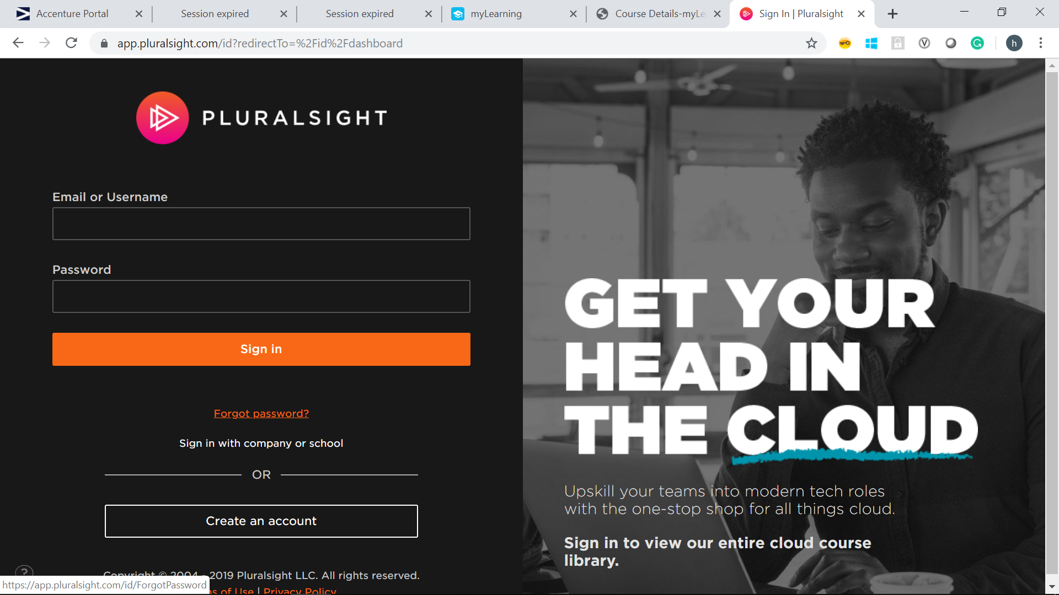

1. User login will be accenture.com (make sure one of your browser tabs is logged in to the Accenture portal for federation)

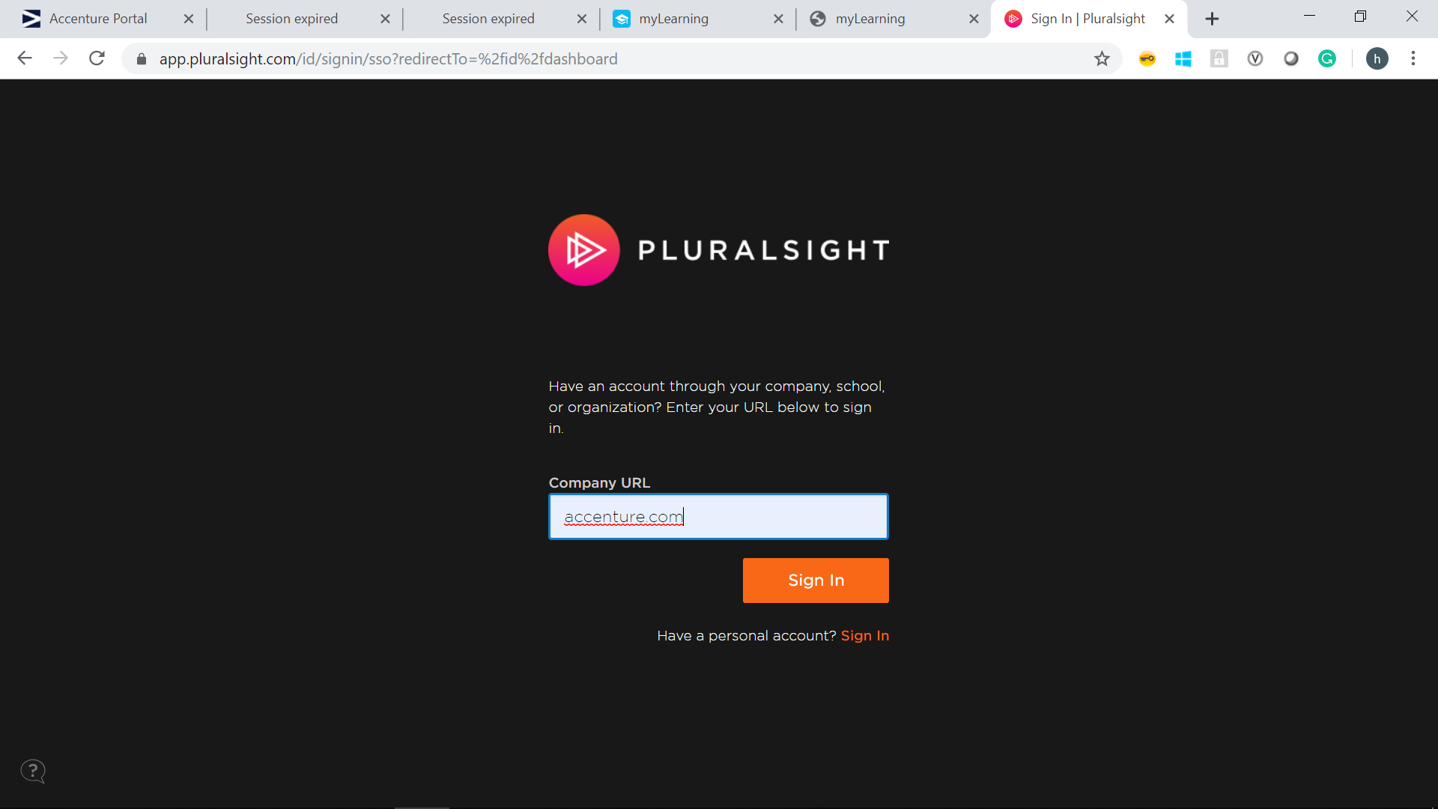

1. Go to the channels (top right) and then select company channels

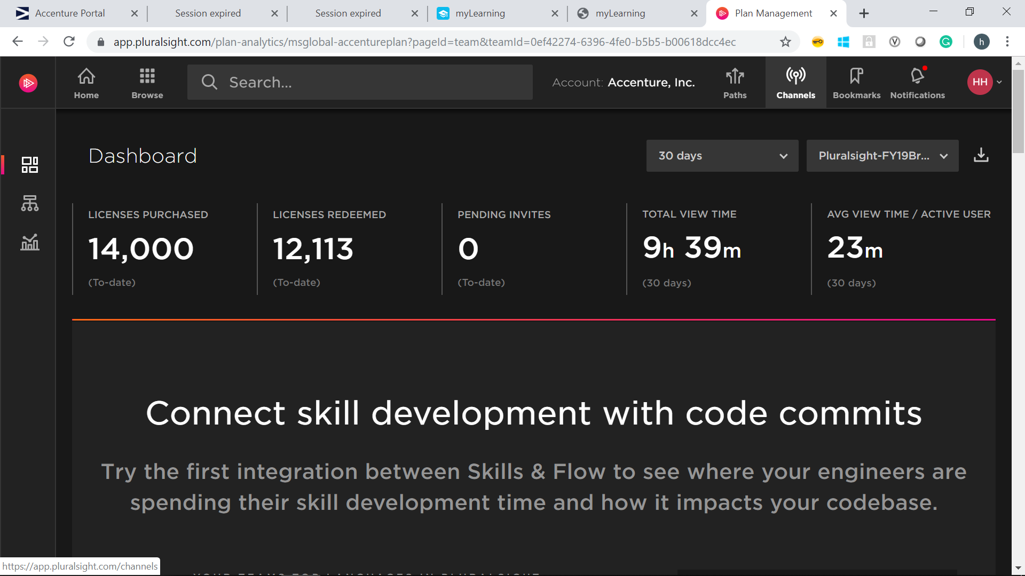

1. Launch the cloud native channel – FrontEnd associates and start learning

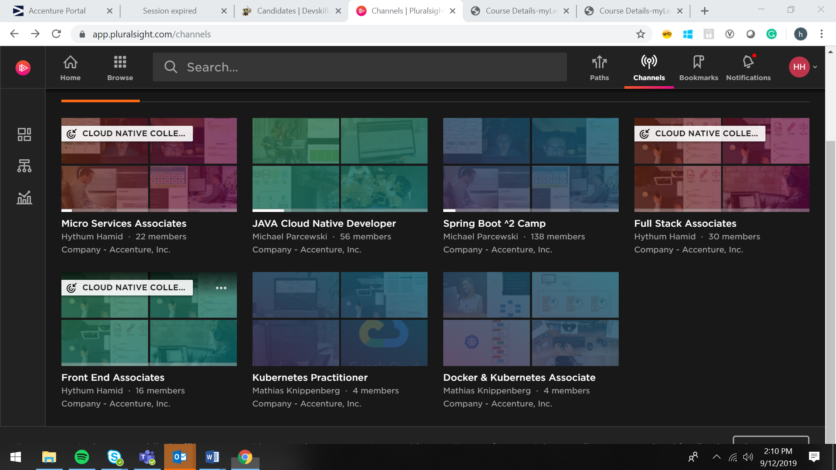

Note: The PS channel contains all the modules (MWA fundamentals and MWA Angular) you can skip over the module that you took as virtual instructor led courses. As stated above, you can mix-and-match Virtual Instructor Led courses with online self-paced versions.

**Assessments**

Students must complete the below PluralSight assessments in order to receive the FrontEnd Associates degree. Please note that you only have 2 attempts to obtain the required minimum score. Pluralsight will lock you out after two attempts.

It’s highly advisable that you complete the course material before attempting the assessments in order to better your chances for success.

Please send a screenshot of your profile summary that will include your skills assessment scores at the bottom of the page. We need to see the browser URL and your assessment scores all in the same frame.

Step 1. You can access your profile by clicking on your user in the top right hand: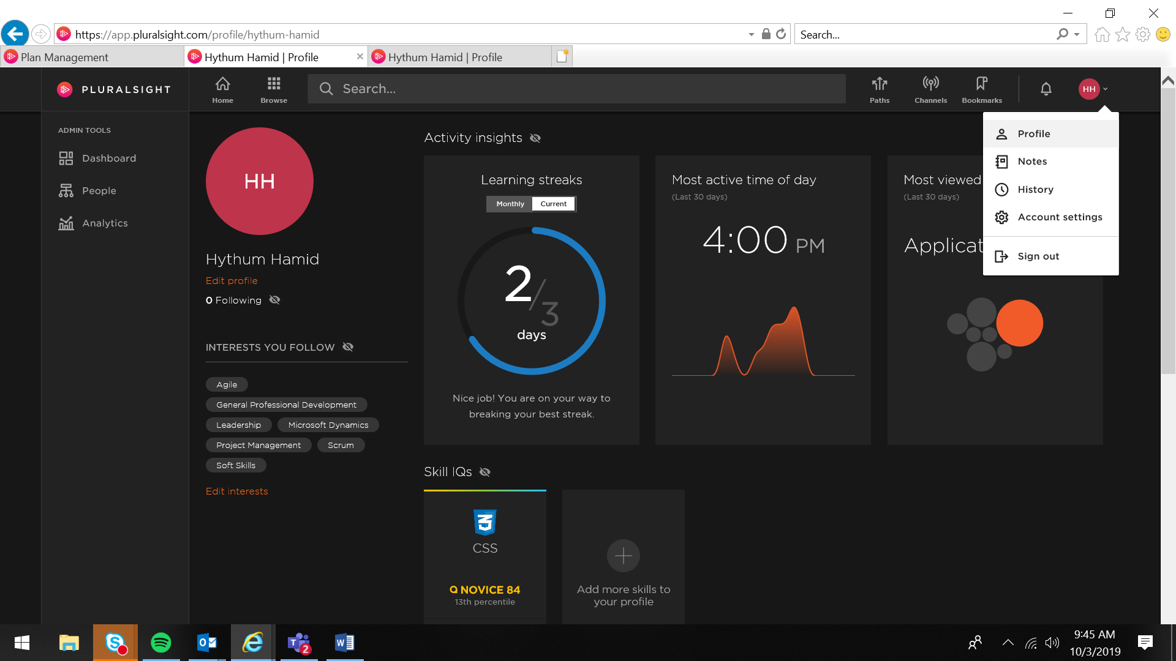

Step 2. Send screen shot of your profile with assessment score to of your plural sight assessment scores to [johanna.dela.cruz@accenture.com](mailto:johanna.dela.cruz@accenture.com) to receive college credit and badge.

Example screen shot:

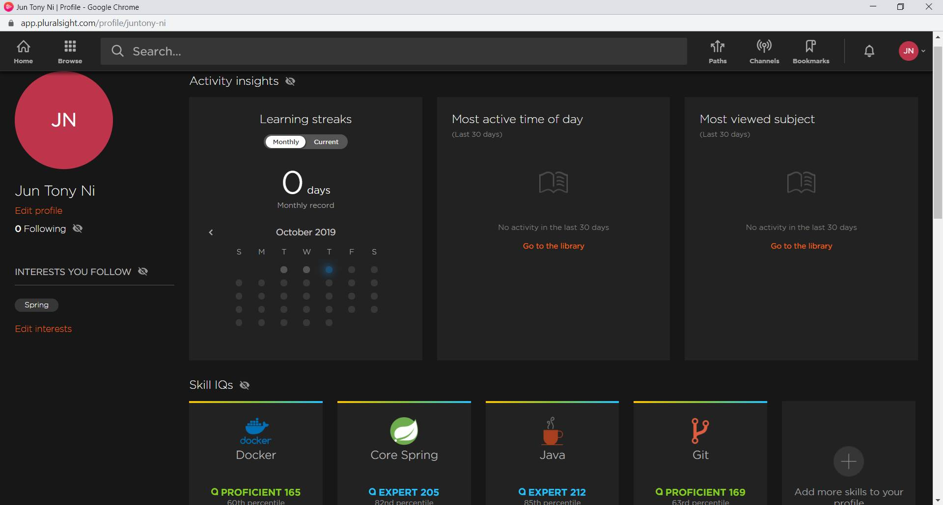

**Assessment Requirements**

|  |  |  |
| --- | --- | --- |
| **Topic** | **Min Score** | **Link (Pluralsight access is required)** |
| **HTML,**  **CSS,Javascript** | 150 | [Building websites with html,css,javascript](https://app.pluralsight.com/score/skill-assessment/html-css-javascript/intro#/v2/landing) |
| **Angular or** | 150 | [Angular Assessment](https://app.pluralsight.com/score/skill-assessment/angular/intro?context=paths&path_type=skill&path_url=angular#/v2/landing) |
| **React** | 150 | [React Assessment](https://app.pluralsight.com/score/skill-assessment/react/intro?context=channels#/v2/landing) |

**Don’t forget to complete the myLearning courses after passing the assessments above. This ensures you receive myLearning credit for the college**.

Feel free to email [hythum.hamid@accenture.com](mailto:hythum.hamid@accenture.com) with any questions you may have