Jake Bailey
AME 559
HW 4 – 11/13/2018

In Search of a Research Project

The sub-problem of astrodynamics that I’ve chosen for this research project is the restricted 3 body problem. Specifically, I’ll be looking at the Sun-Earth-Spacecraft system, and comparing the performance of different formulations of the dynamics under close encounter situations.
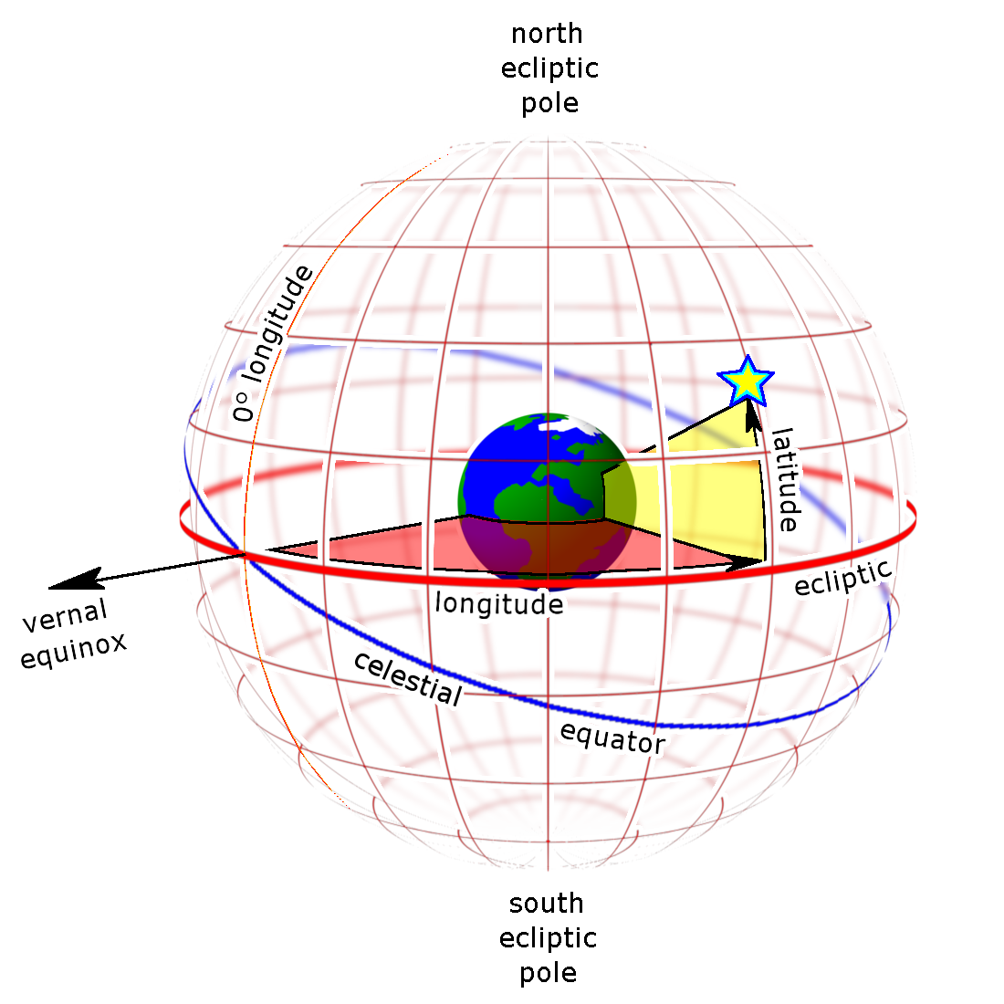
Fig 1: Illustration of the Heliocentric-Ecliptic Coordinate System (Wikimedia Commons)

To start, we investigate the dynamics in the Cowell formulation, where numerical integration is performed directly on the Cartesian position and velocity vectors of the bodies. The coordinate frame used here is the Heliocentric-Ecliptic: origin at the sun’s center, primary axis along the vernal equinox, fundamental plane the Earth’s ecliptic. Additionally, we take the coordinates to be along the three orthogonal axes (rectilinear rather than spherical), and the units of distance to be Earth equatorial radii. This was chosen as a compromise on dynamic range/numerical precision between the Earth’s orbit and the spacecraft’s. Units of time were chosen as seconds, although this was for convenience rather than performance.
We start treatment of the dynamics with the Lagrangian. Ignoring the sun’s dynamics, as it’s the center of our chosen coordinate system, we take the kinetic and potential and kinetic energies of our two remaining bodies as:

This leads us to the corresponding Lagrangian, and – via Euler’s equation – the equations of motion for the two orbiting bodies:

After dropping the final term in the second EOM (an approximation due to the significant differences in magnitude between the accelerations caused on the Earth by the sun and the spacecraft), we arrive at the Hamiltonian of the system via Hamilton’s equations:

Since the Hamiltonian is autonomous and involves no high order functions of the generalized coordinates or momenta, we expect this to be an integral of the motion. Implementing this system in a Python numerical integration scheme, using an adaptive 4th-5th order Runge-Kutta-Fehlberg solver courtesy of Peter Monk of FSU (https://people.sc.fsu.edu/~jburkardt/py_src/rkf45/rkf45.html), we arrive at the system trajectory shown in figure 2 for a propagation time of just over 1 Earth year.

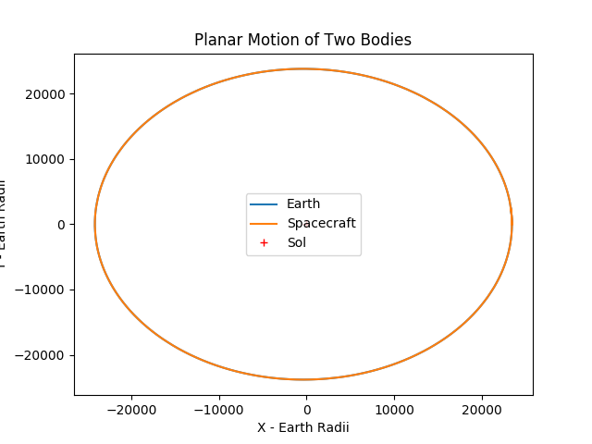
Figure 2: Planar system trajectories over 1 Earth year.

To obtain this trajectory, the system was initialized as follows. Earth began at its average orbital distance along (1 AU), directly along the vernal equinox, with its average orbital velocity (roughly 30 km/s) directly along the inertial y axis. The spacecraft was initialized to a circular low-Earth orbit, approximately 330 km above the Earth’s surface (also in the direction of the positive x axis), with an orbital speed of 7.7 km/s. To show the physical feasibility of the results, we show in figure 3 that the Hamiltonian of the system was indeed conserved, to within the expected error of a 4th order integrator (relative error 4.5*10⁻¹³) .

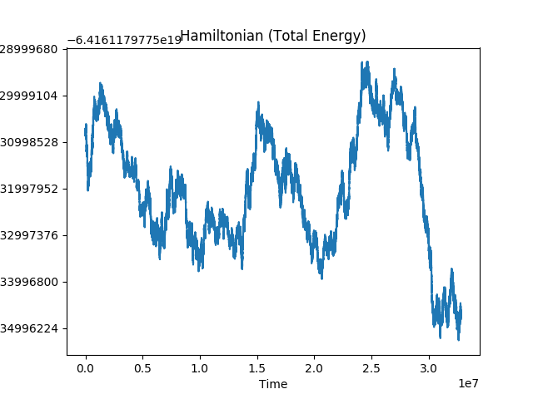
Figure 3: Hamiltonian of the 3 body system over 1 Earth year.

