ANDREW GARRETT SAIKO

MAE 593G: GLOBAL POSITIONING SYSTEMS

DR. JASON GROSS

HOMEWORK #2

10/07/2014

# Problem #1

### DataSet3

Looking at Problem #1, the goal was to model the Tropospheric delay effects and show the improvements in position estimation. While the effects in the East and North positions were relatively small, the Up position gained around 10 meters of accuracy. Ironically, even though it was only an improvement of about 2.5 meters, the North position had the biggest % of accuracy gain. Figure 1 below shows a plot of the beforehand position error for each direction, as well as the position error after adding the tropospheric effects.

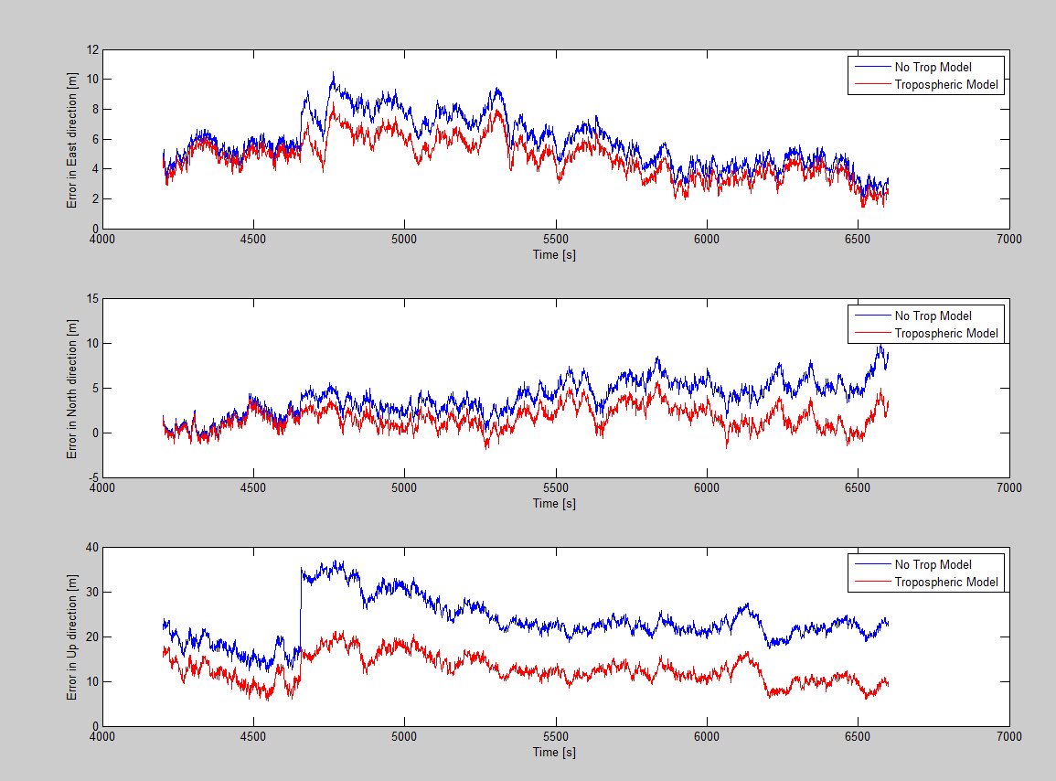

## Figure 1: Modeled vs. Unmodeled Tropospheric Effects in ENU vs. Time

## Table 1: Comparison of Error with and with Tropospheric Delay Model

|  |  |  |  |
| --- | --- | --- | --- |
| **Average Error [m]** | | | |
|  | Without Tropospheric Model | With Tropospheric Model | % Accuracy Increase |
| East | 5.809 | 4.709 | 18.94% |
| North | 3.904 | 1.567 | 59.86% |
| Up | 23.288 | 12.574 | 46.00% |
| Clock | 25.016 | 12.797 | 48.84% |

Table 1 above shows the average error of the East, North, and Up positions both before and after the tropospheric delay was modeled. The clock bias was also shown in Table 1, showing around a 50% improvement after the delay was modeled. Figure 2 below shows the clock error over time, comparing the modeled error to the unmodeled error. The vertical spike in the unmodeled clock error is due to a satellite falling out of signal.

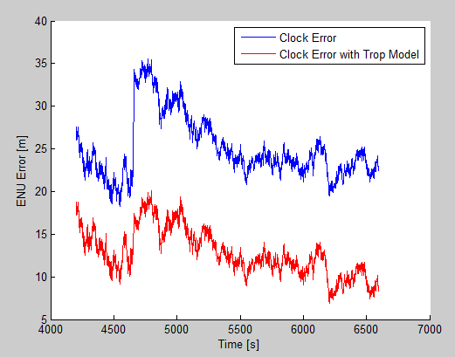

## Figure 2: Modeled vs. Unmodeled Tropospheric Effects for Clock Error vs. Time

## Table 2: Comparing Models for RMS Errors in ENU

|  |  |  |  |
| --- | --- | --- | --- |
| **RMS Error in ENU[m]** | | | |
|  | Without Tropospheric Model | With Tropospheric Model | % Accuracy Increase |
| East | 6.048 | 4.893 | 19.10% |
| North | 4.355 | 2.030 | 53.38% |
| Up | 23.816 | 12.948 | 45.63% |

Table 2 shows the Root Mean Square errors for the East, North, and Up positions. The Up position had the biggest gain, but the North position had the biggest accuracy increase. Table 3 below shows the Root Mean Square errors for the 3D positioning and the clock bias. They were both significantly reduced due to the tropospheric delay model.

## Table 3: Comparing Models for Clock and 3D RMS Errors

|  |  |  |  |
| --- | --- | --- | --- |
| **Clock and 3D RMS Error [m]** | | | |
|  | Without Tropospheric Model | With Tropospheric Model | % Accuracy Increase |
| Clock | 25.284 | 13.084 | 48.25% |
| 3D | 24.955 | 13.990 | 43.94% |

### DataSet4

Looking at Problem #2, the goal (again) was to model the Tropospheric delay effects and show the improvements in position estimation. While the effects in the East and North positions were relatively small, the Up position gained around 15 meters of accuracy. Ironically, the North position for this data set had lost some accuracy. Figure 1 below shows a plot of the beforehand position error for each direction, as well as the position error after adding the tropospheric effects.

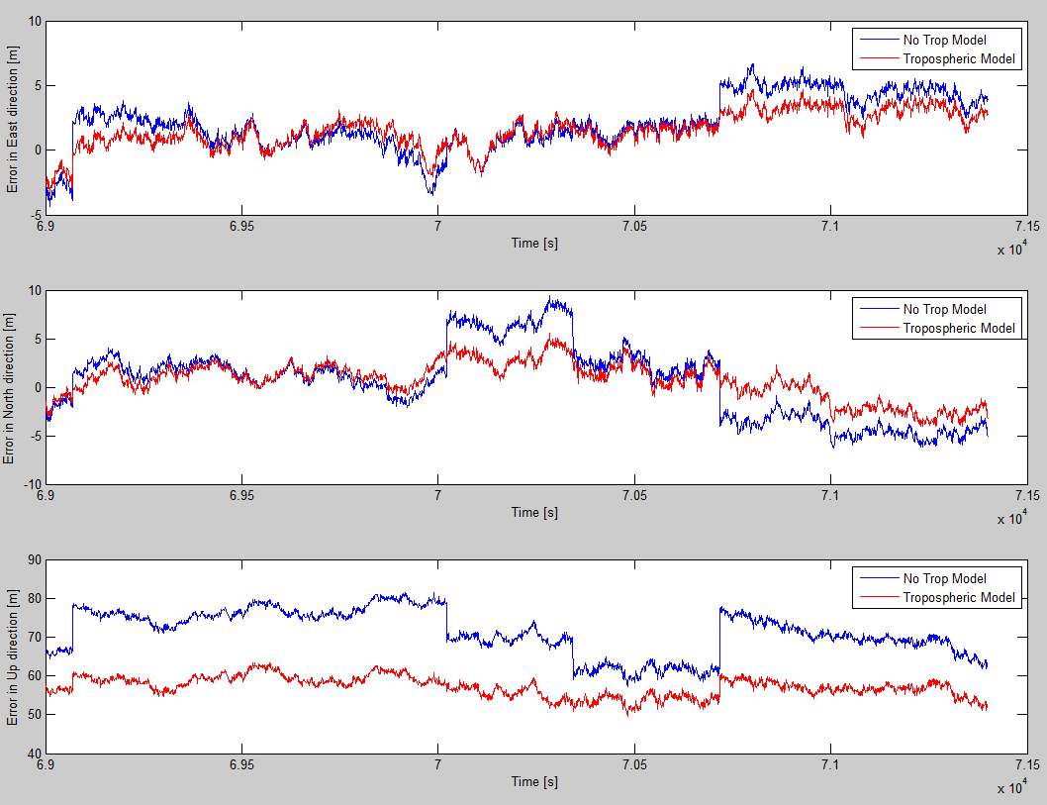

## Figure 3: Modeled vs. Unmodeled Tropospheric Effects in ENU vs. Time

## Table 4: Comparison of Error with and with Tropospheric Delay Model

|  |  |  |  |
| --- | --- | --- | --- |
| **Average Error [m]** | | | |
|  | Without Tropospheric Model | With Tropospheric Model | % Accuracy Increase |
| East | 2.053 | 1.529 | 25.50% |
| North | 0.558 | 0.668 | -19.69% |
| Up | 71.222 | 57.134 | 19.78% |
| Clock | 92.904 | 78.052 | 15.99% |

Table 4 above shows the average error of the East, North, and Up positions both before and after the tropospheric delay was modeled. The clock bias was also shown in Table 4, showing around a 15% improvement after the delay was modeled. Figure 4 below shows the clock error over time, comparing the modeled error to the unmodeled error. The vertical spikes in the unmodeled clock error are due to a satellite falling out of signal.

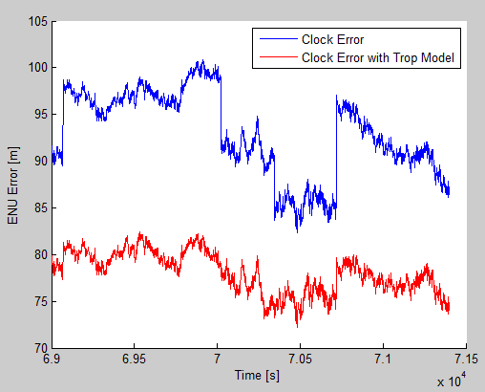

## Figure 4: Modeled vs. Unmodeled Tropospheric Effects for Clock Error vs. Time

## Table 5: Comparing Models for RMS Errors in ENU

|  |  |  |  |
| --- | --- | --- | --- |
| **RMS Error in ENU[m]** | | | |
|  | Without Tropospheric Model | With Tropospheric Model | % Accuracy Increase |
| East | 2.914 | 2.053 | 29.55% |
| North | 3.731 | 2.045 | 45.19% |
| Up | 71.453 | 57.191 | 19.96% |

Table 5 above shows the Root Mean Square errors for the East, North, and Up positions. The Up position had the biggest gain of almost 15m, but the North position had the biggest accuracy increase. Table 6 below shows the Root Mean Square errors for the 3D positioning and the clock bias. They were both significantly reduced due to the tropospheric delay model.

## Table 6: Comparing Models for Clock and 3D RMS Errors

|  |  |  |  |
| --- | --- | --- | --- |
| **Clock and 3D RMS Error [m]** | | | |
|  | Without Tropospheric Model | With Tropospheric Model | % Accuracy Increase |
| Clock | 93.015 | 78.082 | 16.06% |
| 3D | 71.610 | 57.265 | 20.03% |

# Problem 2