**MAE 593**

Homework 2

Ryan Watson

Table of Contents

Problem 1 1

Data Set 3: 2

Data Set 4: 3

Problem 2 5

Klobuchar Model 6

Data Set 3: 6

Data Set 4: 7

Ionosphere Free Combination 8

Data set 3: 9

Data Set 4 10

Questions 11

Appendix 13

# Problem 1

This homework is concerned with the impact that modeling the ionosphere and tropospheric delays can have on the Linear Least’s Squares (LLS) solution. For the first problem we are to model the tropospheric delay alone. There are several models that can be used to estimate the zenith tropospheric delay. For this homework we decided to use the Saastamoinen model.

As stated above, the Saastamoinen model is used to estimate the zenith tropospheric delay. This model can be decomposed into two segments: the wet delay and the dry delay. The equations for the two components of the delay can be seen below as Eq.1 and Eq.2. For this particular homework the constants used in Eq. 1 and Eq. 2 are shown in Table 1. To model the delays on individual signal paths the elevation dependent mapping function shown as Eq.3 was used.

= 0.002277(1+0.00266cos() + 0.0028H)

Eq. 1

= 0.002277(

Eq. 2

Table 1: Saastamoinen Model Values

|  |  |  |
| --- | --- | --- |
|  | Value | Units |
| Temperature | 288.15 | Kelvin |
| Total Pressure | 1013 | mBar |
| Partial Pressure | 12.8 | mBar |

**M(el) =**

Eq. 3

## Data Set 3:

Figure 1 is a comparison of the baseline approach (i.e. no atmospheric modeling) to the solution with the Saastamoinen tropospheric model for data set 3. As can be seen from the figure, the solution that models the troposphere has a smaller error. This smaller error is quantified in Table 2.

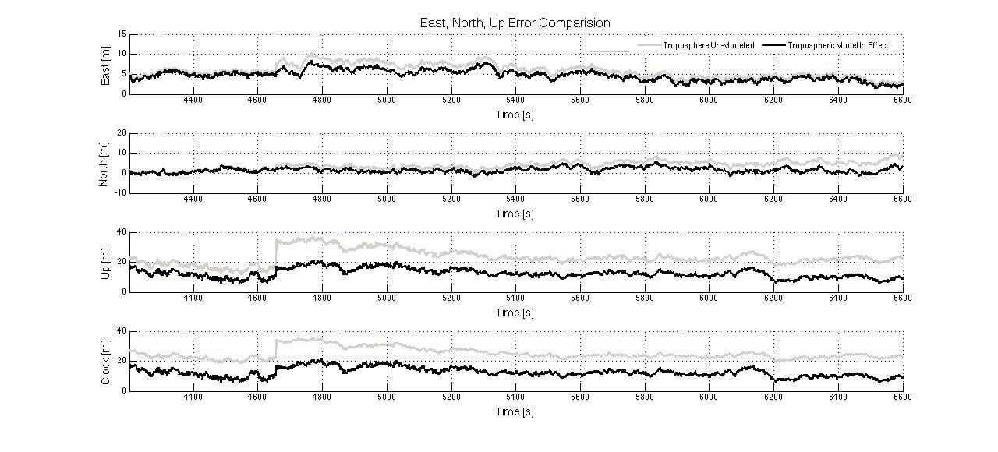

Figure 1: Tropospheric Solution vs. Non-Tropospheric Solution for Data Set 3

Table 2: Comparison of Tropospheric Solution vs. Non-Tropospheric Solution

|  |  |  |
| --- | --- | --- |
|  | Un-Modeled Troposphere  (m) | Modeled Troposphere  (m) |
| East | 6.1 | 4.9 |
| North | 4.4 | 2.0 |
| Up | 23.8 | 12.9 |
| Clock | 25.3 | 13.1 |
| 3-D | 24.9 | 14.0 |

## 

## Data Set 4:

Figure 2 and Table 3 are a comparison of the baseline approach (i.e. no atmospheric modeling) to the solution with the Saastamoinen tropospheric model for data set 4. Once again it can be seen that the solution with the modeled troposphere gives a position solution with a smaller error. This is most noticeable if looking at the error in the up direction. For this data set this is true because of the sudden fluctuations in the elevation angle of the individual satellites. The sudden fluctuations can be seen in Figure 3.

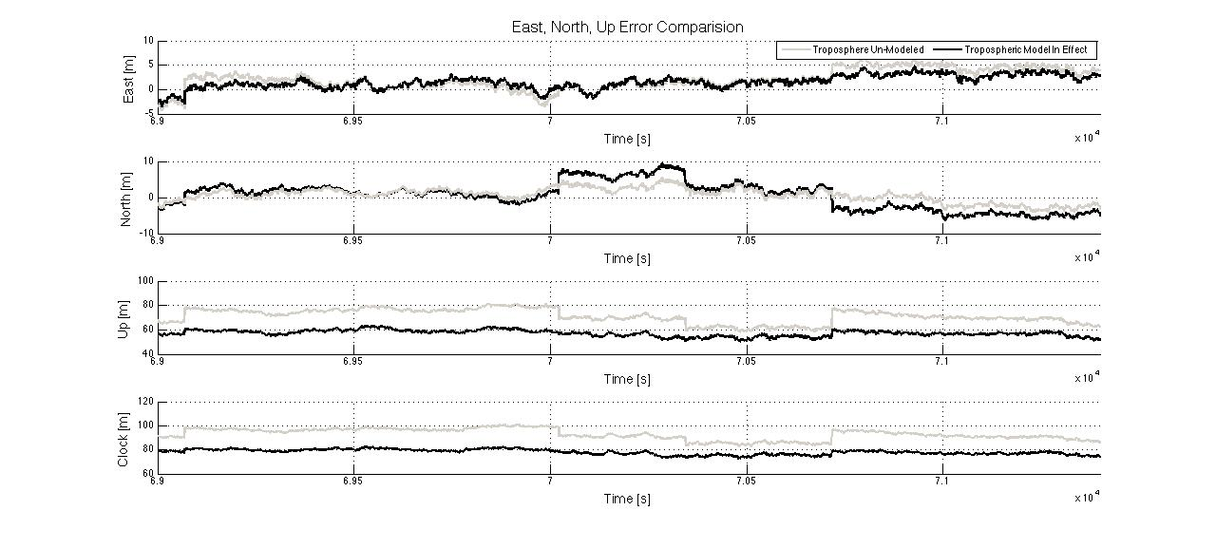

Figure 2: Tropospheric Solution vs. Non-Tropospheric Solution for Data Set 4

Table 3: Comparison of Tropospheric Solution vs. Non-Tropospheric Solution

|  |  |  |
| --- | --- | --- |
|  | Un-Modeled Troposphere  (m) | Modeled Troposphere  (m) |
| East | 2.9 | 2.1 |
| North | 3.7 | 2.1 |
| Up | 71.5 | 57.2 |
| Clock | 93.0 | 78.1 |
| 3-D | 71.6 | 57.3 |

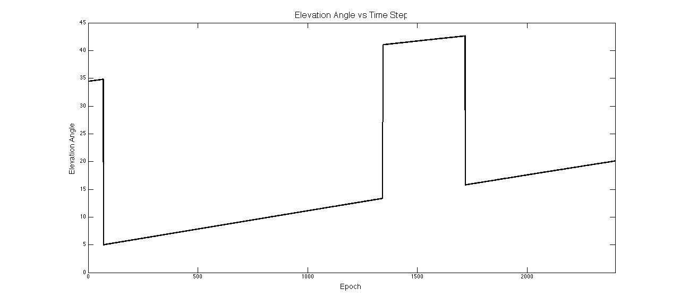

Figure 3: Elevation Angle vs. Time Step

# Problem 2

Problem 2 is concerned with modeling the ionosphere atmospheric delays. This is done in a similar way as the previous problem. By that, I mean, we first generate the zenith delay then we calculate the obliquity factor to map the delay onto each signal path.

There are several methods to calculate the Ionosphere Zenith Delay; however, for this problem we used the Klobuchar model (Broadcast Model). This model represents the zenith delay as a constant value at nighttime and a half-cosine function in daytime. The equation to calculate the Ionosphere delay can be seen as Eq. 4. The values for the constants in Eq.4 can be seen in Table 4. Finally, the equation to calculate the obliquity factor is shown as Eq. 5.

Eq.4

**=**

Eq. 5

**I() =**

Eq.6

Table 4: Klobuchar Model Constants

|  |  |
| --- | --- |
| Variable | Value |
|  | 5e-9 |
|  | 8.6599e-08 |
|  | 50400 |
|  | 100800 |

## Klobuchar Model

### Data Set 3:

Figure 4 is a comparison of the solution using only the troposphere model and the solution using the troposphere and the ionosphere model for data set 3. As can be seen in the figure, the effect on the East and North errors are fairly small; however, there is a noticeable improvement on the Up and Clock solution by modeling the ionosphere. The actually improvement on the solution is numerically represented in Table 5.

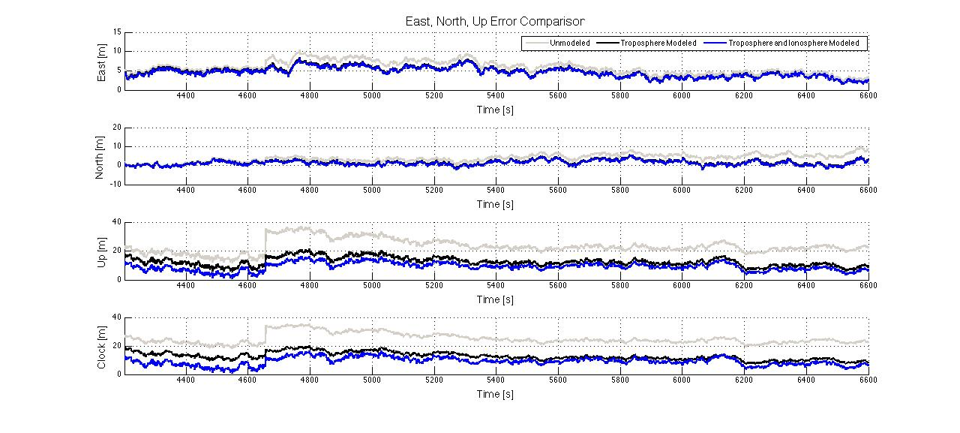

Figure 4: Tropospheric Effects vs. Tropospheric and Ionosphere Effects for Data Set 3

Table 5: Comparison of Tropospheric Solution vs. Tropospheric and Ionosphere

|  |  |  |
| --- | --- | --- |
|  | Modeled Troposphere  (m) | Modeled Ionosphere and Modeled Troposphere  (m) |
| East | 4.9 | 4.7 |
| North | 2.0 | 1.8 |
| Up | 12.9 | 9.5 |
| Clock | 13.1 | 7.1 |
| 3-D | 14.0 | 10.8 |

### Data Set 4:

Figure 5 is a comparison of the solution using only the troposphere model and the solution using the troposphere and the ionosphere model for data set 4. Looking at the plot it is hard to see the improvement made by modeling the ionosphere for data set 4. However, if you look at the 3-D RMS error in Table 6, it can be seen that modeling the ionosphere did reduce the error.

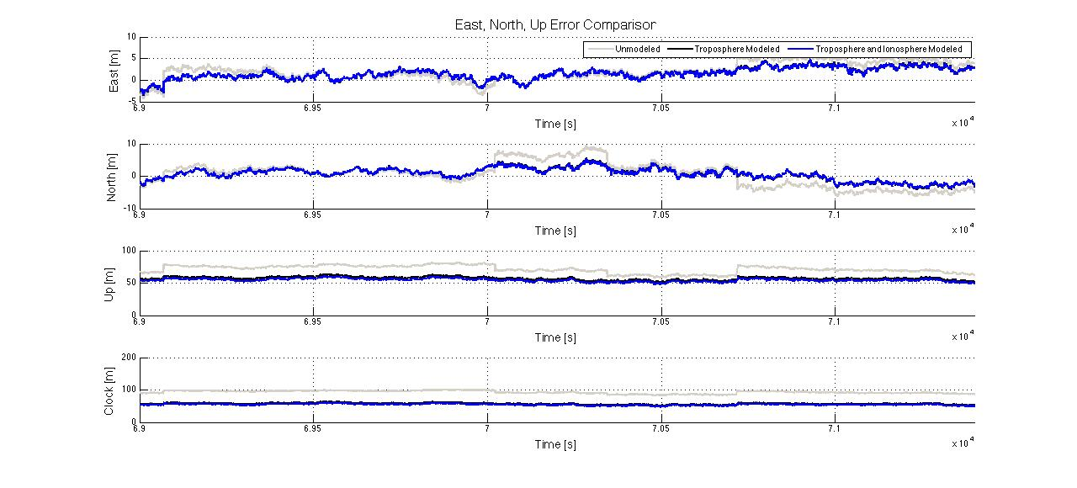

Figure 5: Tropospheric Effects vs. Tropospheric and Ionosphere Effects for Data Set 4

Table 6: Comparison of Tropospheric Solution vs. Tropospheric and Ionosphere

|  |  |  |
| --- | --- | --- |
|  | Modeled Troposphere  (m) | Modeled Ionosphere and Modeled Troposphere  (m) |
| East | 2.1 | 2.0 |
| North | 2.1 | 1.9 |
| Up | 57.2 | 54.5 |
| Clock | 78.1 | 73.7 |
| 3-D | 57.3 | 54.5 |

## Ionosphere Free Combination

This solution takes into account the dispersive nature of the ionosphere. Because the ionosphere delay is frequency dependent we can find a linear data combination that cancels the delay. This ionosphere free data combination is described by Eq. 7.

Eq. 7

The negative effect of using this data combination is that the noise attributed to the signals is magnified. The noise on the signal is magnified by a factor of which is roughly 3 times greater.

### Data set 3:

In the figure below, Figure 6, the RMS errors for the ionosphere free combination can be seen. If you look at the error in the north direction it can be seen that the signal is noisy. This is a consequence of the data combination.

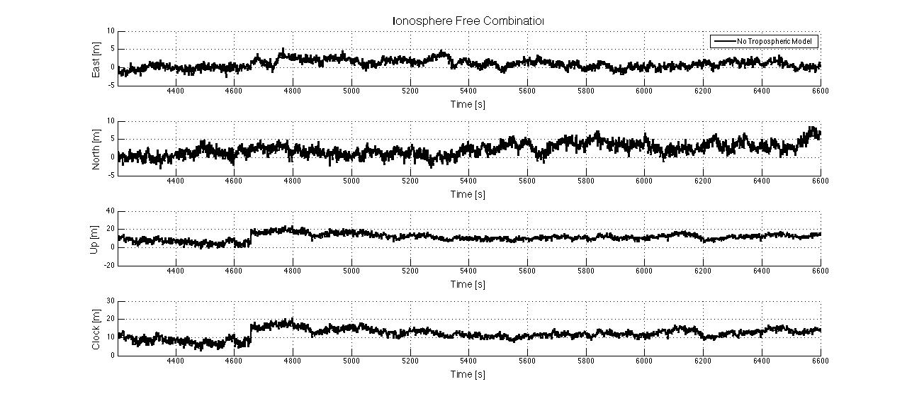

Figure 6: RMS Ionospheric Free Errors

Table 7:

|  |  |  |
| --- | --- | --- |
|  | Modeled Troposphere And Modeled Ionosphere  (m) | Ionosphere Free And Modeled Troposphere  (m) |
| East | 4.7 | 1.5 |
| North | 1.8 | 2.8 |
| Up | 9.5 | 11.9 |
| Clock | 7.1 | 12.3 |
| 3-D | 10.8 | 12.3 |

### Data Set 4

Figure 7 shows the ionospheric free combination for data set 4. By looking at Table 8 it can be seen that the ionospheric free combination reduced the 3D RMS error by 41.3 meters.

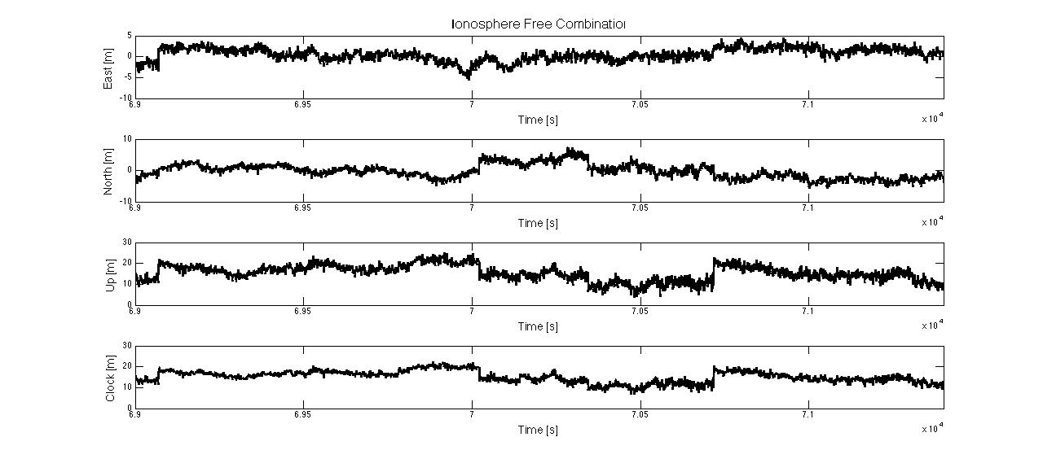

Figure 7: RMS Ionospheric Free Errors

Table 8:

|  |  |  |
| --- | --- | --- |
|  | Modeled Troposphere And Modeled Ionosphere  (m) | Ionosphere Free And Modeled Troposphere  (m) |
| East | 2.1 | 1.6 |
| North | 2.1 | 2.3 |
| Up | 57.2 | 15.8 |
| Clock | 78.1 | 15.4 |
| 3-D | 57.3 | 16.0 |

# Questions

1. *Which type of atmospheric delay (Trop or Iono) is more important to model for low elevation satellite data? Provide back-up to your response by referring to your error analysis plots and* ***also*** *your knowledge of the error source magnitudes and the obliquity factor functions used for each type of delay.*

From the analysis conducted to complete this homework it is believed that the troposphere is more important to model for low elevation satellites. One reason to believe this is because of the obliquity factor used for mapping the tropospheric delay. The troposphere obliquity factor places a much higher weight on the lower elevation satellites. Another reason to believe that the troposphere is more important to model for low elevation satellites can be seen by looking at the results of this analysis. By looking at Table 2 and Table 3 a dramatic reduction in the 3D RMS error due to tropospheric modeling can be seen.

Table 9: Elevation Angle vs Obliquity Factor for Troposphere

|  |  |
| --- | --- |
| Elevation Angle  ͦ | Obliquity Factor |
| 30 | 2 |
| 15 | 4 |
| 5 | 10 |

Table 10: Elevation Angle vs Obliquity Factor for Ionosphere

|  |  |
| --- | --- |
| Elevation Angle  ͦ | Obliquity Factor |
| 30 | 1.8 |
| 15 | 2.5 |
| 5 | 3 |

1. *What are the minimum and maximum TEC values assumed in the above provided Klobuchar model parameters?*

To find the minimum and maximum TEC value Eq. 8 was used. This equation relates the ionospheric delay to the frequency to find the total electron content. The only unknown on the RHS of the equation is the ionospheric delay.

*=*

*Eq. 8*

Table 11: TEC Values

|  |  |
| --- | --- |
|  | *TEC Value* |
| *Min* | *12.7\** |
| *Max* | *56.0\** |

1. *What is the primary difference between* ***dataSet3.m*** *and* ***dataSet4.m****? How did the difference between dataSet3 and dataSet4 impact the relative impact of the two different types of atmospheric delays? Provide back-up to your discussion in the form of comparing the difference (with plots and state) of the difference of L1 and L2 pseudorange measurements contained in each dataset. (e.g. plot(time, prDataL1-prDataL2) )*

The most noticeable difference between dataset3 and dataset4 is the sudden change of elevation angles in dataset4. This elevation angle fluctuation can be seen in Figure 3.

1. *When using pseudorange-only data is the dual frequency ionospheric-free data always better to use or is modeling sometimes better? Refer to your position and clock bias error analyses and also compare the standard deviation of the two different approaches position errors. Consider post-fit residuals as well. What applications might benefit from one approach over the other?*

The method to generate a solution is based upon what is being solved for. For instance, if you are solving for the users position it would be beneficial to use the ionospheric-free data; however, if you are an atmospheric scientist attempting to solve for the TEC value you have to model the atmosphere. Another reason to model the ionosphere over using the ionospheric-free data is the noise that the data combination induces on the signal. The ionospheric-free data combination increases the noise three-fold.

# Appendix