Ryan Watson

3 – Sept – 2014

Homework 3

Problem 1)

1. Statement of Problem

Derive the equation for drag force on a sphere using dimensional analysis.



1. Summary of Solution

To derive this equation, first all relevant parameters needed to be identified. The parameters that were in this analysis are drag force, velocity of medium, diameter or sphere, density of medium, and viscosity or medium. Once all parameters were identified the units of those parameters need to be identified. The units for each parameter can be seen in Table 1. Once all of the units for the parameters were identified, they were written out with exponents from A to E. This equation is shown below as equation 1.

$$M^{A+D+E} L^{A+B+C-3D-E} T^{-B-2A-E }=M^{0}L^{0}T^{0}$$

*Eq. 1*

Because there are 5 unknowns and only three equations the system cannot be solved uniquely. This means that I can select two variables as free variables and solve for the remaining three variables. For this analysis I selected A and E to be free variables. Doing this allowed me to solve for the two PI terms. The Pi terms can be seen below in equation 2.

${(\frac{Fd}{V^{2}D^{2 }ρ})}^{a}$ ${(\frac{μ}{VDρ})}^{E}$

*Eq. 2*

From Eq. 2 it can be easily seen how the drag force equation is derived. The full derivation can be seen in Appendix B.

Table 1: Units for Analysis of Drag Force



Problem 2)

1. Statement of Problem

Derive the equation for the velocity of a wave on the surface of water.



1. Summary of Solution

To derive this equation, first all relevant parameters needed to be identified. The parameters that were in this analysis are velocity of the wave, wavelength, density of medium, viscosity or medium, and the gravitational force. Once all parameters were identified the units of those parameters need to be identified. The units for each parameter can be seen in Table 2. Once all of the units for the parameters were identified, they were written out with exponents from A to E. This equation is shown below as equation 3.

$$M^{D+E} L^{A+B+C-3D-E} T^{-A-2C-E }=M^{0}L^{0}T^{0}$$

*Eq. 3*

Because there are 5 unknowns and only three equations the system cannot be solved uniquely. This means that I can select two variables as free variables and solve for the remaining three variables. For this analysis I selected A and E to be free variables. Doing this allowed me to solve for the two PI terms. The Pi terms can be seen below in equation 4.

${(\frac{V}{\sqrt{gλ}})}^{a}$ ${(\frac{μ}{λ^{3/2}ρg^{1/2}})}^{E}$

*Eq. 4*

From Eq. 4 it can be easily seen how the drag force equation is derived. The full derivation can be seen in Appendix B.

Table 2: Units for Analysis of Problem 2



Problem 3)

1. Problem Statement

Use the masses provided to predict the heat produced from the production of concrete.

1. Summary of Solution

To solve this problem, I took the mass ratio of X1 and divided it by the mass ratio of X4. This data can be seen in Table 3. By doing this I found a correlation between the ratio of ( $\frac{x1}{Total Mass})/(\frac{x4}{Total Mass})$ and the calories produced during production of the concrete to be 0.93. The correlation can be seen clearly in the graphs of the ratio and calories produced in Appendix B.

Table 3: Provided Data

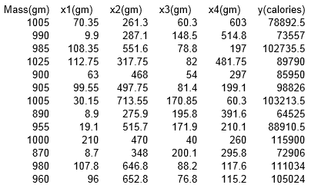

**Appendix A**

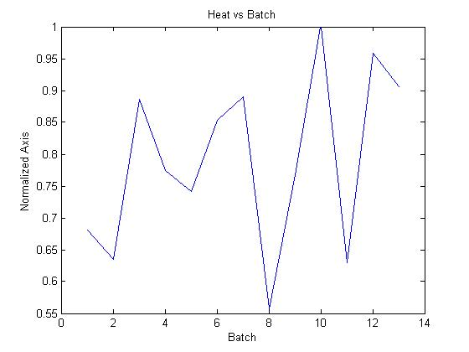

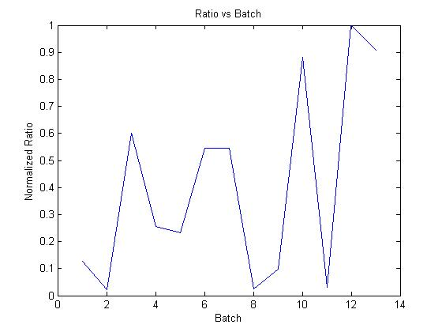

**Appendix B**