Ryan Watson

5 – Sept – 2014

Homework 4

Problem 8)

1. Statement of Problem

A company that produces computer chips has decided to conduct an experiment to determine if they could improve their production process. For this experiment they have decided to test 3 temperatures, 3 pressures, and 3 different washing methods. In this experiment 1 variable will be held constant while the other two will be allowed to fluctuate. In each test there will be nine data points. The wafers are only acceptable if the number of defects within the wafer is below $n_{0}$. For this his homework we were supposed to determine two method which will select the best process for producing wafers for the company.

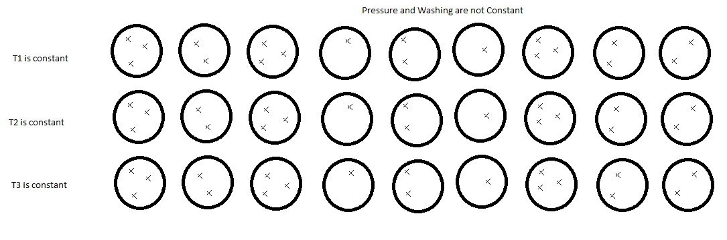

1. Summary of Solution

Because of the nature of this problem I believe that it is ideal for dimensional analysis (i.e. there should be some combination of the data that will give an acceptable answer). So the next step is to find what the proper ratio to look at is. The first ratio that came to mind was temperature over pressure, but this would not give any new information. This is because temperature and pressure within a contained volume are correlated (I.e. as temperature rises, pressure rises. So if temperature is help constant within a volume the pressure should not vary greatly). So I believe the ratio to look at would be either temperature over washing method or pressure over washing method.

The second way that I would go about solving this problem is through least squares. This system is ideally set up for a least squares solution. So if I could not find an acceptable solution using dimensional analysis I would use this method. But I would first try dimensional analysis because if the solution can be found quickly using that method it is a relatively simple solution to a complex problem.