Ryan Watson

[Email address]

Math modeling

Home Work

Problem 17)

**N=100 H=57**

1. Statement of the problem

An experiment is done to see if a coin is fair. In one experiment the coin is tossed 100 time and heads show up 57 times. Use the likelihood ratio test and the result that -2logλ is approximately $X^{2}$ to test p = .5.

1. Summary of the solution

To begin the analysis, I started by calculating the likelihood function for a probability of .5 and .57 given the data. The equation that was used can be seen below as equation 1. In equation 1, n is the number of data points, p is the probability.

L = $\frac{n!}{\left(p*n!\right)\left(\left(1-p\right)n!\right)}{\left(p\right)}^{p*n }{(1-p)}^{\left(1-p\right)*n}$

Eq. 1

Once that was calculated, I used the likelihood ratio test to see if my data approximated $X^{2}$. The likelihood ratio test is important for this type of analysis because it provides the means for comparing the likelihood of the data under one hypothesis against the likelihood of the data under another, more constricted hypothesis. For this analysis:

Alternate Hypothesis $H_{a}$: p ≠ .5

Null Hypothesis $H_{0}$: p = .5

LTR = -2 (log $H_{0}$ $-\log{H_{a}}$) = 1.965 ~

Table : Calculated Results

|  |  |  |
| --- | --- | --- |
|  | Alternate | Null |
| Probability | .57 | .5 |
| Likelihood | .0301 | .0804 |
| Log Likelihood | -3.503 | -2.521 |

Because we are only estimating one parameter, $X^{2}$ only has 1 degree of freedom. The critical significance level for a one degree of freedom $X^{2}$ is 2.706. This can be seen on Table 2, shown below. From this we can see that the fit is not worse under null. So, we have no reason to reject the null hypothesis. That is, the data are consistent with the coin being fair.

Table : Critical Values

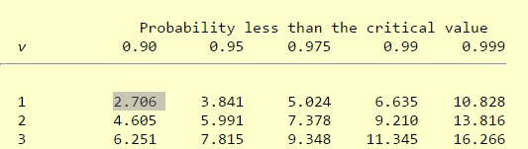

**N=1000 H=570**

When doing the same calculation for a data set of 1000 flips, I found that we would reject the null hypothesis. This means that we would not expect to observe 570 heads out of 1000 flips with a fair coin. I believe that the conclusion between the two data sets differ because of the sample size. The larger sample size decrease the value for lambda which increased the value of $X^{2}$.