|  |
| --- |
| Math 563 |
| Homework |
| Linear Model |

|  |
| --- |
| Ryan Watson  10-31-2014 |

1. Statement of Problem

The problem is to predict the energy consumption of the winter of 1971 (the first quarter of 1971). Write out the linear model y=Xβ+ε.

Table : Original Data



1. Summary of Solution

As said above, the goal of this problem is to create a linear model to best fit the data. To do this I used an Ordinary Least Squares solution. The solution to the Least Squares problem is given by the normal equation, which is shown below.

$Χ^{T}$ Χβ= $Χ^{T}Y$

Eq. 1

Where $\hat{β}$ can be solved for by simply manipulating Eq. 1.

$\hat{β}=inv(Χ^{T}$ Χ) $Χ^{T}Y$

Eq. 2

The two variables needed to solve for $\hat{β}$ are shown below.

Χ = $\begin{matrix}679 & 616 & 816 & 1 \\ 700 & 603 & 814 & 1 \\ 719 & 594 & 819 & 1 \\ 703 & 634 & 844 & 1 \\ 745 & 635 & 871 & 1\end{matrix}$

Y= $\begin{matrix}874 \\ 866 \\ 843 \\ 906 \\ 952\end{matrix}$

By solving Eq.2 with the matrix X and vector Y given above I was able to accurately predict the energy consumption for the winter months. The Equations for $\hat{W}$ can be seen below as Eq. 3. In the equation shown below the subscripts on the “C’s” correspond the column of data shown in Table 1.

$\hat{W}=0.1313C_{2}$ +1.1628 $C_{3}$ +0.8174 $C_{4}$-598.26

Eq. 3

Below is a graph of the actual energy consumption for the winter months and the estimated energy consumption estimated by using Eq. 3

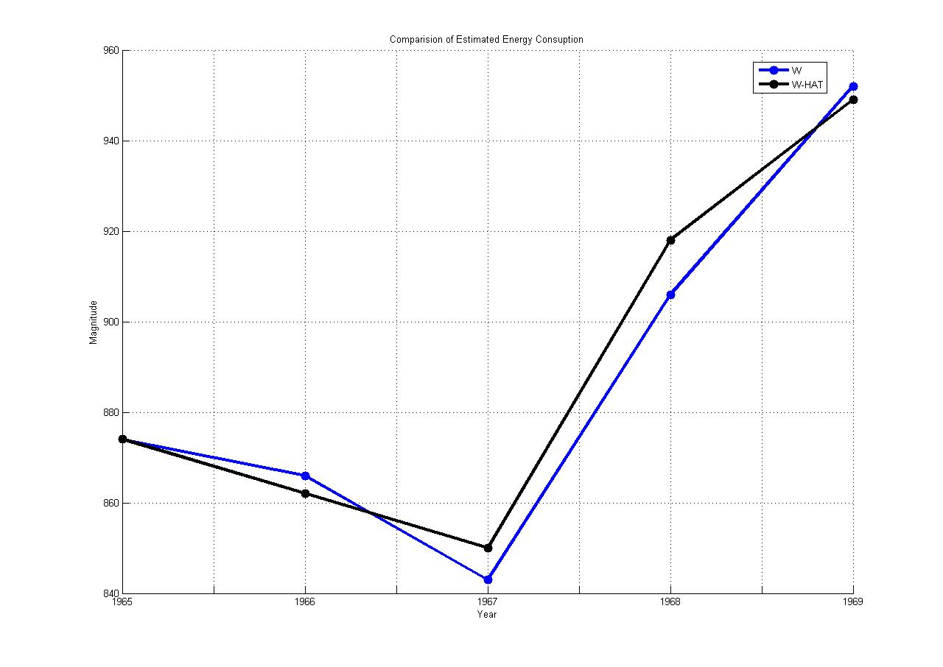

Figure 1: Comparison of Estimated vs Actual